Access VBA

VBA

The Form

To Make a Combo Box Using Table

Change

SQL

E:\Users\Ed\Desktop\Desk-Top\AccessDBases

E:\Users\Ed\Desktop\Desk-Top\FromDeskTop\Desktop\AccessDBases

For Biba stuff: E:\Users\Ed\Desktop\Desk-Top\FromDeskTop\bronc\ED + BILL

E:\Users\Ed\Desktop\Manual1\AccessManuals\AccesVBANew\Adela

ref: Microsoft Access VBA Macro Programming ( PDFDrive.com ).pdf

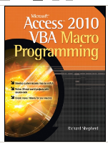
Access VBA 2010

- Create Beg2007.accdb
- Choose Options, Current Database.
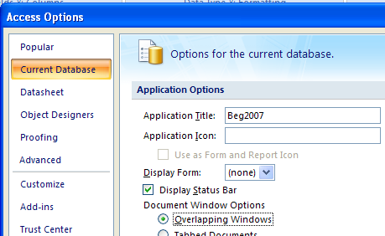

- Good practice to make the Title the same as the database name…

- .. and allow Overlapping Windows.

- Make a new form - don't base it on any table.
Make sure the .Control Wizard is OFF.
- Open it in Design View.
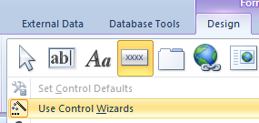

- From the Ribbon click the command button in the Controls group and draw a button on the form.

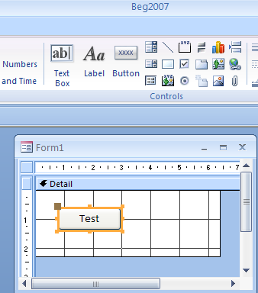

- Change the CAPTION to Test. To do this we could simply type it on the button or alternately change it in the Properties window. (Right click to get the Properties or alternatively press Alt-Enter.)

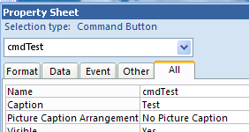

- Also in the Properties Window change the Name to cmdTest.

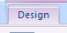
- On the Ribbon choose the Design tab (You may have it in Design already) and then choose View Code.
Tip: Use Al-F11 to toggle the code window.
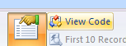

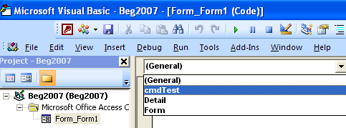
- Choose our object cmdTest.

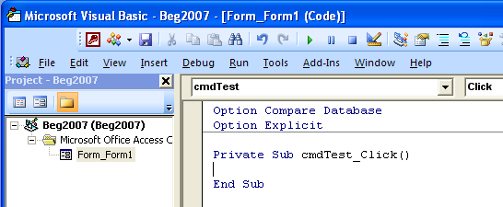

- Type your code here.

eg.

Private Sub cmdTest_Click()
When actually typing in VBA code, it is a good idea not to type any capitals. The VBE (Visual Basic Editor) will capitalize it for you thus confirming your spelling!

MsgBox "Hi"

Debug.Print "Hello"

End Sub

- Click on the Form View button

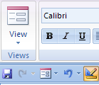

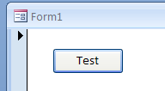

- To run our code, click on the Command Button and the message box should appear as below.

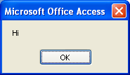

- To view the Debug (Intermediate) Window output press Cntrl-G.

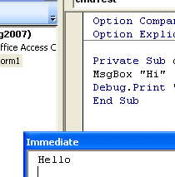

Hello appears in the Debug Window by virtue of Debug.Print "Hello" in the code.

Controls

- In the Design tab of the Ribbon choose the Text Box control and draw one on the form.

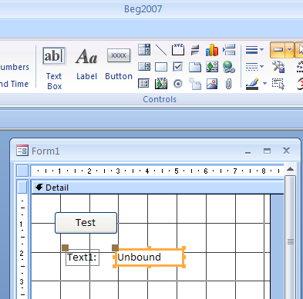

Moving these controls can be a bit tricky.

- The text box and its label can be moved independently if they are both first selected ie both have the orange border (use the Control or the Shift key to select both) and the mouse is placed precisely on one of these little brown tags and dragged. If your mouse is placed anywhere else on the orange border then dragged they will move together.

- Delete its label. Select it first ie it should have an orange border.

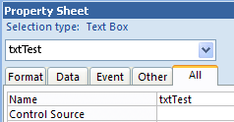

- Change its name to txtTest.
(Alt-Enter will get the Properties.)

- Choose View Code on the Design tag of the Ribbon and add code as below:

Tip: Also use Alt-F11 to go to the code window

Private Sub cmdTest_Click()
Methods DO something to an object.

Properties ARE something which an object HAS.
SetFocus is a METHOD.

Text is a PROPERTY.
txtTest.SetFocus
txtTest.Text = "Hello"

End Sub

An object is something which has properties and methods! There are two things which can come after the dot operator (the full-stop) : Properties or Methods.

- Go to Form view and click the button.
As it happens, the .Text property is a DEFAULT property ie it could be omitted as:
txtTest = "Hello"

Try it. It still works but probably not good practice.

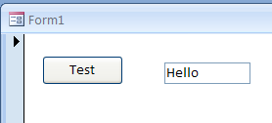

- Comment out the line as below
For comments see page 9 of this manual.

Private Sub cmdTest_Click()

'txtTest.SetFocus
txtTest.Text = "Hello"

End Sub

You will get this error message:

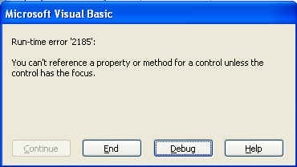

ie it is essential that we use:
txtTest.SetFocus

A text box can also be used to INPUT data.

Exercise:

Alter your code so that when we type text into the textbox and click the button a message box will appear with that text.

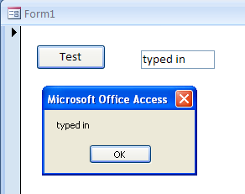

You may be surprised to find that you don’t need the SetFocus method here.

- Try some other controls.
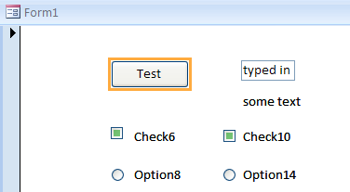

- You will need to quickly type some text into a label lest it disappears!

- Check boxes act independently bit Options act as a group.

- Rename some controls (note the convention) and run the form etc.

Debug.Print chkTest.Value
Debug.Print will cause the output to appear in the Debug – or Intermediate window as we saw previously. The easiest way to open the Immediate window is Ctrl-G from the VBE. Also To display the Immediate window, from the VBE menu choose View, Immediate Window.

Debug.Print optTest.Value

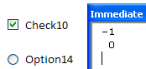
-1 is True
0 is False.

- Test the label. Name it say lblTest and give it the caption “some text”. Note that we can’t accept keyboard input into a label when it is “running” like we can with a textbox (Hence the difference) .

Debug.Print lblTest.Caption

- Practise VBA basics using Excel VBA in Easy Steps – some of which is reproduced in the following pages.

Ref also:
Balter Ch 8

Basic programming techniques

Variables

A variable is a name that we use to store a value.
There are a few restrictions on the names that we may choose – for example they cannot start with a number and they cannot contain periods (fullstops), for example x, y1, var1, sumX are legitimate variable names whereas 1x and x.1 are not.
Be careful not to use keywords as variable names, e.g. Sub is an illegal name for a variable. Variables are used to store values which you may wish to use later in your program.
Variables are categorized depending on the type of data they will contain.

A common type is Integer. A variable of Integer type, strictly speaking, can only hold whole number values, e.g.x = 2

String variable types contain text, e.g.Surname = "Jones"

We indicate the type of the variable by using the Dim statement,
e.g. Dim x As Integer
Dim Surname As String

This is known as declaring variables.

Different variable types occupy different amounts of space in memory.
The Dim statement signals how much memory is going to be required for this
particular variable.
After you enter a
line containing an
illegal variable
name in the VBE,
the line will turn
red
Option Explicit
Private Sub cmdTest_Click()
Dim x As Integer
x = 2
Debug.Print x
End Sub

.
Option Explicit, which will be explained later, may or may not
be included in your code at this stage.)

(Giving a variable a value is known as initializing it.)
Swapping Values

Why use variables? Consider this example.

We have two integers in two labels as shown below.

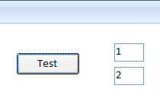

- Name the labels lblTest1 and lblTest2 and make their Captions 1 and 2.

We wish to write a program to swap them.

If you were to try the following code it wouldn’t work.

lblTest1.Value = lblTest2Value
lblTest2Value = lblTest1Value

The problem is that the value in A1 gets overwritten and therefore lost. The result would be that both cells would finally contain 2.

We need to be able to save the value in lblTest1 in a variable as follows:

Private Sub cmdTest_Click()

Dim x As Integer
The value in lblTest1 is saved in x.

x = lblTest1.Value

lblTest1.Value = lblTest2.Value
The saved value is retrieved.
.

lblTest2.Value = x

End Sub

When we run this program by clicking on the command button, the values in the labels will be successfully swapped:

(If you were to click the command button again, the numbers would again be swapped.)

The message box

The message box is a means of displaying data.

We can display a combination of text and the value of a variable:

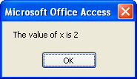
Private Sub cmdTest_Click()
Dim x As Integer
x = 2
MsgBox "The value of x is " & CStr(x)
End Sub

The MsgBox’s message (prompt) must be a string (text), hence the CStr() function is required to convert an integer to a string, which is then concatenated with the first string using the & operator.

Comments
Comments are text that you can place in the code purely for annotation. Comments play no part in the running of the program. Comments can be useful when later reading through your code to remind you what you did! To make a comment, place an apostrophe at the start of the text. After the line is entered, it should turn green to indicate that it is a comment.

Dim x As Integer 'Declare x
'This whole line is a comment

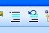
If you have many lines that you wish to comment, you can use the Comment Block button which can be placed on your VBE toolbar as follows. From the VBE menu, choose View, Toolbars and then click Customize.... The Customize dialog box should appear as below.
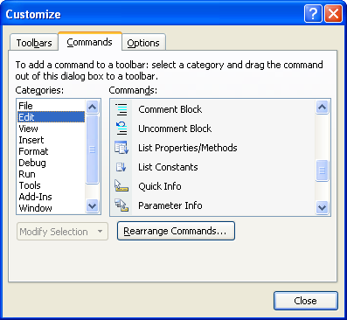

- Choose Edit and then drag a Comment Block onto the menu.

Now, in order to comment out a block of text, simply highlight the block and click the Comment Block button. Likewise, in order to uncomment a block, highlight the commented block and click the Uncomment Block button.

Option Explicit
You may have noticed in our previous code examples, that sometimes Option Explicit appears and sometimes it doesn’t.

That’s because it is optional! Option Explicit at the top of our code module forces us to declare all of our variables, i.e. use Dim statements.

At the least, Option Explicit invokes spell-checking. The example below uses the variable sales, but does not use Option Explicit. (Simply delete/comment Option Explicit if it is there.)

'Option Explicit

Private Sub cmdTest_Click()

sales = 2

MsgBox sales

End Sub
When we run this code by clicking on the command button (first exiting design mode), as we expect, a message box appears displaying the value of 2.
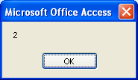

In the example below however, the second sales variable has been inadvertently misspelled as sals.

'Option Explicit

Private Sub cmdTest_Click()

sales = 2
sales has been misspelled.

MsgBox sals

End Sub

When this program is run, the mistake goes undetected! A message box appears, but with a blank value, (see next page) because the misspelled variable sals is regarded as another legitimate variable without a value!

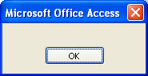
No value is displayed.

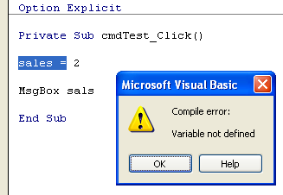
Now include Option Explicit at the very top of the code. Declare (Dim) the variable sales and run it again.

Always include
Option Explicit at
the top of your
code - even
though it is
optional!

This time the program halts with an error message.
Click OK – and don’t forget to click the Stop button!

If you now correct the typo (i.e. change sals to sales), the program should now run as expected, i.e. the message box will now correctly display 2.

If using Option Explicit may seem a bit unnecessary, even at this early stage, it is a good idea to get used to it now – it will eventually save you time, especially as programs become larger.

Option Explicit can be made to appear automatically at the top of your code by checking Require Variable Declaration, after choosing Tools, Options..., Editor from the VBE menu. It will not take effect however, until you close and open the database. Meanwhile, you can simply type Option Explicit in the General Declarations section if it does not already appear.

Other variable types
The Long (meaning long integer) variable type is used for large integers up to 2,147,483,647. (Integer can only take values up to 32,767.)

Single can cater for decimal values as well as integers.

Double (64 bit) is a more accurate version of the 32 bit Single type.

Boolean can take only the values True or False.

Variant can take any type!

Date is used for storing dates. (More about Date later.)

Generally speaking, if you are not sure of the size of variable required, opt for the larger capacity, e.g. use Long rather than Integer.

The following code segment demonstrates common types.

Option Explicit

Private Sub cmdTest_Click()

Dim lg As Long
Dim sg As Single
Dim db As Double
It is very tempting to declare all
variables as variant. This has disadvantages not
only from performance point of view, (i.e. your code will run slower) but you should find that errors are easier to isolate if you are more specific as to the variable type.

Dim tf As Boolean
Dim vr As Variant
Dim dt As Date
lg = 205
sg = 2.125
db = 2.125
tf = True
vr = 2.6
dt = #1/1/2005#
Debug.Print lg
Take Care: The l (“ell”) in the default VBA font can be easily mistaken for the VBA 1 (one).

Debug.Print = sg
Debug.Print = db
Debug.Print = tf
Debug.Print = vr
Debug.Print = design-time

End Sub

It is possible to Dim many variables on the same line, e.g. Dim lg As Long, sg As Single, db As Double.
If we wish to specify a variable as a Variant type, we can omit the type qualifier altogether, e.g. instead of Dim vr As Variant, we could simply have Dim vr, since Variant is the default data type.

Take care however when declaring the variables on one line, e.g.

Dim x, y, z As Integer will declare x and y as Variant, but only z as an Integer.
An alternative method of declaring variables is to use a type declaration character. This is a character which is appended to the variable name, e.g. Dim i As Integer can be replaced by Dim i% and Dim lg As Long can be replaced by Dim lg&.

The use of type-declaration characters however is deprecated, i.e. is to be phased out and eventually not supported, and is only mentioned here in case it is encountered.

It is good programming practice to ensure that all variable declarations are placed at the very start of the code.

Unfortunately, with Access VBA, it is not yet possible to declare and initialize a variable in one statement, e.g. Dim s As Single = 22.1 is not yet possible.

IntelliSense
You have probably by now, noticed a drop-down box which sometimes appears as you type. This is IntelliSense.

IntelliSense is a feature of the VBE which allows you to easily complete your line of code.
Note that as a space is typed, as in the above example after the "as", IntelliSense appears. As further letters are typed, the IntelliSense suggestions become more specific.

To accept the suggestion, either implicitly accept the suggestion by continuing to type the remainder of the line, or double-click on the suggestion.
To accept the
IntelliSense
suggestion
without starting a
new line, press
the Tab key.
IntelliSense can
be made to
appear at any
time by pressing
Ctrl+Spacebar.

(If the Enter key is pressed to accept the highlighted suggestion, a new line will be also started.)

You will also notice that IntelliSense will sometimes even make a suggestion for the value of a variable. For example, in our case, as shown below, when "tf =" is typed, True or False is suggested. (but only if you are declaring your variables using Dim etc.).

If IntelliSense
does not appear,
from the VBE
menu, choose
Tools, Options...,
and check Auto List Members.

Help

AcessVBA has a very comprehensive built-in reference. The most reliable way to get Help is the easiest! Simply highlight the word (you could double-click on the word) for which you want Help, and then press the F1 key. For example, highlight the keyword Boolean as shown below and then press the F1 key.

The Help dialog box appears as shown below.

Try the See Also and then choose Data Type Summary where you
should find data types that we have not yet discussed.
Try the hyperlinks for some extremely useful definitions. (The
hyperlinks change color after being “visited”.)

To get Help, you can sometimes simply place t e cursor in a word and press F1. Help can also be accessed by choosing Help from the VBE menu and clicking Microsoft Visual Basic Help.

Excel VBA Help is not installed by default in a Standard installation of Microsoft Office. You may need to run the Office setup program again and choose the option to install it.

Arithmetic operations

The same operator symbols are used in VBA. We could carry out the above operation in VBA as follows.

Private Sub cmdTest_Click()

Dim x As Single
This formula of course
will multiply the
x by 3, divide by 4 and then
add 3 to the result
giving 9.

x = 8

y = x * 3 / 4 + 3

Debug.Print y

End Sub

Try the exponentiation operator; replace the corresponding line above with
Debug.Print x ^ 2 in which case the value of x is raised to the power of 2.

Parentheses ensure priority as shown below.
Use the Single or
Double data type
when the result
could be a
decimal number.

Private Sub cmdTest_Click()

Dim x As Single, y As Single

x = 8
This line should
cause 9 to be
printed.
16 is divided by
8, and then 1 is
subtracted to
give 1.

y = 16 / x – 1

Debug.Print y

y = 18 /(x + 1)

Debug.Print y
18 is divided by
the sum of 8
plus 1 to give 2.
End Sub

HW Exercise: Make a program that allows you to input a value from a text box and then calculates the total after VAT is applied and then displays the result using a message bor.

Breakpoints

The program can be made to halt temporarily at a particular line by
using a breakpoint.
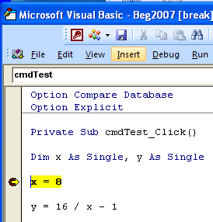

In the VBE Click on the left margin of the VBE at the point where you would like to set a breakpoint. A brown/maroon dot appears

- Run the program by clicking the command button on the
spreadsheet, or by clicking the Run button from the VBE, making
sure that the cursor is within the code. The program will halt at
the breakpoint.
The yellow bar shows the current line.

Note that the yellow line has not been executed yet - it is about to be.

The debugger assists with finding errors. It can be used to step
through the code one line at a time. This is useful for instructional
purposes – the program can be run in slow motion!

- Continue to press F8 to single step through the program.
Instead of pressing the F8 key, from the VBE
menu you can choose Debug,Step Into.

If you wish to stop single stepping, click the Stop button (or click
the (triangular) Continue button to continue running).

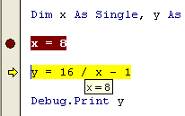
By holding the cursor steady on a variable, we can inspect the
value of the variable.

Single step by pressing the F8 key or continue to click the Continue (Run) button to run
(loop) to the breakpoint. If you wish to stop the program, click the Reset (Stop) button.

To remove the breakpoint, simply click on it. (To clear all breakpoints, from the VBE menu choose Debug, Clear All Breakpoints.)

Whilst debugging, you can type directly into the Immediate window while the program is temporarily halted (break mode).

The For...Next loop
In the Immediate Window, Print i can be
abbreviated to ?i.
If you wish to
repeat a
command whilst
in the Immediate
window, simply
place your cursor at the end of
the command and press the
Enter key.

The For...Next loop is one of the most useful program constructs.

We usually first declare an Integer counter variable which will
get automatically incremented as control is transferred cyclically
from the last line of the loop to the first. The For...Next keyword
pair serve to enclose the code.

This code will simply cause a message box to appear three times
after the command button is clicked to run the program.

Private Sub cmdTest_Click()

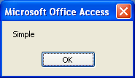
Dim i As Integer
For i = 1 To 3
The message box will
appear (and need to be
dismissed) three times.
MsgBox "Simple"
Next i

End Sub

The For keyword signals the start of the loop. The value of i is
initially 1. Program control continues down, line by line – the
message box is displayed – until the Next keyword is reached.

Program control then automatically returns to the For above.

The value of i is then incremented to 2.

This process continues until i becomes 3 – control is no longer transferred back to the
For but continues down to the statement after the Next – the End
Sub whereupon the program terminates.

Change the code to that shown below so that the message box will
now display 1, 2 and 3 respectively.

Private Sub cmdTest_Click()

Dim i As Integer
The message box will appear three times displaying the value of i each time
For i = 1 To 3
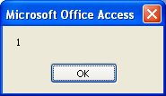
MsgBox CStr(i)
Next i
End Sub

CStr(i) converts a number to a string(text) which is necessary if we are to output it using a message box.

Use the Tab key
to indent a line of
code in order to
improve legibility.
If...Then

Another extremely important statement pair is the If...Then pair.

An action is either performed or not performed, depending on
whether a condition is satisfied.

Private Sub cmdTest_Click()
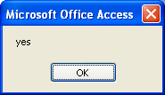
Dim i As Integer

i = 2

If i = 2 Then MsgBox "yes"

End Sub

Change i = 2 to i = 3. The condition i = 2 now of course is
false. When the program runs, nothing happens.

We have just seen how the If...Then construction was placed on
one line. It can be “split” by placing the conditional code in an
If....End If block as shown below.

When run, this code will perform exactly as the previous code.

Option Explicit

Private Sub cmdTest_Click()

Dim i As Integer
The If and End If serve
to enclose the
conditional code.

i = 2

If i = 2 Then

MsgBox "yes"

End If

End Sub

The advantage of this construction is that more than one statement can be executed if the condition is satisfied, as we will now see.

No matter what construction is
used, the If and Then are always
on the same line.

Private Sub cmdTest_Click()

Dim i As Integer
i = 2
The If and End If
now enclose
more than one
statement.
If i = 2 Then
MsgBox "yes"
MsgBox "of course"
End If
End Sub

Else

Else is used with If...Then to cater for the alternative.

Private Sub cmdTest_Click()

Dim i As Integer
i = 1
Since the condition is
not satisfied, only the
Else section of the
code is performed.
If i = 2 Then
MsgBox "yes"
MsgBox "of course"
Else
MsgBox "no"
End If

End Sub

Logical operators

The most common logical operators are And, Or and Not.
When each of the three simple programs below is run, the
result will be the same – “yes” will be placed in the top left
cell of the spreadsheet in each case.

And
To put two
statements on
one line, place a
colon (:) in
between.

Private Sub cmdTest_Click()

Dim i As Integer, j As Integer
Both conditions
must be true.
i = 1 : j = 2
If i = 1 And j = 2 Then MsgBox "yes"
End Sub

Or

Private Sub cmdTest_Click()
Any value for i other than 2 will
result in the condition being satisfied.
Either condition is sufficient.

Dim i As Integer, j As Integer
i = 1 : j = 3
If i = 1 Or j = 2 Then MsgBox "yes"End Sub

Not

Private Sub cmdTest_Click()

Dim i As Integer
i = 1
If Not i = 2 Then MsgBox "yes"
End Sub

Do...Loops

Private Sub cmdTest_Click()
The only difference is that the condition is tested at the start of the loop. After i
becomes 5 inside the loop, Loop sends
control back to the Do Until whereupon
the loop terminates.

Dim i As Integer
i = 0
Do Until i = 5
i = i + 1
Debug.Print 10
Loop
End Sub

Do and Loop also occur in pairs and serve to enclose code which
“repeats”. The program below will perform exactly as the
For...Next example we met previously.

It will place five 10’s in the first column of the sheet. Whereas the For...Next loop will
increment the counter for us automatically, when using the Do...Loop we must increment it explicitly.
The statement i = i + 1 means “take the
present value of i and add 1 to it”.
When we click on the Command Button on the
sheet, five 10’s are placed in the first column.
For values of i less than 5, control is transferred back to the For. When i finally becomes 5, the loop terminates.

Private Sub cmdTest_Click()

Dim i As Integer
i = 0
It is most
important to
understand that
i = i + 1 means
increment the
value of i by 1.
Do
i = i + 1
Debug.Print 10
Loop Until i = 5
End Sub

As you can see, the differences between loops using Do...Loop is
quite subtle – familiarity with one would suffice at this stage.

The condition after the Do (or the Loop) (e.g. i < 5) evaluates to
either True or False. If we were to run something like this...

Do While False
Loop

...nothing would happen, it wouldn’t loop at all, whereas the
following code would loop forever. (Don’t try this!)
Since the condition is True, the program would loop continuously.

Do While True
Loop

In general, a For...Next loop is used when the number of loops
required is quite definite, whereas the other loops, e.g. Do...While
are used when a variable, which is not necessarily the loop counter,
meets a condition inside the loop.

Instead of Do...Until, we may use Do...While.
The following is a variation of the above.

Again the effect of this code will be identical.

Private Sub cmdTest_Click()

Dim i As Integer
i = 0
Do While i < 5
i = i + 1
Debug.Print 10
Loop

End Sub

To halt a
continuous loop,
press Ctrl+Break
on the keyboard.

Select Case

Select Case is like a multiple If statement. The option chosen
will depend on the value of a variable.

Private Sub cmdTest_Click()

Dim x As Integer
The value of the variable x will determine which Case is selected.

x = 7
Select Case x
Case 5
MsgBox "Five"
Since the value of x is 7, this section of the code (only) will be executed.

Case 7
MsgBox "Seven"
End Select

End Sub

As a result of running the program, the message box will appear as
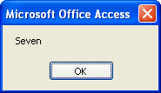
below.

From the VBE, take a look at the Help for Select Case.

The Help Example is particularly useful. Copy and paste it into the
CommandButton procedure. Note in the example how the option
chosen can depend on a range of values rather than a single value.
Note also the use of the comparison operators Is < and Is >.
End Select always accompanies Select Case.

When using this particular Help Example, make sure that the Immediate window is open. (From the VBE choose View, Immediate Window - or Ctrl+G) to see the result of the Debug.Print statement.)

The most
convenient way to
get Help is to
select the words
(e.g. Select Case)
in the VBE and press F1.

Sometimes an error message will appear warning that you have a “Next without For”, where in reality it’s an End If that’s missing.

String handling

We previously mentioned that a piece of text is known as a string in
VBA (and many other languages as well). We can use special
functions to join (concatenate) them, split them, search for one
string inside another, etc.

We have seen how to declare and initialize String types:

Dim st1 As String, st2 As String
st1 = "house" : st2 = "boat"

Concatenation

To join strings, use the & operator.

MsgBox st1 & st2

.Place the above lines of code into a command button procedure and run it.
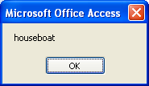

“house” and “boat” are concatenated to give “houseboat”.

Run the following lines of code as well.

Left

Left extracts the leftmost characters from a string, e.g.
MsgBox Left(st1, 2)
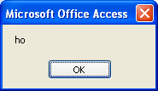
The 2 leftmost characters of
“house”, i.e. “ho” are extracted

Right

Right extracts the rightmost characters from a string, e.g.
MsgBox Right(st1, 2)
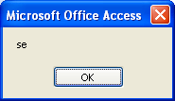
The 2 rightmost characters of
“house”, i.e. “se” are extracted.

Instr

Instr finds the position of a substring in a string, e.g.
MsgBox InStr(st1, "us")
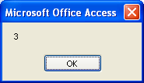
The position of the string “us” inside the
string “house” is found – at position 3

When using the Mid function, if we don’t specify the last number,
the substring extracted will be the rest of the string to the right,
from the position specified, e.g. if instead of
Mid("house", 3, 2) which produced “us”, we used
Mid("house", 3) then “use” would result.

When extracting characters to the right from a string, the Mid function is
surprisingly more useful than Right, since it is usually more
convenient to specify the starting position for string extraction,
rather than the number of characters to the right to be extracted.

Mid

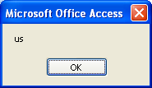
Mid extracts a substring,
e.g. MsgBox Mid(st1, 3, 2)

The substring of the string “house”,
starting at position 3 and of length 2,
i.e. “us” is extracted.

Len

Len simply finds the length of the string, i.e. the number of
characters,
e.g. MsgBox Len(st1)

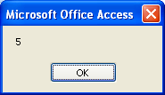
The length of the string “house” is
determined, i.e. 5 characters.

See Help for
more information
about other
interesting string related
functions
e.g. Trim, CStr, Val, etc.
To rearrange a string

We are given a person’s full name, e.g. Jack Robinson.

We wish to convert this to the format Robinson,Jack i.e. the surname followed
by a comma (no space), followed by the Christian name. (See graphic below.)

We require this technique to work for any Christian name-surname
pair. First we must extract the Christian name.

Before that, we need to find the position of the space.

We can then extract all of the characters to the left of this position (the Christian
name).

We then need to extract all of the characters to the right of this position (the surname).

Finally we can concatenate the surname with the Christian name (in that order), not forgetting to
put a comma in between.

Private Sub cmdTest_Click()

Dim fullName As String, pos As Integer, _
cn As String, sn As String, newName As String

fullName = "Jack Robinson"

pos = InStr(fullName, " ") 'position of space

cn = Left(fullName, pos - 1) 'Christian name

sn = Mid(fullName, pos + 1) 'surname

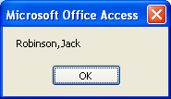
newName = sn & "," & cn

MsgBox newName 'B1 holds new name

End Sub

Test it by using a different full name.

.

Procedures

Procedures allow us to compartmentalize and organize our
code. We discuss the two main types, subs and functions along
with their practical use.

Subs

Procedures are self-contained blocks of code. Procedures become
more useful as program size increases. They are of two main types
– subs and functions. As we will see, the difference between a sub
and a function is that a function can return a value whereas a sub
cannot.

Writing a sub
Square is our name for our sub.

Write this code.

Option Explicit

Private Sub cmdTest_Click()
Square
(As we type “sub Square” and then press Enter, as well as being capitalized,
parentheses and End Sub (formatted blue) appear automatically.)

End Sub

Sub Square()
Dim x As Double
x = 3
x = x ^ 2
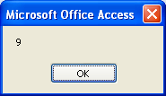
MsgBox x
End Sub

The Square statement in the CommandButton procedure has the
effect of “calling” the sub. The called procedure simply squares 3
to give 9, which is then displayed by the message box.

Generally speaking, in the course of program development, it is
useful to be able to “wrap” code which has been tried and tested
into subs (or functions) with identifiable names, and place them
outside the main calling program. That way, our main code area
should consist of a series of procedure calls (with recognizable
names) with the corresponding encapsulated procedures placed
after the main program area.

Passing a value to a sub

At present our sub can only square 3. We could modify it so that it
could square any number by passing the number to be squared to
the sub as follows.

Option Explicit
Private Sub cmdTest_Click()
3 is passed to x.

Square 3
End Sub

Sub Square(x As Double)
x As Double is the equivalent
of Dim x as Double.

x = x ^ 2
MsgBox x
End Sub

The variable which accepts the passed value (x in
this case), is known as a parameter. Strictly speaking,
the 3 which is passed is known as an argument, but
both are often referred to as parameters.

Change the line
Square 3
to
Square 4

to show that another value can be passed. The result, of course, in
the latter case, should be that 16 is displayed.

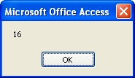
Use Debug to
single step (F8) to
watch the transfer
of program
control.

Functions differ from subs in that they can return a value.

Functions

Writing a function

Modify the code as shown. (Note that after Function is typed,
End Function appears automatically!)

Option Explicit
Private Sub cmdTest_Click()

Dim y As Double
y = Square(3)
MsgBox y
End Sub

Function Square(x As Double) As Double
x = x ^ 2
Square = x
End Function
The return type (also Double) it is also specified when using a function. (If it is omitted, a Variant return type is assumed.)

This time, the value is returned to y and displayed. The name of the function (Square) is always “repeated” (usually at the end of the function) and usually put equal to what is to
be returned (in this case x).

Note that we could replace the command button code with:

Private Sub cmdTest_Click()

MsgBox Square(3)

End Sub

We can even include our function name in an expression such as

MsgBox 2 * Square(3)
Summary: when using functions

• Use the same function name to return the value, e.g.
FindNum = ...

• Use parentheses when passing the arguments, e.g.
FindNum(fnd, Range("A1:A6")) (not with a sub).

• Specify the return type (e.g. As Integer as above).
in which case we could regard the function name as a variable with
value 9, so that 18 would be displayed. Try it.

A function name
invariably appears
on the “right-hand
-side” of an
expression, e.g. y
= Square(3) or MsgBox
Square(3).
Passing ByRef and ByVal

ByRef

Modify the code as shown to pass a variable rather than a constant.

Option Explicit

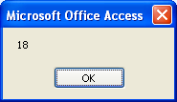
Private Sub cmdTest_Click()
Dim v As Double
The variable v is being passed to the function.
v = 3
MsgBox 2 * Square(v)
End Sub

Function Square( x As Double) As Double
x = x ^ 2
Square = x
End Function
Single step this code. After the function has been called hold your mouse on v to find its value. Quite surprisingly, the value of v is as 9, not 3, i.e. the value has been changed permanently.

Include ByRef in the corresponding line above so that it becomes:

Function Square(ByRef x As Double) As Double
Although discussed in relation to functions, ByVal and ByRef have exactly the same effect when used with subs.

It won’t make any difference, ByRef is the default.

ByVal

Now change the ByRef to ByVal so that it becomes:

Function Square(ByVal x As Double) As Double
ByVal ensures that the value is passed by value and not modified
inside the procedure.
Passing a variable to a function or a sub ByRef (by reference), can permanently change the variable passed, whereas passing ByVal (by value) cannot.

This time, when the code is run (and
after the 18 has been displayed), the
value of v is found to be 3 ie it is unchanged
after the function call.
ByRef is the default. Your variables may unintentionally get changed permanently if they are passed by ByRef.

Technically speaking, ByRef causes the actual memory address of a variable to be passed to the procedure, whereas ByVal causes a copy of the variable to be passed.

Variable scope
Use subs and functions wherever possible to organize your code - just like the professionals

The scope of a variable determines where in the program it is valid.
A variable is only “known” at the “level” at which it is declared.

This code below will fail with the message shown. Try it.

Option Explicit

Private Sub cmdTest_Click()
sub1
sub2
End Sub

Sub sub1()
Dim i As Integer
i = 1
The problem is that i is not known in the second procedure, since it was declared in the first procedure only.

End Sub

Sub sub2()
i = 2
End Sub

Option Explicit

Private Sub cmdTest_Click()
sub1
sub2
End Sub

Sub sub1()
Dim i As Integer
i = 1
Msgbox i
End Sub
Include a Dim statement in the second procedure as well, as shown.
Sub sub2()
Dim i As Integer
i = 2
Msgbox i
Each i in this case
has procedure level
scope.
End Sub

It is important to realize that the second i variable is thereby completely independent of the i in the first procedure.

What if we did want the i in the first procedure to also be known,
and retain its value, in the second procedure?

We need to declare it in the General Declarations section (the top of the module).

Remove the Dim statements from each sub and modify the code as
shown below.

Option Explicit

Dim i As Integer

Private Sub cmdTest_Click()
sub1
sub2
End Sub

Sub sub1()
i = 1
MsgBox i
End Sub

Sub sub2()
MsgBox i
End Sub

Place the Dim statement in the General Declarations. i will be then be
known throughout the whole module.

The value of i was defined as 1 in the first procedure, so this value will also be
known in the second procedure.

It is very strongly recommended that variables are declared as
A global variable is one which is declared in a
standard code module using Public instead of Dim,
e.g. Public
i as Integer. Such a variable would then be available to every module (and accordingly every
procedure) in the program. Try it.
You will need to define the
variable (e.g. i = 3) in a
procedure.
locally as possible, resisting the strong temptation to use the easy
option of module-level variables as above, where the variable is
declared outside the procedures that use it (in the General
Declarations). One alternative to using module-level or global
variables is to pass variables as arguments from one sub to another.
The objective of a programmer is not only to write a program that
works, but to make contingency for when it doesn’t. Declaring
variables as locally as possible is but one of these contingencies.
(Using Option Explicit is another.) Knowing precisely where
variables are declared and defined thereby helps us to localize the
source of any potential errors that may occur.
When the program is run, a message box
will appear twice displaying 1 each time.

The MsgBox function

We have met the MsgBox statement, e.g. MsgBox "Click". We
could regard this as calling the built-in MsgBox sub and passing it
the parameter "Click". MsgBox can also be used as a function,
whereby a value is returned, e.g.

Type in the code as shown below.

.
The Title (“Test”) will appear at the top of the message box (see below).

The Prompt
is “Click”.

As we type into the VBE, Auto Quick Info
provides a guide to the correct syntax (as well as listing the vb constants available).

x = MsgBox ("Click",4,"Test")

The Buttons value of 4 determines that two buttons, Yes and No will appear on the message box (see the VBE Help for more details).

The value of x returned is determined by the button pressed. If Yes
is clicked, the value returned is 6 (vbYes).
If No is clicked, the value returned is 7 (vbNo). To confirm this, you may wish to use another MsgBox statement to display the value of x.

x = MsgBox ("Click",4,"Test")
MsgBox x

Use the VB builtin
constants
where possible,
e.g. vbYesNo
instead of 4.
When calling
functions, use
parentheses to
enclose the
arguments.
To get automatic
syntax assistance,
Auto Quick Info
must be checked.
(From the VBE
editor, choose Tools, Options...)

Named parameters

What if we did not want to specify Yes/No buttons but instead
accept the default of an OK button? We could omit the Buttons
argument altogether as follows.

x = MsgBox("Click", , "Test")

An extra comma indicates a
missing argument.

Keeping the arguments in strict order, and providing the required
extra commas, can be a little tedious – especially as the number of
parameters becomes larger.
Named parameters obviates this. The equivalent of the above,
Always include
the colon with the
equal sign when
using named
parameters.
using named parameters is:

x = MsgBox(Prompt:="Click", Title:="Test")

Note that if named parameters are used, the order of the
arguments no longer matters, e.g. the following statement would
be equivalent to the above.

x = MsgBox(Title:="Test", Prompt:="Click")

In a practical situation, we could test for the returned value. For
example, if we wish to confirm that we want to delete the contents
of the test box, we could use:

Private Sub cmdTest_Click()
Dim x As Integer
x = MsgBox(Prompt:="Delete the contents?",Buttons:=vbYesNo)
txtTest1.SetFocus
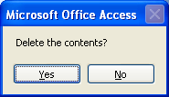
txtTest1.Text = ""
End If

'otherwise do nothing
End Sub

Using arrays

1-D arrays

An array is a set of indexed variables. The variables could be Integers, Variants, etc. but must be of a single type.

One dimensional arrays have only one index which is used to assign and access the individual elements.
For example, we could define an array of three Strings as shown below.

A major advantage of storing variables in an array is that they can
be conveniently processed using a loop. For example, if we wished
to attach the same string to each element in the array, (using a 3rd
command button) we could use:

Option Explicit
This Dim declaration reserves space in memory
for 3 String elements, indexed from 1 to 3.

Dim Company(1 to 3) As String

Private Sub cmdTest_Click()
Company(1) = "Business Systems"
Company(2) = "Best Image"
Company(3) = "Analytical Systems"
End Sub

Note that the declaration Dim Company(1 to 3) As String in
this case has been placed in the General Declarations area rather
than inside the command button procedure, in anticipation of
making the array available to other (command button) procedures
in that module. To display the third element of the array for
example, (using a second command button) we could use:

Private Sub CommandButton2_Click()
An error will occur
in our example if
the first
command button
is not clicked (to
initialize the array) before
clicking the second.
MsgBox Company(3)
End Sub

The third
element is
displayed.
Variables declared
in the General
Declarations have
module-level
scope.
Instead of declaring our array using

Dim Company(1 to 3) As String

we could use:

Dim Company(3) As String

This will give us an element for free! – element zero – in this case
Company(0). We could assign another company name to Company(0

To officially signal the absence of element zero, we
may wish to specify Option Base 1 in the General Declarations,
in which case all arrays (at least in that code module) will now be
1-based rather than 0-based.

Private Sub CommandButton3_Click()
Dim i As Integer
For i = 1 To 3
Company(i) = Company(i) & " Ltd"
Next i
End Sub

Similarly, we could conveniently display all of these array elements
using a simple loop (modifying the code in button 2) as shown
below.

Private Sub cmdTest_Click()
Dim i As Integer
For i = 1 To 3
MsgBox Company(i)
Next i
End Sub

After clicking the three command
buttons (in the order 1, 3 and then 2),
the amended names will be displayed.
Strings are concatenated.

VB arrays are
zero-based by
default. Use
Option Base 1 in
the General
Declarations if you wish your
arrays to be one-based.
2-D arrays

we would use:

Dim Company(1 To 3, 1 To 2) As String
Dim rw As Integer, cl As Integer
For rw = 1 To 3
For cl = 1 To 2
We have a loop inside a loop.
Company(rw, cl) = 5
Next cl
Next rw

The alternative declaration of Dim Company(3, 2) As String,
would reserve space for an array of 4 rows and 3 columns, i.e. the
elements Company(0,0), Company(0,1), Company(1,0) etc.
would also be available (unless we specify Option Base 1).

VB arrays can have more than 2 (up to 60) dimensions.

UBound

As an alternative to For rw = 1 To 3 we could use
For rw = 1 To UBound(Company,1), where
UBound(Company,1) indicates the size of the 1st dimension of the
Company array which is 3 in this case – the number of rows.
Similarly UBound(Company,2) would represent the value of the
2nd dimension which is 2 in this case – the number of columns.
LBound is used in a similar manner to specify the lower limit.
2-D arrays have one index which denotes the row, and one index
which denotes the column, and can therefore can be likened to the
Excel spreadsheet structure itself.

To access
elements of a 2-D array, use two
indices, e.g.
Company(1,2)
would access the element in row
one and column two.
Minimize the
number of fixed
constants in your
code by using
functions such as
UBound.

ReDim
If an array is declared inside a
procedure, it will only be available to that procedure, whereas if it is declared in the
General Declarations, it will be
available to all procedures in
that module.

Sometimes we don’t know in advance how big an array is going to
be, for example when we are entering data into an array looping using
an input box as below.

The trick is to first Dim the array without a dimension,

Dim Company() As String and then ReDim when we know the size, e.g.

ReDim Company(3)

If we wish to preserve the contents of the array however, we must
include the Preserve keyword or else the contents will be lost, i.e.

ReDim Preserve Company(3)

This could be repeated, e.g. ReDim Preserve Company(5).

When inputting data using an input box, an array size could be
dynamically adjusted as more data is input.
In the example below, an input box will appear each time with the prompt "Sales
Figures?". As data is input, the array size is dynamically increased
by one each time to accommodate the new element.
Since we are
using a Static
variable, its
value is
remembered
from click to
click.

Option Explicit
Option Base 1
Dim Sales() As String

Private Sub cmdTest_Click()
Static i As Integer
i = i + 1
ReDim Preserve Sales(i)
Sales(i) = InputBox("Sales Figures?")
End Sub
The Input box function shown
here can only be used to input a
String type. To be able to input other types and have more flexibility, we could use the InputBox method of the Application object. See the VBAHelp for more details.
The ReDim statement ensures that the
array size is increased by one each time.

Multi dimensional arrays can be
ReDimmed, but only the very last
dimension can be changed when
using ReDim withPreserve.

The Array function

The Array function allows us to quickly and easily initialize a
variant array. The code below initializes two variant arrays,
Company and Sales.
This array both IS a variant variable and CONTAINS variants.

Option Explicit

Private Sub cmdTest_Click()

Dim Company As Variant, Sales As Variant

Company = Array("Business Systems", "Best Image", "Analytical Systems")
Sales = Array(2.34, 3.42, 5.62)

MsgBox Company(0)
The first elements have index 0. (If Option Base were set to 1, the first
element would have an index of 1.)
MsgBox Sales(0)

End Sub

Run-time errors

Programming errors are of two main types, syntax and run-time.

Syntax errors are those which occur at development time, e.g.
omitting a Next in a For...Next loop. We see (only too
often!) how these errors will be detected by the syntax checker –
the program will not be allowed to run.

Run-time errors on the other hand, are errors which occur when
the program is actually running.

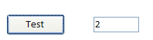
For example, consider this code
segment which will divide 10 by the number
input into the text box on the form.

Private Sub cmdTest_Click()
txtTest1.SetFocus
is required of course if we are then going to read the value from txtTest1.

Dim x As Double

txtTest1.SetFocus
x = CDbl(txtTest1.Text)
CDbl is required to convert the text value into a number which can be then used in a calculation. we are reading a text box since
MsgBox 10 / x

End Sub

No problem is encountered. The value of 10 is dutifully divided by 5 and displayed.
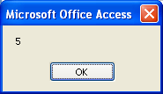

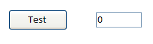
But if there is a zero (or no value),
,a run-time error will occur and the
following message will result.
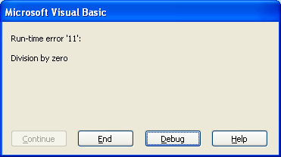
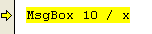
On Error Resume Next
(Take note of this
error number: 11.)

Whereas this is invaluable information to us as program
developers, it is not what the user/customer wants to see.
This runtime error reporting can be temporarily turned off
by including On Error Resume Next before the offending line:

This will cause program execution to continue undaunted after an offending error.

Private Sub cmdTest_Click()

Dim x As Double

On Error Resume Next

txtTest1.SetFocus
x = CDbl(txtTest1.Text)

MsgBox 10 / x

End Sub

In this case, with non-zero values, the result of the division will be
displayed, whereas a division by zero will go unannounced (i.e. no
message box!).

(Such error “trapping” is automatically turned off
when a procedure terminates. Alternatively, On Error GoTo 0
can be used to turn error trapping off.)

On Error GoTo

The user could therefore be alerted, (but not given the option of
debugging or terminating the program) by modifying the code as
follows.

Private Sub cmdTest_Click()

Dim x As Double

On Error Resume Next

txtTest1.SetFocus
x = CDbl(txtTest1.Text)

MsgBox 10 / x

If Err.Number = 11 Then GoTo divZero

Exit Sub

divZero: MsgBox "Text box must contain a non-zero number"

End Sub

The above program code should work correctly for all non-zero
numbers, but give an error message, as shown below if zero (or
nothing) is entered.
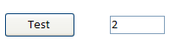
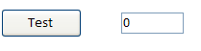

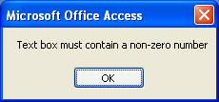
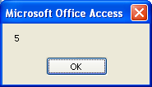

The line If Err.Number = 11 Then GoTo divZero causes
control of the program to be transferred to the line with the label
divZero. (Label names are always followed by a colon.) If an error
ever occurs, the Err object is filled with information about the
current error. Number is a property of this Err object which
indicates the assigned number of the current error.

Note the use of Exit Sub, without which the line with label
divZero would be executed, even if there were no error.

An error with Number 13 will result if text is
Inadvertently placed in cells(1,1) instead of a number
and should also be accounted for in a practical version.

We could also use the Description property to describe the error,
i.e. we could replace the corresponding line above with
divZero: MsgBox Err.Description
in which case we would get the message “Division by zero”.

A run-time error will occur if we try to initialize an array element
beyond the array’s capacity. For example, if this code were run, an
error message would result since element 3 does not exist.
“Subscript out of range” would result.

Dim Sales(2) As Variant

Sales(3) = 32.34

If the user were for example, inputting array elements using an
input box, we could write error trapping code to give an alert if too
many entries were attempted.

Option Explicit
Option Base 1

Dim Sales(2) As Variant

Private Sub cmdTest_Click()

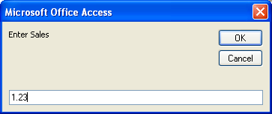
On Error GoTo overRange

Static i As Integer
i = i + 1

Sales(i) = InputBox("Enter Sales")
Exit Sub

overRange: If Err.Number = 9 Then MsgBox "Only 2 entries allowed"

End Sub
An error number of 9 indicates “Subscript out of range”.

Now If the command button is clicked for the third time and an attempt is made to erroneously enter a third sales figure a friendly message appears:

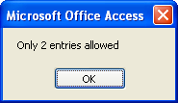

Date and Time

Now

Now specifies the current date and time.

Private Sub cmdTest_Click()
Even though Now() is a function, you may or may not include parentheses, i.e. MsgBox Now will suffice.
MsgBox Now()

End Sub
The format of the date actually
displayed, US or otherwise, will depend
upon the Windows Regional settings.

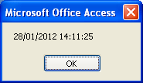

Date and Time

The Date function returns only the current date without the time,
e.g. MsgBox Date would display “09/09/2004” or similar, (again
the format displayed will depend upon the Windows Regional
setting) whereas MsgBox Time would return “15:53:20” or similar.

To explicitly format a Date, use the Format function, e.g.
MsgBox Format (Now, "mmmm") would display “September”
in this case and MsgBox Format (Now, "mmm") would display
“Sep”. (See VBA Help on the Format function.)

Excel stores dates internally as a Date type (which is of the
same 8-byte form as a Double type), the integral part of which
The original intention was to
make Jan 1 1900 day 1, i.e. Dec 31 1899 would be day 0, but unfortunately, somebody included Feb 29 in 1900 (not a leap year – see later), so Dec 30 1899 was subsequently made the start date.
is the number of days since Dec 30 1899, and the decimal part
of which represents the fraction of the day after midnight.
Although dates are stored as decimal numbers, the way that we
view them depends upon how they are formatted. We can force
a type conversion to a Double data type using
:
Private Sub cmdTest_Click()

MsgBox CDbl(Now)
Integral number of days since Dec 30, 1899 (40936) and the fraction of
the day since
midnight (.5933680556).
End Sub

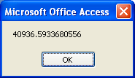
Separating date components

We use the correspondingly-named functions to extract the
required parts as Integer values. Examples are given below.

Year, Month, Day

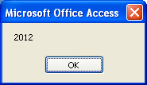
Private Sub cmdTest_Click()

MsgBox Year(Date)

End Sub

Hour, Minute, Second

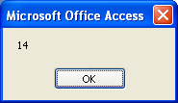
Private Sub cmdTest_Click()

MsgBox Second(Time)

End Sub

(Of course we could have used Now as an
argument in both cases instead of Date and
Time respectively.)

DatePart

DatePart performs identically to the above functions, e.g.
DatePart("yyyy",Date) would also extract the year as did
Year(Date) above.
It does have some special uses however, for
example to find the day of the year:

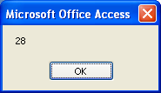
Private Sub cmdTest_Click()

MsgBox DatePart("y",Date)

End Sub

Today is the 28th
day of this year.

DateValue
DatePart is also useful for working with year quarters, e.g.
DatePart(“q”,Date) will return the present numeric quarter (1, 2, 3 or 4).

These extract just the date and time components respectively, e.g.

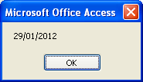
Private Sub cmdTest_Click()

MsgBox DateValue(Now)

End Sub

The date part only of the current date/time is extracted.
(Identical to MsgBox Date.)

TimeValue

Similarly, TimeValue extracts only the time part.
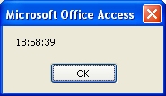

Assembling date components

DateSerial

Whereas Year, Month, etc. split a date into its components, DateSerial does the opposite.

For example, DateSerial(2004,12,1) would form the date Dec 1, 2004.

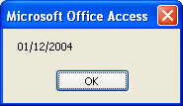
The format of the date which appears will be presented according to your particular Windows Regional settings.
i.e. either 1/12/2004 (UK)or 12/1/2004 (US).

Similarly, MsgBox TimeSerial (1, 2, 3) would display:
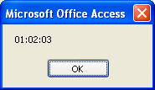
3 seconds after 2
minutes past 1.

To find the date of first day of the current month use:

MsgBox DateSerial(Year(Date), Month(Date),1)
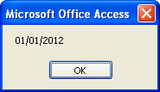
The date of the first day of the month of Jan 2012.
The present date in this case is 29/1/2012.

Date Delimiters

The number sign (#) can be used as a delimiter to enclose a Date
type, e.g. #10/30/98#, but it must conform to American format
(mm/dd/yy).

If it obviously doesn’t, it will be changed before youreyes!
For example, if MsgBox Day(#30/10/98#) is typed, it will
immediately change. Due to this ambiguity, date literals are best
avoided. Using double quotes as a delimiter, e.g. “10/30/98” also
introduces ambiguity, as well as requiring an extra step to convert it
to a date.

To convert a String to a Date, use DateValue, e.g.
DateValue("December 1, 2004"). As well as being preferable to
using date literals, DateValue is forgiving of the format of the
String, e.g. MsgBox DateValue("Dec 1, 2004") will display
the date in a format determined by the Regional settings.

CDate is even more versatile than DateValue. It will accept numerical arguments as well as Strings.
Without any delimiters, Excel
VBA will perform a division, e.g.
MsgBox 1/1/2000
will cause .0005 to be displayed.

Adding and subtracting dates

Since the integer portion of a Date type represents the number of
days, we can simply add or subtract an integral number of days to
find another date, e.g. to find tomorrow’s date we could use:

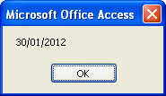
MsgBox DateValue(Now + 1)

Date tomorrow.

DateAdd

To add intervals other than days, we must use DateAdd.

For example, to work with weeks, use the “ww” interval code and to
display the date one week hence use:
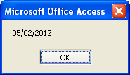
MsgBox DateAdd("ww", 1, Date)

(See the VBE Help for the other interval codes for DateAdd.)

Date in a week’s time.

DateDiff

We can use DateDiff to find the number of days between two
Dates.

As well as taking into account the different lengths of the
various months, DateDiff also takes into consideration the
presence or absence of leap days between the two date intervals.

Private Sub cmdTest_Click()
The number of days between
00:00 hrs Dec 1, 2004 and
00:00 hrs "Mar 1, 2005"
is 90.

Dim strtDate As Date, fnshDate As Date
Dim n As Integer

strtDate = DateValue("Dec 1,2004")
fnshDate = DateValue("Mar 1,2005")

n = DateDiff("d", strtDate, fnshDate)
MsgBox n
End Sub
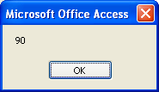
(See Help on the DateDiff function for the other interval
specifiers.)
The DateAdd
interval code is
“m” for months
and “n” for
minutes.

Don’t forget the new day starts at 00:00 hrs in the morning ie 12 am of the previous day

DateDiff can be also be used to find the number of months
between two dates for example by changing the interval specifier to
"m", e.g. DateDiff("m", strtDate, fnshDate).

The number of weekdays

WeekDay
In the case of
days, it would be
possible to simply
subtract the
DateValues to
find the difference.
WeekDay will determine the day of the week as a number between
1 and 7 – where Sunday is 1 by default, e.g.

Private Sub cmdTest_Click()
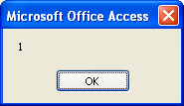
MsgBox Weekday(Date)
Sunday

End Sub

We previously found the number of days between Dec 1 2004 and
March 1 2005 to be 90.
e now wish to find the number of working days (Monday to Friday)
between these two dates. (March 1 2005 itself will this time be included.)

Private Sub cmdTest_Click()

Dim strtDate As Date, fnshDate As Date
Dim dt As Date, n As Long, i As Long
Dim numWorkDays As Long

strtDate = DateValue("Dec 1,2004")
We could omit DateDiff and
modify the code, including the loop
For i = strtDate to fnshDate, since these date values are integral.
fnshDate = DateValue("Mar 1,2005")
numWorkDays = 0

n = DateDiff("d", strtDate, fnshDate)

For i = 0 To n 'n since March 1 is included
dt = Weekday(strtDate + i)
If not a Sat and
not a Sun then...

.

...increment the
number of workdays.

If (dt <> 7 And dt <> 1) Then
numWorkDays = numWorkDays + 1
End If
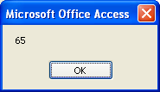
Next i
The number of working days between project start and finish (inclusive) is 65.

MsgBox numWorkDays

End Sub

As it stands, our program does not take account of any public
Use VB built-in constants
wherever possible to make your code more readable e.g. vbSunday and vbSaturday instead of 1 and 7.
holidays in the period, e.g. Christmas day. These would need to be explicitly, individually accounted for by the code.

The Internet is an invaluable source of VBA examples.
Try typing “Excel VBA Date and Time” into your search engine

The Mod operator

Mod gives the remainder after a division.
In this example 13 is divided by 3 (4 times) to give a remainder of 1
which would be displayed.

Private Sub cmdTest_Click()

MsgBox 13 Mod 3

End Sub

Mod is an arithmetic operator, not a Date function but it could be
used for example, to determine whether a year is leap or not. Mod
can be used to determine whether a number is exactly divisible, e.g.
1900 Mod 4 would return 0, indicating that 1900 was exactly
divisible by 4.

This would suggest that the year 1900 was a leap year, since it is
divisible by 4, but in addition, in 1582, Pope Gregory decreed, that
years divisible by 100 were not to be leap years. If a variable yr
were 1900 or 2000 for example, also stipulating that (yr Mod 100)
<> 0, i.e. yr is not divisible by 100, would rule out 1900 and 2000
since they are.

However, to further compensate for the earth’s non-exact rotation,
the good Pope decreed that every 400 years was to be a leap year,
i.e. if we also allow the condition yr Mod 400 = 0 (i.e. yr could
be divisible by 400), 2000 would now qualify, but 1900 would not.
Combining these conditions into one logical expression, we could
test for a leap year (e.g. 1900) using:

Private Sub cmdTest_Click()

Dim yr As Integer
yr = 1900
MsgBox (yr Mod 4 = 0) And (yr Mod 100 <> 0) _
Or (yr Mod 400 = 0)
And will evaluate to False if either expression evaluates to
False. Or will evaluate to True if either expression evaluates to True.

Try MsgBox (True And False Or False)
to confirm that it displays False.
End Sub

We could also determine if a year is leap by testing if Month(DateSerial(yr,2, 29)) = 2, which seems to be forgiving of the bogus 1900 leap year!

Anniversaries

To find your age, you could subtract the year of your birth from
the present year.

The only problem is that you may or may not have had your
birthday yet this year. If you haven’t had your birthday, you will
need to subtract a year. How do we determine if you have had your
birthday this year or not?

We need to test whether today’s date (Date) is less than the date of your birthday this year.

The date of your birthday this year will be given by
DateSerial(Year(Date), Month(dob), Day(dob))
where dob is your date of birth, (i.e. your date of birth with the current
year substituted for your year of birth) so
Date < DateSerial(Year(Date), Month(dob), Day(dob))
will be True if your birthday has yet to come this year.

This program should display your age if you use your date of birth.

Private Sub cmdTest_Click()
True has the Integer value of -1, whereas False has the Integer value of 0.
Try MsgBox CInt(False) and MsgBox CInt(True) to confirm this.
Dim age As Integer
Dim dob As Date, bday As Date

dob = DateValue("Oct 30, 1966")
bday = DateSerial(Year(Date), Month(dob), Day(dob))
age = Year(Date) - Year(dob) + (Date < bday)
MsgBox age & " years old"
(Date < bday) will have
the numeric value of -1
(True) if your birthday
has not yet passed, and 0

End Sub

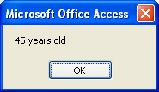

Speaking of birthdays, you could determine the day of the week
that you were born using this code with your date of birth.

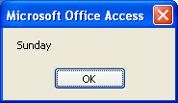
Private Sub cmdTest_Click()

Dim dob As Date

dob = DateValue("Oct 30, 1966")
MsgBox Format(dob, "dddd")

End Sub

DAO:

To Make a New Table from Code Using DAO
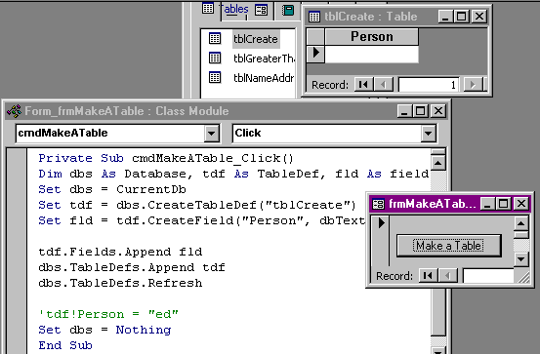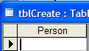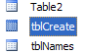
Note that we use CurrenDb when we have a database which is already open ie our current database.
See p.179 Building Applications with Microsoft Access.

If we follow this with single step we can see the table is actually created when the Append is encountered.
- Make sure that the table tblCreate does not already exist – or alternatively write error code to cope if it does.

On frmNames the MakeTable button in VBAManualPart2.mdb.
The above code only makes a table structure. To actually add data to our table we need to use:

The above code only makes a table structure. To actually add data to our table we need to use:

Dim dbs As Database, tdf As TableDef, fld As Field
Set dbs = CurrentDb
- Comment out table-creating code as shown lest you get an error when you try to re-create an existing table.
'Set tdf = dbs.CreateTableDef("tblCreate")
'Set fld = tdf.CreateField("Person", dbText)
'tdf.Fields.Append fld
'dbs.TableDefs.Append tdf
'dbs.TableDefs.Refresh
Dim tbl As Recordset
Set tbl = dbs.OpenRecordset("tblCreate", dbOpenTable)
tbl.AddNew
tbl!Person = "ed"
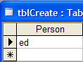
tbl.Update
Set dbs = Nothing

The data duly appears in our table.

To Create a Query from Code Using DAO (This is better done using ADO)

To make a query from code we need to use CreateQueryDef as follows but first:

SQL
On frmNames the MakeQuery button in VBAManualPart2.mdb.

See Help on SQL Expressions.

- Make the following table and then make a query to select all of the 10's in Balance.

(Don't save the query).

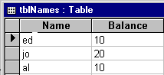

- 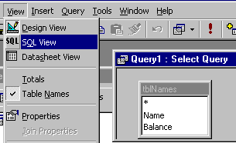With the query in Design View,

- Click View, SQL View.

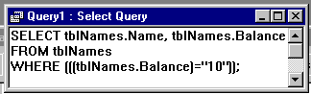

- Highlight all of this SQL text (except the semi-colon) and copy it.

- Make a blank form, place a command button on it and write the code below, pasting the SQL text after sqlStr = (Remove some of the extra parentheses.)
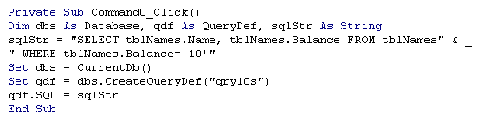(Alternatively just type it in.)

(Note the splitting of the line using the continuation character _ . This is formed by pressing space and then underscore ( _ ) and then pressing Enter.)

- Run this code. You should find that qry10s has indeed been created.

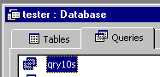

From here we could

- Run this query by double-clicking on it.

- Run it from code by using the OpenQuery action along with the DoCmd command as follows:

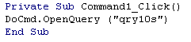

to produce :

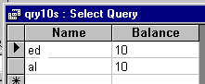

Private Sub cmdQryAsRecordset_Click()
Dim dbs As Database
Dim qryTens As Recordset
Set dbs = CurrentDb()
Set qryTens = dbs.OpenRecordset("qry10s")
qryTens.MoveLast
MsgBox qryTens.Fields(0).Value
End Sub

3. Use OpenRecordset to manipulate the data.

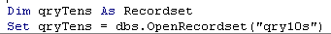

Note that if we wish to make a temporary query ie not save it and give it a name, then we can use an SQL string in place of the query name above.
(See page 265 of Building Applications with Microsoft Access.)
This works slower than a saved ("compiled") query.

If we wish to create an action query, we need to use the Execute method. See p.298 of Building Applications.

Improved version:

We could include error handling to deal with an already-created query (and also code to run the query.

Private Sub cmdMakeQueryError_Click()
Dim dbs As Database, qdf As QueryDef, sqlStr As String
On Error GoTo msg
sqlStr = "SELECT tblNames.Names, tblNames.Bal FROM tblNames WHERE tblNames.Bal=60;"
Set dbs = CurrentDb()
Set qdf = dbs.CreateQueryDef("qry10s")
qdf.SQL = sqlStr
contin:
DoCmd.OpenQuery ("qry10s")
Exit Sub
msg:
MsgBox Err.Number
GoTo contin
On frmNames the MakeQuery1 button in VBAManualPart2.mdb.
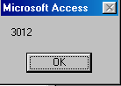End Sub

If the query already exists
, we will get this message.

In any case our query result should appear:

http://www.everythingaccess.com/tutorials.asp?ID=DAO-programming-examples#CreateTableDAO

The Form

Form Events

Data Entry And Record Changing Events

- 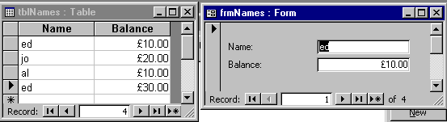For the exercises, make sure that we have this table and form.

frmNames2 in Nick.mdb.

Current

- Place the following code in the form's Current event as below:
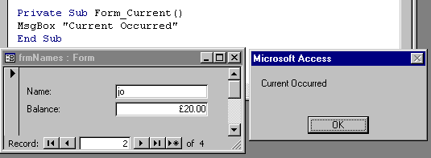

Comment out the above code for the next exercise.
This message box appears.

- Change the record.

BeforeInsert, AfterInsert Chap 4 in Step by Step
frmNames2 in Nick.mdb.
Form Events

- Write the following code. (If using the previous form, comment out the Current code.)

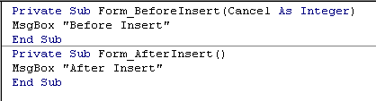
…Insert relates to inserting new data.

BeforeInsert and AfterInsert relate
only to the Form.

These are form events.

- 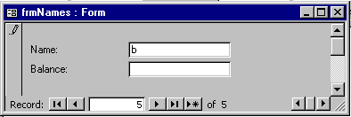Run the program, go to the last record plus one and type the first letter of your new entry.
Note that we don’t have to press Enter etc - we only need to type a character for the BeforeInsert event to fire.

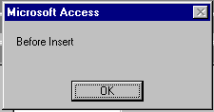You should get this message box.

- Save your record. (To do this you could just move to the next record – which of course implicitly saves the record.)
Note that the BeforeInsert event has a Cancel ie the action can be cancelled by code ie the data removed from the control but AfterInsert does not – it’s too late once the Enter key is pressed!

You should get this message box.
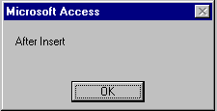

(Recall that with Access no prompt is given when saving data to a table. A prompt is only given when saving changes to Design.)

Summary: BeforeInsert occurs when the first new letter is typed and

AfterInsert occurs after a new record has been added.

To emphasize: The BeforeInsert and AfterInsert occur when we are inserting a completely new record. Try editing an existing record – these BeforeInsert and AfterInsert events don’t fire.
BeforeUpdate and AfterUpdate will behave similarly but apply only when we are altering (or adding) a record.
frmNames2 in Nick.mdb.

BeforeUpdate occurs as we go to save the current record - so we do have a chance to Cancel the saving. AfterUpdate occurs after a record is saved. We cannot cancel the AfterUpdate event.

So far only considered the BeforeUpdate and AfterUpdate events for the form.

Control Events

Each control also has its BeforeUpdate and AfterUpdate events -but of course no BeforeInsert and AfterInsert events which are form events ie events for the whole record.

The BeforeUpdate and AfterUpdate events of a control will fire when we move to another control whereas they will only fire for a Form when we go to another (ie save) record.

Whereas we have a chance to cancel the BeforeUpdate event for a control we cannot cancel the AfterUpdate event.Take a look - it has no Cancel parameter.

The AfterUpdate could be used for example to automatically copy the contents of a recently updated textbox on a form into another textbox on the same form.

(pp 72.6 to 74.6 Step by Step 2002. )

see this manual page 56 for a simplification.

The BeforeUpdate could be used for example to validate data before it is actually accepted.

(pp 81.2 to 82.7 Step by Step 2002.)

Note that in this above example, if there is no address there is no need for a postal code but if there is an address the we must also have a postal code.

see this manual page 58 for simplification of this.

See the Microsoft Help on BeforeUpdate, AfterUpdate Events.

Note that an Insert is also an Update so when we add a new record BeforeUpdate and AfterUpdate will also trigger as well as BeforeInsert and AfterInsert.
ie BeforeUpdate and AfterUpdate always trigger if they are present in the code.

Note the order: For a new record:

BeforeInsert

BeforeUpdate
Always trigger.

AfterUpdate

AfterInsert

See page 95 for applications of AfterIUpdate: eg Using AfterUpdate to Copy Data to Another Field
GotFocus

- Make our standard table and form. Call the form frmNames. Write the following code for the Name control.

frmNames5 uses tblNames1 in Nick.mdb.
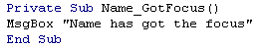

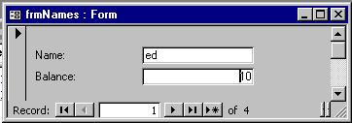

- With the cursor in the Balance field click in the Name field.

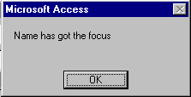
You should get this message box.

If Name has already got the focus and you click on it, the GotFocus event does not occur.

(Note that: If the form is opened after it has been closed and the Name field has a Tab Index of 0 -The Tab Index determines the order in which the controls receive the focus- then the above message box will appear.)

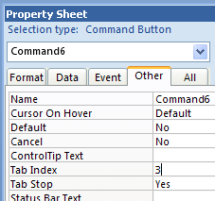
You can change the Tab Index by going to the properties of the Controls – in this case the Text Box. If you set the Tab Index of the Name Text Box to 1 then the Tab Index of the other Text Box will revert to 0 (and the above message box will then not appear upon opening).

Tab Index of the control.

The Enter Event

- From the VBE, choose the Name Object and then choose the Enter procedure
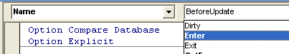

- Type the Name_Enter code as below. (Keep the Name_GotFocus event)
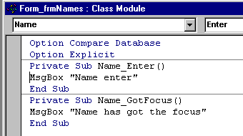

- Run this and move the focus to the Name Text Box from the Balance Text Box.

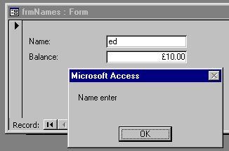The Enter event occurs as well as the GotFocus event.

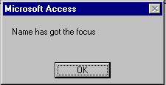

It would appear at this stage at least, that there is no difference between the GotFocus and Enter events! (Except that one occurs before the other). So what's the difference?

GotFocus and Enter both fire when on the same form but:

We will see that The Enter event only occurs when the focus is moved from one control to another (eg textboxes) on the same form.

So let’s make another form:

- Make another blank form ( or open any other existing form). (In order that a completely blank form can be saved, apparently we have to do something to it, eg place a text box on it. )
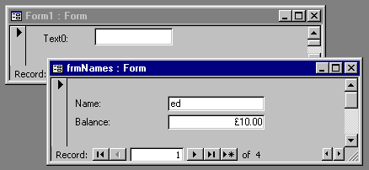
frmNames5 based upon tblNames1 in Nick.mdb.

- 1. Click in the text box of our new form (Form1 in this case).

- 2. Then click in the Name field of the other form.
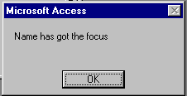Only the Name's GotFocus event occurs. The Enter event does not occur.

The Enter event only occurs when the focus is moved from one control to another (eg textboxes) on the same form.

What's the use of that?

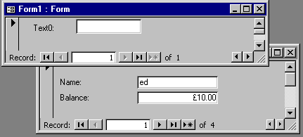Let's say that our forms are overlapping as below and that we wish to bring the underlying form – our frmNames to the top by clicking on it.

- Click on the form (not in the text box)

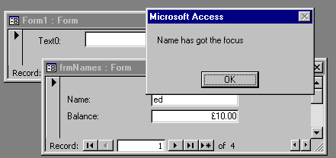The GotFocus event occurs only if it previously had the focus - but more importantly, the Enter event does not occur – even if the Tag Index of the Name control is 0.

- Click OK.

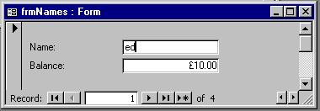
- Note that Name does indeed have the focus if it previously had the focus

So use the Enter event only when we wish to deliberately enter a control as distinct from clicking on a form and thereby giving a control the focus.

Note that the control which has the focus when a form is clicked is the one which previously had the focus.

The LostFocus and Exit events are identical to the GotFocus and Enter except they occur upon leaving the control.

KeyPress etc.

KeyPress, KeyDown, KeyUp KeyCode , Shift etc. See following notes.

- Try the KeyDown event for the City field p 85 (p. 75.8 in 2002 book) and the for any control (setting KeyPreview to Yes) on p.86,87 (p.77,78 in 2002 book)

- Try the remaining examples in Ch’s 3 & 4 of Step By Step.

See Chs 5 & 6 (Write Your Own Functions & Monitor and Debug Your Code.
The Keyboard

- Make a new blank form not based upon a table as below.

- With the form in Design View, click File Save As and give it a name eg Form1.
frmFilter in Nick.mdb. Uncomment the code.

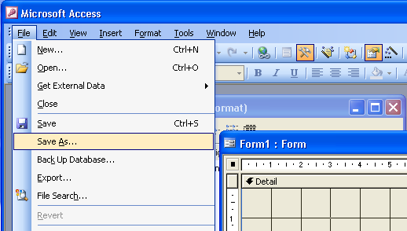

The KeyPress event

- From the VBE Choose the Form object and the KeyPress event
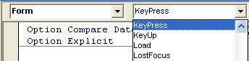

- Type in this code:

Private Sub Form_KeyPress(KeyAscii As Integer)
MsgBox KeyAscii
End Sub

- Run this, click on the form and press a key. For example pressing the a key results in :

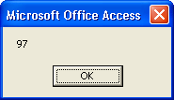

- Try A -> 65
3 -> 51
the return key -> 13
the space bar -> 32

- To see the list of of Ascii characters see Help , Search and type Ascii.

The problem with the KeyPress event is that the following keys are not recognized.

The function keys, the Shift ,Ctrl keys, etc the numeric keypad keys. (Make sure that the Num Lock is off.)

- Try them. You should get no response.

Also we cannot yet determine whether the key has been pressed down or released.

We need …

KeyUp and KeyDown events

- (Make sure that you don’t still have the Form_KeyPress code from the previous example.)

- From the VBE choose the Form object and the KeyDown event

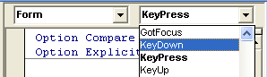

- Type in this code:

Private Sub Form_KeyDown(KeyCode As Integer, Shift As Integer)
MsgBox KeyCode
End Sub

- Run this, click on the form and press a key.

- Try a -> 65
3 -> 51
the return key -> 13
the space bar -> 32
3 on the numeric keypad -> 99
the return key -> 13
the space bar -> 32
F1 -> 112

- In the Form_KeyDown event change the code to that shown below:

Private Sub Form_KeyDown(KeyCode As Integer, Shift As Integer)
MsgBox Shift
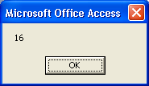
End Sub

You should get the following results:

Pressing Shift -> 1

Ctrl -> 2
Different for laptop?
Alt -> 4

KeyUp

- Try some code in a KeyUp event. It of course works when the key is released rather than pressed down.

- For example try this:

Private Sub Form_KeyDown(KeyCode As Integer, Shift As Integer)
MsgBox "down"
End Sub

Private Sub Form_KeyUp(KeyCode As Integer, Shift As Integer)
MsgBox "up"
End Sub

Note that we have only one KeyCode per key whereas the value of KeyAscii depends upon whether the Shift etc are held down as well..
For example, for the KeyDown event, both A and a here have the code 65 whereas for the KeyPress event a had the code 97 and A had the code 65.

It matters not that the KeyCode for the A key is the same as for a. We can distinguish between which one was pressed by looking at the Shift value as well in code.

Exercise : Write some code to print “A” or “a” when the corresponding key is pressed using the Form_KeyDown event. (Hint use the If statement perhaps with Select Case.)

F1 etc ? doesn’t work with KeyUp.

To look at the list of KeyCodes we can use the Object Browser.

The Object Browser
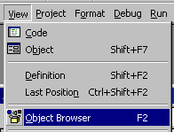

- From the VBE click on View, Object Browser or press F2.

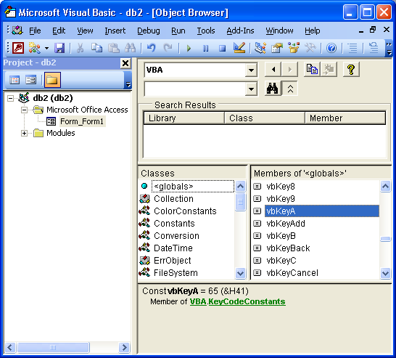

- Choose VBA.

- Choose <globals>.

- Choose the KeyCode constant.

- Note the actual value appears here.

- Close the Browser.

Exercise : Modify the code of the previous exercise to use vbKeyA.

(The constants for the Shift, Control & Alt keys can be found at vbKeyShift, vbKeyControl and vbKeyMenu respectively.)
KeyPreview

Our previous form was blank ie it had no controls on it

- Place a command button on the form and try out any of our keyboard event programs.
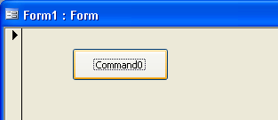

The code won’t work anymore when you press a key!
(Even if you were to click on the form to give it the focus.)

- In Design View,.

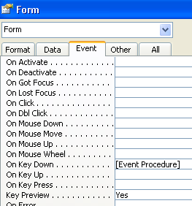

- Change the Form’s KeyPreview property to Yes.

Now our keyboard events should fire when we press a key.

ie KeyPreview = Yes forces the Form to get first go at the event no matter what other control may have the focus.

Summary:

_KeyPress (KeyAscii As Integer)

is used as a cheap quick way of accepting keyboard characters
eg for accepting keyboard input for a game program. It only responds to ascii keys.

_KeyDown (KeyCode As Integer, Shift As Integer)
_KeyUp (KeyCode As Integer, Shift As Integer)

are used when we want to interpret every possible keyboard combination.
For example when we wish to design a fully-fledged word processor

Ch 7 Errors

Errors can occur

1. In writing the code. These are called syntax errors and are not being discussed here.

2. Errors which occur at run-time.

- Place a Command Button on a blank form and write the following code:

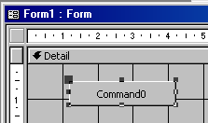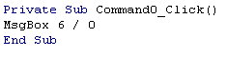
frmError in Nick.mdb.

- Change to Form View and click the Command Button.

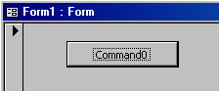

We get the following error message.

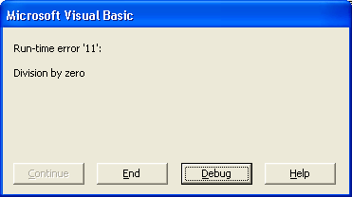

This is not the sort of message that the end user would like to be subject to.

- Click End or Debug.

Private Sub Command1_Click()
On Error Resume Next
- Include this line. When this is run, no error is reported – as if nothing happened.
MsgBox 6 / 0
End Sub

To intercept this error, change the code as follows:

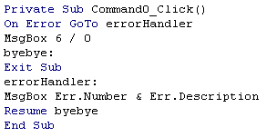
Labels have a colon at the end.

- Try running the code without the Exit Sub. If there is no error, eg MsgBox 6/1, the code will erroneously fall though and try to report an error.

- Change to Form View and click the Command Button.

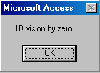

- Click OK.

(For extra revision of this see Creating Error Handling Routines p. 163 - 170 (p 141.4 to p.147.9 in Access2002) or look at the code made by a Wizard when error handling is turned on (and when a macros is converted to VBA code.)
For an easier version, see page 168 Excel VBA in Easy Steps.
What if we are the ones who make an error in using a form or report at run-time?

These errors are handled by the Error event which is part of Access.

To Respond to an Error when we Try to Omit Filling in Data for a Required Field

We will now set the Required property of a field to Yes.

- 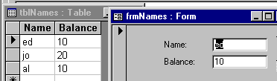Make the following table and its corresponding form.

tblNames1 and frmNames1 in Nick.mdb.

- Change to the Design View of the table.
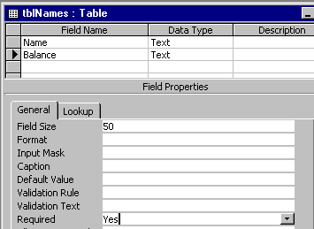

You may wish to later see the effect of having a Default Value or not. For the moment omit a Default value.

- Change to Required property of the table's Balance field to Yes.

- Close the table.

- Try it out. Open the corresponding form in Form View.

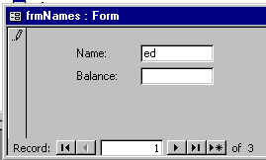
- Attempt to delete a Balance that is already there and then press Enter.
Since Balance is a Required field we should get an error generated.

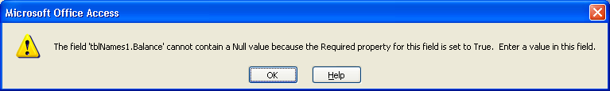
You will get a nasty message from Visual Basic to which we are forced to respond.

- Click OK and choose not to save the data. You may wish to use the Undo button.

We would not wish a user of our database to have to confront this so we need to intercept this error in the Form's Error event as follows:

- Open the form in Design View and place this code in the form's Error event.

Private Sub Form_Error(DataErr As Integer, Response As Integer)
MsgBox DataErr
Response = acDataErrContinue
End Sub
acDataErrContinue tells Access not to bother showing us its error message

- Open the form in Form View and again try to delete a Balance entry.

We get:

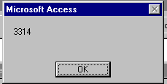
3314 is the code number – DataErr - of the “Required field” error.

On the other hand, setting the Response to acDataErrDisplay would cause the usual Access error message (as above) as well.

- Try it.

To Make a Simple Combo Box on a Form (Using a Value List)

- Make a form based upon a table with no data as shown below. We wish to enter the data in the Person field by using choosing from a drop-down as shown at the bottom of this page.

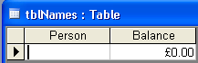
- Drag the Balance field (only) onto the form. Remove its label.

(Make sure that the Wizard button is not depressed.)

- Place a combo box on the form by clicking the Combo Box button on the Control toolbox and dragging onto the form and choose Person as the Control Source from Properties. Delete Person’s label.
frmCombo1, tblNames1 in Nick1.mdb.

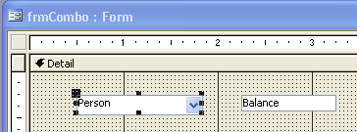
Using a Control Source of Person means that there is a “2-way connection” between the Person field in the table and the combo box.

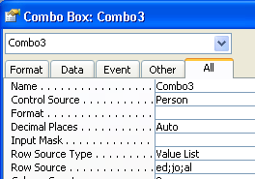

- For Row Source Type Choose Value List since we are going to here explicitly list the combo alternatives.
- Enter these explicit values in the Row Source for the Value List.

- Change to Form View and make an entry as follows:
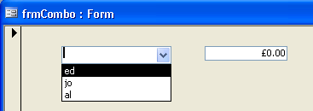
Beware: Being on an existing record and making a choice from the combo box will cause overwriting of existing data.

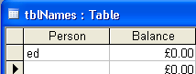
- Check that the entry has been made.
- Choose a Person and then go to the next record to save the entry.

To Make a Combo Box on a Form (Using another Table as a Source)

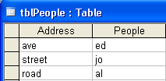
- Make this additional table:

tblPeople in Nick1.mdb?
frmCombo in Nick.mdb E:\Users\Ed\Desktop\Manual1\AccessManuals\AccesVBANew\Adela

We wish to make a form by means of which we can easily enter data into our tblNames by using a combo box whose drop-down data is provided by another table (tblPeople) as shown below:

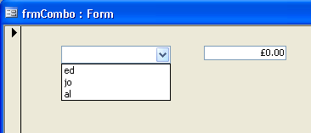
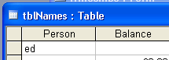
.. the data will be placed into the Person field of tblNames as before.
We wish to make a choice from this list and..

This Person field is the Control Source of the form.
ie where the data is going to go to.
This data is to come from the People field of tblPeople.

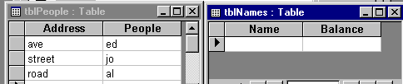

This table is the Record Source. ie where the data is coming from.
The actual column number where the data will come from is called the Bound Column. (See over - Column 2 in this case.)

- With frmNames in Design View, change the properties of the combo box as follows.
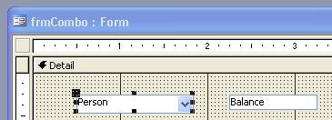
frmNames is based upon tblNames ie set the Record Source to tblNames ie where the data will be ultimately placed.

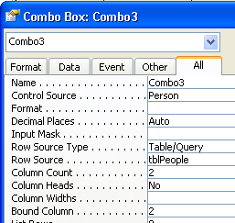

- The Control Source should be Person. The Control Source is the field where the data is going to.
- The Row Source Type and Row Source specify the table where the data is coming from – in this caseTable/Query and tblPeople respectively.
- Open the form in Form View.

- At first all looks well but when we click a choice eg ave ed ...

If the source and destination table are one and the same thing then the Bound Column and the Row Source will be one and the same thing.
- Change the BoundColumn to 2. The Bound Column is the column number of tblPeople from where the data will go – the 2nd column of tblPeople ie to the People fields.

- Make the Column Count 2.
This is the number of columns which are visible in the combo drop-down. (Make sure that the combo box is wide enough to see them – if not drag it wider on the form.)

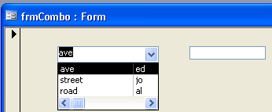
… then ave appears here. Not ed! ed goes into the table because the Bound Column was 2. Take a look at the table tblNames to confirm this (as shown over the page).

- Also enter a Balance and move to the next record in order to save it.

- 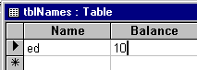Inspect the table- tblNames- indeed the correct entry in the table (ed) (according to the Bound Column) has been made!

Therefore we need to change what is actually being displayed in the Combo Box after a choice is made.

- Change to the Design View of the form and go to the Properties of the Combo Box.

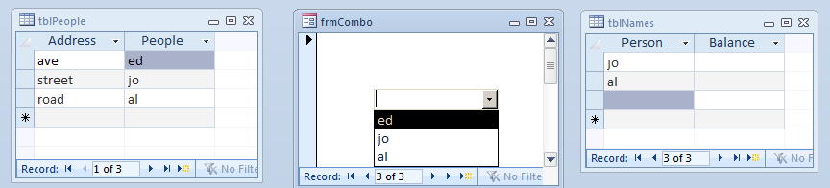

frm RecordSet : tblNames

combo Row Source: tblPeople
combo Bound Column: 2

combo Control Source: Person (not a source!)

- Change the Column Widths as follows:
(Typing 0;1 is sufficient if the units is cm.)

- Open the form in Design View.

You should find now that what gets put into the table is what actually appears in the Combo Box after a choice is made.
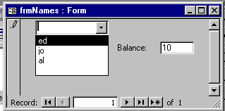

ie by setting the first Column Width to 0, we have hidden the first column (the addresses). This is a purely “cosmetic” effect.
(The width of the combo box could now be reduced.)

Summary:

The Bound Column determines which column the data actually comes from and goes to.
The Column Width determines which column the data appears to be coming from.

For the next topic try this:

- Exercise: Type a new Name in the Text area of the combo box (rather than selecting one). Move to another record to save it. Take a look at the table to confirm that it has been entered. (ie it is possible to type.)
The NotInList Event (Back to our error handling in Ch 7)

- Using the previous combo box – in Design View go to the properties of our combo box.:
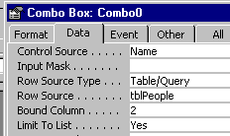

- Change the Limit To List (Choose the Data tab) property of our combo box to Yes. This means that we can't type our own values into the combo box text area at “run-time”.

- Change to form view and try to type in a Person eg rob which is not already in tblPeople.
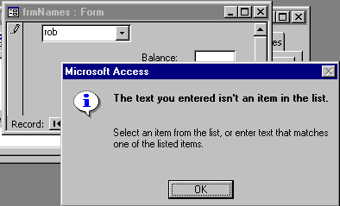
See VBA Help: ComboBox.NotInList Event
How to: Add a Value to a Bound Combo Box

You may wish to click the Undo button to return.
We get this message.

We can intercept this error as follows.

- Change to Design View and view the Properties. On the Event tab: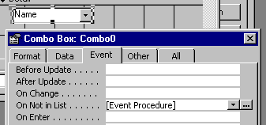

- Enter the following code:
Response is passed by reference and as such will be permanently modified by the Sub below.
- Click and choose Code Builder.
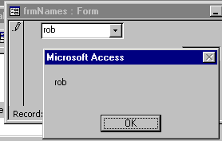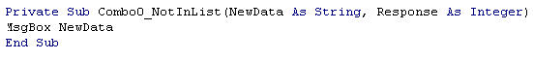
NewData is the data that we typed into the text area of the combo.
Change to Form View and enter the data again.This time we will be told what the faulty data is that we are trying to enter - before we get the usual Access message (as above).

If we wished, we could actually update the table directly from code using this NewData. (To update a table directly from code in Access, it is necessary to use the DAO (Data Access Object) see p.160. (p. 138 in 2002 book). DAO will be covered later but see the Help on “How to: Add a Value to a Bound Combo Box” ) If we were to include Response = acDataErrContinue then the usual Access error massage would not display.
Simplified Examples of the Text Book

ie Application. eg We will use a drop-down combo box to select the record in the body of the form.

To Use the Wizard to Produce a Combo Box to Synchronize the Records on a Form

(Pages 50 – 57 in Step by Step 97 p. 45.9 to p. 52.3 in 2002 book)

- Produce this table (ID is AutoNumber and Balance is Currency) and the corresponding form.

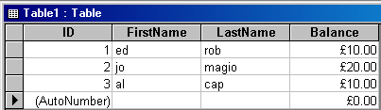
Table1 and frmCombo3 in Nick.mdb.

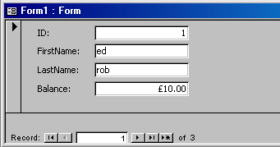

- In Design View, with the wizard selected, draw a combo box.

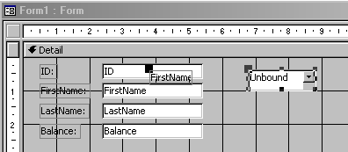

- From the Wizard choose “Find a record on my form based on the value I selected in my combo box”, then Next.

- Choose the ID field and click > and then Next.

- Next, Finish.

- Delete the combo box’s label.

- Try it out ie change to Form View.
- Select an ID….
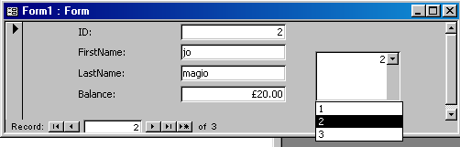
… and the corresponding record displays

- Take a look at the code produced:
You may find that this wizard-produced code has been updated eg Nz and EOF is used etc.

The current record of the Recordset is put equal to the record with the ID displayed in the Combo.

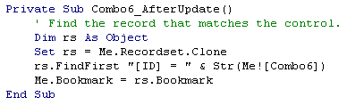
The default property for the combo is Value ie the ID.
The Bookmark of the Form is put equal to the Bookmark of the Recordset.

Nz may be required. (See notes on p 14 of manual 2nd part) which is used to convert a possible Null value to a zero length string in this case. Null values have a nasty propagation effect. A string concatenated with a Null will be Null!!

Recordset.Clone is just a copy of the form’s data (considered later in Part 2 of manual)

FindFirst unfortunately is not a method of the Form but it is a property of the Recordset and hence we use this rather obtuse way of displaying the required record on the form.

- Take a look at the SQL produced by the Wizard for the combo box. (Change to the Design View of the form and look at the Row Source property of the combo box.

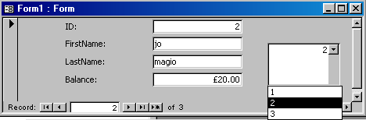
See axsVBAUsing SQL To Update a Table.doc and the SQL book SQL in 10 minutes !! by Forta. See also axsVBAUsing Access To Practise SQL.doc
- The sole purpose of this SQL statement is to populate the combo box from the ID values in Table1.

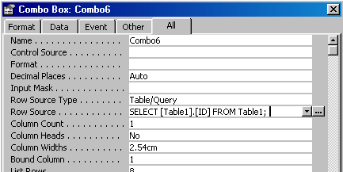
- (Note the
Bound Column, the Column Count
and the
Column Widths properties.)
- Click the ellipses to see the corresponding QBE grid which appears below.

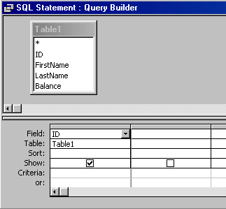

We wish to have the FirstName displayed as the choice in the combo box instead of the ID.

To do this we will to modify our SQL statement as shown at the bottom of this page.

- First drag down the FirstName field on to the QBE grid as shown below.)

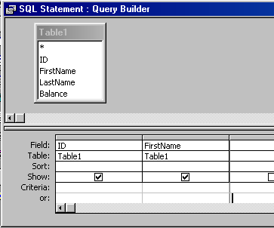

- Modify the properties of the combo box as shown below:

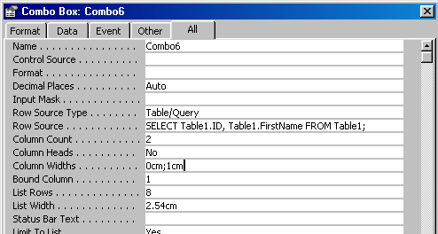
- Change the Column Count to 2 (First see the effect of this only)
and the Column Widths to 0;1.
- Note the change in the SQL string. (We could also have edited this by hand.)

- Open the form in Form View.

To select unique values DISTINCT, change the SQL to SELECT DISTINCT Table1.[FirstName] FROM Table1;
(To see the effect, make sure that you have some duplicates in the FirstName field of the table.)

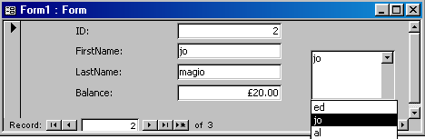

- Note that the data that is presented here - FirstName - is not the data which binds the data of the combo box to the Recordset data. The ID field does that since it is in the Bound Column.

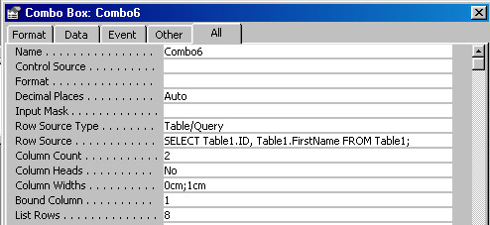

A Bound column of 1 means that the data of the first column of the table is the data referred to here.

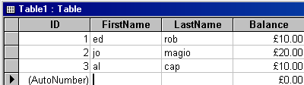

As you can see, this is independent of what actually appears in the combo box. This is determined by the Column Widths property.

FindFirst is not a property of the Form and hence we need to use the RecordSet.Clone.

We wish now to have “FirstName, LastName” to appear as below:

- Modify the QBE expression as shown below.
(In design view, choose properties, Row Source etc.)

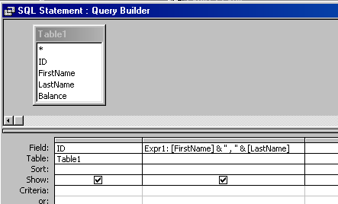
Type: & “,” & LastName after FirstName a shown here.

Result

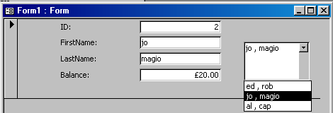

- Take a look at the SQL in the Row Source Property of the combo.
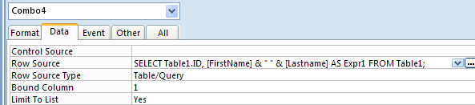
(There is a comma here.)

ie SELECT Table1.ID, [FirstName] & " " & [Lastname] AS Expr1 FROM Table1;

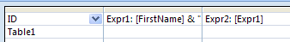
- Note that Expr1 can be referred to eg type = Expr1 in here.

Problem: Using the previous form:

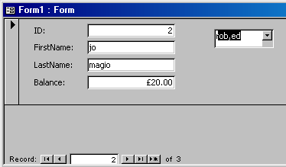

- When changing to a new record using this…
…this doesn’t change.

Solution:

- In the Form_Current event, type this:

Private Sub Form_Current()
Combo4 = ID
End Sub

(Assuming that your combo is named Combo4)

Now this keeps track.

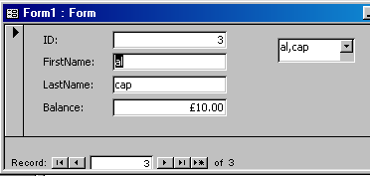

Using an Option Group To Filter

p. 58.9 to 65.9 in 2002 book.
tblNames3 (and frmOptions) in Nick.mdb.
- Make sure that you have the following table and form.

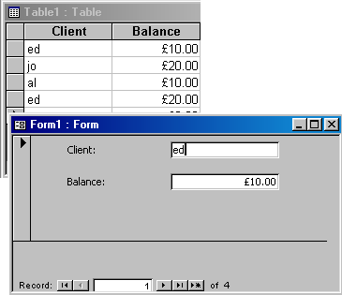

- With the form in Design View…

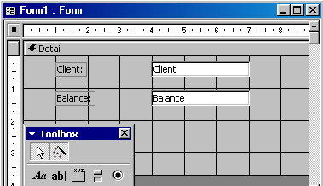

- … make sure that the Wizard button is depressed and draw an Option Group onto the form.
(The wizard may need to be installed.)
For the result see page 56.
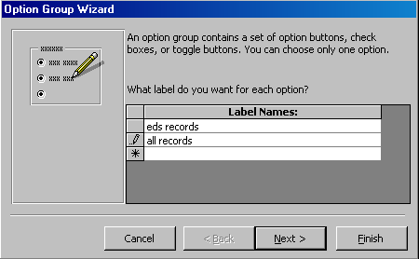
- Type in the label names as shown and click Next.

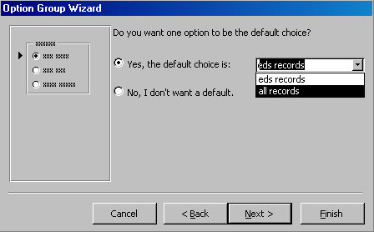
- Change the Default to
all records.

- Click Next.

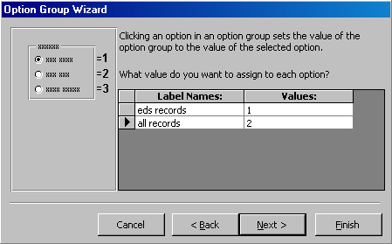
Note these Values 1 & 2.

- Click Next.

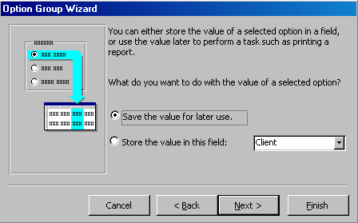
- Choose Save the value for later use. By choosing this option the option controls are not bound to the underlying table. In this case we will write our own code for them to be able to filter records according to the choice.
- Click Next.

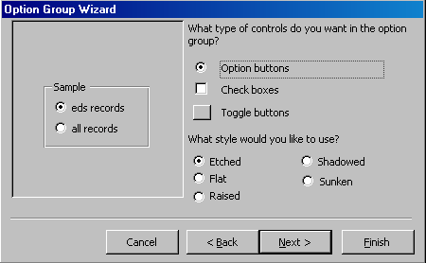
- Choose Option buttons.

- Click Next.

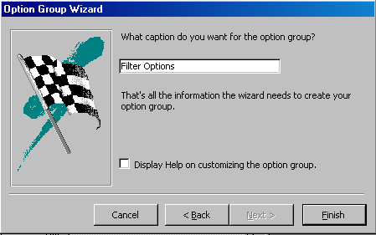
- Type a caption for the group and click Finish.

Note that Filter Options is the Caption and not the Name of the frame control. The Name will be a default. We will now change that.

As just mentioned, unfortunately, the wizard doesn’t give our option group a meaningful name. We will do so now

To Give It A Name:

- In Design View:

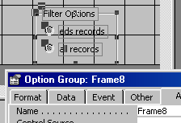
- Change the Name to FilterOptions
- Right click on the Frame and choose Properties.

- Change to Form View:

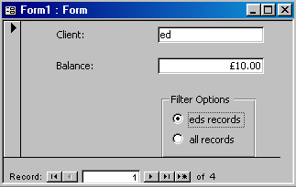
- Change to Form View and try out the option buttons. They don’t do much! We need some code.

In Design View:

- Write this code:

Private Sub FilterOptions_AfterUpdate()
Select Case FilterOptions
Case 1
Filter = "Client = 'ed'"
FilterOn = True
Case 2
Filter = ""
FilterOn = False
End Select
- Try it. It should select ed's record and all records by clicking on the respective option button.
End Sub

Problem:

So far we have successfully applied our filter from the form using the option buttons but what if we apply it from the usual Filter by Form toolbar button (see below)?

We will see that there is a coordination problem. In this case our option buttons on the form unfortunately do not respond to show the corresponding filter state as indicated by the corresponding toolbar button as we will now see.

With the form in Form View, from the toolbar, make a filter by using say Filter By Form as follows:

- Click Filter by Form and apply the filter. etc.

(Choose ed’s record.)
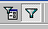

The record for ed is duly found… but…

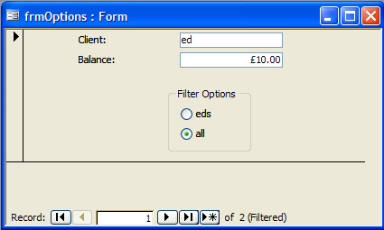
… our Option Group is not coordinated!

There is another problem. What if we choose al’s record using the Filter By Form? In this case we want no option button selected.

In this case it would seem a good idea show no choice on the option buttons (see next diagram).

The following code ought to see to both of these difficulties.

- In the ApplyFilter event for the Form write the following code:

Private Sub Form_ApplyFilter(Cancel As Integer, ApplyType As Integer)

Select Case ApplyType 'ApplyType could be acApplyFilter or acShowAllRecords.
Case acApplyFilter
If InStr(Filter, "ed") > 0 Then 'The filter string could be something like: Table1.Client = "ed" etc.
FilterOptions = 1 'Sets the option button. '1 corresponds to the upper option button for ed's record being checked.
Else
FilterOptions = Null 'Corresponds to al, jo etc being selected ie something selected but not ed.
End If
Case acShowAllRecords
FilterOptions = 2 '2 corresponds to the lower option button (all records) being checked.
End Select

End Sub

Recall that acShowAllRecords is 0 and acApplyFilter is 1.

- Test it.

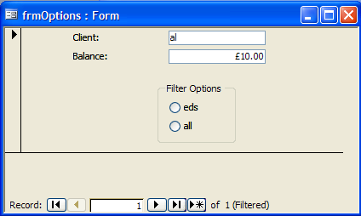
If we are applying a filter but not for ed’s records eg for al, then no option buttons will be selected.

(Note that the text book’s version of this p.64 in the 2002 book,has shortcomings – it does not provide for New York being chosen from the menu bar.

Using the OnEnter Event to Change The BackColor of a Combo

p 69.8 to p. 72.6 in Access 2002

We want to turn the back colour of the text region of the combo to grey when we click away from the combo box control.

- Place a combo box on any form in Design View, and take a look at the BackColor property.

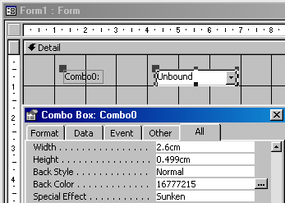
frmComboColor in Nick.mdb.
- Remember this value for White
(or copy it.)

- Click the ellipses.

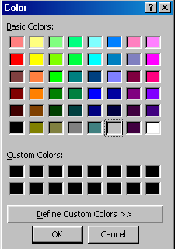
- Choose Grey and click OK.

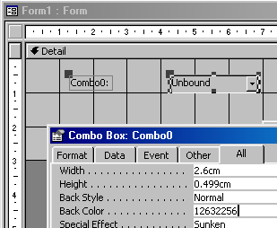
- Remember the Color number.

- Write this code:

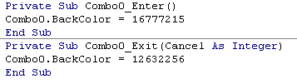

Recall that in order that the Enter and Exit events can operate, we need another (any) control on our form as well.

- eg place a Command Button on the form and change to Form View.

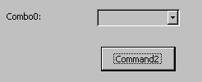
- Click on any other control – in this case the Command Button and the combo box text area goes grey.

- Click in the text area of the combo box and it goes white.
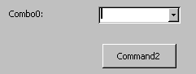

  - Click on the Command Button again and it should go White again etc.

Note that we are clicking from control to control on the same form. Hence the Enter event rather than the GotFocus.
pp 72.6 to 74.6 Step by Step 2002
frmNames3 based upon tblNames3 in Nick.mdb.
Using AfterUpdate to Copy Data to Another Field

- Make sure that you have the following table and form based upon it.

- Place a text box (unbound) on the form. Call it txtRepeat.
We wish this text box to automatically duplicate whatever is showing in the Client text box.

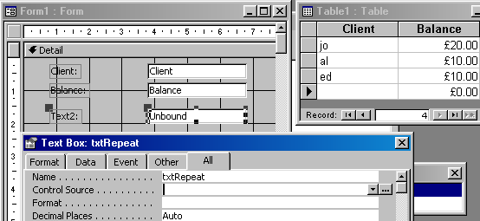

Note that the text box is unbound.

- Place this code in the AfterUpdate of the Client textbox - not the Form AfterUpdate.

Note that we are placing code in the AfterUpdate of the control – not the form. This means that this event will fire when we leave the Client text box control.

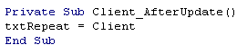
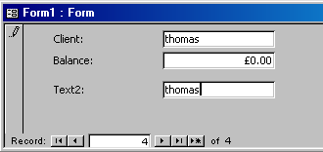
Recall that AfterUpdate occurs after a record has been updated ie changed/edited.
A new records qualifies as an update as well.
The implication here is that as you scroll/navigate through the records the new text box txtRepeat shows nothing.
- …the same entry appears here.
- Type in here and press Enter or Tab and…
To avoid Thomas remaining here for the next record see next page : Use :
Private Sub Form_Current()
txtRepeat = Null
End Sub

Let’s say that we have entered Thomas and it has been duly duplicated in the txtRepeat text box.

We change our mind. We wish to change it to Thom but we don’t wish the change to be repeated in the txtRepeat text box.

At present:

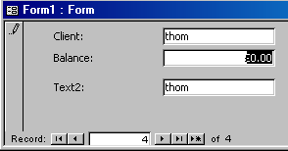
...this changes as well.
- If we modify this…

We wish to avoid such a change occurring in the repeated field.

We wish it to be duplicated therefore, only when the second field (in txtRepeat) is blank.

- Try this solution.

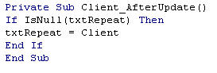
- Now we can modify this field without the other field changing. Try it.
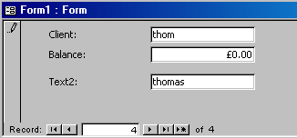

Since txtRepeat is an unbound control, the text in this text box (in this case thomas) will remain as we go from record to record. To ensure that the field is blank when we move to a new record, we could use:

Private Sub Form_Current()
txtRepeat = Null
End Sub

To more closely simulate the book example, make the following table.

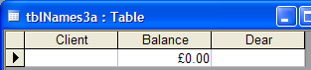
frmNames3a based upon tblNames3a in Nick.mdb.

- Make the following form based upon this table. The form's Dear field is now bound to the table’s Dear field.

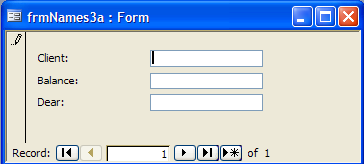

- Place code similar to that of the previous example in the Client_AfterUpdate event as shown below.

Private Sub Client_AfterUpdate()
If IsNull(Dear) Then
(No need for Current() event code.)
Dear = Client
End If
End Sub

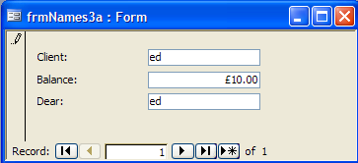
- Only when Dear field of the form is blank will it duplicate the Client field.

The table will be updated :

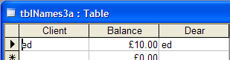
p.81.2 to 83.7 in Access 2002

Using Form_BeforeUpdate to Check the Contents of a Field

Make sure that you have the table and form below:
We have decided that if we have an address, then we must have a postcode as well. If we don’t have an address then we don’t need a postcode.
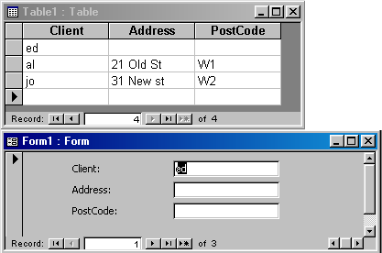
If followed by If has the effect of If… And.
frmNames4 based upon tblNames4 in Nick.mdb.

In the Form_BeforeUpdate (not the Control’s BeforeUpdate):

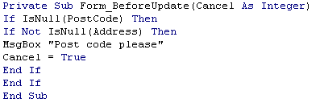
Use the Form BeforeUpdate since we are checking one control against another before we move on and save the record.
ie there is something in the Address text box.
- Enter a new record.
- Go to the next record without having entered a post code.

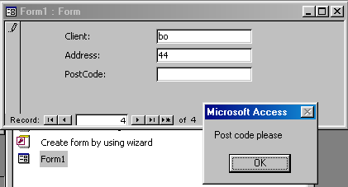

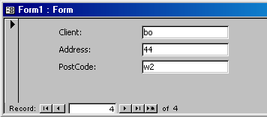
- The action is cancelled and we can now enter a postcode.

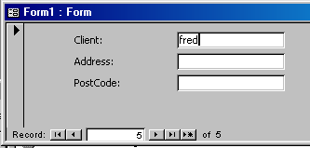
Of course, if we don’t enter an address at all, we don’t need to enter a postcode.
- Try it.

If we then wished to ensure that if we have one we must have the other ie both or none, we could use If IsNull(PostCode)And IsNull(Address)
instead of the two If statements as previously as shown below:

Private Sub Form_BeforeUpdate(Cancel As Integer)
If (IsNull(PostCode) And Not IsNull(address)) Or (Not IsNull(PostCode) And IsNull(address)) Then
MsgBox "If you have one you must have the other"
Cancel = True
End If
End Sub

Access and SQL

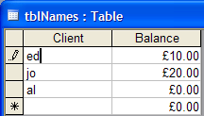
SQLbeginning.mdb in SQL folder.

We wish to try this SQL statement on the table: SELECT Client, Balance FROM tblNames;

- Make a New query not based upon any table.

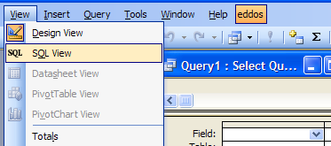
- Choose View, SQL View.
(Make sure that the query is still in Design Mode.)
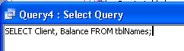

- Paste in the SQL statement

- Run the query.

In this case all of the records are selected from the table.

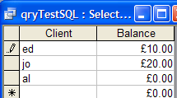
Go to the web page una.co.uk and click this link to download teachSQL_2000.mdb which contains the practice database for Forta and the SQL book examples as well.
http://www.una.co.uk/

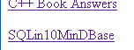

Now see Teach Yourself SQL in 10 minutes by Ben Forta.

Notes on differences for Access: The % and _ are not allowed in Access.
Use * and ? respectively (page 45).

The RunSQL command can also be used with DoCmd to run certain SQL commands as we will now see. (Can’t use SELECT - can use SELECT INTO ).
Using SQL to Update a Table

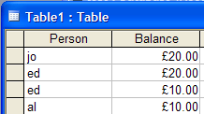

- Make this form based upon this Table.

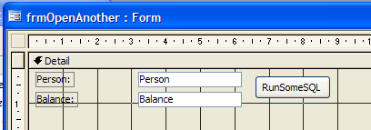

From Help, it appears that we can only use: INSERT INTO, DELETE, SELECT...INTO, UPDATE, CREATE TABLE, ALTER TABLE, DROP TABLE, CREATE INDEX, or DROP INDEX
- Place this code in the button procedure.

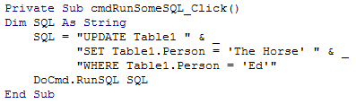
The spaces are important!

- Run it (click the command button).

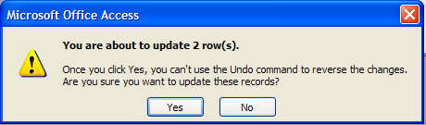

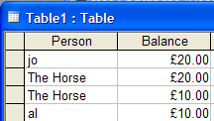
Database description
teachSQL_2000.mdb
placed on una.co.uk
Relationship diagram (not made in the downloaded database).

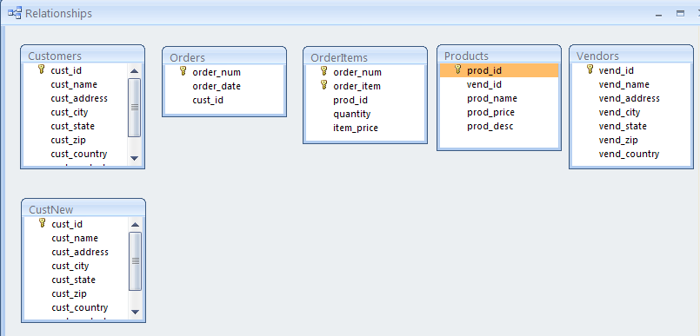
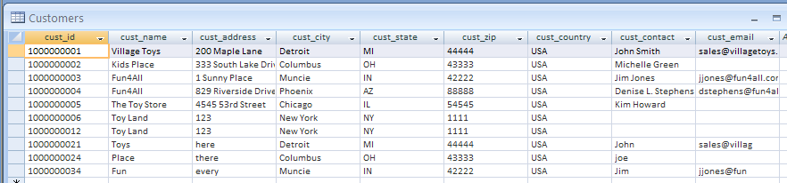
ie Customers:

…place an order.

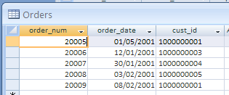

The details of which are…

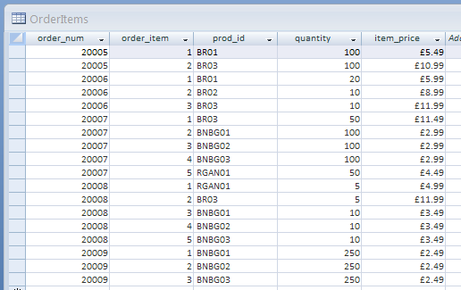

For individual products:
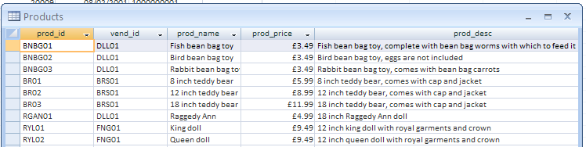

Which are supplied by these Vendors:

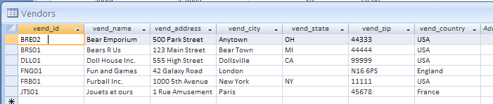
Forta

Ch2

Page 14 qryProdName

SELECT prod_name
FROM Products;

Select is used to select columns of data from a table.

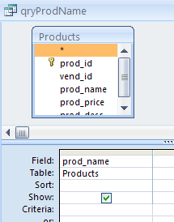

- Selecting a column is equivalent to checking this. Uncheck it and you will get:

SELECT
FROM Products;

(which won’t now do anything.)

Ch3 Sorting

Ch4 Filtering

WHERE selects rows.
! = does not work in Access.
Page 28:

Ch5 Filtering

OR: page 33.

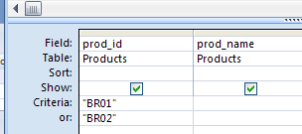

BR01 not BRO1.

SELECT Products.prod_id, Products.prod_name
FROM Products
WHERE (((Products.prod_id)="BR01")) OR (((Products.prod_id)="BR02"));

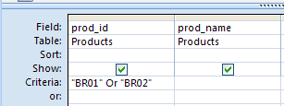

Reverts to a single line when run.

The AND is across 2 columns:

Page 36:

SELECT Products.prod_name, Products.prod_price, Products.vend_id
FROM Products
WHERE (((Products.vend_id) In ('DLL01','BRS01')))
ORDER BY Products.prod_name;

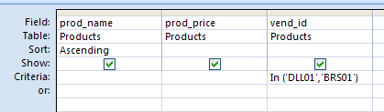

Ch6 Filtering

Page 41: Use * instead of % in Access.

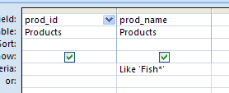

SELECT Products.prod_id, Products.prod_name
FROM Products
WHERE (((Products.[prod_name]) Like 'Fish*'));

Page 43: Use ? instead of _ in Access.

SELECT Products.prod_id, Products.prod_name
FROM Products
WHERE (((Products.prod_name) Like '?? inch teddy bear*'));

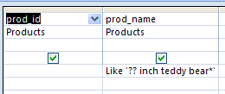

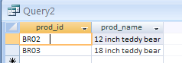

Page 44:
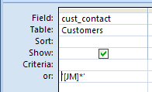

- Type this and ..
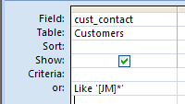

- .. Like is added.

SELECT Customers.cust_contact
FROM Customers
WHERE (((Customers.cust_contact) Like '[JM]*'));
Ch7 Calculations

Page 48:

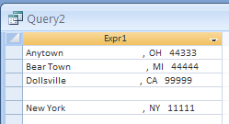

Access supports TRIM.

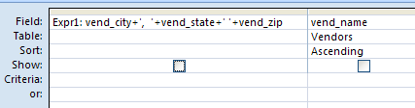

qryRTrim:

SELECT trim(vend_city)+' , '+trim(vend_state)
+' '+trim(vend_zip) as address2
FROM Vendors;

Ch8 Functions
Seems that some functions will work in a brand new 2007 database but not one which was created in an older version!

Page 59 table 8.2 functions don’t work with the SQL SELECT. (In an expression?)

Access SQL doesn’t support comments!
To get Help on the statements available in
Microsoft Access SQL

type SQL

Then choose SQL Reserved Words.
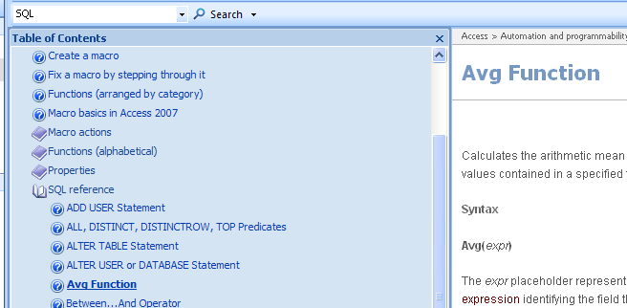
See:
Comparison of Microsoft Access SQL and ANSI SQL

eg this works in a brand new 2007 database!

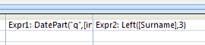

Page 64 Math functions:

Seems that some functions will work in a brand new 2007 database but not one which was created in an older version!

eg this wont work in teachSQL_2000.mdb but will in a new database.

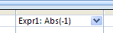

Ch 9 Sum etc

Avg works OK in Access

Page 67:

SELECT AVG(prod_price)
FROM Products;

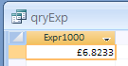

Page 69:

SELECT COUNT(cust_email) as num_cust
FROM Customers;

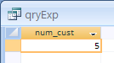

Count (*) works OK.

Page 72:

SELECT SUM(item_price*quantity) AS Total_Price
FROM OrderItems
WHERE order_num=20005;

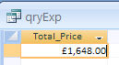

Page 73:

Works without DISTINCT:

SELECT Avg(prod_price) AS avg_price
FROM Products
where Products.vend_id="DLL01";
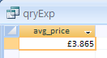

But not with DISTINCT:

SELECT Avg(DISTINCT prod_price) AS avg_price
FROM Products
where Products.vend_id="DLL01";

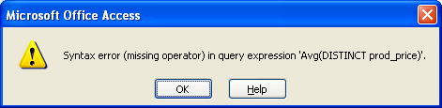

See:

Comparison of Microsoft Access SQL and ANSI SQL

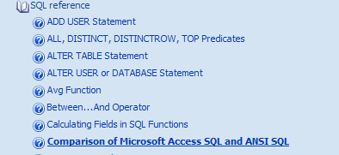

Microsoft Access SQL does not support the following ANSI SQL features:
DISTINCT aggregate function references. For example, Microsoft Access SQL does not allow SUM(DISTINCT columnname).

Ch 10 Grouping

Page 73:

SELECT vend_id,COUNT(*) AS num_Prods
FROM Products
GROUP BY vend_id;

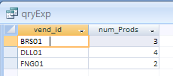

Page 83:

Access doesn’t like this

SELECT order_num, COUNT(*) As items
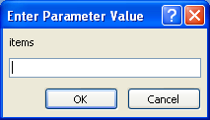
FROM OrderItems
GROUP BY order_num
- Doesn’t like items so..
HAVING COUNT(*)>=3
ORDER BY items, order_num;

…replace items by count(*):

SELECT order_num, COUNT(*) As items
FROM OrderItems Now works:
GROUP BY order_num
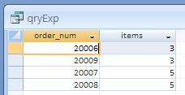
HAVING COUNT(*)>=3
ORDER BY COUNT(*),order_num;

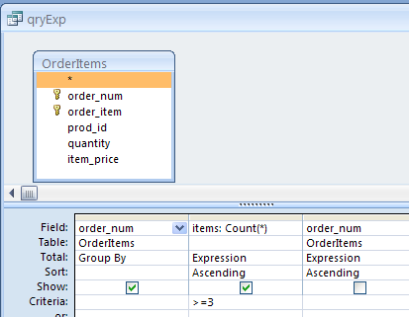
Note the QBE grid:

Ch 11 SubQueries
To apply a Where condition (ie before the grouping) select the where in the Total row!
- Having means that the criterion is applied after the grouping.

Page 86:

Query For OrderItems:

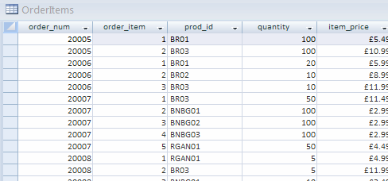

- We ultimately want a list of all customers who ordered RGAN01.

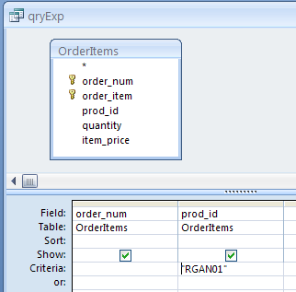

SELECT OrderItems.order_num
FROM OrderItems
WHERE (((OrderItems.prod_id)="RGAN01"));

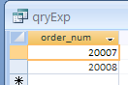

Query For Orders:

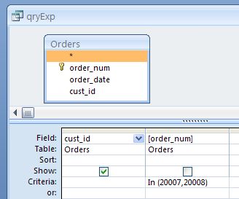

SELECT cust_id
FROM Orders
WHERE (((order_num) In (20007,20008)));

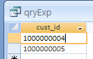

Now combine these:
Page 87:

Now copy the first SQL into the In statement of the second query (Don’t copy the first semicolon)

SELECT cust_id
FROM Orders
Where order_num IN
(SELECT order_num FROM OrderItems WHERE prod_id = 'RGAN01');

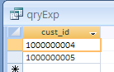

Note strange behavior of the SQL in the Criteria row:

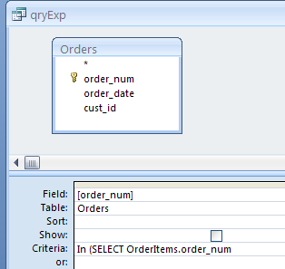

- Click here and press the down arrow to see the rest of it.

This can be remedied by putting the SQL statement in the SQL View onto one line.

This could also be done using a join. see page102

Page 88:

SELECT cust_name,cust_contact
From customers WHERE cust_id IN (SELECT cust_id FROM Orders Where order_num IN (SELECT order_num FROM OrderItems WHERE prod_id = 'RGAN01'));

Page 89.

Total num of orders by each customer.

For example, for customer 1000000001…

…go thru the Orders for this customer 100000001 and count them.

Repeat for all customers.

Page 90 .

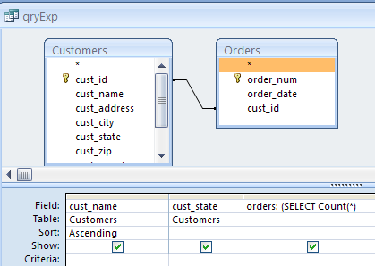
SELECT Customers.cust_name, Customers.cust_state,
(SELECT Count(*)
FROM Orders
WHERE Orders.cust_id = Customers.cust_id ) AS orders
FROM Customers INNER JOIN Orders ON Customers.cust_id = Orders.cust_id
ORDER BY Customers.cust_name;

Need to physically add the Orders table to the QBE grid?

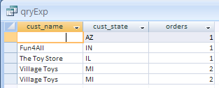

Ch 12 Joins

Page 102 : Inner join – Inner Join version:

SELECT Customers.cust_id, Customers.cust_contact, Customers.cust_name
FROM (Customers INNER JOIN Orders ON Customers.cust_id = Orders.cust_id) INNER JOIN OrderItems ON (Orders.order_num = OrderItems.order_num) AND (Orders.order_num = OrderItems.order_num)
WHERE (((OrderItems.prod_id)='RGAN01'));

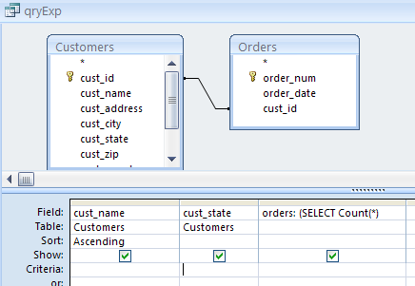

Note the double inner join where 2 or more tables are related.

SELECT [Customers].[cust_name], [OrderItems].[prod_id]
FROM (Customers INNER JOIN Orders ON [Customers].[cust_id]=[Orders].[cust_id]) INNER JOIN OrderItems ON [Orders].[order_num]=[OrderItems].[order_num]
WHERE ((([OrderItems].[prod_id])="RGAN01"));

Ch 13 Joins
Ch 13 page 105?:

SELECT Customers.cust_id, Customers.cust_contact, Customers.cust_name
FROM (Customers INNER JOIN Orders ON Customers.cust_id = Orders.cust_id) INNER JOIN OrderItems ON (Orders.order_num = OrderItems.order_num) AND (Orders.order_num = OrderItems.order_num)
WHERE (((OrderItems.prod_id)='RGAN01'));

Page 106:

SELECT Customers.cust_id, Customers.cust_name, Customers.cust_contact
FROM Customers
WHERE (((Customers.cust_name) In (SELECT cust_name
FROM Customers
WHERE cust_contact='Jim Jones')));

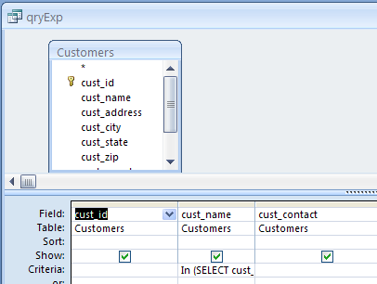

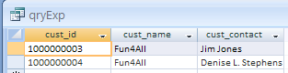

Page 107:

SELECT c.cust_id, c.cust_name, c.cust_contact, c1.cust_contact
FROM Customers AS c, Customers AS c1
WHERE c.cust_name=c1.cust_name AND c1.cust_contact='Jim Jones';
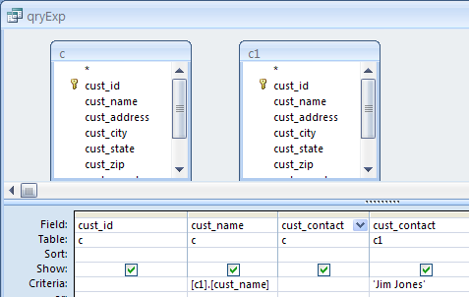

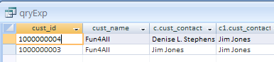

Page 108:

Natural Join:

SELECT [Orders].[order_num], [Orders].[order_date], [OrderItems].[prod_id], [OrderItems].[quantity], [OrderItems].[item_price], [Customers].[cust_id], [OrderItems].[order_num], [OrderItems].[prod_id]
FROM Customers, Orders, OrderItems
WHERE [Customers].[cust_id]=[Orders].[cust_id] And [OrderItems].[order_num]=[Orders].[order_num] And [OrderItems].[prod_id]="RGAN01";

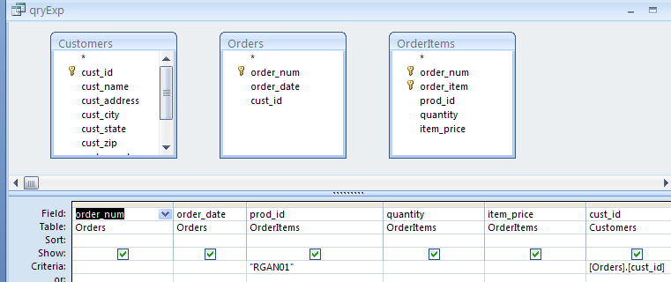

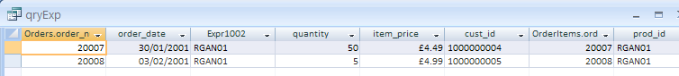
Ch 14 etc see corresponding queries in teachSQL2000.mdb

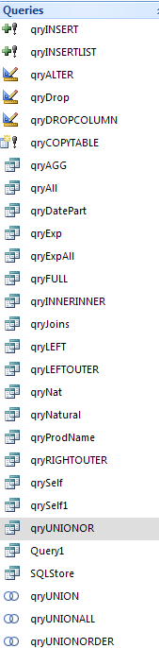

Query To Update a String

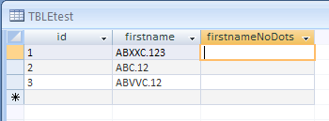
We wish to find the text to the left of the dot….

…. so that we get:

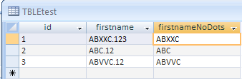

Design a Select query and then convert it to an Update query:

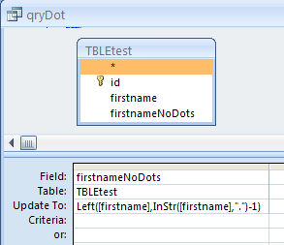

Left( [firstname] , InStr( [firstname] ,"." ) -1 )

SQL View:

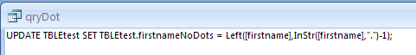

UPDATE TBLEtest SET TBLEtest.firstnameNoDots = Left([firstname],InStr([firstname],".")-1);

To Narrow Down the Search for Data in a field

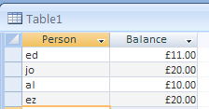

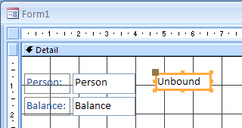

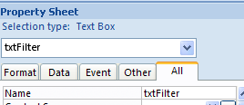

Private Sub txtFilter_change()

Dim strSQL As String, strFilter As String

strFilter = "'" & txtFilter.Text & "*'"

strSQL = "SELECT Table1.* FROM Table1 " & _
"WHERE Table1.Person Like " & strFilter & ";"

Me.RecordSource = strSQL

txtFilter.SetFocus

End Sub

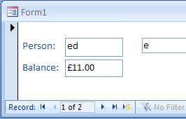

- As we type the records are progressively narrowed down.

To Update a database by checking a checkbox (and unchecking it)
testCheckUpdate.mdb

- Make sure that frmOpenAnother is open also.

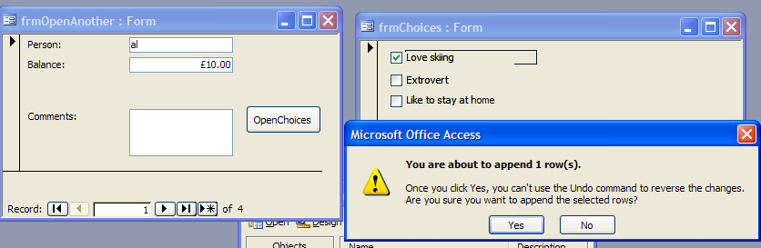
- Check (or uncheck) a check box and the record will be updated.

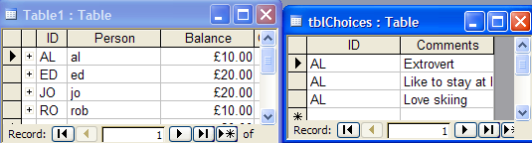

Option Explicit

Private Sub chk1_AfterUpdate()
Updatetable 1
End Sub

Private Sub chk2_AfterUpdate()
Updatetable 2
End Sub

Private Sub chk3_AfterUpdate()
Updatetable 3
End Sub

Sub Updatetable(ID As Integer)

DoCmd.SetWarnings False

Dim SQL As String, st As String, st1 As String

st1 = Forms![frmOpenAnother].ID

If Controls("chk" & CStr(ID)).Value = True Then
st = Controls("lbl" & CStr(ID)).Caption
SQL = "INSERT INTO tblChoices(ID,Comments) VALUES (Forms![frmOpenAnother].id," & "'" & st & "'" & ");"
DoCmd.RunSQL SQL
End If

If Controls("chk" & CStr(ID)).Value = False Then
st = Controls("lbl" & CStr(ID)).Caption
SQL = "DELETE FROM tblChoices WHERE Comments = " & "'" & st & "'" & " AND id = " & " '" & st1 & "';"
DoCmd.RunSQL SQL
End If

DoCmd.SetWarnings True

End Sub

Option Explicit

Private Sub Check29_Click()
AddText Check29, Label30
End Sub

Private Sub Check31_Click()
AddText Check31, Label32
End Sub

Private Sub Form_Current()
Check29.Value = False
Check31.Value = False
End Sub

Sub AddText(chk As CheckBox, lbl As Label)

Comments.SetFocus

If IsNull(Comments.Value) Then
Comments.Value = lbl.Caption
Else
Comments.Value = Comments.Value & vbCrLf & lbl.Caption
End If

chk.SetFocus

End Sub

Dirty Event

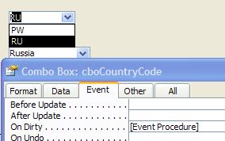
- When choose from here…

Private Sub cboCountryCode_Dirty(Cancel As Integer)
MsgBox cboCountryCode.OnDirty
End Sub

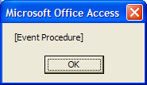
- MsgBox appears.

How does this _Dirty differ from the _Change event?

Private Sub Form_Dirty(Cancel As Integer)
MsgBox "ed"
End Sub

The Dirty event only occurs once for a particular record no matter how many changes we make.

If we return to that record and make another change of course it will then fire again.

Private Sub Form_Dirty(Cancel As Integer)
“The Dirty property determines whether the record has been modified since it was last saved.”
MsgBox "dirty form"
MsgBox Me.Dirty
End Sub

Now if we type into any text box on a form :

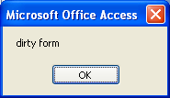
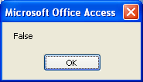
- !!

Means the record has been saved ie not a new record?

For a control: “When a record is saved, Microsoft Access sets the Dirty property to False. When a user makes changes to a “record, the property is set to True. ??
Change Event
Almanac2ndNov2006.mdb
frmCountryCodes.
Robertholmes.mdb?

- Write the code below.

Text Boxes Combos
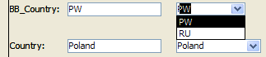
- Change the cboCountryCode combo box.

Private Sub cboCountryCode_Change()
cboCountry.Value = "England"
End Sub
… this doesn’t fire. (Just as well.)

Private Sub cboCountry_Change()
MsgBox "cboCountry_Change"
End Sub

The MsgBox doesn’t appear ie the cboCountry_Change event doesn’t fire even tho …

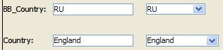
…both change.

But if we include the line as below:

Private Sub cboCountryCode_Change()
cboCountry.SetFocus
cboCountry.Text = "France"
End Sub

Private Sub cboCountry_Change()
MsgBox "cboCountry_Change"
End Sub
- Now change the cboCountryCode combo box.
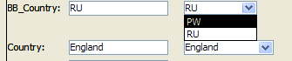

… the cboCountry_Change()event also fires.

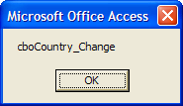

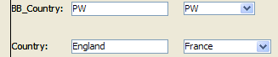

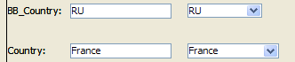
(The “Text” is not yet entered into the table. But when we click OK, it is. ie it is now a Value. )

Without the cboCountry_Change event, France goes straight into the Country text box of the combo but not into the table until we go to another control or save it.

So the following code (fortunately) does not cascade (chain-react):

Private Sub cboCountryCode_Change()
cboCountry.Value = cboCountry.ItemData(cboCountryCode.ListIndex)
End Sub
Private Sub cboCountry_Change()
cboCountryCode.Value = cboCountryCode.ItemData(cboCountry.ListIndex)
End Sub

… and keeps combo boxes synchronized.
- Change either and the other changes.
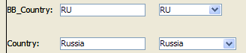

Which is what we want. ie as long as we don’t use a SetFocus it won’t cascade.

