C++
Training Manual

Kensington College

To Produce a Console Application | 2 | Returning a Structure From a Function | 38
To Edit our Code | 8 | Inline Functions | 39
To Use the Source Code for the Lessons | 8 | Two Functions With the Same Name | 40
setw | 11 | Variable Scope | 41
Summary: | 10 | Global Variables | 42
Type Cast | 12 | Static Variables | 43
The Modulo Operator (Remainder Operator) | 12 | Trick to Effectively Return More Than One Value From a Function | 44
Increment Operators | 13 | To Use Graphics | 45
To Open a Project | 14 | Member Function
Chapter 3 Loops And Decisions | 16 | Classes | 48
The If Statement: | 16 | Constructors | 52
Else | 17 | One Argument Constructor | 53
The Switch | 18 | The Scope Resolution Operator( :: ) | 54
True and False | 18 | Passing an Object as an Argument of a | 56
The For Loop | 19 | Returning an object from a member function | 57
While | 19 | Static Class Data | 58
 |  | To Make and Use a Compiled library | 62
Do While | 19 | Arrays | 59
getche() | 20 | A Two-Dimensional Array | 61
Compound Statements | 20 | To Pass an Array To a Function | 62
The Conditional Operator | 20 | An Array of Structures | 63
Logical Operators | 21 | An Array of Objects | 64
Debugging | 22 | Formatting Numbers | 65
To View a Variable in Memory | 23 | To Generate Random Numbers | 66
Binary Numbers | 24 | To Produce The IBM Character Set | 67
Hexadecimal | 25 | Strings | 82
Chapter 4 Structures | 27 | An Alternative Way to Initialize a String
Putting Structures Equal To One Another | 28 | To Put One String Equal To Another.
enum | 29 | strcpy
The Use of a “Flag” | 30 | strcat()
Adding Two Structures | 31 | strcmp()
Functions | 32 | strstr()
Pass a Value to a Function | 32 | _strset()
Passing By Reference | 34 | An Array Of Strings
Returning a Value From a Function | 35 | Making a Class to Hold a String
Passing a Structure to a Function | 36 | To Add 2 String Classes
Passing a Structure By Reference | 37 | Adding Objects
info@kensingtoncollege.co.uk

© E B Robinson 2023

Good tutorial! https://www.w3schools.com/CPP/cpp_encapsulation.asp

Lessons

1.
2.
3.
4.
5.
6. OvlOp Inheritance

7. Pointers

8.
Function Pointers
Virtual Functions
Friends
Static Functions
this
The Copy Constructor

9.
Files & Streams
Templates
Exceptions

10. STL Lambda

YouTube :https://youtu.be/u4PK23QvgFI Lesson1
-> HelloWorld from scratch

A Console Application Using Visual C++ 2022 (community)

A Free! Version of a C++ compiler can be found at:

https://visualstudio.microsoft.com/downloads/

https://visualstudio.microsoft.com/thank-you-downloading-visual-studio/?sku=Community&rel=17

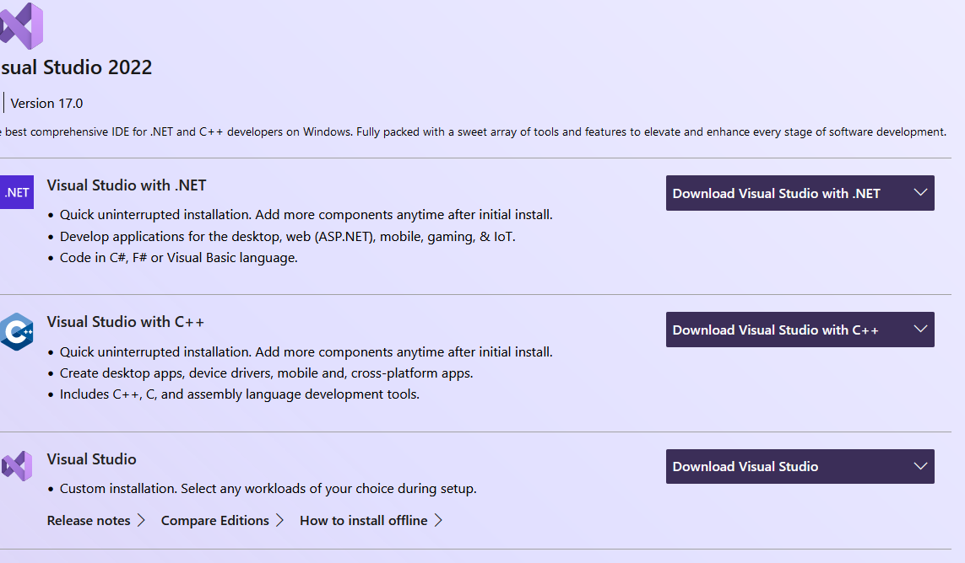

- Click to download and follow the instructions.

- Download Visual Studio Community.
(Note that after initial installation/setup you may have to subsequently make further installation.)


- Double-click to start.

To Create a C++ Console Application
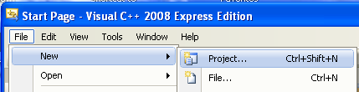
- File, New, Project…

In Visual Studio 2017 we must use the wizard if we want to avoid a pch.
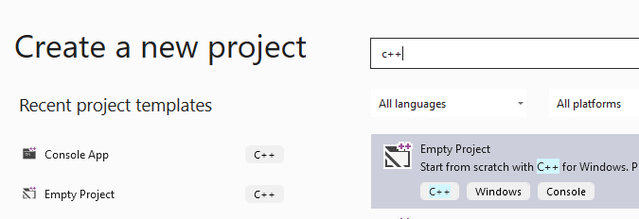

Choosing Console Application
Choosing this means that our output will eventually appear in a black screen.
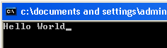

- Type a name for the project – eg exp

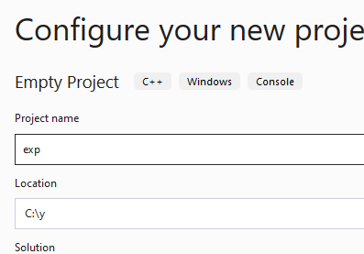

- Note the folder where the project will be stored. (It’s a good idea to make it simple.)

- Click Create.

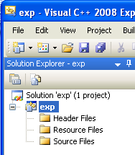
A solution is produced. A solution can contain many projects.
In class will not deal with more than one project at a time. A project can contain more than one file as we will see but the main one is the .cpp file which will contain our program.

First make sure that exp ie your project is selected – and not the solution!
We will now add a “code sheet” ie a .cpp file.

- Choose Project, Add New Item…

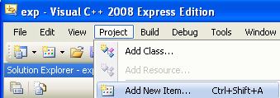
In later versions the source code file is included ie no need to do this.

- C++ File (.cpp).
- Choose Visual C++.

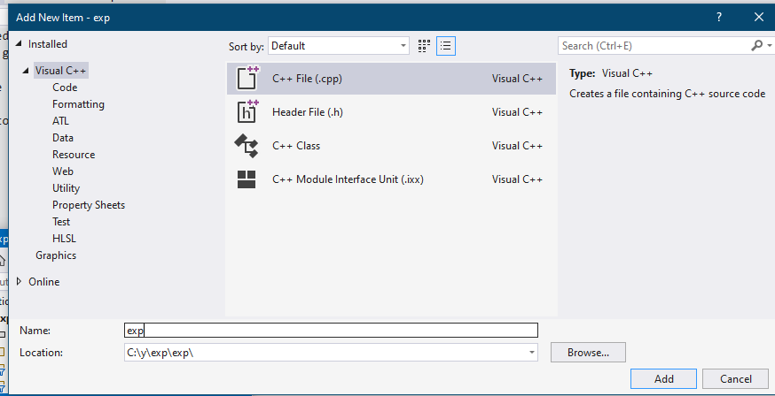

- Click Add.

- For convenience, call the filename the same as the project: exp ie exp.cpp.

- Type or copy this code below. (See C++Man1 (A soft copy of this manual) from the web site www.una.co.uk for the code. See next page.

https://youtu.be/qgn6TCWbC0w Lesson 1a
- Make sure that you use lower case as shown as C++ is case sensitive.

#include <iostream>
using namespace std ;
int main(void)
- Make sure that you use the exact type of brackets and braces.
{
cout << "Hello World" ;
cin.get() ;
return 0 ;
Include the line cin.get() ; before return 0; ;
This has the effect of waiting for a key press, which effectively delays the window closing as we will see. The same effect can be achieved by choosing Start Without Debugging (Ctrl-F5).
This no longer (finally!) seems necessay in lastest versions!
}

- Don’t forget the semicolons. You may wish to tab them out and keep them in line so that you can notice any missing.

Spaces don't count!

To Use the Source Code for the Lessons

Copy the code from the manuals http://www.una.co.uk/

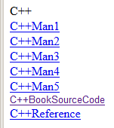
- Open the Word document.

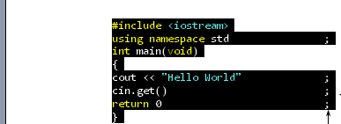

- Copy the code from the Word document.

- Switch to the C++ editor.

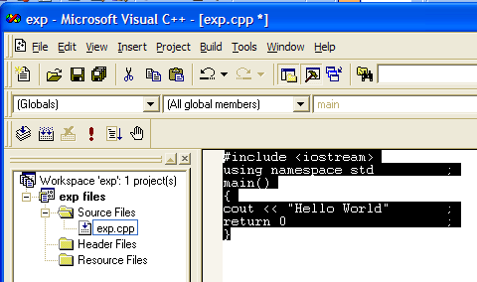
- Paste the code into our exp.cpp file.

- Note that the C++ source code file (with the extension .cpp) has been added to the project.

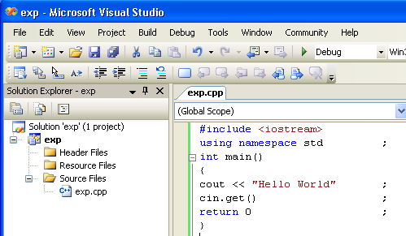
- (An asterisk will appear at the end of the file name if the file has yet to be saved.)

- Press F7 to Build.

Or if youre confident its OK then click the green Run button with no further ado.

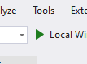

Hopefully you will get a message in the Build window saying that you have no errors as below.

- ( If you do have errors, press the F4 key to go straight to the first error which you can then directly edit and build again.)

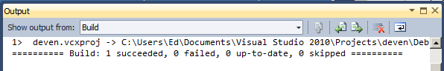
No errors!

- Run by clicking the Run button – or press F5.

- (Make sure that you do press a key or else the Command window will remain open.)

https://youtu.be/bJk416dZ7iQ CPPLesson 1b
compiling binary editor

Not required – but interesting:

If you may wish you take a look at your program as binary!

File Open

C:\y\exp\x64\Debug
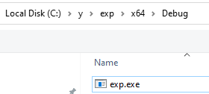
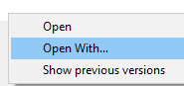

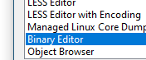

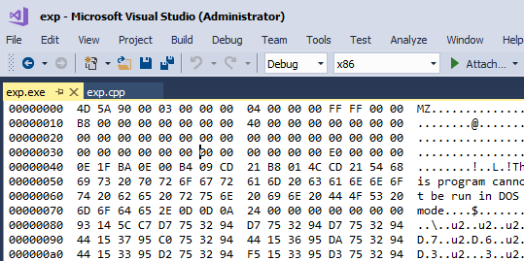



5 volt

4D -> 79 -> 01001101
Binary Numbers

How many ice-creams can you order with one hand?
5 right ? wrong 32!

Consider that a finger (and thumb) can be in 2 states
raised or not-raised and that we start with the thumb
as 1 and multiply by 2 for the other fingers as shown


If the thumb and 1st finger were raised this could
represent 3 (1+2) as shown.

If all fingers were raised, this would represent 31 (1+2+4+8+16).

If no fingers were raised, this would of course represent 0- this would indeed have to be a valid ice-cream order!.
Therefore the total no. of orders possible is 32 ( If we include 0).

We could indicate 5 as follows

Now we could further represent a finger raised by 1 and a finger not-raised by 0.

5 would then be represented by: 00101 - this is called binary
(Actually the leading zeros can be omitted. so that we would have 101.)
The respective 1’s and 0‘s are called bits (8 bits makes one byte)

Exercise

101 is the binary representation of ……5…
1101 is the binary representation of …13……
1000 is the binary representation of ……8…

7 is the decimal representation of ……………
12 is the decimal representation of ……………
- is the decimal representation of ……………

16 8 4 2 1

0 0 1 0 1

voltage
Hexadecimal

Whereas decimal numbers are to base 10 anad binary is base 2 hexadecimal numbers are to base 16.
Numbers in hexadecimal from 1 to 9 are the same – 0 to 9.
But numbers from 10 to 15 are given the letters A to F

Decimal Hexadecimal
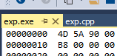
1 1
2 2
. .
. .
9 9
10 A
11 B
12 C 64 + 13 = 77
13 D
14 E
15 F

Hex numbers in C++ are preceded with 0x eg 0xAD23F3.
- Try this

#include <iostream>
using namespace std ;
int main()
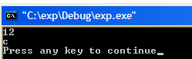
{
int h ;
h = 0xC ;
cout << h << endl ;
cout << hex << h << endl ;
cin.get();
return 0 ;
}

To evaluate to 2 digit hex number eg 2A

Whereas of course decimals increase by a factor of 10 from right to left, hex placeholders increase by a factor of 16 from right to left.
… 256 16 1

So hex 2A can be evaluated:
… 256 16 1
- A

i.e. 2 times 16 plus 10 times 1 i.e. decimal 42.

Exercise: What is the decimal equivalent of the hex number 22A ?

What algorithm would you use to convert a number from decimal to hex e.g. convert decimal 42 to hex.
Why use hex? Hexadecimal is a shorthand way of writing binary

For example, decimal 42 is the equivalent of the hex 2A.

- Write the 2 and the A separately in binary:

2 A

8 4 2 1 8 4 2 1

… … 1… …0 1… 0… 1… 0…

- Now write 42 as binary:

128 64 32 16 8 4 2 1

… … 1… …0 …1 …0 1… …0

They are the same! This is always true – since all of the numbers of the higher hex digit are 16 times those of the lower.

Summary:
No semicolon here!
Always include a main().
Always include opening and closing curly brackets

#include <iostream>
using namespace std ;
int main(void)
{
cout << "Hello World" ;

return 0 ;
}
void means nothing.

cout << for the moment! means "print". (See page 36 of the text)

#include <iostream> is always necessary when we use cout. This header file includes the code necessary to perform – in this case - printing out to the screen. The corresponding .lib file contains the executable code for the cout function etc. (See page 66 of the text.)

using namespace std is the (recently introduced into Standard C++) way of pre-empting any potential keyword name conflicts with other project code which might be introduced into our workspace. Just include it!
We can indeed remove using namespace std but….
#include <iostream>
int main(void)
{
we then need to qualify each an every input/output statements with std::

std::cout << "Hello World" ;

return 0 ;
}

To Edit our Code
- Double-click on our source code file - make sure that first of all, the FileView tab is selected as shown.

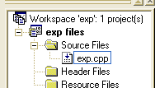

- Edit the code - then choose Build, Build exp.exe as before

https://youtu.be/Wew7wSxp7bc CPPLesson 1c up to swapping variables
Summary: (page 37 onwards)

- // or /* ….. */ combination can be used as comment indicator. (see page 36.)

int i = 100 ;
long i = 100 ;
char i = 'A' ;
float f = 1.23f ;
double d = 1.23 ;
bool b = true;
- Variables can be int (whole numbers eg 23 )
long is used for very large integers.
char (letters eg A or a )
float (decimals eg 23.3)
double is used for large decimals.

See variable summary on p.54

- '\n' (When enclosed in a string) used with cout produces a new line (so does cout << endl - page 41) eg cout << "ed\n" - page 35

- Try this.

#include <iostream>
using namespace std ;
int main()
- A variable can be declared and initialized on one line.
{
int i = 4 ;
cout << i << endl ;
cin.get() ;
return 0 ;
}
- The insertion operator << can be cascaded. (See page 47 of the text).

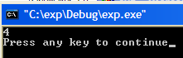

- cin >> i will have the effect of asking you to input a value from the keyboard (p.45)

- Type this into your exp.cpp file:

#include <iostream>
using namespace std ;
int main()
{
int i ;
cin >> i ;
You will may need two cin.get()’s !! (This is because a character may not be flushed from the input buffer as it should.)
cout << 2 * i << endl ;
cin.get() ;
return 0 ;}
* means multiply.
/ means divide.

Build & Run it.

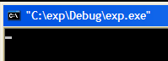
Exercise: Start with two variables:
int var1 = 3 ;
int var2 = 4 ;
Write a program to swap the two values so that var1 will be 4 and var2 will be 3. Output the results before and after.

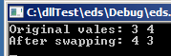

start with this code

#include <iostream>
using namespace std;
void main()
{
int var1 = 3;
int var2 = 4;

cout << "Original vales: " ;
cout << var1 << " " << var2 << endl;

//code in here to swap

cout << "After swapping: " ;
cout << var1 << " " << var2 << endl;
cin.get();
}

Waiting for input.
- Input a value.

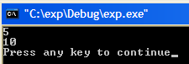

- If you don't wish a variable to change
in value , use const in front
eg const double Pi = 3.14 ;

Note that if we try to change the value later
in the code, like so:
Pi= 3 ; ;
We will get an error message like so:

C:\exp\exp.cpp(6) : error C2166:
l-value specifies const object
(l-value means the value on the left
of an equal sign.)

setw page 52

The following code will print integers into a field of width 5 (right justified).

#include <iostream>
- Note <iomanip>

#include <iomanip>

using namespace std ;

int main()

{

cout << setw(5) << 123 << endl ;

cout << setw(5) << 1234 << endl ;
cin.get() ;

return 0 ;

}

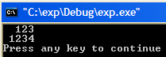
Type Cast Page 58

- Try this:
Implicit conversion:
Data will be lost.

float v = 1.1F ;
int v = f ;

OK but gives a warning
#include <iostream>
using namespace std ;
int main()
{
double d = 1.23 ;
cout << static_cast<int>(d) << endl ;
return 0 ;
}
Implicit conversion:
Data will not be lost.

int i = 1 ;
float f = i ;

but also just gives a warning.

The double is explicitly cast to an integer.

Data is lost.

1.23 has been truncated to 1.

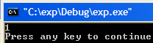

Note that in “non-Standard C++” we achieve the same result using :

cout << (int)d << endl ;
or:
cout << int(d) << endl ;

- A lot easier to use!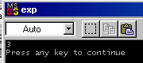 Try them

The Modulo Operator (Remainder Operator)

- Try this.

#include <iostream>
using namespace std ;
int main()
{
cout << 23 % 4 << endl ;
return 0 ;
}

ie what's left over after 23 is divided by 4

Increment Operators page 63.

- Try these:
- Include cin.get() where necessary.

#include <iostream>
using namespace std ;
int main()
{
int j = 3 ;
j = j + 2 ;
cout << j << endl ;
return 0 ;
}

#include <iostream>
using namespace std ;
int main()
{
int j = 3 ;
j += 2 ;
cout << j << endl ;
return 0 ;
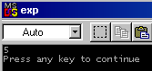}
This means
j = j + 1;
- Change ++j to j++. It won’t make any difference, j is still incremented by 1.
#include <iostream>
using namespace std ;
int main()
{
int j = 3 ;
++j ;
cout << j << endl ;
return 0 ;
}

There is a very subtle difference however:

#include <iostream>
using namespace std ;
int main()
{
int j = 3 ;
cout << ++j << endl ;
return 0 ;
}

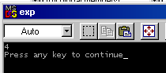
But…

#include <iostream>
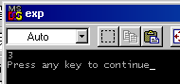using namespace std ;
j is 3, not 4 as might have been expected.
int main()
{
int j = 3 ;
cout << j++ << endl ;
return 0 ;
}
j is printed and then incremented!
Include a cout << j ; after this line. j is found (eventually) to be 4.

Library functions. For example to raise to a power eg 2³ :
double p = pow(2,3.00) ; Note that the 3.00 must be a double.
You must also #include <cmath>. See also sqrt.

Exercise: No 6 page 72 of the text.
Result:
No 6. On a certain day the British pound was equivalent to $1.487 U.S., the French franc was $0.172, the German deutschemark was $0.584, and the Japanese yen was $0.00955. Write a program that allows the user to enter an amount in dollars, and then displays this value converted to these four other monetary units.

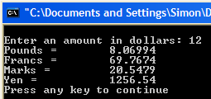

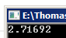
Optional Exercise : Use the formula (1 +1/n) ^{n} to find
(an approximate value of) e.

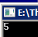
Optional Exercise Given the sides of a right triangle
(say 3 & 4) find the hypotenuse.

Chapter 3 Loops and Decisions Lesson2.avi YouTube: https://youtu.be/5i0RyEeeM_Y

The If Statement: page 94.

- Edit your exp.cpp as follows, build and execute.

#include <iostream>
using namespace std ;
int main()
ie if x is bigger than 1 which of course it is (since it's 2), do the following…
{
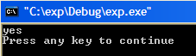
int x = 2 ;
if (x > 1)
cout << "yes\n" ;
cin.get();
return 0 ;
}

- Modify the code as follows:

#include <iostream>
using namespace std ;
int main()
Note that when we are assigning we use one equal sign but when we are testing (comparing) we use two equal signs.

{
int x=2 ;
if (x==2)
cout << "yes\n" ;
cin.get();
return 0 ;
}

When this program runs then of course the output should be "yes" once again
For compound if see now page 21 : Logical Operators.

If we wish more than one thing to be performed then we must enclose these things in braces as follows (This is generally true for a group of C++ statements.)

#include <iostream>
using namespace std ;
int main()
{
Enclosingbrace.

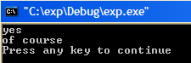
int x=2 ;
if (x==2)
{
cout << "yes\n" ;
cout << "of course\n" ;
}
Enclosing brace.
These ensure that all of the code contained within these braces are executed if the condition (x=2)is true – which it is.
cin.get();
return 0 ;
}

else
- Try this:
Don’t forget cin.get() if necessary.

#include <iostream>
using namespace std ;
int main()
{
int x=2 ;

if (x==2)
cout << "yes\n" ;
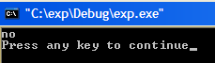
else
cout << "no\n" ;
return 0 ;
}
Exercise:
Write code to swap the values only if if the first value is bigger than the 2nd.
It must work for ANY values given to var1 and var2.
Use an if statement.

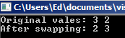

You could start with your solution of page 10 which just swaps.
#include <iostream>
using namespace std;
void main()
{
int var1 = 3;
int var2 = 2;
etc
- Change
if (x==2) to if (x==1)
and the else should be executed.

More than one if statement has the effect of AND as below:

#include <iostream>
using namespace std ;
int main()
For AND, both these conditions must be satisfied.
{
int x = 2 ;
if (x==2)
if (x > 1)
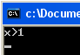
cout << "x>1" ;
return 0 ;
}

Using else if has the effect of OR:

#include <iostream>
using namespace std ;
else if is similar to if in that it has a condition. This is what makes it different from the else which does not have a condition.
int main()
{
int x = 2 ;
if (x > 2)
cout << "x>2\n" ;
Note also that if one else if (or an if) is encountered which is true, all other else if‘s are then not even considered.
else if (x > 1 )
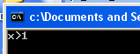
cout << "x>1\n" ;
else if (x > 0)
cout << "x>0\n" ;
return 0 ;
}
The Switch …is an alternative to using else if.
Whereas the switch may seem impressive it is perhaps only useful as a “menu selection”. It has limitations cf If.

#include <iostream>
using namespace std ;
int main()
{int x = 5 ;
As with else if, if one case is found to be true, any following cases are not considered but if no break is present, it will fall through. Try removing the breaks. It will mistakenly then print “five” and “six”.

switch (x)
{
case 4:
cout << "four" ;
break ;
case 5:
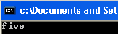
cout << "five" ;
break ;
case 6:
cout << "six" ;
case 4:
case 5:
cout << "Either 4 or 5";
break;
would catch both 4 and 5.

break ;
}
cin.get() ;
return 0 ;
}

True and False

A true expression produces the value of 1. A false expression produces the value of 0.

#include <iostream>
using namespace std;
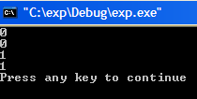
int main()
{
cout << (10<5) << endl;
cout << (10==5) << endl;
cout << (10>5) << endl;
cout << (10!=5) << endl;
cin.get() ;
return 0 ;
}
!= means not equal.

Note that unfortunately, the bool value is not output as true or false (as is the case with C# for example) but rather as 1 or 0:

#include <iostream>
using namespace std ;
int main()
{
bool b ;
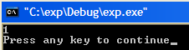
b = true ;
cout << b << endl ;
cin.get() ;
return 0 ;
}

The for Loop page 78

#include <iostream>
The int declaration could alternatively be placed here as shown

for (int i=0;i<4;i++)
Note that in this case, the i will only be “known” inside the loop.
using namespace std ;
int main()
i+=2 to increment by 2 instead of 1.
{
int i ;

for (i=0;i<4;i++)
cout << i< endl
cin.get() ;
return 0 ;
Use for (i=3;i>=0;i--)
to go backwards.
}

To execute a series of statements in a for loop, use enclosing braces (as we did for the if).
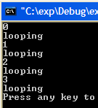
for (i=0;i<4;i++)
{
cout << i << endl;
cout << "looping" << endl;
}

while
page 86

#include <iostream>
using namespace std ;
int main()
i < 4 evaluates to either true or false. If false ie i = 5, it will stop.
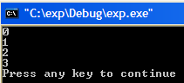
{
int i = 0;

while (i < 4)
{ cout << i << endl ;
i++ ;}
cin.get() ;
return 0 ;
}
When to use a for and when to use a do ?
See page 19 of this manual for discussion.

Do While page 86

#include <iostream>
using namespace std ;
int main()
{
int i = 0 ;

do
{ cout << i << endl ;
i++ ;}
Note the semicolon!

while (i < 4) ;
cin.get() ;
return 0 ;
}
The while and the do….while are almost identical. The only difference is that the do while evaluates the condition at the end ie it always goes through at least once and doesn’t find out it shouldn’t have until too late

In class

Use for loops to produce these respective outputs

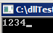
1.

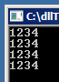
2.

hint : use a loop inside a loop.

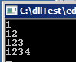
3.
hint : for i = 1 to j.

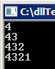
4.

hint : print out 4321 on a single line first.

5. Write code to produce the following: (ie multiply by 2 each time)
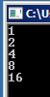

Supplementary problem 1. (Optional for math students:):

Find the value of the exponential e (approximateley 2.718) using a for loop.
Hint:
First find the factorial bit (eg 3! = 3 x 2 x 1):
In a loop say for(int i=1; i<=……; i++)
use d = d * i where d is the result of the previous multiplication.

CPPLesson2b https://youtu.be/g3VXkzcQYBI

getche() page 100
getche() is now deprecated. Use _getche()?

getche has the same effect as cin.get().

#include <conio.h>
The include file for getche().
#include <iostream>
using namespace std ;
int main()
The e in getche means echo (print) the character to the screen.
{
char ch ;
ch = getche() ;
return 0 ;
}

When the program is run, it is waiting for a (single) key to be pressed. We could press the Enter key but any other key will do.

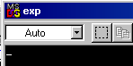

using namespace std;
int main()
{
char c ;
do
{
cin >> c;
cout << c << endl;
} while (c != 'a');

return 0;
}
Compound Statements page 101

Note that
i = getche()) is performed first.

The value retrieved is then compared with 'a' which evaluates to either true or false.

If the value is true, the while will continue. If it is false, it stops.

i = getche()
while (i != 'a' )

can be replaced by the single statement

while ( (i = getche()) != 'a' )
Evaluate from inside out.

When do we use a for loop and when do we use a while? When we know in advance how many loops are required, use a for but when we are waiting for something to happen as illustrated by the above example, use a do.

ie
For MAC: Use
#include <stdio.h> and getchar().
#include <conio.h>
using namespace std ;
int main()
{
char i;
while ((i = cin.get()) != 'a')
{}
would also work but need to press return each time.
char i ;
while ( (i = getche()) != 'a' )
{ }
return 0 ;

}
The Conditional Operator page 111

#include <iostream>
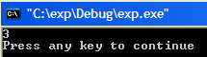
using namespace std ;
int main()
{
int i = 1 ,j ;

j = (i < 2) ? 3 : 4 ;
cout << j << endl ;

cin.get() ;
return 0 ;
}
If the condition is true, which it is in this case, the first alternative (the 3) is assigned to j. If false, the 4 would be assigned to j.

Logical Operators

or

#include <iostream>
using namespace std ;
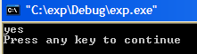
int main()
or

{
int i = 2 ;
i can be either 1 or 2.

if (i == 1 || i == 2)
cout << "yes" << endl ;

cin.get() ;
return 0 ;
}

and

#include <iostream>
using namespace std ;
int main()
{
and

int i = 1 , j = 2 ;
i must be 1 and j must be 2.
if (i == 1 && j == 2)
cout << "yes" << endl ;

Debugging

- Click Build, Start Debug, Step Into (or press F11).

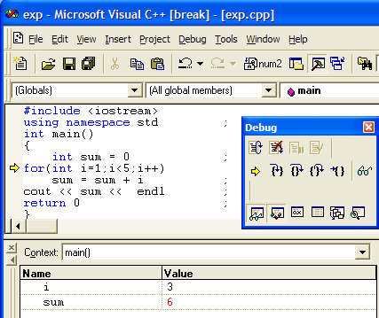

When the program reaches cout, press F10 to step over or else control will jump into the code for the cout function. To exit from the cout code, press Shift F11 (Step out.). As well as pressing Shift F11 to jump out of this file, you will need to close this header file which has been inadvertently opened. (You may wish to take a look at it while you’re there.)
- Note the values of the variables in the Variables window. (A red value means that it has just changed.)
- If this window is not visible, choose View, Debug Windows, Variables.
( Debug, Windows, Local in Visual C++ 2008 Express Edition.)

- By holding the mouse steady on a variable, the value appears in a little yellow box.
- Continue to press F11. You will see the program looping around the for loop.

- To set a break point, right click on the line and choose Insert/Remove Breakpoint. It is also possible to choose Run To Cursor (after suitably placing the cursor) (Shift-F10).

- To view the memory window, choose View, Debug Windows, Memory.
(Not available in Express Editions!)

By default the memory addresses and the values in those addresses appear in hexadecimal.
If they are not choose Hexadecimal display from the Options. (Tools, Options, Editor.)

To View a Variable in Memory

CPPLesson2c https://youtu.be/yoDaOL5CUy0
Content: part. Adding.enum. exercise (IBM).

- First we need to ascertain the memory address of the variable. Whilst debugging, choose Debug Windows, Watch.

- Type in &i and press Enter. & (ampersand) means “the address of”.

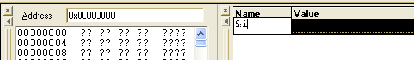

- The address of i appears here. Copy this address (You must use Crl-C and not the menu for some reason or other.)

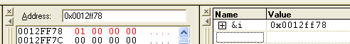

- Paste the address of i here. You may need to edit it. (0x means hexadecimal.)
- Lo and behold, the value of i appears! The bytes (eg 01 is one byte) are backwards!

Read ch 3.

To show the assembler. Ctrl-Alt-D or right-click and Go to Disassembly Visual Studio 2012 (Express version Alt-8 ?)

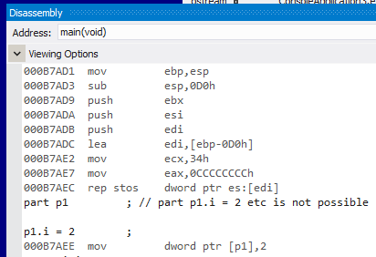

CourseWork exercise

Page 127 no5

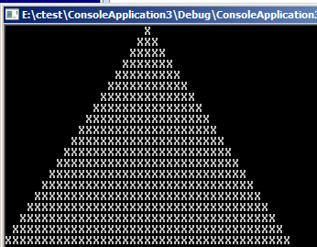

You may alternatively want to use the compound interest formula. A(1+r)^{n}.
ie A * pow(1+r,n) which doesn’t need a loop. Don’t forget that pow is expecting a double.
Page 127 no 7
Chapter 4 Structures page 132

YouTube: CppCh4.avi https://youtu.be/474qLnuV8Ek

A structure can contain data of different types in this case integer and character. Compare a structure to an array (see later). An array can only contain ONE type of data eg ALL integers, ALL strings etc.
- Run the following program.

#include <iostream>
using namespace std ;
The keyword struct defines a sort of template for the structure.
It does not at this stage actually create a variable - ie it does not reserve any memory space for any variable.
struct part
{int i ;
char s ;
} ;

int main()
Must use struct part p1 in XCode?
Note the semicolon!!
{
part p1 ; // part p1.i = 2 etc is not possible
part is now a type, much the same as int or float is a type, so that saying part p1 is analagous to saying for example int i. Memory space is now reserved for the structure.

p1.i = 2 ;
p1.s ='A' ;

cout << p1.i ;
cout << p1.s << endl ;
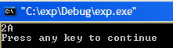
return 0 ;
}

- Try this:

#include <iostream>
using namespace std ;

struct part
{int i ;
char s ;
part p1 = {2,'A'} ;
is equivalent to:
part p1 ;
p1.i = 2 ;
p1.s = 'A' ;

} ;

int main()
{
part p1 = {2,'A'} ;
cout << p1.i ;
cout << p1.s << endl ;

return 0 ;
}

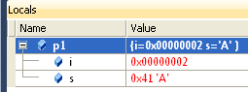
- Try Debug. (Press F11 and take a look at p1 in the Locals window to see how the components of p1 are stored. (Or try Debug, Windows, Locals.)

We can also view the structure directly in memory. (In Express edition we may need to go to Expert Settings to be able to view the memory windows)

- First get the address of p1: Whilst debugging, choose Debug, Windows, Watch, Watch1.
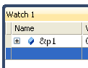
- Click here in the Watch window, type &p1 and press Enter. ( & means “the address of”.)

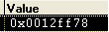

- To open the Memory window, choose Debug, Windows, Memory, Memory1
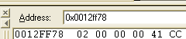
- In the Memory window, type the address of p1. It is possible to copy it from the above window with some editing. Use ctrl-C to copy. (41 is hex for ‘A’).

The elements of the structure are seen directly in memory. They appear contiguously. The integer is stored in 4 bytes. LSB (Lowest Significant Byte) first!

Putting Structures Equal to One Another page 138

- Modify the code as follows and run it.

#include <iostream>
We have here put one structure equal to another !

using namespace std ;

struct part
Note that it is not possible to simply add 2 structures eg p3 = p1 + p2 !
Although as we shall shortly see, it is possible to effectively add them – element by element.

Indeed we will see much later that it is indeed possible to add two particular structures using notation like
p3 = p1 + p2 when we associate a different meaning to the “+” sign, for any given particular structures. We then say that the “+” sign is overloaded.

{int i ;
char s ;
} ;
int main()
{
part p1 = {2,'A'} ;
part p2 ;
p2 = p1 ;

cout << p1.i ;
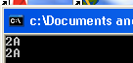
cout << p1.s << endl ;
Structures are reference types and as such are stored on the heap ( cf the stack).

p2 is stored in a lower memory address than p1 ie “above”.

cout << p2.i ;
cout << p2.s << endl ;
cin.get() ;
return 0 ;
}
Adding Two Structures page 140

The respective elements must be added individually. This example sums only one element.

#include <iostream>
using namespace std ;

struct part
{int i ;
(The char s is unused in this program.)
char s ;
} ;

int main()
{
part p1, p2, p3 ;

p1.i = 4 ;
p2.i = 5 ;
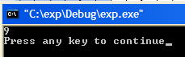
p3.i = p1.i + p2.i ;

cout << p3.i << endl ;

return 0 ;
}
Structure exercise. (In class)

Make a structure called shares which holds a string type.
(We are yet to cover string types.) For the moment use
string CoName and a double price .
(To initialize use s1.CoName = "IBM";)
Include the header file #include <string>

Intitalize 3 instances called IBM, ICL & USG and print them out to the screen so that the output should be:

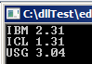

Exercise: Add together the prices of the previous structure instances to get the total of the shares for the 3 companies.

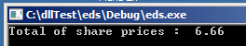

- Read and try the examples of Ch 4.

Note that the following …

struct part
{int i ;
char s ;
} ;

int main()
We could initialize the three in one go like so:
shares s1 = {"IBM",2.31} ;
shares s2 = .....etc.
{
part p1 ;
}
…is equivalent to :

struct
{int i ;
char s ;
} p1 ;

int main()
{
There is no need here for the tag part. (This notation is less common.)

}
enum page 148 (do later)
Exercise A vector is a set of numbers. Make a vector strucure containing 2 integers x and y. Make 3 instances v1, v2 and v3. Initialize v1 (eg x=1, y=2) and v2 (eg x=2, y=1) and then write code to add them add them to give vector v3 (in our case should give x=3, y=3).

Sometimes we may wish a variable to only be able to take certain values eg 0,1 ,2 & 3.
Furthermore, these values can also be given “names” so that they can easily be remembered and referred to. We use the enum operator to define such a type of variable.

For example, enum suite {heart,diamond,club,spade}; defines a suite type.
Variables of this type can only take values heart,diamond,club or spade (0,1,2,3 respectively.) So heart has the value of 0 etc.
Not Modern C++
Use Class-based enum. See later.

For example we can then define a variable card1 to be of this type like so:
suite card1 ;
Now card1 can only take values heart, diamond, club or spade (0,1,2,3).
Programing is not all about writing code that works but also about providing for when it doesn’t work. ie finding bugs. Using enum provides code rigour.
- Run the following program.

#include <iostream>
enum allows us to use names eg … = heart rather than values.
using namespace std ;

int main()
{
enum suite {heart,diamond,club,spade} ;
suite card1 ;
enum is simply a way of making our code look more organized..
card1 = club ;
enum is really just to make our code more readable – and type safe.
cout << card1 << endl ;
return 0 ;
}

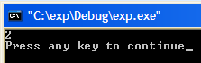
suite is now a type just like int is a type.
Unfortunately C++ prints out 2 and not card1.

At present, the first value, heart, is 0. If we wished to start the sequence of consecutive values at another value, say 1, then we would use:

enum suite {heart=1, diamond, club, spade};

- Modify the line above as shown above and try it. You should get the following result:

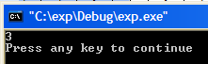

Before the days of the bool type, it was necessary to define our own type like so:
enum bool {false,true} ;

Programming Technique: The use of a “Flag” Page 152 (do this later?)
Enum exercise: Make an enum called trade which could have the values of buy and sell.
Devise a program of a few lines (maybe use an if ?) to show how this might be used practically.

Sometimes we need to run through a list of variables to find if a particular condition is satisfied or not - yes or no – irrespective of how many times.
For example, is any of the numbers 1 to 12 is divisible by 6 ?
(Of course 6 is divisible by 6 and so is 12, so yes is the answer - we are not concerned that there is more than one divisible by 6. We just need to flag when a 6 is found.

- Try this:
(exit(0) (which requires the header file <process.h>) instead of break would cause the program to do just that - exit completely from the program.)
We could also break; here to break out of a loop. Don’t forget the braces ( { } ) that will now be required for the compound if. You would need to single-step to see the difference.
(flag is a variable name not a keyword.)
#include <iostream>
using namespace std ;

int main()
{
bool flag = false ;

for (int i = 1; i <= 12; i++)
if (i % 6 == 0) flag = true ;

if (flag == true)
cout << "a number divisible by 6 was found" << endl ;

return 0 ;
}
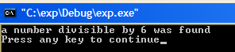

Homework exercise:

Preliminary: Make a structure t1 of type time and simply input variables t1.hours t1.mins t1.secs etc from the keyboard.

No 9, 11 page 159 (shown here)

9. Create a structure called time. Its three members, all type int, should be called hours, minutes, and seconds. Write a program that prompts the user to enter a time value in hours, minutes, and seconds. This can be in 12:59:59 format, or each number can be entered at a separate prompt (“Enter hours:”, and so forth). The program should then store the time in a variable of type struct time, and finally print out the total number of seconds represented by this time value:
long totalsecs = t1.hours*3600 + t1.minutes*60 + t1.seconds

11. Use the time structure from Exercise 9, and write a program that obtains two time values from the user in 12:59:59 format, stores them in struct time variables, converts each one to seconds (type int), adds these quantities, converts the result back to hours-minutes- seconds, stores the result in a time structure, and finally displays the result in 12:59:59 format.

The input and output from the console should look something like this:

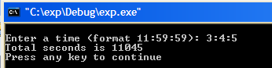

Trick: (Used by the text.) To “parse” the input, we could use a character type to “absorb” the two colon characters and effectively input the three respective integers (3, 4 and 5 in the example screen above) to the respective t1.hours, t1.minutes & t1.seconds as follows:
char c ;
cin >> t1.hours >> c >> t1.minutes >> c >> t1.seconds ;
Explanation: The characters c serves to "absorb" the (colons). Try

int main()
{

int i, j, k;
char c;
cin >> i >> c >> j >> c >> k;

cout << i << endl;
cout << j << endl;
cout << k << endl;

}

Functions Chap 5 YouTube CPPCh5a.avi https://youtu.be/-1w49849_NA page 163

“A function groups a number of program statements into a unit and gives it a name. This unit can then be invoked from other parts of the program.”

- Run the following program.
The function prototype warns whats coming later,

#include <iostream>
using namespace std ;
The void in front of dodo means that nothing is returned by the function.

The void inside the parentheses means that nothing is passed to the function

void dodo(void) ; //Semicolon
Function prototype or declaration.
int main()
The function is called.
{
Nothing is passed to i.
dodo() ;

return 0 ;
}
Function declarator.

void dodo(void) // No semicolon
{
cout << "do nothing" << endl ; // Function definition
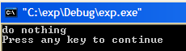
}
For an example of the way that a good program is set out see:
http://people.sc.fsu.edu/~jburkardt/cpp_src/simple_ga/simple_ga.cpp
The whole of the function definition could be moved (cut & pasted) in front of main()
We would not then require the function prototype.
The next program demonstrates how we can…

Pass a Value to a Function

- Modify the previous program as follows.

#include <iostream>
using namespace std ;
void dodo(int) ;
int main()
The prototype forewarns that an int type will be passed. We could also incluse thevariable name if we wished:
void dodo(int i) ;
{
dodo(4) ;

return 0 ;
4 is passed to j.
}

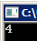
void dodo(int j)
{
cout << j << endl;
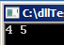
}

Exercise : Modify the program above to pass two values (and print them out).
ie dodo(4) ; etc
page 170
Passing a Variable to a Function
Passing By Value

#include <iostream>
using namespace std ;
This program demonstrates that the variable inside a function is independent of the variable outside, ie if we modify the variable inside the function the value outside the function doesn’t change – as we would probably expect.
void dodo(int) ;
int main()
{
int i = 4 ;
dodo(i) ;
cout << i << endl ;
return 0 ;
}
void dodo(int j)
The variable inside the function (j in this case) is a copy of i. In this case even though j increases by 1, (of course) i does not.
{
j++ ;
cout << j << endl ;
}

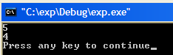
j is printed out first. It has been increased to 5.
i is then printed out, but it is still 4.

- Single step the program.
- Add Watches for &i and &j - which are the addresses of i and j respectively.
- Open the memory window and paste in the address of j or i. (you may need to use Ctrl-c.)

The address of j in this case is 0x0012ff2c. this is j

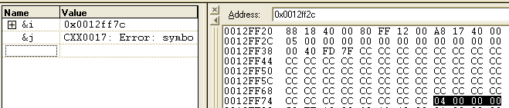
(Don’t worry that an Error is indicated for i and j when they are not in scope ie they are outside of the program segment that we happen to be perusing at that particular moment. More about scope later.)

This is i - a bit further down.
The address of i in this case is 0x0012ff7c.

The whole point here is that i and j have different memory locations.
j is a copy of i so they then act independently. When one changes, the other does not.

We just saw that the variable was passed to the function by value in which case the value is not permanently changed by the function.

Passing By Reference Page 163 (but a bit confusing)

When we pass by reference, we can permanently change the variable that we pass to a function.

#include <iostream>
- To pass by reference include an &.

When we pass by reference, we don’t actually pass the address, but behind the scenes, the compiler passes the address.
using namespace std ;

void dodo(int& ) ;
int main()
{
int i=4 ;
dodo(i) ;
cout << i << endl; // <- This value gets changed permanently
return 0 ;
}
The & has the effect of passing by reference - the value is changed by the function.
.

void dodo(int& j)
{
j++ ;
cout << j << endl ;
}
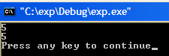
j is printed out first. It has been increased to 5.
i is then printed out it has also been changed to 5.

- Single step the program and add Watches for &i and &j.

- Open the memory window and paste in the address of i. (It is 0x0012ff7c as before.)

But you should find that the address of j is the same!
the address of j is ALSO 0x0012ff7c.

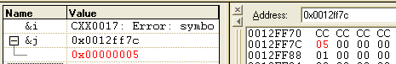

ie i and j are one and the same thing. Whatever happens to j happens to i !

Whereas passing by reference effectively passes the address of the variable to the function the address is not passed explicitly as we will learn to do using pointers (which has the same effect as passing by reference).

This method is not related to "returning a value" which we will consider now
Try the “swap variables” function exercise now (see later: Page 42.

Passing By Value is the default.way of passing a variable.
Returning a Value from a Function Page 176 Run the following program

#include <iostream>
using namespace std ;
int dodo(int) ;
int main(void)
{
int k ;
int i=4 ;
This time we have made a variable (k) equal to the function and …

k = dodo(i) ;
cout << k << endl ;

return 0 ;
… included the keyword return.

}
k is explicitly returned.
The effect is that the value has been returned to the calling function.
Note carefully the difference between returning a value and passing by reference. Even though the value is effectively changed in each case, the technique is very different.

int dodo(int j)
{
j++ ;
cout << j << endl ; ;
return j ;
}

(As well as returning a variable, we could equally return an expression eg return 2 * j.)

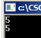
5 is returned and printed.

Unfortunately, we are only able to return one value from a function.
To circumvent this we could pass many variables by reference and thereby allow them to be changed (we don’t need to return them). We will see this in an exercise soon on page 41.

Alternatively we could pass and return a structure (see page 38) or pass a structure by reference (see page 34) containing many variables which could be changed if we wished.

Note also that the function name can be treated like a variable and included in expressions
eg we could replace the line:
k = dodo(i) ; with
k = 2 * dodo(i) + 5 ; etc.

YouTube: CppCh5b.avi https://youtu.be/ESURd9FPzz0 hypotenuse. default args. overloaded. junk at end.

Exercise: Here is part of the code to find the hypotenuse of a triangle:
#include <cmath>
double s1 = 3.00, s2 = 4.00;
double hyp = sqrt(s1*s1 + s2*s2);
- Place some of this code in a function called hypotenuse which calculates the hypotenuse of two numbers representing the two sides are passed. The function should return the hypotenuse.

- Page 212 nos 1,3, The answers are on page 925.
Default Arguments
Page 197
If no value is passed to a function, which expects an argument, we can arrange for a default value to be automatically passed.

#include <iostream>
using namespace std ;

void dodo(int = 1) ; //Default argument is 1.

int main(void)
{
dodo() ; //If no argument is offered, i will be 1.
dodo(2) ; //In this case i will be 2.
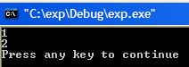
return 0 ;
}
void dodo(int i)
{
cout << i << endl ;
}

- Page 212 nos 2, The answer is on page 925.

Inline Functions page 195

With “normal” functions, the function code is only compiled and placed in memory once.
Whenever the function is called, program control then refers to this one instance.
On the other hand, inline functions are compiled and placed wherever they are called. Although this is wasteful of memory space it can lead to an increase in speed.

#include <iostream>
using namespace std ;
inline void dodo(void)
{
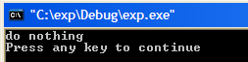
cout << "do nothing" << endl;
}
int main()
{
dodo() ;
return 0 ;
}
void dodo(int i)
{
cout << i << endl ;
}
Inline functions are uncommon in simple programs.
Think of the consequences of calling a function twice.
- Do that using the code above:
dodo() ;
dodo() ;
The function code would be placed in memory twice – taking up valuable space ( but it would run faster).
Two Functions with the Same Name page 188-193

Two functions may have the same name but take different types of argument.
Which function gets called is determined by what type of argument is passed.

#include <iostream>
using namespace std ;
The type of the argument function determines which function gets called.

void dodo(int) ;
void dodo(float) ;
int main()
{
The arguments, in the parentheses determine which function is called.

dodo(1) ;
dodo(2.0F) ;

cin.get() ;
return 0 ;
The function is overloaded.

}

void dodo(int i)
{
These are 2 completely different functions with the same name (dodo) .

cout << i << endl ;
}
void dodo(float f)
{
cout << f << endl ;
}
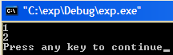
The first dodo was called because an int argument was used.
The second dodo was called because a float argument was used.

The Function which is Called is also Determined by the Number of Arguments

As well as void dodo(int i)
we could, define another function dodo which would take two arguments:
- Try this.
void dodo(int i, int j)
{
cout << i << j << endl ;
}
(Don’t forget the extra prototype.)
void dodo(int, int);

and call it thus:

dodo(3,4) ;

Here, the functions which gets called depends upon the number of arguments.
Variable Scope YouTube: CppCh5c.avi https://youtu.be/Y8lBpVDEyTQ Page 199
In summary: Which function gets called depends on both the number and type of arguments passed. Function overloading!
local scope global scope static swap

The scope of a variable is where it is recognized.

- Run this program which calls two functions which simply prints out the values of their respective variables, i and j.

#include <iostream>
using namespace std ;
void dodo(void) ;
void eddo(void) ;
int main(void)
{
dodo() ;
eddo() ;
return 0 ;
}
void dodo(void)
{
int i = 1 ;
cout << i << endl ;
}

We will see below that i is only known in this function…

void eddo(void)
{
int j = 2 ;
cout << j << endl ;
}
.. and that j is only known in this function.

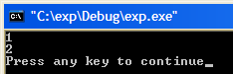

Now include this line in the first function:
cout << j << endl ;

and/or this line in the second function:
cout << i << endl ;

The code will not even compile and you will get a message like this:

C:\exp\exp.cpp(19) : error C2065: 'j' : undeclared identifier
C:\exp\exp.cpp(26) : error C2065: 'i' : undeclared identifier

We can therefore see that a variable is only visible in the section that they are declared.

In this case the variables i and j have the scope of their respective function blocks. They only exist while that particular function is executing.

We say i and j that are local to those respective functions.

Note that i and j are also not visible in main()and correspondingly :
If we were to declare a variable in main(), then it would only be local to main() and not known in the functions called from main() as shown here.
(This program is incomplete.)

void dodo(void) ;
void eddo(void) ;
int main(void)
eg k would not be known outside of main() (and not known in these functions called by main(). )

{
int k ;
dodo() ;
eddo() ;
return 0 ;
}

Global Variables page 202

- A global variable is available to all functions throughout a program. If it is changed anywhere in the program it is permanently changed. Try this.

#include <iostream>
using namespace std ;
When a variable is defined before main() it is a global (or external) variable.

void dodo(void) ;

int i ;
Whereas declaring variables as global might appear convenient it is error prone and to be avoided

int main()
{
i = 4 ;
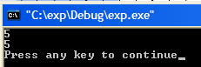
dodo() ;
i has been changed permanently.

cout << i << endl ;
return 0 ;
}
Always declare your variables as locally as possible.

void dodo(void)
{
i++ ;
cout << i << endl ; //i is known here!
}
void eddo(void)
{
int j = 2;
cout << j << endl;
}

The opposite of a global variable is an automatic* variable (or local variable) ( one which is defined within a particular function and known only to that function.)
* Called “automatic” because it is created and destroyed “automatically” by that function each time the function is called.

Static Variables Page 204

A static variable is one which is remembered when a function is called again.

#include <iostream>
using namespace std ;

void dodo(void) ;
int main()
{
dodo() ;
dodo() ;
return 0 ;
}
It may arrpear a little incongruous that i is given the value of 3 and then it is a different value next time round – ie it is NOT reset to 3 each time!
void dodo(void)
{
static int i = 3 ;
i++ ;
cout << i << endl ;
}
When the function is first called, i assumes the value of
3 which is then increased to 4 and then output.
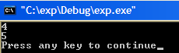

Next time round, ie when the function is called again, the previous value of i, which was 4, is remembered! It is then increased to 5 which is then output.

Notice how clever the compiler is. It knows to only initialize i once when it sees
static int i =3 ;

Next time the function containing the above code is called, this initialization is ignored!

- Try placing this line in main().
cout << i << endl ;

It won’t work. i is unkown in main() ie outside the function dodo() !

This means that although i has the lifetime of the whole program (ie its value is remembered throughout the whole program, it is only recognized ie can only be used (ie is only “visible” ie its scope is) in the block in which it was declared (the function dodo() in this case).

- Exercise: Remove the word static and see the effect. You should see that i remains 3.
Trick to effectively “return” a value from a function Page 182

#include <iostream>
using namespace std;
int dodo(int&);
int main(void)
{
i is not initialized.
int i;
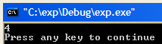
dodo(i);
cout << i << endl;
return 0;
}

int dodo(int& j)
{
j = 4;
return j;
}

Passing two values by reference.

Exercise1:

Modify the code so that two variables are passed by reference.
Say int i = 2;
int j = 3;
Modify them in some way inside the function.
Notice how the originals are changed as well.

Exercise2:

Call the function swap instead of dodo.
Write code to pass two variables to this swap function which swaps the variables inside the function and thereby swaps them permanently. START with this (errors).
#include <iostream>
using namespace std;
void swap(int&);

int main()
{
int i = 4;
int j = 5;
cout << i << " " << j; /// -> 4 5
swap(i,j);
cout << i << " " << j; /// -> 5 4

return 0;
}
void swap()
{
}

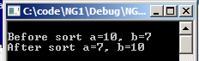
Exercise3

Write a function to sort two variables in
ascending order in a function and thereby
sort the two variables permanently.
Passing a Structure to a Function page 172

#include <iostream>
using namespace std ;

struct part
{int i ;
char s ;
} ;
The function prototype indicates that we are going to pass a structure (part).
void dodo(part) ;

int main()
{
part part1={2,'A'} ;
The part structure is passed to the variable p1 (which as you can see is also of type part).
dodo(part1) ;
cin.get() ;
return 0 ;
}
void dodo(part p1)
{
cout << p1.i << endl ; //These structure variables
cout << p1.s << endl ; //are independent of the ones in main()
} //since the structure has been passed
//by value(the default).
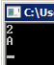

- Inside the function body include:
p1.i++ ;

and in main()- after the function call, include:
cout << part1.i << endl ;

You should find that the original value of i inside main() is unchanged ie remains 2.

Summary: A structure is also passed by value by default in which case,
values changed inside the function will not be permanently changed.

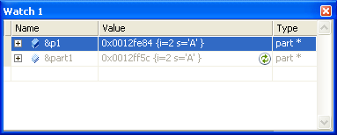
View the two structures in memory.
Find the addresses first: &part1 and &p1.

Passing a Structure By Reference page 186
Two structures.

#include <iostream>
using namespace std ;

struct part
{int i ;
char s ;
} ;
void dodo(part& ) ;
& indicates a pass by reference.

int main()
{
part part1={2,'A'} ;

dodo(part1) ;

cout << part1.i << endl ;
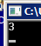
cin.get() ;
return 0 ;
i has been changed from 2 to 3.

}

void dodo(part& p1) //part1 gets changed by remote control!
{
p1.i++ ;
}
Returning a Structure from a Function page 180
The structure is returned implicitly.
Summary: When a structure is also passed by reference, thevalues in the structure which are changed inside the function will be permanently changed.
Take a look in the memory and note that there is only one structure.

- Run the following program.

#include <iostream>
using namespace std ;
struct part
{int i ;
Since we are going to return a structure we need to define a structure (part2) to return it to.

char s ;
} ;
part dodo(part) ;

int main()
{
This time we have put a variable (part2) equal to the function and …

part part1={2,'A'} ;
part part2 ;

part2 = dodo(part1) ;

cout << part2.i << endl ;
cout << part1.i << endl ;
We are here explicitly returning the structure p1.

return 0 ;
}
… included the keyword return.

part dodo(part p1)
{
p1.i++ ;
return p1 ;
}

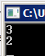
part2.i has been increased to 3.
part1.i is still 2.

Once again, this method of returning an object from a function has no relation to the technique of passing by reference.
Multifile Programs

We could place our code in more than one file.

Make these three files in your console app project:
#include <iostream>
using namespace std ;
int times (int) ;
exp.h
#include "exp.h" effectively cuts and pastes the text from the header file into this file. (Recall that the quote marks means “look in the current directory for this include file”.

#include "exp.h"
int main()
{
cout << times(2) << endl;

return 0 ;
}

exp.cpp
Note that if a function such as times() is used in a file, it must be declared in each and every file, (which it will behere since the line int times(int); is effectively included because exp.h is included).

int times(int i)
{
return i * i ;
}
expF.cpp

In the workspace window, make sure that the File View tab is selected so that you can see the folders and files as shown below.
If get a warning about PCH (pre-compiled header) go to properties and make sure that there are no PCH files listed.
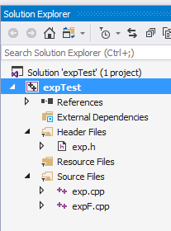

Make sure that Exclude From Build is not checked. (See Project, Project Settings, General.)


These could then be built as a unit and run.

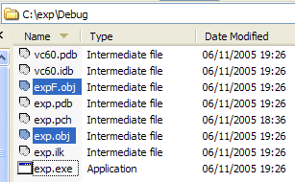

- Note that two compiled object files are produced: expF.obj and exp.obj. These are then linked by the linker to produce exp.exe (All behind the scenes!)
Sometimes, many .obj files are grouped together in a .lib file which the linker can then deal with as a unit. See the diagram on page 636 of the text.

- Read and Build the rest of the programs of Chapter 5.
linker!

H/work : page 213 no 10. (Reproduced here)

10. Write a function that, when you call it, displays a message telling how many times it has been called: “I have been called 3 times”, for instance. Write a main() program that calls this function at least 10 times. Try implementing this function in two different ways.First, use a global variable to store the count. Second, use a local static variable. Which is more appropriate? Why can’t you use a local variable?

YouTube CppClasses1.avi https://youtu.be/6AL9yZhfg9Q

class structure. data members. creating object. private public. exp.lib in hex. library being used.

Classes Chap 6 page 216 Classes1 in Manual1.sln in C:\CPP

A class is like a structure but as well as containing data a class usually contains functions as well!

(You will probabaly not see the point of classes yet! This will be made clearer soon when we talk about compiling. For the moment just try to learn the main features.)

#include<iostream>
using namespace std;
This is a class. The essential features are that …

class part
{
private:
int i;

public:
void setdata(int j)
{
i = j;
}

int getdata()
{
return i;
}
};

….1 it contains private: data and….
…2. public functions which can act on that data.
private means that the data is private to the class and cannot be accessed directly from outside the class by using p1.i. Try it- it wont work.
public means that the functions can be accessed from outside the class using
p1.setdata(4);
cout<< p1.getdata();

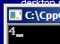
public functions are used to access private data. Much like the Trojan horse was used to access the city of Troy.
part p1 = new part(); can be used? It will call the default constructor. See later.
When we use new, the object is created on the heap and need be deleted. Without new it is created on the stack and need not be deleted.
int main()
{
part p1;
p1.setdata(4);
cout<< p1.getdata();
return 0;
}

Run the code:

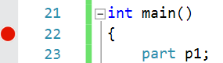

Place a breakpoint here: and single-step.

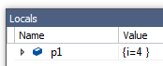

See how an object is created by :

A class is a “template” for creating objects
Remember that:

private: means that it can't be simply accessed from outside the class .
public: means that it can be accessed from outside the class.

The data of a structure is public by default - in fact this is the main difference between a structure and a class whose data of courseis private.

Rule: It is usual for a class to have data private and the functions public.

Note that whenever we use the keyword private: or public: then the data (or functions) are public or private from then on eg if we were to use the word private: then everything would be private until we used the keyword public:

Let us reflect a bit at this stage about object oriented programming.

What is a class? It has data and it has functions-that-can-only-operate-on-this-data. But isn’t that what a program is? Data and it’s functions? Yes. So classes are “unit “computer programs.

So, these are the objects about which all is oriented!

In order to hopefully see the relevance of classes let us fast forward to

To Make and Use a Compiled library (Click)

YouTube CppClasses2.avi https://youtu.be/s-1W88YGoAM
Constructors. Scope Resolution Operator.

Constructors Page 227

A constructor is a function which is called automatically every time that an object of that class is created. It is used to initialize data.

Replace setdata()) in our previous code with the constructor code in yellow (or just copy in all of the below code) as shown below and build/run it.

#include<iostream>
Using setdata()) was used previously for demonstation purposes only.( It is not the best way to initialize data – we should use constructors as shown here to initialize data.)
.
using namespace std ;

class part
Note that a constructor always has the same name as the class.

{
private:
int i ;
char s ;
Read i(4) as i = 4.
If we use
part() : i()
{ ;}
i defaults to 0.
public:
part() : i(4)
{ ;}
int getdata()
{return i ;}
Single step thru the code. Watch how the constructor is called.
i is given the value of 4.

} ;

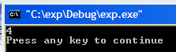
int main()
{
part p1 ;
cout << p1.getdata() << endl ;
cin.get() ;
return 0 ;
}

We have thus created a no-argument constructor.

Note the ‘old-fashioned’ way of calling a no argument constructor
- Try it – it still works! Replace the constructor above with:
part()
{ i = 4 ; }

Exercise . Add to the code code to initialize s to 'a' as well as i being initialized to 4 as above in the no-argument constructor. Hint: Use a comma in the argument list of the constructor.

One Argument Constructor Classes2
In order to retrieve this character data we could modify getdata() to:

char getdata()
{return s ;}
and use
cout << p1.getdata() << endl ;

Previously we had only a no-argument constructor. The value of 4 was “built-in” to the class.
ie every object created will have i=4. If we wish to override this and choose what value we will give to the data from main() we use a one-argument constructor as follows:
Solution from prev page.
public:
part() : i(4),s('a')
{ ;}

or
part()
{ i = 4 ;
s= 'a' ; }

#include<iostream>
using namespace std ;
class part
{
private:
int i ;
char s ;

public:
Think of i(j)as meaning i = j.
part() : i(4)
{ ;}
j is just a “dummy” temporary variable which accepts the value passed (5 in this case).

part(int j) : i(j)
{ ;}

int getdata()
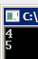
{return i ;}
} ;
(The no-argument constructor is called as before and i gets the default value of 4.)

int main()
{
part p1 ;
part p2(5) ;
- The one-argument constructor is called and i gets the value of 5 (indirectloy via j). Follow this with the single-step.
cout << p1.getdata() << endl ;
cout << p2.getdata() << endl ;
return 0 ;
}
- Comment out the 0-argument constructor. You will find that the program no longer works or even compiles. (It did before when we didn’t have a one-argument constructor!) but if we also now comment out: part p1 ; then it does!
- So in summary :
Once we have a 1-argument constructor then we need a 0-argument constructor – but only if we call it!
Stop press: To alleviate this inconvenience Visual Studio 14 allows us to use default keyword as follows: Delete the no-argument constructor above and replace it with part() = default;

We could still use the ‘old-fashioned’ way of calling a one-argument constructor
- Try it – it still works.
part(int j)
{i = j ; }
- Exercise: Also make a 2-argument constructor which initializes s as well as i. Create a p3 object which calls it using say 6 and ‘a’.

(If we wished to print out s from main() as well we would need a separate function to “get s”.)
Solution to the exercise from previous page: 2-argument constructor:
part(int j, char t) : i(j),s(t)
{ }
Called from main() using: part p3(6,'a');

The Scope Resolution Operator ( :: ) Page 236

Having made such a fuss of emphasizing how the member functions belong to the class and are the only functions privileged to have access to the internal class data, we will now proceed to move them outside the class!

- Modify the previous code as follows.

#include<iostream>
using namespace std ;
class part
{
private:
int i ;
char s ;
public:
part() : i(4)
{ ;}
int getdata(void) ;
} ;
- Make this the function prototype inside the class as shown.

- The function itself is placed outside main().The class to which it belongs is indicated by the part::.
int main()
{
part p1 ;

cout << p1.getdata() << endl ;

return 0 ;
}
int part::getdata(void)
{return i ;}

int part::getdata(void)
{return i ;}
could also be placed before main()instead of after main()as is shown above.

Exercise:
- Move the above no-arg constructor part() : i(4)
(and any other constructors that you have) outside as well using the :: operator.
Solution to previous exercise: Moving the constructors outside as well: Classes3
The dot operator ie . indicates the object something belongs eg p1.i to whereas the double colon operator ie :: indicates the class to which someting belongs eg part::getdata().

#include<iostream>
using namespace std ;

class part
{
private:
int i ;
char s ;

public:
part();
part(int j);
part(int j, char t);

int getdata(void);
} ;

int main()
{
part p1 ;
part p2(5) ;
part p3(6,'a');
cout << p1.getdata() << endl ;
cout << p2.getdata() << endl ;

return 0 ;
}

part::part() : i(4)
{ ;}
part::part(int j) : i(j)
{ }
part::part(int j, char t) : i(j),s(t)
{ }

int part::getdata(void)
{return i ;}

We now wish to add together the data elements - the 4 of p1 and the 5 of p2.
But where are we going to put the results?
For the moment we are going to place the result in p2, ie the 5 of p2 will be replaced by 9.
(As we shall see later, we could put the result into a new object p3.)

We can achieve this by passing an object as an argument of a member function as follows:

To Add Two Data Elements: Passing an Object as an Argument of a Member Function

- Try this: Classes4
For second reading?

#include<iostream>
using namespace std ;

class part
{
private:
int i ;
char s ;

public:
part() : i()
{ }
part(int j) : i(j)
{ }

int getdata(void) ;
Since p2 was used to call the function with the statement p2.add(p1), the solitary i here implicitly belongs to p2.
ie the statement
i = i + p.i
is equivalent to (don’t try it– it won’t work!)
p2.i = p2.i + p1.i

void add(part p)
{ i = i + p.i ;}

} ; // end of the class

int main()
p1 is passed to p.
{

part p1(4) ;
part p2(5) ;

p2.add(p1) ;

cout << p1.getdata() << endl ;
cout << p2.getdata() << endl ;
return 0 ;
}
int part::getdata(void)
{return i ;}

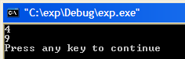
p1’s i is still 4
but p2’s i has
been made 9.

Default Copy Constructor Page 238

Single-step this program. It puts one object equal to another.
For second reading.
#include<iostream>
using namespace std;

class part
{
private:
int i;
We have previously mentioned that we can have p1 = p2.
Now: another way of copying an object:
char s;
public:
part()
{ }
part(int j):i(j)
{ }
};

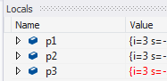
int main()
{
part p1(3);
p2 is a copy of p1.
p3 is a copy of p1. Both notations
are possible.

part p2(p1);
part p3 = p1;

return 0;

}

Behind the scenes part() has a constructor which puts one object equal to another – the default copy constructor.
Returning an object from a member function Classes5
In the Virtual Functions chapter we will learn how to overload this copy constructor.

In this program the add function is modified to return an object.

#include<iostream>
using namespace std ;
class part
{
private:
int i ;
char s ;
public:
This program transfers the value of p1’s i to a temporary object p, increments it to 5 and then returns that object to p2.
part() : i()
{ ;}
part(int j) : i(j)
{ ;}
int getdata(void);

part add(void)
Since we are going to return a value from the add() function, we create a temporary object p of type part (watch the no-argument constructor get called) which will be used to return it.
We could replace this with just:
return part(i++);
then the temporary object is implicit!
{
part p ;
In this case since p1 was used to call the add() function with
p2 = p1.add() , p1 “owns” this solitary i which has the value of 4.
p.i = i ;
p.i++ ;
return p ;}
} ;
p - and its i which is now 5, is passed back to p2.

int main()
{

part p1(4) ;

part p2 = p1.add() ;

cout << p1.getdata() << endl;
cout << p2.getdata() << endl;

return 0 ;
}

int part::getdata(void)
{return i ;}
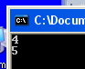
- p1’s i is 4 but p2’s i has been increased to 5.

Static Class Data statdata project in Manual.sln on C:\X on QW.

- Build and run statdata.cpp p.249 shown below. Use the debugger to single step.
statdata.cpp in Manual1
static data is “generic” – belonging to the class as a whole and therefore has the same value for each object.
ie static means it pertains to the class rather than to an object.
#include <iostream>
using namespace std;

class foo
{
private:
static int count; //Only one data item for all objects
//note: ‘declaration’ only!
public:
foo() //Increments count when an object is created
{ count++; }
int getcount() //Returns count
{ return count; }
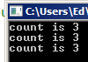
};
In general the :: operator indicates that something belongs to a class compared with the . (dot) operator which indicates it belongs to an object.
//--------------------------------------------------------------
int foo::count = 0;

int main()
{
foo f1, f2, f3; //create three objects

cout << "count is " << f1.getcount() << endl; //each object
cout << "count is " << f2.getcount() << endl; //sees the
cout << "count is " << f3.getcount() << endl; //same value
cin.get();
return 0;
}
- View the static variable in the Locals window (Debug, Windows, Locals).

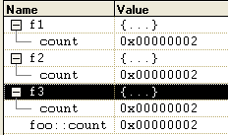
At any given stage in the program (single step it), the value of the count variable for f1, f2 & f3 is the same (0, 1, 2 &3).

- Build the programs of chap 6.

See const member functions p.252
const objects p.255

Coursework Exercise page 261 no 3? 4, 8. (“I am object 3” etc.)
Optional No 6.

No 8: Lets say that the objects created are ships. Then the output would be something like this:
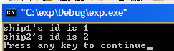
Multifile Programs Using a Class Spliting our program up into separate files:
Hint: Put a private class member data variable (say id) equal to the static data variable (say sn) which is increased by 1 each time that a new ship is created. This would occur in the no-argument constructor.
Classes6 project in Manual.sln on C:\X on QW.
We can place our code in more than one file and build it:
exp.h

#include<iostream>
using namespace std ;
class part
{
private:
int i ;
char s;
public:
part() : i(4)
{ ;}
int getdata(void) ;
} ;

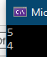

exp.cpp Classes6.cpp
#include "exp.h"
int main()
{
part p1 ;
cout << p1.getdata() << endl;
return 0 ;
}

#include "exp.h" effectively cuts and pastes the text from the header file into this file. (Recall that the quote marks means “look in the current directory for this include file”.

Make sure that Exclude From Build is not checked. (See Project, Project Settings, General.)

expF.cpp

#include "exp.h"
int part::getdata(void)
{return i ;}

These are then built as a unit and run.

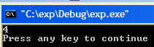
- Note that two compiled object files are produced: expF.obj and exp.obj. These are then linked by the linker to produce exp.exe (All behind the scenes!)
Sometimes, many .obj files are grouped together in a .lib file which the linker can then deal with as a unit. See the diagram on page 636 of the text.

Place the header file here:

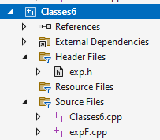

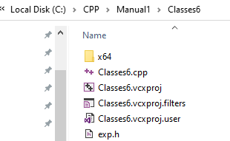
but when finding the exp.h we need to type it in ie C:\CPP\Manual1\Classes6 cause its not visible!

ie

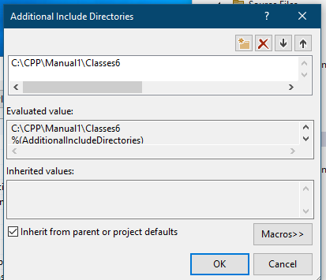

To Make and Use a Compiled library

Make The Library:

- File, New, Project. Solution : LibraryTest. Project expFuncs
- OK.
expFuncs

LibraryTest

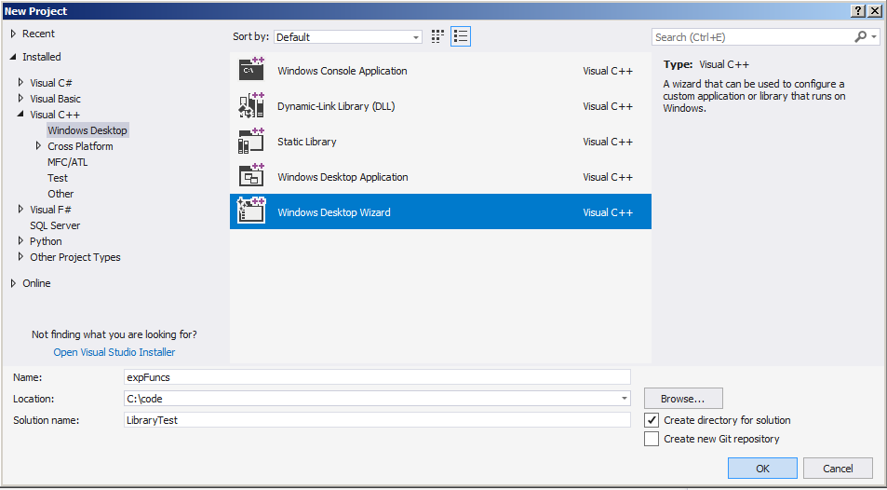
(This method allows turning off PCH’s.)

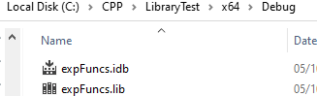
- Uncheck Precompiled header.
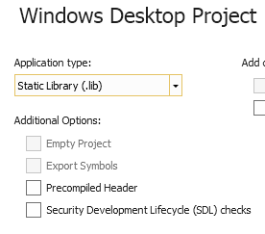

- Uncheck
- Choose Static Library.
Or using the wizard:

C:\CPP\LibraryTest\x64\Debug



Add a new cpp file to the project: ie Project, Add New Item, C++ File . Call it expFuncs.cpp

- Place this code into the cpp file.
Use <exp.h> rather than “exp.h” in the #include!
#include "exp.h"

void part::setdata(int j)
{i = j ;}

int part::getdata(void)
{return i ;}
Don’t worry that errors

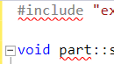

are showing.

- Add a new header file to the project: Project, Add New Item Header File. Call it exp.h

- Place this code into the .h file.
Header file location
C:\CPP\LibraryTest\expFuncs\
class part
{
private:
int i ;

public:
void setdata(int j) ;
int getdata(void) ;
} ;

Notice that we don’t have a main() - it’s a library!

Location C:\CPP\TestLibrary\expFuncs\

Your Solution Explorer should look like this:

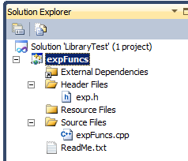
View, Solution Explorer if you don’t see it.

Your library's header file.

Your library's "functions file".

- Build. You should get a message:

========== Build: 1 succeeded, 0 failed, 0 up-to-date, 0 skipped ==========

Perhaps ignore this page and continue to the next. But “Note the folder that the library is in”.

This should have produced the library file named expFuncs.lib in the Debug folder. You may wish to take a look at it.
Tip: Copy the path for future use.

Better still: Copy this path and then open the folder using Windows Explorer and leave it open for future use.
Note where it is. From your project choose Open, File to navigate to the ‘lib file – in the Debug folder.
(There is more than one Debug folder.)
Note!

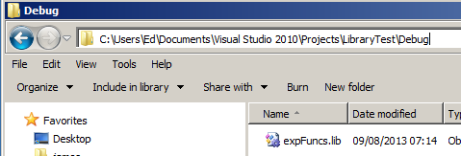

Your library of compiled code!

Incidentally this is what it looks like up close. An exectable - not very readable!
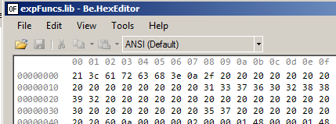

E:\ctest1\LibraryTest1\Debug

File, Open, Choose the ‘lib File and then Open With and choose Binary Editor

---------------------------------------------------------------------------------------------------------------------

Might need to turn off Precompiled headers – After making projects!

Also could avoid using headers altogether and just include the .h code in the .cpp file. See bottom
Page 68.

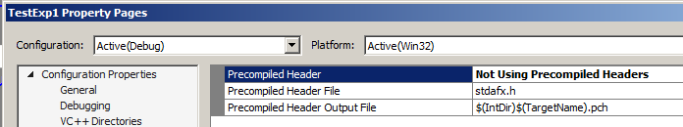
Test The Library. (With the library in the same folder as the test Console app.)

Add a new project.

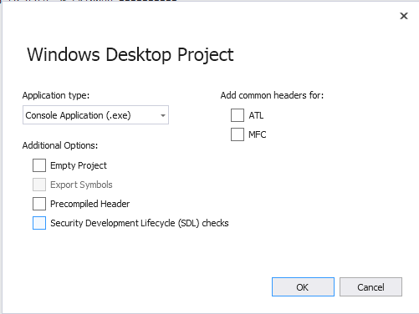
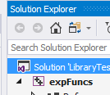
- First make sure that the SOLUTION is selected - not the Project- in Solution Explorer.
- Uncheck Precompiled header.
- Uncheck
- Choose Console Application.
- OK.

  - Make a new project: File, New Project, Windows Desktop Wizard.

- Call it TestExp etc but Add to Solution.

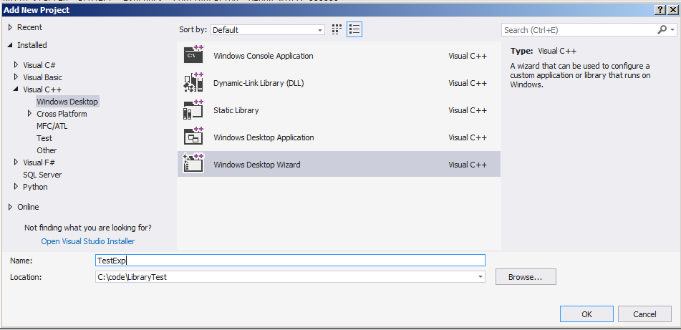
#include<iostream>
#include "exp.h"
using namespace std ;

int main()
{
part p1 ;

p1.setdata(4) ;

cout << p1.getdata() << endl ;

return 0 ;
}
Don’t worry if errors are showing.
- OK.

- Add this source code file expTest.cpp to TestExp project.

ie Right click on it, Add, New Item, C++ File and name it. Paste in this code.

#include<iostream>
#include "exp.h"
using namespace std ;

int main()
{
part p1 ;

p1.setdata(4) ;

cout << p1.getdata() << endl ;

return 0 ;
}
Don’t worry if errors are showing.
- OK.

- Add this source code file expTest.cpp to TestExp project.

ie Right click on it, Add, New Item, C++ File and name it. Paste in this code.

We now need to Set a Reference to our library project.

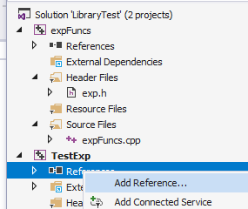
Project Properties C/C++ Command Line Additional Options /Y-.

- Right-click on our test project and …… choose, References Add Reference….as shown here.

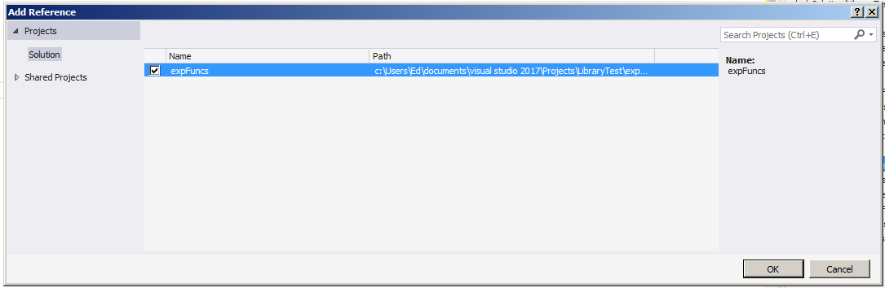
- Check our library and click OK.

We now need to let our Test Project know where the header file is.

- With our Test Exp project selected, choose Project Properties from the main menu (or right-click Test Exp in Solution Explorer and choose Properties.)

- Choose Configuration Properties, C/C++, Additional Include Directories.

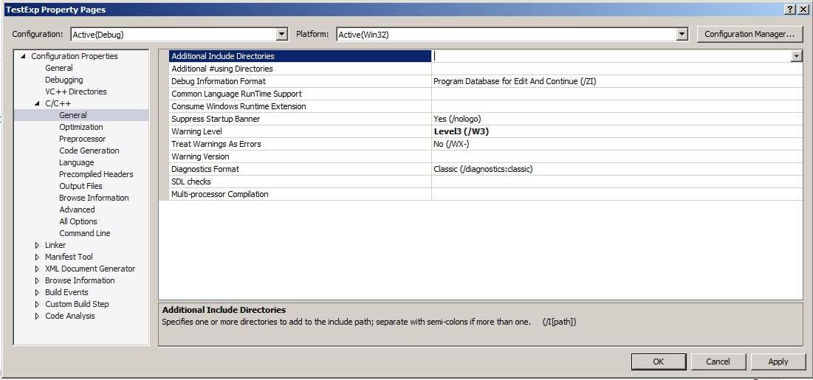

Go to your open Windows explorer window and locate and copy the path of your header file (exp.h).
- Its best to just copy the path from Windows Explorer!
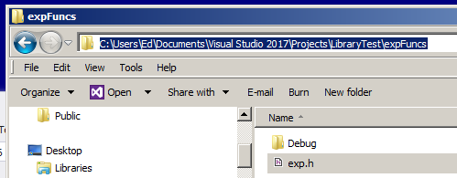

- Paste it into the Additional Include Directories.
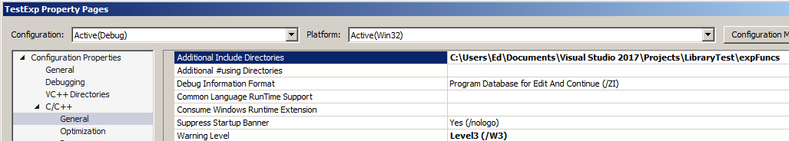
- Click Apply/OK.

- Build and Run.

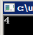
- Our test program has successfully called our library expFuncs.lib.

--------------------------------------------------------------------------------------------------------------------

Could avoid using headers: (It gives error “can’t find part” etc.)

#include<iostream>

using namespace std;

class part
{
private:
int i;

public:
void setdata(int j);
int getdata(void);
};

int main()
{
part p1;

p1.setdata(4);

cout << p1.getdata() << endl;

return 0;
}
<- Library

TestLibrary1
Project1
Source.cpp
Project2

#include<iostream>
using namespace std;

int main()
{
part p1;
p1.setdata(4);
cout << p1.getdata() << endl;
return 0;
}

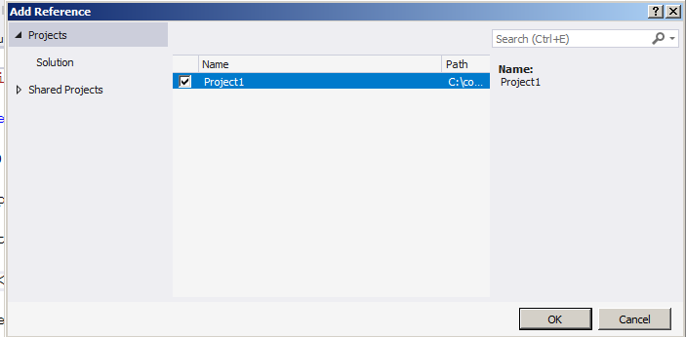

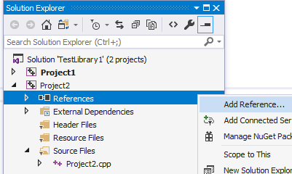
To Make another "Independent" Project to use the Library Functions

So far we have built both projects in the same solution. It may seem more relevant to have the library and test project in different locations.
Use the Wizard in order to get rid of pch’s etc.

  - File, New Project (and new solution) , Console Application,
Empty Project no pre-compiled header, Finish.

- Call it TestExp1. No precompiled header etc. (The solution is also called TestExpt1.)

- Note the cpp file and called TestExpt1.cpp.

- Place this code in the file. (Same as before).

#include<iostream>
#include "exp.h"
using namespace std ;

int main()
{

part p1 ;

p1.setdata(4) ;

cout << p1.getdata() << endl;

return 0 ;
}

- Add a reference to our header file as before: Project, Properties etc.

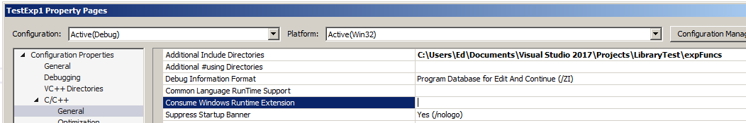
Edit etc doesn’t appear til we click on it!
Don’t close the Properties box yet.

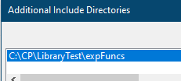

Just paste in the path from Windows Explorer.

C:\CPP\LibraryTest\expFuncs
This time we need to set two references to the library via the Linker.

1. The folder containing the expFunc.lib file:
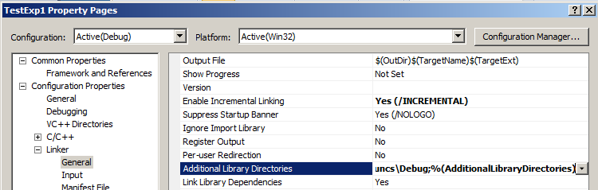
- Choose
Linker General.
- Click here and specify Additional Library Directories as
C:\CPP\LibraryTest\x64\Debug AdditionalLibraryDirectories.(ie The location of the expFuncs.lib file) Oct 2023

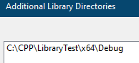

- Additional Dependencies
2. The .lib file itself expFuncs.lib.

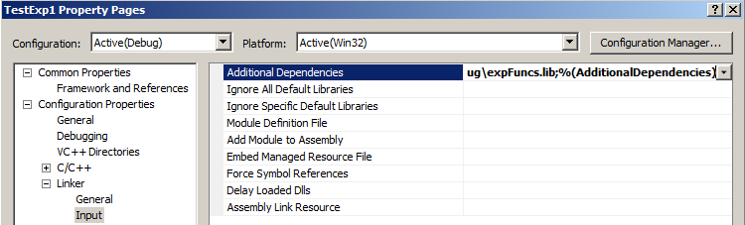

- Linker
- Input.

Oct 2023
C:\CPP\LibraryTest\x64\Debug\expFuncs.lib ;%(AdditionalDependencies)

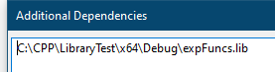

- Build and run it.
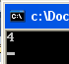
Finally: Your program should set and produce the value of 4 !

See also Static Library Walkthrough:

https://msdn.microsoft.com/en-us/library/ms235627.aspx

It only sets the header file – not the linked directories.

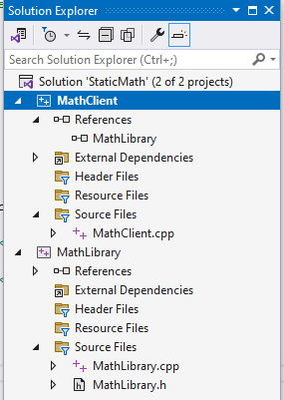
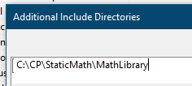

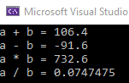

C:\CP\StaticMath\MathLibrary

C:\CP\StaticMath\ StaticMath.sln

Note the way that the functions are called using the format:

namespace::class::function. eg
MathFuncs::MyMathFuncs::Add(a, b)
ie we don’t create and use an object of a class (that’s why they are called static functions)
as we did with:
part p1 ;
p1.setdata(4) ;

Exercise: Get the walkthrough working and then remove the namespace MathFuncs to show that it still works.

Dynamic Library Walkthrough:

https://docs.microsoft.com/en-us/cpp/build/walkthrough-creating-and-using-a-dynamic-link-library-cpp
Note the use of static functions. Note that he uses a PCH (pre-compiled header) project.
It's also possible to create DLLs that can be called from apps written in other languages and built using other compilers by using the C calling convention. For more information about specifying C linkage, see Exporting C++ Functions for Use in C-Language Executables.

See Manual Part 5 for #define but basically
#define MATHLIBRARY_API __declspec(dllexport)
means the variable MATHLIBRARY_API is put equal to “__declspec(dllexport) “

Arrays Chapter 7 page 264
Arrays is not Modern C++
See the array in the STL (later) which wraps these arrays in a class to overcome their main shortcomings.
Vector is actualy the preferred C++ container. Nevertheless, it is necessary to study these “old” arrays because 1. They will appear in legacy code . 2. To understand their shortcomings and how the std::array overcomes them.

YouTube CppArrays https://youtu.be/0-HJJupiBsw
1d array 2d array
An array is a collection of variables of one particular
type. For example, we could have an array of integers.

- Type in and run the following program.

The int indicates that what’s inside the array is integers.

This 4 indicates the number of elements in the array, 4 in this case - Actually the 4 is not necessary in this case! Its implied by the array itself.
- Try running the program without it!

#include <iostream>
using namespace std;
int main()
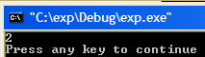
{
int age[4]={1,2,3,4};
cout << age[1] << endl;

return 0 ;
}
We don’t have to initialize the array immediately. But we would then have to indicate the number of elements eg: int age[4];
Note that counting starts from zero.
ie age[0] = 1 , age[1] = 2, age[2] = 3, age[3] = 4.
There are 4 elements in total. There is no age[4] !!

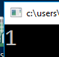
- Try cout << age[0] << endl ; to confirm that 0 is the index of the first element.

- Single step the program. View the Locals Window as shown below. (View, Debug Windows, Variables – or similar!).
Note the name of the array, age in this case has a very important significance: age is also a “variable” which contains the address of the first element of the array.

Recall how & means the “address of”. Therefore &age[0] means the address of the first element in the array. Hence
age ≡ &age[0].

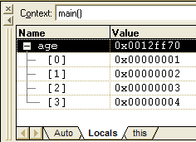
Note the address of the first element of the array - 0x0012ff70 in this case. We will now use this information to view the array in memory
- Click on the memory address to highlight it and then copy it. You may need to Ctrl-C.

.
- Open the memory window. (Debug Windows, Memory).
Recall how the individual bytes of each integer are stored in “reverse order” – little endian cf big endian.

You may also note how the elements (integers) are stored in ascending order – as you might expect!
Paste in the address and press Enter.

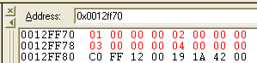

Stored on the heap.

The 4 integers of the array – each 4 bytes long can be seen at that address.

To Pass an array to a function

We only need to pass the name of the array. Thearray is necessarily passed by reference so if we change an element inside the function then it will be chaged permanently.

Eg for a function to calculate the mean of some numbers (which are in an array):

#include<iostream>
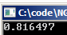
#include<cmath>

using namespace std;

double mean(double x[3]);

int main()
{
double x[3] = { 1.0, 2.0, 3.0 };

cout << mean(x) << endl;
We only need to pass the name of the array - x in this case (which is a pointer to the address of the start of the array.)

return 0;
}

double mean(double x[3])
{
return (x[0]+ x[1]+x[2]) / 3.0;
}

The previous array was one-dimensional. Now..
Take care: Danger: Since the function does not know the size of the array then it may poke into memory which it is not supposed to:
eg x[4]=3; would (hopefully!) cause an error.

A Two-Dimensional Array page 270
2 rows of 4 columns.
1 2 3 4
5 6 7 8

#include <iostream>
using namespace std;
2 lots of 4

int main()
{
int age[2][4]={{1,2,3,4},{5,6,7,8}} ;
cout << age[0][1] << endl ;

return 0 ;
}
This 2 is redundant (ie optional)! *(see below). Try it without it ie age[ ][4].
It still works. (But If we don’t intitialize the array then we MUST provide both indices.)
In order for the compiler to reserve sufficient memory, it must be certain – told explicitly - how many elements are in each of the columns {1,2,3,4} and {5,6,7,8}, ie 4, whereas the compiler determines for itself how many of these rows are in the array {{1,2,3,4},{5,6,7,8}}. ie 2 in this case.

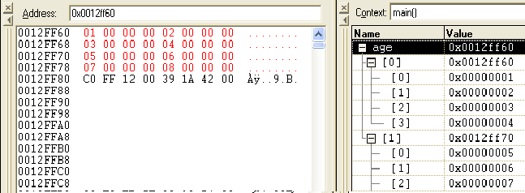
- Single step to see how the elements are stored in memory.
age ≡ &age[0][0]
age is the address of 01.
ie The address of the array is the same as the address of the first element.

* If we don’t initialize the array with values as we do here, then the 2 will be necessary.
To Pass an Array to a Function page 274 Array1.sln on C:\CPP\CPPManualPart1 on QW

If an array is passed to a function and the function changes the array, it will be changed permanently. Ie Arrays are passed by reference.
ag is optional here.

#include <iostream>
using namespace std;
void dodo(int []) ;
Originally the value of age[2] is 3.

int main()
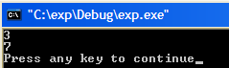
{ // 4 is optional.
int age[4]= {1,5,3,4} ;
cout << age[2] << endl ;
dodo(age) ;
cout << age[2] << endl ;

return 0 ;
Upon return from the function age[2] is now 7.

} // 4 is again optional..
void dodo(int ag[])
{
ag[2] = 7 ;
}
- ag is a new array variable.
We need to indicate that ag is the address of an array by using ag[].
age is the address of the first element of the array. When we pass an array to a function, we only need to tell the function the address of the first element.

Element 2 (the 3rd element) which was 3, is here permanently changed to 7

- Note the address of the array age[].
Single step in main().

// ag is a variable which points to the first element of the array
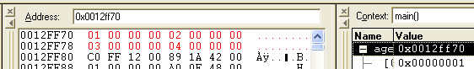
- Single step
- Note the address of the array ag is the same as the address of age!
into dodo().

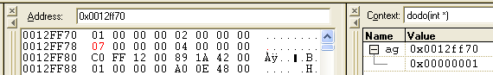
- Since the two arrays are one and the same thing, changing 3 to 7 inside the function, obviously changes it permanently.
Exercise. Modify the code to pass a 2-dimensional array to the function. Change element ag[0][2] to say 5. Don’t forget your prototype.

An Array of Structures page 277
Array1.sln on C:\CPP\CPPManualPart1 on QW

- Try these.
In the C language you may see the equivalent: Try it!

typedef struct
{
int i ;
char s ;
} part ;
#include<iostream>
using namespace std ;
An array of objects of type part.

struct part
{
int i ;
char s ;
} ;
An array of objects of type part.

int main(void)
{
part p[2] ;

p[0].i= 1 ;
p[0].s='A' ;
p[1].i= 2 ;
p[1].s='B' ;

return 0 ;
}
(This program produces no output. Use the debugger to single-step.)

- Note the dot notation used to access the individual values.

41 hex is the ascii for A.
42 hex is the ascii for B.

- Note how the 4 elements are stored sequentially.

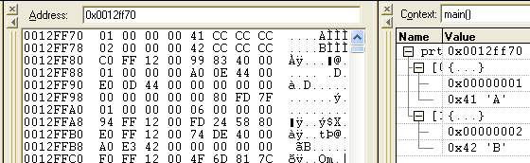

The arrays of structures could be initialized at once like so:

- Exercise: Loop thru the array 1. printing out all of the i values.
2. adding the i values.(ie find the total of the i’s)
An Array of Objects page 283

We have just seen how to make an array of structures. Using classes we will now make an array which can hold objects of that class.

- Make this simple class which has two data elements (i & s) and one member function init.
This program produces no output. Use the debugger to single-step.
#include <iostream>
using namespace std;
class part
Instead of this init function we could use a
2-arg constructor as follows: (Probably better-do this as well.)
part(int j, char t):i(j),s(t)
{ ;}
To call the constructor use
p[0] = part(1,'A'); etc.
Since we are calling a many argment constructor we will need a 0-arg (default) constructor as well.

In “modern C++” we can use part() = default; to force the compiler to produce a default constructor.
{
private:
int i ;
char s ;
public:
void init(int j , char t)
{
i = j ;
s = t ;
}
} ;
int main(void)
An array of objects of type part.
{
part p[2] ;
Exercise: Place methods inside the class called getI() and getS()to return the respective values of i and s print them out from main() using a loop.
p[0].init(1,'A') ;
p[1].init(2,'B') ;

return 0 ;
}

- Note the way that the array of objects is stored in memory:

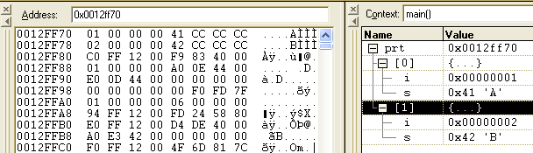

Matrices A matrix is a 2-dimensional array.

customer A :
⎥
⎦
⎤
⎢
⎣
⎡
2
1
3
2
This matrix for example could represent the February purchases in row 1 for customer A and in row 2 for customer B

customer B :

I U
B S
M G

Then we may wish to add this to the January purchases.

Exercise 1

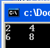
1. Write a C++ program to add together two matrices (arrays). (Add the respective elements)
You might start by defining a 2x2 array: double m1[2][2] = { { 1,2 },{ 3,4 } };
Write code to print (using setw – see page 11 of manual – don’t forget <iomanip> ) the output the matrix to the screen.

- Now place the addition code in a function called add().(See page 62 of manual). Pass the three matrices to the function. There is no need to return the resultant matrix since arrays are passed by reference.

- Now place the addition code in a function called printout(). Pass the matrix to be printed to the function. M1

2. Page 314 No 4. ie
Start with a program that allows the user to input a number of integers, and then stores
them in an int array. Write a function called maxint() that goes through the array,
element by element, looking for the largest one. The function should take as arguments
the address of the array and the number of elements in it, and return the index number of
the largest element. The program should call this function and then display the largest
element and its index number. (See the SALES program in this chapter.)

Exercise 2:

- Make a class to hold a 2-D array. You might start by defining a class:

class matrix
{
private:
double m[2][2] ;

- Use a 4-argument constructor to initialize the arrays m1 and m2. Use a no argument constructor to initialize the array elements of m3 to 0.
- Include a printout method in the class so that we can print out any desired matrix like so:
m1.printout()
;
- Later : Overload the + sign to add together two such matrix objects of this type…
…so that we can write: m3 = m1 + m2 ;

See page 82 of the manual but you will need to add the elements individually inside the o/operator function like so:

temp.m[0][0] = m[0][0] + mat.m[0][0];

Optional. Write a function to multiply 2 matrices.

Formatting Numbers page 272

- Try these: (Crrl-F5 will “Start without Debugging”)
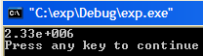
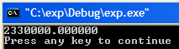
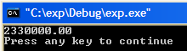
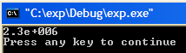
#include <iostream>

using namespace std ;
int main()
{
float var = 2330000 ;
cout << var << endl ;
return 0 ;
}
#include <iostream>
#include <iomanip>
using namespace std ;
int main()
{
float var = 2330000 ;
cout << setiosflags(ios::fixed) ;
cout << var << endl ;
return 0 ;
}

#include <iostream>
#include <iomanip>
using namespace std ;
int main()
{
float var = 2330000 ;
cout << setiosflags(ios::fixed) ;
cout << setprecision(2) ;
cout << var << endl ;
return 0 ;
}
#include <iostream>
#include <iomanip>
using namespace std ;
int main()
{
float var = 2330000 ;
cout << setprecision(2) ;
cout << var << endl ;
return 0 ;
}
This will force the number to be printed in fixed point notation.

A floating point number by default will be printed in exponential notation. e means 10 here – not e!
Further, this will cause 2 decimal points only to be printed.

- Remove the setiosflags(ios::fixed).
Of course it now returns to floating point notation but the setprecision(2) NOW sets the number of significant figures.

For more info see Help on setiosflags and then flags.

<iomanip>is necessary.

To Generate Random Numbers page 289

This program generates 12 random numbers.
Not Modern
rand() not encouraged,
Use new random generator.

#include <iostream>
#include <cstdlib> // for srand and rand()
#include <ctime> // for time
#include <iomanip > // for setw
using namespace std ;
srand(unsigned(time(NULL)) ) ;
seeds the random number generator. (It makes it jump to another starting number in the set of pseudo* random numbers) - based on the time of day! Try it with this line commented out. We will get the same pseudo random numbers each time! This can be actually very desirable when testing code.

int main()
{
srand(unsigned(time(NULL)) ) ;
for (int j=1; j<=12; j++)
cout << setw(10) << rand() ;
cout << endl ;

return 0 ;
}
It produces 12 five-digit-max random numbers: 32767 is the maximum.

*Random numbers are not as easy for the computer to generate as you may think.Pseudo random numbers are random numbers which were originally somehow generated as random numbers and then saved. By using srand(unsigned(time(NULL)) ); , we are setting a different starting point in this list of pseudo random numbers.

If we wish to only produce numbers between 0 and 51 include %52 after rand(). ie
cout << setw(10) << rand()%52 ;
- Try it.

Result:

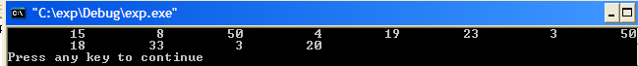

Random numbers are used extensively in Financial Math as Monte Carlo eg for the simulation of a stock price over some time period. See demo. Unfortunately, the random number generator is not as random as it should be for such mission critical simulation. Other library functions exist which are more accurate.
- Now try the following: Could be ignored Page 289

#include <iostream> // for cout
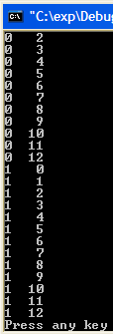
#include <iomanip > // for setw
using namespace std ;
These demos are purely to facilitate the understanding of the card examples in the text.
int main()
{
for (int j=0;j<26;j++)
cout << j/13 << setw(4)
<< (j%13) << endl ;
return 0 ;
}
j/13 gives the result of the integer division of the number by 13 ie the integer (whole number only) number of times that 13 goes into the numbers 0 to 25.

To Produce The IBM Character Set page 289

#include <iostream>
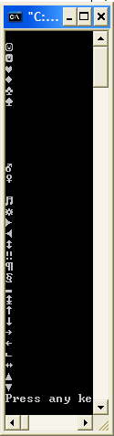
using namespace std ;
int main()
{
for (int i=0; i<32; i++)
cout << static_cast<char>(i) << endl;
return 0 ;
}
- (You may need to scroll your window up to see all of the characters.)

- Ascii (one byte) has been replaced by Unicode (2 bytes) - because of demand for foreign language charcters etc.

- Build the programs p.264 to p.290.

Use #include <string>
Modern C++
C++ Strings

Strings1.sln on C:\CPP\CPPManualPart1 on QW
The include file <string> contains the string class.
#include <iostream>
#include <string>
using namespace std ;
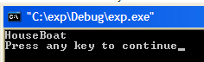
int main(void)
{
string s1("House") ;
string s2("Boat") ;
string s3 ;
The + sign knows what to do with the objects s1 and s2! We will learn how this is done in the next chapter.
s3 = s1 + s2 ;
cout << s3 << endl ;

return 0 ;
}
Note that even cout knows what to do with the string object s3. We will see later how the << operator has also become overloaded.

Try the examples p. 302 to p.310 (repeatead over). Note the use of:

The overloaded += The overloaded == The overloaded >>
size() swap() compare() find() substr() replace() length() erase() at() append() copy()

which all belong to the string class.

Page 303 C++ Strings

//sstrass.cpp
//defining and assigning string objects
#include <iostream>
#include <string>
Use Debug
Start Without Debugging.
using namespace std;
int main()
{
string s1("Man"); //initialize
string s2 = "Beast"; //initialize
string s3;
s3 = s1; //assign
cout << "s3 = " << s3 << endl;
s3 = "Neither " + s1 + " nor "; //concatenate
s3 += s2; //concatenate
cout << "s3 = " << s3 << endl;
s1.swap(s2); //swap s1 and s2
cout << s1 << " nor " << s2 << endl;
return 0;
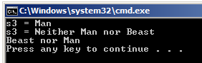
}

Page 305

#include <iostream>
#include <string> //for string class
using namespace std;
int main()
{ //objects of string class
string full_name, nickname, address;
string greeting("Hello, ");
cout << "Enter your full name : ";
getline(cin, full_name); //reads embedded blanks
cout << "Your full name is : " << full_name << endl;
cout << "Enter your nickname : ";
cin >> nickname; //input to string object
greeting += nickname; //append name to greeting
cout << greeting << endl; //output: "Hello, Jim"
cout << "Enter your address on separate lines\n";
cout << "Terminate with '$'\n";
getline(cin, address, '$'); //reads multiple lines
cout << "Your address is : " << address << endl;
return 0;
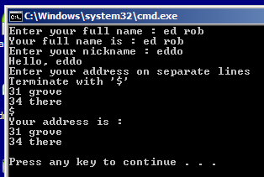
}

Page 306 C++ Strings

// sstrio.cpp
// string class input/output
//sstrchng.cpp
//changing parts of string objects
#include <iostream>
#include <string>
using namespace std;
int main()
{
string s1("Quick! Send for Count Graystone.");
string s2("Lord");
string s3("Don’t ");
s1.erase(0, 7); //remove "Quick! " 6!! error!!
s1.replace(9, 5, s2); //replace "Count” with "Lord"
s1.replace(0, 1, "s"); //replace ‘S’ with ‘s’
s1.insert(0, s3); //insert "Don’t " at beginning
s1.erase(s1.size() - 1, 1); //remove ‘.’
s1.append(3, '!'); //append "!!!"
int x = s1.find(' '); //find a space
while (x < s1.size()) //loop while spaces remain
{
s1.replace(x, 1,"/"); //replace with slash
x = s1.find(' '); //find next space
}
cout << "s1: " << s1 << endl;
return 0;
}
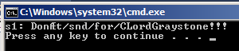

error!

Page 308

//sstrcom.cpp
//comparing string objects
#include <iostream>
#include <string>
using namespace std;
int main()
{
string aName = "George";
string userName;
cout << "Enter your first name : ";
cin >> userName;
if (userName == aName) //operator ==
cout << "Greetings, George\n";
else if (userName < aName) //operator <
cout << "You come before George\n";
else
cout << "You come after George\n";
//compare() function
int n = userName.compare(0, 2, aName, 0, 2);
cout << "The first two letters of your name ";
if (n == 0)
cout << "match ";
else if (n < 0)
cout << "come before ";
else
cout << "come after ";
cout << aName.substr(0, 2) << endl;
return 0;
}

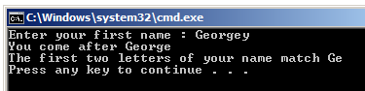

Page 309

//sstrchar.cpp
//accessing characters in string objects
#include <iostream>
#include <string>
using namespace std;
int main()
{
char charray[80];
string word;
cout << "Enter a word : ";
cin >> word;
int wlen = word.length(); //length of string object
cout << "One character at a time : ";
for (int j = 0; j<wlen; j++)
cout << word.at(j); //exception if out-of-bounds
// cout << word[j]; //no warning if out-of-bounds
word.copy(charray, wlen, 0); //copy string object to array
charray[wlen] = 0; //terminate with ‘\0’
cout << "\nArray contains : " << charray << endl;
return 0;
}

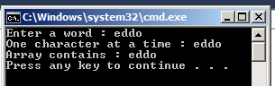

// string::substr
#include <iostream>
#include <string>

int main ()
{
std::string str="We think in generalities, but we live in details.";
// (quoting Alfred N. Whitehead)

std::string str2 = str.substr (3,5); // "think"

std::size_t pos = str.find("live"); // position of "live" in str

std::string str3 = str.substr (pos); // get from "live" to the end

std::cout << str2 << ' ' << str3 << '\n';

return 0;
}

Exercise:

1. Write a program which extracts (parses) the data between the XML tags <Person> and <\Person> in the following XML string:
string stXML = "<Table1><Person>ed</Person><Person>joe</Person><\Table1>";

This must be perfectly general. Hint: Start off by searching for the position of the first <Person>. You may wish to use the techniques of page 302 -> in the C++ book including substr. (And then just submit the code to just find the first bit of data (“ed”).)’

Then use a loop to find each of them. Note the use of find: eg stXML.find("<Person>",10) will start looking at position 10 for <Person>.

Bonus question: Make a function called parseData which can be called like so:
parseData(stXML,srch);

For comprehensive summary:

https://en.cppreference.com/w/cpp/string/basic_string

eg std::basic_string::find

#include <string>
#include <iostream>

void print(std::string::size_type n, std::string const &s)
{
if (n == std::string::npos) {
std::cout << "not found\n";
} else {
std::cout << "found: " << s.substr(n) << '\n';
}
}

int main()
{
std::string::size_type n;
std::string const s = "This is a string";

// search from beginning of string
n = s.find("is");
print(n, s);

}
Output:
found: is is a string
found: is a string
found: a string
not found

C Strings p.290 A C-sring is an array of characters
This topic of c–strings (or “zero-terminated” strings) is included here for historical reasons !. C++ strings are more important.

YouTube : C++ C-Strings.avi https://youtu.be/4RDeHL63JGM

Strings are arrays of characters of type char.
As we will see later, to pass the string to a function eg In order to print out the string, we only need to pass the address, str of the first element in the string array to the cout operator. Indeed, the cout operator expects an address (of the first element).

- Try the following:

#include <iostream>
using namespace std;
int main()
{
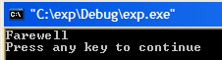
char str[]="Farewell" ;
cout << str << endl ;

return 0 ;
}

Let’s take a look to see how the string is actually stored in memory.

- Start the debugger by pressing F11.
- Continue to step (F11) to the line beneath cout << str << endl ;
as shown below
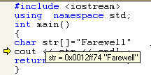

- Hold the mouse cursor over str as shown.

- Take note of the memory address (in hex) of the string.
- (Alternatively, copy the address of the string from the Locals window.)

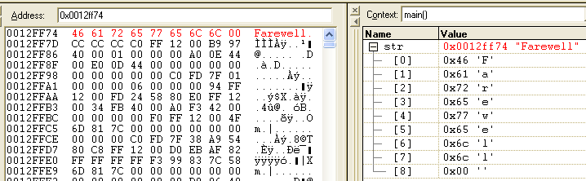
Open the memory view window. Enter the address of our string (and press Enter).

The characters have been placed in a 1-D .array.

Exercise: Print out eg the 2nd character.
A zero byte at the end of the string is always present – C-strings ie strings which are defined as an array of characters are always terminated with a zero byte - also called a null character.
- Note carefully the zero byte which has been automatically placed at the end of our string. This characterizes the (famous) c-string.

When we output the string using:
cout << str << endl ;
cout knows where to stop – where it meets the zero-terminating byte.

Note that C-strings abound in legacy code so its best to be familiar with them.

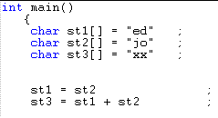Can we simply put one string equal to another and add strings as below? No!

Neither of these is possible!

We can do this however using “C++ strings” cf these C-strings as we will see..
To Put One String Equal To Another

- If we wish to put one string equal to another string we can copy it character by character as shown below. Try it.

#include <iostream>
using namespace std;
int main()
{
(The 2nd array is made more than big enough (20 characters).)
char st1[]="Farewell" ;
char st2[20] ;
for (int i=0; i<9; i++)
9 bytes (0 to 8) (including the null-terminating byte) are copied.
st2[i] = st1[i] ;
cout << st2 << endl ;

return 0 ;
}
- Single step and watch the individual elements being placed in memory.

Historically, functions exist for use with these so-called C-strings but are somewhat limited. These were developed for use with C and are therefore called C run-time library functions.

We will now take a look at some of these C-string library funcions.

To use them we must include <cstring>.

strlen() To Find the Length of a String

- Try this.

#include <iostream>
Note the include file <cstring>.
#include <cstring>
using namespace std ;
int main()
{
char st1[]="Farewell" ;
cout << strlen(st1) << endl ;

return 0 ;
}

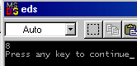
Note that the real length of a string is one more than the number of characters. In the case above, the real length is 9.

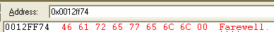
strcpy To Copy One String to Another
Not Modern
Use String class.
Althought this should work you will get a warning that strcpy is deprecated so better (safer) to use strcpy_s.
(You could actualy turn off these warnings using:
#define _CRT_NONSTDC_NO_DEPRECATE 1
#define _CRT_SECURE_NO_DEPRECATE 1 )

- Try this.

#include <iostream>
#include <cstring>
using namespace std;
int main()
{
st2 is replaced by st1. (Think of st2 = st1.)
char st1[]="Farewell" ;
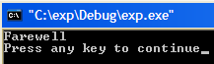
char st2[20] ;
cout << strcpy(st2,st1) << endl;

return 0 ;
}
strcpy()expects the addresses (pointers) of the strings as arguments.

After running the program, single step and note how st1 and st1 are stored in memory.
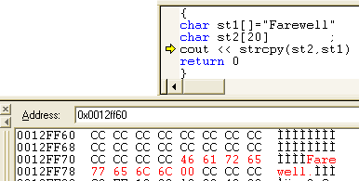

When copying one string to another, make sure that the 1st string being over-written is bigger!

Before the copy:

st1

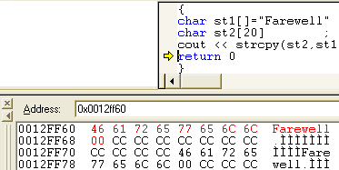

st2
st1
After the copy:

So the strings themselves are actuall swapped in memory.We will see later that the addresses can be swapped using pointers. Much more efficient!

Note how st2 is stored before (lower in memory than) st1 in memory ( the heap.)

strcpy_s will not allow a smaller string to be overwritten by a larger string – try it.
eg char st2[4] ;

strcat() To Add One String to Another (concatenation)

- Try this.
Not Modern
Use String class.

#include <iostream>
Use strcat_s instead of strcat.
#include <cstring>
using namespace std ;
int main()
{
char st1[10]="House" ;
st2 is concatenated to st1.
char st2[]="Boat" ;
cout << strcat(st1,st2) << endl ;
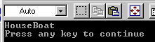
return 0 ;
}

- 10 bytes are reserved so that Boat can be concatenated to House.

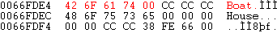

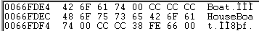

If st1 is not made large enough initially to accommodate both strings, an error will occur. Danger!

strcmp() To Check If Two Strings Are Equal

- Try this.

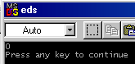#include <iostream>
using namespace std ;
#include <cstring>
0 is returned since the strings are equal.
int main()
{
char st1[]="House" ;
char st2[]="House" ;
cout << strcmp(st1,st2) << endl;

return 0 ;
}

If the strings are unequal, -1 or 1 is returned depending on which string is lexographically (alphabetically before or after) bigger.
strstr() To See If One String is Contained in Another

#include <iostream>
using namespace std ;
#include <cstring>
int main()
{
char st1[]="House" ;
Checks to see if st2 is contained in st1 (Which it is of course).
char st2[]="se" ;
if (strstr(st1,st2)!= NULL)
cout << "found" << endl ;

return 0 ;
}
But if not found however, the NULL pointer is returned. So if the result is not NULL then the string was found.

To report the position:

#include <iostream>
using namespace std ;
#include <cstring>
int main()
{
Don’t worry that we are here using a pointers - which we will discuss later. (In fact p1 is the memory address of the string House and st1 is the memory address of the string st1.)
char st1[]="House" ;
char st2[]="se" ;
char * p1 ;
p1 = strstr(st1,st2) ;

if (p1!= NULL)
cout << st2 << " found" << " at posn " << p1-st1 << endl ;
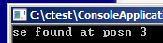
return 0 ;
}

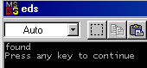
_strset() To Make a String of Many of the Same Character

- 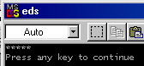Try this.

#include <iostream>
Use _strset_s instead of _strset.
using namespace std ;
#include <cstring>
int main()
_strset causes the string House to be replaced by ∗’s.
{
char st1[]="House" ;
_strset(st1,'*') ;
cout << st1 << endl ;

return 0 ;
}
An Array of Strings

An array of strings is an array of arrays ie a 2-D array.

- Try this.
If we placed a 3 here, it wouldn’t make any difference. (It would appear that the compiler is smart enough to count the three strings but can’t determine the max size of the respective strings – therefore the 5 is necessary to let it know what the size of your biggest string might be. (Remember that john is actually 5 bytes long.)
Not Modern C++
Use String class.
#include <iostream>
using namespace std;
int main()
{
char st1[][5]={"ed","joe","john"} ;
for (int j = 0;j<3;j++)
cout << st1[j] << endl ;

return 0 ;
}
Note how we only need the first indices (0,1 & 2) to access the strings. Recall that cout expects the address of the respective string elements – to be more precise, the addresses of the first elements of each string which are st1[0] st1[1] st1[2]. See below.
Ponder hard on this. It might make more sense when we discuss pointers.
(Note that we would need the 3 if we didn’t initialize the array.)

Take a look at the successive pointers in memory at the address given by st1.

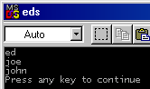
- Try debugging and note how all of the strings are allocated 5 bytes. (Waste of memory!)

st1[0] st1[1] st1[2]

;
Note the matrix analogy. 3 rows and 5 columns:

e d . . .
The address of the individual strings can be ascertained by viewing the Local Window.
j o . . .
j o h n .

Exercise : Pass the array of strings to a function and print one out inside the function. Start with code similar to that of the exercise at the bottom of page 75 shown here partially:
dodo(st1) ;
void print(char s[])
{

Homework. 1. Change one of the strings of the array inside the function.

- Read and build the string programs p. 290 to p.297

stringin.cpp p.290 entering a string from the keyboard.

safetyin.cpp p.292 safely entering a string from the keyboard.

strinit.cpp p.292 intitialize a string and define it - 2 ways

blanksin.cpp p.293 read embedded spaces.
Not Modern
Use String class.
linesin.cpp p.294 a different terminating character

strcop1.cpp p.295 copying a string - one character at a time.

strcop2.cpp p.296 copying a string using strcpy

straray.cpp p.297 array of strings (note: storage space is wasted with fixed length strings)

So far, so good but we still can’t have simple statements similar to s1 = s2 and certainly not
s3 = s1 + s2. (As we can easily do in Visual Basic!)

We can tackle the first problem using c-strings by making a class. We create objects s1 and s2 “representing” (actually containing”) c-strings and as we well know, it is possible to simply assign objects equal to one another as in s1 = s2.

Similarly in order to be able to use the notation s3 = s1 + s2 with our class as we shall see need to add an overloaded + operator to our class.

Firstly we will make a class and show how we can put two objects equal to one another
s1 = s2 where our two objets are “disguised” as strings. Slight of hand!

http://www.cplusplus.com/reference/cstring/
for list of c string functions

