Lesson 10:

Generics - List genericMethods GenericClass genericDictionary
linq select lambda predicate

Async & Task writeFileAsync Func linqobject
json vsCode
weatherforecast

For source code projects: GitHub: https://github.com/edthehorse/jack
Download (From Add File) and Unzip CSChapt10.

C# Generics YouTube https://youtu.be/SFUm8p1JUGw GenericTest on Chap10 on QW :C\X

Generics is used for passing of a type parameter using angle brackets <>.

public static void Main()
We can use any variable
(more correctly an indicator) rather than T eg X.

{
push<int>();
The type is passed. method.
}
Two implications.
- Only variables of that type may be passed.
- We can choose which variables to pass.
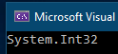
static void push<T>()
{
Console.WriteLine(typeof(T));
}
Note how we can single-step to observe T. Open the Locals Window.

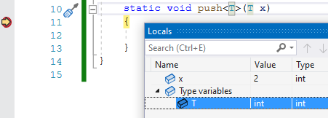
T has a Value of int!

We can of course pass parameters as well:

public static void Main()
{
push<int>(2);
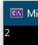
}
static void push<T>(T x)
{
Console.WriteLine(x);
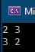
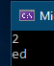
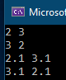
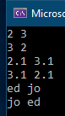
}

Exercise:

- Add to the above code to also pass (and print) a string.

- a. Write a generic method called swap() which will swap two integers.
(Remember to pass by ref and that you will need a temporary variable
eg T temp = …)

b. show how it can be used to swap two doubles as well.

c. and two strings:
Solutions: GenericExp on CSChap10 on C:\X
1.
(Note that we don’t need any extra usings for generics.
Generics is part of the C# spec since version 2.0.)
namespace GenericExp
{
class Program
{
Actually <int> and <string> could be omitted! Try it. Then the type would be implicitly inferred ie just: push(2);and push("ed"); and the type is inferred.
public static void Main()
{
push<int>(2);

push<string>("ed");

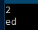
}

static void push<T>(T x )
{
T is a type variable. It could be any name eg Ted but usually T, U etc.
push<T> declares to be a generic type. T x then uses that type.

}
}
}

- . a,b,c.

public static void Main()
{
int x = 2; int y = 3;
Console.WriteLine($"{x} {y}");
swap<int>(ref x, ref y);
Console.WriteLine($"{x} {y}");

double u = 2.1; double v = 3.1;
Console.WriteLine($"{u} {v}");
swap<double>(ref u, ref v);
Console.WriteLine($"{u} {v}");

string s = "ed"; string t = "jo";
Console.WriteLine($"{s} {t}");
swap<string>(ref s, ref t);
Console.WriteLine($"{s} {t}");

}

static void swap<T>(ref T a, ref T b)
{
T temp = a;
a = b;
b = temp;
}

Generic Return Type GenericExp

Note how we can also specify the return type.
In our case below the return type is of the same generic type.

eg To return and print our int and string respectively:

class Program
{
public static void Main()
{
int r = push<int>(2);
Console.WriteLine(r.ToString());

string s = push<string>("ed");
Console.WriteLine(s.ToString());
}
Take a good look at this: The first T is the return type and the 2nd T specifies the type inside the function.
static T push<T>(T x)
{
return x;
}
}

Generic Class GenericClass.on CSChapt10
Item<T>declares T to be a generic variable.
T is a parametric type placeholder.
The type T “permeates” the whole class!

using System;

class Item<T>
{
public T push<T>(T x)
We have created our own generic class called Item which contains our generic function push().
{
return x;
}
}

class Program
{
static void Main()
{
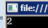
Item <int>i1 = new Item<int>();

Console.WriteLine(i1.<int>push(2));));

}
<int> is optional.
}

Generics have restrictions though. It won’t work to have:
public Item(T price)
{ this.price = price * 1.175; }

We cannot have any arithmetic operations with a generic type!

Exercise: Modify code above so that we can pass a string type to push:
Console.WriteLine(i1.push<string>("ed"));

Solution:

using System;

class Item<T>
{
public U push<U>(U x)
{
return x;
}
}
class Program
{
static void Main()
{
Item<int> i1 = new Item<int>();

Console.WriteLine(i1.push<int>(2));
Console.WriteLine(i1.push<string>("ed"));
}
}

Pass a string and an integer:

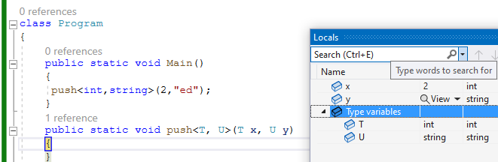

-------------------------------------------------------
Generic List // List in Chap10 on QW

List<> The angle brackets hold the type eg <int> or <string>

List<int> primes = new List<int>{1,2,3,5,7};
<int> says that our list can only hold integers.

(Try putting in a string eg {“1”,2,3,5,7}; and you will get an error.)

On the other hand, to specify that our list will only hold strings:

But we could also have:
List<string> names = new List<int>{“ed”,”jo”,”al”};
Note that this checking occurs at compile time ie we don’t have to wait to run the program to find out we got an error.ie its Type Safe.

See https://www.tutorialsteacher.com/csharp/csharp-list
Excellent reference for the generic list.

Note:
- [] ie use square brackets eg primes[0]to access and set elements
- .Add()
- .Remove()
- .Insert()
- .AddRange() to initialize our list using an array.

To print then out use for each to print them out:
foreach (var e in primes)
Console.WriteLine(e.ToString());

Exercise: Using this List,

List<int> primes = new List<int> { 1, 2, 3, 5, 7 }; // List in Chap10 on QW

1. Add 1 to the end
2. Remove the 5.
3. Insert a 9 at position 2.
4. Use a foreach to print them out.

Exercise: Make a list called lst of doubles.

Add two values 4.0 & 4.1. Print then out using a loop.

Solution:

List<int> primes = new List<int> { 1, 2, 3, 5, 7 }; // List.sln

primes.Add(1); // 1 to the end
primes.Remove(5); // removes the 5.
primes.Insert(2,9); // 9 at position 2.

foreach (var e in primes)
Console.Write(e.ToString()+ " "); // 1 2 9 3 7

var res = from s in primes
where s == 1
select s;

foreach (var e in res)
Console.Write(e.ToString()+ " "); // 1 1

List of Objects ListPart.sln

Our list could hold a custom type eg objects of the Part() class:

ie public class Part {
public string? Name { get; set; }
public int Age { get; set; }
Exercise: Print them out ie

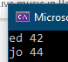
}
class test
{
public static void Main()
{
Part p1 = new Part{ Name ="ed", Age = 42};
Part p2 = new Part{ Name ="jo", Age = 44};

List<Part> people = new List<Part>{ p1,p2};
}
}

List of Lists ListLists.sln

List<List<string>> myList = new List<List<string>>();

myList.Add(new List<string> { "a", "b" });
Exercise: Print them out ie

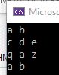

Hint: you will need a foreach inside a foreach.
myList.Add(new List<string> { "c", "d", "e" });
myList.Add(new List<string> { "q", "a", "z" });
myList.Add(new List<string> { "a", "b" });


Generic Dictionary Dictionary on Chap10 on QW
See Lorentz.sln in Chap10,sln on QW. It just demos the XOR.

A Dictionary contains pairs: a Key and a Value
eg The codes for the German Lorentz machine: codes["A"] = "11000";

using System.Collections.Generic;

static void Main()
{
Dictionary<string, string> d = new Dictionary<string, string>() { { "A", "11000" }, { "B", "10011" }, { "C", "01110" }, { "D", "10010" } };

Console.WriteLine(d["A"]);

foreach (KeyValuePair<string, string> kvp in d)
{ Console.WriteLine("{0} {1}", kvp.Key, kvp.Value);}
}
Our Generic dictionary can only hold pairs of strings.
Access the elements using a KeyValuePair type.
: For full Lorentz code see:

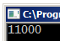
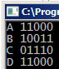

It is straightforward to get the value given the key using d["A"]); but the other way ie getting the key given the value is not straightforward. There is not direct way of doing that.
One way is to loop through all of the values until we find our value and return the corresponding key as below.

static void Main(string[] args)
{
Dictionary<string, string> d = new Dictionary<string, string>();

d["A"] = "11000"; d["B"] = "10011"; d["C"] = "01110"; d["D"] = "10010";

foreach (KeyValuePair<string, string> kvp in d)
{
// Exercise: Add code here to find the key for the value of 11000.
}
}
or- Use Linq! (see over)
// To find the key corresponding to 11000 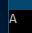

var key = codes.First().Key;

Generic collections (including dictionary) See: M/SoftSummary :
https://docs.microsoft.com/en-us/dotnet/api/system.collections.generic?view=netframework-4.7.1

For good description of Dictionary see:
https://msdn.microsoft.com/en-us/library/xfhwa508(v=vs.80).aspx
LINQ LinqTest in CSChap10.sln on QW.

LINQ avoids looping. It uses “one liners” similar to SQL (but backwards).

eg Determine whether "mango" is in this list of fruits. (Of course, it is.)

static void Main()
{
string[] fruits = { "apple", "banana", "mango", "orange", "grape" };

bool b = fruits.Contains("mango");
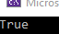
Console.WriteLine(b);
}
The Contains() extension method is attached to the array by means of a dot.

Consider the code we would need to write (don’t do this!) if we were to use a function and looping instead of Linq. LinqTest1 Chap10 on QW

static void Main()
{
string[] fruits = {"apple", "banana", "mango", "orange", "grape"};

bool b = Contains("mango",fruits);

Console.WriteLine(b);

static bool Contains(string f, string[] fr)
{
bool fnd = false;
foreach(string v in fr)
{
if (v == f)
{
fnd = true;
break;
}
}
return fnd;
}
}
ie Linq is much simpler!

.

Microsoft List of Linq Extension Methods
Aggregate
All
Any
Append
AsEnumerable
Average
Cast
Concat
Contains
Count
DefaultIfEmpty
Distinct
ElementAt
ElementAtOrDefault
Empty
Except
First
FirstOrDefault
GroupBy
GroupJoin
Intersect
Join
Last
LastOrDefault
LongCount
Max
Min
OfType
OrderBy
OrderByDescending
Prepend
Range
Repeat
Reverse
Select
SelectMany
SequenceEqual
Single
SingleOrDefault
Skip
SkipLast
SkipWhile
Sum
Take
TakeLast
TakeWhile
ThenBy
ThenByDescending
ToArray
ToDictionary
ToHashSet
ToList
ToLookup
Union
Where
Zip

https://docs.microsoft.com/en-us/dotnet/api/system.linq.enumerable?view=netframework-4.7.1

Take a look at these Methods
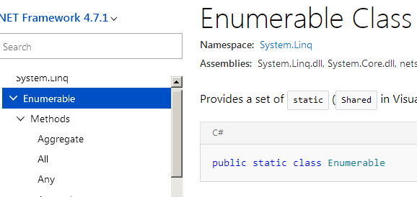

.

using System; LinqEx0 on Chap10.sln on QW.
using System.Linq;

class IntroToLINQ
{
static void Main()
{
int[] nums = new int[7] { 3, 0, 1, 5, 6, 5, 1 };

//A NUMBER
var a = nums.Min(); // 0
var b = nums.Count(); // 7
var c = nums.Sum(); // 21
var d = nums.Average(); // 3

//AN ELEMENT
var e = nums.Last(); // 1
var f = nums.First(); // 3
var g = nums.FirstOrDefault(); // 3 If array empty -> 0
var h = numQuery.ElementAt(0); // 3 Not nums(0) :-(

//A COLLECTION
var i = nums.Append(7); // 3, 0, 1, 5, 6, 5, 1, 7
var j = nums.Take(2); // 3, 0
var k = nums.ToList(); // eg int x = k[0]; ->3
var l = nums.Distinct(); // 3, 0, 1, 5, 6, 1

var m = Enumerable.Range(2, 7); // 2 3 4 5 6 7 8
var n = Enumerable.Repeat<int>(10, 4); // 10 10 10 10

}
}

To print single elements eg:
Console.WriteLine(a); //NUMBER or ELEMENT
Console.WriteLine(e);

But for a collection:
foreach (var x in i) // SEQUENCE
Console.WriteLine(x);

Exercise1: LinqEx on Chap10.sln on QW. (CSSolution page 104)

string[] fruits = {"apple", "banana", "mango", "orange", "grape"};

Apply these Extension Methods to our fruits above.

• Count
• First
• Last

Exercise2: Using the array of ints: int[] numbers = { 1, 2, 3 }; Apply

• Average
• Max
• Min
• Sum

Excellent reference for Linq etc.
https://www.tutorialsteacher.com/linq/why-linq
very comprehensive
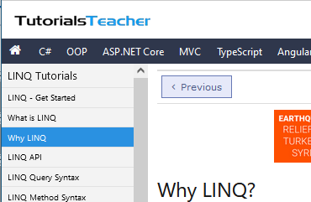

Linq functions can return IEnumerable LinqTest on Chap10

So far, we have used Lambda methods which have returned a single value eg int, string or bool. But many lambdas return a collection of items:

eg Take :

int[] grades = { 59, 82, 70, 56, 92, 82, 59 };

var firstThree = grades.Take(3); // -> 59 82 70
IEnumerable<int> firstThree = grades.Take(3);

will do the same thing since firstThree is a collection – more precisely an IEnumerable<int> type.
You could check that out by single-steping and looking at firstThree in the Locals window:

IEnumerable<int> means that we can iterate over them (ie loop through them.).

Ie add this code to iterate through the result:
(If the elements were strings we would have
IEnumerable<string>)
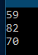
foreach (int grade in firstThree)
{
Console.WriteLine(grade);
}
}

Exercise1: Use Distinct to print out the distinct values in the original array grades see LinqTest
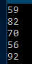

ie

Extension Methods can be chained eg

int c = grades.Distinct().Count();- which makes them very powerful!

Exercise 2: What does the above line of code do? – and what will be the result?

Lambda Functions ..continued. Lambda in CSChapt10 on C:\X on QW.

static void Main()
{
var arith = (int a) => a * a;
arith is a delegate. A delegate refers to a function.

Console.WriteLine(arith(5)); // -> 25
}
input variable
The return.

The equivalent static function is:
static int arith (int a)
{
return a * a ;
}
Note the role of the => is to “separate”.
->

At the moment it appears that nothing is gained. We will see later that we can use lambdas in
- Linq statements
- Delegates whereupon we don’t even need to give it a name (arith in this case).
See later*

The previous lambda had only one input.

A lambda with two inputs. Now we have 2 inputs (And a function body { } .)

static void Main()
{
var arith = (int a, int b) => { return a * b ; } ;

Console.WriteLine(arith(2,3));
}
2 semicolons.
A return.

We could of course have more than one statement inside the braces

Exercise: What type is var in the example above? Use Func to replace our var in the example above. You may wish to single-step to find out?
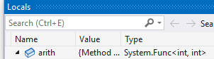

Replace var in the above with it to show it still works.
Func Lambda in CSChapt10 on C:\X on QW

So, in our lambda above, we might equally have

Func<int,int,int> arith = (int a, int b) => { return a * a ; };

Two int inputs.
An int return (output).

Funcs must always have exactly 1 output.

https://www.tutorialsteacher.com/csharp/csharp-func-delegate

Func with 2 inputs 1 output

static void Main(string[] args)
{
Func<int, int, int> Sum = (x, y) => x + y;

Console.WriteLine(Sum(10,10)); // ->20
}

Func with 1 input 1 output

static void Main(string[] args)
{
Func<int, int> Sum = (x) => x + 10;

Console.WriteLine(Sum(10));
}

Func with 0 input 1 output
Func like VBA Function always return something.

Action like VBA Sub.
never return anything.

static void Main(string[] args)
{
Func<int> Sum = () => 10 + 10;

Console.WriteLine(Sum()); // -> 20.
}

So, what if we want 0 output? Ans use: Action. (Like void)

Action https://www.tutorialsteacher.com/csharp/csharp-action-delegate

static void Main(string[] args)
{
Action<int> Sum = i => Console.WriteLine(i);

Sum(20); // ->20
Action has no output.
(Think void)
}

This is 1 input.

(Looks like we cant delete this int ie Action must have at least one input ! )
Look like Func is badly designed. Might instead of
Func<inputs , outputs> be better to have had
Func<inputs> <outputs> and therefore no need for Action ??

Summary: If you want a Func which returns void use Action.

Revision:

A lambda with no inputs:
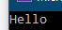
var arith = () => Console.WriteLine("Hello");
arith();

Action

When we don’t have any output then instead of Func we use Action. ie

Action arith = () => Console.WriteLine("Hello");
arith();

Remember that the signature of the delegate Func always corresponds with the signature of the method.

static void Main()
{
Action<int> printDel = CP;

printDel(10);
}

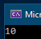
static void CP(int i)
{
Console.WriteLine(i);
}

3.

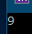
Func<int, int> sqr = x => x * x;
int y= sqr (3);
Console.WriteLine (y);

Func<int,int> sqr = x => x * x; // may be simplified to
var sqr = x => x * x; // or
var sqr = (int x) => x * x; // if we make the input type explicit

Func Exercises Func on Chap10

Exercise1 : Write our above delegate code to find the cube (of 3) rather than sqr
using a Func delegate.

Exercise2: Write Func delegate code to input two ints and return the sum.

Func<int,int,int> add = (x,y) => x+y;
int z = add(3,4);
Console.WriteLine(z);

Exercise 3: Make a Func delegate which inputs a string and finds its length.
We utilize a lambda which returns the length of a sting:

Input is string and output is int.

Func<string, int> totalLength = (s) => s.Length;
int total = totalLength ("hello");
Exercise 4: Make a Func delegate which inputs two strings and finds the total length of them.

Exercise 5: Make a Func delegate which takes no input and returns a string

() ‘s indicates no input ie no argument.

// Zero arguments:
Func<string> greeter = () => "Hello, world";
Console.WriteLine(greeter());

Lambda Functions Examples LambdaFunctions on CSChap10 on QW

The following code will find if there are any negative numbers or not in an array.

static void Main()
{
int[] numbers = new[] { 1, 3, -2, 5 };

bool cn = numbers.Any(x => x < 0);
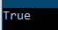
Console.WriteLine(cn);

}
(We can choose any variable name besides x.)

For the lambda function x => x < 0 , x values is the input and x<0 is the output as explained here:

Consider the long way of doing this ie using a function and a loop. (Don’t do this.)
static void Main() LambdaFunctions on Chap10 on QW

{
int[] numbers = new[] { 1, 3, -2, 5 };

bool cn = FindAnyNeg(numbers);

Console.WriteLine(cn);

static bool FindAnyNeg(int[] x)
{
bool b = false;

foreach (int i in x)
{
if (i < 0)
{
b = true;
break;
}
}
return b;
}

//bool cn = numbers.Any(x => x < 0);
//Console.WriteLine(cn);// -> True

}

x is the input to the function.

x<0 (True) is the output.

So, for the lambda (x => x < 0);
Writing lamdas can be a bit tricky so think:
Use any variable on the left of the => and then put whatever output we want from our function on the right.

x is the input to the function.
x<0 (True) is the output.

Exercise: Wite a Func called Sum which accepts an int and returns a bool.

Soln: FuncActionTest in CSChap10.sln

Func<int,bool> Sum = s => true;

Console.WriteLine(Sum(10)); // -> 10

Predicate https://www.tutorialsteacher.com/csharp/csharp-predicate

is a way of rewiring the above ie.

Predicate<int> Sum = s => true;

Console.WriteLine(Sum(10)); //-> true
“A predicate delegate method must take one input parameter and return a Boolean.”

This predicate is slightly more useful!

static void Main(string[] args)
{
Predicate<int> Sum = s => s==10; // <- A criterion.

Console.WriteLine(Sum(10)); //-> true
}

From the https://www.tutorialsteacher.com/csharp/csharp-predicate reference:
“ie Predicate is the delegate like Func and Action delegates.
It represents a method containing a set of criteria and checks whether the passed parameter meets those criteria.”

Excellent lambda-expression revision: see

https://www.tutorialsteacher.com/linq/linq-lambda-expression

Multiple Statements in Lambda Expression Body
You can wrap expressions in curly braces if you want to have more than one statement in the body:
Example: Multi Statements Lambda expression C#

(s, youngAge) =>
{

int oldAge = 92; // Also local variable

Console.WriteLine("Lambda expression with multiple statements in the body");

Return s.Age >= youngAge;
}
-----------

Action<Student> PrintStudentDetail = s => Console.WriteLine("Name: {0}, Age: {1} ", s.StudentName, s.Age);

--------------
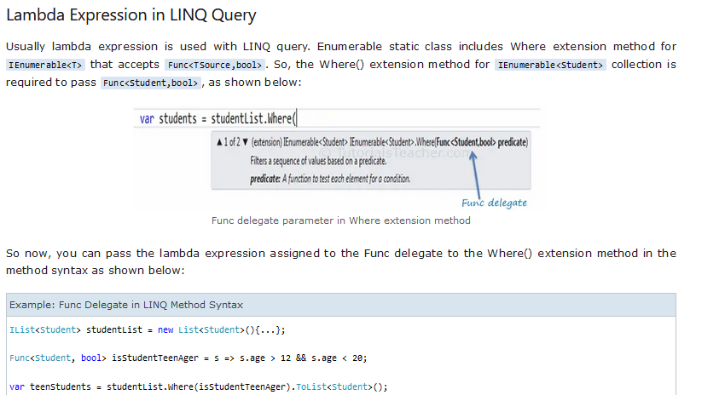

See PredicateTest in CSChap10.sln on QW X:\

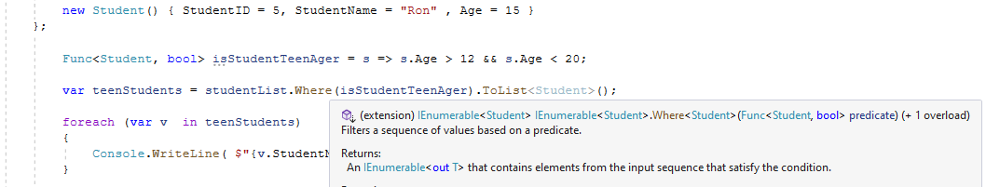

IList<Student> studentList = new List<Student>() {

Not actually a Predicate as such!:

Func<Student, bool> isStudentTeenAger = s => s.Age > 12 && s.Age < 20;

IEnumerable<Student> is what is returned.
An enumerable list.
IEnumerable<Student> is the studentList to which the extension method is attached.
An enumerable list.

Note the dot before the Where extension method.

A predicate that’s not a Predicate.
Ie Func with bool output performs as a Predicate.

Could just as easily have:
var teenStudents = studentList.Where(s => s.Age > 12 && s.Age < 20).ToList<Student>();

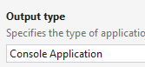
Sorting using Linq • OrderBy LinqFruit (WPF)

string[] names = { "Tom", "Dick", "Harry" };

The unordered list is input.
(If we wanted the list to be sorted by length we would use n.Length here instead n of where n.Length is then known as a key selector.

var filteredNames = names.OrderBy(n=>n);

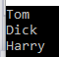

Exercise 0: Write code to output the above names:

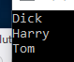
Exercise 1: Sort the above alphabetically ascending and print them.

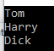
Exercise 1a: Sort them alphabetically descending and print them.
(Use OrderByDescending instead of OrderBy)

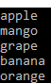
Exercise 2: Sort these below by length (see above) ascending and print them out.

string[] fruits = { "apple", "banana", "mango", "orange", "grape" };

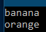
Exercise 3: Make a sorted ascending list of fruit names of length >5 and print them out.

Exercise 4: Find the number of sorted fruit names of length >5. (See below for chaining extension methods.)

For descending order see : • OrderByDescending

Select See: • Select

Select produces a new IEnumerable

eg To make a string uppercase:
var filteredNames = names.Select(n=>n.ToUpper());

It can be chained:
var filteredNames = names.Select(n=>n.ToUpper()).OrderBy(n=>n).Where(n => n.Length >= 4);

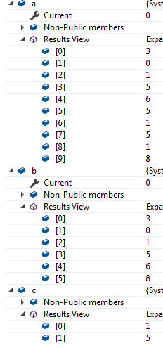
Linq for Two Arrays: Concat Union Intersect LinqTwoArrays

using System; Locals: :->
using System.Linq;

class IntroToLINQ
{
static void Main()
{
int[] nums = new int[7] { 3, 0, 1, 5, 6, 5, 1 };
int[] num1 = new int[3] { 5, 1,8 };

//COLLECTION
var a = nums.Concat(num1); //3, 0, 1, 5, 6, 5, 1 5, 1, 8
var b = nums.Union(num1); //3, 0, 1, 5, 6, 8
var c = nums.Intersect(num1); //1, 5

}
}

Miscellaneous :

var v = Enumerable.Range(1, 10) produces number 1 -> 10.

Exercise 5. Use Select to produce squares from 1 –> 10 ie 1 4 9 , etc. LinqFruit (WPF)

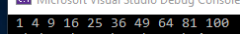

Hints: Attach Select to the above and use x=>x*x

• ToArray converts from IEnumerable to an ordinary array ie we can iterate thru them using usual array notation eg x[3]

Exercise 6. Place the above elements in an array.
Print out the 3rd element for example.

https://www.geodanila.com/article/useful-linq-extension-methods/
Excellent examples use this
V good consolidation and elaboration

-------------------------

Linq Methods with Class Objects. LinqObjects on CSChapt10

See also example on FuncPredicate Predicate

class Student
{
public int StudentID { get; set; }
public String? StudentName { get; set; }
public int Age { get; set; }
}

class Program
{
static void Main(string[] args)
{
Student[] studentArray = {
new Student() { StudentID = 1, StudentName = "John", Age = 18 } ,
new Student() { StudentID = 2, StudentName = "Steve",Age = 21 } ,
new Student() { StudentID = 3, StudentName = "Bill", Age = 25 } ,
new Student() { StudentID = 4, StudentName = "Ram" , Age = 20 } ,
new Student() { StudentID = 5, StudentName = "Ron" , Age = 31 } ,
new Student() { StudentID = 6, StudentName = "Chris",Age = 17 } ,
new Student() { StudentID = 7, StudentName = "Rob", Age = 19 } ,
};

Exercises:
- Use LINQ to find teenage students
- Use LINQ to find first student whose name is Bill.
- Use LINQ to find student whose StudentID is 5.

// Use LINQ to find teenage students

// 1. Use LINQ to find teenage students

Student[] teenAgerStudents = studentArray.Where(s => s.Age > 12 && s.Age < 20).ToArray(); // A collection.

foreach (var v in teenAgerStudents)
{ Console.WriteLine(v.StudentID); } // 1, 6, 7.

// 2. Use LINQ to find first student whose name is Bill

Student? bill = studentArray.Where(s => s.StudentName == "Bill").FirstOrDefault(); // Single

if (bill != null)
Console.WriteLine(bill.StudentID); // 3

// 3. Use LINQ to find student whose StudentID is 5

Student student5 = studentArray.Where(s => s.StudentID ==5).FirstOrDefault();

Console.WriteLine(student5.StudentID); // 5
}
}

Exercise (Later after doing Funcs) : Use Func instead of the predicates:
s => s.Age > 12 && s.Age < 20).ToArray(); (Hint Student -> bool) and
s => s.StudentID ==5

See LinqObjects for solution

Exercises: First using Where & Lambdas. LinqTest on Chap10.sln on QW

For int[] grades = { 59, 82, 70, 56, 92, 98, 85 };

Exercise 1: Find the grades greater than 80.

Exercise 2: Find the grades between 80 and 90.

Exercise 3:

For string[] fruits = { "apple", "banana", "mango", "orange", "grape" };
- Find all the fruit of length > 5.

- Find how many are of length >5.

Exercise: (Optional)

From we saw how to find a dictionary key corresponding to the value of 1100 using a loop:

static void Main(string[] args)
{
Dictionary<string, string> d = new Dictionary<string, string>();

d["A"] = "11000"; d["B"] = "10011"; d["C"] = "01110"; d["D"] = "10010";

foreach (KeyValuePair<string, string> kvp in d)
{
if (kvp.Value == "11000")
Console.WriteLine(kvp.Key); // -> A
}
}

Use Linq to find the key corresponding to "11000"

var k = d.Where(x => x.Value == "11000").ToList();

foreach (var v in k) Console.WriteLine(v.Key); // ->A

Update: Use First(). Much easier – only one result!
FirstOrDefault?

Method Syntax cf Query Syntax QuerySyntax on CSSharp10

So far, we have been using Method syntax.

Less commonly it’s possible to achieve the same result using Query syntax

For this array int[] numbers = new int[7] { 0, 4, 1, 5, 6, 5, 2 };

find the values in this array which are greater than 3:

Note the Itellisense help as you type.)

using System.Linq; // Not necessary these days!

var numQuery = from num in numbers where (num >3) select num; // -> 4 5 6 5

l
num is here a range variable. Obviously take care to use the same variable name (num in this case) throughout – in 3 places in this case.

Query syntax starts with a from and ends with a select (or group)
Don’t forget the = .sign.
Don’t forget the in.

The equivalent method syntax was:
var nums = numbers.Where(n => n > 3);

Method syntax (which recall uses full stops and arrows ie ‘.s and =>’s)
is more common than query syntax and so we will continue to use Method syntax.

Ultimately the compiler will compile query syntax -> method syntax anyway.

Async & Task

Asynchronous means that we can (appear) to do two things at once.

eg Appear to read a disc file and do some calculation simultaneously.

This is achieved by the microprocessor allocating time slices to each task or in the case of multiple cores allocating processors.

In C# we use the await, sync and Task:

Despite common parlance Asynchronous means “together” – at the same time!
Synchronous means one after another.

Good Reference: https://zetcode.com/csharp/async-await/
(Most of the following examples are from this site.)

Two types of async tasks:

IO-bound
Requesting data from a network, accessing a database, or reading and writing.
CPU-bound tasks are tasks that are computationally expensive, such as mathematical calculations or graphics processing.

An async method runs synchronously until it reaches its first await operator, at which point the async method is suspended while the awaited task is completed.

A Task is a set of operations eg to read a file. They can run async.
As well as containingg the result of the completed task it contins other properties:
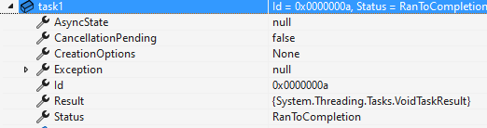
eg the Status property keeps track. eg Canceled, Running,etc
https://learn.microsoft.com/en-us/dotnet/api/system.threading.tasks.taskstatus?view=net-8.0

<- The Result.


Ref:

https://learn.microsoft.com/en-us/dotnet/api/system.threading.tasks.task?view=net-8.0

For these async tasks the total time taken is only slightly more than the longest task.

Three tasks f1, f2 & f3 are set running concurrently.

Task.Delay(4000); (see below) simulates a lengthy process such as file access.

using System.Diagnostics; AsyncMain in CSChapp10.sln on QW. C:\X

static async Task Main(string[] args)
The Task object is used to keep track of whole operation.
{
Stopwatch is used to time the whole operation.)

var sw = new Stopwatch();
sw.Start();

Task task1 = f1(); // Task object will see over the async operation.
Task task2 = f2(); // ie keep track of each one.
Task task3 = f3();
Wait for all tasks to finish.
await Task.WhenAll(task1, task2, task3);

sw.Stop();
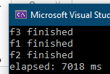
Total time is about the time of the longest task (7000 msec)
The shortest tasks finish first.
f1(), f2() & f3() are said to run concurrently ie they appear to run simultaneously. (Actually, the CPU allocates many short intervals to each one.
await requires async.
.
await here means “wait for me” insofar as the main thread is concerned …
.
… but it doesn’t stop another await asking to be awaited as well.
var elapsed = sw.ElapsedMilliseconds;
Console.WriteLine($"elapsed: {elapsed} ms");

static async Task f1()
{
await Task.Delay(4000);
Console.WriteLine("f1 finished");
}

static async Task f2()
{
await Task.Delay(7000);
Console.WriteLine("f2 finished");
}

static async Task f3()
{
await Task.Delay(2000);
Console.WriteLine("f3 finished");
}
}

Compare the previous Async with this Sync:

Calling Functions without Async NoASync on CSChap10.sln on QW C:\X

using System.Diagnostics;

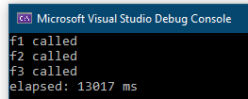
namespace NoAsync
Total time is the cumulative sum of the time for each function!
Functions execute in the order they are called.
{
class Program
{
static void Main()
{
var sw = new Stopwatch();
sw.Start();

f1();
f2();
f3();

sw.Stop();

var elapsed = sw.ElapsedMilliseconds;
Console.WriteLine($"elapsed: {elapsed} ms");
}
static void f1()
{
Console.WriteLine("f1 called");
Thread.Sleep(4000);
}

static void f2()
{
Console.WriteLine("f2 called");
Thread.Sleep(7000);
}

static void f3()
{
Console.WriteLine("f3 called");
Thread.Sleep(2000);
}
}
}

Other uses of async:

Writing files asynchronously I-O … WriteFiles on CSChap10.sln on QW C:\X

static async Task Main()

{
string st = "ed the horse";

var task1 = File.WriteAllTextAsync(@"C:\X\data1.txt",st);
var task2 = File.WriteAllTextAsync(@"C:\X\data2.txt",st);
var task3 = File.WriteAllTextAsync(@"C:\X\data3.txt",st);
var task4 = File.WriteAllTextAsync(@"C:\X\data4.txt",st);

var tasks = new Task[] { task1, task2, task3, task4 };

Task.WaitAll(tasks);

}
}

Total time should be about the same as for each one!

Reading files asynchronously I-O … ReadFiles on CSChap10.sln on QW C:\X

All files are read concurrently ie there is no waiting for one to finish.

namespace ReadFiles
All four text files contain “ed the horse”.
{
internal class Program
{
static async Task Main()
{
var task1 = File.ReadAllTextAsync(@"C:\X\data1.txt");
var task2 = File.ReadAllTextAsync(@"C:\X\data2.txt");
var task3 = File.ReadAllTextAsync(@"C:\X\data3.txt");
var task4 = File.ReadAllTextAsync(@"C:\X\data4.txt");

var tasks = new Task[] { task1, task2, task3, task4 };

Task.WaitAll(tasks);

var content1 = await task1;
var content2 = await task2;
var content3 = await task3;
var content4 = await task4;

Console.WriteLine(content1.TrimEnd());
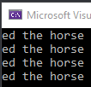
Console.WriteLine(content2.TrimEnd());
Console.WriteLine(content3.TrimEnd());
Console.WriteLine(content4.TrimEnd());
}
}
}

- CPU Intensive (“CPU-Bound”) CPUBound on CSChap10.sln on QW C:\X

For example, a game cannot wait for extended periods of time whilst a positional calculation is performed.

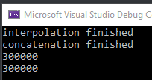
namespace CPUBound
{
internal class Program
{
static async Task Main(string[] args)
{
var tasks = new List<Task<int>>();
Two Tasks run concurrently.
tasks.Add(Task.Run(() => DoWork1()));
tasks.Add(Task.Run(() => DoWork2()));

await Task.WhenAll(tasks);

Console.WriteLine(await tasks[0]);
Console.WriteLine(await tasks[1]);

async Task<int> DoWork1()
{
var text = string.Empty;

for (int i = 0; i < 100_000; i++)
{
text += "abc";
}

Console.WriteLine("concatenation finished");

return await Task.FromResult(text.Length);
}

async Task<int> DoWork2()
{
var text = string.Empty;

for (int i = 0; i < 100_000; i++)
{
text = $"{text}abc";
}

Console.WriteLine("interpolation finished");

return await Task.FromResult(text.Length);
}
}
}
}

Download Web Pages HttpClient on CSChap10.sln on QW C:\X

A web spellchecker that runs quickly with very large documents by leveraging all available cores.

This code gets a large document allwords.txt from a website and uses it to check the spelling of WordLookup.txt (in which a couple of badly spelled words are inserted as a test).

namespace HTTPClient
{
class test
{
struct IndexedWord { public string Word; public int Index; }
public static async Task Main()
{
string wordLookupFile = Path.Combine(Path.GetTempPath(), "WordLookup.txt");
// DICTIONARY wordLookupFile
if (!File.Exists(wordLookupFile)) // Contains about 150,000 words
File.WriteAllText(wordLookupFile, await new HttpClient().GetStringAsync(
http://www.albahari.com/ispell/allwords.txt"));
var wordLookup = new HashSet<string>(
File.ReadAllLines(wordLookupFile),
StringComparer.InvariantCultureIgnoreCase);

// TESTDOC wordsToTest
var random = new Random();
string[] wordList = wordLookup.ToArray();

string[] wordsToTest = Enumerable.Range(0, 1000000) // Set of random nos 0->100000
.Select(i => wordList[random.Next(0, wordList.Length)]) // Use a random no to select a word from the Dictionary.
.ToArray();

wordsToTest[12345] = "woozsh"; // Introduce a couple
wordsToTest[23456] = "wubsie"; // of spelling mistakes.

var query = wordsToTest
.AsParallel() // Parallel threads
.Select((x, i) => new IndexedWord { Word = x, Index = i }) // Put them into the structure.
.Where(x => !wordLookup.Contains(x.Word)) // where NOT true ie not there.
.OrderBy(word => word.Index); // might as well sort them.

//query.Dump();
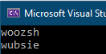
foreach (var v in query)
Console.WriteLine(v.Word.ToString());
}
}
}

A problem with Microsoft web Apps MyBlazorApp on CSChap10


Eg :

When we run it:
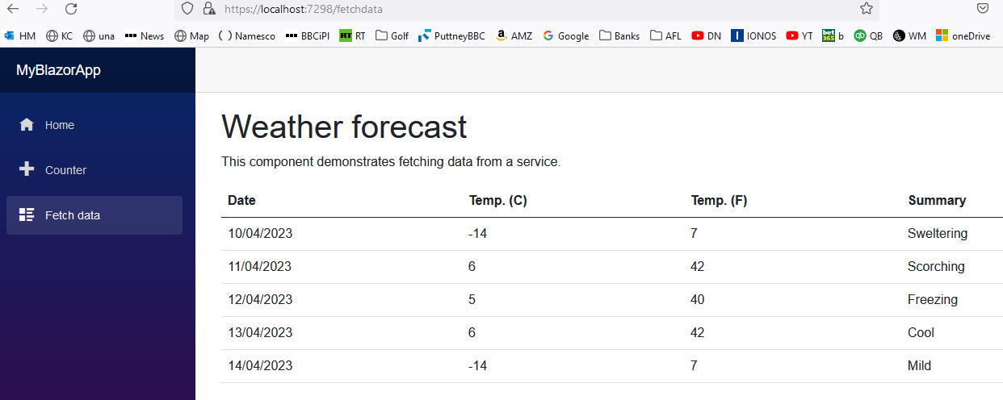
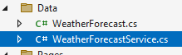
-14 is hardly Sweltering! Etc!

Click ->

Here is the errant code: in

public class WeatherForecastService
{
private static readonly string[] Summaries = new[]
{
"Freezing", "Bracing", "Chilly", "Cool", "Mild", "Warm", "Balmy", "Hot", "Sweltering", "Scorching"
};

public Task<WeatherForecast[]> GetForecastAsync(DateTime startDate)
{

return Task.FromResult(Enumerable.Range(1, 5).Select(index => new WeatherForecast
Random temps between -20 and 55.
{
Date = startDate.AddDays(index),

TemperatureC = Random.Shared.Next(-20, 55),

Summary = Summaries[Random.Shared.Next(Summaries.Length)]
}).ToArray());
}
The problem is here. Random Summaries are (incorrectly) independently randomly assigned with no relation to the 5 random temperatures above.
}

Exercise: Fix it!

Explanation of above:

1.Enumerable.Range(1, 5).Select(index will simply produce index integers index =1->5
for the 5 consecutive days.
2.Date = startDate.AddDays(index),will produce five consecutive dates starting from today.

3.TemperatureC = Random.Shared.Next(-20, 55), will produce five random temps between
-20 & 55.

new WeatherForecast
{ will produce five WeatherForecast objects based upon:
public class WeatherForecast
{
public DateTime Date { get; set; }
public int TemperatureC { get; set; }
public int TemperatureF => 32 + (int)(TemperatureC / 0.5556); // A method!
public string? Summary { get; set; }
}

- The method public Task<WeatherForecast[]> GetForecastAsync(DateTime startDate) is called from: (in FetchData.razor)

private WeatherForecast[]? forecasts; // Declare the object used to receive the data.

protected override async Task OnInitializedAsync()
{
forecasts = await myForecastService.GetForecastAsync(DateTime.Now);
}

ie forecasts is an array of WeatherForecast objects ie of type:

public class WeatherForecast
{
public DateTime Date { get; set; }
public int TemperatureC { get; set; }
public int TemperatureF => 32 + (int)(TemperatureC / 0.5556); // A method!
public string? Summary { get; set; }
}

Solution! BlazorAppDemo in Chap10 on C:\X\

Random r = new Random();

public Task<WeatherForecast[]> GetForecastAsync(DateTime startDate)
{
int nx;

var W = Task.FromResult(Enumerable.Range(1, 5).Select(x => {

nx = r.Next(0, 9); // 0->9 ie 10 forecasts.

return new WeatherForecast // ONE forecast.
{
Date = startDate.AddDays(x), //Consecutive day.

// Corresponding temps -20 -> 55:
TemperatureC = (int)(75.0 / 9.0 * (double)nx - 20.0),

Summary = Summaries[nx] // and corresponding Summaries.
};

}).ToArray());

return W;
}

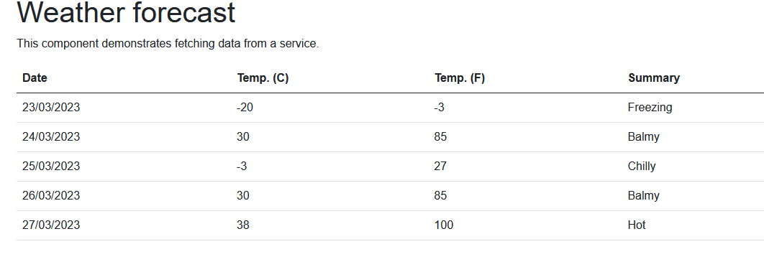

See BlazorAppDemo for an expanded view of the above code.

Advanced note on Async/Wait:
https://www.codeproject.com/Articles/1239585/The-Foreground-Await-Async-Anti-Pattern
async/await will indeed allow concurrency eg we can still type on the keyboard whilst a file is downloaded.
However, apparently the total time taken may not necessarily be reduced!
And… bottlenecks may occur.


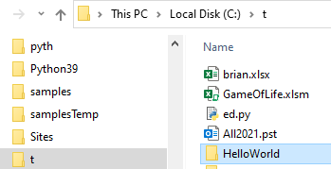
VSCode: To Make Hello World.

Create a Folder 1st:

Start VSCode:

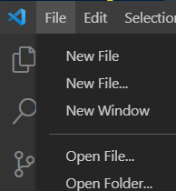

We have called our new folder HelloWorld. This will be the name of our project (and namespace).

Open.

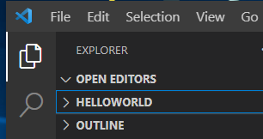

Open a new terminal.
Select our Folder

Creates a new console app called HelloWorld.

At terminal prompt: HelloWorld>dotnet new console --framework net6.0
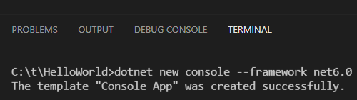

cls will clear the terminal.

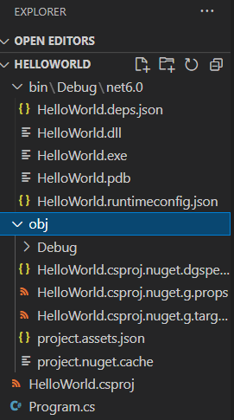

https://channel9.msdn.com/Blogs/dotnet/Get-started-VSCode-Csharp-NET-Core-Windows
https://docs.microsoft.com/en-us/dotnet/core/tutorials/with-visual-studio-code?pivots=dotnet-6-0

(If we are asked to build a Configuration agree and then these 2 files below will appear in this created .vscode folder for debug.)

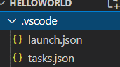

Take a look in Program.cs for our code.

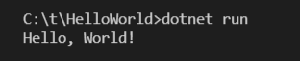
Now: HelloWorld>dotnet run

