C#

Training Manual

Kensington College

Lesson 01: Getting Started: Expressions, Types, and Variables
Lesson 02: Control Statements (If, For, Do etc)
Lesson 03: Structs and Enums.
Lesson 04: Static Methods
Lesson 05: Classes. Methods. Properties.
Lesson 06: Arrays and Strings
Lesson 07: Class Inheritance.
Lesson 08: Overloaded Operators. Indexers, Casting, Delegates, Events, Anonymous Methods
Lesson 09: Exception Handling, Forms, WPF, File Handling.
Lesson 10: Generics, XML, , Linq Lambda Database.
In order to access the source code for this manual visit www.una.co.uk and download the corresponding chapter by chapter eg C#Lesson1.doc.

Good BasicsTutorial: https://www.w3schools.com/cs/index.php (very good)
Also: https://docs.microsoft.com/en-us/dotnet/csharp/

For Mac: 1. Install Visual Studio for Mac Mono or Xamarin:
http://www.c-sharpcorner.com/uploadfile/201fc1/programming-c-sharp-on-mac-one-post-guide/

You Tube: C# Lesson 1: https://youtu.be/DO9YkKNW480
Download Visual Studio Community 2033: https://www.visualstudio.com/free-developer-offers/)

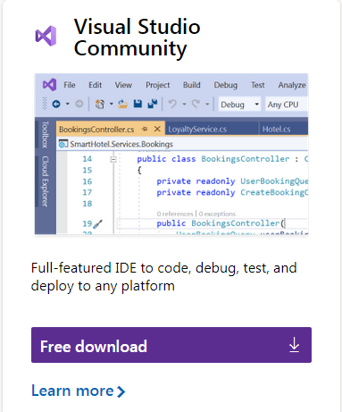

- Click to Download etc.

Text Books

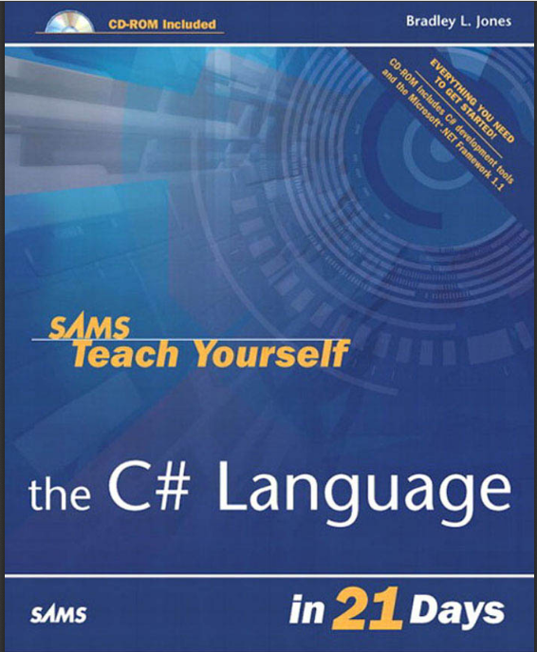

Dated but classic. Easy to follow
but limited eg no Generics.
(Good for exercises.) See .pdf.

Lesson 01: Getting Started: Expressions, Types, and Variables

To Start Programming in C#

- 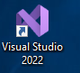From Windows, start Visual Studio.

Reference for C#Lesson1:
Chapters 2 & 3
Teach Yourself C# in 21 days.
Bradley Jones. Sams.

- Double-click.

To Produce a Console Application

- Click File, New Project…

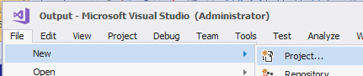

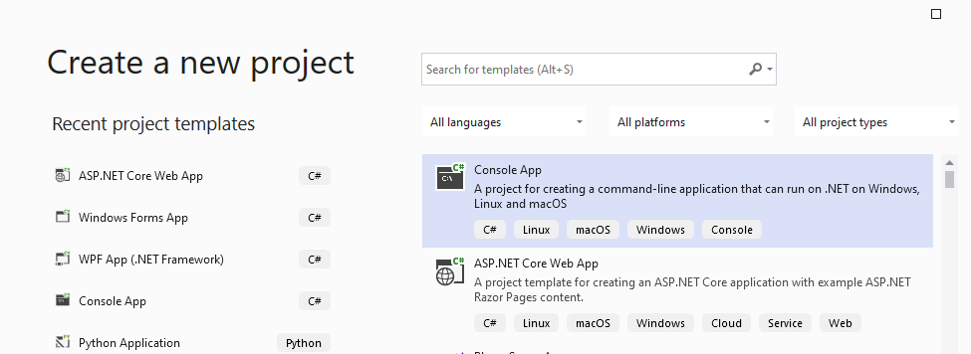
Select C# Console App.

Click Next.

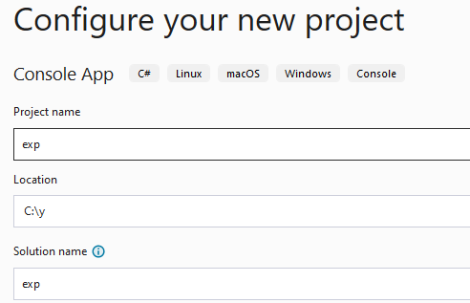

Try to use simple folder eg C:\X
The Solution name (exp in this case) and the Project name (exp in this case) are the same by default. You could change either of them.
(A Solution is a container for the Project, but we will see later that we can have more than one project in a solution eg when we have one project to test another project or when we use one of the projects for a library and the other project to test the library.

Click Next.

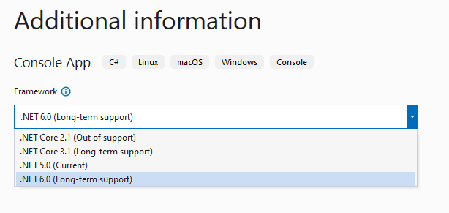

Choose 6.0 (LTS)

.NET 5.0 will reach end of support on May 08, 2022. After the .NET May updates, Microsoft will no longer provide servicing update

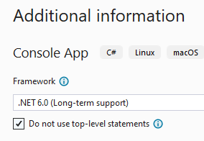
Check this.
We don’t want top-level statements. Microsoft is trying to be helpful and doing some coding for us but its more trouble than not at the moment.

Click Create.
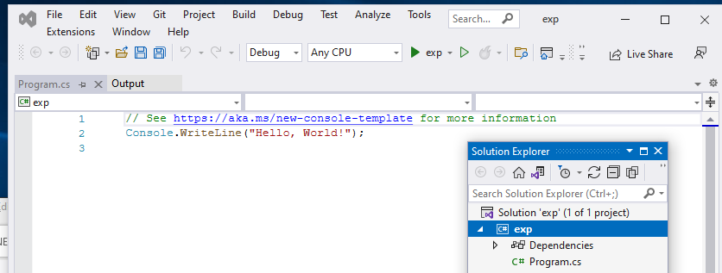
You could if you wish, click the Run button to run your code – to get Hello World printed out on a console but let’s step back a bit.

The name of the solution is exp and the name of the project is exp.

Program.cs is the default name of our source code file.

Paste this code below in place of our code so far code in program.cs:
(You could even leave out this namespace statement – explained later..)
using System;
namespace exp;
class Program
{
static void Main()
{
Console.WriteLine("Hello World");
}
Build it.
}

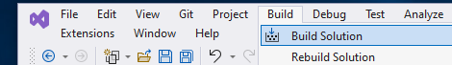

Hopefully, at the very bottom of your screen you will see:


Otherwise, if you have any errors, you will get: eg:

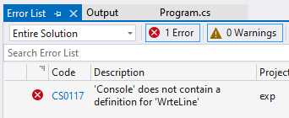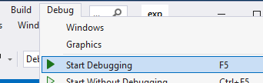
If you double-click, it will take you to your error!
Click Start Debugging (or press F5.) Or better, click the “Run button: 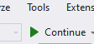

Hello World appears in a Console:
If you’re confident your program is OK, there is no need to build it. You could just click the “Run button”.
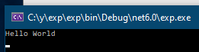

To stop it close the above console window or click 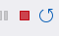

Note that the name of the namespace is the same as the name of the project by default – exp in this case. A namespace is used to organize our code hierarchically and prevent name conflicts. Change it if you wish or delete it! It won’t make any difference! For the moment.
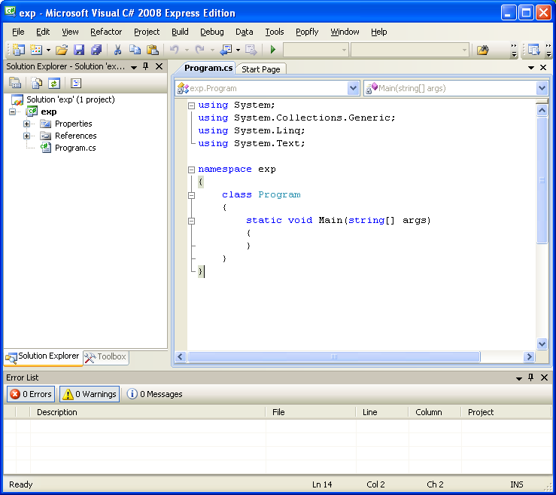

The default Program class always will be produced. You can change this name to anything you like! *
This is where we will write our code!

We will see later than a namespace is important when we have more than one source file. The namespace eg namespace exp is important in “grouping” source code files.
* If you do change the class name it is usual to change the name of the class sheet containing it as well.

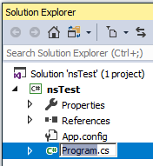

using System;
Note that in days gone by, we needed to include the line Console.ReadLine(); ;
This had the effect of waiting for a key press, which effectively delays the window closing before we can view the result!
class Program
{
static void Main()
{
Console.WriteLine("Hello World") ;
Console.ReadLine() ;
}
}
- Hint: Type svm (static void Main()) then immediately TAB TAB .
static void Main() will appear.
- Don’t forget the semicolons. You may wish to tab them to align them and keep them in line so that you can notice any missing. (Personal preference.)

Make sure that you use the correct case as shown as C# is very case sensitive.
(It won’t automatically capitalize it like VBA does for example!)
If you don’t feel like typing in this code visit www.una.co.uk and download the manual CSLesson1ver1 and copy the code from there.

Make sure that you use the exact type of brackets and braces. () {} []
Spaces don't count!

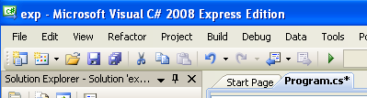
- Note the asterisk at the end of the file name if the file is yet to be saved.

Summary:
No semicolon.

using System;
Always include your code in a class. The name of the class is not important. Classes are not discussed until much later so for the moment just use it.

class Program
{
static void Main()
{
Console.WriteLine("Hello World") ;
Console.ReadLine() ;
}
}
Always include
static void Main()to show where the program starts.
Always include opening and closing curly braces to “contain” the program.

WriteLine for the moment means "Print".

System contains the code necessary for the WriteLine and ReadLine.

If we omitted using System; we would need to qualify the input and outputs as follows:

class Program
{
static void Main()
{
System.Console.WriteLine("Hello World");
System.Console.ReadLine();
}
}
.
According to Microsoft:

The System namespace contains fundamental classes and base classes that define commonly-used value and reference data types, events and event handlers, interfaces, attributes, and processing exceptions. In other words System namespace contains all the code to make instructions like Console.WriteLine("Hello World") work!

Simplest program : (no namespace & using)
class Eds
{
static void Main()
{
System.Console.WriteLine("ed");
}
}
…if we use Debug, Start Without Debugging so that it (the console) doesn’t disappear as soon as it runs..
To Edit our Code
To see the actual program – that the microprocessor sees:

- Locate the .exe file.

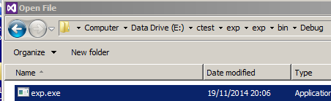.

- Open it : File, Open, File, Open With

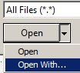

- Choose Binary Editor.

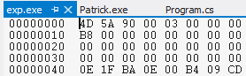

This is hexadecimal which is a shorthand way of writing binary. (See later) This is the actual file of binary electrical impulses (on or off!) which are sent to the microprocessor!

- Double-click on our source code file.

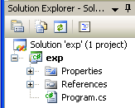



4D -> 77 -> 01001101

Summary: YouTube: CPPLesson1b: https://youtu.be/s4tl9JVGk5o

- // or the /* ……*/ combination can be used as comment indicator.

See Page 73 C# in 21 days for C# Data Types.

- Variables can be int i = 23; Whole numbers
long i = 23; Large integers.
char c = 'a'; Letters eg A or a.
float f = 2.3f; Decimals.
double is the default decimal type.
double d = 2.3; Large decimals.
var x = "ed"; Can be anything

When defining a float we should qualify it thus:float x = 1.23F (or 1.23f)
Variables must be declared in C#.
- A variable can be declared and initialized on one line.

int i = 4 ;
Console.WriteLine(l);
Console.WriteLine(c);
Console.WriteLine(f);
Console.WriteLine(d);
Console.WriteLine(s);
Console.WriteLine(x)

int i = 23;
long l = 23;
char c = 'a';
float f = 2.3f;
double d = 2.3;
string s = "joe";
var x = "ed";

WriteLine ("Hello World") produces a new line as well as printing the line.
Teach Yourself C# in 21 days.
Bradley Jones.
Chap (Days) 2 & 3
Write ("Hello World") does not... but..

Write("Hello World\n"); will also produce a new line.

The use of placeholders: Try this code:
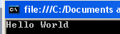
Console.WriteLine("Hello {0}","World");
New feature: This code does the same as above.

string wld = "World";
Console.WriteLine($"Hello {wld}");

The $ is necessary here. It now says that it is an “interpolated string”.

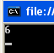Arithmetic operators. eg * means multiply. / means divide etc.

eg: Console.WriteLine(2 * 3);

Exercise: Start with two variables:

int var1 = 3 ;
int var2 = 4 ;

Preliminary; Write code to output these two variables.
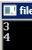

Write a program to swap the two values so that var1 will be 4 and var2 will be 3. Output the results before and after. Hint : Use a temporary variable.

You may wish to use placeholders to achieve this console output:
ie Console.WriteLine("var1 = {0}……….etc

Debugging : Breakpoints and Single-Stepping

Type the code below to include:
int x = 3;
int y = 2 * x;

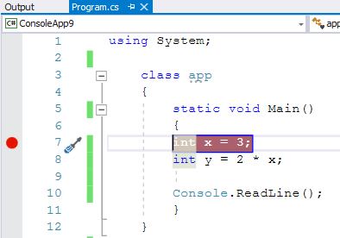
Click in the margin- it must be to the very left. The brown-red break-point appears.

Run the code(F5).
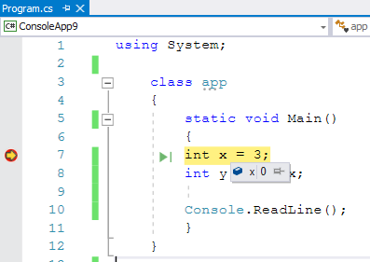
It stops here. This (yellow) line has not been executed yet so ..
.. when you hover your mouse on this x it shows the value of x to be 0.

Press F11 to single-step (or use the Debug menu).

If you now hover your mouse on x it now shows it to be 3 etc.
const

- If you don't wish a variable to change in value , use const in front
eg const double Pi = 3.14 ;
Note that if we try to change the value later in the code, like so:
Pi= 3 ;
We will get an error message like so:
Error 1 The left-hand side of an assignment must be a variable, property or indexer

If a variable is declared eg:
int j;
and then not assigned ie we don’t say
eg j = 1; then a warning is flagged! (Green squiggly lines 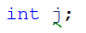

Type Casting page 105-106 C# 21 Days.

is the conversion of one type to another
eg
int i = 5;

float flt = (float)i;

Note that no information is lost here so the compiler does not complain.

The above is an explicit conversion.

float flt = i; is implicit. - but no error is flagged.

Type Safe

C# is a type safe language.
This means that an error will be flagged if illegal type conversions are attempted.
(Intentionally - or otherwise as shown here:

using System;

class app
{
static void Main()
{
double d = 1.1;
This implicit conversion is forbidden since data will be lost.
int i = d;
}
}

The compiler thinks that we may not know what we are doing so won’t allow it. Very considerate.
We get this syntax error (ie even before compiling) :

Error 1 Cannot implicitly convert type 'double' to 'int'.

Of course we could explicitly cast to show the compiler that we know what we are doing:
int i = (int)d;
Then the compiler allows it and there is no error message.

Similarly, an error message will appear if we illegally try to pass a wrong type to a method (see later).

The type is resolved at run-time (as distinct from compile time.)
When we use var as the type, the type of the variables declared is based on the value that it is initialized with.
using System;
class app
{
static void Main()
{
var s = "ed";
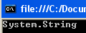
Console.WriteLine(s.GetType());

As we can see, s is now an array of type integer.
}
}
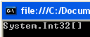
This implicit typing can also be applied to arrays. (Arrays done later)

var s = new []{1,2,3};
Console.WriteLine(s.GetType());

The Operator (Remainder Operator)
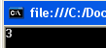
- Try this.

Console.WriteLine(23 % 4);

ie what's left over after 23 is divided by 4 page 92 C# 21 Days.

Integer Division Take care: eg.
DANGER!

int j = 13, k = 4;

Console.WriteLine(j/k); not 3.25 !

Exercise: Write code to convert seconds to min and secs eg 175 sec -> 2 min and 55 sec.
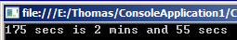

Hint: Use % and integer division.

Increment Operators Page 94 C# 21 Days.

- Try these:

1. using System;
class Program
{
static void Main()
{
int j = 1;
j = j + 2;
Console.WriteLine(j);
}
}

2. Replace j = j + 2;

with j += 2 ;

then the result is the same.

3. Try

int j = 2 ;

++j ;

++j and j++ are equivalent to j = j + 1.
See C# in 21 days page 93 for /= etc.

The Difference Between ++j (prefix) and j++ (postfix)
j is assigned to k and then incremented.
int k, j = 2 ;
k = j++ ;
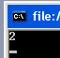Console.WriteLine(k) ;

j is incremented and then assigned to k.
int k, j = 2 ;
k = ++j ;
Console.WriteLine(k) ;

Similarly consider
(This subtle difference between ++j and j++ does not usually concern us.)
Console.WriteLine(j++) ; and

Console.WriteLine(++j)
Raising to a Power

Math.Pow(3,2) -> 9 ie 3²= 9.

To Open a Project

- Choose File, Recent Projects or look at the recent file list presented.

- Click File, Open Project.
If your workspace is not recent…

Help
Probably the best way to get help is to Google.

Exercises:

For practice exercise: Page 115 C# in 21 days (as below).

Or see:

https://techstudy.org/csharp/Csharp-Program-to-Add-Two-Numbers/
etc.

Exercise.

Write code which will convert Centigrade to Fahrenheit.

F= 9/5*C + 32

Exercise:
3. Write a program that calculates how much money you’ll end up with if you invest an
amount of money at a fixed interest rate, compounded yearly.
Use use the compound interest formula. A(1+r)^{n}.
ie A * Math.Pow(1+r,n). Don’t forget that pow is expecting a Double.
eg r=.05; // 5% interest.

To write to 2 decimal places use eg : Console.WriteLine("{0:F2}",35.5645); -> 34.56
F means Fixed point
For others see : https://learn.microsoft.com/en-us/dotnet/standard/base-types/standard-numeric-format-strings

C#3.0LibertyAnswersAndSolutions.pdf.

Making a Solution with many Projects

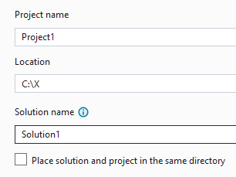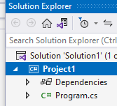
Don’t check this – unchecked really means “Allow us to call the project something different from the solution.“

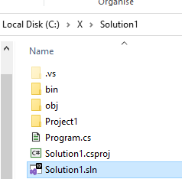
If we open the solution, then we can set the respective projects as startup.

Note that the namespace will be as per the name of the project.

namespace Project1
{

If we rename the project it only renames the .csproj file
- not its namespace.
The stack and heap are just different locations in memory.

Generally speaking, when you declare a local variable, you are declaring the variable on the stack. Therefore, a value type's value will be on the stack.

A reference type's reference will be on the stack, but the object instance is still on the heap.

