Lesson 07: Inheritance library Extension Methods Interfaces

1 :
2.
3. constructors
four override
five declareAssign
six Abstr Sealed.
seven Extension
eight Interface

YouTube CSInheritance.avi https://youtu.be/4ISrTz14rzw
Brief basics revision library call constructors virtual override methods Chapter7.sln

Inheritance enables you to create new classes that reuse, extend, and modify the behavior that is defined in other classes.
When a class is derived from a base class, the new derived class will have all the characteristics of the base class and some of its own.

Here is a class and class derived from it:

Make this simple class called Part which has only one data element i.

myDerived is the name of the class which derives from it.

using System;
Keep in mind that this Part class could be in a (compiled) library.
public class Program
{

public class Part
{
Use protected int i; instead of private int i ; when we know we will derive classes from it.
protected means that this data (in this case i) will then be available to methods (ses later) in the derived class as well. If I were private it would not be.
protected int i;

public Part()
{
i = 1;
}
}
myDerived : Part indicates that Derived inherits from Part.
Note the single colon.

public class myDerived : Part
{
}

static void Main()
{
myDerived d1 = new myDerived();
}
}

Single-step the previous program.

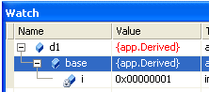
d1 inherits i

- The Need for inheritance: runArithLibrary in Chapter7.sln
C:\X\Chapter7
Let’s say we had a simple class called Arith. It contains a method called add.

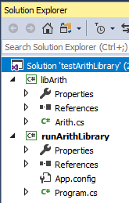
libArith
Make the library libArith
and call it from the Console App called runArithLibrary. For convenience, put both in the same solution: (Add, New Project)

namespace libArith
{
public class Arith
{
public int Add(int i, int j)
{ return i + j; }
}
}

Program.cs

using System;
using libArith;

namespace runArithLibrary
{
class Program
{
static void Main()
{
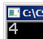
Arith a = new Arith();
Console.WriteLine(a.Add(3,1));

}
}
}
Here is our compiled library.

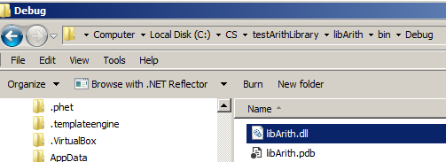

- Exercise:

Make a Derived class called DevArith containing a method called Sub (similar to Add) which subtracts two numbers. Place it inside our console app runArithLibrary.

Create a new derived object: DevArith d = new DevArith(); and use it to call our Sub method.:

Solution: runArithLibrary in Chapter7.sln

To Add a Method using a derived class:

We now want to be able to subtract two number.

In our console app we make another class called say DevArith which is derived from Arith like so:

using System;
using libArith;
Add this code (grey) to our console app.

namespace runArithLibrary
{
class Program
{
DevArith derives from Arith.
DevArith will contain all of the characteristics (properties, methods etc of Arith – and more!
public class DevArith:Arith
{
public int Sub(int i, int j)
{ return i - j; }
}

static void Main()
{
Arith a = new Arith(); // or DevArith a = new DevArith();
Console.WriteLine(a.Add(3,1));


DevArith d = new DevArith();
Console.WriteLine(d.Sub(3, 1));

}
}
}

Including a no-Parameter Constructor in the Derived Class

- Also include a default constructor in the derived class as shown below.

Using single-step we will show that when a derived object is created, both default constructors in the derived class and the base class are called.

using System;
public class app
{
public class Part
{
protected int i;

public Part()
{
i = 1;
}
}
The 0-parameter constructor of the derived class is called which immediately diverts to the 0-parameter constructor of the base class where i is set to 1.
It then returns to the derived class to set j = 2.

public class myDerived : Part
{
3
2
private int j;

public myDerived()
{
j = 2;
}
}
1

static void Main()
{
myDerived d1 = new myDerived ();
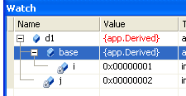
}
}

Using the debugger, you should find that
d1 has both j = 2 and i = 1.

- One-Parameter Constructors DerivedConstructors in Chapter7.sln

using System;
- Include a one-parameter constructor in the derived class as shown. We now have a 1-param constructor in both.
public class app
{
public class Part
{
protected int i;
- Confirm all of this by single-stepping.

public Part()
{
i = 1;
The no-parameter constructor is also called in the base class to set i to 1 in this case.

}

}
public class myDerived: Part
{
private int j;

public myDerived()
{
j = 2;
}
public myDerived(int _j)
{
j = _j;
Of course only the one-parameter constructor of the Derived class is called to set j to 3.

}
}

static void Main()
{
myDerived d1 = new myDerived (3);
- …and explicitly call it using a base class object as follows. (Insert the line shown below in Main().

Part p1 = new Part(4) ;

The result will be:

}
}
- Now also include a one-parameter constructor in the base class…:

public Part(int _i)
{
i = _i;
}
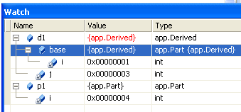
To Call the Base Class 1-Parameter Constructor (as well) from the 1-Parameter Derived Class Constructor

… i being given the value of 4.
Now the base class 1-parameter constructor is also called to set i to 4.
- Single-step.
You should see the base class 1-parameter constructor being explicitly called and..

using System;
- Modify the previous code so that it appears as shown here and single-step it.
public class app
{
public class Part
{
private int i;

public Part()
{
i = 1;
}

public Part(int _i)
{
i = _i;
}
}
public class myDerived : Part
… immediately the one-parameter constructor of the base class Part class is called.

2
{
private int j;

public myDerived()
{
Note that base is a generic term. It is not the name of a class. It means one class higher up the tree (not necessarily the base class!)

j = 2;
}
public myDerived(int _j): base(4)
{
j = _j;
}
The one-parameter constructor of the Derived class is called first but...

1
}
static void Main()
{

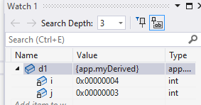
myDerived d1 = new myDerived(3) ;
}
}

So, the net effect is that j is set to 3 and i is set to 4.

Summary: One parameter Base Class Constructors:

The base class one-parameter constructor can be called either using a base class object Part p1 = new Part(4) ; or explicitly called from the derived class as above:
public myDerived(int _j): base(4)

Exercise:

Make a 2-parameter constructor in the derived class and call it using a derived object.

- Overriding Methods Methods in Chapter7.sln
If we place a method with the same name in the derived class as in the base class that method overrides it.

Virtual /Override
If it is likely that a method in a base class is to be overridden in a derived class then we must mark it as virtual.

using System;

public class app
- Mark the base class method as virtual. This means “overriding will be possible”.
{
public class Part
{
public virtual void push()
{
Console.WriteLine("base");
Technically (see later) virtual allows the decision as to which method is to be used to be resolved at run-time. This is called late-binding)
}
}

public class Derived : Part
{
- Mark the derived class method as override.
This means it will override the base class push() method.
public override void push()
{
Console.WriteLine("derived");
}
}

static void Main()
{
Derived d1 = new Derived() ;
d1.push();
}
If we forgot to use virtual then we can use new but there are then disadvantages – the method called depends on the assigned type rather than the declared type – see over.
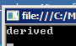
}

The method of the derived class is called.

Include:
Part p1 = new Part() ;
p1.push() ;
then of course the base class method would be called.

When we use virtual don’t have to provide an override method in the derived class.
It is optional (c.f. abstract methods which we will see later where it is compulsory).

If we had a hierarchy of such derived class methods, then the "most derived" would be called.

- Show that this is true. Remove the push method from the derived class in the original code at the top of this page (or comment it). You should see that the push method in the base class gets called.

Override Property Accessors In Inheritance

Since property assessors are considered methods we could override them:

using System;

public class app
{
public class Part
{
public int i
{ get; set; }
}
public class Derived : Part
Single-step to see that (only this property is accessed.

{
public override int i
{ get; set; }
}

static void Main()
{
Derived d1 = new Derived();


d1.i = 1;

Console.WriteLine(d1.i) ;
}
}

Depending on your settings, if you want to see it called whilst single-stepping.)
Use the "expanded" form of the property:

private int _i;

public int i
{
get { return _i; }
set { _i = value; }
}

- Declared and Assigned Types DecAssigned in Chapter7.sln

Note that the declared type and the assigned types don't need to be the same.
Of course this could be done in two lines:
Part p ;
p = new Derived() ;

Part d1 = new myDerived();
The Assigned type
The Declared type

(The assigned type is often referred to as the actual type.)

If instead of:
No difference in which declared type we use. It’s the assigned type which is important.
Derived d1 = new Derived();
d1.push();
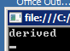
we had:
Part d1 = new Derived() ;
d1.push();

It makes no difference - the result is the same:

The overloaded method which gets called depends upon the assigned type not the declared type. Just as well! See below:
When in practice would we ever have the assigned type different from
the declared type?
Ans: eg when we have an array of Part objects as this example:
using System;
public class app
{
public class Vehicle
{
public virtual void push()
{Console.WriteLine("Vehicle");}
}
public class Car : Vehicle
{
public override void push()
{
Console.WriteLine("Car");
}
}
public class Van : Vehicle
{
public override void push()
{
Console.WriteLine("Van");
}
}
static void Main()
{
Vehicle [] v = {new Car(), new Van()};
v[0].push();
v[1].push();
}
}
Declared type is Vehicle.
Assigned type is Car etc.
The method which gets called depends on the assigned type.
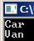
Fortunately, the method called depends on the assigned type (Car and Van) even though the declared type is Vehicle.
Think about it. It is more convenient to declare a “generic” type using the declared type.
new

What if the base class code has already been written and compiled into a library and does not have the keyword virtual?
new to the rescue but with new we will now find that the method which is called now depends on the declared type. (Which is not very convenient.)

using System;
public class app
{
public class Part
{
public void push()
{
Console.WriteLine("base");
}
}

public class Derived : Part
new literally creates a new method in the derived class rather than overriding the base class method.

{
public new void push()
{
Console.WriteLine("derived");
}
}
The base class method is now called in each case since the method which is called depends only on the declared type - the base class Part in this case.
static void Main()
{
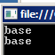
Part p1 = new Part();
p1.push();

Part d1= new Derived();
d1.push();
Exercise: Show for the Vehicle example from the previous the effect of not using virtual and using new for the derived method.

}
}

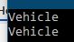
Of course, if we had

Derived d2= new Derived();
d2.push();

then the derived class push() would be called because d2 is a declared type.

Don't confuse the 2 uses of new: If we google C# new we can get: In C#, the new keyword can be used as an operator or as a modifier. new operator Used to create objects on the heap and invoke constructors. new modifier Used to hide an inherited member from a base class member.

If we attempt to write our code forgetting to use the word new with the overriding method - it still

Exercise: Finance in Chapter7.sln

Here is some code to find the mean of 3 numbers passed as an array.
Make a derived class called myVariance to find the variance of the 3 numbers and print it out.
(You may or may not incorporate the mean code in your variance code in order to do the variance calculation.)

using System;

public class Program
{
public class Finance
Finally put this class into a library?
{
private double[] _s;

public double[] s
{ get { return _s; }
set { _s = value; } }

public Finance()
{ s = new double[5]; }

public Finance(double[] _st)
{
s = new double[_st.Length];
_st.CopyTo(s, 0);
}
public double mean()
{
double sumS = 0.0;
int x = s.GetUpperBound(0);
for (int i = 0; i <= s.GetUpperBound(0); i++)
{ sumS = sumS + s[i]; }
return sumS / (double)s.Length;
}
}
static void Main()
{
double[] arr = { 1.0, 2.0, 3.0 };
Finance f = new Finance(arr);
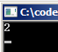
double m = f.mean();
Console.WriteLine(m);

}
}
Hint: Method to find the variance:

public double variance()
{
//Find the mean first
double mn = this.mean() ;
double sumS = 0.0 ;
for (int i = 0; i <= s.GetUpperBound(0); i++)
{
sumS = sumS + s[i]*s[i] ;
}
double n = (double)s.Length ;
double var = sumS / n - mn * mn ;
return var ;
}

6. Abstract Classes Abstract in Chapter7.sln

If a class is made abstract then we can only derive from it. We can’t make objects from it.
Here is an abstract class called Shape.

using System;
public class app
{
For a class to contain an abstract method it must itself be abstract.
All the methods in an abstract class must be marked abstract.

abstract public class Shape
{
abstract public double Area();
}

public class Rectangle:Shape
(Of course we must use override in the derived classes.)

.
{
override public double Area()
{
return 1.00;
Returning 1.00 is not very clever but it gets our code working. Eventually we’d like to return an area specified by l & w. (length & width.) See next page.

.
}
}

static void Main()
{
We can create an object of the derived class of course but…
Rectangle r1 = new Rectangle();

//Shape s1 = new Shape(); // Error!

Console.WriteLine(r1.Area());
}
…we can’t create an object of an abstract class.
}

Question: So why bother?

Answer: Since it doesn’t make sense to create a Shape object. We would prevent others creating a Shape object!

Exercise: Make some more derived classes Circle and Triangle besides Rectangle. Make sure that they also each contain an area method.
(Their area method could just return 1.00 as above for our rectangle for the moment to get it working) Remember that we must provide Area() methods.

Marking a class abstract is a way of demanding that any derived classes MUST implement a particular method.

Rules: An abstract method (in the base class)
1. Cannot have any implementation.
2. MUST be overridden.

Exercise: Make code to return the area of a rectangle given its length & width.

Solution:

using System;
public class app
{
abstract public class Shape
{
abstract public double Area();
}
public class Rectangle : Shape
{
protected int len;
protected int wid;

public Rectangle(int _len, int _wid)
{
len = _len;
wid = _wid;
}
override public double Area()
{
return len * wid;
}
}
static void Main()
{
Rectangle r1 = new Rectangle(3,4);

Console.WriteLine(r1.Area());
}
}

Exercise: Do the same for a circle ie find its area given a radius.
Use pi times r squared.

Sealed Classes C#2008 page 191

A sealed class cannot be derived from. Making a class sealed is another "safety technique".

using System;
- Type sealed here.
This program will then not build
class app
{
sealed class Square
{
}
Error: this sealed class cannot be derived from!

class Derived : Square
{
}
static void Main()
{
}
}

We can also seal a method.
See page 192 c#2008.

For example, if we had a Square class derived from Rectangle derived from Shape) it would not make much sense to derive from Square ie we would make it sealed because it is at the "end of the tree" ie we won’t ever derive from it.

Exercise Make an Employee class as per page 377 C# Book.
Base class called Person
Derive Employee & Contractor

Interesting application of Inheritance in Unity: C:\X\ unity-pong-tutorial-main
Paddle.cs
public class Paddle : MonoBehaviour // Sets properties for each paddle.
{
public float speed = 8f; /// Vertical speed of the Paddle!

ComputerPaddle.cs
Public class PlayerPaddle : Paddle
{ // The LHS paddle. Move it with keys W & S.
public Vector2 direction { get; private set; }

PlayerPaddle.cs
public class ComputerPaddle : Paddle // The RHS paddle. Computer controlled.
{
public Rigidbody2D ball;

7.Extension Methods Introduced in C# ver 3.0. ExtensionMethods in Chapter7.sln

Extension Methods are a bit of an "afterthought". After the class code has been written and compiled it allows us to provide extra functionality (as does a derived class).
They enable us to write extra methods for a class but outside the class! This is useful if we do not have access to the class code.
For example, let’s say that we wished to provide functionality to square the i member variable below. We could indeed make a derived class to do this as we have seen but another way is to make an extension method.

We will then be able to call our method like so: p1.square(); as if it were a class member function!

using System;

namespace ed
{
public class Part
This class is placed outside our app class!
{
public int i { get; set; }
}

class app
{
static void Main()
{

Part p1 = new Part() { i=2 };
This calls the square() method which is "external" to the class.
double d = p1.square();

Console.WriteLine(d);

}
}
We create a separate (static ) class ie outside! our “main” class”.

public static class test
{
square() is an extension method.
public static double square(this Part p)
{
return p.i * p.i ;
}
}
An extension methods must have
1 A static class
2 A static method.
3 this.
We can use extension methods to add functionality to a class without altering the class or deriving from it.

}

Take care: Don’t enclose extension methods in main class
(app in this case) otherwise you’ll get this error:
Error 1 Extension method must be defined in a top-level static class; test is a nested class

Exercise: Make an extension method to cube the 2 in the previous example and call it like this:

d = p1.cube(); Console.WriteLine($"The cube is {d}");
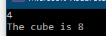

We are more likely to encounter extension methods when using Linq (See later.) eg.

static void Main()
{
string[] fruits = { "apple", "banana", "mango", "orange", "grape" };


bool b = fruits.Contains("mango");

Console.WriteLine(b);
}
The Contains() extension method is attached to the array by means of a dot.

https://docs.microsoft.com/en-us/dotnet/csharp/programming-guide/classes-and-structs/how-to-implement-and-call-a-custom-extension-method

List<>

Prelim: See Page 7-8 (and exercises.) CSLesson10.docx

- Interfaces Interface in Chapter7.sln

Watch this: https://youtu.be/h46kfnlDZtw Uses IComparer

At the end of the day an interface is used by your code to communicate with C# (ie its Framework). This communication is two-way.

For an example fast-forward to ExampleOfInterfaceInPractice

Then take a look at a basic interface below.

An interface looks like this:
- Always use the keyword interface.
An interface is a specification
Interfaces are notorious for being difficult to understand. The reason being, that we expect them to DO something. They don’t. They just specify eg they may specify what methods that a derived class must implement.

using System;

public class app
{

public interface Shape
{
2. This interface code specifies that any class which implements it not only should but must implement an Area() method.

3. Use a colon to show that Circle implements Shape and promises to abide by its rules.
double Area();
}

public class Circle : Shape
{
public double Area()
{ return 1.00 ; } // 1.00 for the moment.
}
An Interface is similar to Abstract class.
static void Main()
{
}
}

This program will run (and not do much) but if you remove (or comment out) the Area() method from the class and see that it will immediately complain ie we don’t have to wait until it runs to find the error!

Exercise Make a Square class which would also specify the Shape interface.

The Square class need also provide an Area method – which calculates the area. (L squared)

Write the Area method for the Circle using pi * R squared.

using System; Shape in Chapter7.sln.

public class app
{
public interface Shape
{
double Area(double R);
}
Circle must have an Area method.

public class Circle : Shape
{
Remove (maybe comment it out) the Area() method from a class and see that it now won’t even build. You get error message.

public double Area(double R)
{
return 3.14 * R * R;
}
}
Square must have an Area method.
public class Square : Shape
The Circle and Square classes have been “categorized” as Shapes. In a way an interface is the opposite of deriving.
{
public double Area(double L)
{
return L * L;
Of course we could just create an ordinary object (without s = new Circle());
Circle c = new Circle { r = 3.0 };
}
}
(The method which gets called depends on the (assigned) type – in this case Circle.)

static void Main()
{
Shape s;

s = new Circle();
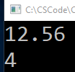
Console.WriteLine(s.Area(2.0).ToString());

s = new Square();
Console.WriteLine(s.Area(2.0).ToString());

and in this case Square.
}
}

Once again, we need to keep in mind that an interface eg

public interface Shape
{
double Area(double R);
}

is a way we can organize our code. Maybe consider it as a specification to which our code must conform.

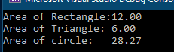
Lambda functions are abbreviated functions.
So for the above we could use
eg public double Area(double L) => L * L;
public double Area(double R) => 3.14 * R * R;
Use these instead if you wish!

Interfaces are used extensively in .Net framework (but we don’t get to see them).
Interfaces are used to facilitate communication between our code and the .Net framework (ie “C#”).

Most importantly they formalize communication from the Framework BACK to our code.

For example, let’s say that we wanted to call the Framework’s Sort function like this:

Array.Sort(p); where p is an object of type Part that we wish to sort.

class Part
{
private int i
private int j
*Specified by an interface called IComparable buried deep within C#.
}

We have a problem. Do you want C# to sort on i or j?

We need to tell it through a specified* method called CompareTo() in this case.

public int CompareTo(object obj)
{
Part obj2 = obj as Part;
return this.i.CompareTo(obj2.i);
}

Our complete code looks like this (See next page):

------------------------------------------------------------------------------------------------------------------------------

http://msdn.microsoft.com/en-us/library/system.icomparable%28v=vs.110%29.aspx
NET framework classes (C#).
Interface. IComparable in this case specifies we must provide a function called CompareTo().

CompareTo() function. Tells C# which variable i or j that we wish to sort upon.
- Sort() function

To sort using the IComparable interface: Interface in Chapter7.sln

This program sorts the values of i. Todo: Repeat this using generics : https://learn.microsoft.com/en-us/dotnet/api/system.linq.enumerable.cast?view=net-8.0 etc

Include this interface specification.
Single-step this and view i in the Locals window. this. You may need to ignore nullability warnings. It should sort on i.
.
using System;
class app
{
1. We implement IComparable.* (See box at bottom right.)
class Part:IComparable
{
public int i {get; set; }
2. If we look in the Help for IComparable (See below)
we will see that C# expects us to provide a CompareTo function. We are under contract to do this. C# will be calling back to our code and it better be there!

public int j
{get; set; }

public int CompareTo(object obj)
{
CompareTo allows us to specify what we want to compare with what.
We are here comparing our i to the obj2.i which has been passed back from the framework. Note that CompareTo calls itself.

Part obj2 = obj as Part;
return this.i.CompareTo(obj2.i);
}
}
static void Main()
{
Part[] p = new Part[3] { new Part(), new Part(), new Part() };
(You may need to ignore nullability warnings - green squiggly lines.)
It should sort on i.
.
p[0].i = 12; p[1].i = 10; p[1].i = 16;

p[0].j = 12; p[2].j = 14; p[2].j = 10;
3. Sort calls the C# Sort code to sort based upon the comparison method CompareTo that we provided above.

Array.Sort(p);
}
}
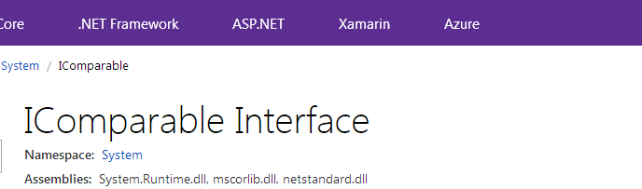
- Note that CompareTo() is recursive and will actually be called 5 times (ie 5 comparisons) to sort 3 numbers.
Help:

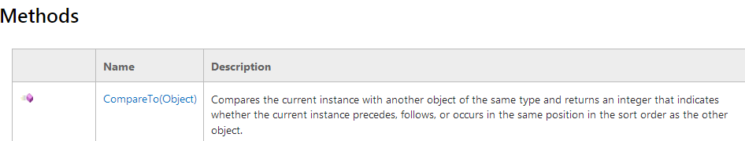
- If you follow p in the Locals window you will see that the array of objects is sorted on i.

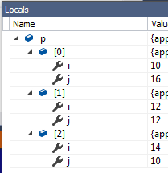
* Using :IComparable allows us to have 2-way communication with C#. In this case we signal to C# that we want to use the Sort method – but we must therefore provide some indication on how we wish to sort by means of a CompareTo method ie we are contracted to do this. Not providing the stipulated methods will cause an error.
You will see that they have been sorted on i. (10, 12, 14)

An interface is a specification.
In this case, an interface is a contract between us and the .Net framework’s Sort() method.
Cw

The interface in this case Interface will allow us to use extra functionality in our code eg Sort() (We must include the IComparable interface in our code) and foreach (we must include the IEnumerable interface in our code).

More importantly interfaces are used extensively by C# (ie by the Framework).
The Framework uses them to make sure that the code we write confirms to its specification!

Eg if we use the framework’s Sort() function in our code we must use code that behaves!
If we use its Sort to sort an array of integers we don’t need to think about the framework’s interfaces but what if we want to sort our custom type which contains integers.

eg
public class Part
{
private int i;
private int j;
}
We could create objects and initialize the integers and then call the framework’s Sort() eg Array.Sort(p); but just a minute – which integer do we want to sort on? i or j?

Let’s take a look at the framework’s Sort() method.

What happens when we call it?

It calls back to us and asks for a particular function – the CompareTo() method.

public int CompareTo(object obj)
{
Part obj2 = obj as Part;
return this.i.CompareTo(obj2.i);
}

In this function it expects to find information on how to sort our class.
i? j? ascending/descending? What if we don’t provide it? Crash.

We therefore need a way of ensuring that we provide it in the first place – at build time – an interface!

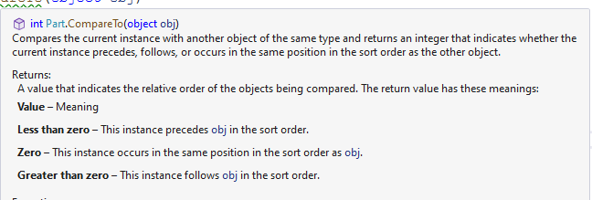
Exercise:
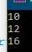
- Write code to print out their values after sorting.
Start with this foreach (var x in p)
{

- Recall in our previous code - in order to sort by i in ascending order we had:

return this.i.CompareTo(obj2.i);

How do we sort descending rather than ascending? Ans:
These have been swapped.

- Now return obj2.i.CompareTo(this.i); will sort in descending order.
(Take a look at the Locals window as above to confirm that they have indeed been sorted in descending order or use the printout code as per the top of this page.)

4. Sort on j.

- What happens if we don’t have a CompareTo method in our class when we implement IComparable? Impossible - we must provide one! Try removing it and you will get an error like this: Error 1 'app.Part' does not implement interface member 'System.IComparable.CompareTo(object)'

If an Interface specifies certain methods (see the Help for which methods are specified) then our class MUST provide implementation for ALL of these nominated methods.

Remember: We can’t provide any implementation for our methods in the interface. We can only specify their signatures.

eg interface Shape
{
double Area(){};
}

Passing an interface type

We can better organize our code ie make it more structured by using a custom interface.

We can determine the method which gets called according to the TYPE of the object passed.

The method (Area() in this case) which gets called depends upon the type (Circle or Square).

using System;
Implementing a Shape interface ensures that ONLY types of either Circle or Square ie Shape types can be passed to the CalculateArea function.

public class app
{
public interface Shape
{
double Area(double R);
}

public class Circle : Shape
{
public double Area(double R) => 3.14 * R * R;
}
Which Area() method gets called will depend upon the type ie Square or Circle.

public class Square : Shape
{
public double Area(double L) => L * L;
}

public class Calculator
{
public double CalculateArea(Shape s, double r) => s.Area(r);
Note the =>. This indicates a lambda function. A lambda function (discussed later) is basically a shorthand way of writing a conventional function.
static void Main()
{
Calculator cal = new Calculator();

double A1 = cal.CalculateArea(new Circle(), 2);

double A2 = cal.CalculateArea(new Square(), 2);

Console.WriteLine("Circle: {0} Square: {1}", A1, A2);

Console.ReadLine();
}
}
}

This technique is tidier than using say a Select Case to choose the method called.
Design Pattern:
It is more organized passing a TYPE rather than modifying a Select Case (to select the appropriate function) for example.
We simply add a new (Concrete) CLASS eg Triangle( Equilateral).

https://scottlilly.com/c-design-patterns-the-strategy-pattern/

