Lesson 08: Lesson8.sln CSChap8.sln C:\X\CSChap8\CSChap8

Overloaded Operator
delegates https://youtu.be/UKJ8HNdZ8h4
Events
Anonymous Methods
Windows Forms func https://youtu.be/uFskDyUWoH4
Do Lists of Chap

Overloaded Operator

C#OverloadedOperatorPart1 https://youtu.be/0SEda2GgUtM + 8:42
C#OverloadedOperatorPart2 https://youtu.be/PN1CzQAVQyQ > < += ++ 5:51

We have seen that we can very easily put 2 objects equal to each other.
eg p1 = p2.

but we can’t as yet add 2 objects.

With operator overloading we can - so we could have

p3 = p1 + p2

We will now see that we are able to thus give the plus sign a new meaning - when applied to objects ie we overload the + operator.

We now wish to give significance to adding p1 and p2.
In our case we wish p3 = p1 + p2 to signal that we wish to add individual respective data elements i in this case ie we need to give a new meaning to the + operator.

Code for all these projects in this chapter: CSChap8 on C:\X on QW.

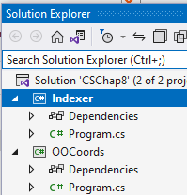

Code at https://github.com/edthehorse/jack/upload/main
Download zip and unzip it

using System; OO in Lesson8.sln OOp in C:\X\CSChap8\CSChap8

class app
{
class Part
{
public int i
static is used ie it is a function in its own right.)
A Part object is returned.
{get; set; }

public static Part operator +(Part a,Part b)
{
Part p = new Part();
(Note that we could replace these 3 lines with: return new Part{i= a.i + b.i};
or return new Part(a.i + b.i);
but in the last case we would need to have a 1-parameter constructor in our class - and then we would need to make sure that we had a 0-parameter constructor as well!)

p.i = a.i + b.i;
return p;
}
}

static void Main()
{
Part p1 = new Part(){i=1};
Part p2 = new Part(){i=2};
Part p3 = new Part();
p3 = p1 + p2;

Console.WriteLine(p3.i);
}
}
The overloaded + operator is a type of function/method.
The overloaded operator function in our case gets called when the + sign is encountered between two objects of type Part.
One of the features of C# is the many ways that it can automatically call a function!

Exercise:

1. Overload the – sign so we can have p3 = p1 - p2;.

Note that += and -= operators are automatically also now overloaded.
ie we can just use p2 += p1 ; Similarly, for p1 -= p2 ; // Try them.

Similarly, we only need overload the – operator and the -= takes care of itself. Try them.

If it doesn’t single-step into the overloaded operator code: Tools, Options and uncheck:

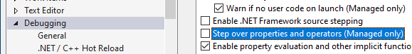

Example: Add Coordinates CooordsDemo.sln in Lesson8 OOCoords in CSChap8.sln
This section is optional. C:\X\CSChap8\CSChap8
In graphics we often wish to translate a point in space.

…to here by
x=2 y=1

..to here
x=1 y=2
eg move from here…

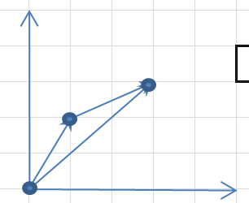

Can you see how we get the total move x=3 y=3?

Recall how we did this previously using structures:

using System;
class test
{
struct Coords
{
public int x;
public int y;
}
static void Main()
{
Coords p1 = new Coords { x = 1, y = 2 };
Coords p2 = new Coords { x = 2, y = 1 };

Coords p3 = new Coords ();

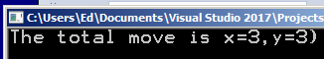 p3.x = p1.x + p2.x;
p3.y = p1.y + p2.y;

Console.WriteLine("The total move is x={0},y={1})", p3.x, p3.y);
}
}

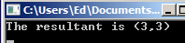
The vector 3
3 could be considered to be the resultant of
1 2
2 + 1
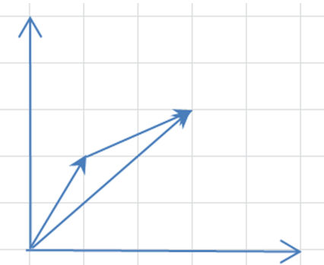

Wouldn’t it be nice if we could have simply p3 = p1 + p2; (ie simply add 2 vectors)?
We can. Exercise Using the above overload the + sign so we can have p3 = p1 + p2;
Start with the above code.

Also: Place this print code Console.WriteLine("{0,2} \n{1,2}\n", x, y ); into a class method called PrintOut. -> 1
2
Solution: CooordsDemo1.sln in Lesson8
C:\X\CSChap8\CSChap8?
using System;
class test
{
Or use:
public double x { get; set; }
public double y { get; set; }
public class Coords
{
double x;
double y;

public Coords()
{
x = 0;
y = 0;
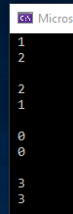 }
public Coords(double a, double b)
{
x = a;
y = b;
}
public static Coords operator +(Coords p1, Coords p2)
{
Coords p = new Coords();
p.x = p1.x + p2.x;
p.y = p1.y + p2.y;
return p;
}

public void printout()
{
Console.WriteLine("{0,2} \n{1,2}\n", x, y );
}
}
static void Main()
{
Coords p1 = new Coords (1, 2);
p1.printout();

Coords p2 = new Coords (2, 1);
p2.printout();

Coords p3 = new Coords();
p3.printout();
We could rewrite using property accessors so we can for example use:
Coords p1 = new Coords { x = 1, y = 2 }; but note that we would need to use the property accessors public double x { get; set; } etc as above.

p3 = p1 + p2;
p3.printout();
}
}

Exercise: 1. Overload and demo the – operator in the above code and
2. Demo that the += and -= operators also work.

Vectors are used extensively in Unity (Game programming)
This may be ignored for non-gamers!

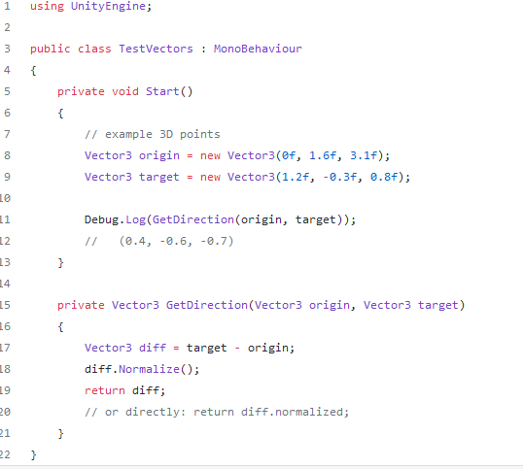
The overloaded - operator.

(Normalize means to find the size of a vector using Pythagoras. eg the size of a vector (3,4,12) is 13.)

Exercise: Make a class called Vector3 etc!

See Vector.sln C:\X\CSChap8

Make constructors initialize a vector.

Make an overloaded operator to subtract etc.
Exercise:
- Overload the relational operators ie the < and the >.
- Overload the is equal operator ie ==.
(You will find that you also need to overload the != as well.)
- Overload the is equal operator ie ++ and the -– operators.
- Indexers?

Solution partial:

Overloading the Relational Operators

using System;
class app
{
class Part
{
private int _i;
public int i
{
get
{
return _i;
}
set
{
_i = value;
}
}
public static bool operator <(Part p1, Part p2)
{
if (p1.i < p2.i) return true;
else
return false;
}
public static bool operator >(Part p1, Part p2)
{
Try removing (or commenting) the whole of this > operator code.
(And of course the Console.WriteLine(p2 > p2);below.)
Error.
If you have one you must have the other!
if (p1.i > p2.i) return true;
else return false;
}
}
static void Main()
{
Part p1 = new Part {i=1};
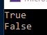 Part p2 = new Part {i = 2};

Console.WriteLine(p1 < p2); // True
Console.WriteLine(p2 > p2); // False
}
}

Similarly, if you overload the <= you must also overload the >=.

Overloading the == Operator : As an Exercise: Include this code in the above to test equality ==.

public static bool operator ==(Part p1, Part p2)
{
if (p1.i == p2.i) return true;
else return false;
}

Console.WriteLine(p1==p2); // ->False

Passing Different Types to the Overloaded Operator

So far, we have passed two objects of the same type (ie of type Part in our case). What if we wish to pass our object along with an integer?

- Modify the code of the previous program to include these 2 overloaded operators etc:

using System;
class app
{
class Part
{
public int i
{ get; set; }

public static Part operator +(Part p1, Part p2)
{
Part p3 = new Part();
p3.i = p1.i + p2.i;
return p3;
}
public static Part operator +(Part p1, int _i)
{
Part p3 = new Part();
p3.i = p1.i + _i;
return p3;
}
public static Part operator +(int _i , Part p2)
{
Part p3 = new Part();
p3.i = _i + p2.i;
return p3;
}
}
static void Main()
{
Part p1 = new Part();
Part p2 = new Part();
Part p3 = new Part();
p1.i = 1;
p2.i = 2;

p1 = p1 + p2 ;
p2 = p1 + 5 ;
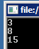 p3 = 7 + p2 ;
Console.WriteLine(p1.i);
Console.WriteLine(p2.i);
Console.WriteLine(p3.i);
}
}

Exercise:

Write code to pass a vector and. a scalar (ie a number) by which to multiple the vector eg for a vector (2,3) multiplied by 4 would give (8,12).
(Use the previous Coords() code. Change the name Coords() to Vector.)

Exercise: Add an overloaded operator to add the matrices and add them using:

m3 = m1 + m2;

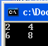

Optional: Multiplying Matrices

Indeed, this is the rule for multiplying matrices - across then down and add - for ANY sized matrices. Remember it’s “as easy as falling of a log” – across and down.

Exercise: Make an overloaded operator * to multiply two matrices.
Delegates YouTube: C#DelegatesEvents https://youtu.be/UKJ8HNdZ8h4 arith,multicast 10:11
Delegates in Chap08.sln C:\X\CSChap8\CSChap8
A delegate is an object that can hold a reference to a method.
(You can think of a delegate as a object variable which can hold a function’s name.)

In the case below arith is an object variable which can hold function name (add and sub respectively).

A delegate can be used when we wish to call different methods when the program is running ie we can delegate the same name (arith in our case) to different methods at run-time.
The static methods, add and sub are delegated to arith at run-time.
(In this case, our Mydel can be used only for functions which take two int parameters and returns an int ie only for that signature.) *
1. We declare the type of the delegate using int since int will be the return type in this case along with the delegate keyword.

using System;
public class Program
{
delegate int Mydel (int x, int y);
2. Make an object of that class.
Mydel is a class and arith as an object of that class - which is used as a reference to the different methods (add & sub) which arith invokes.

public static void Main()
{
Mydel arith? = add;

Console.WriteLine(arith(6, 2));

arith = sub;
..could also be written as :
Mydel arith = new Mydel(add);
new Mydel(add) is calling a constructor and passing a METHOD.

Console.WriteLine(arith(6, 2));

arith = null;
}

static int add(int x, int y)
{
return x+y;
Delegates are used commonly with events. Events (later) are notifications to your program from a class.
}

static int sub(int x, int y)
{
return x-y;
}
}
* If we wished to be able to make methods which took different type of parameters from the above eg float or returned different types, then we would have to make another separate delegate eg.
delegate int MyOtherdel (float x, int y, double z);
Do this – say to add 3 integers, Call the function add3.

The above methods are static. We now make a class Part and place the add and sub methods in the class. The methods of course being public ie change static to public above and assign our delegate object like so: Mydel arith = p.add.
Taks a look in the Locals window whilst single-stepping:
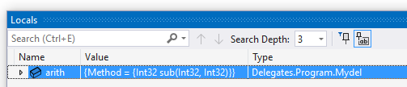

using System;

public class Program
{
delegate int mydel(int x, int y);

class Part
{
public int add(int x, int y)
{ return x + y; }

public int sub(int x, int y)
{ return x - y; }
}

public static void Main()
{
Part p = new Part();

mydel arith = p.add;

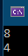 Console.WriteLine(arith(6, 2));

mydel arith = p.sub;

Console.WriteLine(arith(6, 2));

}

}

Exercise 2: Exercises in CSChap08.sln
C:\X\CSChap8\CSChap8

Make 2 functions called Function1 and Function2

Ask for user input. Without using an if statement or any other conditional, call the Function1 if the user types “Function1” and Function2 if the user types “Function2”.
The functions need not accept any arguments or return anything.
Starter code:
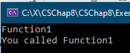
delegate void Mydel();
public static void Main()
{
String? s;
s = Console.ReadLine();
Mydel chooseFunc; // create delegate instance
if (s == "Function1")

To Successively Call a List of Methods

using System;

public class Program
{
delegate void Mydel(int x, int y);
We are here adding another method to the multicast delegate invocation list. arith "stores" both methods.
“Winding up the spring.”

public static void Main()
{
Mydel arith = add;

arith += sub;
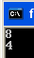
Calls both methods.
“Unwinds the spring.”

arith(6, 2);
}
The methods which are to be called by a multicast delegate can only ever return void.
ie No return type is permissible when using a multicast delegate.

static void add(int x, int y)
{
Console.WriteLine(x+y);
}

static void sub(int x, int y)
{
Console.WriteLine(x-y);
}
}
Note that the order in which they are added is the same as the order in which they are (automatically) called.

Multicast delegates have more use with event programming (see later).

Mydel is now called a multicast delegate.

https://docs.microsoft.com/en-us/dotnet/csharp/programming-guide/delegates/how-to-declare-instantiate-and-use-a-delegate
Func (Revisited) is a (fairly recent) simplified way of using delegate to call different methods
.
This section may be deferred until later (Chapter 10)

Func is a more compact way of writing delegate code as previously.

https://msdn.microsoft.com/query/dev11.query?appId=Dev11IDEF1&l=EN-US&k=k(System.Func%602);k(Func);k(TargetFrameworkMoniker-.NETFramework

Func allows us to combine these three into one:
1. delegate int Mydel (int x, int y);
2. Mydel arith = add;
3. static int add(int x, int y)
{return x+y;}

using System;
public class Program
{
The last parameter (int in this case) is always the return type!

The first two: int,int are the types that are passed into the function.
public static void Main()
{
Func<int,int,int > add = delegate (int x, int y)
{
return x + y;
};

Func<int, int, int> sub = delegate (int x, int y)
{
return x - y;
};

Console.WriteLine(add(6, 2));
Console.WriteLine(sub(6, 2));

}
}

Action Instead of Func use Action if we don’t have a return type

using System;

public class Program
{
public static void Main()
{
Action<int, int> add = delegate (int x, int y)
{
Console.WriteLine(x + y);
};

Action<int, int> sub = delegate (int x, int y)
{
Console.WriteLine(x - y);
};

add(6, 2);
sub(6, 2);
}
}
This section may be deferred until later (Chapter 10)

We can also use lambda functions (see Chap 9) with Func to make it even more compact to do the same things as above:

using System;
We don’t now use delegate.
See how compact and simple it now is.
public class Program
{
public static void Main()
{
Func<int, int, int> add = (x, y) => x + y; // 1 output 2 inputs.

Func<int, int, int> sub = (x, y) => x - y;
Console.WriteLine(add(6, 2));

Console.WriteLine(sub(6, 2));

}
}

Events Event in Chap08.sln example from the WPF Tetris?
C:\X\CSChap8\CSChap8
An event is a way that we can call methods FROM a class.

using System;

public class Program
{

class Part
{
Obviously we can call methods IN a class eg ask() as in this example (by creating an object of type Part as below) but we wish to call methods FROM a class.
public delegate void Mydel();

public event Mydel event1 = default!;

public void ask()
{
event1();
}
}
Basically we call eddo() from the class Part.

public static void Main()
{
Part p = new Part();

p.event1 += eddo; // Register the event

p.ask(); // We call into the class and the class calls back.
(A call-back!)
}

static void eddo()
{
Console.WriteLine("Whatever");
}
}

Events simplify delegate use. Event in CSChap08.sln
C:\X\CSChap8\CSChap8
Using the event keyword we can simplify the previous callback code.

using System;
The whole point is that our methods are being called from the class.
That class can be in the .Net framework! See later. We pass to the class the name of the methods that we want to be called - in this case eddo.

public class Program
{
class Part
{
public delegate void Mydel(string s); // declare a delegate type

public event Mydel del = default!; /// declare our delegate in an event.
When we use event…

public void ask()
{
An event del in this case is used to call methods in Main() - from a class.
del("hello from Part");
}
ie equivalent to: del ≡ eddo
}

public static void Main()
{
…just add the method to the invocation list.
(del is public.) Note that we use += even though we are adding it for the first time.
Part p = new Part();
p.del += eddo;
p.ask(); //sets off the event.

}
"Event handler"
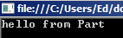 static void eddo(string s)
{
Console.WriteLine(s);
}
}

Exercises:

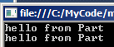1. Include another method called dodo which also gets called when using p.ask();

2. Optional:Write some code in the eddo method above which identifies the class which called the event (Part in our case. Use GetType() to identify the class.)
Hints: del will then need to pass two arguments now like so: del(this, "hello from Part");
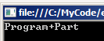Change the delegate definition to: public delegate void Mydel(object source, string s);

namespace HttpClientExample
CrestronEnvironment.SystemEventHandler += new SystemEventHandler(ControlSystem_ControllerSystemEventHandler);

- //Events:– Using multicast
- ie adding more than one callback. MultiEvent in CSChap8.sln
C:\X\CSChap8\CSChap8
using System;
public class Program
{
class Part
{
public delegate void Mydel(string s);
public event Mydel del;
public void ask()
{ del("hello from Part"); }
}

public static void Main()
{
Part p = new Part();
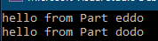 p.del += eddo;
p.del += dodo;
p.ask();
}

static void eddo(string s)
{ Console.WriteLine("{0} eddo",s); }

static void dodo(string s)
{ Console.WriteLine("{0} dodo", s);}

}

2. //Optional: Events: Identify the calling class

using System;
public class Program
{
class Part
{
public delegate void Mydel(object source, string s);

public event Mydel del;

public void ask()
{ del(this,"hello from Part"); }
}
public static void Main()
{
Part p = new Part();
p.del += eddo;
p.ask();
}
static void eddo(object source, string s)
{ Console.WriteLine(source.GetType()); }
}
https://docs.microsoft.com/en-us/dotnet/csharp/programming-guide/events/how-to-publish-events-that-conform-to-net-framework-guidelines

Calling an event when a property is changed. Uses an Action delegate

Uses set to notify CoordChanged in Chap08.sln
C:\X\CSChap8\CSChap8

using System;
struct Coordinate
{
public event Action<int> CoordinatesChanged;
Calls this method when x is changed or initialized).
Calls this method when y is changed.
or initialized).

private int _x, _y;

public int x
{
get { return _x; }
set { _x = value; CoordinatesChanged(_x); }
}

public int y
{
get { return _y; }
set { _y = value; CoordinatesChanged(_y); }
}
}
public class Program
{
public static void Main()
{
Coordinate point = new Coordinate();

point.CoordinatesChanged += StructEventHandler; // Setup the handler.
point.x = 10;
point.y = 20;
}
static void StructEventHandler(int point) // The handler.
{
Console.WriteLine("Coordinate changed to {0}", point);
}
}

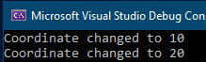

Making a Timer Timer in Chap08.sln See C# page 208
C:\X\CSChap8\CSChap8
We can use the events already defined in the Timer class.

using System;
using System.Timers;

public class Example
{
private static System.Timers.Timer? aTimer;

public static void Main()
{
SetTimer();
Console.ReadLine(); // Waits here for a key press and then Stops etc.
aTimer.Stop();
aTimer.Dispose();
}
Elapsed event is defined in the Timer class. We are here telling the class the name of our method eddo which it needs to call. (The callback function.)
The Elapsed event is automatically set off in the Timer class (every 1000 msec) in this case by a computer hardware timer.

private static void SetTimer()
{
// Create a timer with a two second interval.
aTimer = new System.Timers.Timer(1000);

// Hook up the Elapsed event for the timer.
aTimer.Elapsed += eddo;

aTimer.AutoReset = true;
aTimer.Enabled = true;
}

private static void eddo(Object source, ElapsedEventArgs e)
{
Console.SetCursorPosition(0, 0);
Console.WriteLine("The Elapsed event was raised at {0:HH:mm:ss.fff}",
e.SignalTime);
}
}
The time is updated on the screen every 1000 msec ie every second.

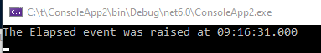

https://docs.microsoft.com/en-us/dotnet/api/system.timers.timer?view=net-6.0

We will return to events when we make a Windows Form (next chapter). Meanwhile:
We use the timer to run eg Game of Life – using a Windows Form or a WPF. See later.

Anonymous Methods Anonymous methods have no name. anonymous in CSChap08.sln
C:\X\CSChap8\CSChap8
First recall how we use a multicast delegate to call methods successively:

using System;
public class Program
{
We are not using anonymous methods yet.

delegate void Mydel(int x, int y);

public static void Main()
{
Mydel arith;
arith = add;
arith += sub;
(Calls both methods.)

arith(6, 2);

}
static void add(int x, int y)
{
Console.WriteLine(x+y);
}
static void sub(int x, int y)
{
Console.WriteLine(x-y);
}
}
Modify the above code ie remove the
method names and include delegate
constructors so that in Main() we now have:

delegate void Mydel(int x,int y);

public static void Main()
{
Mydel arith;
The anonymous methods have no name - they are anonymous!

arith = delegate(int x, int y)
{
Console.WriteLine (x + y);};
Note the semi-colon at the end of each anonymous method.
arith += delegate(int x, int)
{
Console.WriteLine(x - y);};

arith(6, 2);
}
Both methods are called.

An Anonymous method is a block of code that can be passed to a delegate constructor. The code for the method is included as a part of the delegate declaration instead of as a separate method.
Windows Forms MyProject in CSChap08 solution Lesson8 Ref: Day 16 & 17 C#21 days.
C:\X\CSChap8\CSChap8
C#WindowsForms.avi https://youtu.be/uFskDyUWoH4
Label button Hello World Listbox 8:16
An alternative to Windows Forms is Windows Presentation Foundation (WPF) (See next chapter.)

Making a Windows Forms Project

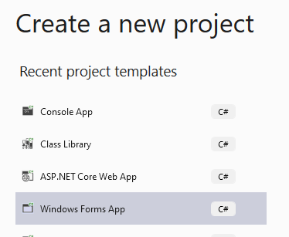
- On the File menu, click New Project.
- Select the Windows Forms app template
- Click Next.
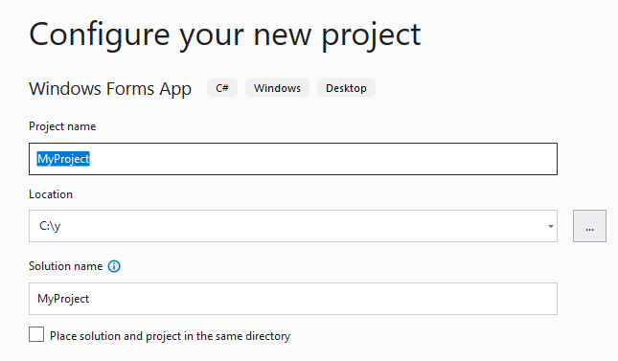
- In the Name field, type "MyProject".

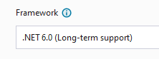

  - Create.

You will see a Windows Form in the Windows Forms Designer as below.
This is the design user interface of your application.
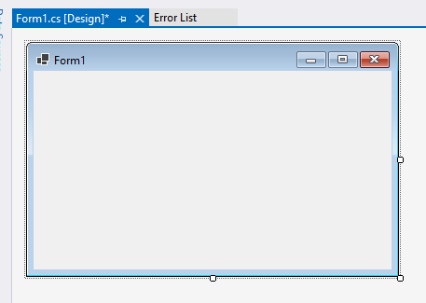

- Click View, Toolbox. (Make sure your form is in Design View.)
- Choose the All Windows Forms tag.
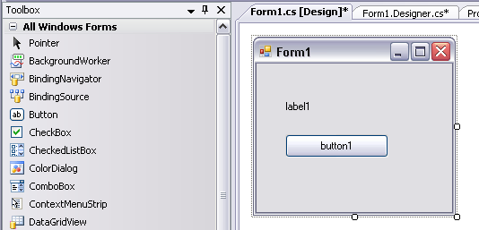

- Click Label, and then drag the label control to the onto your form.
- From the Toolbox, drag a button onto the form, near the label.
- Double-click your button to open the Code Editor.

C# has inserted a method called button1_Click that will be executed when the button is clicked. Change the method so it reads

private void button1_Click(object sender, EventArgs e)
{
label1.Text = "Hello, World!";
}
To get the Properties box, right-click on the label (or with the label selected, press F4.)
Make sure that your label on the form is indeed named lablel1.
If not change it either here or in Properties.

- Press F5 to compile and run your application.
- When you click the button, a text message is displayed.
To view your code:
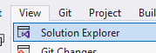Best to have the Designer open.
To Open Solution Explorer:
If not open Double-click Form1.cs in Solution Explorer.
Then Double-click on it.
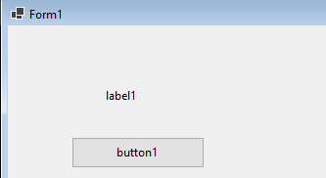

or…
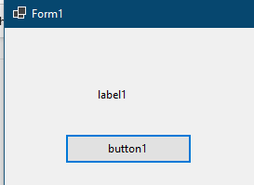
Right-click on Form1.cs and choose View Code.
(It won’t do to just double-click on Form1.cs that opens the Designer – as above.)

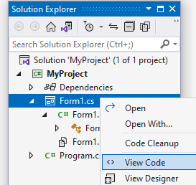

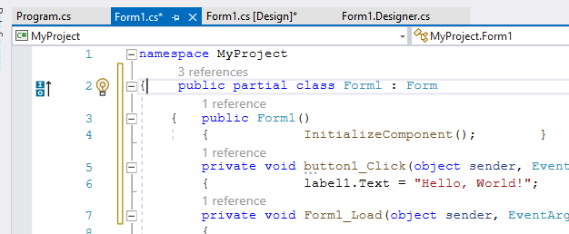
This is the really the only file which concerns us but take a look at the other three tabs above.

More Controls

We wish to add a List Box and populate it at run time.

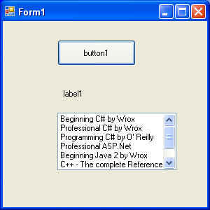
- If the Toolbox is not visible, choose View, Toolbox.

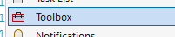

- Drag a ListBox control onto our design-time form.

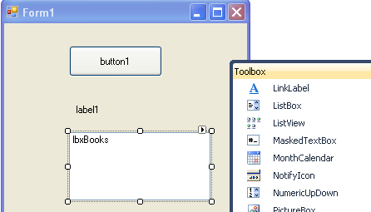

Change its name by right-clicking on the List Box and choosing Properties.

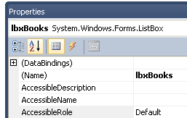

- Change the Name to lbxBooks.

If we wish the list box to be populated upon opening, then we need the Form’s Shown event as below.

This fires when the form appears.

- Go to the Properties of the Form. (Make sure that the Form
is selected when you right-click and choose Properties.)

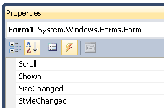

- Choose Events.

- Double-click Shown.

Copy this text into your Shown event.

Note the name of our ListBox.

private void Form1_Shown(object sender, EventArgs e)
{
lbxBooks.Items.AddRange(new String[] { "Beginning C# by Wrox",
"Professional C# by Wrox", "Programming C# by O' Reilly",
"Professional ASP.Net", "Beginning Java 2 by Wrox",
"C++ - The complete Reference", "Java Servlets Programming",
"Java Server Pages - JSP)"});
}

Works in the Form1_Load event as well.

- Run it.
We could also add data using:

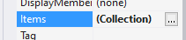

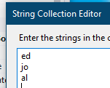

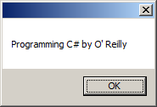
Exercise: Write code that will MessageBox the item in the ListBox that we click upon at run-time:

Hints:

1.MessageBox.Show("ed"); // -> ed. (Try it on lbxBooks_Click.)
2. Place the required code in the event which fires when you change a selection
ie the List Box’s _SelectedIndexChanged event. (Get this by double-clicking on the ListBox.)
If you type lbxBooks and then a full-stop, you can see all the properties of the list box

3. Itellisense:
3. 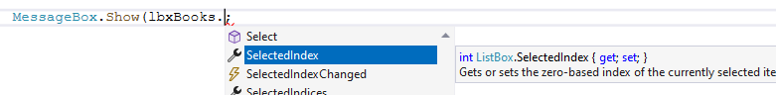
To Place a ListBox see:
https://www.c-sharpcorner.com/UploadFile/mahesh/listbox-in-C-Sharp/
Excellent demos of all the Properties and Methods of the ListBox.

