Mongo Lesson

1. Construct a Mongo database from scratch.

2. Use C# to do same.

3 Mongo / Asp.net

4. Publish AspToAzure (Revision)

5. PublishMongoToAzure todo

6. Mongosh

7. Mongo/VSCode

Here is a Mongo database:

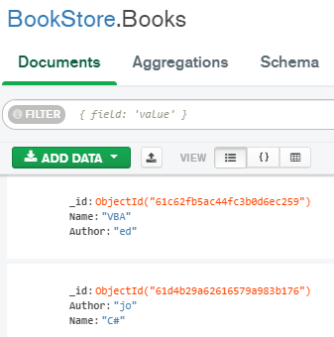
The database name is BookStore
The “table” (actually “collection”) name is Books.
Most importantly, the records (documents!) are written in Json.
No SQL!

:

First: Install Mongo :3 parts:

Compass

Mongosh and

Atlas:

1. Compass: A UI. Desk top App for creating, updating etc

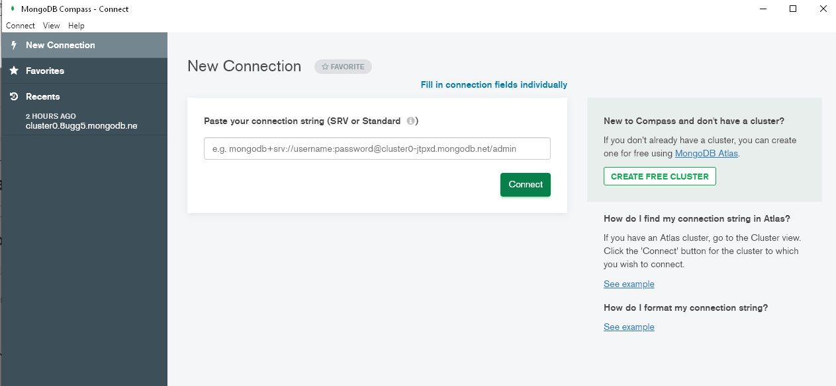

2. Mongosh is a CL (Command Line) Desktop app. Also for creating, updating etc.

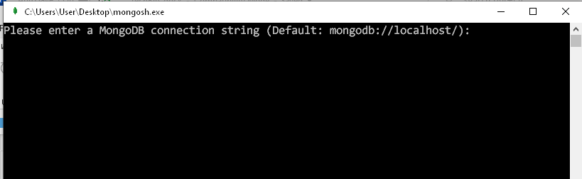

Whereas the above are apps on our PC, Atlas is accessed on the internet.
Cloud-based. Where our database is !

Login to Atlas (Create an account first):

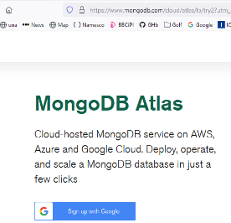

Log In with Googel?

Make a Cluster

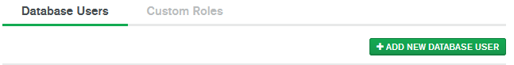
Add a User.

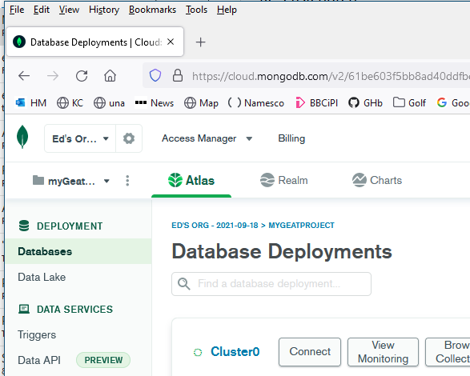
Connect.

Perhaps a little strangely we are directed to 3 possibilities of connecting:

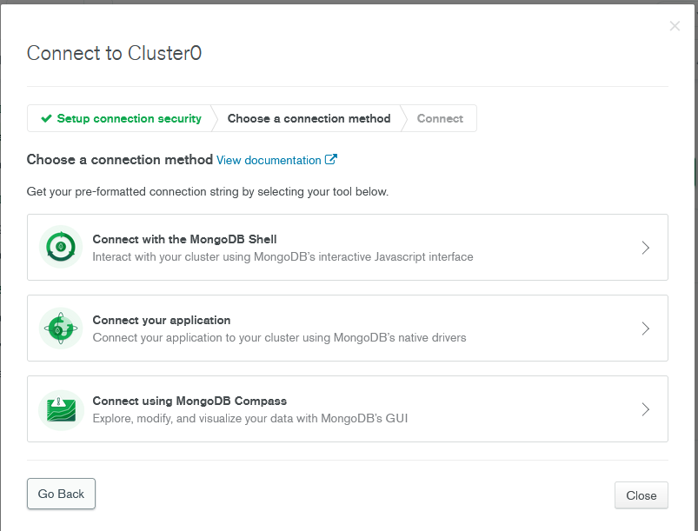
We will choose to use the GUI: ie Compass.

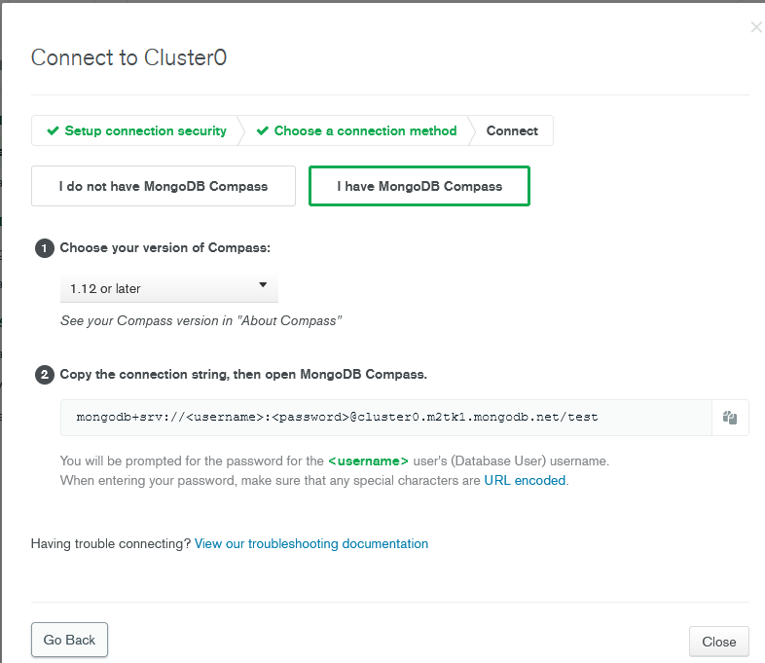
Make sure that this is chosen.
Copy the connection string :

Note the connection string so far:

mongodb+srv://<username>:<password>@cluster0.m2tk1.mongodb.net/test
This is for connecting to the server (ie not the local.)

Open Compass:

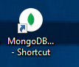

Note in Compass:

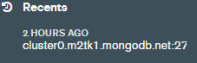

Paste in the string and modifiy it ie:

mongodb+srv://ed:mypassword@cluster0.m2tk1.mongodb.net/test
Replace with your uname & pword. (The ones that you signed intot Atlas with.)
This will be the name of our server.
test seems to be the name of a generic database.

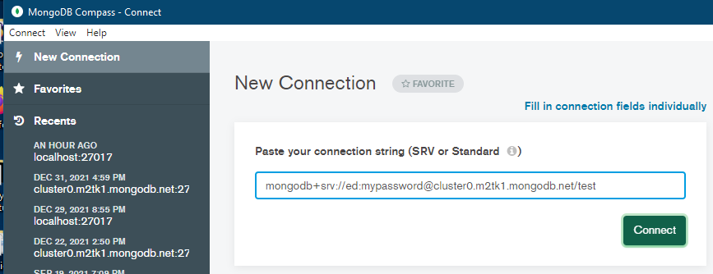
Paste:

Connect

Create Database.

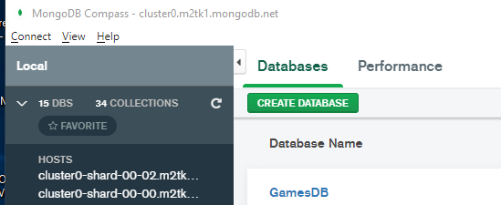
Click Create Database
(You may or may not already have some databases.)

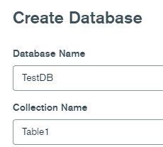

Create Database.

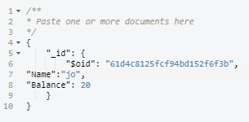
24-digit random no id is always added by default. (Can be a nuisssance if you want to find a record by its Id!)
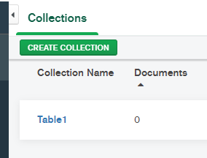

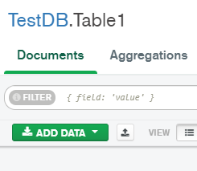
// Recall that with an SQL table we add only the DATA eg "ed" to a field (eg "Person".)

// Whereas with Mongo we add the FIELD NAME as well as the data eg ("Person", "ed") each time as well.

// (Note that if mis-spell the field name it adds another field of this name!)

// Thats why with Mongo we say that we add a DOCUMENT each time rather than a RECORD.

Add Data

Insert Document.

/**
* Paste one or more documents here
*/
{
"_id": {"$oid": "61d4c6b45fcf94bd152f6f39",
"Name": "ed",
"Balance": 10
}
}

Insert then 2 more:

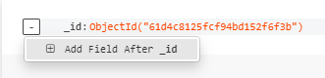

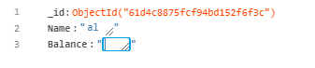

Update

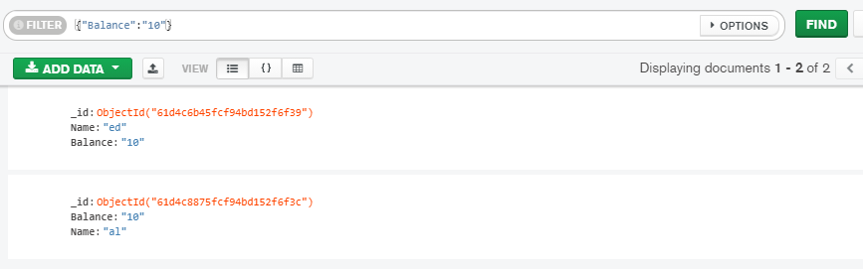
To “Query” - In Mongo we do a Find.

Reset

Trouble connecting?

Make sure that you have listed your IP address – so the Atlas knows how to connect to your PC!

Add IP Access List Entries

Go to IP Access List view.
In the Security section of the left navigation, click Network Access. The IP Access List tab displays.
Click Add IP Address.

We will now do the same thing ie make the simplest of Mongo databases but using C#:

Getting Started With MongoDB - MongoDB With C# Csharp Corner.

https://www.c-sharpcorner.com/article/getting-started-with-mongodb-mongodb-with-c-sharp/

See end of article for complete code.

C:/x/ConsAppMongoDBCRUD on QW

But try this first’

To Create a simple Mongo database: Make a console app.

using MongoDB.Bson;

using MongoDB.Driver;

MongoClient dbClient = new MongoClient("mongodb://127.0.0.1:27017");// Local connection

IMongoDatabase db = dbClient.GetDatabase("BookStore"); // Existing Dbs. If it doesnt exist then it creates it!

var things = db.GetCollection<BsonDocument>("things"); // Make/Get a new "table". (Note its a var.) (Collection)

A local connection. Compare this with our connection to the server:
("mongodb+srv://ed:mypassword@cluster0.m2tk1.mongodb.net/test")

NuGet:

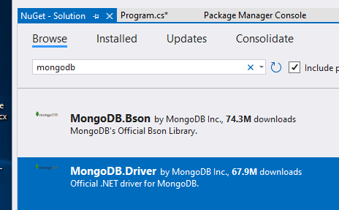

(Looks like Mongo.Driver contains the Bson stuff as well)

Open Compass
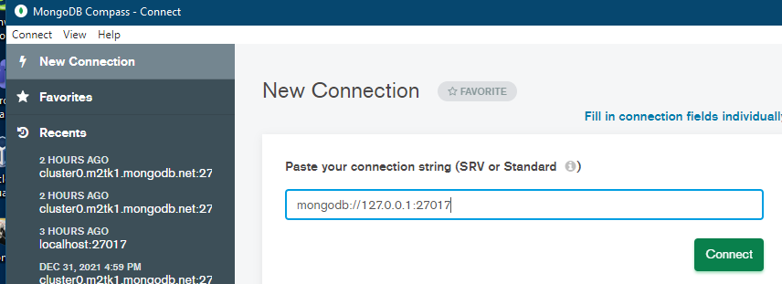

Connect

Our database! Local,
Compare this with the connection we had in Compass to the Server:

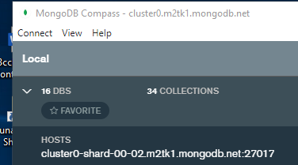

One at a time (Although we could start two instances of Compass and have both!

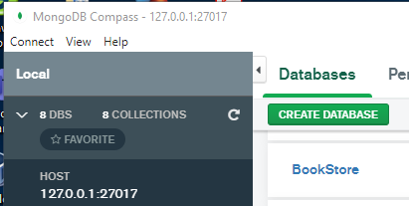

With a things table (maybe call it Table1)

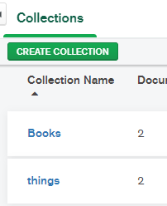

Now add code to enter some data

// CREATE(Keeps adding each time we run!)
BsonDocument personDoc = new BsonDocument(); // Create a new record (document)
personDoc.Add(new BsonElement("Person", "al")); // Add a column/data
personDoc.Add(new BsonElement("PersonAge", 10)); // Add a column/data
things.InsertOne(personDoc);

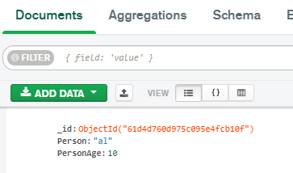
Don’t forget to refresh the database.

Exercise: Add ed:10 & jo:20

To list all of the “records” (documents!) in a “table” (collection!)
(Comment out the CREATE code)

//READ
var res = things.Find(new BsonDocument()).ToList(); // Find all the document objects.
foreach (var item in res)
{
Console.WriteLine(item.ToString());
}

Result:

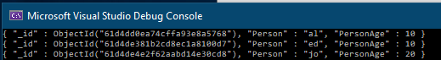

Update
BsonDocument <-> Record
BsonElement <-> Field

Replace Ed with bo:

//UPDATE

// Replacement:
BsonDocument newRec = new BsonDocument(); // New record(document)which is to be loaded with data to be updated.

BsonElement Person = new BsonElement("Person", "bo");// A BsonElement is one field AND data.
newRec.Add(Person); // Add the Person data-to-update to the record-to-update.

newRec.Add(new BsonElement("Age", 24)); // Ditto for the Age. (In one go this time.)

// To be replaced:

BsonDocument oldRec = new BsonDocument(new BsonElement("Person", "ed"));

var newDoc = Table1.FindOneAndReplace(oldRec, newRec);

// Console.WriteLine(newDoc); // {"Person":"ed", "Age": 24 }

printout(Table1);

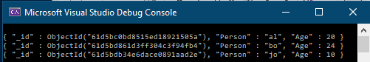

Deleting

BsonDocument docToDelete = new BsonDocument(new BsonElement("Person", "ed")); // Whole Record

Table1.FindOneAndDelete(docToDelete);

See comments: C:/x/ConsAppMongoDBCRUD on QW

Exercise Make a “query” to find those with age of 10.

public async Task<List<Book>> GetAsync() =>
await _booksCollection.Find(_ => true).ToListAsync();

public async Task<Book?> GetAsync(string id) =>
await _booksCollection.Find(x => x.Id == id).FirstOrDefaultAsync();

Extra to: previous article:

https://www.c-sharpcorner.com/article/getting-started-with-mongodb-mongodb-with-c-sharp/

To list all the databases on the local server:

using MongoDB.Driver;

MongoClient dbClient = new MongoClient("mongodb://127.0.0.1:27017"); // Local database!

// Database List
var dbList = dbClient.ListDatabases().ToList();

Console.WriteLine("The list of databases is :");
foreach (var item in dbList)
{
Console.WriteLine(item);
}
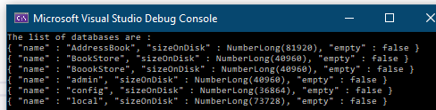

.
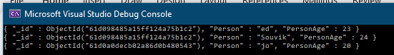
After his Update:

BsonDocument is a record.

BsonElement is a column/data. No equivalent in SQL!

How to Connect MongoDB to C# the Easy Way
Tim Corey (Local Mongod database!)

TODO: This for extension & revision of MongoDB/C#

I just did the first part – making a simple database – cause hteyre’s no source code.

Good illustration of 1. Async 2. Using a Model to insert records (documents)

https://www.youtube.com/watch?v=exXavNOqaVo&list=RDCMUC-ptWR16ITQyYOglXyQmpzw&start_radio=1&rv=exXavNOqaVo&t=708

Makes a LOCAL database!! ConnectionString =“mongodb://127.0.0.1:27017”

C:\X\MongoDBDemoApp\ MongoDBDemoApp.sln on Laptop

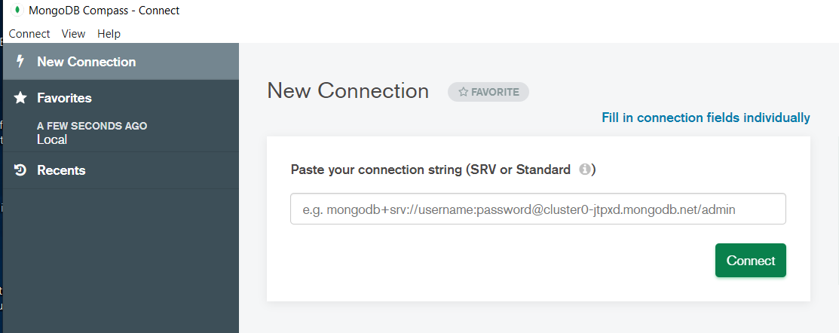

Need to click Connect.

My and pre-existing databases:

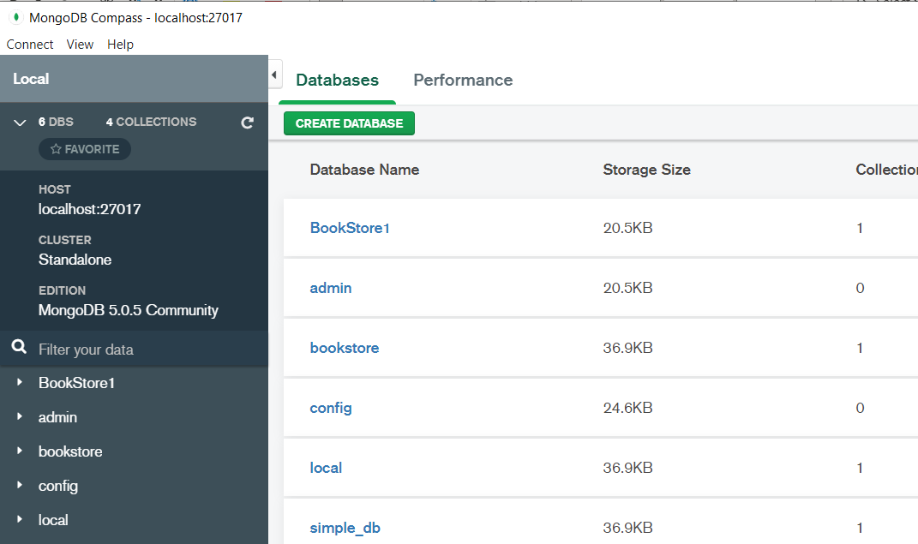
Tim creates this:
using code.

Simple_db AND BookStore1 !

Program.cs

using MongoDB.Driver;
using MongoDBDemo;
using MongoDB.Driver;
using MongoDBDemo;

string connectionString = "mongodb://127.0.0.1:27017";
string databaseName = "simple_db";
string collectionName = "people";

var client = new MongoClient(connectionString);

var db = client.GetDatabase(databaseName);

var collection = db.GetCollection<PersonModel>(collectionName);

var person = new PersonModel {FirstName="ed", LastName="rob"};

await collection.InsertOneAsync(person);

var results = await collection.FindAsync(_ => true);

foreach (var result in results.ToList())
{
Console.WriteLine(result.Id);
}

PersonModel.cs

using MongoDB.Bson;
using MongoDB.Bson.Serialization.Attributes;
namespace MongoDBDemo;
public class PersonModel
{
[BsonId]
[BsonRepresentation(BsonType.ObjectId)]
public string? Id { get; set; }
public string? FirstName { get; set; }
public string? LastName { get; set; }
}

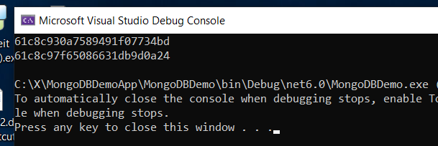

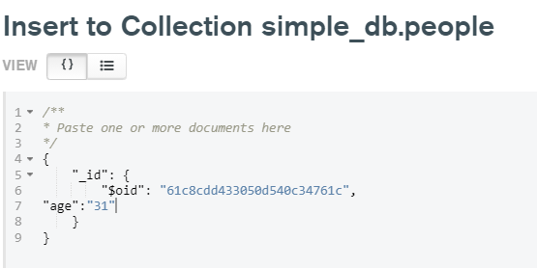

Now Mongo & ASP.Net

3. Create a web API with ASP.NET Core and MongoDB edit this
See p 17 on Mongo.doc
https://docs.microsoft.com/en-us/aspnet/core/tutorials/first-mongo-app?view=aspnetcore-6.0&tabs=visual-studio excellent. follow all.

All code: https://github.com/dotnet/AspNetCore.Docs
Downloaded laptop & QW

eg on QW:
C:\X\AspNetCore.Docs-main\aspnetcore\tutorials\first-mongo-app\samples\6.x\BookStoreApi
BookStoreApi.sln

Run it:

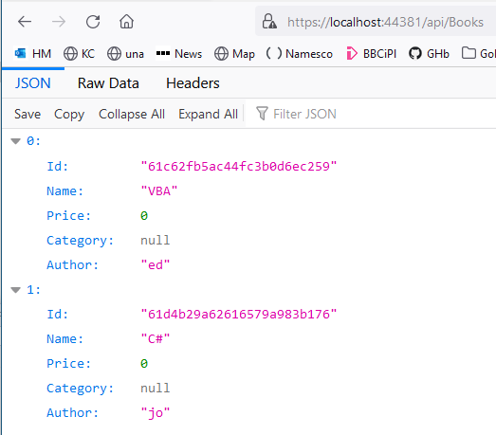

On \Y on laptop now
C:\X\AspNetCore.Docs-main\aspnetcore\tutorials\first-mongo-app\samples\3.x\SampleApp

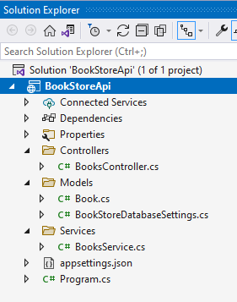

Note installed packages.

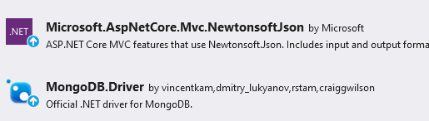

?

Basic app:

Tested it!: (Without mongo yet ie with : https://localhost:44354/WeatherForecast )

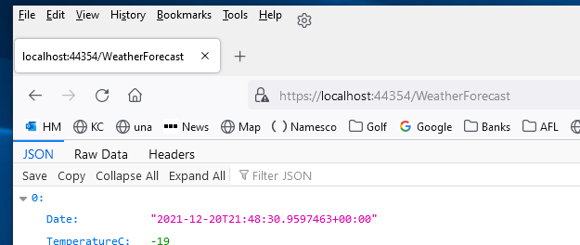
Does CRUD as well.

Works.
https://docs.mongodb.com/manual/tutorial/install-mongodb-on-windows/

This tutorial installs MongoDB 5.0 Community Edition (but its already installed)
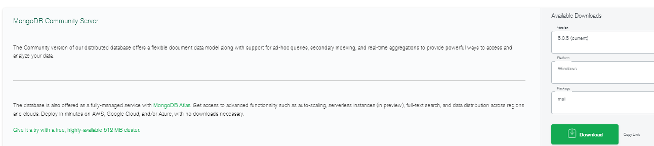

Note on the Service ConfigurationL
And for this:

Program.cs:

builder.Services.AddSingleton<BooksService>();
In the preceding code, the BooksService class is registered with DI to support constructor injection in consuming classes. eg
public BooksController(BooksService booksService) => bs = booksService;
and then bs. …… is everywhere in the code.
Looks like this:

Program:

// Add services to the container.
builder.Services.Configure<BookStoreDatabaseSettings>(
builder.Configuration.GetSection("BookStoreDatabase"));

connects this:

appsettings:

"BookStoreDatabase": {
"ConnectionString": "mongodb://localhost:27017",
"DatabaseName": "BookStore",
"BooksCollectionName": "Books"
},

with this:

public class BookStoreDatabaseSettings
{
public string ConnectionString { get; set; } = null!;
public string DatabaseName { get; set; } = null!;
public string BooksCollectionName { get; set; } = null!;
}

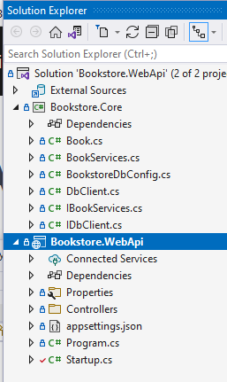
GAINESVILLE p 29 Mong.doc edit this

Bookstore | Using ASP.NET Core 5.0 and MongoDB

https://gitlab.com/asielalvarez/bookstore.webapi

https://www.youtube.com/watch?v=MNepwvCcKXA

Uses a service (library) and a secret

I cloned the source code to C:Users/…repo

PM> dotnet user-secrets set "CONNECTION_STRING" ="mongodb+srv://ed:cockatoo@cluster0.m2tk1.mongodb.net/BookstoreDb?retryWrites=true&w=majority"

Start again and use just the code.
Doesnt restore mongo.driver?

C:\x\BookstoreWebApi

BookServices.cs

public class BookServices:IBookServices
{

Controller:

private readonly IBookServices _bookServices;

public BooksController(IBookServices bookServices)
{
_bookServices = bookServices;
}

Now in program.cs not startup.cs:

builder.Services.AddTransient<IBookServices, BookServices>();

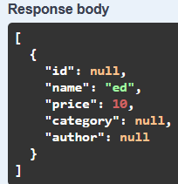

4. Then Publish to Azure

Intro To Azure Static Web Apps - Free Hosting, SSL, Global Distribution, and More
(A Static Web app is one which dishes up html pages and nothing more.)

C:\samples\TimCoEnterpriseApp on QW. Use this

https://www.youtube.com/watch?v=OW6OfW5SkNw
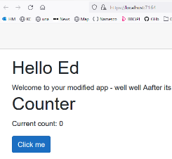
app->GitHub -> Azure

1. Create GitHub repository

Click Repositories. New etc.
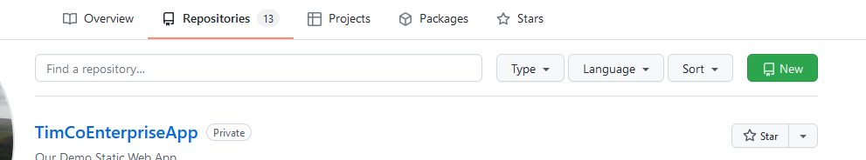

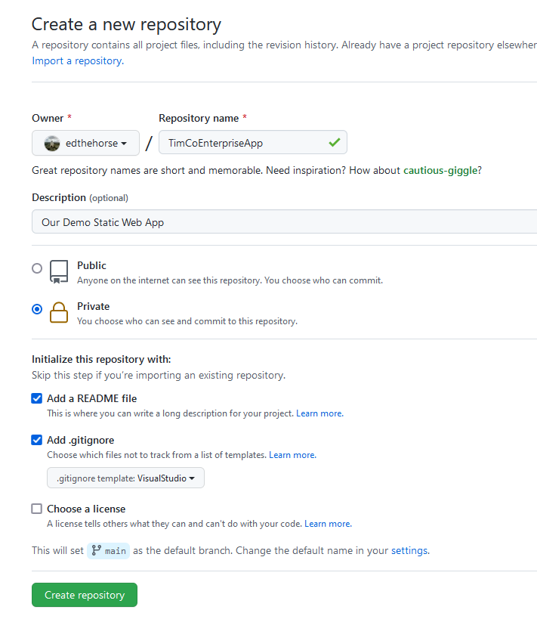

.

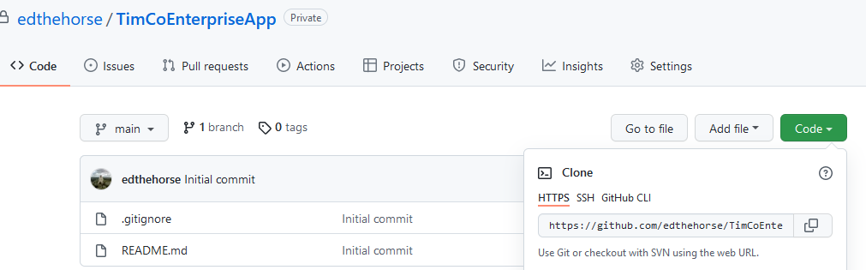

Copy path (from Code button!). Then

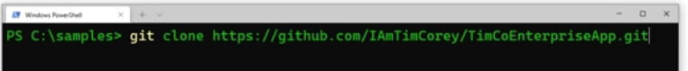

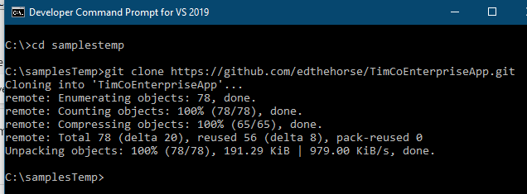

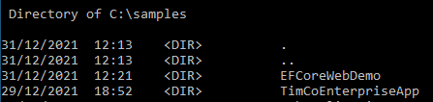

2. Create (simple Blazor) web app.

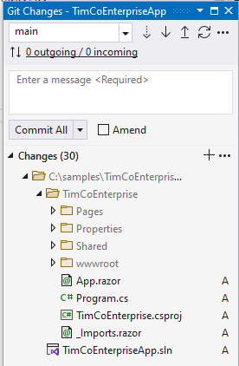

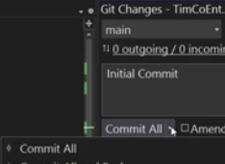

Commit All & Sync

(Take a look at our project in GitHub.)

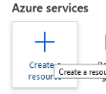
3. Azure

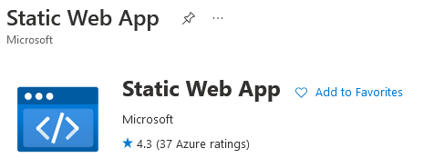

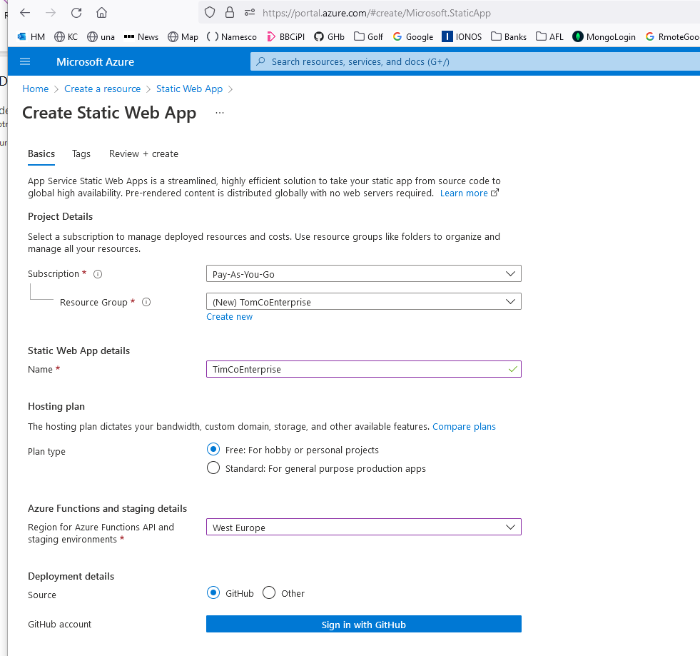
Free only appears afer a Resource change?
OK!

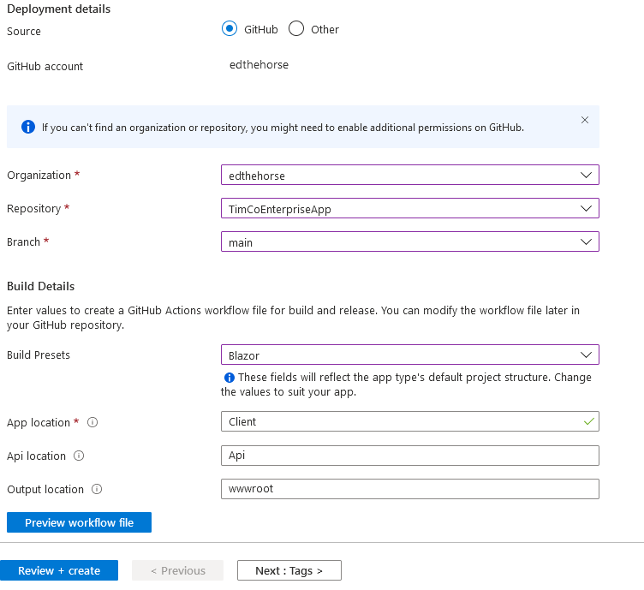
He makes error. Should be TimCoEnterprise.

The (editable) workflow file will be a text file version of the above.

As follows:

From azure

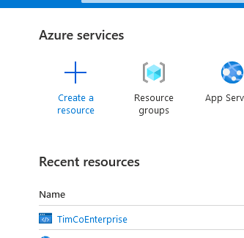

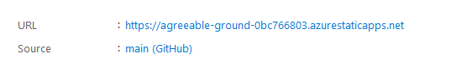

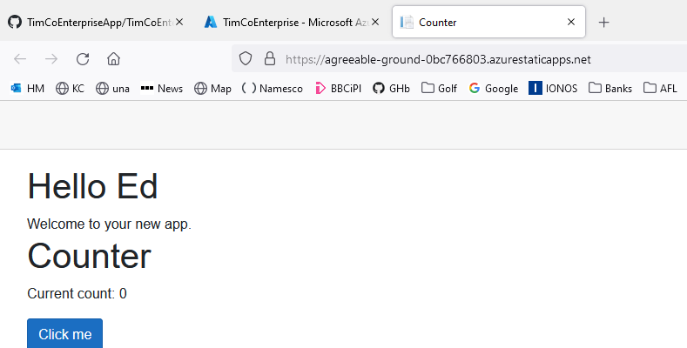

ie
https://agreeable-ground-0bc766803.azurestaticapps.net/

To make ammendments: @ 30:35 min in video.

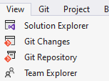

Team Explorer:

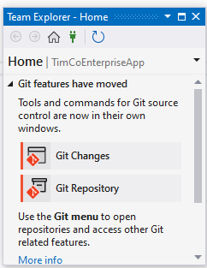
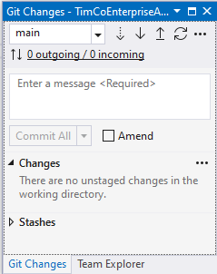
Git Changes.

Make (any) change to the project.

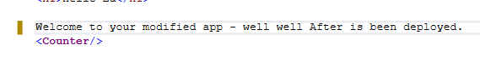

(Spelling was Aafter)

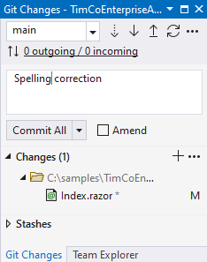
Annotate.
At least one change is indication (along with the affected file name.)
Push.

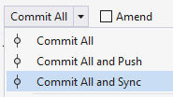

Go to GitHub and refresh
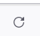

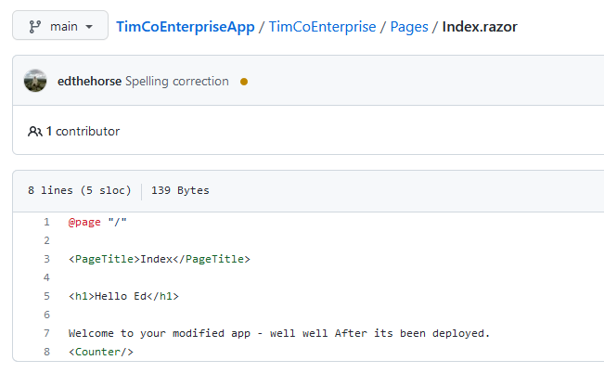

Spelling OK now.

Click Actions:

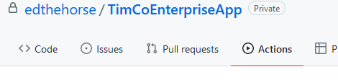

To see our action.

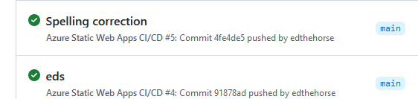

Now go to https://agreeable-ground-0bc766803.azurestaticapps.net/

Ammended:

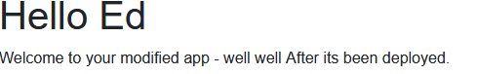

Read the rest of the youtube if you want a better domain name incorporated etc

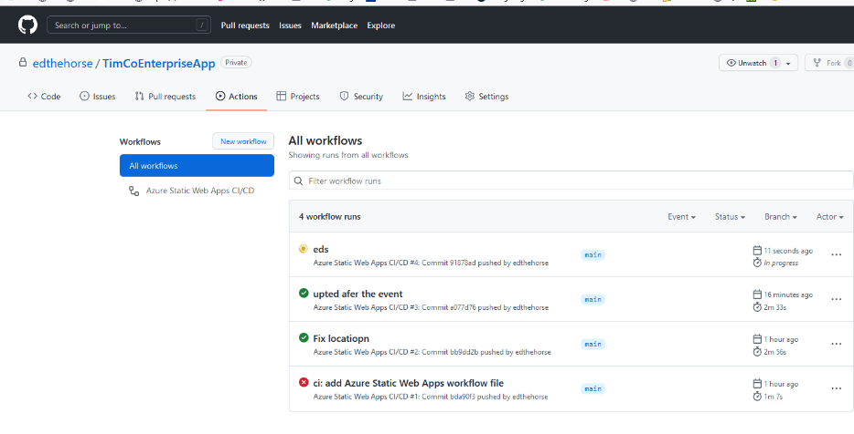

Takes a while to deploy!

How To Publish To Azure From Visual Studio 2019
Use this instead
https://www.youtube.com/watch?v=1ScH-USLYXg

EdCoApi

https://edcoapi.azurewebsites.net/

http://edcoapi.azurewebsites.net/Author/Create

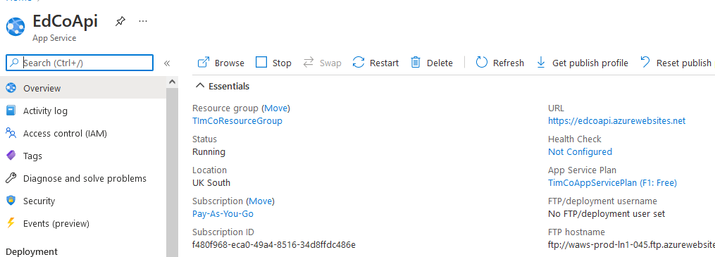
1st set up: azure
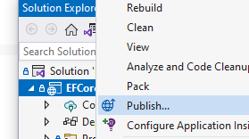

Publish
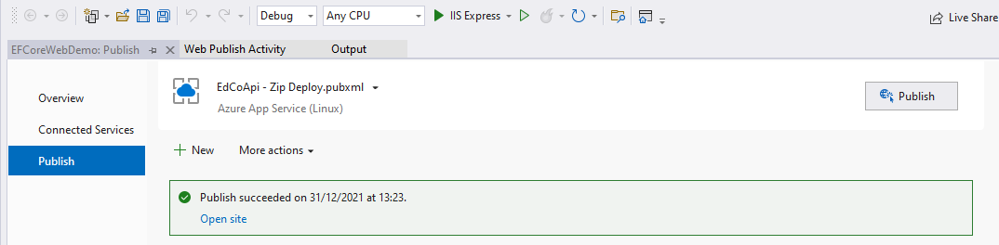

But I had to do a + New after a botched

Azure Next
Azure Linux Next

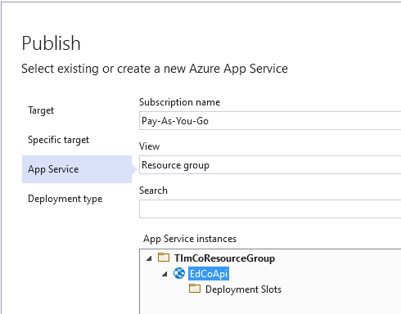

Finish

Publish

Wait

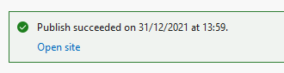

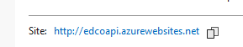

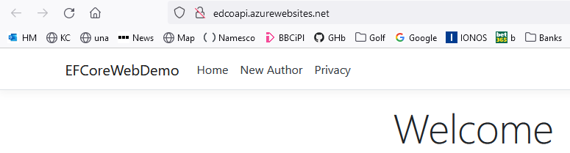

5. Publish Mongo to Azure.

MonGosh

C/Line:

After installation we may need to include it in the windows path:

C:\Program Files\MongoDB\Server\5.0\bin Add this to path as follow:

Env at Windows prompt
Env variables
System Path Edit New

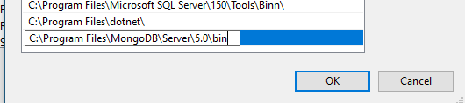

OK OK
db.createCollection('Books')
etc
wont paste!

Start Mongosh:
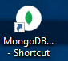
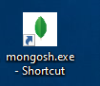
Note the symbol for Mongosh cf Compass:

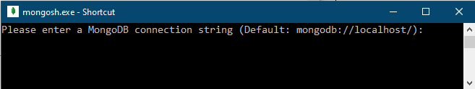

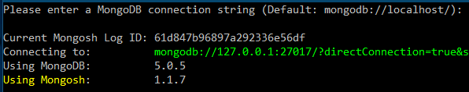
Just press Enter to connect to the LOCAL server !!

etc

Commands:

eg show databases:

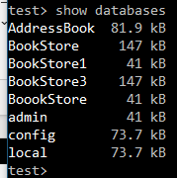
Mongosh does the same things as Compass!

(Seems that test is some kind of default database.)

use BookStore Take case, If BookStore does not exist, it will be created!

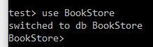

Then showcollections:

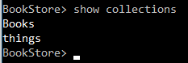

etc:


Excellent elaboration:
https://www.youtube.com/watch?v=ofme2o29ngU

Using Mongo with VSCode

https://www.youtube.com/watch?v=xrc7dIO_tXk&list=PL4RCxklHWZ9v2lcat4oEVGQhZg6r4IQGV&index=3 @ 6 min

2nd video in playlist

Intro to MongoDB Atlas in 10 mins | Jumpstart 2021

https://www.youtube.com/watch?v=xrc7dIO_tXk&list=PL4RCxklHWZ9v2lcat4oEVGQhZg6r4IQGV&index=2

He uses :

Vscode

Start it then: Extensions:

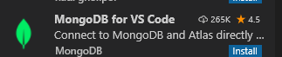

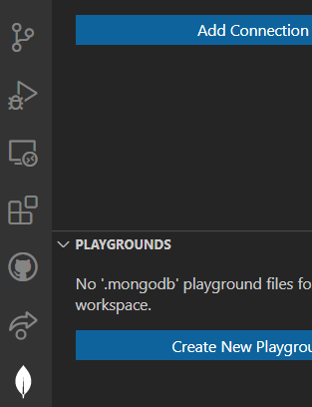
This leaf appears. Click it and Add Connection.

Login string:
mongodb+srv://ed:cockatoo@cluster0.m2tk1.mongodb.net/test
all conn strings use test !
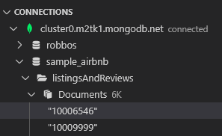

mongoDB is the actuall script ! ?

Playground 6:47

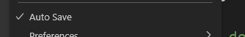

Create New Playground -> templatewhich we can ruin:


To run: on very top rhs

[
{
"_id": "jkl",
"totalSaleAmount": 20
},
etc
]

ie result of “query” :

use('mongodbVSCodePlaygroundDB');
{ $group: { _id: '$item', totalSaleAmount: { $sum: { $multiply: [

etc: read for practice.

Database is created!

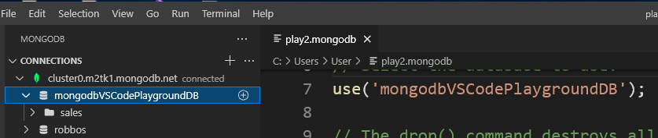

use('Test');
db.Table1.drop();
db.Table1.insertMany([
{ '_id': 1, 'name': 'ed', 'balance': 10, },
{ '_id': 2, 'name': 'jo', 'balance': 20, },
{ '_id': 3, 'name': 'al', 'balance': 10, },
]);

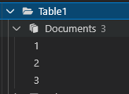

Saved workspace as eds

Copy connection string
mongodb+srv://ed:cockatoo@cluster0.m2tk1.mongodb.net/test?authSource=admin&replicaSet=atlas-2z3lvq-shard-0&readPreference=primary&ssl=true
Need to open! Files in the editor
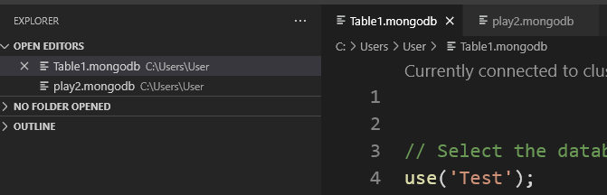
“Query”
use('test');
db.Table1.find( {balance:20 } );
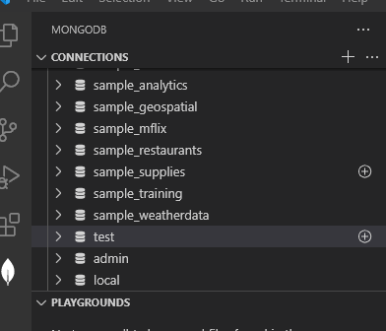
[
For connectios/database.
For scripts
{
"_id": 2,
"name": "jo",
"balance": 20
}
]

Don’t forget:

