Make an SQL Table
Stored Procedure

my Entity Framework Database
CRUD
SProcedure
Related Tables
Transactions
Raw SQL Queries
ChangeTracker
Shadow Property
Connected Disconnected
Concurrency
DataBaseFirst

Make an SQL database
To Make a Query
Stored Procedures
Entity Framework (Core)
Add Data
Transactions
Update
Delete
Query the table data using Linq
Attributes
Migrations
Fluent API
Raw SQL Queries
Working with Stored Procedure in Entity Framework Core
RelatedTables
Concurrency
Database-First

mungoDB

myEF.sln

----------------------------------------------------------------------------------------------
public class Student
{
public int Id { get; set; }
public string Person { get; set; }
public int Age { get; set; }
}
--------------------------------------------------------------------------------------------

public class MyDbContext:DbContext
{ public DbSet<Student> Students{ get; set; }

protected override void OnConfiguring(DbContextOptionsBuilder optionsBuilder)
{
optionsBuilder.UseSqlServer(@"Server=(localdb)\mssqllocaldb;Database=myTest;Trusted_Connection=True;");
}

protected override void OnModelCreating(ModelBuilder modelBuilder)
{ }
}

----------------------------------------------------------
public class Customer
{
public int CustomerId { get; set; }

public string Name { get; set; }

public int BankId { get; set; }

public Bank Banks { get; set; }
}
----------------------------------------------------------

optionsBuilder.UseSqlServer(@"Server=(localdb)\mssqllocaldb;Database=myTest;Trusted_Connection=True;");

EntityFramework Tutorial Web Site myEF.sln myTest database

Ch 11 Book SchoolDB
Excellent follow this.

Microsoft
https://docs.microsoft.com/en-us/ef/core/get-started/?tabs=netcore-cli
Quite elaborate so do after all others

DataBaseLesson : Make an SQL database.
Not using C# (& of course not using Entity Framework )

We will create a database: Here is a table from an SQL database

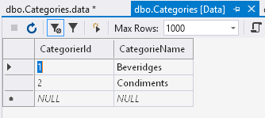

Here’s how we produce it (and the database):

Open Visual Studio 2017. It doesn’t matter if we have a project or not!

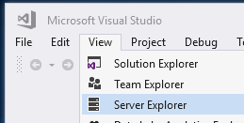

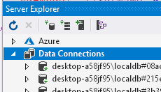
Right-click and choose Refresh.
ie get rid of the little red crosses.

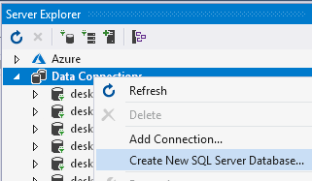
Right-click and choose

Create a database called NorthWnd (a much abbreviated version of the notorious Northwind) as below: Use (LocalDb)\MSSQLLocalDB.
:
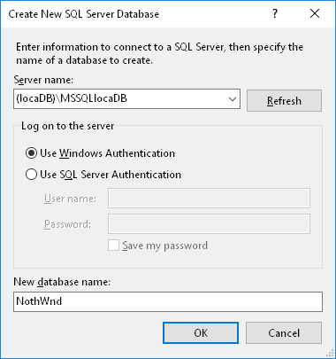

Right-click and type (LocalDb)\MSSQLLocalDB.
This is a local server. A server is a program usually on another computer which manages databases. We make a ”connection” to that program from our program. For experimental purposes it is convenient to have this program on our same computer ie it is “local”

- Click OK
Making the table

All being well we now have a connection from our database to the server

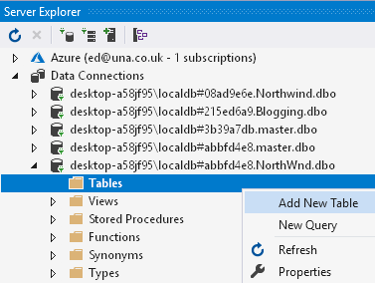
Right-click on Tables
and choose Add New Table.

Change/Add these field names.

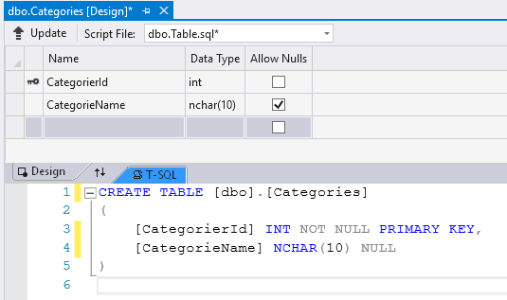
Watch the SQL change before your very eyes!
Change the name of the table to Categories.
Update database.

CREATE TABLE [dbo].[Categories]
(
[CategorierId] INT NOT NULL PRIMARY KEY,
[CategorieName] NCHAR(10) NULL
)

In Server Explorer Refresh the table.

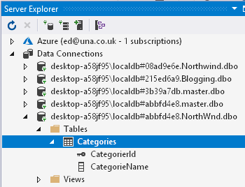

Then our table will appear.

To Add data to the table:
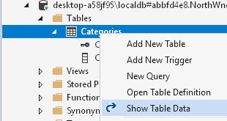
Take a look at the data.

Type in a CategoryName.
The CategorieID should appear automatically.

To see the script for the insertion of the data click Script.

If we close everything and re-open
we will see that this data persists.

INSERT INTO [dbo].[Categories] ([CategorieId], [CategorieName]) VALUES (1, N'Beveridges')
INSERT INTO [dbo].[Categories] ([CategorieId], [CategorieName]) VALUES (2, N'Condiments')

Alternatively: Making the table: Script method.

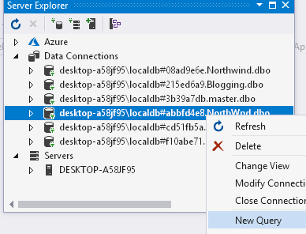
We will now add a new table to our NorthWnd database but this time we will run a script to produce the table.

Right-click
and New Query.

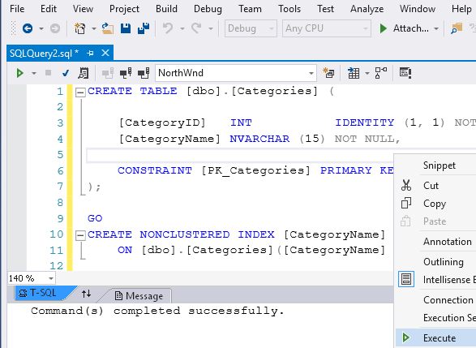
Place this code below in the query. Right-click and choose Execute
CREATE TABLE [dbo].[Categories]
(
[CategorierId] INT NOT NULL PRIMARY KEY,
[CategorieName] NCHAR(10) NULL
) Fix

(Maybe call it Categories1 if you already have a table called Categories.)

Update the database.

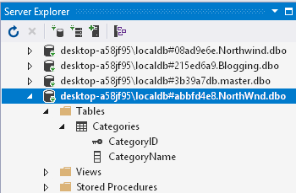
Our table is created.

To Add data: (You could just add table manually to the table if you want!).
Right-click on table in Server Explorer. New Query (or just add the new script as below to an existing script).

INSERT INTO [dbo].[Categories] ([CategorierId], [CategorieName]) VALUES (1, N'Beveridges')
INSERT INTO [dbo].[Categories] ([CategorierId], [CategorieName]) VALUES (2, N'Condiments')

The data will be added as below:

(Take care that the table doesn’t already contain Id’s of 1 and/or 2.)

(You may or may not want to save the scripts as you exit.)
To Make a Query

We will make a query to find the record with Id = 1 (ie Beveridges)

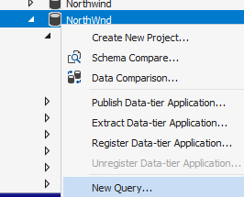

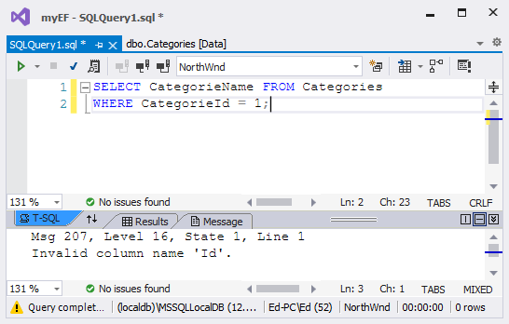

SELECT CategorieName FROM Categories
WHERE CategorieId = 1;

Click Execute.
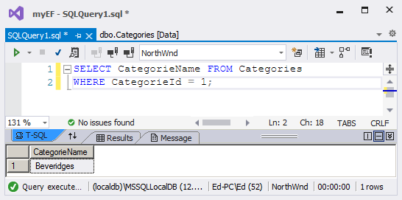
Results appear here.

Stored Procedures are like queries but run faster because they are compiled.

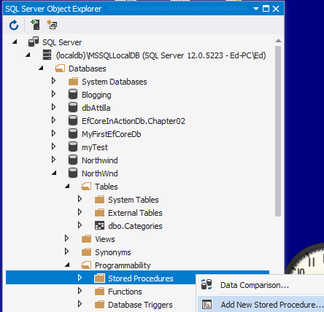

Click and type in the code below.

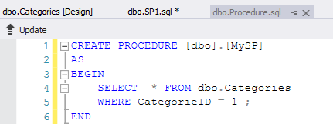
MySP is the name of the procedure.
The SQL code goes between BEGIN & END.

CREATE PROCEDURE [dbo].[MySP]
AS
BEGIN
SELECT * FROM dbo.Categories
WHERE CategorieID = 1 ;
END

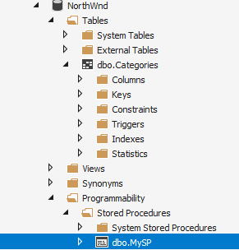

After we click Update then our Stored Procedure will appear here.

But now we must make another script to run (and compile) it.

Right-click on our database and choose New Query.

Type the code in the query.

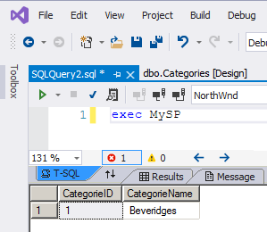
Click Execute.
The result appears.

Ref : Stored Procedures:

1.
https://www.w3schools.com/sql/sql_stored_procedures.asp
TO DO: Work thru all of it!

and…
2.

Entity Framework (Core) enables C# to produce a SQL database
We can work the other way around as well – we can create the classes from an existing database ie Database-First but this is less common. (We see here a Code-First approach.)
Basically it converts C# classes to SQL objects.

See myEF.sln myTest database

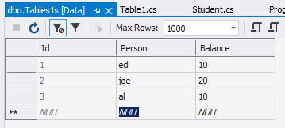
public class Student
{
public int Id { get; set; }
public string Person { get; set; }
public int Age { get; set; }
}

“Domain class SQL table

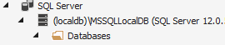
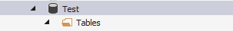
public class MyDbContext:DbContext
{
public DbSet<Student> Students{get;set;}
}
This class is incomplete (See later.)

“Context” class - represents the database Database
structure (schema) itself.

To make this conversion C# Core needs some Entity Framework Core packages which we must first download and install from NuGet (for every new project that we create.). Later we will see how to “run” these libraries.

We are using Entity Framework Core.
Entity Framework Core is very different from the previous Entity Framework version – Entity Framework 6.

Summary of what we must do to make a database.

1. Make C# classes.

2. Load the required Entity Framework libraries using Nuget.

3. Run these libraries from the NuGet console using update database etc.

Entity Framework Core cont’d. See myEF.sln

Video link: https://youtu.be/HOk96Ocp0P8 EntityFramework1.avi
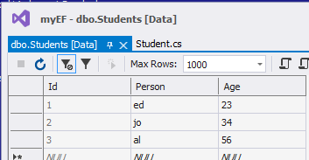

We will use C# to build this SQL table:

We will create the table from C# code like that below:

public class Student
We will use Entity Framework (to produce an SQL table from such classes.
ie the Code-First approach (cf Database-First)
{
public int Id { get; set; }
public string Person { get; set; }
public double Balance { get; set; }
}

).

To use Entity Framework we must download some Entity Framework NuGet packages.

First make a new Project:
From Visual Studio 2019
Create a Core Console App C:\code\TesttEF.sln
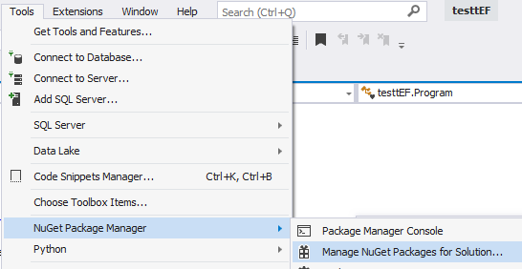

Browse for these in Nuget and Install.
Since our particular database will be using local SQL
(cf SQLite etc.)

Microsoft.EntityFrameworkCore.SqlServer
Microsoft.EntityFrameworkCore.Tools
design?

See https://www.entityframeworktutorial.net/efcore/install-entity-framework-core.aspx for images of what to do.

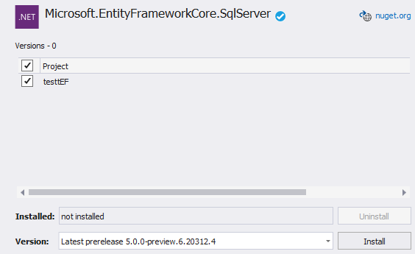

We should now have:
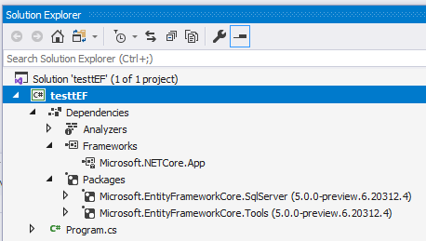
These are the downloaded Entity Framework classes which will connect our c# classes to our SQL table.

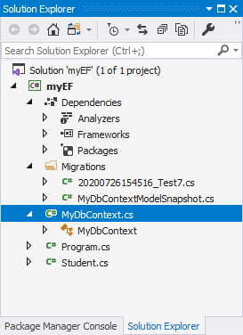
Now add these 2 classes MyDbContext & Student (see code below) as “templates” for our SQL database.

using System;

namespace myEF
{
Student.cs

public class Student
{
public int Id { get; set; }
public string Person { get; set; }
public int Age { get; set; }
}
}

A context is the C# representation of the whole database.
Our database is represented by MyDbContext which is derived from DbContext.
using Microsoft.EntityFrameworkCore;
MyDbContext.cs

namespace myEF
{
public class MyDbContext:DbContext
{
public DbSet<Student> Students{ get; set; } // Student is the name of the class. Students wil be the nameof the new table.

protected override void OnConfiguring(DbContextOptionsBuilder optionsBuilder)
{

optionsBuilder.UseSqlServer(@"Server=(localdb)\mssqllocaldb;Database=myTest;Trusted_Connection=True;");
}
protected override void OnModelCreating(ModelBuilder modelBuilder)
{
}
The name of our database to be created.
One DbSet for each table.
}
}
Our connection string is to an SQL database.

We will now generate Entity Framework code that will produce the database structure and its table (not the data) - from the previous two classes.

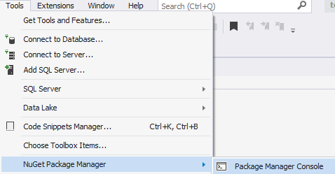

Choose Tools,
NuGet Package Manager, Package Manager Console.

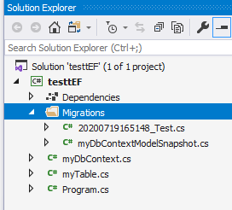
PM> add-migration Test (Call the migration whatever you like.)
This “migration” code has been created.
Migrations are C# code that create (or alter) the structure (or schema) of the database. They do not add data. (We will do that from our code.)
Build started...
Build succeeded.

Take a look at this migration code produced:

eg migrationBuilder.CreateTable(
name: "Students",
columns: table => new
{
Id = table.Column<int>(type: "int", nullable: false) etc.

It creates corresponding tables etc.

Now update our database:

PM> update-database

To take a look at our SQL database…
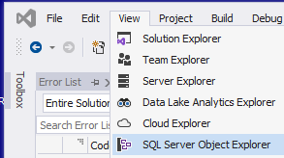

…open SQL Server Object Explorer.

Right-click and choose Refresh.

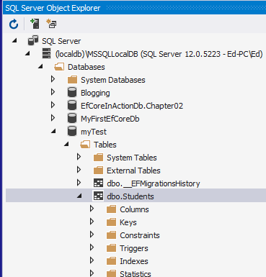

Our myTest database appears:

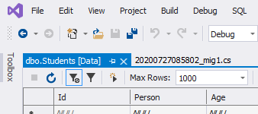

Right-click our table and choose View Data…

..our Student table appears.

To view the corresponding SQL (below) that is produced - which generated our table - right-click our table and choose View Code.

Auto incrementing (by 1) primary key starting at 1.
Nulls not allowed.

CREATE TABLE [dbo].[Students] (
[Id] INT IDENTITY (1, 1) NOT NULL,
[Person] NVARCHAR (MAX) NULL,
eg The Person String field is an NVARCHAR with max size of MAX = 8000)
[Age] INT NOT NULL,
CONSTRAINT [PK_Students] PRIMARY KEY CLUSTERED ([Id] ASC)
);

You may wish to compare the above with our Student “domain” class.

public class Student
Any name you give for this property which ends in Id eg PersonId (or just Id as shown here) will be mapped into a Primary key as above: [Id] INT IDENTITY (1, 1) NOT NULL,
{
public int Id { get; set; }
public string Person { get; set; }
public int Age { get; set; }
}

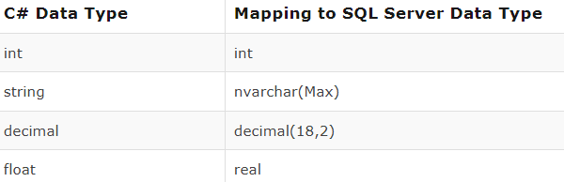
For description of translation of properties (eg Id) into column headings
See C# Data Type | Mapping to SQL Server Data Type
https://www.entityframeworktutorial.net/efcore/conventions-in-ef-core.aspx
These “conversions are according to so-called “conventions”.
We can change (ie “configure” these conventions.
To Add Data to our SQL table we use code in our program as below.

EntityFramework2.avi https://youtu.be/t5j9JtgeO-I
Changing data is referred to as a CRUD operation:
Create (Add)
Read
Update
Delete
Change Program.cs as shown below:

namespace myEF
{
class Program
{
static void Main(string[] args)
{
using (var context = new MyDbContext())
{
var std = new Student()
We are now using our context (context) to “communicate” with our database.
{
Person = "JoeJoe"
};

context.Students.Add(std);

context.SaveChanges();
To add many at the same time, put the data in a C# list using .ToList() and use AddRange.
}
}
}
}

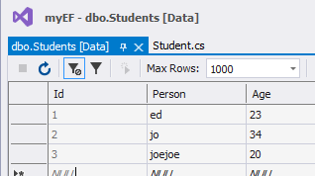
Run the program. (Refresh the table?)

(We don’t need to apply migrations
because there is no structural
change to the database.)

Data has been added.
Transactions

SaveChanges completes what we call a “Transaction”.

If we were to add two students….

var std = new Student()
{
Person = "JoeJoe"
};
context.Students.Add(std);

var std1 = new Student()
{
Person = "Robert"
};
context.Students.Add(std1);

context.SaveChanges();

… then both additions will not be made until SaveChanges is finally called. If we had say have a connection failure after only one student had been “added” then the change would be “roll backed”. ie no change. We can control transactions - see later.

To Update table data.

See https://www.entityframeworktutorial.net/efcore/saving-data-in-connected-scenario-in-ef-core.aspx

using System.Linq;

namespace myEF
{
class Program
{
static void Main(string[] args)
{
using (var context = new MyDbContext())
{
var std1 = context.Students.First<Student>();

std1.Person = "Steve";

context.SaveChanges();
}
}
}
}
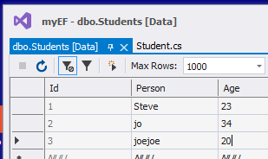
Run it & Refresh:
The first Person’s name has been changed to Steve as required.

To Delete table data:

using System.Linq;

namespace myEF
{
class Program
{
static void Main(string[] args)
{
using (var context = new MyDbContext())
{
var std1 = context.Students.First<Student>();

context.Students.Remove(std1);

context.SaveChanges();
}
}
}
}

For the following exercise first make sure that you have data in your SQL table. If not enter it directly.
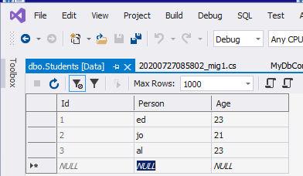

Query the table data using Linq

See https://www.entityframeworktutorial.net/efcore/querying-in-ef-core.aspx

To find whose Age is 23: (ed & al)

Add the code to program.cs as shown below:

using System.Linq;

namespace myEF
{
class Program
{
static void Main(string[] args)
{
using (var context = new MyDbContext())
{
var PersonsWithBalance = context.Students
.Where(s => s.Age == GetValue()) // == 23 is OK.
.ToList(); // Linq makes a C# List.

foreach (var p in PersonsWithBalance)// <- Now loop to output them
{ System.Console.WriteLine(p.Person); }

System.Console.ReadLine();
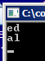
}
}

public static int GetValue()
{ return 23; }

}
}

Run the code.

Note that since we are not changing the structure of the database we don’t run add-migration etc.

Convention & Configuration.
We saw how eg public string Person { get; set; } caused [Person] NVARCHAR (MAX) NULL by “Convention”. We can “Configure” this default convention behaviour by using Attributes or Fluent API.

Attributes Attributes qualify a field (or table). https://youtu.be/-ia3M8l4das

eg We will qualify the Person field using [Required] (See below) .(Attributes have (square) brackets.)
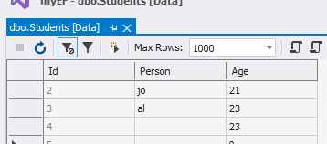
As mentioned, currently the data is not required ie can be null. This was the default conversion (more correctly the “convention”) of
public string Person { get; set; } -> [Person] NVARCHAR (MAX) NULL.
Currently we don’t have to enter data (ie it’s not Required.) in the Person field. Try it. Add a new record but don’t enter a Person. It won’t mind.
We have seen how the Person Field by default (convention) is “not required” ie it can be null. We will change (configure”) that behaviour so that it is required.

Let’s say that we wished to make the field Required (no nulls allowed) ie we must add a Person.
Add this…
using System.ComponentModel.DataAnnotations;

namespace myEF
{
public class Student
{
…and this.
This Attribute insists that each Person must have an entry.
public int Id { get; set; }
[Required]
public string Person { get; set; }
public int Age { get; set; }
}
}
Rule: Whenever we change the schema (database structure) then we need to run add-migration. (Tedious!).
(If doing a CRUD then we only need to run code.)

Updating Migrations:

Since we are changing the structure of the table then we need to run another “migration”

PM> add-migration Test1
Tip: PM> clear
will clear the PMC (Package Manager Console).

PM> update-database

(Test1 is the name of the new migration. Call it anything you like.)

The meaning of ?: eg public int? Age { get; set; }
The int data type in C# will by default produce an INT column in the database table which is NOT NULLABLE by default. Adding a question mark in the code eg int? will make it NULLABLE ie it can now accept a NULL.

Now if we try to only enter an Age without entering a Person…
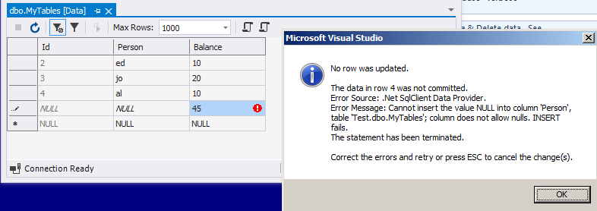

…we get this message saying that we can’t.
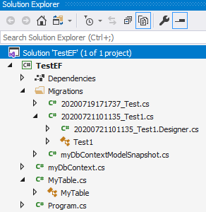
Note that the new migration Test1 has been added to our database.

Note that we cannot remove (PM> migration-remove) this migration Test1 once it has been run ie PM> update-database has been run again.?

update-database will always run the latest migration.

Migration

https://www.entityframeworktutorial.net/efcore/entity-framework-core-migration.aspx

You can remove the last migration if it is not applied to the database

Reverting a Migration
Suppose you changed your domain class and created the second migration named MySecondMigration using the add-migration command and applied this migration to the database using the Update command. But, for some reason, you want to revert the database to the previous state. In this case, use the update-database <migration name> command to revert the database to the specified previous migration snapshot
This will not remove the migration files related to MySecondMigration. Use the remove commands to remove them from the project.
----------------------------------------------

See list of other attributes in the https://www.entityframeworktutorial.net
web site.

For EF6 really so test them:
https://www.entityframeworktutorial.net/code-first/dataannotation-in-code-first.aspx
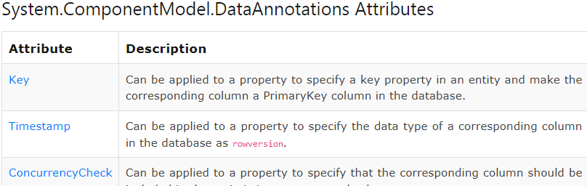

Using Fluent API here is an alternative to Attributes. Fluent API is similar to Linq.

eg Let’s limit the size of the Person (to 2 characters!) field but this time using Fluent API

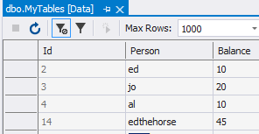

At the moment we can enter a string as it is less than 2 GByte!
Note: [Person] NVARCHAR (MAX) NULL,

We could do this -but won’t- using an attribute:

using System;
using System.ComponentModel.DataAnnotations;

namespace myEF
{
public class Student
{
public int Id { get; set; }
[Required]
[StringLength(2)] Attribute
public string Person { get; set; }
public int Age { get; set; }
}
}

Use Fluent API: In MyDbContext.cs https://youtu.be/tzQwpa4JTi8

using Microsoft.EntityFrameworkCore;

namespace myEF
{
public class MyDbContext : DbContext
{
public DbSet<Student> Students { get; set; }

protected override void OnConfiguring(DbContextOptionsBuilder optionsBuilder)
{
optionsBuilder.UseSqlServer(@"Server=(localdb)\mssqllocaldb;Database=myTest;Trusted_Connection=True;");
}
protected override void OnModelCreating(ModelBuilder modelBuilder)
{
Add this Fluent API
modelBuilder.Entity<Student>().Property(p => p.Person).HasMaxLength(2);
}
}
}

Now: PM> add-migration Test2
PM> update-database

So when we now try to enter a person larger than 2 characters…
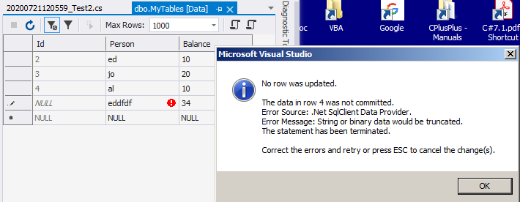
Age
Raw SQL Queries

Good old SQL as an alternative to Linq.

Execute Raw SQL Queries in Entity Framework Core
using Microsoft.EntityFrameworkCore;
using System.Linq;

var db = new MyContext();
var stds = db.Students
.FromSql("Select * from Students where Name = 'ed'")
.ToList();// FromSql doesnt work. Deprecated for security?
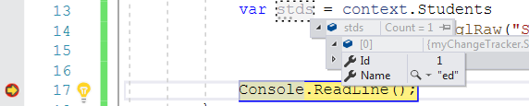

Parameterized

string name = "ed";
var context = new SchoolContext();
var students = context.Students.FromSqlRaw($
"Select * from Students where Name = '{name}'").ToList();

A variation of:
"Select * from Students where Name = '{0}'", name

To read:
https://www.entityframeworktutorial.net/efcore/raw-sql-queries-in-ef-core.aspx
for limitations etc
also
https://docs.microsoft.com/en-us/ef/core/querying/raw-sql

Working with Stored Procedure in Entity Framework Core

------------------------------------------------------------------------------------

Revision: Make a stored procedure called SP1 in the MyTest database to select all students with age 23. See: Stored Procedures page 7

Recall that to run our Stored Procedure we must run another script: exec SP1
(Don’t forget to update the Stored Procedure.)
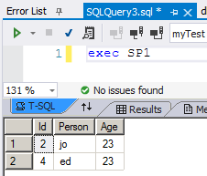
Exercise: Make a Query as well – to do the same thing.
myEF.sln.
myTest database.

SQL query https://youtu.be/r0dyEyrsRbQ
SQL Stored Procedure https://youtu.be/0m1__rqZazQ (not using Entity Framework)

-------------------------------------------------------------------------------------

To run our Stored Procedure SP1 place this code in program.cs and run it.

using Microsoft.EntityFrameworkCore;
using System.Linq;
using System;
using myEF;

class Program
{
static void Main(string[] args)
{
var context = new MyDbContext();
var students = context.Students.FromSqlRaw("SP1").ToList();
Console.ReadLine();
}
}

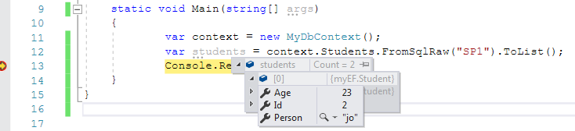
or use foreach (var s in students)
{
Console.WriteLine(s.Person);
}


To Make the Stored Procedure in the first place in Entity Framework

https://www.entityframeworktutorial.net/efcore/working-with-stored-procedure-in-ef-core.aspx

Recall how we made the Stored Procedure SP1 directly from the database (exercise of previous page)

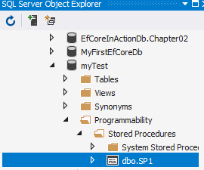

CREATE PROCEDURE [dbo].[SP1]
AS
BEGIN
SELECT * FROM Students
WHERE Age = 23;
END

We will produce this using Entity Framework code.

https://www.entityframeworktutorial.net/efcore/working-with-stored-procedure-in-ef-core.aspx

First make this migration.

PM> add-migration mig2

Don’t do update-database so that we will have an empty migration into which we will put our code.

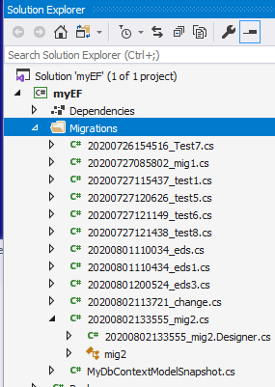
Open the empty migration – (if it is not already) and add the following code.

using Microsoft.EntityFrameworkCore.Migrations;

namespace myEF.Migrations
The name of the migration is mig2.
{
public partial class mig2 : Migration
{
protected override void Up(MigrationBuilder migrationBuilder)
{
The SQL is placed between BEGIN & END.
The name of the stored procedure will be SP6.
var sp = @"CREATE PROCEDURE[dbo].[SP6]
AS
BEGIN
SELECT* FROM Students
WHERE Age = 23
END";

migrationBuilder.Sql(sp);
}

protected override void Down(MigrationBuilder migrationBuilder)
{

}
}
}

Now:

PM> update-database

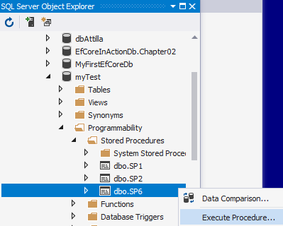

Execute it from here or run it from Entity Framework code as we did 2 pages ago.
Our Stored Procedure SP6 appears.

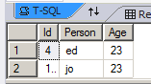
Result:

RelatedTables You Tube: https://youtu.be/lVPrWGbKtig

One-Many

https://www.entityframeworktutorial.net/efcore/one-to-many-conventions-entity-framework-core.aspx

We have two banks. ANZ & RBS.

One bank of course has many people.

This relationship is a one (bank) to many (people).

one many
ANZ
RBS
ed
jo
al
∞ ( ∞ denotes many)

In our simple example the ANZ bank has only two customers: ed & jo.

RBS has one only customer: al.

This is a one-many relationship. One bank many customers.

We are here assuming a customer cannot belong to more than one bank! If that were the case we would have a many-many relationship which will be discussed later.

So in summary:

ed & jo belong to ANZ. al belongs to RBS.

or the ANZ has two customers ed& jo. RBS has one customer

The one table is called the Principle table (or primary table)

The Customers table is called the Dependent table (or Child table.)

ANZ
RBS
ed
jo
al

As we usually do with related tables in a database, the trick is to add a BankId to the many table. (In this table BankId is known as a Foreign Key.)
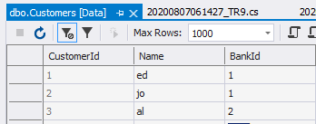
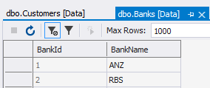

First we have two tables:

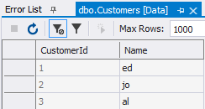
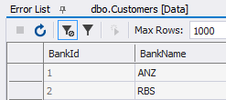

But how do we relate them? Place a BankId in the many-table as below.

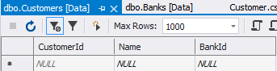

If you haven’t got a Customers table: Make Customer class:

and of course add this to the context file (MyDBContext.cs.)
public DbSet<Customer> Customers { get; set; }

Customer.cs

Make sure Customers is populated.
(Or whatever.)
namespace TRBank
{
public class Customer
{
public int CustomerId { get; set; }

public string Name { get; set; }
Foreign key has been added.

public int BankId { get; set; }

public Bank Banks { get; set; }
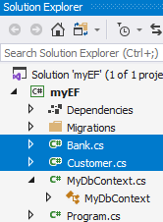
}
}
But with Entity Framework, we need to tell it that the tables are related. Since the property(Banks) is of type Bank – and not of an “ordinary” scalar type eg int or string, Entity Framework knows to use this as Navigation Property to “join” the two tables.

Then – since we are changing the structure of our database:

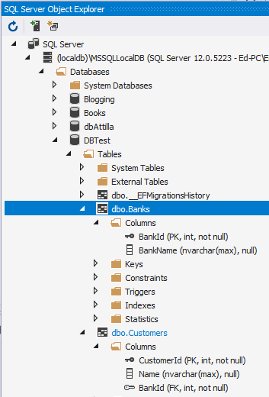
PM> add-migration Test6 (or whatever)
PM> update-database

Note the foreign key

(The rest of the Code
-------------------------------------------------------

namespace TRBank
{
public class Bank
{
public int BankId { get; set; }
public string BankName { get; set; }

public Customer Customers { get; set; } // Need this for the query.
}
---------------------------------

using Microsoft.EntityFrameworkCore;
namespace TRBank
{
public class MyContext : DbContext
{
public DbSet<Bank> Banks { get; set; }
public DbSet<Customer> Customers { get; set; }

protected override void OnConfiguring(DbContextOptionsBuilder optionsBuilder)
{
optionsBuilder.UseSqlServer(@"Server=(localdb)\mssqllocaldb;Database=DBTest;Trusted_Connection=True;");
}

protected override void OnModelCreating(ModelBuilder modelBuilder)
{
}
}
}
---------------------------------------

This is the migration code generated:

modelBuilder.Entity("TRBank.Bank", b =>
{
b.Property<int>("BankId")
.ValueGeneratedOnAdd()
.HasColumnType("int")
.UseIdentityColumn();

b.Property<string>("BankName")
.HasColumnType("nvarchar(max)");

b.HasKey("BankId");
Produces
the Banks table

b.ToTable("Banks");
});

modelBuilder.Entity("TRBank.Customer", b =>
{
b.Property<int>("CustomerId")
.ValueGeneratedOnAdd()
.HasColumnType("int")
.UseIdentityColumn();
Relates to the Bank table via BankId.
b.Property<int>("BankId")
.HasColumnType("int");

b.Property<string>("Name")
.HasColumnType("nvarchar(max)");
Produces
the Customers table
b.HasKey("CustomerId");

b.ToTable("Customers");
});

Cascade Delete: If we delete in the one table then the corresponding dependents in the many table will be deleted as well.

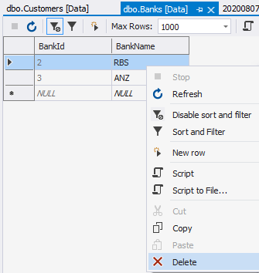
Delete the RBS bank entry in the principle table.

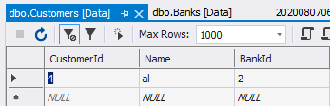

The customers in the many table related to the RBS are deleted as well!
ie Cascade Delete.

Using Fluent API to Relate the Tables

So far the relationship was added by Entity Framework by “Convention”.

We can do the same thing (ie don’t do the previous method) using Fluent API but Fluent API gives us more control.

Add this Fluent API code in the context class: In the OnModelCreating method.

protected override void OnModelCreating(ModelBuilder modelBuilder)
{
the one side table ie Banks
is joined to the many side Customers.
by means of the foreign key BankId.
For the Bank table (entity)
modelBuilder.Entity<Bank>()

.HasOne<Bank>(b => b.Banks)

.WithMany(c => c.Customers)

.HasForeignKey(c => c.BankId);

}

This should just relate the tables as before. If we wished to not have cascade delete then we could add:
.OnDelete(DeleteBehavior.ClientNoAction);

And then add-migration abc (or whatever) & update database.

Now try to delete RBS (after restoring them from the previous exercise). It is not allowed

---------------------------------------------------------------------------------------------------------------
But: For related tables we seem to need this as well
It appears that we need this as well!
ie Add IList to all relevant tables as a matter of course (see the EntityFrameWorkTutorial) . This seems to give us access to all the appropriate properties when using queries etc.

public class Bank
{
public int BankId { get; set; }
public string BankName { get; set; }

public IList<Customer> Customers { get; set; }
}

Put a IList in Customers as well.
-------------------------------------------------------------------------------------------------------------------
Now when we try to delete the one-table:
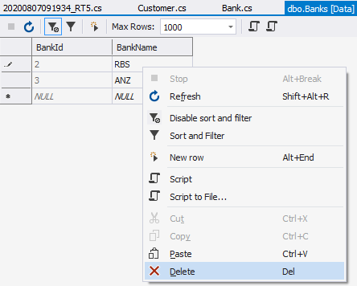
Nothing happens!

Other cascade commands:
- Cascade : Dependent entities will be deleted when the principal entity is deleted.
- ClientSetNull: The values of foreign key properties in the dependent entities will be set to null.
- Restrict: Prevents Cascade delete.
- SetNull: The values of foreign key properties in the dependent entities will be set to null.
Exercise: Make a database containing a Categories and Products table.
Join them as One-Many using Navigation properties( in both tables).
Query them.
Use Fluent API to join them.
See csDataBaseLessonVer1.docx for solution

To Query Related Tables Use linq

In program.cs:

using Microsoft.EntityFrameworkCore;
using System.Linq;
Count() (below) probably needs
public ICollection<Customer>Customers {get;set;}in Bank.
using System.Collections.Generic
using myEF;

class Program
{
static void Main(string[] args)
{
Yes this is why we need these “extra properties” not to link them but to be able to refer to them in queries etc!
QueryBank();
}

static void QueryBank()
The many side.
{
using (var db = new MyDbContext())
{
IQueryable<Bank> bnks = db.Banks.Include(x => x.Customers);

foreach (var b in bnks)
{
//System.Console.WriteLine("Bank {0} has {1} customers", b.BankName, b.Customers.Count); // Customers.Count don’t work

if(b.Customers !=null)
System.Console.WriteLine("Bank {0} has {1} customers", b.BankName, b.Customers.Name);

}
Include means Eager Loading which is the “default”. If we omit the Include then we have lazy-loading ie we don’t get the results from the related table!
Include is used to query related tables as well as the one-table.

}
}
}

}

Page 441 of book.

Exercise: Query both the Categories & Products tables.

using:
using (var db = new MyContext())
{
IQueryable<Customer> bnks = db.Customers.Include(x => x.Banks);
foreach (var b in bnks)
{
System.Console.WriteLine("Bank {0} has Customer {1} ", b.BankId, b.CustomerId);
}
System.Console.ReadLine();
}
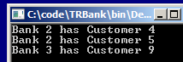
gives:

But I suspect that using the collection in Bank.cs & Customer.cs will allow all properties eg CustomeName to be accesses?

Transactions EFTransactions.avi https://youtu.be/r9uxWDOfdNQ

A Transaction is a series of data changing operations eg adding deleting changing etc.
We mentioned previously (on page 14 – and see below) that SavedChanges() is only executed when ALL the entries have been made ie.

Transactions

SaveChanges completes what we call a “Transaction”.

If we were to add two students….

var std = new Student()
{
Person = "JoeJoe"
};
context.Students.Add(std);

var std1 = new Student()
{
Person = "Robert"
};
context.Students.Add(std1);

context.SaveChanges();

… then both additions will not be made until SaveChanges is finally called. If we had say have a connection failure after only one student had been “added” then the change would be “roll backed”. ie no change. We can control transactions - see later.

First revise the above.

For the full code see the following page – without the red lines of code.

BeginTransaction allows us to use Commit & Rollback.

Add the lines in red below.

namespace myTransactions
{
class Program
{
static void Main(string[] args)
{
using (var context = new MyContext())

using (IDbContextTransaction tr = context.Database.BeginTransaction())
{
Using BeginTransaction())means that we must now use Commit() to save all of the changes.
If you comment out tr.Commit(); then the changes (additions) will not be made – try it.)
{
var std = new Student()
{
Person = "JoeJoe"
};
context.Students.Add(std);

var std1 = new Student()
{
Person = "Robert"
};
context.Students.Add(std1);

context.SaveChanges();

tr.Commit();
}
}
}
}
}

To account for any errors we can use Rollback(). This should be placed in a Catch block as follows: Add the red lines below.

Run this code. Since no error occurs (eg loss of connection) then it runs as before. JoeJoe and Robert will be added.

using Microsoft.EntityFrameworkCore.Storage;

namespace myTransactions
{
class Program
{
static void Main(string[] args)
{
using (var context = new MyContext())

using (IDbContextTransaction tr = context.Database.BeginTransaction())
{
try
{
{
var std = new Student()
{
Person = "JoeJoe"
};
Now to simulate an error include
throw new Exception(); here. (And make sure that we have the namespace using System included at the top.)
Run it.
The error message will appear at the console.
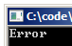

context.Students.Add(std);

var std1 = new Student()
{
Person = "Robert"
};
context.Students.Add(std1);

context.SaveChanges();

tr.Commit();
}
}

catch
{
tr.Rollback();
System.Console.WriteLine("Error");
}
}
}
}
}

See https://www.entityframeworktutorial.net/entityframework6/transaction-in-entity-framework.aspx

Note that this was written for EF6 as well as Entity Framework core so beware of differences.
Change Tracker

We can use a ChangeTracker object to keep track of the State of entities:

Added, Modified, Deleted, Unchanged, Detached.

ChangeTracker has a method called Entries() which will retrieve its properties ie

eg:
static void Main(string[] args)
{
using (var db = new MyContext())
{
var std1 = new Student() { Person = "bo" };
db.Add(std1);

var std2 = new Student() { Person = "ro" };
db.Add(std2);

var es = db.ChangeTracker.Entries(); }
}
Our es is a collection of properties for each record in Students table.

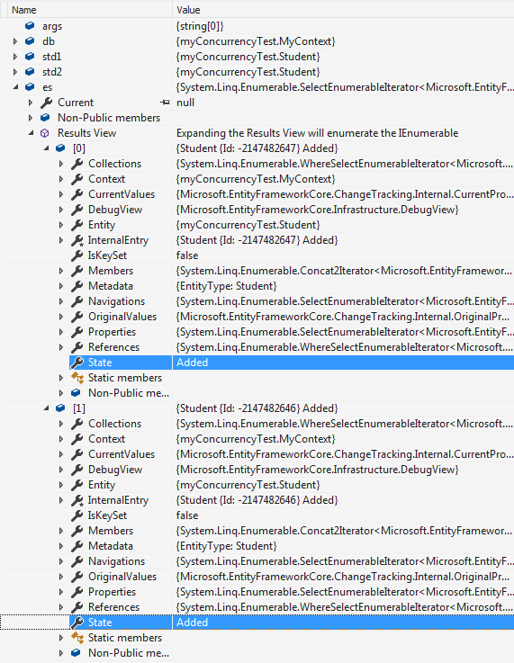

We are interested in the State of each record.

(es is a rather unwieldy type: Microsoft.EntityFrameworkCore.ChangeTracking.EntityEntry> )

ToList Is needed to convert the collection to an accessible List.

So to access each state use:

var st1 = es.ToList()[0].State; // -> Added. (bo)
var st2 = es.ToList()[1].State; // -> Added. (ro)

or iterate thru them:

foreach (var e in es)
{
Console.WriteLine(e.State.ToString());
}

Exercise: Show

// RETRIEVE an entity
var std1 = db.Students.First(); // -> Unchanged

// CHANGE an entity
var std1 = db.Students.First();
std1.Person = "Rob" // -> Modified

// CHANGE an entity
var std1 = db.Students.First();
db.Students.Remove(std1); // -> Deleted

Further: https://www.entityframeworktutorial.net/efcore/changetracker-in-ef-core.aspx

Shadow Property

https://www.entityframeworktutorial.net/efcore/shadow-property.aspx

A Shadow Property is a database variable - it is used to hold values (similar to a usual (global) C# variable.)

They are configured in the OnModelCreating() method of the context class:

public class MyContext : DbContext
{
Need using System;
…
protected override void OnModelCreating(ModelBuilder modelBuilder)
{
modelBuilder.Entity<Student>().Property<DateTime>("CreatedDate");
}

If you wished to run it now you would need to add-migration etc now.

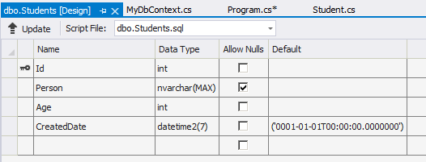
CreatedDate field is added to the structure.

and after refresh you may see:
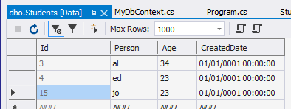

A CreateDate has been arbitrarily assigned.

The value and state of the shadow properties are maintained by the ChangeTracker.

In program.cs
(Need using System; for DateTime.)
using System;
using System.Linq;

namespace myTransactions
{
class Program
{
static void Main(string[] args)
{
Check the name of your Context.
using (var db = new MyContext())
{
var std1 = db.Students.First();

// Sets the value to the shadow property
db.Entry(std1).Property("CreatedDate").CurrentValue = DateTime.Now;

// Gets the value of the shadow property
var cd = db.Entry(std1).Property("CreatedDate").CurrentValue;

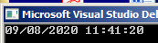
Console.WriteLine(cd);
}
}
}
}

add-migration etc

If we wish to update the shadow properties automatically then override SavedChanges() in the Context class:
Place this code in the MyContext.cs file (maybe after OnModelCreating(ModelBuilder)modelBuilder).

The code looks amongst the ChangeTracker.Entries…
public override int SaveChanges()
{
var es = ChangeTracker.Entries()
.Where(e => e.State == EntityState.Added || e.State == EntityState.Modified);
…for the States which are Added or Modified.
foreach (var v in es)
{
v.Property("UpdatedDate").CurrentValue = DateTime.Now;

if (v.State == EntityState.Added)
{
v.Property("CreatedDate").CurrentValue = DateTime.Now;
}
…and print out their values upon Save.
No record has been added yet so no point in running it yet.
}
return base.SaveChanges();
}
(This is a good example of use of ChangeTracker!)

(An Enum constant)

Then of course we need to Add a record to see it in action:

Modify Program.cs

using System;
using System.Linq;

namespace myTransactions
{
class Program
{
static void Main(string[] args)
{
using (var db = new MyContext())
{
var std1 = new Student() {Person = "flo" };

db.Add(std1);

db.SaveChanges(); // Now calls the overloaded SaveChanges()

//db.Entry(std1).Property("CreatedDate").CurrentValue = DateTime.Now; // now not needed

// Gets the value of the shadow property
var cd = db.Entry(std1).Property("CreatedDate").CurrentValue;

Console.WriteLine(cd);

cd = db.Entry(std1).Property("CreatedDate").CurrentValue;
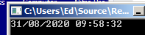
Console.WriteLine(cd);
}
}
(We don’t really need to do these 4 lines.)
}
}

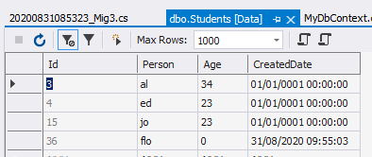

The new student’s Created Date has been included.

A shadow property is also created when we don’t specify a foreign key.
https://www.entityframeworktutorial.net/faq/how-to-check-shadow-property-at-runtime.aspx

Connected / Disconnected Entities EFConnDisConn.avi : https://youtu.be/Oy0pCosFzRA

An entity is connected if it’s added within the context. Otherwise it is disconnected.
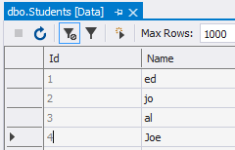
public class MyContext : DbContext
{
etc
optionsBuilder.UseSqlServer(@"Server=(localdb)\mssqllocaldb;Database=myTest9;Trusted_Connection=True;");
}
Remember the context (db in this case) represents the whole database.
Recall how we usually add data to a table

using (var db = new MyContext())
{
var std = new Student() { Name = "Joe" };
db.Students.Add(std);
db.SaveChanges();
}

The data is added within our database context MyContext.
Connected Disconnected more important in Wed/Server apps see ASP.Net later.
But when we think about it our context makes a connection.

MyContext.cs

ie the above data addition has been made in the connected state…

using Microsoft.EntityFrameworkCore;
using System;
using System.Linq;
… but if we add data outside of our context it will be disconnected (or detached).
namespace myChangeTracker
{
class Program
{
static void Main(string[] args)
{
var std = new Student() { Name = "Rob" };

using (var db = new MyContext())
{
db.Entry<Student>(std).State = EntityState.Added;

db.SaveChanges();
So now before we call Savedchanges, the context needs to be told that it is to be Added (inserted) (cf Deleted or modified ie EntityState.Modified
EntityState.Deleted ).

The entity is now being “tracked” by the context.

}
}
}
And finally we can save it to the table.
}

Confusingly db.Students.Add(std); will do the same as db.Entry<Student>(std).State = EntityState.Added;!

See further : https://www.entityframeworktutorial.net/efcore/saving-data-in-disconnected-scenario-in-ef-core.aspx

Exercise:

1. Use .Entry(std).State to show that std is “Detached” before context.Entry<Student>(std).State = EntityState.Added;
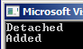
and “Added” after it.

Console.WriteLine(db.Entry(std).State); // Detached
db.Entry<Student>(std).State = EntityState.Added;);
Console.WriteLine(db.Entry(std).State); // Added

2. Show how
EntityState.Modified
EntityState.Deleted
.Unchanged ?
would be used to indicate to the context an “edited” and deleted entity respectively.

Modified:
https://www.entityframeworktutorial.net/efcore/update-data-in-entity-framework-core.aspx

static void Main(string[] args)
{
var std = new Student() { Id=1}; // Make sure Id=1 exists.
std.Name = "mo";

using (var db = new MyContext())
{
Console.WriteLine(db.Entry(std).State); // Detached

db.Entry<Student>(std).State = EntityState.Modified;

Console.WriteLine(db.Entry(std).State); // Added
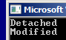
db.SaveChanges();
}
}
Deleted:
https://www.entityframeworktutorial.net/efcore/delete-data-in-entity-framework-core.aspx
There is no difference in deleting an entity in the connected and disconnected scenario in EF Core

static void Main(string[] args)
{
var std = new Student() { Id=1}; // Make sure Id=1 exists.

using (var db = new MyContext())
{
Console.WriteLine(db.Entry(std).State); // Detached

//db.Entry<Student>(std).State = EntityState.Modified;
db.Entry<Student>(std).State = EntityState.Deleted;

Console.WriteLine(db.Entry(std).State); // Added

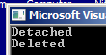
db.SaveChanges();
}
}
}

Concurrency EFConcurrency.avi https://youtu.be/aFJJMbeVYSg

https://www.mssqltips.com/sqlservertip/6115/how-to-handle-concurrency-in-entity-framework-core/

Concurrency conflicts happen when two or more users try to access the same resource concurrently, i.e., at the same point of time

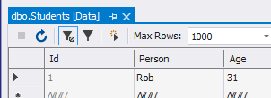
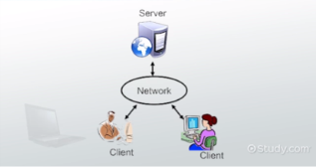

First we wish to change Rob.

class Program
{
static void Main(string[] args)
{
using (var db = new MyContext())
{
var std0 = db.Students.Where(p => p.Id == 1).FirstOrDefault();
std0.Person = "Bob";

db.SaveChanges();
Change the table data back to Rob.

}
}

No problem. But now we will simulate an attempt by another client to also change the data using ExecuteSqlRaw,

db.Database.ExecuteSqlRaw( "UPDATE dbo.Students SET Person = 'Jojo' WHERE Id = 1");

Before we run that we need to indicate that the Person field will be subject to concurrency checking by adding a [ConcurrencyCheck] attribute:

using System.ComponentModel.DataAnnotations;

namespace myConcurrencyTest
{
public class Student
{
public int Id { get; set; }
Add a ConcurrencyCheck attribute.
[ConcurrencyCheck]
public string Person { get; set; }
public double Age { get; set; }
}
}

We then need to add-migration etc.
Now when we run this we will get the following error message when we try to save:
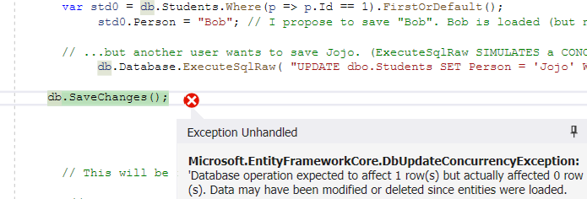

Note that we won’t get an error if the table data is Bob!

To summarize so far: We have two clients trying to alter the same record which induces an error.

To trap the error, use a try-catch as follows:

using Microsoft.EntityFrameworkCore;
using System;
using System.Linq;

namespace myConcurrencyTest
{
class Program
{
static void Main(string[] args)
{
using (var db = new MyContext())
{
var std0 = db.Students.Where(p => p.Id == 1).FirstOrDefault();
std0.Person = "Bob"; // I propose to save "Bob". Bob is loaded (but not saved into d/base)...

// ...but another user wants to save Jojo. (ExecuteSqlRaw SIMULATES a CONCURRENCY conflict!)
db.Database.ExecuteSqlRaw( "UPDATE dbo.Students SET Person = 'Jojo' WHERE Id = 1");

db.SaveChanges();

try
{
db.SaveChanges();// Attempt to save Bob to the database
// No error will occur if Bob is already in the table!
}

catch (DbUpdateConcurrencyException ex) // ex will contain the records which are in conflict.
{
var cv = ex.Entries[0].CurrentValues["Person"]; // Bob

var dv = ex.Entries[0].GetDatabaseValues()["Person"]; // Jojo

//At the moment Jojo has been saved. But we could decide to save Bob if we wanted as follows:

ex.Entries[0].CurrentValues["Person"] = cv; // Saves Bob

}}}}}

ex.Entries[0] is the first conflict ie the 1st record.

ex.Entries[0].CurrentValues["Person"]; is the Person column of that field. ie Bob.

ex.Entries[0]. GetDatabaseValues()[" ["Person"]; is the Person column of that field. ie Jojo.

https://docs.microsoft.com/en-us/ef/core/saving/concurrency

optimistic.
Other method : RowVersion.

Database-First EFDataBaseFirst https://youtu.be/48_q7y1JFLo

We need to have the database first. Then we run our code to produce the c# classes. (Doing this is less common then database first.)

http://www.entityframeworktutorial.net/efcore/create-model-for-existing-database-in-ef-core.aspx

We will now make C# classes from an existing database.

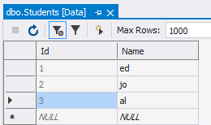
The “Existing database” could be eg myTest9
(ie one that we have produced using Code-First ! )
Perhaps containing a simple table like this.

http://www.entityframeworktutorial.net/efcore/create-model-for-existing-database-in-ef-core.aspx (as above) uses SchoolDb database.

Create a new Console Core App. eg testDataBaseFirst.sln

As usual ie Microsoft.EntityFrameworkCore.SQlServer
But we also now need this as well. Microsoft.EntityFrameworkCore.Design

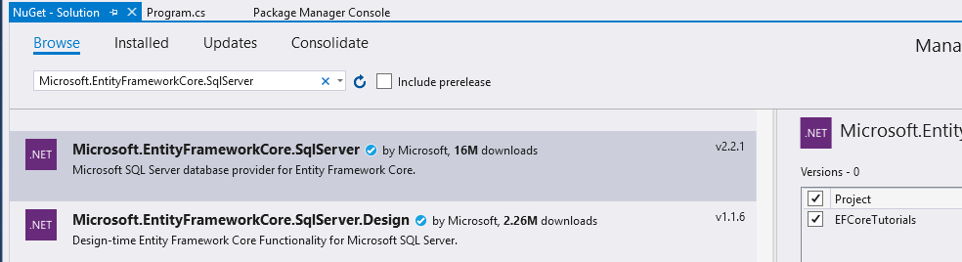

Use the name of your database.

Run this at the PMC:

PM> Scaffold-DbContext "Server=(localdb)\mssqllocaldb;Database=myTest9;Trusted_Connection=True;" Microsoft.EntityFrameworkCore.SqlServer -OutputDir Models
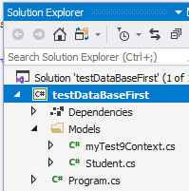
Result:

Take a good look at the classes which have been automatically produced.

Extra stuff:

Getting Started with Entity Framework Core [1 of 5]

https://channel9.msdn.com/Series/Entity-Framework-Core-101/Getting-Started-with-Entity-Framework-Core

Excellent
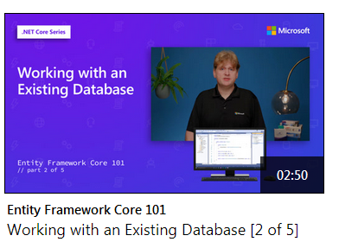

Watch 1 & 2? (Brief database first (note annotations option)). (Watch 3 for ASP).

https://docs.microsoft.com/en-us/learn/modules/persist-data-ef-core/

Tips:
prod tab tab to get new property

Migration Commands
https://www.entityframeworktutorial.net/efcore/pmc-commands-for-ef-core-migration.aspx

Chapter11.sln BOOK

For the book database open WorkingWithEFCore from Visual Studio 2019

CSharp71andNETCore20ModernCrossPlatformDevelopmentThirdEdition_Code

C:\Users\Ed\OneDrive\Public\C#\c#\CSharp71andNETCore20ModernCrossPlatformDevelopmentThirdEdition_Code\VSCode\Chapter11\WorkingWithEFCore\WorkingWithEFCore.sln

For book code visit https://packtpub.com/
Mine is at: C:\Users\Ed\OneDrive\Public\C#\c#\CSharp71andNETCore20ModernCrossPlatformDevelopmentThirdEdition_Code\VSCode

For book pdf C:\code\c#7.1.pdf

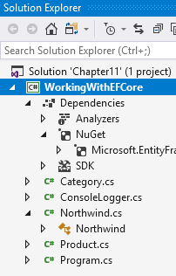
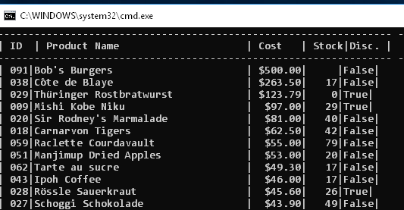

Lazy Loading: When we SELECT a category then we want to select all of the products for that category they would be loaded EACH TIME. ie a lot of work for the dbs. Not implemented in core yet!
.
db.Products.RemoveRange(products);
RemoveRange is more efficient when you want to delete multiple entities.

You can use the DbContext.Database API to begin, commit, and rollback transactions

CH 11 dbs in /code folder laptop?

C#7.1.pdf in C# folder

TO GET HIS SCRIPT FILE: Not easy to find!
https://github.com/markjprice/cs7dotnetcore2/tree/master/sql-scripts

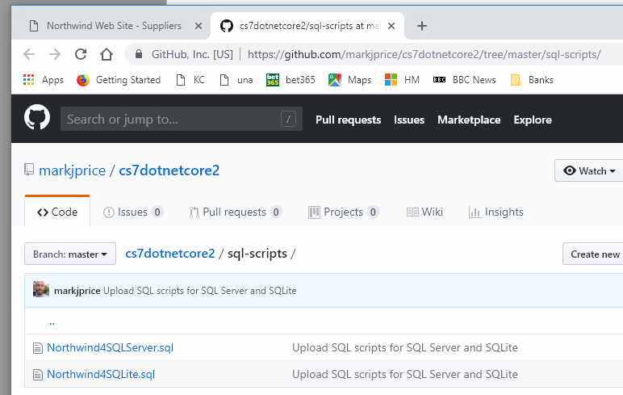
Choose

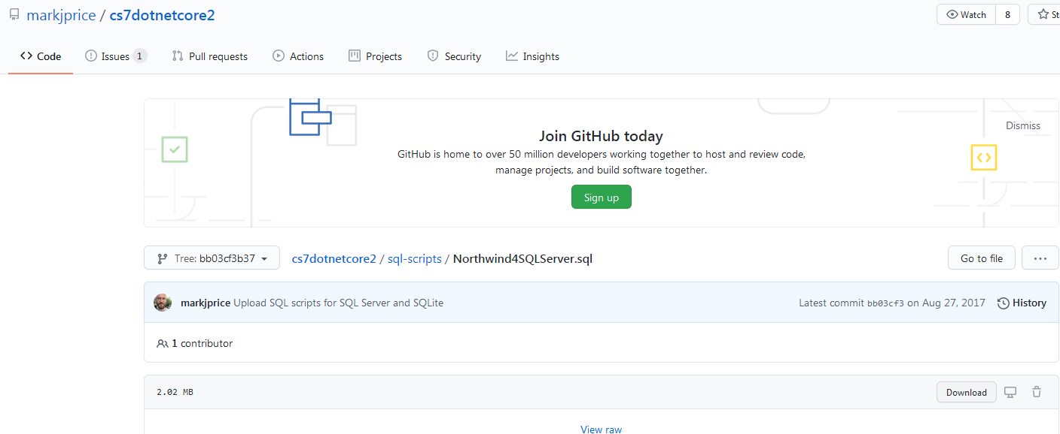
download
At the end of the day we want this!: (“upload” ! ?) download
/*
** Copyright Microsoft, Inc. 1994 - 2000
** All Rights Reserved.
*/
SET NOCOUNT ON
GO
USE master
GO
if exists (select * from sysdatabases where name='Northwind')
drop database Northwind
go
DECLARE @device_directory NVARCHAR(520)
SELECT @device_directory = SUBSTRING(filename, 1, CHARINDEX(N'master.mdf', LOWER(filename)) - 1)
FROM master.dbo.sysaltfiles WHERE dbid = 1 AND fileid = 1

EXECUTE (N'CREATE DATABASE Northwind

etc

In Visual Studio 2017, go to File | Open | File... or press Ctrl + O.
Browse to select the Northwind4SQLServer.sql file and choose Open.
In the editor window, right-click and choose Execute or press Ctrl + Shift + E.

In the Server Explorer window, right-click on Data Connections and choose Add
Connection.... etc see excellent digrams

The result of WorkingWithEFCore on PC:
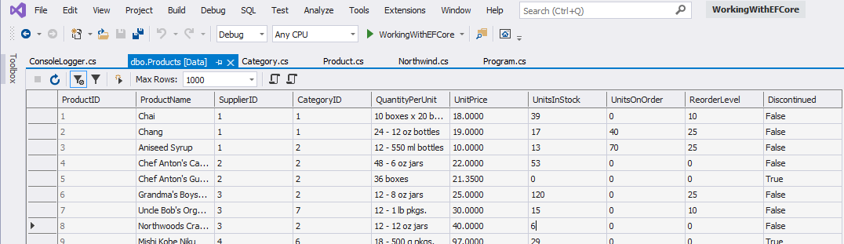
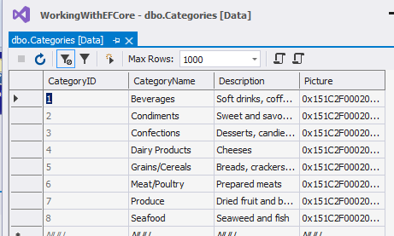

MungoDB

Uses Json not SQL.

Download (On QW)
https://www.mongodb.com/try/download/community

https://www.youtube.com/watch?v=69WBy4MHYUw
types in code!

Service: ie will run when not logged in !

Compass is the equivalent of SMSS-for- SQL

GitHub code?
https://github.com/ameetj85/MongoDBDemoApp

open code in Geany! and copy it in.

MongoDBDemo on QW.

using MongoDB.Bson.Serialization.Attributes;
using MongoDB.Driver;
using System;

namespace MongoDBDemo
{
class Program
{
static void Main(string[] args)
{
MongoCRUD db = new MongoCRUD("AddressBook"); // Will create db if doesnt exist!

// Ceates table Users - if not present will create it.
db.InsertRecord<PersonModel> ("Users", new PersonModel { FirstName = "Ed", LastName = "Rob" });
// converts PersonModel object to Json - more correctly Bson.

}
My doing. Implicit before ? !
}

public class PersonModel
{
[BsonId] // stored in Mongo as _id. If Guid is passed in as null Mongo will create a new Guid
public Guid Id { get; set; }
// Uses a Guid SO.. If it doesnt exist then it will Insert- if it does it will modify!

public string FirstName { get; set; }
public string LastName { get; set; }
//public AddressModel PrimaryAddress { get; set; }

[BsonElement("dob")]
public DateTime DateOfBirth { get; set; }
Step 1. “Passes” the name of the TYPE.
}

public class MongoCRUD
{
private IMongoDatabase db;

public MongoCRUD(string database)
{
var client = new MongoClient(); // no params = connect to local server
Step 2. Specifies that record can only be of that TYPE.

db = client.GetDatabase(database);
}
public void InsertRecord<T>(string table, T record)
{
var collection = db.GetCollection<T>(table);

collection.InsertOne(record);
}

}
}

Start Compass, click Connect and…

..there it is : AddressBook !

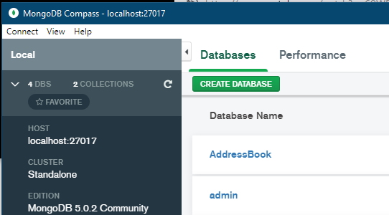

And the data (Documents!)

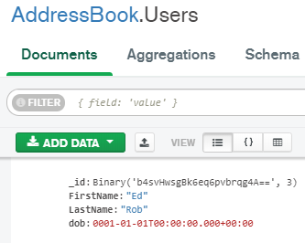

Todo: rest in detail
Good examples of C# notation! Use as example! In my course.

