Services(last)Lesson

Entity Framework related tables?.

1. ValueService & Weather controller

NorthWnd ?

2. AuthorsDBs authors Use this

3. less3 simple but go thru the tute

4. less4 excellent MVC CRUD Use this

C:\Users\User\source\repos\edthehorse\Part3

namespace NorthwindService.Controllers

C# and The Web UsingPostman

Very Simple Web

Razor Pages Razor Form

YouTubes
Y-1
Y0

Y2
Y3
Y4

MVC MakeMVC

Start Here for MVC 1. SummaryMVCDBS MVC & Database Add Data DBS(Form) MVC Form NewPage (Watch videos)

3. Then https://www.tektutorialshub.com/asp-net-core-tutorial/ see p 137 of Extra1

Source code: https://github.com/tekTutorialsHub/ASP-NET-Core-MVC
ON PC
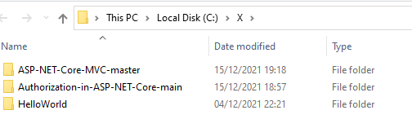

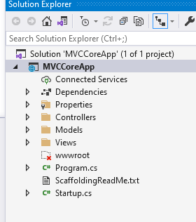
On Laptop

Good for DI see Extra1 manual

(For authorization code
https://github.com/tekTutorialsHub/Authorization-in-ASP-NET-Core

ON PC QW : C:\X\ASP-NET-Core-MVC-master\MVCCoreApp.sln
Very basic MVC but complete the tutorial

http://localhost:51811/Home/Index
or !! app.UseMvc();

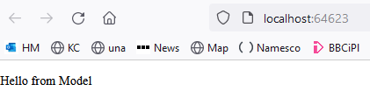

The Controller has three major responsibilities
Handle the Request
Build a Model
Send the Response

There are two main options.
MVC Controller
API Controller

Action methods Must be a public method
The Action method cannot be a Static method or an Extension method.
Action methods Cannot contain ref or out parameters.
ASP.NET Core MVC framework has built-in support for several types of Action results including
- ViewResult – Represents HTML and markup.
- EmptyResult – Represents no result.
- RedirectResult – Represents a redirection to a new URL.
- JsonResult – Represents a JavaScript Object Notation result that can be used in an AJAX application.
- ContentResult – Represents a text result.
- The API Controller’s inherit from the ControllerBase class, while MVC Controllers inherit from Controller class.
The API Controllers are expected to return data in serialized to format, While MVC Controllers are expected return views. Apart from that, there is not much difference between them.
app.UseEndpoints(endpoints =>
endpoints.MapControllerRoute(
name: "default",
pattern: "{controller=Home}/{action=Index}/{id?}");
});

Now, remove the routes from the code.
app.UseEndpoints(endpoints =>
{
});

Run this app and try the following URLs. /,/Home, /Home/Index or any other URL
In all the above cases you will receive the “Fails to Find a Route“ message. This is because we have not registered any Route.

Todo: conventional routing
https://www.tektutorialshub.com/asp-net-core/asp-net-core-convention-based-routing/

JavaScript

JQuery

Json

NPM

NodeJS

TypeScript

Angular

Azure

Extra

Logging

public class Student
{
public int Id { get; set; }
public string Person { get; set; }
public int Age { get; set; }
}

public class MyDbContext:DbContext
{ public DbSet<Student> Students{ get; set; }

protected override void OnConfiguring(DbContextOptionsBuilder optionsBuilder)
{
optionsBuilder.UseSqlServer(@"Server=(localdb)\mssqllocaldb;Database=myTest;Trusted_Connection=True;");
}

protected override void OnModelCreating(ModelBuilder modelBuilder)
{ }
}

To make a website we transfer our program code to another computer. A server – or host.

Then we (or other client computers) connect to that host by means of a browser and make a request for certain pages – or services (eg to get the time).

The server or host computer then sends back html (or json in the case of a service) pages - a response - which are then viewed in the browser.

Preliminary: To view an HTML file in a browser

<html>
<body>
Hello Ed
</body>
</html>

Building a web site

By means of C# : Design -> Publish (upload) to another internet connected computer a web server/host.

We first have to buy space on a host eg namesco.co.uk (We will later publish to Microsoft Azure) so that we can upload our web to it.

It is more convenient however to publish (ie move it) onto our own computer which simulates our host. This is called a local server eg IIS which is what we will be using with Visual Studio 2007.

HTML YouTube: https://youtu.be/E2ePHgAElbk (More relevant to Excel VBA.) HTML * Publish.

What is it? It’s a simple text file with lots of angle brackets. eg

<head>
HTML is hierarchical.
An opening tag eg <head>is always matched by a closing tag < /head>. Allowing “nesting”.
<b>
hello
</b>
</head>

- Make this above file in notepad and save it as html.html . (I saved mine to C:/temp - easy to find).

What’s HTML used for? To render a document. To render means to lay it out according to instructions – much the same as you might give instructions to the high street printer.
An HTML file is a set of instructions for a browser (renderer) such as Internet Explorer.

- Open Internet Explorer (or FireFox) etc
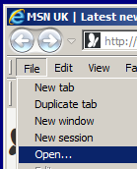
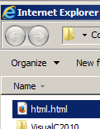
- Hey Presto our html file has been rendered.
- Navigate to your html file and open it.

- File, Open.

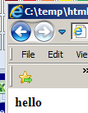

To view the html source from Internet Explorer:
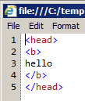
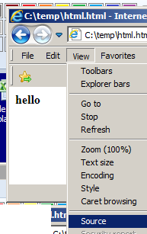
Note the use of the opening and closing b tags which have the effect of making hello bold.
- View, Source.

For more on HTML (great tutorials) see: https://www.w3schools.com/html/default.asp

Conclusion: A browser is a program for viewing (or rendering) HTML. So far we have not mentioned the internet. We call this “client-side” activity. ie browser <-> Client.

Cascading Style Sheets are a method of adding formatting to HTML pages.
CSS will explain Layout files which use similar to CSS.
They are text files.

Make this css in a text editor eg Notepad++
The background will be lightblue. See below.
body {
background-color: lightblue;
}
All HTML headings will be navy.
h1 {
color: navy;
margin-left: 20px;
}

and save it to the desktop as mystyle.css

Make this html file. Save it tio the desktop. Open it from a browser.

<!DOCTYPE html>
<html>
<head>
<link rel="stylesheet" type="text/css" href="mystyle.css">
</head>
<body>

<h1>This is a heading</h1>
<p>This is a paragraph.</p>

</body>
</html>

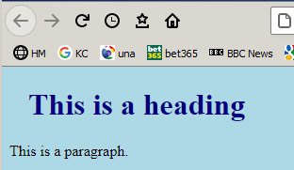

navy header

…light blue body.

To Make and view a website (Just renders text (Hello World) onto a page)

-1 https://youtu.be/JAsY5x5l27k just makes a Hello World web app.
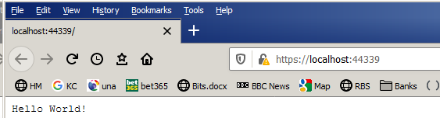

On QW PC in X folder.
HelloWorld.sln
Net 5.0 Current

https://localhost:44325/

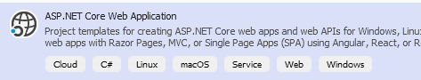
1. Make an Empty ASP.Net Web Core

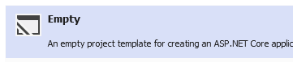

Empty project

Or in Visual Studio 2022

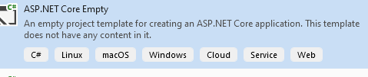

c:\code\aspnetcoreapp\aspnetcoreapp.sln for video (on black PC)
Run it.

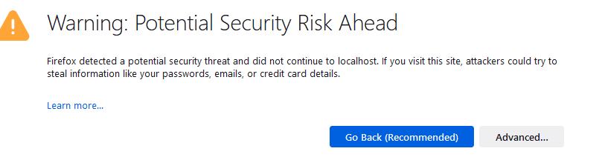

etc

https://localhost:44325/ because in launchsettings.json:
"sslPort": 44325
Making a web is not easy. It would be extremely difficult to build one from scratch! Microsoft makes the skeleton web for us. We will then consider all the components.
You will need to use HTML, Linq, Razor etc to modify the site.

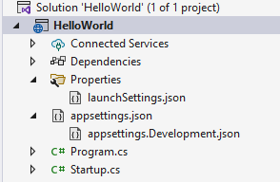
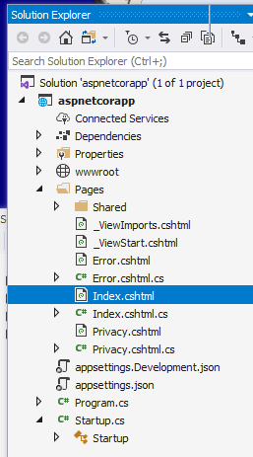

1
Program.cs Starts here

public static void Main(string[] args)
{

public static IHostBuilder CreateHostBuilder(string[] args)
{
webBuilder.UseStartup<Startup>();

2
“Calls” Startup
Startup.cs

public class Startup
{
// This method gets called by the runtime. Use this method to configure the HTTP request pipeline.

public void Configure(IApplicationBuilder app, IWebHostEnvironment env)
{
app.UseRouting();

app.UseEndpoints(endpoints =>
{
endpoints.MapGet("/", async context =>
{
await context.Response.WriteAsync("Hello World!");
});
});
}
}

Extension method
Lambda method
Endpoint refers to the URL end.
await along with async means other stuff can carry on.
UseRouting means that the URL is to be “parsed” to redirect control.
MapGet("/",means Map the last \ of the URL to a Get() by default.
Since these middleware pipeline commands refer the result of each one to the nextthey must be in the correct order in our code.

An Endpoints is where the URL“ends up”.

3

After we type in our URL https://localhost:44342/ (actually it appears automatically in our case) the Response from the server causes the text render the text “Hello World!” in the browser.

Use (see above) as in app.UseEndpoints indicates a “middleware” service. These are bespoke services we introduce to handle our URL request.- which servers to delegate to.

In the Startup class, there are two methods where most of our work will take place. The Configure method of the class is where you build your HTTP processing pipeline.
- This defines how your application responds to requests. Currently this application can only say Hello World! but if we want the application to behave differently, we will need to change the pipeline by adding additional code in this Configure method.
- For example, if we want to serve the static files such as an index.html file, we will need to add some code to the Configure method (see below.)
- You can also have an error page or route requests to an ASP.NET MVC controller; (see later) both of these scenarios will also require to do some work in this Configure method.
await context.Response.WriteAsync("Hello World!");
It is this line of code that responds to every HTTP request to your application and it simply responds with the text Hello World!

To open a page rather than simply print “Hello World!” to the browser:

Add this (simplest possible) html page:
See Chapt 14 of book.
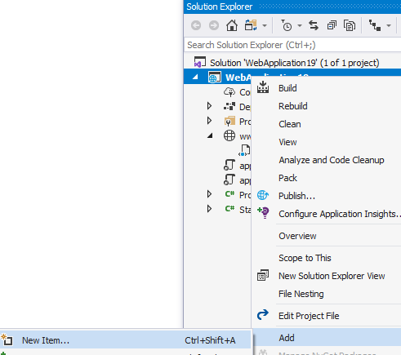
Right-click on wwwroot.
Make a new folder and name it wwwroot. (This is where it will go looking for the Index.html page that we are about to make.

A browser can only access the wwwroot folder.

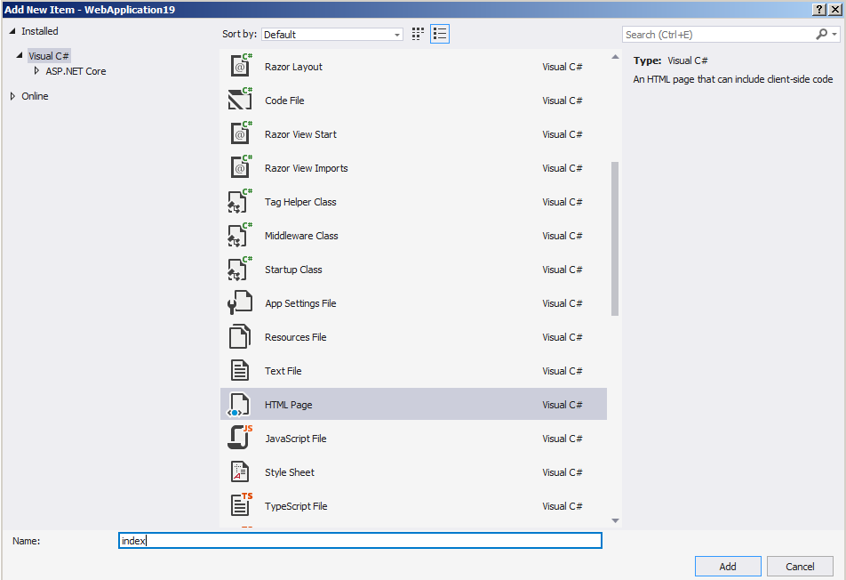

Add a new html page and call it index.html

Replace with this (simplest possible) text in the html file:

<html>
<body>
Ed Again
</body>
</html>

Save it into the wwwroot folder

Open Startup.cs

Replace as shown:

app.UseRouting();
//app.UseEndpoints(endpoints =>
//{
Comment this:
//endpoints.MapGet("/", async context =>
//{
// await context.Response.WriteAsync("Hello World!"); });
//});
Add this.
app.UseStaticFiles();


Run it.
Add the URL segment /Index.html to the end and press Enter.

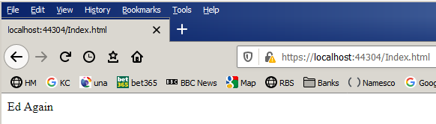

Now add this extra line.
app.UseDefaultFiles();

app.UseStaticFiles();
(These 2 lines must be in that order.)
This middleware “pipeline” is sequential.
Run it

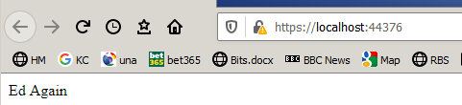
Now we don’t have to add the /Index.html

This is just an alternative way of doing
what we have just done
– using CLI (the Command Line Interpreter.)

https://docs.microsoft.com/en-us/aspnet/core/getting-started/?view=aspnetcore-3.1&tabs=windows

This does the same thing but using CLI. Ex: Go thru it.
Do this as revision after next page of this manual!.

dotnet new webapp -o aspnetcoreapp
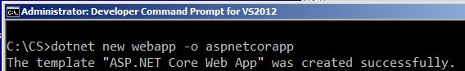

Edit the Razor page:
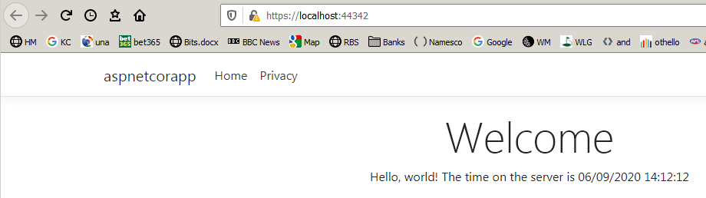

C# Razor pages
Razor allows us to embed C# code in our HTML page.
“C# code is following” is indicated by @.

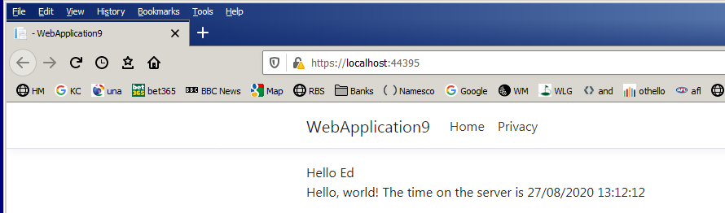
Following the video: https://youtu.be/JAsY5x5l27k
This is executed on the server (in our case IIS). Server-side code.
It executes and returns the time as shown to the browser – as a “Response” object.
Razor pages have a .cshtml extension.
(ie csharp / html)

Change the Index.cshtml file as below:

@page

<html>
<body>
Hello Ed
<p>Hello, world! The time on the server is @DateTime.Now</p>

</body>
</html>

Thanks to Razor C# our page is now dynamic. (Refresh F5 and the time is updated!) cf plain HTML which is static content.

Make a web app (not empty) https://youtu.be/z2Hg1j_KaaY ?

Video Explains: ?
Razor Page (Index) Data
A bit of layout (Privacy tag)
ViewData

Errors: “One of these id like html” – not xml

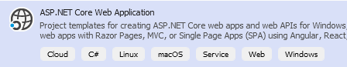

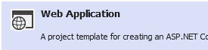

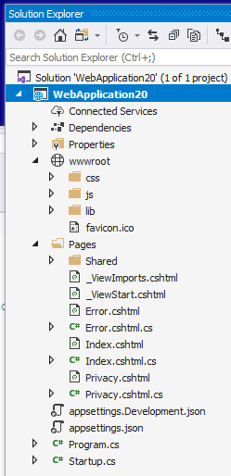

To add content to our Index page

<p>Hello, world! The time on the server is @DateTime.Now</p>

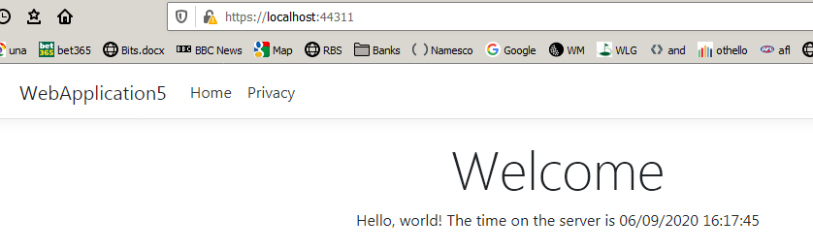

To Add a new Razor page to our web:

https://youtu.be/CxFlQ_J3Z6Y

Make a web app ASP.Net Web Application. Web Application

We could call it RazorTest.sln. C:\CS\RazorTest\RazorTest.sln

New Page <-> Razor Page

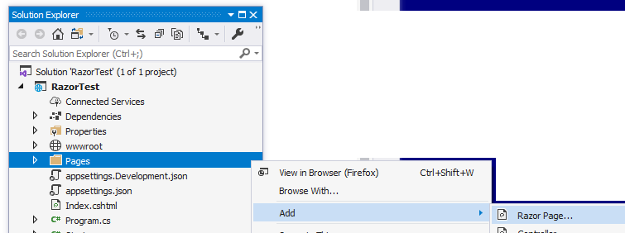
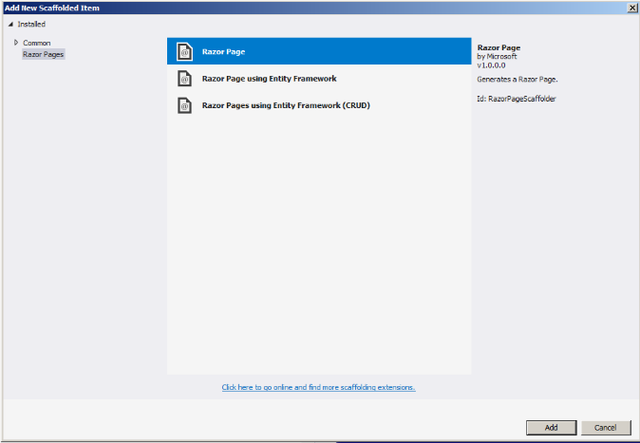
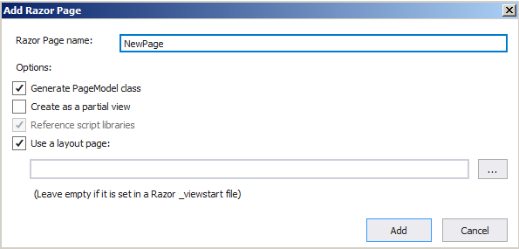
Right-click on the Pages folder.
New (Razor) pages should be placed there.)

In startup.cs
public void ConfigureServices(IServiceCollection services)
{
services.AddRazorPages();
}

Name it NewPage

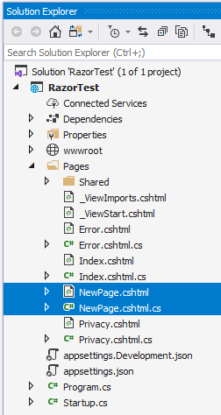
Razor pages come in pairs cshtml & cshtml.cs

No controller.

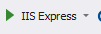
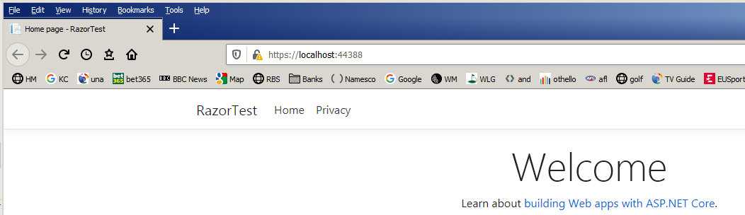
Run it.
Type /NewPage after the default URL and press Enter.

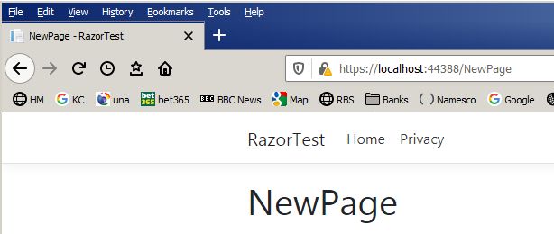
Our new page appears.

ASP knew where to go looking for the new page – in the Pages folder!

The process of finding the page corresponding (to /NewPage in our case) in the Pages folder is called routing.

We now want our page to be able to handle a Get request eg

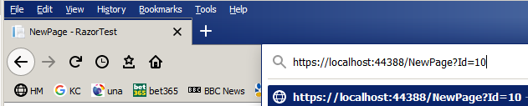
A GET request (?Id=10 in this case) is one which is passed on the end of the URL. (c.f. a POST request which is passed in via a page header - usually from a form - can also pass data.

First take a look at the auto-generated code in our Razor pages:

NewPage.cshtml NewPage.cshtml.cs
Note that the name of the class: NewPageModel is the name of our new page (“NewPage”) with “Model” attached at the end.
@page says it is a razor page. (Always present)

using Microsoft.AspNetCore.Mvc.RazorPages;

namespace RazorTest.Pages
{
public class NewPageModel : PageModel
{
public void OnGet()
{

}
}
}
@page
@model RazorTest.Pages.NewPageModel
@{
ViewData["Title"] = "NewPage";
}

<h1>NewPage</h1>
/NewPage will trigger this Get().

The PageModel (or ViewModel)
Basically, contains the code to handle the URL Request/Response. The “code-behind” sheet.
The View ie this is essentially
the HTML markup which renders
the page – along with our C# code!

model (and with a capital M) is now a reference to the NewPageModel class.

How can these files liaise?

NewPage.cshtml NewPage.cshtml.cs

Modify both these files as below:

The added code is in red.)

NewPage.cshtml NewPage.cshtml.cs
using Microsoft.AspNetCore.Mvc;
using Microsoft.AspNetCore.Mvc.RazorPages;

namespace RazorTest.Pages
{
public class NewPageModel:PageModel
{
[BindProperty(SupportsGet=true)]
public int Id { get; set; }

public void OnGet()
{

}
}
}

@page
@model RazorTest.Pages.NewPageModel
@{
ViewData["Title"] = "NewPage";
}
This public property Id is now used to communicate - behind the scenes.
@Model.Id

<h1>NewPage</h1>

Now Model.Id will be rendered on the NewPage page (with value 10 in this case – see below.)

This communication is all handled automatically in the background in asp.net.

Now include ?Id=10 as below:

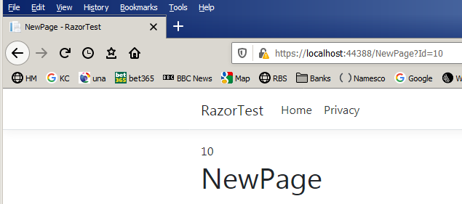
Now when we type in our Get request with the Id passed (of value 10)…
…the value is passed to NewPage.cshtml which renders the page showing the value of the Id.

Watch: Tim Corey
https://www.youtube.com/watch?v=68towqYcQlY

Apparently [BindProperty(SupportsGet=true)] in the code above “makes the Id property writeable” and
Then SupportsGet=true makes it usable by a Get() (c.f. a Post())

the files were “loosely coupled” by means
of the binding BindProperty.

This makes the two files “independent”. ie Code is separated. This makes it easier to maintain them individually (and test them – see Testing later). There is a minimum (none!) of fixed code in either file.

ViewModel.
View <------> [BindProperty]

This is a fashionable “design pattern”.
(Remember: You should regard a View as what we see in the browser.)
ViewModel is called ViewModel since its Model data that is been passed to the View.

Use Razor to make a form to get data WebApplication16

https://youtu.be/UsjVoieggKs in C:\CS

We wish to make a form to add a student (eventually to our database.)

We will add a Razor page called AddStudent, but first make a folder inside Pages called Forms in which to place this Razor page.

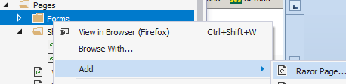
Then right-click on Forms and Add a new Razor page.

It’s important to right-click
the folder cause then all the usings are automatic in the code.

AddStudent.cshtml

@page
@model WebApplication16.Pages.Forms.AddStudentModel
@{
ViewData["Title"] = "AddStudent";
This is the way that we add a form to our html.
}

<h1>AddStudent</h1>
This is the way that we add a text box to a form:

<form>
Add this code.
The form has 2 text boxes and one button.
<input type="text" />
Add /Forms/AddStudent segment to the URL as shown here and press Enter.

The form (containing the text boxes and button) appears as shown.

<input type="text" />
This is the way that we add a button to a form:
<button type="submit">Add the Student</button>

</form>"

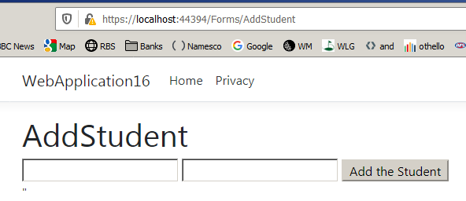

We now wish to make a tag here on the web page for opening the form (so that we don’t have to type in the URL segment /Forms/AddStudent each time we want to open our form.)
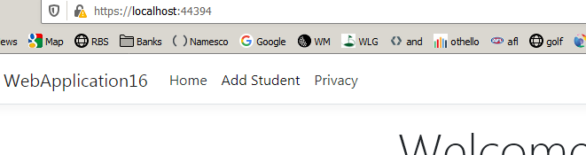

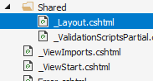
Open the _Layout file.
Incidentally: _Layout.cshtml is the “default” layout for our whole web site.

Take a look at ViewStart. This is called by default whenever the app is called upon to do some rendering. Open it. You will simply see:
@{
Layout = "_Layout";
}

Add this navigation item to _Layout.cshtml:

<li class="nav-item">
<a class="nav-link text-dark" asp-area="" asp-page="/Index">Home</a>
</li>

<li class="nav-item">
<a class="nav-link text-dark" asp-area="" asp-page="/Forms/AddStudent">Add Student</a>
</li>

<li class="nav-item">
<a class="nav-link text-dark" asp-area="" asp-page="/Privacy">Privacy</a>
</li>

Now run the app.

Click on our new Add Student tag.

Our Add Student form should appear:

We now wish to be able to add actual data using our new form.
(Eventually it could be saved to a database but for the moment we will just observe the variable Details containing the data using single-step).

First make a class called Student to represent that data as below.
Classes such as these are called Models. So it is appropriate that we first make a folder called Models to place it in.

Student.cs

namespace WebApplication16.Models
{
public class Student
{
public int Id { get; set; }
public string Name { get; set; }
public int Age { get; set; }
}
}

We now define Details property with the [BindProperty] attribute.
This provides “communication between the 2 files. ie Loose binding.

AddStudent.cshtml AddStudent.cshtml.cs
using Microsoft.AspNetCore.Mvc;
using Microsoft.AspNetCore.Mvc.RazorPages;
using WebApplication16.Models;

namespace WebApplication16
{
public class AddStudentModel : PageModel
{
[BindProperty] // Needs
public Student Details { get; set; }

public void OnGet()
{
}

public IActionResult OnPost()
{
return RedirectToPage("/Index");
}
}
}
@page
@model WebApplication16.AddStudentModel
@{
ViewData["Title"] = "AddStudent";
}

<h1>AddStudent</h1>

<form method="post">

<input type="text" asp-for="Details.Name"/>
<input type="text" asp-for="Details.Age"/>

<button type="submit">Add Student</button>

</form>"

The form uses the post method…

asp-for puts the data from the form into the Details properties:
Name & Age.

After the Post it displays the Index page.
… so we make a method OnPost() which “listens” for the post (of the data) on the form.

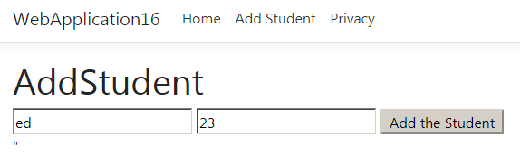

/Forms/AddStudent
To see that it is working we can place a breakpoint as shown below and observe the Details property.

Run it to this breakpoint after adding this data (ed 23).

Click

Open the Locals window. (Only visible when debugging.)
AddStudent.cshtml.cs

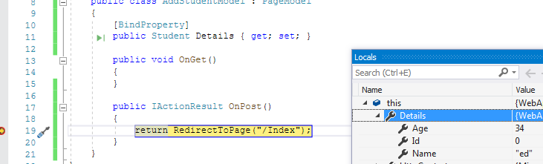
We can see that our data has been retrieved from the form.

Finally displays the Index page

AddStudent.cshtml AddStudent.cshtml.cs Student.cs

View ViewModel or PageModel Model
(a type of controller)

M VM V (Model ViewModel View)

M V C (Model View Controller)

A controller by definition “handles HTTP requests”.

Watch: Tim Corey
https://www.youtube.com/watch?v=68towqYcQlY

To Publish. First make a web App to publish.

ASP1.avi 1. https://youtu.be/nlfQVfS4a-o Explain simple html, IIS Hello Ed Explains publishing not MVC but never mind. Start here.
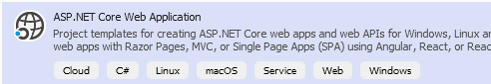

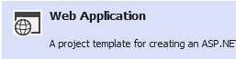

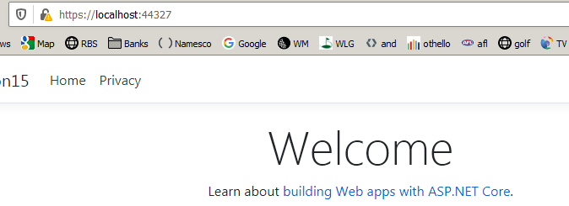

So far, we have produced a web which is placed on the local web server and accessed:

https://localhost:60751

We now wish to put our web on the internet ie “publish” it. ie we wish to view it on a host remote computer.

We could choose Microsoft Azure as host as follow:

MVC

Intro: Explaining relation between the M, C & V.

https://youtu.be/2Jj3xEonY_c (MVC intro)

Explains the 3 files: Model, View, Controller.

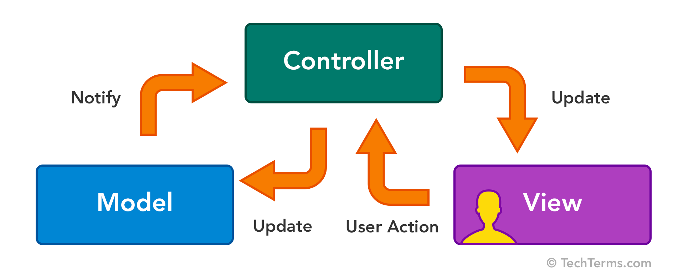

Stop- press

https://docs.microsoft.com/en-us/aspnet/core/getting-started/?view=aspnetcore-6.0&tabs=windows

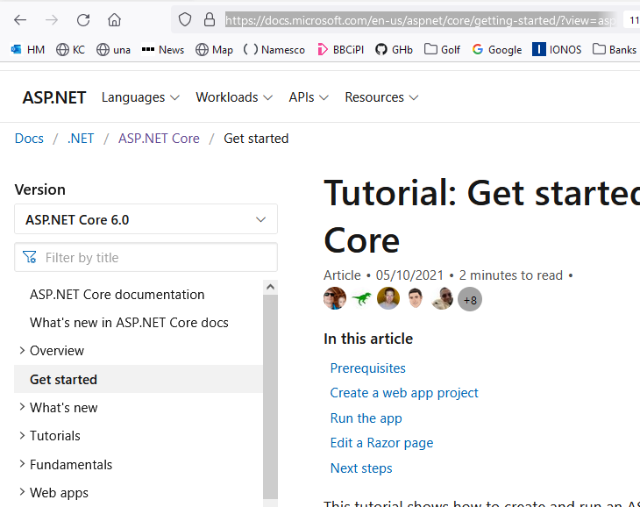

Deploy to Azure

November 2021

https://docs.microsoft.com/en-us/aspnet/core/tutorials/publish-to-azure-webapp-using-vs?view=aspnetcore-6.0

To Make an ASP.Net Core MVC app 2. https://youtu.be/Uku8TxA49Gg

Video shows creating basic ASP.net Core and then makes a model

Model View Controller is just a better way (“pattern”) of organizing files in the web apps that we have seen so far.

Make a basic MVCCore project. myMVCNetCore.sln in C:\CS on PC

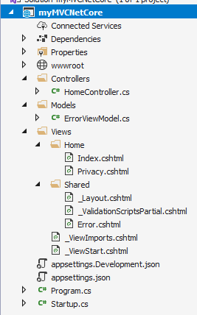
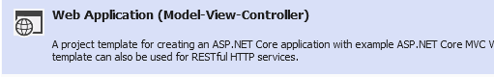

Controller

View

There will be no Model yet.

Model Controller View
is a pattern for the data handles http requests displays in browser
C# classes via the URL C# C# / HTML

M <-> V <-> C

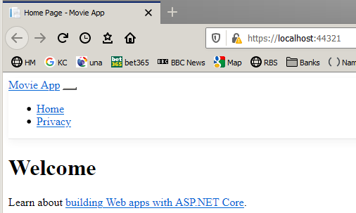
Student.cs

public class Student
{
public int Id { get; set; }
public string Name { get; set; }
public int Age { get; set; }
}

HomeController.cshtml

using System;

namespace Home.Controllers
{
public class HomeController : Controller
{
public IActionResult Index()
{
return View();
}

Index.cshtml

@{
}

<h2>Index</h2>

<h1>Welcome</h1>

Renders

These two files are pretty much the same as we have seen in our razor webapp – and do much the same. The difference with MVC is that we don’t put model (in this case the Student class) in this now-named “controller” class. The (Student) class is placed in its own (Model) class and reference from the Controller). MVC or MCV?

Known as “Separation of concerns”. There is loose coupling between them

So how do they communicate with each other?

In myMVCNetCore.sln

(Do this after making a very basic MVC app. as per the first part of the youtube.)
Use IActionResult when we want to return more than an eg int . eg 404 errors etc

Make the following code additions and then add these segments to the URL:

https://localhost:44353/Home/Index

Controller View
Goes looking for the Index view. How does it know? Because the Action which calls it is called Index.
View("Index" would do the same?);
HomeController.cs

using System;

namespace HomeController.Controllers
{

public class HomeController : Controller
{
public IActionResult Index()
{

ViewData["Message"] = "How’s it Going? " ;

return View();

}

Index.cshtml

@{
}
<p>@ViewData["Message"]</p>

ViewData is a dictionary which can hold many key-value pairs.
(Message is the key in this case).

ViewData dictionary is used to “transfer” the data. (PropertyBag can be used similarly.)

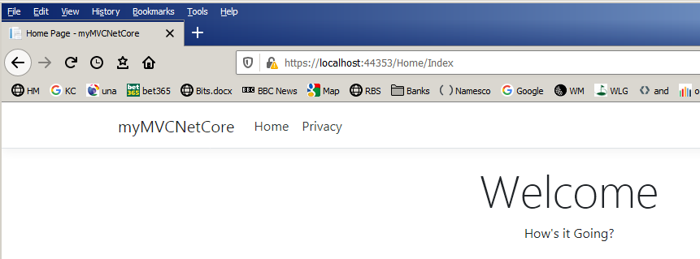
Renders

After the above URL is typed in the page is rendered. How’s it Going? appears.

Explanation of the way the controller works
ie how it deals with a URL:

Our Index.cshtml is located in the Home folder and Index is the name of the file.
Hence https://localhost:44353/Home/Index sends the Index file to the server.

(44353 is the port number here. Yours will be probably different.)

return View(); will cause it to go looking for a view with the same name as the action method - Index in this case - ie the Index.cshtml view.
return NameView();will find he view named Name.

https:/localhost:44395/Home/Index
controller
action

Note that “Controller” was automatically added to the name of the controller when we made it.
ie Home -> HomeController.Controllers. That’s how C# identifies.

You may have noticed that we don’t actually have to add the full URL segments
ie https://localhost:44395/Home/Index ie https://localhost:44395 is sufficient.

This is because Home is the name of the default controller and Index is the name of the default page – as specified in the startup file. (Take a look below.)

Start.cs
endpoints.MapControllerRoute(
name: "default",
pattern: "{controller=Home}/{action=Index}/{id?}");

(We will now see that we can optionally include (nullable) data in the URL (Id) )
eg https://localhost:44395/Home/Index/5

Exercise:

Write code so that when we use the URL https://localhost:44353/Home/Index/?name=Rick
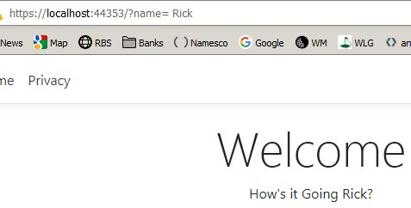
then we will get

Hint: The Index method can accept a parameter.

Notice we could also use only https://localhost:44353/?name=Rick because remember that Home and Index are the default

public IActionResult Index(string name)
{
ViewData["Message"] = "How's it Going " + name + "?";

return View();
}

In practice ViewData["Message"] (and ViewBag) is not used normally for “communication between Controller and View as above. Instead we use another technique: We use a “strongly typed” object in this case model in the View as we will now see:

Hint: Comment out using the comment button on the toolbar or Ctrl-K C.
Using strongly typed variable to pass data to the View.

ie using @model myMVCNetCore.Models.Student (See below – model is a “variable” holding the model class name - Student in this case.)

But first we need to make the model class: In this case Student.

Student.cshtml (The model)

namespace myMVCNetCore.Models
{
public class Student
{
ie The data is “modelled” upon this class.
public int Id { get; set; }
public string Person { get; set; }
public int Age { get; set; }
}
}

Now make a student object in the controller called s1 in this case and pass it as to the corresponding view (ie the view with the same name as the action: Index) as below. The controller goes looking for a view named Index as below. It starts off looking in the Views folder – if there is one.

HomeController.cshtml (the controller)

public IActionResult Index(string name)
{
Student s1 = new Student {Id = 1, Name = "ed", Age = 34};
Usually this data would come from a database.
return View(s1);
}

Index.cshtml (the view)
Actually it is not necessary to “declare” our model variable! (Try it without.) It will work just fine but we won’t have strong typing ie 1. We won’t find out until runtime! if we made a mistake like: model.anotherpropertry 2. We won’t have Itellisense.
ie the View will understand that the variable model (or Model) represents the Student object in this case. Ed:check this.

@model myMVCNetCore.Models.Student
@{
ViewData["Title"] = "Home Page";
}

<div class="text-center">
<h1 class="display-4">Welcome</h1>

<p> @Html.DisplayFor(model => model.Id) </p>
<p> @Html.DisplayFor(model => model.Person) </p>
<p> @Html.DisplayFor(model => model.Age) </p>

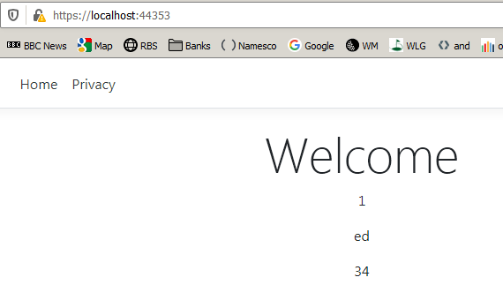
</div>

DisplayFor gets the Id etc and renders them.

https://localhost:44316/Home/Index or https://localhost:44316/
Exercise: Make a web app that places some Product data on the page instead:

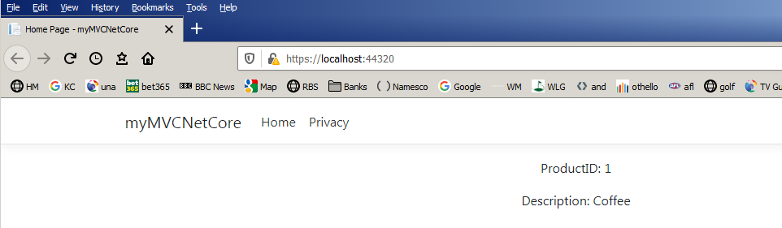

public class Product
{
public int ProductID;
public string Description;
}

<p> @Html.DisplayFor(model => model.ProductID) </p>
<p> @Html.DisplayFor(model => model.Description) </p>

Product s1 = new Product { ProductID = 1, Description = "Coffee" };

@model myMVCNetCore.Models.Product

Solution in c:myMVCNetCore - Copy (2)
ASP.Net Core and database 3. Follow this https://youtu.be/cJ6b_oUyh8k
Video shows how to add a database and a form

We will access data from our database…

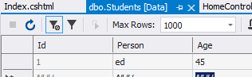
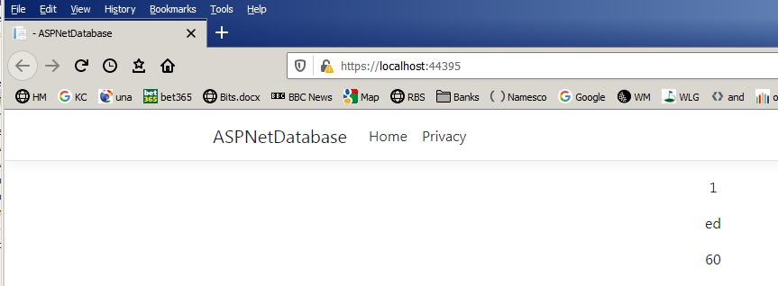
https://localhost:44335/Home/Index or https://localhost:44335/
…and render it on our web page:
Make C:\CS\ ASPNetDatabase
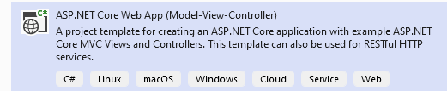

Add the standard database classes as we did in our previous database section:

Add MyDbContext.cs to the project.
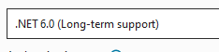
using ASPNetDatabase.Models; !!
using Microsoft.EntityFrameworkCore;

namespace ASPNetDatabase
{
public class MyDbContext : DbContext
{
public DbSet<Student> Students { get; set; }

protected override void OnConfiguring(DbContextOptionsBuilder optionsBuilder)
{
optionsBuilder.UseSqlServer(@"Server=(localdb)\mssqllocaldb;Database=myTest12;Trusted_Connection=True;");
}

protected override void OnModelCreating(ModelBuilder modelBuilder)
{ }
}
}

Student.cs (in the Models folder)

namespace ASPNetDatabase.Models
{
public class Student
{
public int Id { get; set; }
public string Person { get; set; }
public int Age { get; set; }
}
}

Add the usual:

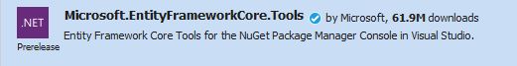

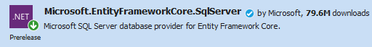

and run migrations and update-database (So far - much the same as database lesson.)

Now modify the controller class

HomeController.cs

using Microsoft.AspNetCore.Mvc;
using Microsoft.Extensions.Logging;
using ASPNetDatabase.Models;

namespace ASPNetDatabase.Controllers
Add the code in red.
{
etc
public class HomeController : Controller
{
public IActionResult Index()
{
using (var context = new MyDbContext())
{
var s1 = context.Students.First<Student>();

return View(s1);
}
}
…………
}
}

may need

usi using Microsoft.EntityFrameworkCore;
ng ASPNetDatabase.Models;
and the View (ie Index.cshtml) becomes:
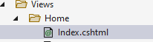
@model ASPNetDatabase.Models.Student
@{
}
<div class="text-center">
<p> @Html.DisplayFor(model => model.Id) </p>
<p> @Html.DisplayFor(model => model.Person) </p>
<p> @Html.DisplayFor(model => model.Age) </p>
</div>

Make sure we have a record in our database table:

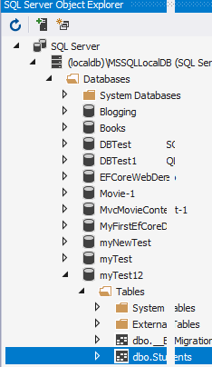

ie Right-click etc.

Run it.

Our data should be displayed on our web page:

C:\CS\ASPNetDataBase on QW? yes

https://localhost:7263/Home/Index

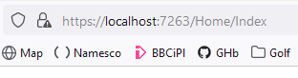
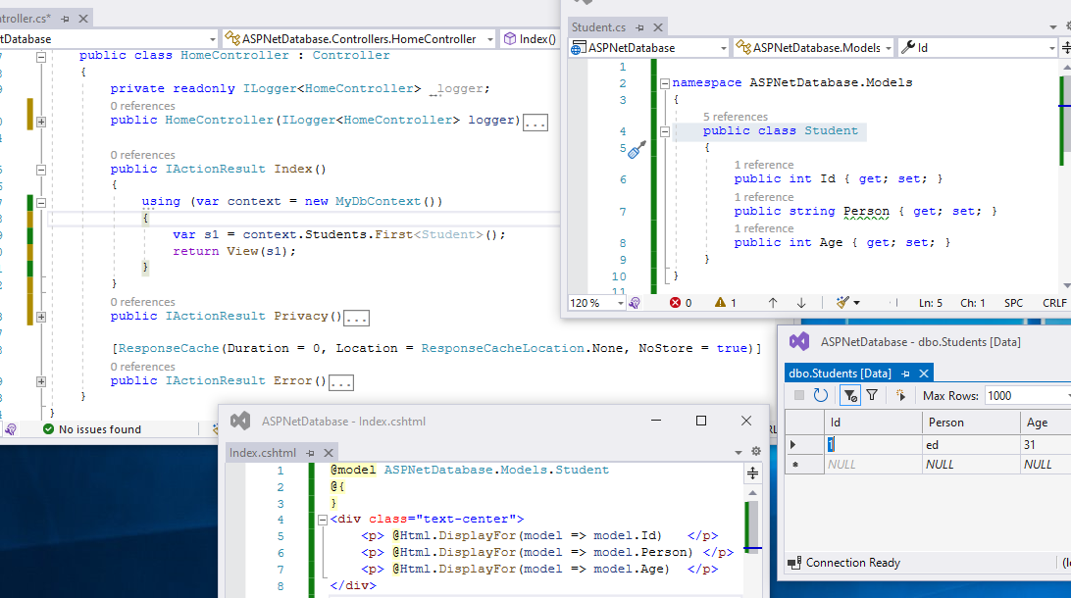
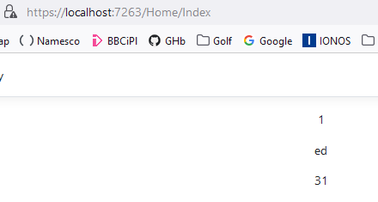

Model

Controller

View

To Add Data To our Database We need a form (and a Post)

We wish to enter the data into the form and press Submit…

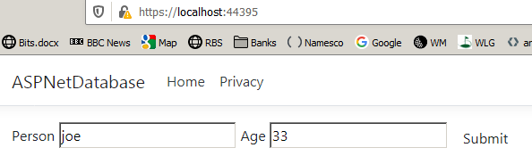
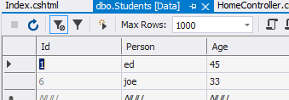

Use previous ASPNetDatabase

… and it will appear (after refresh) in our database table.

In HomeContoller.cs

public IActionResult Index()
{
//using (var context = new MyDbContext())
//{
Comment this stuff.
//var s1 = context.Students.First<Student>();
return View();
//}
}
[HttpPost]
public async Task<IActionResult> Index([Bind("Id, Person","Age")] Student s1)
{
using (var context = new MyDbContext())
{
Add this
context.Add(s1);
await context.SaveChangesAsync();
return RedirectToAction("Index");
}
}

In Index.cshtml
Get : When we pass info via a URL eg https://localhost:7263/Home/Index(Id=1)

Post : When we pass info in the page which is sent. Data is sent eg 1,ed, £40 usually buy means of a form (See here,)

@model ASPNetDatabase.Models.Student
@{
}

@using (Html.BeginForm())
{
<div class="form-group">

@Html.LabelFor(model => model.Person)
@Html.TextBoxFor(model => model.Person)

@Html.LabelFor(model => model.Age)
@Html.TextBoxFor(model => model.Age)

<button type="submit" class="btn btn-default">Submit</button>

</div>
}

Run it etc. (No need for migrations.)

My code referenced from here:

https://www.learnentityframeworkcore.com/walkthroughs/aspnetcore-application
Uses VSCode. Has got a drop-down

1. For Drop-down tute:
@Html.DropDownListFor(model => model.AuthorId, (IEnumerable<SelectListItem>)ViewBag.Authors, string.Empty, new { @class="form-control"})
C:\EFCoreWebDemo
see all notes on CShapExtra.docx search learnentity

ie Do this as revision

--------------------

Other controls: https://docs.microsoft.com/en-us/dotnet/api/microsoft.aspnetcore.mvc.rendering.htmlhelperinputextensions.textboxfor?view=aspnetcore-3.1

2. Exercise: Make a database containing Id, Name, Email address and make a form to input these to the database.

General:
See: http://www.binaryintellect.net/articles/87446533-54b3-41ad-bea9-994091686a55.aspx

4. Follow this tutorial:

Get started with ASP.NET Core MVC

https://docs.microsoft.com/en-us/aspnet/core/tutorials/first-mvc-app/start-mvc?view=aspnetcore-3.1&tabs=visual-studio

but uses scaffolding (scaffolding means: automatically produce C# class code from the database objects – database first?)
- ASP.NET Core documentation
- What's new in ASP.NET Core docs
• Get started
• Overview
• Get started
• Add a controller etc
For the project source code: C:\code\AspNetCore.Docs-master\aspnetcore\tutorials\first-mvc-app\start-mvc\sample\MvcMovie3

Downloaded from https://github.com/dotnet/AspNetCore.Docs
AspNetCore.Docs

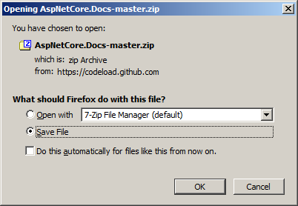

5. The book Chapter 15: Notes: ch 15 MVC controller approx. page 78 of CSExtra.docx manual. See next page.

6. See
https://asp.mvc-tutorial.com/getting-started/hello-mvc-world/
A good MVC Tute
Doesn’t use Entity Framework. Works from scratch !

from the book
Laptop C:\Code\book\Part3\ Part3.sln

Ch 14 NorthWind

This program builds an Empty ASP.NET Core Web.
Run it:
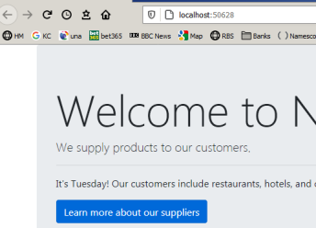
Click

The Suppliers new page appears.

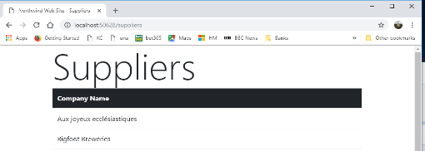
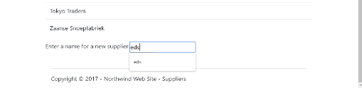
..type a new name and click the Submit button.

Shows all of the Suppliers.

But to add a new Supplier…

(Now look to see the new supplier added.)

Open Part3.sln and

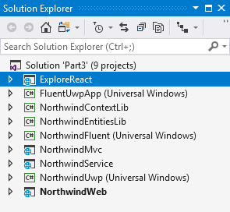
C:\VS2017\Part3\Part3.sln
Right-click and choose Setup as Starter project.

The context and models classes are made into two respective libraries which are then referenced by NorthwindWeb. ie:

NorthwindContextLib

public class Northwind : DbContext
{
public DbSet<Category> Categories { get; set; }
public DbSet<Customer> Customers { get; set; }
public DbSet<Employee> Employees { get; set; }
public DbSet<Order> Orders { get; set; }
}

NorthwindEntitiesLib contains the models
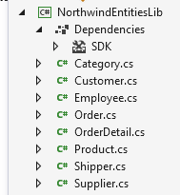

The database.

services.AddDbContext<Northwind>(options => options.UseSqlServer("Server=(localdb)\\mssqllocaldb;Database=Northwind;Trusted_Connection=True;MultipleActiveResultSets=true"));

The database already contains data from Ch 11?

The new Form Razor Pages.

The View: Suppliers.cshtml

@page
@model NorthwindWeb.Pages.SuppliersModel
@addTagHelper *, Microsoft.AspNetCore.Mvc.TagHelpers

<div class="row">
<h1 class="display-2">Suppliers</h1>
<table class="table">
<thead class="thead-inverse">
<tr><th>Company Name</th></tr>
</thead>

<tbody>
@foreach(string name in Model.Suppliers)
{ <tr><td>@name</td></tr> }
</tbody>

</table>
</div>

<div class="row">
<p>Enter a name for a new supplier:</p>
<form method="POST">
<div><input asp-for="Supplier.CompanyName" /></div>
<input type="submit" />
</form>
</div>

Inserts an extra form – which does a Post back to the code-behind.
Uses a C# loop to print the companies to the Suppliers form.
Inputs from the form.

Header

The way to get a new row.

and its code-behind: PageView (or “ViewModel”):

Suppliers.cshtml.cs
namespace NorthwindWeb.Pages
{
public class SuppliersModel : PageModel
{
private Northwind db;

public SuppliersModel(Northwind injectedContext)
{
db = injectedContext;
}

public IEnumerable<string> Suppliers { get; set; }

public void OnGet()
{
ViewData["Title"] = "Northwind Web Site - Suppliers";

Suppliers = db.Suppliers.Select(s => s.CompanyName).ToArray();
} // Selects from the database.

[BindProperty]
public Supplier Supplier { get; set; }

public IActionResult OnPost()
{
if (ModelState.IsValid)
{
db.Suppliers.Add(Supplier);
db.SaveChanges();
return RedirectToPage("/suppliers");
}
return Page();
}
}
}
Suppliers.cshtml.cs

To use dep inj we must provide it as a Service – in ConfigureServices .

Uses dep. injection. That means that we can use db anywhere - not just in a using block ?

Defines a property which confusingly is called Supplier.
Because it is a [BindProperty] then it communicates directly with the Supplier model (which is in a library!)
Suppliers is also name of the SQL table!
Suppliers is the array (List)
See how our new property (Supplier) is used in the previous code (the view)
OnGet in response to the URL.
Adds a new supplier to the database!

From form

namespace Packt.CS7
{
public class Supplier
{
public int SupplierID { get; set; }
public string CompanyName { get; set; }
public string ContactName { get; set; }
public string ContactTitle { get; set; }
public string Address { get; set; }
public string City { get; set; }
public string Region { get; set; }
public string PostalCode { get; set; }
public string Country { get; set; }
public string Phone { get; set; }
public string Fax { get; set; }
public string HomePage { get; set; }
public ICollection<Product> Products { get; set; }
}
}

The code below - to press a button to display the Suppliers form - is placed in Index:

Index.cshtml
@page
@functions {
public string DayName { get; set; }

public void OnGet()
{ ViewData["Title"] = "Northwind Web Site";
Model.DayName = DateTime.Now.ToString("dddd"); // sets the DayName property.
}
}
<div class="jumbotron">
<h1 class="display-3">Welcome to Northwind!</h1>
<p class="lead">We supply products to our customers.</p>
<hr />
<p>It's @Model.DayName! Our customers include restaurants, hotels, and cruise lines.</p>
<p>

<a class="btn btn-primary"
href="suppliers">Learn more about our suppliers </a>

</p>
</div>

Displays the DayName property.

Puts a button on the Index form.

Makes a link to open suppliers.cshtml page.

A GET is by URL. A POST is passed in the header.

Basically, it retrieves and updates data on this dbs:

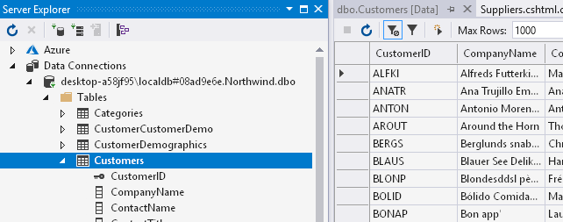

----------------------- end of book --------------------------------

Extra
This builds the Contoso database. Very detailed but v comprehensive:

Razor Pages with Entity Framework Core in ASP.NET Core - Tutorial 1 of 8
https://docs.microsoft.com/en-us/aspnet/core/data/ef-rp/intro?view=aspnetcore-2.0&tabs=visual-studio

___________________________________________________________________

Java Script https://youtu.be/wyrUn0h0bXM (Just covers these next pages

JavaScript is the world's most popular programming language.
(But later we will see how we can make it run on the server!!)
It runs on the client (ie in the browser)

Make a test.html page in say Notepad as described previously which we will open in our browser - but beforehand insert this JavaScript (all in orange) into the html as shown:

<!DOCTYPE html>
<html>
<body>

<p>Enter a number and click OK:</p>
This is how we create a text box in JavaScript.
<input id="id1" type="number" max="100">
This is how we create a button in JavaScript.
<button onclick="myFunction()">OK</button>

<p>If the number is greater than 100 (the input's max attribute), an error message will be displayed.</p>

<p id="demo"></p>

<script>
function myFunction() {
var txt = "";
if (document.getElementById("id1").validity.rangeOverflow) {
txt = "Value too large";
} else {
txt = "Input OK";
}
document.getElementById("demo").innerHTML = txt;
}
</script>
For comparison with the above code, see a Razor page which runs on the server eg.
@page
<html>
<body>
<p>Hello, world! The time on the server is @DateTime.Now</p>
</body>
</html>

</body>
</html>

Open the html file using eg Firefox:

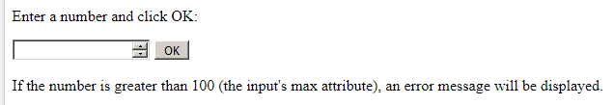
Visit:
Enter 101 and click the OK button.
You will get an error message.
Visit https://www.w3schools.com/js/tryit.asp?filename=tryjs_validation_rangeOverflow
and you can see this in action without the bother of creating our own html page as above.

So the point of JavaScript:
It performs client side duties – in this case checking the validity of a number – which could be the number of items in your online order for example - rather than having it being performed on the server. This is the use of JavaScript:

Execution of code on the client rather than the server.

Another JavaScript example:

Try this in our html document:

<!DOCTYPE html>
<html>
<body>

<script>
This writes 11 to the html page.
document.write(11);
</script>

</body>
</html>

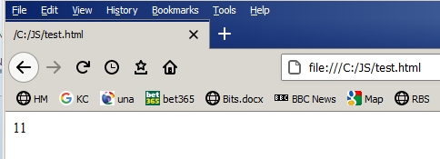

or try it yourself! in https://www.w3schools.com/js/tryit.asp?filename=tryjs_output_write

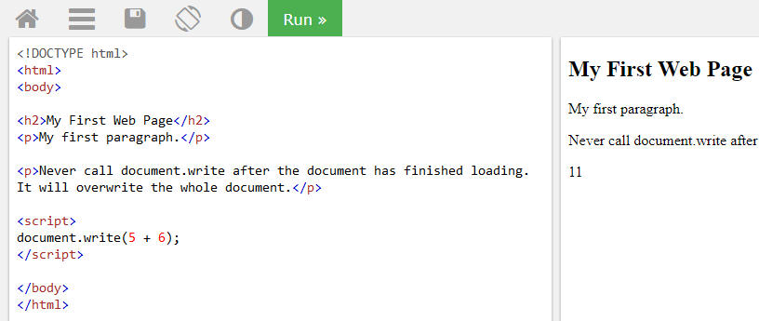

Note that you can paste any of your own code in here! as practice and re-run it !

Another way of writing to the html page

Modify your html

<!DOCTYPE html>
<html>
<body>
id is used to identify a position in your html.

<p id="demo"></p>

<script>
document.getElementById("demo").innerHTML = 11;
</script>
getElementById is used to locate the position in the innerHTML of the html document with id demo and put 11 in its place.
</body>
</html>

This notation (getElementById etc)is part of DOM (Document Object Model) which will be discussed later. For the moment just use it to demonstrate JavaScript in our html.

JavaScript can "display" data in different ways:
- Writing into an HTML element, using innerHTML.
- Writing into the HTML output using document.write().
- Writing into an alert box, using window.alert().
- Writing into the browser console, using console.log().
You may wish to try the above but in any case complete the JavaScript tutorial ! at

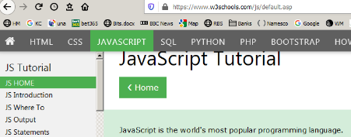
https://www.w3schools.com/js/default.asp

and don’t miss the examples at

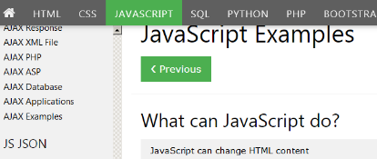
https://www.w3schools.com/js/js_examples.asp

JavaScript using Visual Studio
https://www.howtosolutions.net/2016/05/visual-studio-creating-javascript-project/

eg on https://www.w3schools.com/js/js_whereto.asp see

External JavaScript

Scripts can also be placed in external files:

Reproduced here

Save this text file to eg C:\CS as myScript.js.

function myFunction()
{
document.getElementById("demo").innerHTML = "Paragraph changed.";
}

And save this file as "testJS.html" to C:\CS
Calls the function as if it were in the same file.
< !DOCTYPE html >
Substitutes
<html>
<body>

<p id="demo">A Paragraph.</p>

<button type="button" onclick="myFunction()">Try it</button>

<script src="myScript.js"></script>

</body>
</html>

Open it in FireFox (or another browser):

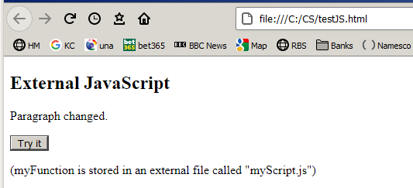
File Open etc
JQuery

If you see lots of $() ‘s and functions eg:
$("#panel").slideDown(); then it’s probably JQuery.

jQuery greatly simplifies JavaScript programming.

See: https://www.w3schools.com/jquery/
jQuery is a JavaScript Library eg
<script src="https://ajax.googleapis.com/ajax/libs/jquery/3.5.1/jquery.min.js">

The jQery Syntax

Basic syntax is: $(selector).action()

A $ means use jQuery.

(selector) is used to "query (or find)" HTML elements.
A jQuery action() eg .hide() is the action to be performed on an html element.
Examples:
$("p").hide() - hides all <p> elements.
Place this code in a text file using NotePad++ and then Open it in FireFox etc
<!DOCTYPE html>
<html>
JQuery is good at finding stuff – in this case our button.
<head>
<script src="https://ajax.googleapis.com/ajax/libs/jquery/3.5.1/jquery.min.js"></script>
<script>

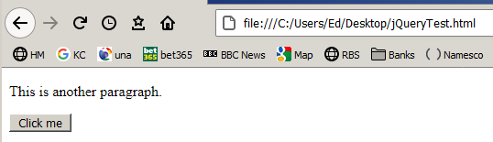
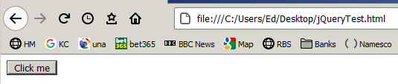
$(document).ready(function () {
After clicking the above button the text is hidden.
$("button").click(function () {
$("#test").hide();
});
});

</script>
</head>
<body>
<p id="test">This is another paragraph.</p>
<button>Click me</button>
</body>

</html>

JQuery is good for web scraping. See Traversing at w3schools
Json

Json is similar to XML. Recall how XML is just a text file used to store data in a hierarchical way eg
This is XML not Json.
<Name>
Ed
</Name>

The equivalent in Json is:

var x= {"Name": Ed}
And we can access it x.Name -> Ed. or if we had

var x= {"Name": Ed. "Age": 34}
and we can access it x.Name -> Ed. & Name.Age -> 34.

Note the dot operator gives Json a more object-oriented feel.

Make this in Visual Studio:

<!DOCTYPE html>
<html>
<body>
<h2>JSON Object Creation in JavaScript</h2>
<p id="demo"></p>
<script>
var text1 = '{"name":"ED Johnson","street":"Oslo West 16","phone":"555 1234567"}'
var obj = JSON.parse(text1);
document.getElementById("demo").innerHTML =
obj.name + "<br>" +
parse will separate the field names…
obj.street + "<br>" +
obj.phone;
</script>
</body>
</html>
..so that we can refer to them using our defined object.

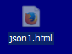
getElements is a sort of a loop.

Open with Internet Explorer

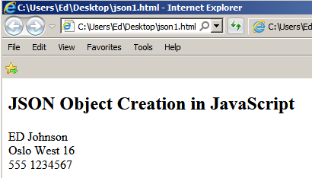

Follow this tutorial w3schools https://www.w3schools.com/js/js_json_intro.asp
Node.js (This is not c# !)

We have seen so far that JavaScript is designed exclusively for client-side application but:

Node.js allows you to run JavaScript on a server.
With Node.js we can create, open, read, write, delete, and close files on the server

We will now see how we can create own server! using node.js along with the following JavaScript.

but first we must install Node.js. Go to: https://nodejs.org/en/download/
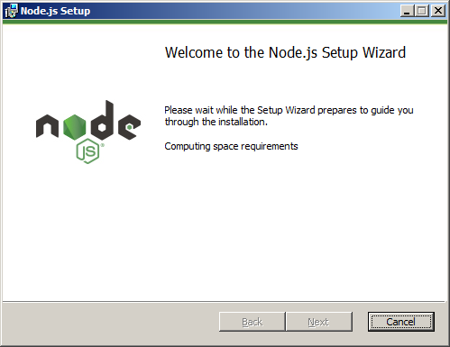
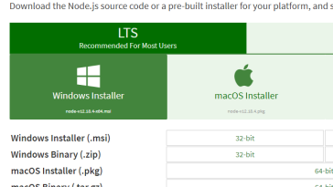

etc

Open eg Notepad++ and write the code below. Save it as myfirst.js to C:\Users\ed\. (Replace ed by your own username.)

http.createServer(function (req, res) {
res.writeHead(200, {'Content-Type': 'text/html'}); // 200 is success. ie I’m Returning HTML
res.end('Hello World!'); // The response
}).listen(8080); // I’m listening!

Follow excellent: https://www.w3schools.com/nodejs/nodejs_get_started.asp
-Some reproduced here:

Getting Started
Once you have downloaded and installed Node.js on your computer, let's try to display "Hello World" in a web browser.
Create a Node.js file named "myfirst.js", and add the following code:
myfirst.js
http.createServer(function (req, res) {
res.writeHead(200, {'Content-Type': 'text/html'}); // 200 is success. ie I’m Returning HTML
res.end('Hello World!'); // The response
}).listen(8080); // I’m listening!
Save the file on your computer: C:\Users\ed\myfirst.js (Replace ed by your username)
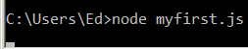
Enter node myfirst.js
Now, the computer works as a server!

(Ctrl-C will stop it.)

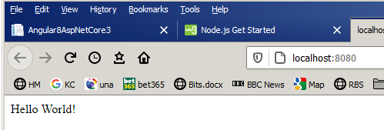
The code tells the computer to write "Hello World!" if anyone (e.g. a web browser) tries to access your computer on port 8080 ie http://localhost:8080/

The following code will produce An HTML form:
Open eg Notepad++ and edit the myfirst.js file as shown here.
var http = require('http');
http.createServer(function (req, res) {
res.writeHead(200, {'Content-Type': 'text/html'});
res.write('<form action="fileupload" method="post" enctype="multipart/form-data">');
res.write('<input type="file" name="filetoupload"><br>');
res.write('<input type="submit">');
res.write('</form>');
You will need to stop (Ctrl-C) and restart the server (node myfirst.js).
return res.end();
}).listen(8080);
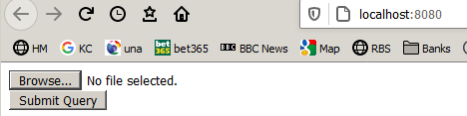

NPM

NPM is a universal store for files - like GitHub.

NPM is a package manager for Node.js packages, or modules if you like.

npm is the world’s largest software registry https://docs.npmjs.com/about-npm/
is an excellent video explaining npm. Watch it!

(npm started life as the node package manager.)

The NPM program is installed on your computer when you install Node.js

NPM creates a folder named "node_modules" in your project where the package will be placed.
All packages you install in the future will be placed in this folder.

TypeScript

TypeScript is widely used eg Angular is written using it.

JavaScript has a problem. It is not type safe. ie it is not necessary to declare variables. Typescript is a type safe version of JavaScript ie we are able to declare variables.
eg if we defined a variable number myVar = 3; and later misspelled myVar as myVor then the error would go undetected in JavaScript, but not in TypeScript.

TypeScript also adds classes etc to JavaScript. ie TypeScript is an object-oriented version of JavaScript! (ie Typescript is to JavaScript what C# is to C – actually they have the same designer! Anders Hejlsberg - Wikipedia. )

Typescript files have the extension .ts .JavaScript has a .js extension

But the way that we use TypeScript is a little unusual. We cannot introduce it directly into our html:

We write a .ts file and then compile it into a corresponding .js file! as we will see.

Here is a .ts file and a .js file for comparison.
is compiled! into

main.ts main.js
function greet(name) {
console.log(name);
}
function greet(name:string):void{
console.log(name);
}

Variable declarations have disappeared.
The variable name is given a type string ie it is declared as a string.

We can then use this corresponding JavaScript file in our program!

How to make and use a Typescript file

https://medium.com/@ralph1786/getting-started-with-typescript-84cf8b9bfc3f

First make sure that we have got node & npm installed by typing in the Developer Window:
ie type the following: (It should return with your version number.)
eg v12.18.3
eg 6.14.6
node -v
npm –v

Now type: npm i -g typescript
This will install TypeScript globally allowing you to use it within any project

In the C:\CS:folder create this:

index.html
I changed this index.html completely from the web tute but at the end of the day we just want an index.html!
<!DOCTYPE html>
<html>
<body>
<p id="demo">A Paragraph.</p>
<button type="button" onclick="greet('ed')">Try it</button>
<script src="main.js"></script>
</body>
Calls the function as if it were in the same file.
</html>
Tip: To view any of these files type eg type main.js from the \CS prompt ie
C:\CS\type main.cs

main.ts

function greet(name:string):void{
console.log('Hello ${name}');
}
Didn’t work - changed it to: console.log(name);
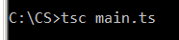
In the CS folder type tsc main.ts ie.

It produces this corresponding JavaScript file (in the same \CS folder)

main.js

function greet(name) {
console.log('Hello ${name}'); -> console.log(name);
}

Type in Google Chrome c:\js\Index.html :
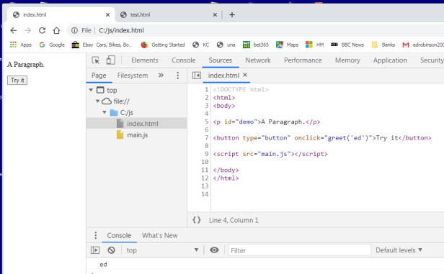
Summary: Make an index.html file and a main.ts file.
Compile the main.ts using tsc main.ts.

Click

We get ed in the Chrome console

To use TypeScript in a Visual Studio project

YouTube: https://youtu.be/7WzVaQjk6j4

https://docs.microsoft.com/en-us/visualstudio/javascript/tutorial-aspnet-with-typescript?view=vs-2019

Tutorial: Create an ASP.NET Core app with TypeScript in Visual Studio

When we build & run it, we get this page C:\Code\ASPNET_Core_TS on black PC

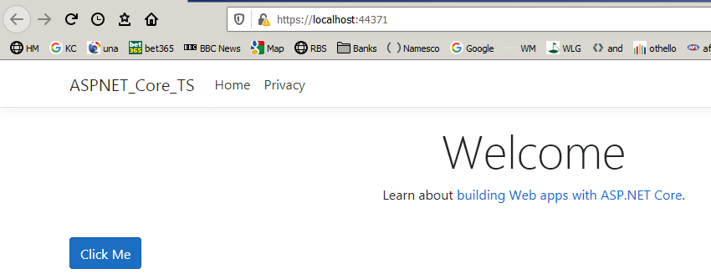
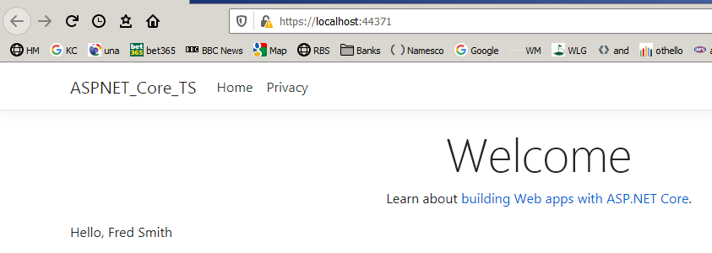
We will add TypeScript code to a MVC project which will simply print some text onto the page when we click a command button.

Click the button & Hello, Fred Smith replaces the button!.

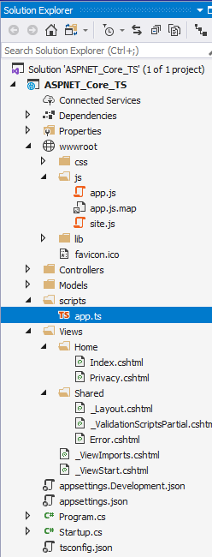
function greeter(person) {
return "Hello, " + person.firstName + " " + person.lastName;}
function greeter(person: Person) {
return "Hello, " + person.firstName + " " + person.lastName;}
Note that when we make our project, but before we build it, these app js files are not here. They are the result of compiling the corresponding .ts file - in this case app.ts (See below).
Note the when we added a .ts file by using Add, New Item etc it is automatically placed in the scripts folder. (Which you may have to create.)
How does the app know where to find the resultant .js files after it has been produced from app.ts in the build?
Ans : Look in Layout.cshtml for this:
<script src="~/js/app.js"></script>

This file does the work

.
BTW: You will find the usual MVC controller stuff here – to handle the URL eg https://localhost:44371/ eg

public IActionResult Index()
{
return View();
}

Take a look at the Index page. This is what gets us started and calls the JavaScript TSButton() function. (See app.js)

<div id="ts-example">
<br />
<button type="button" class="btn btn-primary btn-md" onclick="TSButton()">
Click Me
</button>
</div>
Take a look at tsconfig.json. The ts compiler looks for this to find where it can find the .ts files:

"include": [
"scripts/**/*"
]

and where to put the corresponding compiled .js files:

"outDir": "wwwroot/js"

At the end of the day this is where it happens – in this JavaScript file below:

app.js

The button – whose id is ts-example - is replaced by user.
This JavaScript function is called when the button on the Index page is clicked.

function TSButton() {
var name = "Fred";
document.getElementById("ts-example").innerHTML = greeter(user);
}
var Student = /** @class */ (function () {
function Student(firstName, middleInitial, lastName) {
this.firstName = firstName;
this.middleInitial = middleInitial;
this.lastName = lastName;
this.fullName = firstName + " " + middleInitial + " " + lastName;
}
return Student;
}());

function greeter(person) {
return "Hello, " + person.firstName + " " + person.lastName;
}
var user = new Student("Fred", "M.", "Smith");
//# source
pingURL=app.js.map

2. Services

Services A service is an app on the server that returns information
– not necessarily as html! eg eg weather, stock prices etc.

A Service is a program on the server which returns data from the server to the client.
An API is code which interfaces between applications eg
A Service uses (Web) APIs but doesn’t have to.

Web API is used in Core to make a service.

Intro: RESTful <-> Web API (Computer connected to computer)

Make an Asp.net core project Choose Web API
:
1 Make one first.
WebApi !
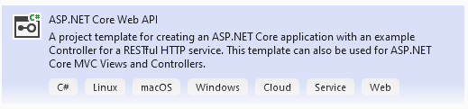

C:\CS\WebAPITest\WebAPITest.sln 2021 Dec: Use 6.0 long term support
WebApplication3 on laptop 1 C:\X\WebAPITest. On QW
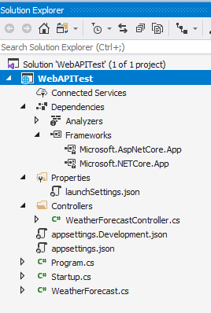
Run it: Then https://localhost:7063/weatherforecast

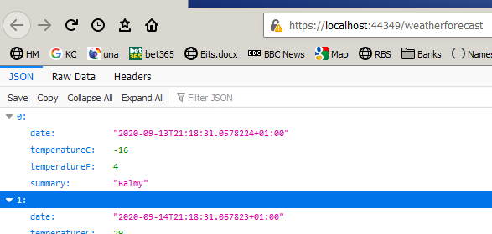
etc ie json is returned.

The above app simulates getting weather forecast data using

This service just returns Json – not html!! ]

This just does a Get(), We could do a Post as well. (We Could also provide CRUD.)

Now Dec 2021: By default, uses Swagger:
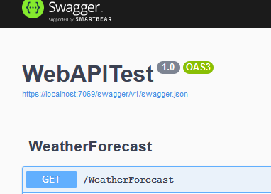
Already set up for us!
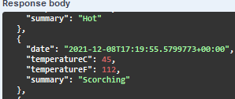
Ty it out
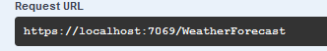
Execute
launchSettings.json we get this by default

"WebAPITest": {
"commandName": "Project",
"dotnetRunMessages": true,
"launchBrowser": true,
"launchUrl": "swagger",
"applicationUrl": "https://localhost:7063;http://localhost:5063"

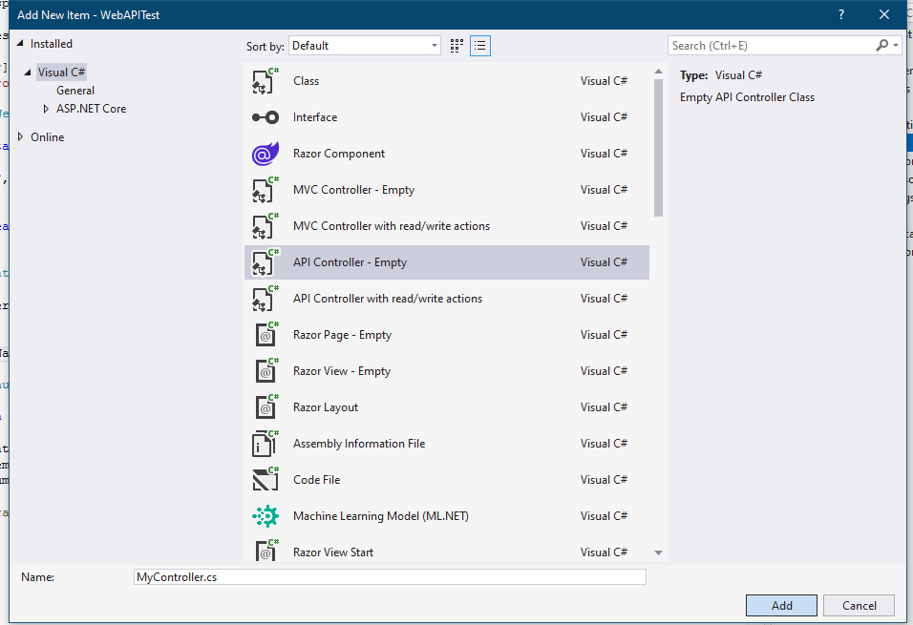
MyController

namespace WebAPITest.Controllers
Ie the form of the url segment is
/Name of controller
eg /My
{
[Route("/[controller]")]
[ApiController]
public class MyController : ControllerBase
{
[HttpGet]
public string Get()
{
return "Hello" ;
}
}
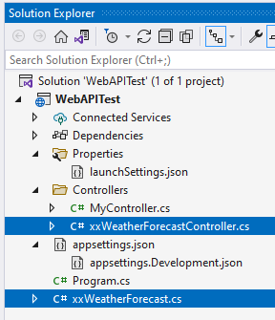
}

https://localhost:7063/My

For clarity you may want to delete these 2 files?:

Not really – can use https://localhost:7063/weatherforecast

Notes:

1.
[HttpGet]
public string Get()// When using an attribute the name of this method ie Get() is irrelevant. (ie Always use attributes)

eg we could call it:
public string Other
{
return "Hello" ;
}
and https://localhost:7063/My would still work.

2. Add some text: (no leading slash.) (already there so delete it !)
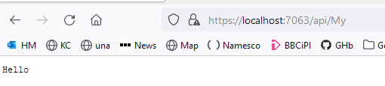
namespace WebAPITest.Controllers
{
[Route("api/[controller]")]

Now we need it in the url:

https://localhost:7063/api/My

3. In launchSetting.json

"profiles": {
"WebAPITest": {
"commandName": "Project",
"dotnetRunMessages": true,
"launchBrowser": true,
"launchUrl": "api/My",
"applicationUrl": "https://localhost:7063;http://localhost:5063",
"environmentVariables": {
"ASPNETCORE_ENVIRONMENT": "Development"
}
},
"IIS Express": {
"commandName": "IISExpress",
"launchBrowser": true,
"launchUrl": "api/My",
"environmentVariables": {
"ASPNETCORE_ENVIRONMENT": "Development"
}
}
}

Now when we run it, we don’t have to type in the segment in the url.
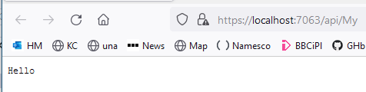

4. To return an array of strings:

[HttpGet]
public IEnumerable<string> Get()
{
return new string[] { "Hello", "Bye" };
}

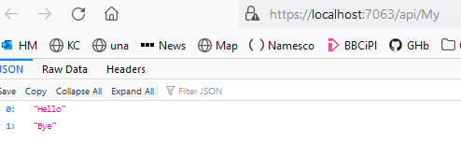

4. Could make our own square root service!. Add a controller
Square root service!

return Math.Sqrt(5.0);

public double Get(double id) // api/values/4.5
{
return Math.Sqrt(id);
}

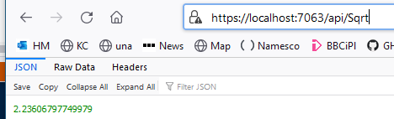

https://localhost:7063/api/Sqrt

using Microsoft.AspNetCore.Mvc;

namespace WebAPITest.Controllers
{
[Route("api/[controller]")]

public class SqrtController : Controller
{
[HttpGet]
public double Index()
{
return Math.Sqrt(5.0);
}
}
}

IEnumerable<string> indicates a collection of strings which is iterable.

It appears frequently. eg try:

public IEnumerable<string> Get()
{
string[] stArray = new string[] { "Hello", "Bye" };
List<string> L = stArray.ToList();
int s= stArray.Count();
return stArray;
}

Hint: Use var if you’re not sure of the return type!

Difference between MVC & Service

In the controller:

MVC

// URL: /Home/Index

public class HomeController : Controller
{
public IActionResult Index()
{
return View();
There is no View in a service.

Returns a page.

Returns data

}

SERVICE

// URL: api/values

[Route("api/[controller]")]
public class ValuesController : ControllerBase
{
[HttpGet]
public IEnumerable<string> Get()
{
return new string[] { "value1", "value2" };
}

Use this controller: C:\X\WebAPITest Use this ! WebAPITest.sln
Its got Swagger already
Make sure that you Right-click on the Controllers folder! Add New Item.
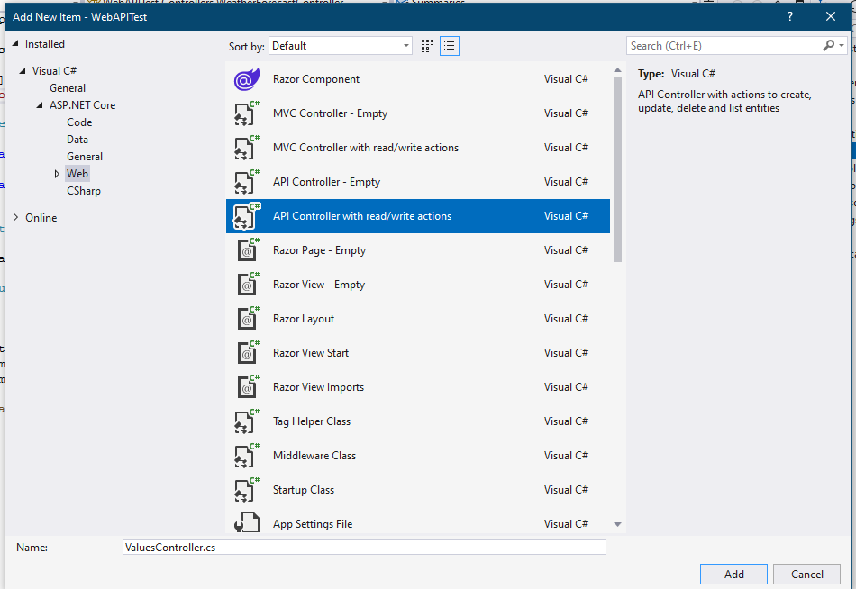
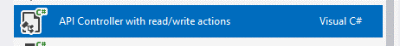

MyCRUDController

No View! cause it’s a Service!

We get this default code:

using Microsoft.AspNetCore.Mvc;

namespace WebAPITest.Controllers
{
[Route("api/[controller]")]
[ApiController]
public class MyCRUDController : ControllerBase
{
Try: https://localhost:7063/api/MyCRUD

0: “value1”
1: “value2”
// GET: api/<MyCRUDController>
[HttpGet]
public IEnumerable<string> Get()
{
return new string[] { "value1", "value2" };
}

// GET api/<MyCRUDController>/5
Try: https://localhost:7063/api/MyCRUD/1

“value”

[HttpGet("{id}")]
public string Get(int id)
{
return "value";
}

// POST api/<MyCRUDController>
[HttpPost]
public void Post([FromBody] string value)
{
}
}
}
To use Post we must either 1. make a form with text boxes etc or
2. Use Swagger (or Postman) which allows us to use post values directly.

To Use Swagger:

Change these back:

"profiles": {
"WebAPITest": {
"commandName": "Project",
"dotnetRunMessages": true,
"launchBrowser": true,
"launchUrl": "swagger",
"applicationUrl": "https://localhost:7063;http://localhost:5063",
"environmentVariables": {
"ASPNETCORE_ENVIRONMENT": "Development"
}
},
"IIS Express": {
"commandName": "IISExpress",
"launchBrowser": true,
"launchUrl": "swagger",
"environmentVariables": {
"ASPNETCORE_ENVIRONMENT": "Development"
}

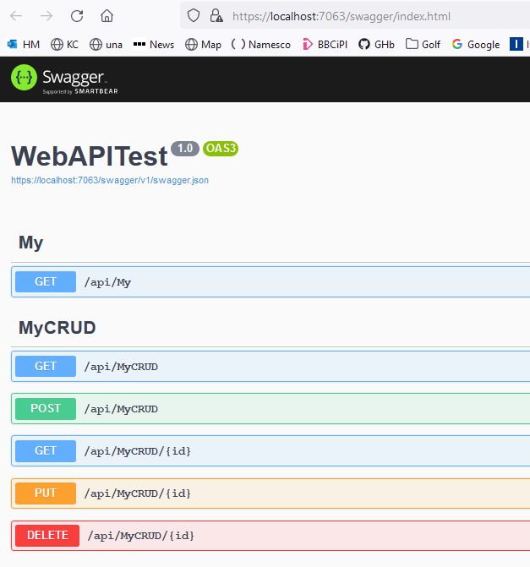

Try the Gets first. eg
/api/MyCRUD/{id}
Result should be as before when we used a url.

Click Post, Try it out,

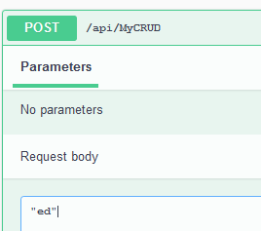
Use break point :
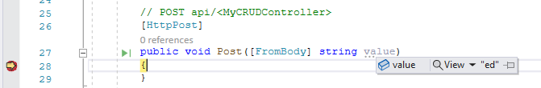

Execute

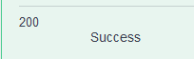

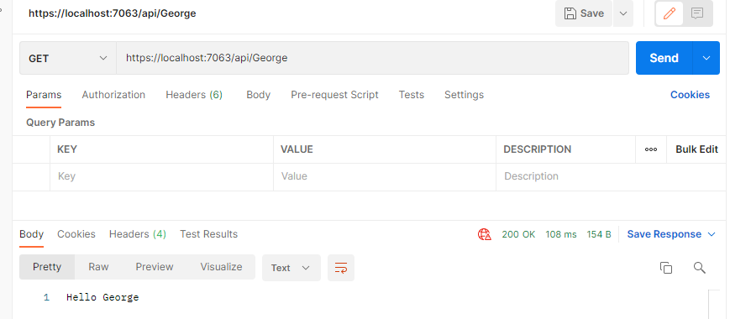
Run it using PostMan!

The Weather controller

Appears in the web api by default.

Try it.

https://localhost:7063/WeatherForecast

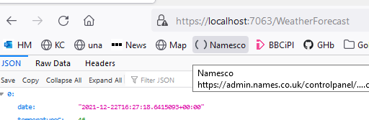

Code is wonky:

Better code:

In the controller: This code produces 5 random forecasts. ie

IEnumerable<int> squares = Enumerable.Range(1, 5).Select(x => x * x);

would produce 1 4 9 16 25

So this code simulates getting weather forecast data using this url: https://localhost:44349/weatherforecast
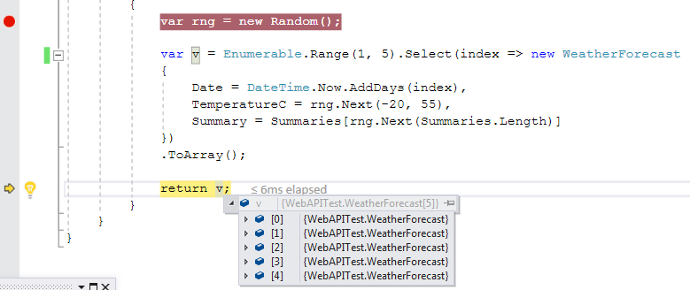
Produces a sequence of 5 WeatherForecast objects.
With 5 sequential dates etc starting today.
Indexes them.
Result.
eg Weatherforcast[0].
The Summaries don’t correspond to the temperatures – just random! eg could be -10 and sweltering!

eg
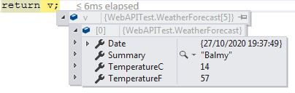

TemperatureC = rng.Next(-20, 55) Gives a temp between -20 & 55.

Summary = Summaries[rng.Next(Summaries.Length)] Gives a random choice from:

private static readonly string[] Summaries = new[]
{ "Freezing", "Bracing", "Chilly", "Cool", "Mild", "Warm", "Balmy", "Hot", "Sweltering", "Scorching"
};

Note that we get an extra “generated” temperature TemperatureF inside WeatherForecast:

public int TemperatureF => 32 + (int)(TemperatureC / 0.5556);

Original:

using Microsoft.AspNetCore.Mvc;
using Microsoft.Extensions.Logging;
using System;
using System.Collections.Generic;
using System.Linq;
using System.Threading.Tasks;

namespace WebApplication1.Controllers
{
[ApiController]
[Route("[controller]")]
public class WeatherForecastController : ControllerBase
{
private static readonly string[] Summaries = new[]
{
"Freezing", "Bracing", "Chilly", "Cool", "Mild", "Warm", "Balmy", "Hot", "Sweltering", "Scorching"
};

[HttpGet]
public IEnumerable<WeatherForecast> Get()
{
var rng = new Random();
return Enumerable.Range(1, 5).Select(index => new WeatherForecast
{
Date = DateTime.Now.AddDays(index),
TemperatureC = rng.Next(-20, 55),
Summary = Summaries[rng.Next(Summaries.Length)]
})
.ToArray();
}
}
}

Modified: on laptop WebApplication1

[HttpGet]
public IEnumerable<WeatherForecast> Get()
{
var rng = new Random();
List<WeatherForecast> L = new ();

for (int i = 1; i <= 5; i++)
{
DateTime d = DateTime.Now.AddDays(i);
int ndx = rng.Next(0, 90); // 0 -> 90
int t = (int)(75.0 / 99.0 * (double)(ndx) - 20.0); // -20 -> 55
string s = Summaries[ndx / 10]; // eg Bracing

WeatherForecast w = new WeatherForecast { Date = d, TemperatureC = t, Summary = s };// new object
L.Add(w);// Add to the list to be sent ..
}

The Values controller is not included anymore! In the default Web API Service

using System.Collections.Generic;
using Microsoft.AspNetCore.Mvc;
namespace NorthwindService.Controllers
{
[Route("api/[controller]")]
public class ValuesController : Controller
{
// GET api/values
[HttpGet]
public IEnumerable<string> Get()
{
return new string[] { "value1", "value2" };
}
// GET api/values/5
[HttpGet("{id}")]
public string Get(int id)
{
return "value";
}
// POST api/values
[HttpPost]
public void Post([FromBody]string value)
{}
// PUT api/values/5
[HttpPut("{id}")]
public void Put(int id, [FromBody]string value)
{}
// DELETE api/values/5
[HttpDelete("{id}")]
public void Delete(int id)
{}
}}

https://localhost:44345/api/values

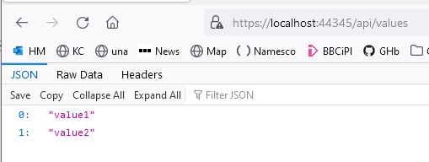

To configure the routing:

in StartUp.cs

public void ConfigureServices(IServiceCollection services)
{
services.AddControllers();
}

app.UseRouting();

app.UseEndpoints(endpoints =>
{
endpoints.MapControllers();
});

Angular

Angular is a client-side app. It is “bolted on” to other apps to provide a UI.

It might look like this:
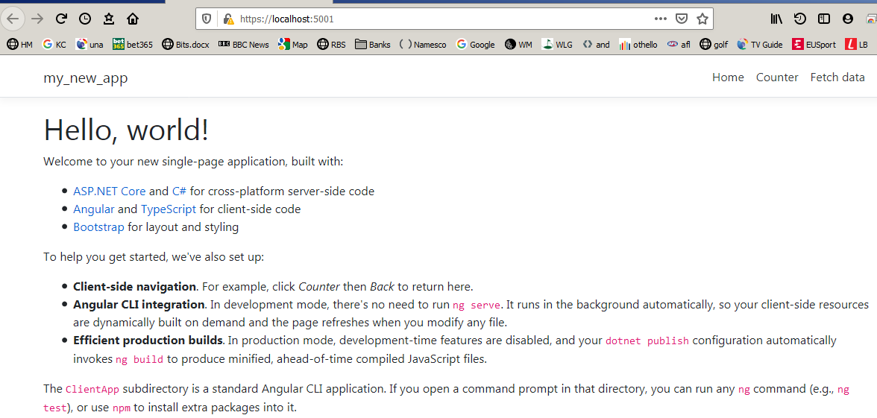

Click Fetch data. It fetches data from a completely separate (service) app. (Try this after we build the app as below.)

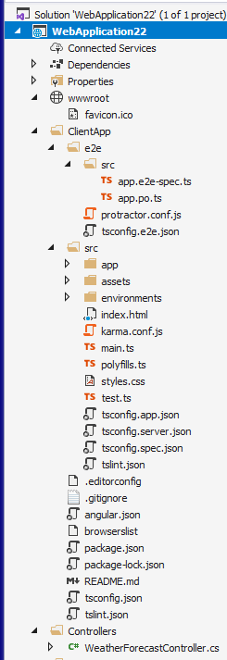
Let’s build a default Angular app.
This is our Angular app. It acts as a client to …

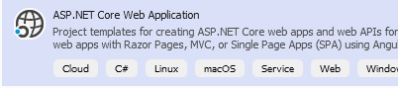

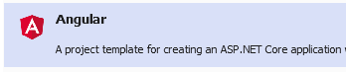

Takes ages! to build!

Finally: Note that I have already installed Nodejs.which
is necessary – and npm which comes with Node.js.

Run:

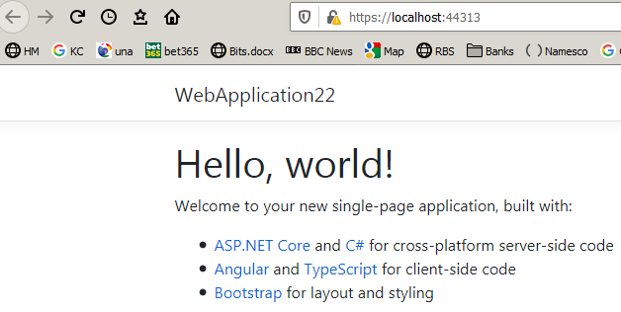

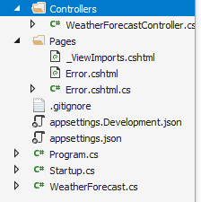
… our MVC service app.

Two apps for the price of one. WeatherForecast is just a sample app – to show Angular in action. Take a look at ClientApp (the Angular app). It is written in TypeScript.
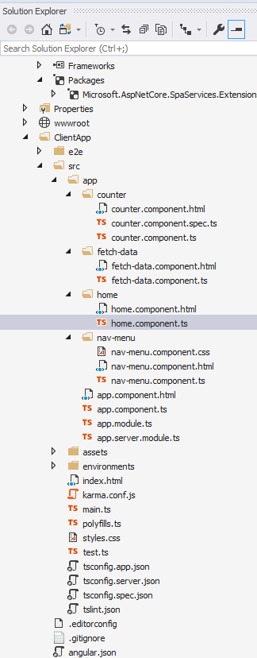
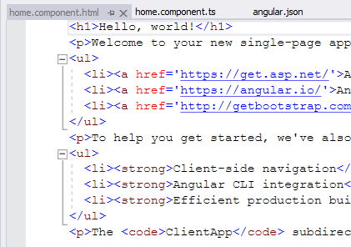
fetch-data is ts code which enables the “interface” to our service. Take a good look at it. If we were to “interface” to another service – maybe in another project (in the same solution) this (ie in the app folder) is where we would need to write ts code to do it.
(counter is just an example of an Angular component. Run the app and click Counter.

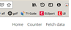
You will see a toy counter that you can try.)
When we add a component, we add 4 files.
.html
.spec.ts
.ts
.css

home.component.ts

home.component.html does the displaying.

BTW this is what you see when we clicked the Fetch data tag. (See start of topic on previous page.) Take a look at
WeatherForecastController.cs and you will see from whence this dummy data has come. eg:
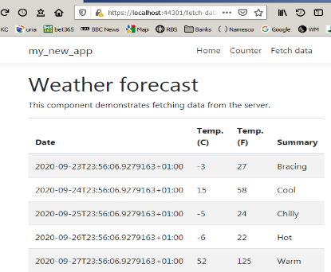
private static readonly string[] Summaries = new[]
{ "Freezing", "Bracing", "Chilly", "Cool", "Mild", "Balmy", "Hot", "Sweltering", "Scorching"};

C:\code\VS2017\Part3\ Part3.sln Part3 folder contains the project files from the book.

Here is an example of where Angular acts as a front-end client to another separate project.

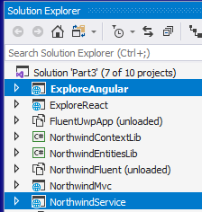

import { Component, Inject } from '@angular/core';
import { Http } from '@angular/http';

@Component({
selector: 'home',
templateUrl: './home.component.html'
})
export class HomeComponent {
public customers: Customer[];

constructor(http: Http, @Inject('BASE_URL') baseUrl: string) {
http.get('http://localhost:5001/api/customers').subscribe(result => {
this.customers = result.json() as Customer[];
}, error => console.error(error));
}
}

interface Customer {
customerID: string;
companyName: string;
contactName: string;
contactTitle: string;
address: string;
city: string;
region: string;
postalCode: string;
country: string;
phone: string;
fax: string;
}

Blue background code has been added to the default Angular home.component.ts.

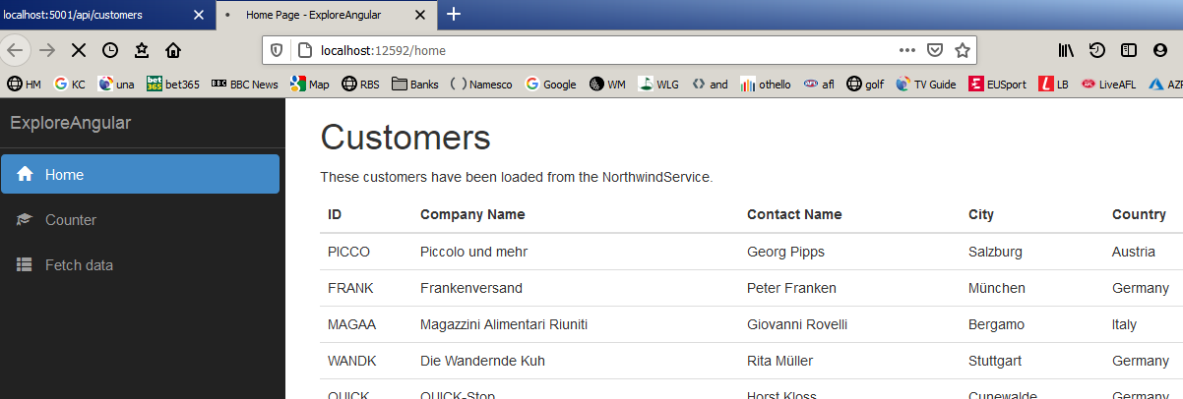

Another example of Angular acting as a Client:

Publish an ASP.NET Core app to Azure with Visual Studio

First need an Azure account
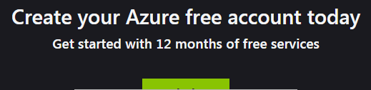

Navigate to this.

Mine: https://azure.microsoft.com/en-gb/account/

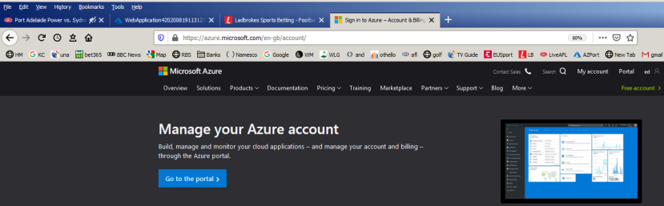
Publish this as well: C:\EFCoreWebDemo

Follow this:https://docs.microsoft.com/en-us/azure/app-service/quickstart-dotnetcore?pivots=platform-windows
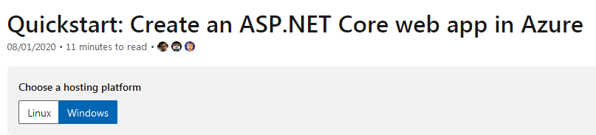

This quickstart deploys an app to App Service

When you're finished, you'll have an Azure resource group consisting of an App Service hosting plan and an App Service with a deployed web application.

myFirstAzureWebApp.sln in C:\CS.

First make an ASP.NET Core Web App. (But I chose Empty Web):
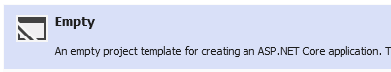

Choose no Authentication.

Test it if you wish -> Hello World!

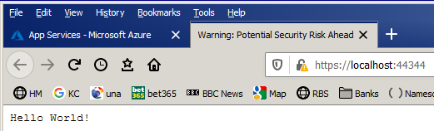

Now to publish it:

Follow these steps to create your App Service and publish your web app:
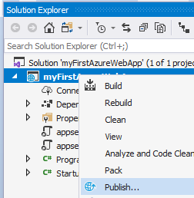
Right-click & choose Publish.

(Below is a bit different now):
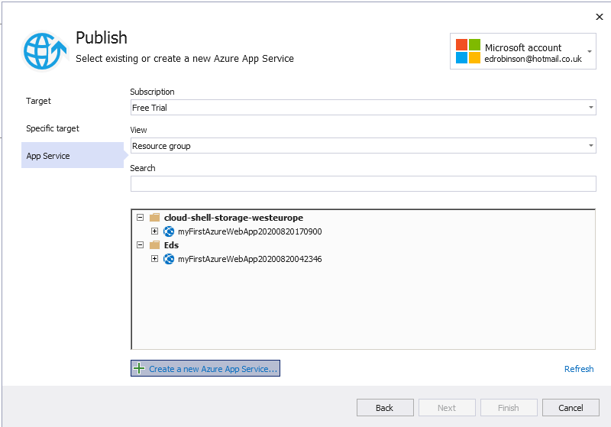

A Resource group eg Eds is a folder on our website. Later when we build a database it can be placed in this resource folder as well as the web itself.

At the end of the day: We need

1. A Resource group for our web. Resource Group is a folder on the web site.
2. Make a new Azure service for our website.
3. Be logged into my Azure account.
4. Publish.

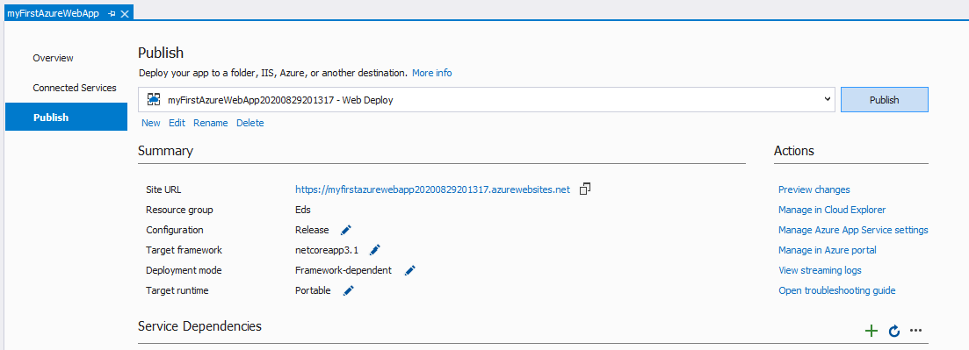

We don’t need to Run our project!
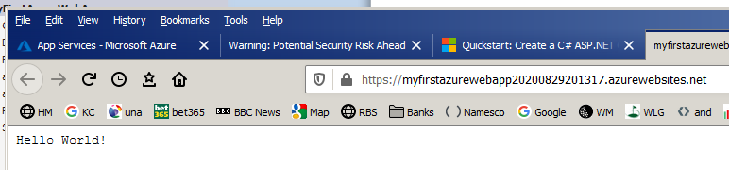

https://efcorewebdemo20201029133251.azurewebsites.net/

To Delete a resource group:
Note: We need to be IN the Resource website in order to delete it.?

Delete a website:

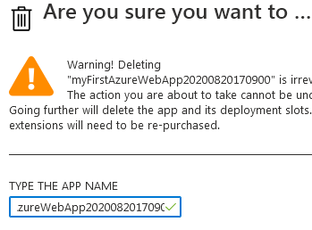

Click refresh maybe & F5!
2 Miscellaneous MVC etc
This program shows how to add related data to a database & using drop-down.

Make Youtube yet? no
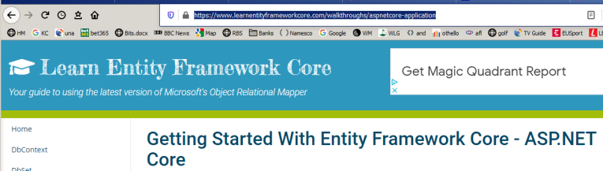
First make an MVC Entity Framework with database.
C:\x\EFCoreWebDemo on QW

https://www.learnentityframeworkcore.com/walkthroughs/aspnetcore-application

He uses vscode. I used Visual Studio. Make an MVC. See comments
(Make an MVC casue we want a New Book form on an html page ie use a View().)
C:\EFCoreWebDemo\authors\Create (See comments!)on Ed PC & in C:\X

optionsBuilder.UseSqlServer(@"Server=(localdb)\mssqllocaldb ;Database=EFCoreWebDemo;Trusted_Connection=True;MultipleActiveResultSets=true"); (Ran migrations & populated the database.)

(Changed from =\. which is some vscode local database!)

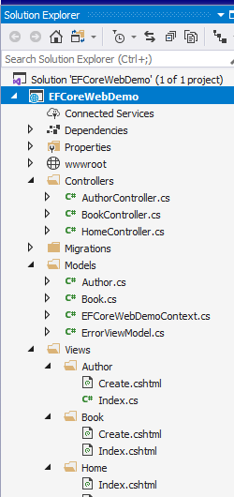
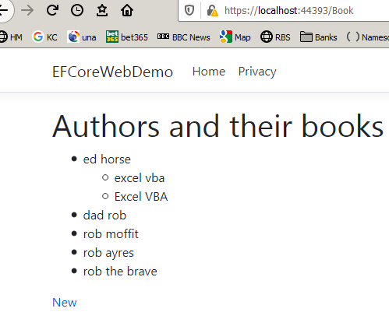
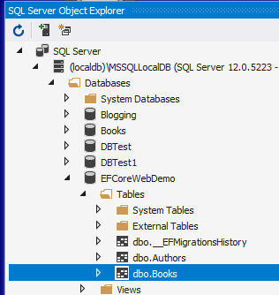

After the Welcome page:
New Author (Moved to root)
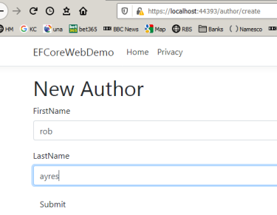
\author\create (.cshtml)

and fill
in form:

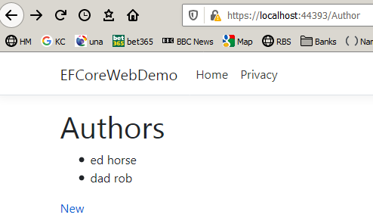
After button click:

\author\Index.cshtml

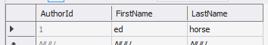

New Book

https://localhost:44393/Book/create
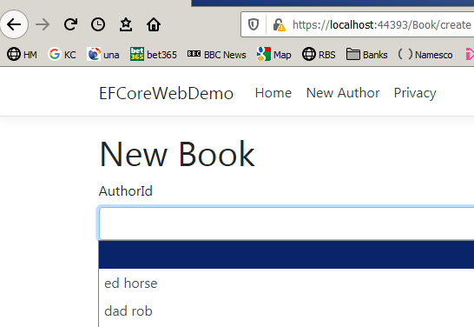
Index.cshtml
<ul>
@foreach (var author in Model) // Lists all the authors onto the PAGE...
{
<li>@author.FirstName @author.LastName</li> // ...in pairs.

}
</ul>

https://localhost:44393/create Index.cshtml
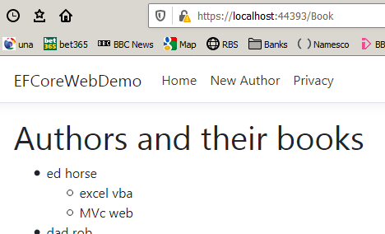
@foreach (var author in Model)
{
<li>
@author.FirstName @author.LastName
<ul>
@foreach (var book in author.Books)
{
<li>@book.Title</li>
}
</ul>
</li>
}

Note how tables are related:

public class Author
{
public int AuthorId { get; set; }
[StringLength(50)]
public string FirstName { get; set; }
[StringLength(75)]
public string LastName { get; set; }
public ICollection<Book> Books { get; set; } = new List<Book>();
}
and in Book,CamStudio

public Author Author { get; set; } // Relates to the Books! Simple"
// ie this book has an author (or not).
Create a new book has drop-down. Create.cshtml in Book in Views.

https://localhost:44393/Book/Create

@model Book

@{ ViewBag.Title = "New Book";}

@using (Html.BeginForm())
{

<div class="form-group">
@Html.LabelFor(model => model.AuthorId)
@Html.DropDownListFor(model => model.AuthorId, (IEnumerable<SelectListItem>)ViewBag.Authors, string.Empty,
new { @class = "form-control" })
</div>
2nd parameter is the list with which to populate the drop-down.

<div class="form-group">
@Html.LabelFor(model => model.Title)
@Html.TextBoxFor(model => model.Title,
new { @class = "form-control" })
</div>

<button type="submit" class="btn btn-default">Submit</button>
}

BookController.cs

ViewBag.Authors = authors; // Save them for the drop-down.

[HttpPost]
public async Task<IActionResult> Create([Bind("Title, AuthorId")] Book book)

SelectList Class

Definition
Namespace:System.Web.Mvc
Represents a list that lets users select one item.

Summary

Follow the display of all authors – and their books.

1. https://localhost:44393/Author/

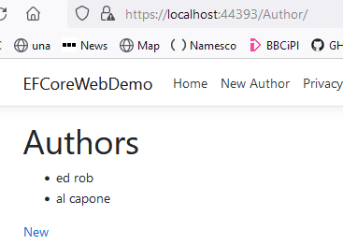

In the (Author) controller)
var model = await context.Authors.AsNoTracking().ToListAsync(); // Gets all of the authors from dbs.
return View(model); // Displays them ALL.

Prints them out in the (Authors) view
<ul>
@foreach (var author in Model) // Lists all the authors onto the PAGE...
{ <li>@author.FirstName @author.LastName</li> } // ...in pairs.
</ul>

Note also how we make a hyperlink.

<div>@Html.ActionLink("New", "create")</div>


https://localhost:44393/Author/create

ie New Authors pagae appears.

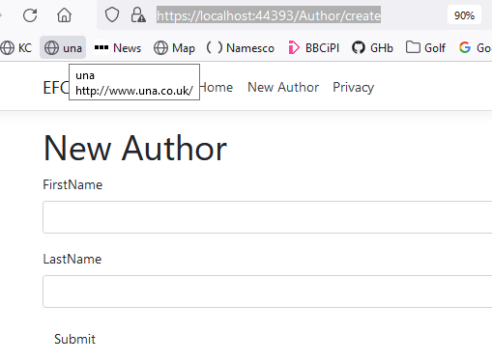

2. Other ways to get the new author page
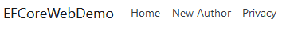

In _Layout page:
<li class="nav-item">
<a class="nav-link text-dark" asp-area="" asp-controller="Author" asp- action="Create"> New Author</a>
</li>

https://localhost:44393/Author/create

Or just type https://localhost:44393/Author/create
3. Fill in the New Author form and click Submit.

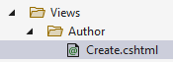
Mode is a “placeholder” for the Author object.

@model Author

@using (Html.BeginForm()) Html tags
{
Properties of Author.
/*FIRST NAME*/
<div class="form-group">

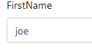
@Html.LabelFor(model => model.FirstName)
@Html.TextBoxFor(model => model.FirstName
, new { @class = "form-control" })

</div>

Author controller

public async Task<IActionResult> Create([Bind("FirstName, LastName")] Author author)
{
using (var context = new EFCoreWebDemoContext()) // We will add stuff to the dbs.
{
context.Add(author);// Adds it to the context first.
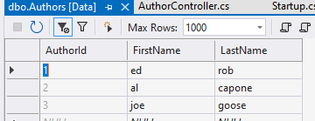

ie adds the author to the dbs

Add a New Book:

As fro add anew auhor Todo

Look at Dependency Injection in the conext: Todo

The article explains related as well as loads of stuff eg queries

See CSharpExtra for elaboration

Source code ??

Display Authors and Books

https://localhost:44393/book/

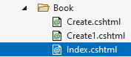
model = list of Authors

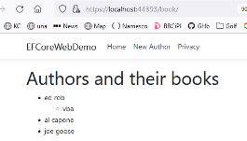
@model IEnumerable<Author>

<ul>
@foreach (var author in Model)
{

<li>
@author.FirstName @author.LastName
<ul>
@foreach (var book in author.Books)
{ <li>@book.Title</li> }
</ul>
</li>

}
</ul>

Author.cs
public class Author
{
public int AuthorId { get; set; }
[StringLength(50)]
// ANything with Id at the end automatically becomes a dbs Id field.
public string FirstName { get; set; }
[StringLength(75)]// Max length of the fitst name is 75.
public string LastName { get; set; }
public ICollection<Book> Books { get; set; } = new List<Book>();
// Relates the Author to his books.
// One author has many (collection) books.
}

and in the Book controller
Tracking is a feature that keeps track of alterations.

await Async means other stuff can goon while this does.
var model = await context.Authors.Include(a => a.Books).AsNoTracking().ToListAsync();

return View(model); // Displays the form above.

BTW: HomeController gets up the Welcome page a the very start!

Modifying The Database With Migrations
(Contains drop-down.)

Working With Data already done

ViewBag.Authors = authors; // In BookController

@Html.DropDownListFor(model => model.AuthorId, (IEnumerable<SelectListItem>)ViewBag.Authors, string.Empty, new { @class = "form-control" }) // In Book/Create.cshtml

book/create
In summary to get to a newly added Razor page. 1. On “toolbar at top. 2. typye in the URL segment. 3. put an anchor hyperlink on the Index.cs page.
<div>@Html.ActionLink("New", "create")</div>
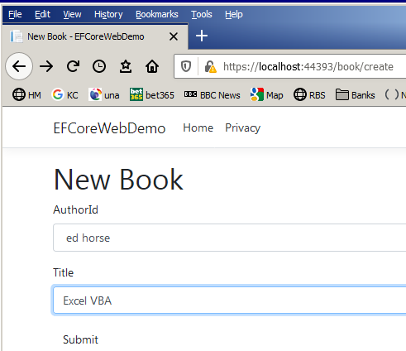
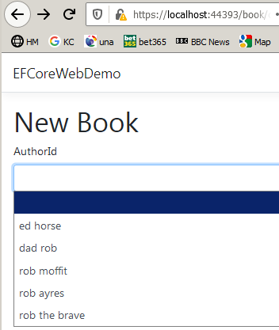
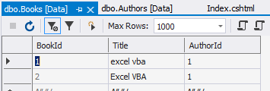
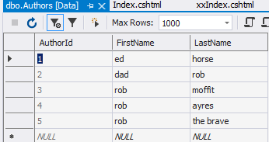

See comments C:/CS/EFCoreWebDemo

?
Index.cs view (in Book folder)

@model IEnumerable<Author>

BookController.cs

[HttpGet]
public async Task<IActionResult> Create()
{
using (var context = new EFCoreWebDemoContext())
{
var authors = await context.Authors.Select(a => new SelectListItem // SelectListItem For the Drop-down.
{
Value = a.AuthorId.ToString(),
Text = $"{a.FirstName} {a.LastName}"
}).ToListAsync();

ViewBag.Authors = authors; // Save them for the drop-down.
}
return View();
}

Create.cshtml Make a form with drop-down
To populate the drop-down.
@model Book

@using (Html.BeginForm())
{
<div class="form-group">
@Html.LabelFor(model => model.AuthorId)
@Html.DropDownListFor(model => model.AuthorId, (IEnumerable<SelectListItem>)ViewBag.Authors, string.Empty, new { @class = "form-control" })
</div>

<div class="form-group">
@Html.LabelFor(model => model.Title)
@Html.TextBoxFor(model => model.Title, new { @class = "form-control" })
</div>

<button type="submit" class="btn btn-default">Submit</button>
}

4. https://www.youtube.com/watch?v=DqD-NJf7-OM

Actually detailed explanation of MVC etc

V good long

source
https://drive.google.com/file/d/1YJC8JATqAAP6qGY7RBKDsqXjXF2HyIWO/view

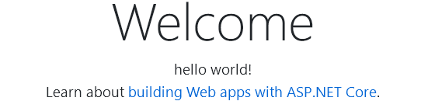

On laptop C:\X\InAndOut\

In appsettings.json
{
"ConnectionStrings": {

"DefaultConnection":
"Server=.
Database=InAndOut;Trusted_Connection=True;MultipleActiveResultSets=True

//"DefaultConnection":
Server=(LocalDB)\MSSQLLocalDB;
Database=InAndOut;Trusted_Connection=True;MultipleActiveResultSets=True"
},

And in startup

services.AddDbContext<ApplicationDbContext>(options =>
options.UseSqlServer(Configuration.GetConnectionString("DefaultConnection"))
);

Applied migrations ok

Use this !
-----------------------------------

How To Bind DropDownList In ASP.NET MVC 5 2015 but good

https://www.c-sharpcorner.com/UploadFile/0c1bb2/how-to-bind-dropdownlist-in-Asp-Net-mvc-5/

C:\CS\BindingDropDownList
This code just populates the drop-down.
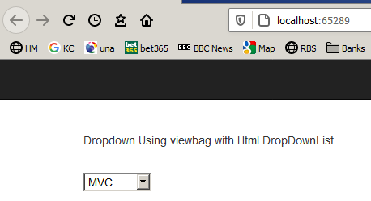

Index.cshtml
DropDownList “knows what to do with” a SelectListItem object.

@Html.DropDownList("ListItem")
See help on DropDownList
// Returns a single-selection MvcHtmlString select element using the specified HTML helper and the name of the form field.
// Parameters:
// HtmlHelper: The HTML helper instance that this method extends.
// name: The name of the form field to return.
// Returns: An HTML select element
public static MvcHtmlString DropDownList(this HtmlHelper htmlHelper, string name);

homecontroller.cshtml
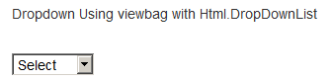
public ActionResult Index()
{
//using SelectListItem class
List<SelectListItem> ObjItem = new List<SelectListItem>()
{
new SelectListItem {Text="Select",Value="0",Selected=true },
new SelectListItem {Text="ASP.NET",Value="1" },
new SelectListItem {Text="C#",Value="2"},
new SelectListItem {Text="MVC",Value="3"},
new SelectListItem {Text="SQL",Value="4" },
};
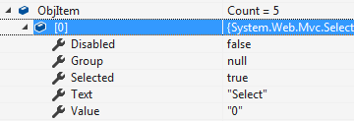
ViewBag.ListItem = ObjItem;

return View();
}
All the properties of the SelectListItem.
}

5 of them in the List

You can bind the list from the database, since this is an example so it did not used any database.
--------------------------------------------

A web app: 1. Handles a URL eg and then renders a web page.

A razor Page web handles the URL in its .cs file and displays it in its .cshtml file whereas as MVC extend/organizes this idea and has a special controller .cs page

Razor Page unnecessary in MVC cause MVC has got the controller whereas Razor has a “Get() .cs page to do the same thing.

A controller is like a “startup” like “Form Load” where we can put any “initialization” as above. ie the controller is where your “program” goes.

Binding Dropdownlist With Database In MVC v comprehensive

https://www.c-sharpcorner.com/UploadFile/4d9083/binding-dropdownlist-in-mvc-in-various-ways-in-mvc-with-data/

---------------------------------------------------


Binding DropDownList With Database in ASP.NET
not MVC not Core?
----------------------------------------------------

Authentication-and-Authorization
--------------------------------------------
http://future-shock.net/blog/post/creating-a-simple-login-in-asp.net-core-2-using-authentication-and-authorization-not-identity less4

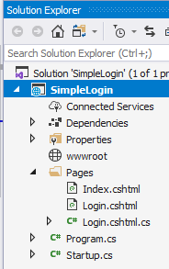
Creating a simple login in ASP.NET Core 2 using Authentication and Authorization (NOT Identity)

C:\CS\SimpleLogin\SimpleLogin.sln
See comments made using Razor not MVC
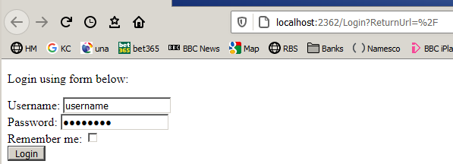

Login.cshtml

starts here because:

}).AddCookie(options => { options.LoginPath = "/Login"; });

Click login takes us here:

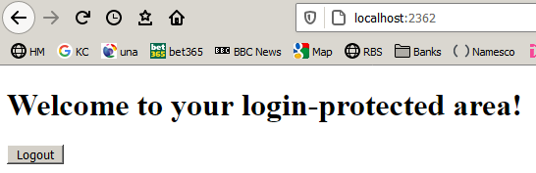

Index.cshtml

The Configure method tells our site to use Authentication and MVC (so that we can create some pages).

app.UseAuthentication();
app.UseMvc();

Login.cshtml

<!DOCTYPE html>

<html>
<body>

<p>Login using form below:</p>

<form method="post">

<div asp-validation-summary="All" class="text-danger"></div>

Username: <input asp-for="loginData.Username" value="username" /><br/>

Password: <input asp-for="loginData.Password" value="password" /><br />

Remember me: <input asp-for="loginData.RememberMe" type="checkbox" /><br />

<input type="submit" value="Login" />

@Html.AntiForgeryToken()

</form>
</body>
</html

Login.cshtml.cs

[BindProperty] // Bind on Post // ed alternative to ViewBag?
public LoginData loginData { get; set; }

var isValid =(loginData.Username == "username" && loginData.Password ==" password ");
// TODO Validate the username and the password with your own logic @ed ie your u/name and p/word. (from dbs?)

------------------------------------------------------------------

Very Simple Password Form less2

To make a new page in an MVC Core ASP.Net app: 4. https://youtu.be/v8-NRLpfjgE

To make a password form: https://youtu.be/-W_BsN6YJLw

https://www.completecsharptutorial.com/aspnet-tutorial-mvc/adding-a-controller-in-asp-net-core-1-0-app.php shows some new page techniques

C:\CS\CookieDemo.sln Made an MVC & then made a new razor? page called loginPage. Maybe just a .cshtml not a razor pair.
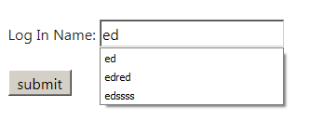
1. To make another new page in MVC.
2. Show a form Post.
LoginPage.cshtml
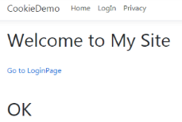
l

<form asp-controller="Home" asp-action="FormMessage">
@* Connects to the HOME Controller : the FormMessage action *@

Log In Name: <input name="LogText" type="text" /> @* The received textBox value from the form is passed to the (Home)controller*@

<input id="Submit1" type="submit" value="submit" /> @* The submit button does all that. *@
See abbreviated code! in video.
</form>

HomeController.cs

public IActionResult LoginPage()
{ return View(); }

[HttpPost]
public IActionResult FormMessage()
{
string msg = HttpContext.Request.Form["LogText"].ToString();

if (msg == "ed") {
ViewBag.Messages = "OK";
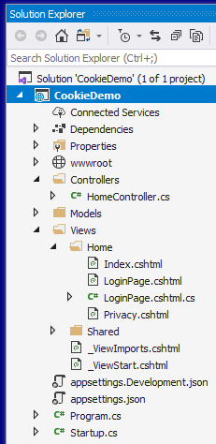
} // Pass this message via the ViewBag.Messages property

else {
ViewBag.Messages = "oops" ;
} //

return View("Index"); // Now return Index.cshtml View Page to browser
}
ViewBag is a dynamic property that is used to pass temporary data between controllers and view
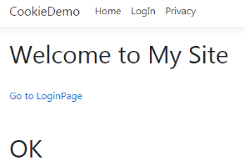
Index.cshtml

<h1>@ViewBag.Messages</h1>

And heres how to make a hyperlink:

<a asp-controller="Home" asp-action="LoginPage">Go to LoginPage</a>
@* <a> </a> is an anchor ie an embedded hyperlink.
asp-controller says to go to Home Controller and
asp-action says find LoginPage action method in this controller.*@

Logging see extra manual

Corey:
https://www.youtube.com/watch?v=oXNslgIXIbQ&t=1747

maybe:
https://www.youtube.com/watch?v=oXNslgIXIbQ&t=325s

indian
https://www.youtube.com/watch?v=WyAJe6lA-bY

MVC REST API Tutorial in 5 Hours | ASP.NET CORE Web API C# |
https://www.youtube.com/watch?v=HVZMTkhonZk

R E S T
Todo; watch
----------------------------------

