1. Watch my videos.
https://youtu.be/co9OcQZ4W4U
-> Point
https://youtu.be/1eWCTZS3W7w
Point Line Array Polyline
https://youtu.be/sGV-tj3FNos
line intersection video3.gh
https://youtu.be/5ypmYo2MhNg
transformation video4.gh

2. Zach Ancilliary.See my source code to save time. Actually not a priority.

2. Vestartas
The documentation is lacking but examples are great.
CurvesEtc (This manual)
Read in conjunction with his “manual”
https://issuu.com/petrasvestartas/docs/documentation_4357172c034de5

3. RhinoCommon examples. (Note how the examples are notated with omigi.) Actually for help better to use Itellisense!

From Rhino type grasshopper.

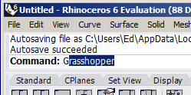

File New Document

Drag C# Script.

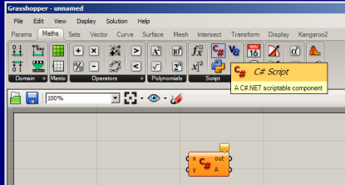

Originally orange because no code ie inactive.
If we placed another component on the canvas ANOTHER script will be associated with this 2nd component.
Drag Panel and connect to A.

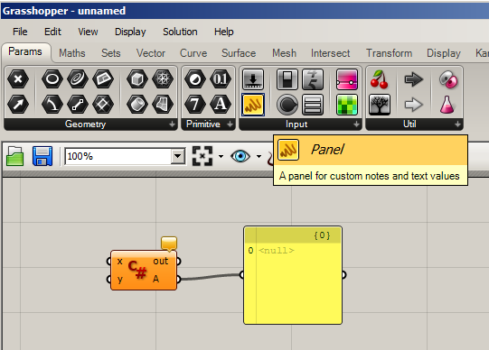

Global variables (and classes) go at the end cf c# go at start.

using Rhino.Commands;
using Rhino.Input;
using Rhino.DocObjects;
using Rhino.Geometry.Intersect;
using Rhino.Collections;

Double-click on C#.

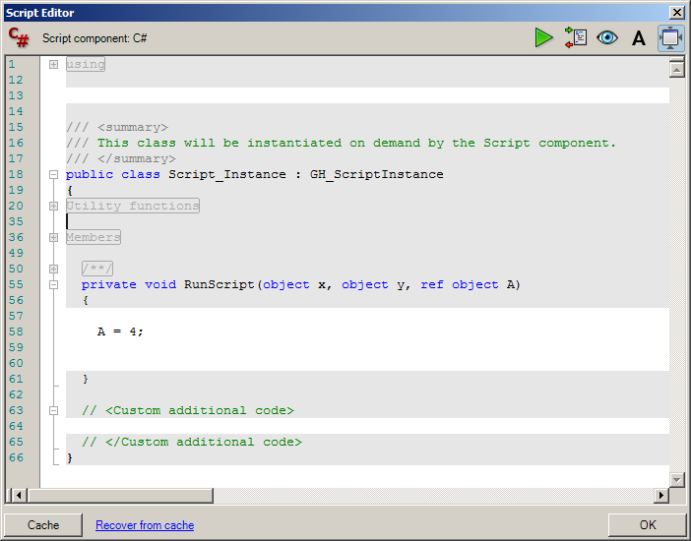

Type. Note A in input as well.

Click OK to run the script. The script window will then close. To keep it open Run it using the green triangle (Run button) at the top.

End result: serpLatest7.gh
Result:

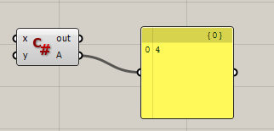
(Grey when “out of focus”)
Dull grey when not Enabled/Preview.

No single-step available in gh !

Debugging.

Connect another Panel to out.

Change code.Create an error.

private void RunScript(object x, object y, ref object A)
{
B = 4; // (B is unknown.)
}

and Run.

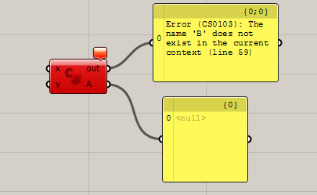

(Red when error)

Amend the code.

Type Hint

Note that these are immutable from the script window. Try changing them here. You can’t.
(Nor can you change the type from here.) Nor the grey stuff. Only white “gaps”

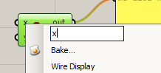
Right-click and change to z.

(Green when ready to go.)

It automatically changes in the code. (Need to reopen the script!)

private void RunScript(object z, object y, ref object A)

To change the type of the input variable right-click on the input (z in this case)

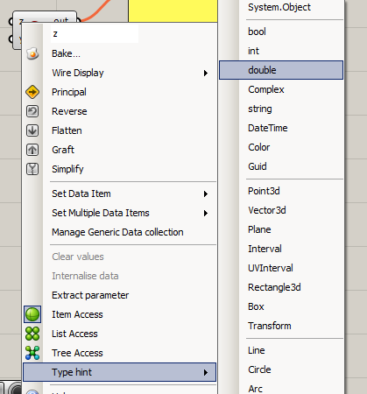
Choose Type Hint, double.

It changes in the code as well. Need to reopen script.

private void RunScript(double z, object y, ref object A)

To Display a 3D Object

Point3d pt = new Point3d(10, 10, 10);
Grasshopper knows - since it’s a grasshopper object – to output onto Rhino canvas.

A = pt;

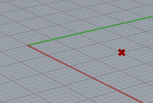
Grasshopper is actually a Rhino plug-in.

Print("ed"); To out.

Rhino.RhinoApp.WriteLine("ed");

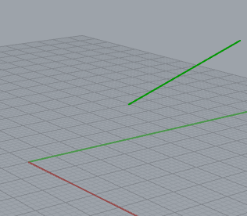
Vector3d unitZ = new Vector3d(0,0,10);
A = unitZ; //to paneloutput

Line ln = new Line(10 ,10, 10, 20,20,20);
A = ln;

Grasshopper Not C#.

Great simple animated! tute:
https://blog.ramboll.com/rcd/tutorials/a-beginners-guide-to-visual-scripting-with-grasshopper.html just grasshopper
good Rhino intro: https://player.vimeo.com/video/58212839

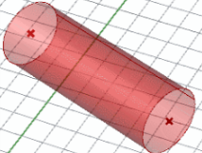
The little red cross goes from red to green when the corresponding gh component is selected:


To create a new C# component, double click on the canvas and type C# Script or go to Maths tab > Script > C# Script.

To edit the script, just double click in the center or right click on it and select “Edit Source…”

Note Preview options!

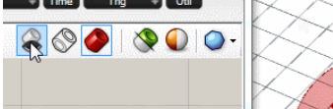

--------------------------------------------------------------------------------------------------

Good reference for Point3D etc at back of manual C#
https://issuu.com/petrasvestartas/docs/documentation_4357172c034de5

Cant copy from it! Just (not great) outline.

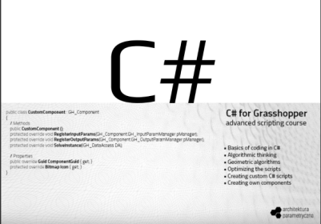

http://petrasvestartas.com/

____________________________________________________

Best Video set : Zach Downey. Good intro to scripting.

http://designalyze.com/intro-c-scripting-grasshopper/scripting-gh-part-01

Type in -02 to get the next one!

-03

Line

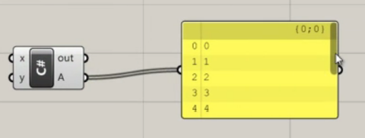

-04

Lists Loops Multiple points

List<Point3d> pts = new List<Point3d>();
for (int i = 0; i < 10; i++) {
Point3d tempPt = new Point3d(i, 0, 0);
pts.Add(tempPt);
}
A = pts;

-05
Can only be changed from right-clicking on C# component input and choosing Type Hint.

For Each

private void RunScript(List<Point3d> pts, ref object A)
{

List<double> xpos = new List<double>();
foreach(Point3d pt in pts) {
xpos.Add(pt.X);
Circles created at different centres.
}
A = xpos;
List<Circle> circles = new List<Circle>();
foreach(Point3d pt in pts) {
Circle tempCircle = new Circle(pt, 1.0);
circles.Add(tempCircle);
}
A = circles; // output is drawing object so goes to Rhino.
// if input is list then it goes to Pane.

}

GitHubless5.

06

List<int> numbers = new List<int>();

int i = 0;
while (i < count) {
numbers.Add((i*step) + start);
i++;
}
A = numbers;

07

List<Point3d> pts = new List<Point3d>();

if (x == null) {
x = new Point3d(0,0,0);
}

double spacingX = xSize / numDivsX;
double spacingY = ySize / numDivsY;

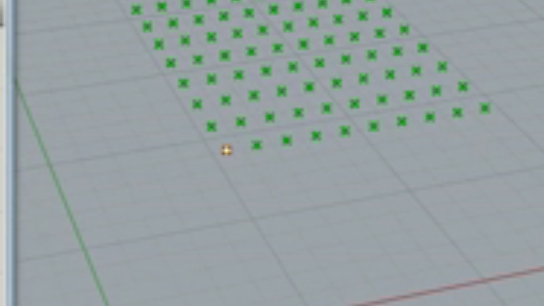
Point3d tempPt = x;

for (int i = 0; i < numDivsX; i++) {
tempPt.X = x.X + (spacingX * i);

for (int j = 0; j < numDivsY; j++) {
tempPt.Y = x.Y + (spacingY * j);
pts.Add(tempPt);
}
}

A = pts;

08

if (x == true) {
A = "It's True!";
} else {
A = "It's False";
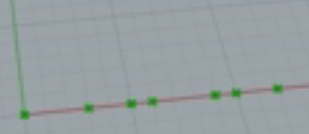
}
List<Point3d> pts = new List<Point3d>();

for (int i = 0; i < 100; i++) {
if (i%3 == 0 || i %5 == 0) {
Point3d ptTemp = new Point3d(i, 0, 0);
pts.Add(ptTemp);
}
}
A = pts; // 3,5,6,10 etc

-09

Point3d pt = new Point3d();
pt = x.PointAtNormalizedLength(t);

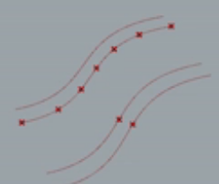
A = pt;
List<Point3d> pts = new List<Point3d>();
Point3d pt = new Point3d();

double spacing = 1.0 / numDivs;
double t;

for (int i = 0; i <= numDivs; i++) {
t = i * spacing;
pt = x.PointAtNormalizedLength(t);
pts.Add(pt);
}

A = pts;

GHLess8

-10

Random random = new Random();

Vector3d unitZ = new Vector3d(0,0,1);

-----------------------------------------------------------------------------------------------------------------

https://www.youtube.com/watch?v=LlBaIyLoN3Y
Reinhard! Slow!
Create a surface – need a brep first
rect - ->

-----------------------------------------------------------------------

Rhino.Geometry.Line ln

https://developer.rhino3d.com/api/RhinoCommon/html/N_Rhino_Geometry.htm

Rhino.Geometry Namespace

‘’’’’’’’’’’’’’’’’’’’’’’’’’’’’’’’’’’’’’’’’’’’’’’’’’’’’’’’’’’’’’’’’’’’’’

RhinoCommon Examples

Rhino Developer Docs
https://developer.rhino3d.com/samples/

Add Brep Box

private void RunScript(object x, object y, ref object A)
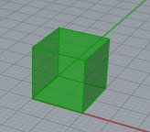
{
Point3d pt0 = new Rhino.Geometry.Point3d(0, 0, 0);
Point3d pt1 = new Rhino.Geometry.Point3d(10, 10, 10);

BoundingBox box = new Rhino.Geometry.BoundingBox(pt0, pt1);

Brep brep = box.ToBrep();

A = brep;
Instead use:
using Rhino.Geometry;
}}

Add Circle

Rhino.Geometry.Point3d center = new Rhino.Geometry.Point3d(0, 0, 0);
const double radius = 10.0;
Rhino.Geometry.Circle c = new Rhino.Geometry.Circle(center, radius);

Add Clipping Plane
Demonstrates how to add a clipping plane from an
array or corner points.
Instead use:
using Rhino.Commands;
using Rhino.Input; etc.

Rhino.Geometry.Point3d[] corners;
First allows us to select a rectangle:
Rhino.Commands.Result rc = Rhino.Input.RhinoGet.GetRectangle(out corners);
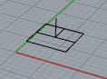
Byref

Point3d p0 = corners[0];
Point3d p1 = corners[1];
Point3d p3 = corners[3];
Then draws it:
Plane plane = new Plane(p0, p1, p3);
Guid id = doc.Objects.AddClippingPlane(plane, p0.DistanceTo(p1), p0.DistanceTo(p3), view.ActiveViewportID);

Full Code:

https://developer.rhino3d.com/samples/rhinocommon/add-clipping-plane/

public static Rhino.Commands.Result AddClippingPlane(Rhino.RhinoDoc doc)
{
// Define the corners of the clipping plane
Rhino.Geometry.Point3d[] corners;
Rhino.Commands.Result rc = Rhino.Input.RhinoGet.GetRectangle(out corners);
if (rc != Rhino.Commands.Result.Success) return rc;

// Get the active VIEW
Rhino.Display.RhinoView view = doc.Views.ActiveView;
if (view == null) return Rhino.Commands.Result.Failure;

Rhino.Geometry.Point3d p0 = corners[0];
Rhino.Geometry.Point3d p1 = corners[1];
Rhino.Geometry.Point3d p3 = corners[3];

// CREATE a plane from the corner points
Rhino.Geometry.Plane plane = new Rhino.Geometry.Plane(p0, p1, p3);
// Add a clipping plane object to the document
Guid id = doc.Objects.AddClippingPlane(plane, p0.DistanceTo(p1), p0.DistanceTo(p3), view.ActiveViewportID);
if (id != Guid.Empty)
{
doc.Views.Redraw();
return Rhino.Commands.Result.Success;
}
return Rhino.Commands.Result.Failure;
}

-------------------------------------------------------------

Point3d pt1 = new Point3d(10, 10, 10);
Point3d pt2 = new Point3d(20, 20, 20);
var L = RhinoDoc.ActiveDoc.Objects.AddLine(pt1,pt2);

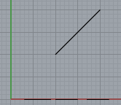

------------------------------------------------------------

Add Cone
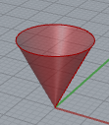
Plane plane = Plane.WorldXY;
const double height = 10;
const double radius = 5;
Cone cone = new Rhino.Geometry.Cone(plane, height, radius);
A = cone;
------------------------------------------------

OR use original RhinoCommon code: (abbreviated)

using Rhino.Commands;

var D = RhinoDoc.ActiveDoc.Objects.Document;

var R = Examples.AddCone(D);

partial class Examples
{
public static Result AddCone(Rhino.RhinoDoc doc)
{
Plane plane = Plane.WorldXY;
const double height = 10; const double radius = 5;
Cone cone = new Cone(plane, height, radius);

const bool cap_bottom = true;
Brep cone_brep = cone.ToBrep(cap_bottom);

doc.Objects.AddBrep(cone_brep); // I guess rather than A= …
doc.Views.Redraw();

return Result.Success;
}
}

--------------------------------------------
Add Cylinder

Rhino.Geometry.Cylinder cylinder = new Rhino.Geometry.Cylinder(circle, zaxis.Length);

Add Line

gp.DrawLineFromPoint(pt_start, true);

Rhino.Geometry.Point3d pt_end = gp.Point();

Rhino.Geometry.Vector3d v = pt_end - pt_start;

A = v; ??

Add Mesh

private void RunScript(object x, object y, ref object A)
{
Rhino.Geometry.Mesh mesh = new Rhino.Geometry.Mesh();
mesh.Vertices.Add(0.0, 0.0, 1.0); //0
mesh.Vertices.Add(1.0, 0.0, 1.0); //1
mesh.Vertices.Add(2.0, 0.0, 1.0); //2
mesh.Vertices.Add(3.0, 0.0, 0.0); //3
mesh.Vertices.Add(0.0, 1.0, 1.0); //4
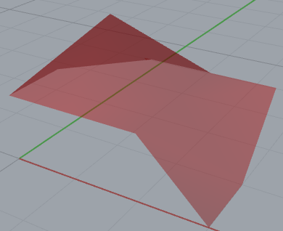
mesh.Vertices.Add(1.0, 1.0, 2.0); //5
mesh.Vertices.Add(2.0, 1.0, 1.0); //6
mesh.Vertices.Add(3.0, 1.0, 0.0); //7
mesh.Vertices.Add(0.0, 2.0, 1.0); //8
mesh.Vertices.Add(1.0, 2.0, 1.0); //9
mesh.Vertices.Add(2.0, 2.0, 1.0); //10
mesh.Vertices.Add(3.0, 2.0, 1.0); //11

mesh.Faces.AddFace(0, 1, 5, 4);
mesh.Faces.AddFace(1, 2, 6, 5);
mesh.Faces.AddFace(2, 3, 7, 6);
mesh.Faces.AddFace(4, 5, 9, 8);
mesh.Faces.AddFace(5, 6, 10, 9);
mesh.Faces.AddFace(6, 7, 11, 10);
mesh.Normals.ComputeNormals();
mesh.Compact();

A = mesh;

}

Add Mesh

Demonstrates how to construct a mesh box from a Brep box.

private void RunScript(object x, object y, ref object A)
{
Rhino.Geometry.Box box;

Rhino.Commands.Result rc = Rhino.Input.RhinoGet.GetBox(out box);

Mesh mesh = Rhino.Geometry.Mesh.CreateFromBox(box, 2, 2, 2);

A = mesh;
}

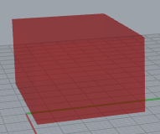
GetBox(allows me to draw this f/hand. Press Enter

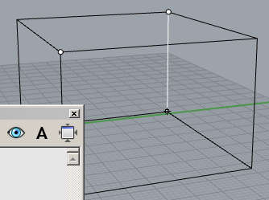

Add NURBS Circle

// The easy way to get a NURBS curve from a circle is with
// the following two lines of code.
// Rhino.Geometry.Circle c = new Rhino.Geometry.Circle(20);
// Rhino.Geometry.NurbsCurve nc = c.ToNurbsCurve();
// BUT this sample demonstrates creating a NURBS curve from scratch.

const int dimension = 3;
const bool isRational = true;
const int order = 3;
const int cv_count = 9;

Rhino.Geometry.NurbsCurve nc = new Rhino.Geometry.NurbsCurve(dimension, isRational, order, cv_count);

nc.Points.SetPoint(0, 1.0, 0.0, 0.0, 1.0);
nc.Points.SetPoint(1, 0.707107, 0.707107, 0.0, 0.707107);
nc.Points.SetPoint(2, 0.0, 1.0, 0.0, 1.0);
nc.Points.SetPoint(3, -0.707107, 0.707107, 0.0, 0.707107);
nc.Points.SetPoint(4, -1.0, 0.0, 0.0, 1.0);
nc.Points.SetPoint(5, -0.707107, -0.707107, 0.0, 0.707107);
nc.Points.SetPoint(6, 0.0, -1.0, 0.0, 1.0);
nc.Points.SetPoint(7, 0.707107, -0.707107, 0.0, 0.707107);
nc.Points.SetPoint(8, 1.0, 0.0, 0.0, 1.0);

nc.Knots[0] = 0.0;
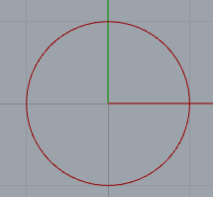
nc.Knots[1] = 0.0;
nc.Knots[2] = 0.5 * Math.PI;
nc.Knots[3] = 0.5 * Math.PI;
nc.Knots[4] = Math.PI;
nc.Knots[5] = Math.PI;
nc.Knots[6] = 1.5 * Math.PI;
nc.Knots[7] = 1.5 * Math.PI;
nc.Knots[8] = 2.0 * Math.PI;
nc.Knots[9] = 2.0 * Math.PI;

A = nc;

}

Add NURBS Curve

//or using Rhino.Collections;

private void RunScript(object x, object y, ref object A)
{
Point3dList points = new Rhino.Collections.Point3dList(5);
points.Add(0, 0, 0);
points.Add(0, 2, 0); // Control points
points.Add(2, 3, 0);
points.Add(4, 2, 0);
points.Add(4, 0, 0);
Rhino.Geometry.NurbsCurve nc = Rhino.Geometry.NurbsCurve.Create(false, 3, points);
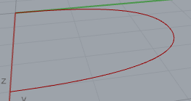
A = nc;

}

• Add Objects to Group

if (go.CommandResult() != Rhino.Commands.Result.Success)
return go.CommandResult();

List<Guid> ids = new List<Guid>();
for (int i = 0; i < go.ObjectCount; i++)
{
ids.Add(go.Object(i).ObjectId);
}
int index = doc.Groups.Add(ids);

• Add Sphere

• Add Texture

// Make sure the object has it's material source set to "material_from_object"
rhino_object.Attributes.MaterialSource = Rhino.DocObjects.ObjectMaterialSource.MaterialFromObject;

- Add Torus
- Add Truncated Cone
- Duplicate Object done
- Extend Curve
- Find Objects by Name
- Object Color
- Pick Point

Blocks
Add Nested Block

Block Insertion Point
- Create Block Definition
- Delete Block Instance Definition
- Instance Definition Objects
- Lock Layer
- Rename Block

Curves
- Add Arrowheads to Curves
- Add NURBS Curve done
- Brep from Curve Bounding Box
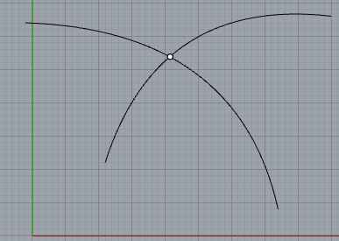
- Calculate Curve Intersections

using Rhino.Commands;
using Rhino.Input;
using Rhino.DocObjects;
using Rhino.Geometry.Intersect; // Just use these usings all the time!

var d = RhinoDoc.ActiveDoc;

Result rc = Examples.IntersectCurves(d);

partial class Examples
{
public static Rhino.Commands.Result IntersectCurves(Rhino.RhinoDoc doc)
{
// SELECT two curves to intersect
var go = new Rhino.Input.Custom.GetObject();
go.SetCommandPrompt("Select two curves");
go.GeometryFilter = ObjectType.Curve;
go.GetMultiple(2, 2);

// Validate input
Curve curveA = go.Object(0).Curve(); Curve curveB = go.Object(1).Curve();

// Calculate the intersection
const double intersection_tolerance = 0.001; const double overlap_tolerance = 0.0;

var events = Intersection.CurveCurve(curveA, curveB, intersection_tolerance, overlap_tolerance);

// Process the results
if (events != null)
{
for (int i = 0; i < events.Count; i++)
{
var ccx_event = events[i];

doc.Objects.AddPoint(ccx_event.PointA); // Plot the point of intersection

if (ccx_event.PointA.DistanceTo(ccx_event.PointB) > double.Epsilon) // Closest if dont intersect. Or curve bit in common?
{
doc.Objects.AddPoint(ccx_event.PointB);
doc.Objects.AddLine(ccx_event.PointA, ccx_event.PointB);
}
}
doc.Views.Redraw();
}
return Result.Success;
}
}
- Constrained Copy
- Create Contour Curves
- Curve Bounding Box
- Curve Deviation

- Divide Curve by Segments
using Rhino.Commands;
using Rhino.Input;
using Rhino.DocObjects;
using Rhino.Geometry.Intersect;

var d = RhinoDoc.ActiveDoc;
Result rc = Examples.DivideCurveBySegments(d);

partial class Examples
{
public static Result DivideCurveBySegments(RhinoDoc doc)
{
const ObjectType filter = ObjectType.Curve;

ObjRef objref;

var rc = RhinoGet.GetOneObject("Select eDS curve to divide", false, filter, out objref);

if (rc != Result.Success || objref == null)
return rc;

var curve = objref.Curve();
if (curve == null || curve.IsShort(RhinoMath.ZeroTolerance))
return Result.Failure;
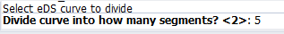
var segment_count = 2;// Default.

rc = RhinoGet.GetInteger("Divide curve into how many segments?", false, ref segment_count);

if (rc != Result.Success)
return rc;

Point3d[] points;

curve.DivideByCount(segment_count, true, out points);

if (points == null)
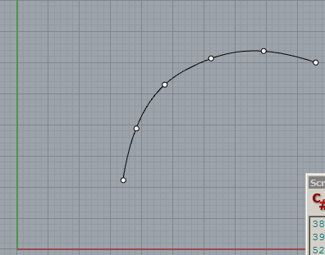
return Result.Failure;

foreach (var point in points)
doc.Objects.AddPoint(point);

doc.Views.Redraw();
return Result.Success;
}
}

- Divide Curve Straight
Demonstrates how to divide a curve using equi-distance points.
- Extend Curve done
- Extract Isocurve
- Fillet Curves
- Find Curve Parameter At Point
- Find point on curve at distance
- Hatch Curve
- Increase NURBS Curve Degree
- Intersect Lines
if( !Rhino.Geometry.Intersect.Intersection.LineLine(line0, line1, out a, out b))
- Line Between Curves
Demonstrates how to draw a line between two user-specified curves.
- Offset Curve

var curves = curve.Offset(point, Vector3d.ZAxis, 1.0,
doc.ModelAbsoluteTolerance, CurveOffsetCornerStyle.None);
- Reparameterize Curves

- Reverse Curve
- Surface from Edge Curves

- Tween Curve

Drawing
- Conduit Draw Shaded Mesh
- Draw Mesh done?

- Dynamically Draw Geometry when Picking Points
- Overlay Text Display Conduit

Layers
- Add Child Layer
- Add Layer
- Determine Object Layer
- Lock Layer
- Move Objects to Current Layer
- Rename Layer
- Select Objects on Layer

Picking and Selection
- Dynamically Draw Geometry when Picking Points
- Get Angle
- Pick Point
// this creates a point where the mouse is clicked.
var gp = new GetPoint();
gp.SetCommandPrompt("Click for new point");
gp.Get();
if (gp.CommandResult() != Result.Success)
return gp.CommandResult();
var point3d = gp.Point();
doc.Objects.AddPoint(point3d);
doc.Views.Redraw();

// selects a point that already exists
ObjRef obj_ref;
var rc = RhinoGet.GetOneObject("Select point", false, ObjectType.Point, out obj_ref);
if (rc != Result.Success)
return rc;
var point = obj_ref.Point();
RhinoApp.WriteLine("Point: x:{0}, y:{1}, z:{2}",
point.Location.X,
point.Location.Y,
point.Location.Z);
doc.Objects.UnselectAll();
- Pick Points
- Replace the Color Picking Dialog
- Select Objects in Object Groups
- Select Objects on Layer

Viewports and Views
- Add Layout
- Add Named View
- Determine Active Viewport
- Get and Set the Active View
- Set Viewport Name
- Viewport Resolution

Other
- Add Leader
- Add Radial Dimension
- Advanced Display Settings
- Array By Distance
- Boolean Difference
- Box Shell
- Calculate Surface Curvature
- Change Dimension Style
- Circle Center
- Closest Point Calculation with RTree
- Create Mesh from Brep
- Create Spiral
- Create Surface From Points and Knots
Warning (CS0618): 'Rhino.Geometry.Collections.NurbsSurfacePointList.SetControlPoint(int, int, Rhino.Geometry.Point3d)' is obsolete: 'Use one of the SetPoint() overrides' (line 129)
var nurbs_surface = NurbsSurface.Create(number_of_dimensions,
is_rational,
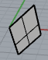
u_degree + 1,
v_degree + 1,
u_control_point_count,
v_control_point_count
);

- Curve Surface Intersection
- Custom Geometry Filter
- Custom Python
- Custom Undo
- Determine Language Setting
- Determine Normal Direction of Brep Face
- Display Conduit Arrowheads
- Display Conduit
- Display Order
- Display Precision
- Divide by Length Points
- Duplicate Surface Border
- Duplicate Mesh Boundary
- Dynamically Drawing Text Strings
- Edit Text
- Explode Hatch
- Export Control Points
- Extend Surface
- Extract Render Mesh
- Extrude Brep Face
- Furthest Z on Surface given X Y
- Get Multiple With Options
- Increase NURBS Surface Degree
- Insert Knot
- Instance Archive File Status
- Instance Definition Names
- Instance Definition Tree
- Intersecting Line and Circle
- Is Planar Surface in Plane
- IsBrepBox Test
- Isocurve Density
- Loft Surfaces
- Mesh Volume
- Modify Light Color
- Move CPlane
- Move Points Non Uniform
Move Points
var xform = Transform.Translation(end_point - start_point);
- Object Iterator
- Orient On Surface
- Orthogonal Mode
- Planar Surface
- Project Points to Breps

- Project Points to Mesh

- Read Dimension Text
- Set RhinoPageView Width and Height
- Show Surface Direction
- Single Color Back Faces
- Space Morph
- Split BReps with Planes

- Sprite Drawing
- Surface from Corner Points
- Sweep Surfaces with Sweep1
- Text Justify
- Tight Bounding Boxes for Breps
- Transform Breps
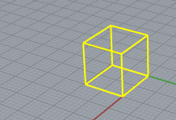
1st Draw Solid, Box and then Select it.

var rc = RhinoGet.GetOneObject("Select brep", true, Rhino.DocObjects.ObjectType.Brep, out rhobj);

// Simple translation transformation

var xform = Rhino.Geometry.Transform.Translation(10, 10, 10);

doc.Objects.Transform(rhobj, xform, true);

A = rhobj;
using Rhino.Commands;
using Rhino.Input;
using Rhino.Collections;
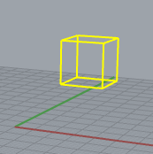

using Rhino.Geometry.Transform;
nope:
Error (CS0138): A using namespace directive can only be applied to namespaces; 'Rhino.Geometry.Transform' is a type not a namespace (line 16)
------------------------------------------------------------------------------------------------------------
Tweak Colors
Unroll Surface and Mesh
Unroll Surface
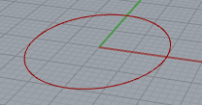
Visual Analysis Modes
Circle:

Rhino.Geometry.Point3d center = new Rhino.Geometry.Point3d(0, 0, 0);

const double radius = 10.0;

Rhino.Geometry.Circle c = new Rhino.Geometry.Circle(center, radius);

A = c;
comment ctrl K,C (keep ctrl key held won for the C!)
uncomment ctrl K,U

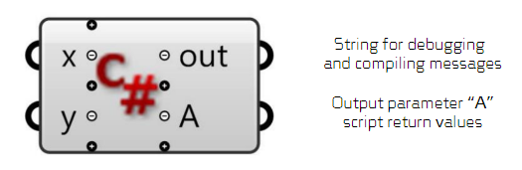

http://wiki.theprovingground.org/genetic-algorithm-problem-solving
Genetic Algorithm Problem Solving
Not grasshopper.
---------------------------------------------------------------------------------------------------------------
http://grasshopperprimer.com/en/1-foundations/1-3/3_mathematics-expressions-conditionals.html

v good detailed no C# but for rhino 5.ctrl-alt click on a component

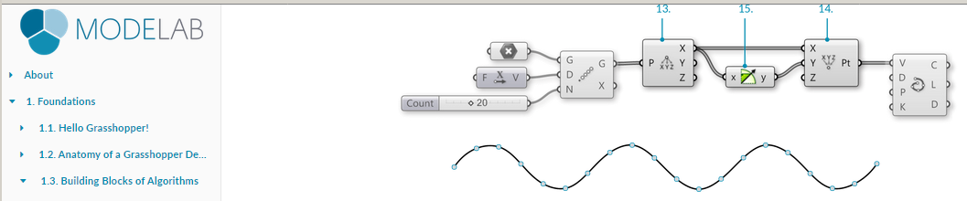

----------------------------------------------------------------------
Grasshopper tutorial.pdf in grasshopper folder

VBScript!

private void RunScript(object x, object y, ref object A)
{
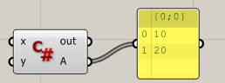
List<int> lst = new List<int>();
lst.Add(10);
lst.Add(20);
A = lst;
}

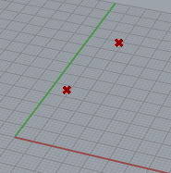
private void RunScript(object x, object y, ref object A)
{
Point3d pt1 = new Point3d(10, 10, 10);
Point3d pt2 = new Point3d(20, 20, 20);

List<Point3d> lst = new List<Point3d>();
lst.Add(pt1);
lst.Add(pt2);
A = lst;
}

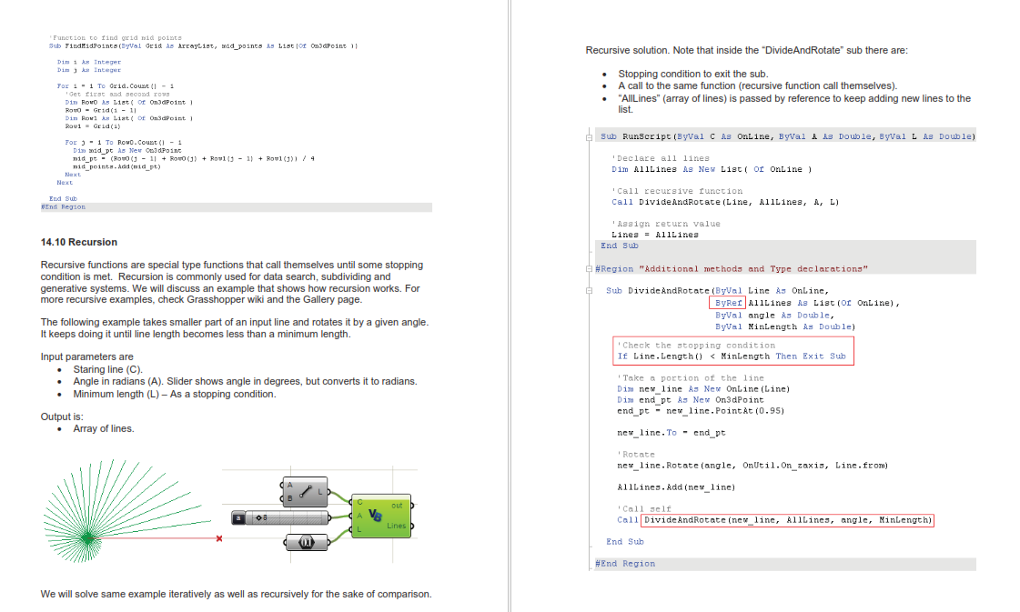
etc
takes one line at a time. rotates it line.Rotate() etc and then adds its to the list AllLines.Add.

FILE I/O

see examples for same about page 95

Vectors

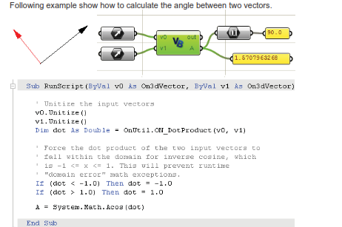

TODO Convert code for Nurbs etc to C#

Good.

End Grasshopper tutorial.pdf

https://rhino.github.io/components/curve/center.html



bit useless

A Circle between a collection of points

Red circle I drew as guide. I drew 3 points.
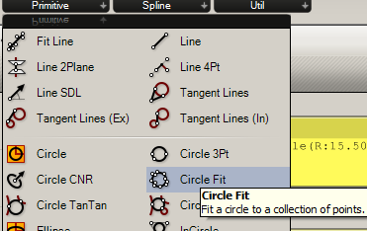
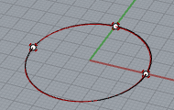

5/div

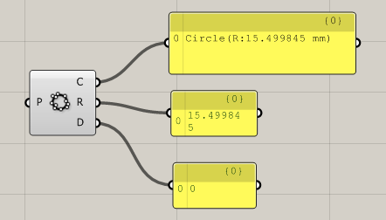

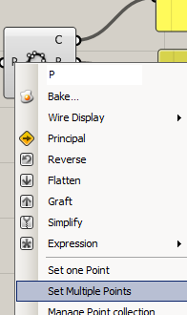

More points and script.

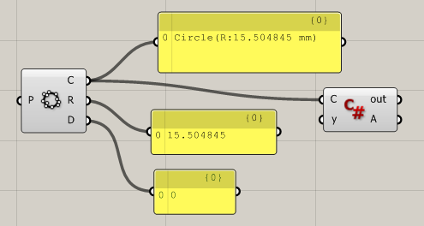

private void RunScript(Circle C, object y, ref object A)
{
A = C;
}

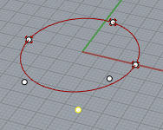

Move a point and circle moves in real-time!

circleFind.gh

bake.
Dynamic Rhino Circle
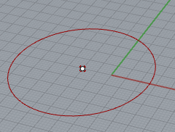
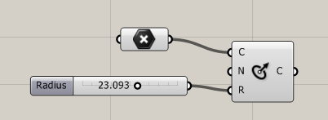

grasshopper primer

Value List
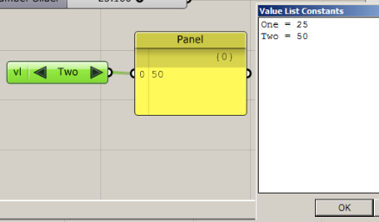

circle input parameter:

Box.m

box input parameter:
Print(x.Center.ToString());
Print(x.X.ToString());
Print(x.Y.ToString());
Print(x.Z.ToString());
A = x;

curve
private void RunScript(Curve x, object y, ref object A)
{
//Print(x.GetLength.ToString());
Print(x.IsPeriodic.ToString());

Genetic Code

E:\MyCode\GAHelloWorld\GAHelloWorld

Practice GA code:

// Random rnd = new Random();
// int [] genes;
// Print("ed");
// genes = new int [3];
//
// int r = (int) rnd.Next(256);

private void RunScript(object x, object y, ref object A)
{
// List<Box> boxes = new List<Box>();

Box B = new Box();

B = draw(0);
boxes.Add(B);

B = draw(1); // new box
boxes.Add(B);

A = boxes; // draw the lot.

}

// <Custom additional code>

static Box draw(int i)
{
Box box = new Box(Plane.WorldXY, new Interval(0, 100), new Interval(0, 100), new Interval(0, 100));

int numRows = 10; int height = 150; int width = 150; // amount of tranlation - not actual height, width!

Transform trans = Transform.Translation(width * (i % numRows), height * (i / numRows), 0);

box.Transform(trans);

return box;
}

public static List<Box> boxes = new List<Box>();

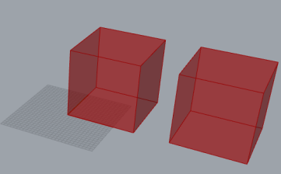
http://petrasvestartas.com/C-for-Grasshopper

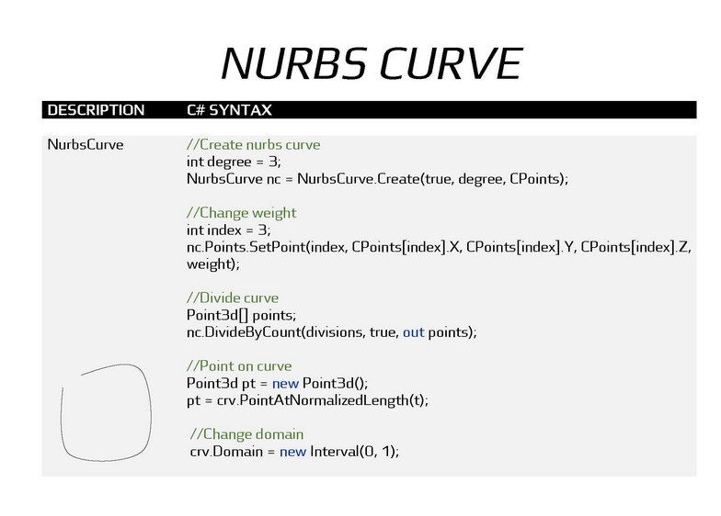
see petrasvestartas.gh
and surface etc

need to get this code working

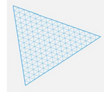

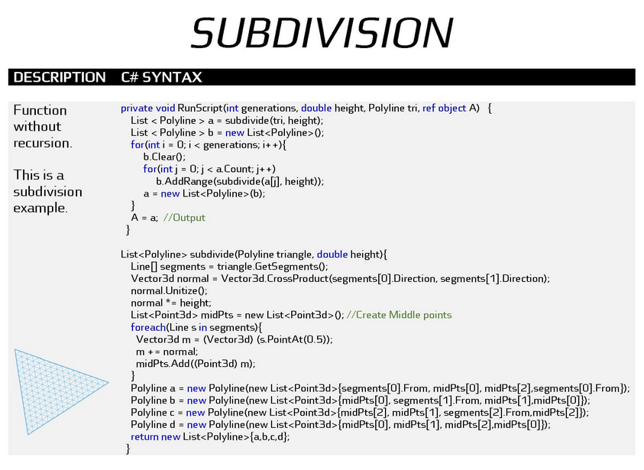
subdivision.gh
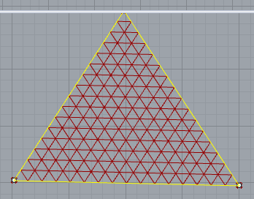
generations = 3 h=0

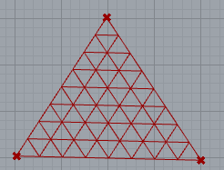
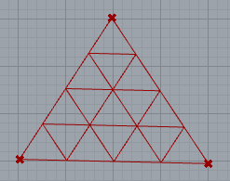
gen=2 h=0

generations = 1

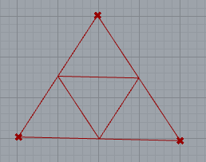

generations = 0 h=0

Actually has height as well

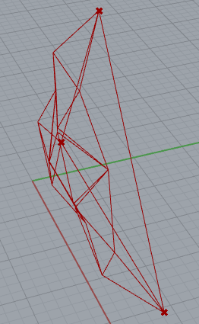

-----------------------------------------------------------

private void RunScript(Polyline tri, int generations, double height, ref object A)
{
List<Polyline> a = subdivide(tri, height);// calls the function
// tri is output from polyline control (from 3 points).
List<Polyline> b = new List<Polyline>(); //Loads of polylines.

for (int i = 0;i < generations; i++); // Say generations = 3
{
b.Clear(); // Clear the list.

for (int j=0;j < a.Count; j++)

b.AddRange(subdivide(a[j],height));

a = new List<Polyline>(b);
}
A = a;
}
**********************************************************************
List<Polyline> subdivide(Polyline triangle, double height)
{
Line[] segments = triangle.GetSegments();

Vector3d normal = Vector3d.CrossProduct(segments[0].Direction, segments[1].Direction);

normal.Unitize();

normal *= height;

List<Point3d> midPts = new List<Point3d>(); // Create Middle points

foreach(Line s in segments)
{
Vector3d m = (Vector3d) (s.PointAt(0.5));
m += normal;
midPts.Add((Point3d) m);
}
Polyline a = new Polyline(new List<Point3d>{segments[0].From,midPts[0],midPts[2],segments[0].From});

Polyline b = new Polyline(new List<Point3d>{midPts[0],segments[1].From,midPts[1],midPts[0]});

Polyline c = new Polyline(new List<Point3d>{midPts[2],midPts[1],segments[2].From,midPts[2]});

Polyline d = new Polyline(new List<Point3d>{midPts[0],midPts[1],midPts[2],midPts[0]});

List<Polyline> lin = new List<Polyline>();

return new List<Polyline>{a,b,c,d};
}
}
***********************************************************************
--------------------------------------------------------------------

We can hand edit points eg:

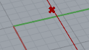
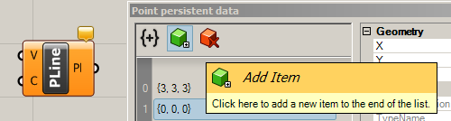

SO: Creates polylines

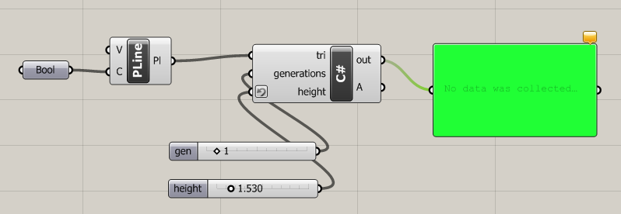

--------------------------------------------------

https://discourse.mcneel.com/t/use-recursion-in-grasshopper-c/35663

loads of examples
http://www.giuliopiacentino.com/grasshopper-tools/#more-1033
bit obscure

Grasshopper Scripting 101

https://www.modelical.com/en/grasshopper-scripting-101/

just change this

Point3d is part of the RhinoCommon library. Being a Reference-Type class, we should declare it as we did with lists.

1 | Point3d myPoint = new Point3d();

https://www.modelical.com/en/grasshopper-scripting-107/

B11_GHS_107.gh Not recursive maybe we should make it so.

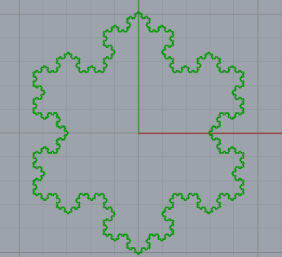

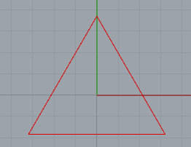

y = 0. x is size of triangle.

See also sierp triangle.gh in grasshopper.

private void RunScript(double x, int y, ref object A)
{
//declare a list for our points
List<Point3d> ptList = new List<Point3d> ();
//create the first 4 points of the triangle, 4 because we want it to be a closed polyline
ptList.Add(new Point3d(0, x, 0));
ptList.Add(new Point3d(-x * Math.Cos(Math.PI / 6), -x * Math.Sin(Math.PI / 6), 0));
ptList.Add(new Point3d(x * Math.Cos(Math.PI / 6), -x * Math.Sin(Math.PI / 6), 0));
ptList.Add(new Point3d(0, x, 0));

//Declare a point for each of the 3 points we'll add to each side
Point3d Pt0, Pt1, Pt2;

//initialize a counter for the number of iterations we perform
int c = 0;

//This loop will keep running until the lists becomes too big or we reach the number of iterations
while ((ptList.Count * 4 < 10000) && (c < y))
{
//Iterate through the list of points
for (int i = 0; i < ptList.Count - 1; i++)
{
//calculate each of the three points using functions
Pt0 = PtA(ptList[i], ptList[i + 1]);
Pt1 = PtB(ptList[i], ptList[i + 1]);
Pt2 = PtC(ptList[i], ptList[i + 1]);

//add the points to the list - in the right place
ptList.Insert(i + 1, Pt0);
ptList.Insert(i + 2, Pt1);
ptList.Insert(i + 3, Pt2);

//shift the iterator to skip the newly added points
i += 3;
}//end of list loop

//increase the counter and start again
c++;
}

//at the end, output A as a polyline and print some info
A = new Polyline(ptList);
Print("Solution reached in {0} steps with {1} vertices", c + 1, ptList.Count);

}

//this function returns the a point at one third of two given points
Point3d PtA(Point3d a, Point3d b){

return a + ((b - a) / 3);
}

//this function returns the tip point in the sierpinski division
Point3d PtB(Point3d a, Point3d b){
Point3d p1 = a + ((b - a) / 3);
Point3d p2 = a + (2 * (b - a) / 3);
//declare a transformation where we rotate the second-third point 60º around the first-third
Transform trans = Transform.Rotation(-Math.PI / 3, Vector3d.ZAxis, p1);
//apply the transformation
p2.Transform(trans);
return p2;

}
//this function returns the a point at one third of two given points
Point3d PtC(Point3d a, Point3d b){

return a + (2 * (b - a) / 3);
}
// </Custom additional code>
}

B11_GHS_107Expt.gh

//Declare a list for our points
List<Point3d> ptList = new List<Point3d> ();
//Create the first 4 points of the triangle, 4 because we want it to be a closed polyline
ptList.Add(new Point3d(0, x, 0));
ptList.Add(new Point3d(-x * Math.Cos(Math.PI / 6), -x * Math.Sin(Math.PI / 6), 0));
ptList.Add(new Point3d(x * Math.Cos(Math.PI / 6), -x * Math.Sin(Math.PI / 6), 0));
ptList.Add(new Point3d(0, x, 0));

//At the end, output A as a polyline and print some info
A = new Polyline(ptList);

etc

ie need a vector for transformations!

Subdividing a Curve https://www.modelical.com/en/grasshopper-scripting-107/

Subdividing a Curve.gh

private void RunScript(Curve x, double y, ref object A)
{
//To find the Curve's endpoints we need to evaluate the extremes of its domain.
Point3d startPoint = x.PointAt(x.Domain.Min);
//retrieve Curve's start point

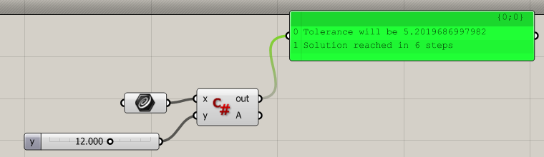
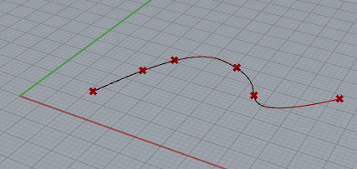

private void RunScript(Curve x, object y, ref object A)
{
// x is curve! y = 12 -> 6 points?

//To find the Curve's endpoints we need to evaluate the extremes of its domain.

//Retrieve Curve's start point
Print(x.Domain.Min.ToString()); // 0 parameter value
Point3d startPoint = x.PointAt(x.Domain.Min);

//Retrieve Curve's end point
Print(x.Domain.Max.ToString()); //74.87 parameter value
Point3d endPoint = x.PointAt(x.Domain.Max);

//Declare a point for the middle point
Point3d mPt;

//set the tolerance to a fraction of the Curve's length
Print(x.GetLength().ToString()); // 64.42 y=12.
double tolerance = x.GetLength() / y;

//Print some info to the user
Print("Tolerance will be {0}", tolerance.ToString()); // 5.20

//initialize a flag to keep the loop running
bool keepOn = true;

//initialize a counter for the number of iterations we perform
int c = 0;

//declare a list to hold our points
List<Point3d> ptList = new List<Point3d>();

//add the start point
ptList.Add(startPoint);

//if the curve is closed we might want to add some more points to ensure we run the subdivison
if(x.IsClosed)
{
Point3d p1 = x.PointAt((x.Domain.Max - x.Domain.Min) * 0.25 + x.Domain.Min); //.25 way along curve
Point3d p2 = x.PointAt((x.Domain.Max - x.Domain.Min) * 0.5 + x.Domain.Min); //.50 way along curve
Point3d p3 = x.PointAt((x.Domain.Max - x.Domain.Min) * 0.75 + x.Domain.Min); //.75 way along curve
ptList.Add(p1); ptList.Add(p2); ptList.Add(p3);
}

ptList.Add(endPoint);//add the actual endpoint - as well.

//Declare a double to hold a parameter
double t = 0;

//Declare a double to hold a distance
double d = 0;

//This loop will keep running until keepOn is false or we reach 100 iterations
while ((keepOn) && (c < 100))
{
//Deactivate the loop by default, we will activate it later if we add a point
keepOn = false;

//Iterate through the list of points
for (int i = 0; i < ptList.Count - 1; i++)
{
//calculate the midpoint using a function
mPt = midPt(ptList[i], ptList[i + 1]);

//Try to find the closest point to mPt on the curve, the function modifies the t number with the parameter
//on x for the closest point and returns a true if successful
bool flag = x.ClosestPoint(mPt, out t); // t returned byref.

//If the closest point is found
if (flag){

//then build a 3D point on the curve at the t parameter
Point3d cPt = x.PointAt(t);

//Retrieve the distance between the closest point and the mid point
d = cPt.DistanceTo(mPt);

//If the distance is bigger than our tolerance...
if (d > tolerance){

//...then insert the point
ptList.Insert(i + 1, cPt);

//Re-activate the loop, as we have added a point
keepOn = true;

//Increase the count to skip the recently added point
i++;

}//End of d>tolerance if
}//End of flag if
}//End of list loop

//Increase the counter and start again
c++;
}

//At the end, output A and print some info
A = ptList;
Print("Solution reached in {0} steps", c + 1);

}

//This function returns the midpoint of two given points
Point3d midPt(Point3d a, Point3d b)
{

return (a + b) / 2;

}
}

- Take the end points of the curve, insert them in order in a list.

- Take the first point in the list and it’s neighbor.

- Build a line with those two points.

- Find the mid point of the line.

- If the distance from the midpoint to the curve is larger than, say, 1/100th of the curve’s length… (curve length about 70 tol abt 5 for y-12).

- Project the midpoint to the curve and insert it in the point list in the right place.

- Move to the next point in the list. If you reach the last one, start again with step 2.

- Keep doing this until you run through all the list once without adding any new point. Then finish.

RhinoCommon:

Point3d[] points;

curve.DivideByCount(5, true, out points);

foreach (var point in points)
doc.Objects.AddPoint(point);

doc.Views.Redraw();

Loads of ways we can divide a curve: see RhinoCommon:

DivideByCount(Int32, Boolean)

DivideByLength(Double, Boolean)

DivideEquidistant

NurbsCurve

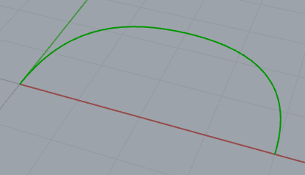

private void RunScript(object x, object y, ref object A)
{
Rhino.Collections.Point3dList points = new Rhino.Collections.Point3dList(5);
points.Add(0, 0, 0);
points.Add(0, 2, 0);
points.Add(2, 3, 0);
points.Add(4, 2, 0);
points.Add(4, 0, 0);

Rhino.Geometry.NurbsCurve nc = Rhino.Geometry.NurbsCurve.Create(false, 3, points);

A = nc;
}

Surface from Corner Points
var surface = NurbsSurface.CreateFromCorners(
new Point3d(5, 0, 0),
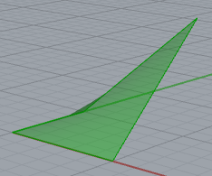
new Point3d(5, 5, 5),
new Point3d(0, 5, 0),
new Point3d(0, 0, 0));

A = surface;

GrasshopperTutorial.pdf in \Grasshopper
VB script

see Willian.sln

Genetic

First a Population is created
pop = new Individual[popNum];
for (int i = 0; i < popNum; i++)

100 Individuals in Population.

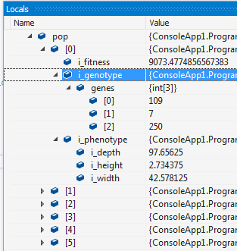

Each Individual has
1. fitness.
2. Genotype
For operations eg mutate.
3.Phenotype
For display)

Each Genotype has an array of 3 genes.

Each Phenotype 3 doubles variable for the height etc of a single box.

(The lower the fitness the better.)

The distinction between Phenotype and Genotype seems pretentious.

For each Individual creation:

public double evaluate()
{
double fitness = 3;
fitness += Math.Pow(i_width + i_height + i_depth, 2);
fitness -= (i_width * i_height * i_depth);
return fitness;
} // WTH is this?

one by one

ie a “fitness” is calculated from the height etc (which is ultimately simply calculated by the gene values!)

Next: p.evolve();

For each element in the Population:

a = selectIndividual();
b = selectIndividual();

dodgey code! double d = rnd.NextDouble();
if ( d < 5) // d will be ALWAYS < 5 !!

public Individual selectIndividual()
{
int which = (int)Math.Floor(((double)popNum - 1e-3) * (1.0 - Math.Pow(rnd.NextDouble(), 2)));
return pop[which]; -> 93

giving a bias towards higher end of the population eg closer to 100?

GA Code: “complete” – actually doesn’t run automatically – yet.

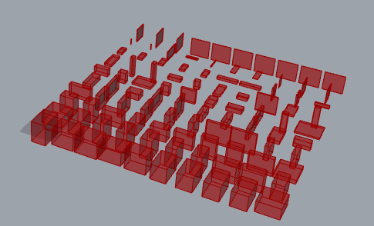

Maybe the task is to get the biggest box at front!
Willian.gh

From Grasshopper

private void RunScript(object x, object y, ref object A)
{
// if(reset||init)
// {
// a = new genotype();
// b = new phenotype(a);
// print(b.evaluate().tostring());

p = new Population();
// init = false;
// reset = false;

p.evolve();

boxes.Clear();

for(int i = 0; i < p.pop.Length; i++)
{
p.pop[i].draw(i);
}

A = boxes;
// }

}

// <Custom additional code>

public class Genotype
{
public int [] genes;

public Genotype()
{
genes = new int [3];
for( int i = 0; i < genes.Length; i++)
{
genes[i] = (int) rnd.Next(256);
}
}

public void mutate()
{
for(int i = 0; i < genes.Length; i++)
{
if(rnd.Next(100) < 5)
{
genes[i] = (int) rnd.Next(256);

}
}
}

}

public static Genotype crossover (Genotype a, Genotype b)
{
Genotype c = new Genotype();

for(int i = 0; i < c.genes.Length; i++)
{
if(rnd.NextDouble() < 5)
{
c.genes[i] = a.genes[i];
}
else
{
c.genes[i] = b.genes[i];
}
}

return c;
}

public class Phenotype
{
public double i_width;
public double i_height;
public double i_depth;

public Phenotype(Genotype g)
{
i_width = g.genes[0] * width / 256;
i_height = g.genes[1] * height / 256;
i_depth = g.genes[2] * width / 256;
}

public void draw(int i)
{
Box box = new Box(
Plane.WorldXY,
new Interval(-i_width / 2, i_width / 2),
new Interval(-i_height / 2, i_height / 2),
new Interval(-i_depth / 2, i_depth / 2));
Transform trans = Transform.Translation(width * (i % numRows), height * (i / numRows), 0);
box.Transform(trans);

boxes.Add(box);
}
public double evaluate()
{
double fitness = 3;
fitness += Math.Pow(i_width + i_height + i_depth, 2);
fitness -= (i_width * i_height * i_depth);
return fitness;
} // WTH is this formula??
}

public class Individual : IComparable
{
public Genotype i_genotype;
public Phenotype i_phenotype;
public double i_fitness;

public Individual()
{
i_genotype = new Genotype();
i_phenotype = new Phenotype(i_genotype); // A phenotype is created based upon the genes of the genotype.
i_fitness = 0;
}
public void draw(int i)
{
i_phenotype.draw(i);
}

public void evaluate()
{
i_fitness = i_phenotype.evaluate();
}

public int CompareTo(Object objI)
{
Individual iToCompare = (Individual) objI;

if (i_fitness < iToCompare.i_fitness)
{
return -1;
}
else if (i_fitness > iToCompare.i_fitness)
{
return 1;
}
return 0;
}
}

public static Individual breed(Individual a, Individual b)
{
Individual c = new Individual();
c.i_genotype = crossover(a.i_genotype, b.i_genotype);
c.i_genotype.mutate();
c.i_phenotype = new Phenotype(c.i_genotype);
return c;
}

public class Population
{
public Individual[] pop;

public Population()
{
pop = new Individual[popNum];
for (int i = 0; i < popNum; i++)
{
pop[i] = new Individual();
pop[i].evaluate(); // Evaluates fitness.
}
}

public void evolve()
{
Individual a, b, x;

for (int i = 0; i < popNum; i++)
{
a = selectIndividual(); // Selects an individual toards the higher end eg 97.
b = selectIndividual(); // ditto
x = breed(a, b);
pop[i] = x;
pop[i].evaluate();
Array.Sort(pop); // Sort in ascending order
}
}
public Individual selectIndividual()
{
int which = (int) Math.Floor(((double) popNum - 1e-3) * (1.0 - Math.Pow(rnd.NextDouble(), 2)));
return pop[which];
}
}

public static Random rnd = new Random();
public static Population p;
//public genotype a;
//public phenotype b;
public static double width = 100.0;
public static double height = 100.0;

public static List<Box> boxes = new List <Box>();

public static bool init = true;

public static int popNum = 100;
public static int numRows = 10;

// </Custom additional code>
}
TODO Make it run continuously

end genetic

Make A Component

First install

https://developer.rhino3d.com/guides/grasshopper/installing-tools-windows/

first
https://developer.rhino3d.com/guides/grasshopper/your-first-component-windows/

actually
https://marketplace.visualstudio.com/items?itemName=McNeel.GrasshopperAssemblyforv6

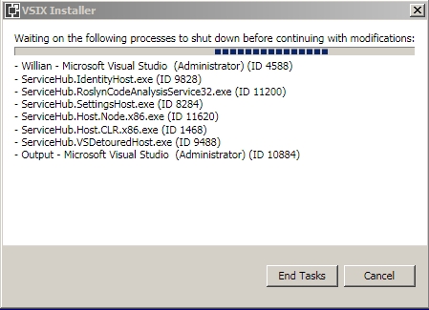

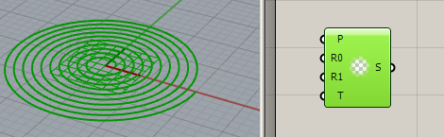

using System;
using System.Collections.Generic;

using Grasshopper.Kernel;
using Rhino.Geometry;

// In order to load the result of this wizard, you will also need to
// add the output bin/ folder of this project to the list of loaded
// folder in Grasshopper.
// You can use the _GrasshopperDeveloperSettings Rhino command for that.

namespace HelloGrasshopper
{
public class HelloGrasshopperComponent : GH_Component
{
/// <summary>
/// Each implementation of GH_Component must provide a public
/// constructor without any arguments.
/// Category represents the Tab in which the component will appear,
/// Subcategory the panel. If you use non-existing tab or panel names,
/// new tabs/panels will automatically be created.
/// </summary>
public HelloGrasshopperComponent()
: base("HelloGrasshopper", "ASpi",
"Construct an Archimedean, or arithmetic, spiral given its radii and number of turns.",
"Curve", "Primitive")
{
}

/// <summary>
/// Registers all the input parameters for this component.
/// </summary>
protected override void RegisterInputParams(GH_Component.GH_InputParamManager pManager)
{
// Use the pManager object to register your input parameters.
// You can often supply default values when creating parameters.
// All parameters must have the correct access type. If you want
// to import lists or trees of values, modify the ParamAccess flag.
pManager.AddPlaneParameter("Plane", "P", "Base plane for spiral", GH_ParamAccess.item, Plane.WorldXY);
pManager.AddNumberParameter("Inner Radius", "R0", "Inner radius for spiral", GH_ParamAccess.item, 1.0);
pManager.AddNumberParameter("Outer Radius", "R1", "Outer radius for spiral", GH_ParamAccess.item, 10.0);
pManager.AddIntegerParameter("Turns", "T", "Number of turns between radii", GH_ParamAccess.item, 10);

// If you want to change properties of certain parameters,
// you can use the pManager instance to access them by index:
//pManager[0].Optional = true;
}

/// <summary>
/// Registers all the output parameters for this component.
/// </summary>
protected override void RegisterOutputParams(GH_Component.GH_OutputParamManager pManager)
{
// Use the pManager object to register your output parameters.
// Output parameters do not have default values, but they too must have the correct access type.
pManager.AddCurveParameter("Spiral", "S", "Spiral curve", GH_ParamAccess.item);

// Sometimes you want to hide a specific parameter from the Rhino preview.
// You can use the HideParameter() method as a quick way:
//pManager.HideParameter(0);
}

/// <summary>
/// This is the method that actually does the work.
/// </summary>
/// <param name="DA">The DA object can be used to retrieve data from input parameters and
/// to store data in output parameters.</param>
protected override void SolveInstance(IGH_DataAccess DA)
{
// First, we need to retrieve all data from the input parameters.
// We'll start by declaring variables and assigning them starting values.
Plane plane = Plane.WorldXY;
double radius0 = 0.0;
double radius1 = 0.0;
int turns = 0;

// Then we need to access the input parameters individually.
// When data cannot be extracted from a parameter, we should abort this method.
if (!DA.GetData(0, ref plane)) return;
if (!DA.GetData(1, ref radius0)) return;
if (!DA.GetData(2, ref radius1)) return;
if (!DA.GetData(3, ref turns)) return;

// We should now validate the data and warn the user if invalid data is supplied.
if (radius0 < 0.0)
{
AddRuntimeMessage(GH_RuntimeMessageLevel.Error, "Inner radius must be bigger than or equal to zero");
return;
}
if (radius1 <= radius0)
{
AddRuntimeMessage(GH_RuntimeMessageLevel.Error, "Outer radius must be bigger than the inner radius");
return;
}
if (turns <= 0)
{
AddRuntimeMessage(GH_RuntimeMessageLevel.Error, "Spiral turn count must be bigger than or equal to one");
return;
}

// We're set to create the spiral now. To keep the size of the SolveInstance() method small,
// The actual functionality will be in a different method:
Curve spiral = CreateSpiral(plane, radius0, radius1, turns);

// Finally assign the spiral to the output parameter.
DA.SetData(0, spiral);
}

private Curve CreateSpiral(Plane plane, double r0, double r1, Int32 turns)
{
Line l0 = new Line(plane.Origin + r0 * plane.XAxis, plane.Origin + r1 * plane.XAxis);
Line l1 = new Line(plane.Origin - r0 * plane.XAxis, plane.Origin - r1 * plane.XAxis);

Point3d[] p0;
Point3d[] p1;

l0.ToNurbsCurve().DivideByCount(turns, true, out p0);
l1.ToNurbsCurve().DivideByCount(turns, true, out p1);

PolyCurve spiral = new PolyCurve();

for (int i = 0; i < p0.Length - 1; i++)
{
Arc arc0 = new Arc(p0[i], plane.YAxis, p1[i + 1]);
Arc arc1 = new Arc(p1[i + 1], -plane.YAxis, p0[i + 1]);

spiral.Append(arc0);
spiral.Append(arc1);
}

return spiral;
}

/// <summary>
/// The Exposure property controls where in the panel a component icon
/// will appear. There are seven possible locations (primary to septenary),
/// each of which can be combined with the GH_Exposure.obscure flag, which
/// ensures the component will only be visible on panel dropdowns.
/// </summary>
public override GH_Exposure Exposure
{
get { return GH_Exposure.primary; }
}

/// <summary>
/// Provides an Icon for every component that will be visible in the User Interface.
/// Icons need to be 24x24 pixels.
/// </summary>
protected override System.Drawing.Bitmap Icon
{
get
{
// You can add image files to your project resources and access them like this:
//return Resources.IconForThisComponent;
return null;
}
}

/// <summary>
/// Each component must have a unique Guid to identify it.
/// It is vital this Guid doesn't change otherwise old ghx files
/// that use the old ID will partially fail during loading.
/// </summary>
public override Guid ComponentGuid
{
get { return new Guid("44ff94e1-882e-40d1-922b-1a097eb0c8a2"); }
}
}
}

RHINO itself

Rhino Tute
https://www.youtube.com/watch?v=oVqO-driekw
too slow rambling german

https://www.youtube.com/watch?v=1p8CX-0jUIk&list=PLsmYGpX9Vfv06ujp-lvW7GuOpE9NuhTP5&index=3&t=0s
not bad bit quicker actually use this
AND do the Rhino official tute:

guids
http://docs.mcneel.com/rhino/5/usersguide/en-us/index.htm

Rhinoceros for Windows
User's Guide

Section 1: Working in 3-D
Introduction
Rhino Objects
Selecting Objects
Navigating Viewports
Accurate Modeling
Create Surfaces from Curves
Edit Curves and Surfaces
Transforms - Move, Copy, Rotate, Scale
Curve and Surface Analysis
Organization and Annotation
Render

Section 2: Tutorials
Pull Toy - Solids and Transforms
Flashlight - Revolve Curves
Headphone - Sweep, Loft, and Extrude
Penguin - Point Editing and Blending
Boat Hull - Loft and Sweep
Dragonfly - Trace Images
Wrap Text - Flow along surface
Mechanical Part - Blocks
Mechanical Part - Layouts
X Y Z!
Gumball.

http://tips.rhino3d.com/search/label/grasshopper%20tutorials
Grasshopper tutes no c# but excellent. Start here! for Grasshopper.

https://developer.rhino3d.com/guides/general/essential-mathematics/

Table of Contents

1. Vector Mathematics
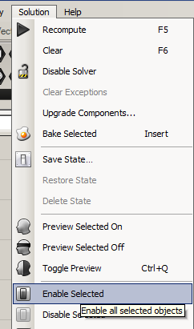
1.1 Vector representation
Position vector
1.5 Tutorials
Face direction Select and then..
2. Matrices and Transformations
3.2 NURBS curves
3.10 Tutorials
Continuity between curves
Surfaces with singularity

And Preview ON
TheEssentialMathematics_3rdEdition.gh (at bottom left)
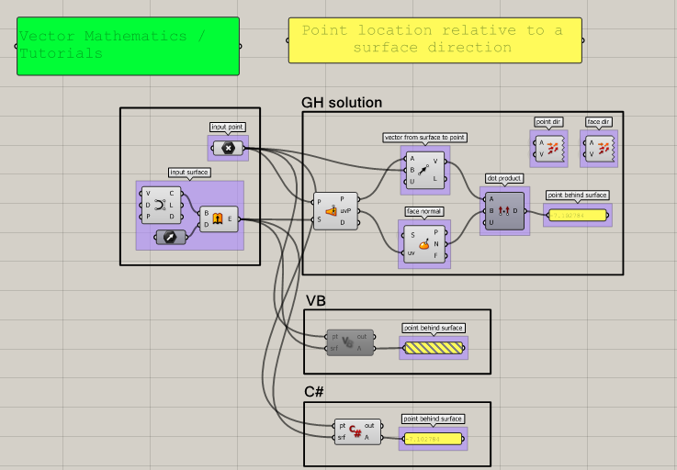

Previews Vectors!

Nurbs Curve

disable

See manual:
1.5 Tutorials
Face direction Ctrl-Alt-click to find which control!!

To Display a vector.

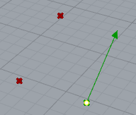
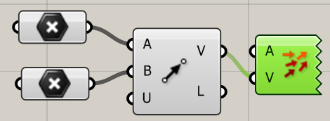

To deal with a Line.
I guess this obviates using A= … to get 3D output.
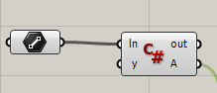

By setting the input to Line YOU will be asked to drag a line.

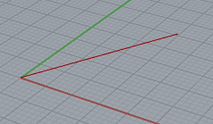

private void RunScript(Line ln, object y, ref object A)
{
eg

Point3d ptA = ln.From;
Point3d ptB = ln.To;
Line Branch1 = new Line(ptA, 2*ptB); // new line to draw.
A = Branch1; // output is a line object.
}

will draw a line (twice as long)

Imp College tute: good place to start! Just grasshopper.

https://blog.ramboll.com/rcd/tutorials/a-beginners-guide-to-visual-scripting-with-grasshopper.html

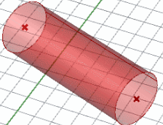

+ Youtubes (Imperial college)
https://www.youtube.com/watch?v=Qqk_c1eBdYo&list=PLaHDu7VE0uzk0KWLCht14nqU42tbj9JVS&index=4&t=0s
ignore first bit
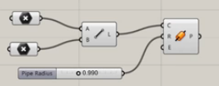

imperial.gh

https://www.youtube.com/watch?v=qYMRECQf85M&list=PLaHDu7VE0uzk0KWLCht14nqU42tbj9JVS&index=10C# scripting slow!
Make sure Preview is on!

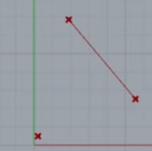

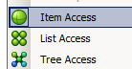

private void RunScript(List<Point3d> x, Point3d y, ref object A)
{
double md =1000000000000;
Point3d c= Point3d.Unset;

foreach(Point3d pt in pt.DistanceTo(B))
{
if (d < md)
{
md = d;
c = pt;
}
}
L = new Line(A, c);
}
Not quite working

Shift Right-click to move in Rhino

Double-click Persective to make that the large viewport.
From the Imperial DP Eng Session 8

linesExpt.gh corrupt nothing
linesExptAutosave crashes all.gh

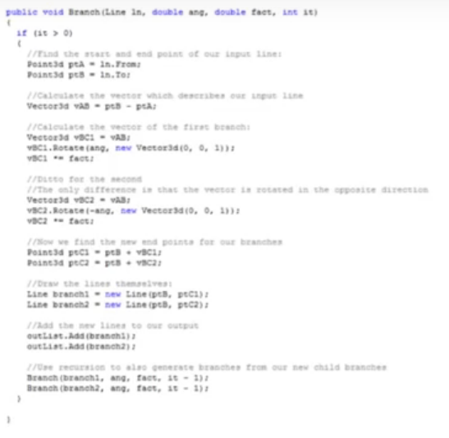
We can add a point to a vector! Result is point.eg ptB = ptA + vBC1;
---------------------------------------------------------------

https://developer.rhino3d.com/samples/

The length of the line between this and the other point; or 0 if any of the points is not valid.
https://developer.rhino3d.com/api/RhinoCommon/html/M_Rhino_Geometry_Point3d_DistanceTo.htm

value list
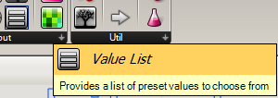
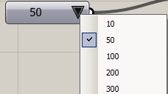

Lesson 02_ Factorial, Recursion,L-System.gh

**************************************************************************

private void RunScript(int scale, int depth, ref object A, ref object B)
{
//this is to set points
Point3d startPt = new Point3d(0, 0, 0);

Vector3d vec = new Vector3d(0, 0, 1); //is a vector that looks up. my starting branch
double len = 7;

Line ln = new Line(startPt, vec, len);

List<Line> lns = new List<Line>();

lns.Add(ln);
// This is to create a list of color
List<System.Drawing.Color> col = new List<System.Drawing.Color>();
col.Add(System.Drawing.Color.FromArgb(0, 0, 0));

initDepth = depth;
//branch function
branch(depth, ln, vec, scale, lns, col);

A = lns;

B = col;
}

// <Custom additional code>

// this is the global variations
Random rnd = new Random();
//int depth = 10;
int initDepth;

//counter as well. its called outside so it starts there
//random need to be called out one because if its in the loop is always going to call the same number every loop

//every time i call the below i am going to substract from depth. its impotant so it doesnt run forever. i set the end
//below is a function
void branch(int depth, Line ln, Vector3d vec, double scale, List<Line> lns, List<System.Drawing.Color> col) //vec needs the direction
{

//the line is going to be scaled

// exit expression is below and its fundamental

if (depth > 0)
{

double angleX = 0;
double angleY = 0;
double angleZ = 0;

//Branch 1
angleX = (double)rnd.Next(-100, 100) * (Math.PI / 4) / 100;
angleZ = (double)rnd.Next(-100, 100) * (Math.PI) / 100;
//random only outputs integers. so to make it more variable i divide by 100 to give a wider range of numbers
//By doing so above we have decimals instead of integers which is what is given by a random number

//Now rotate the vector. and create a new vector vec1 with the new position/angle
Vector3d vec1 = new Vector3d(ln.PointAt(1).X - ln.PointAt(0).X, ln.PointAt(1).Y - ln.PointAt(0).Y, ln.PointAt(1).Z - ln.PointAt(0).Z);
//Rotate the vector

vec1.Rotate(angleZ, Plane.WorldXY.ZAxis);//worlXY gives you the world coordinate system rotating around Z and centre of rotation is the global
vec1.Rotate(angleX, Plane.WorldXY.XAxis);
Line ln1 = new Line(ln.PointAt(1), vec1, ln.Length * scale);
lns.Add(ln1);//branch 1 is completed now. now i need to call the branch within the branch

int RGB = 255 - (int)(255 * ((double)depth / initDepth));
col.Add(System.Drawing.Color.FromArgb(RGB, RGB, RGB));
branch(depth - 1, ln1, vec1, scale, lns, col);//vec1 and lns could be removed if we made sure to specify the coordinates in global variables

//Branch 2

angleY = (double)rnd.Next(-100, 100) * (Math.PI / 4) / 100;
angleZ = (double)rnd.Next(-100, 100) * (Math.PI) / 100;
//random only outputs integers. so to make it more variable i divide by 100 to give a wider range of numbers
//by doing so above we have decimals instead of integers which is what is given by a random number

//now rotate the vector. and create a new vector vec1 with the new position/angle
Vector3d vec2 = new Vector3d(ln.PointAt(1).X - ln.PointAt(0).X, ln.PointAt(1).Y - ln.PointAt(0).Y, ln.PointAt(1).Z - ln.PointAt(0).Z);
//rotate the vector

vec2.Rotate(angleZ, Plane.WorldXY.ZAxis);//worlXY gives ou the world coordinate system rotating around Z and centre of rotation is the global
vec2.Rotate(angleY, Plane.WorldXY.YAxis);
Line ln2 = new Line(ln.PointAt(1), vec1, ln.Length * (scale - 0.1));
lns.Add(ln2);//branch 1 is completed now. now i need to call the branch within the branch

RGB = 255 - (int)(255 * ((double)depth / initDepth));
col.Add(System.Drawing.Color.FromArgb(RGB, RGB, RGB));
branch(depth - 1, ln2, vec2, scale, lns, col);//vec1 and lns could be removed if we made sure to specify the coordinates in global variables
}
}

// </Custom additional code>
}

*********************************************************************
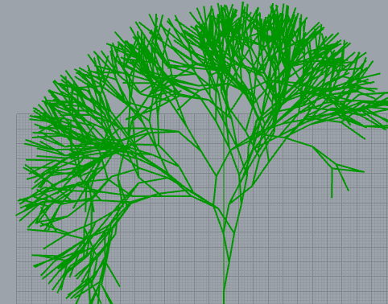

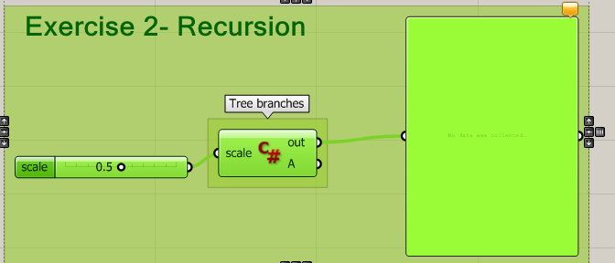

private void RunScript(int scale, ref object A)
{
Point3d startPt = new Point3d(0, 0, 0);

Vector3d vec = new Vector3d(0, 1, 0); //is a vector that looks up. my starting branch
double len = 10;

Line ln = new Line(startPt, vec, len);

List<Line> lns = new List<Line>();

lns.Add(ln);

branch(depth, ln, vec, scale, lns); //branch function

A = lns;
}

Random rnd = new Random();
int depth = 10;

// counter as well. its called outside so it starts there
//random need to be called out one because if it’s in the loop is always going to call the same number every loop

//Every time i call the below i am going to substract from depth. its important so it doesn’t run forever. i set the end

void branch(int depth, Line ln, Vector3d vec, double scale, List<Line> lns) //vec needs the direction
{
//the line is going to be scaled
// exit expression is below and its fundamental

if (depth > 0)
{
double angle = 0;

//Branch 1
angle = (double)rnd.Next(-100, 100) * (Math.PI / 4) / 100;
//random only outputs integers. so to make it more variable i divide by 100 to give a wider range of numbers
//by doing so above we have decimals instead of integers which is what is given by a random number

//now rotate the vector. and create a new vector vec1 with the new position/angle

Vector3d vec1 = new Vector3d(ln.PointAt(1).X - ln.PointAt(0).X, ln.PointAt(1).Y - ln.PointAt(0).Y, ln.PointAt(1).Z - ln.PointAt(0).Z);

//rotate the vector
vec1.Rotate(angle, Plane.WorldXY.ZAxis);//worlXY gives ou the world coordinate system rotating around Z and centre of rotation is the global

Line ln1 = new Line(ln.PointAt(1), vec1, ln.Length * scale);

lns.Add(ln1);//branch 1 is completed now. now i need to call the branch within the branch

branch(depth - 1, ln1, vec1, scale, lns); // vec1 and lns could be removed if we made sure to specify the coordinates in global variables

//Branch 2
angle = (double)rnd.Next(-100, 100) * (Math.PI / 4) / 100;
//random only outputs integers. so to make it more variable i divide by 100 to give a wider range of numbers
//by doing so above we have decimals instead of integers which is what is given by a random number

//now rotate the vector. and create a new vector vec1 with the new position/angle
Vector3d vec2 = new Vector3d(ln.PointAt(1).X - ln.PointAt(0).X, ln.PointAt(1).Y - ln.PointAt(0).Y, ln.PointAt(1).Z - ln.PointAt(0).Z);
//rotate the vector

vec2.Rotate(angle, Plane.WorldXY.ZAxis);//worlXY gives ou the world coordinate system rotating around Z and centre of rotation is the global

Line ln2 = new Line(ln.PointAt(1), vec1, ln.Length * scale);

lns.Add(ln2);//branch 1 is completed now. now i need to call the branch within the branch

branch(depth - 1, ln2, vec2, scale, lns);//vec1 and lns could be removed if we made sure to specify the coordinates in global variables
}
}
}

Make a box and rotate it:
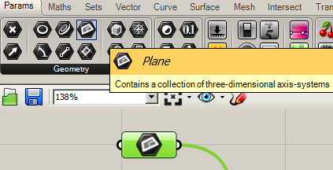

this appears
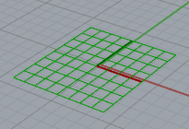

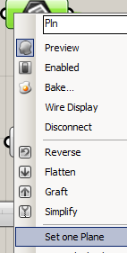

No - Use Surface Rhino!:

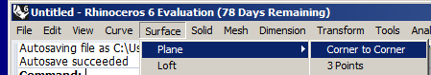

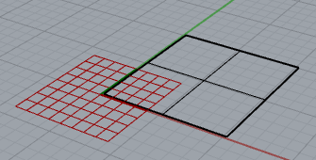

SurfaCE COMPONENT
grasshopper !
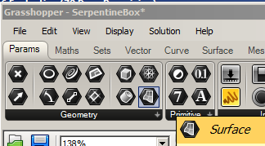
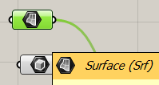

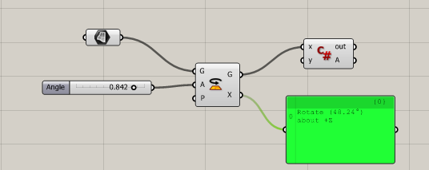
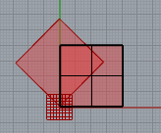

default z axis.

No C# yet Now!
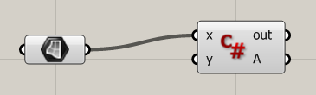

private void RunScript(Surface x, object y, ref object A)
{
// Vector3d vc = new Vector3d(0, 0, 0);
Point3d pt = new Point3d(0, 0, 0);
// Point3d ptR = new Point3d(20, 20, 20);
// x.Rotate(1.5, vc, pt);//doesn’t complain about this but nothing shows! // ByVal ?? Need to make a new vector?? TODO

Transform trans = Transform.Rotation(.5, Vector3d.ZAxis, pt);

x.Transform(trans);

A = x; // Works!
}

http://digitaltoolbox.info/grasshopper-basic/



just grasshopper but looks good
All just grasshopper

range.m

http://digitaltoolbox.info/grasshopper-basic/range-function/
Plot sine curve – needs a pointoutput!

http://digitaltoolbox.info/grasshopper-basic/circle-extrude/

http://digitaltoolbox.info/grasshopper-basic/explode-divide/
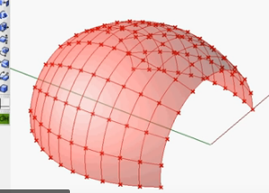

https://www.youtube.com/watch?v=_imC3vFD2JA uv on surface lofted grasshopper only normal

loft.gh but version 5 so difficult to follow the video

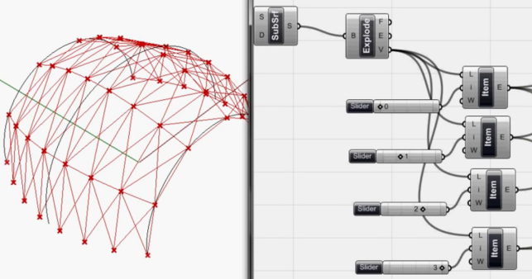

http://digitaltoolbox.info/grasshopper-basic/list-item/

Brep boundary representation

//collision test
var ln = new Line(e[em], centre); //ray
var startpt = new Point3d(ln.PointAt(0.001)); //modify ray so start/end don't intersect
var endpt = new Point3d(ln.PointAt(0.999));
ln.From = startpt;
ln.To = endpt;
Int32[] intersections; //where intersection locations are held
Rhino.Geometry.Intersect.Intersection.MeshLine(r, ln, out intersections);
//calculate emission contribution and add to that receiver
if(intersections == null)
{
//if no intersections, we can assume ray is unimpeded and do our calcs
double contribution = Math.Cos(alpha) / (dist * dist);
rtnvals[f] += Math.Max(contribution, 0);
}
///////////////////////////////////////////////////////
private void RunScript(Curve ln, int x, double angle, ref object A)
{
List<Curve> lines = new List<Curve>();
Int16 i = default(Int16);
for(i = 0; i <= x; i++){
ln.Rotate(angle * i, Vector3d.ZAxis, ln.PointAtEnd);
lines.Insert(i, ln);
}
A = lines;
///////////////////////////////////////////////////////////////////
private void RunScript(Curve ln, int x, double angle, ref object A)
{ List<Curve> lns = new List<Curve>();
Int16 i = default(Int16);
for(i = 0; i <= x; i++){
ln.Rotate(angle * i, Vector3d.ZAxis, ln.PointAtEnd);
lns.Insert(i, ln);
}
A = lns;
}
ie can rotate a point a line a box (brep)
how about a polyline??

eg Box
A brep is one or more surfaces joined together. Boundary Representation.
private void RunScript(Brep x, object y, ref object A)
{
Point3d pt = new Point3d(0, 0, 0);
x.Rotate(0.5,Plane.WorldXY.ZAxis,pt);

A = x;
}

If a brep only contains a single face, then it is the same thing as a surface

Shatter

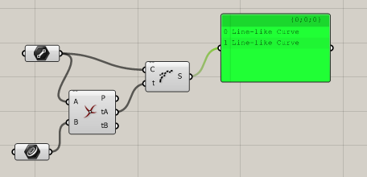
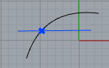

line_scripting.gh

From forum

trim_with_curves.gh

private void RunScript(Curve C1, Curve C2, double T, ref object CurveCurve, ref object Curve_t)
{
// using Rhino.Geometry.Intersect;

var tol = 0.001;

// Intersect Curv 1 with Curve 2:
var isect = Intersection.CurveCurve(C1, C2, tol, tol);

// Trim at t (between 0 and 1)
var t = isect[0].ParameterA;

// White color

// Trim away t with slider
Curve_t = C1.Trim(0.0, T); // Black color

}

Print(C1.GetLength().ToString());
Print(C1.Dimension.ToString()); //3
Print(C1.PointAtStart.X.ToString());

CurveCurve is an object not a curve but
Curve C = (Curve) CurveCurve; is OK ?

Print("t is " + t.ToString());

Reparamerterize the Curve component

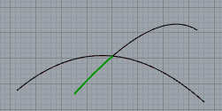

Conclusion: Don’t need to actually TRIM. Use t to reduce the length.
see SerpLatest

----------------------------------

offset to view:

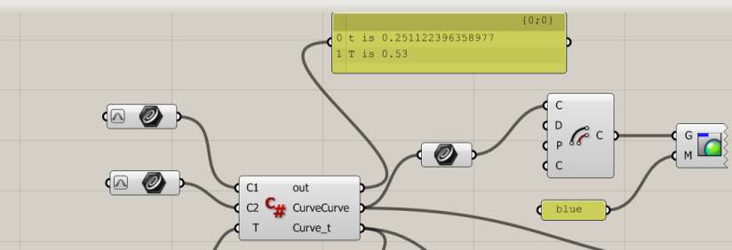

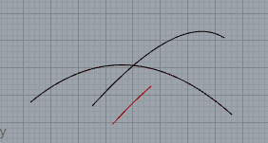

Their (forum) help suggestions:
https://developer.rhino3d.com/5/api/RhinoCommonWin/html/M_Rhino_Geometry_Intersect_Intersection_LineLine.htm just intersect

https://developer.rhino3d.com/5/api/RhinoCommonWin/html/M_Rhino_Geometry_Intersect_Intersection_LineLine_1.htm

---------------------------------------------------------------------

using System;
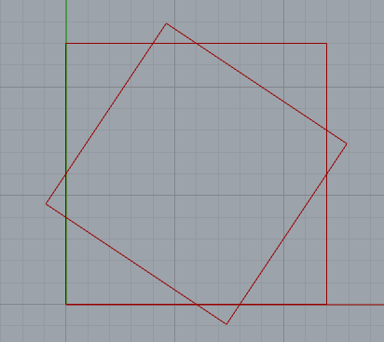
using System.Collections;
using System.Collections.Generic;

using Rhino;
using Rhino.Geometry;

using Grasshopper;
using Grasshopper.Kernel;
using Grasshopper.Kernel.Data;
using Grasshopper.Kernel.Types;

using Rhino.Geometry.Intersect;

private void RunScript(object x, object y, ref object quad, ref object rect)
{
var tol = 0.001 ; double s = 12.0;

List<Line> Rect = new List<Line>();
List<Line> Quad = new List<Line>();

Point3d pt0 = new Point3d(0, 0, 0); // These are the vertices of our original square.
Point3d pt1 = new Point3d(0, s, 0);
Point3d pt2 = new Point3d(s, s, 0);
Point3d pt3 = new Point3d(s, 0, 0);

Line s1 = new Line(pt0, pt1); // These are the 4 sides of our original square.
Line s2 = new Line(pt1, pt2);
Line s3 = new Line(pt2, pt3);
Line s4 = new Line(pt3, pt0);

Rect.Add(s1); // Add the edges to the List.
Rect.Add(s2);
Rect.Add(s3);
Rect.Add(s4);

Line q1 = makeLine(pt0, pt1, pt1, pt2 );
Line q2 = makeLine(pt1, pt2, pt2, pt3 );
Line q3 = makeLine(pt2, pt3, pt3, pt0 );
Line q4 = makeLine(pt3, pt0, pt0, pt1 );

// Need to trim each line.
double t1,t2;

bool rc = Intersection.LineLine(q1, q2, out t1, out t2, tol, true);
q1.Length = q1.Length * t1;
q2.From = q2.PointAt(t2);

rc = Intersection.LineLine(q2, q3, out t1, out t2, tol, true);
q2.Length = q2.Length * t1;
q3.From = q3.PointAt(t2);

rc = Intersection.LineLine(q3, q4, out t1, out t2, tol, true);
q3.Length = q3.Length * t1;
q4.From = q4.PointAt(t2);

rc = Intersection.LineLine(q4, q1, out t1, out t2, tol, true);
q4.Length = q4.Length * t1;
q1.From = q1.PointAt(t2);

//Print("t1 is " + t1.ToString());
//Print("t2 is " + t2.ToString());
//Print("length is " + q1.Length);

Quad.Add(q1); // Add the edges to the List.
Quad.Add(q2);
Quad.Add(q3);
Quad.Add(q4);

rect = Rect; // output line

quad = Quad; // output

}

// <Custom additional code>

Line makeLine(Point3d ptA1, Point3d ptA2, Point3d ptB1, Point3d ptB2)
{
double ta = 0.5; double tb = 1.0 / 3.0; double s = 10.0;

Point3d p1 = divideSegment(ptA1, ptA2, ta);
Point3d p2 = divideSegment(ptB1, ptB2, tb);

Line q1 = new Line(p1, p2); // ie will form(after truncation) the first side of our new quadrilateral.

bool b = q1.Extend(s, s); // extend s units in both directions.

return q1;
}

Point3d divideSegment(Point3d p1, Point3d p2, double t)
{
Point3d p = ((1 - t) * p1 + t * p2);
return p;
}

Autosave folder empty but there are script backups

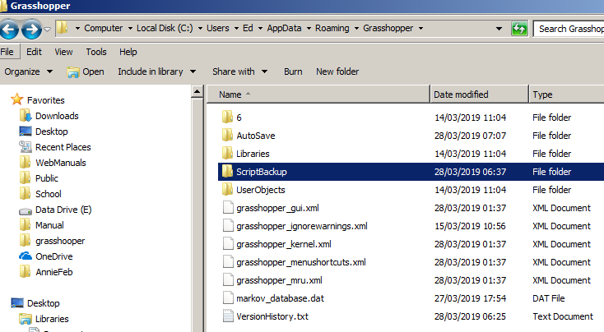

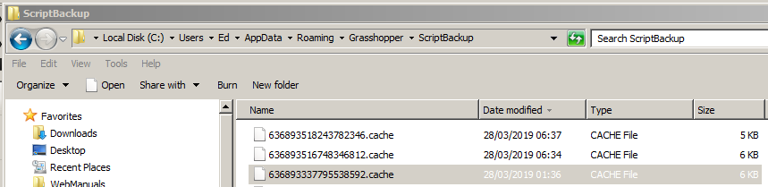

opened with Notepad++

Also Script option on
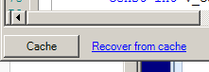

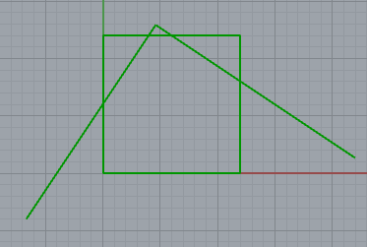

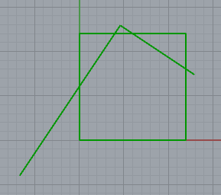

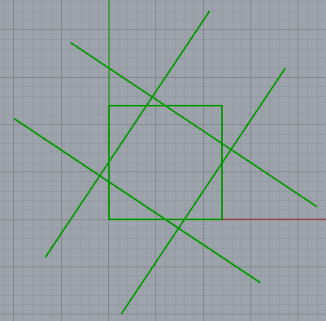

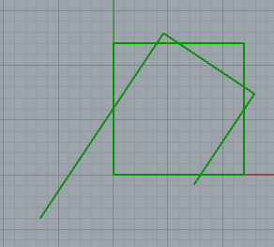

serpLatest.h

using Rhino.Geometry.Intersect;

private void RunScript(object x, object y, ref object rect, ref object quad)
{
var tol = 0.001; double sd = 12.0; double t1,t2; bool rc;

List<Line> Rect = new List<Line>();

List<Line> Quad = new List<Line>();

Point3d[] pt = new Point3d[4]; // vertices

Line[] s = new Line[4]; // sides of square

Line[] q = new Line[4];// sides of new polygons.

pt[0] = new Point3d(0, 0, 0); // These are the vertices of our original square."
pt[1] = new Point3d(0, sd, 0);
pt[2] = new Point3d(sd, sd, 0);
pt[3] = new Point3d(sd, 0, 0);

for (int i = 0 ; i < 4; i++)
{
s[i] = new Line(pt[i], pt[(i + 1) % 4]); // These are the 4 sides of our original square.
Rect.Add(s[i]); // Add the edges to the List.

q[i] = makeLine(pt[i], pt[(i + 1) % 4], pt[(i + 1) % 4], pt[(i + 2) % 4]); // Extended Line q[i] between line segments.
}

//Now need to trim each line.
for (int i = 0; i < 4; i++)
{
rc = Intersection.LineLine(q[i], q[(i + 1) % 4], out t1, out t2, tol, false); // t1,t2 measured form the line start.
q[i].Length = q[i].Length * t1; // Trim the 1st line at the end. (Shorten it.)
q[(i + 1) % 4].From = q[(i + 1) % 4].PointAt(t2); // Trim the 2nd line at the start.(Move its start point up.)

// Quad.Add(q[i]); // Add the edges to the List
}

for (int i = 0; i < 4; i++)
{
Quad.Add(q[i]);
}

rect = Rect; // output line
quad = Quad;

}

// <Custom additional code>

Line makeLine(Point3d ptA1, Point3d ptA2, Point3d ptB1, Point3d ptB2)
{
double ta = 0.5; double tb = 1.0 / 3.0; double sd = 12.0;
Point3d p1 = divideSegment(ptA1, ptA2, ta);
Point3d p2 = divideSegment(ptB1, ptB2, tb);
Line q1 = new Line(p1, p2); // ie will form(after truncation) the first side of our new quadrilateral.
bool b = q1.Extend(sd, sd); // extend s units in both directions.
return q1;
}

Point3d divideSegment(Point3d p1, Point3d p2, double t)
{
Point3d p = ((1 - t) * p1 + t * p2);
return p;
}

}

polyline

Polyline pl2

pl2[0].DistanceTo(pl2[3]);

Polyline pl3 = new Polyline();

pl3.Add(pl2[index]);

pl3.Add(10,10,10)

https://csharp.hotexamples.com/examples/Rhino.Geometry/Polyline/Transform/php-polyline-transform-method-examples.html
loads

Polyline pl2 = new Polyline(pl);
pl2.Transform(Transform.PlaneToPlane(p, Plane.WorldXY))

Rhino.Geometry.BoundingBox box = pl2.BoundingBox;
Polyline pl3 = new Polyline();
pl3.Add(box.Corner(false, false, false));
pl3.Add(box.Corner(false, true, false));
pl3.Add(box.Corner(true, true, false));
pl3.Add(box.Corner(true, false, false));
pl3.Add(box.Corner(false, false, false));

List<Point3d> ls = new List<Point3d>();
ls.Add(new Point3d(1, 0, 0));
ls.Add(new Point3d(0.707, 0.707, 0));
Polyline l1 = new Polyline(ls);

mycode
Point3d[] pt = new Point3d[4]; // vertices
pt[0] = new Point3d(0, 0, 0); // These are the vertices of our original square."
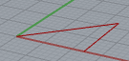
pt[1] = new Point3d(0, sd, 0);
pt[2] = new Point3d(sd, sd, 0);
pt[3] = new Point3d(sd, 0, 0);

List<Point3d> polyList= new List<Point3d>();
polyList.Add(pt[0]);
polyList.Add(pt[2]);
polyList.Add(pt[3]);
polyList.Add(pt[0]);

Polyline P = new Polyline(polyList); // Must be a list of POINTS not eg lines.

A = P;

https://developer.rhino3d.com/api/RhinoCommon/html/T_Rhino_Geometry_Polyline.htm for props and methods

bool b = P.IsClosed;
Print("closed = " + b.ToString() ); -> close = True

List<Point3d> polyList= new List<Point3d>();

polyList.Add(pt[1]);
polyList.Add(pt[2]);
polyList.Add(pt[3]);
polyList.Add(pt[1]);

Polyline P = new Polyline(polyList);// Must be a list of POINTS not eg lines.

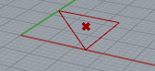
Point3d C = P.CenterPoint();

rect = C; // output line
quad = P;

////////////////////////////////////////////////////////////////////////
Point3d C = P.ClosestPoint(pt[0]);
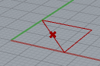

--------------------------------------------------------
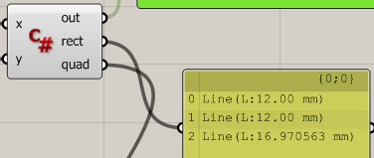
Line[] lin = P.GetSegments();

rect = lin; // output line

……………………………………………………………………………………………………………………………………………………………………………….

PolyLine needs Points so I would need to convert all the line segments to Points! Start again!

TODo put into a function!
Then call it again
recursively?

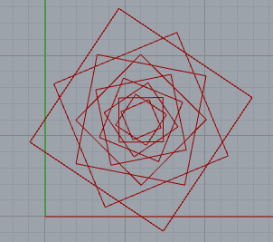

serpLatest4.gh (not centred)

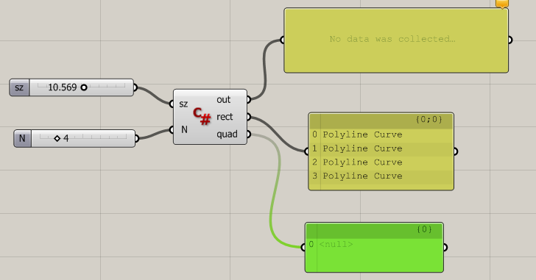

private void RunScript(double sz, int N, ref object rect, ref object quad)
{
//double sz = 12.0; int N = 10; // sz is the length of the square. N is the number of quads to draw.

Point3d[] pts = new Point3d[4]; // An array of 4 points (vertices)for each polygon.

Polyline[] Quads = new Polyline[N]; // N polyline quadrilaterals (to be drawn in one go).

List<Polyline> Polys = new List<Polyline>(); // Aggregate of all the polylines to display in one go.

//++++++++++++++++++++ ORIGINAL SQUARE ++++++++++++++++++

pts[0] = new Point3d(0, 0, 0); pts[1] = new Point3d(0, sz, 0); // These are the 4 vertices

pts[2] = new Point3d(sz, sz, 0); pts[3] = new Point3d(sz, 0, 0); // of our original square.

Quads[0] = myPolyline(pts); // Makes the original square. Quads[0] is the polyline for the square.

// ++++++++++++++++++ CONSTRUCT MANY POLYGONS+++++++++++++++++

for (int i = 1; i < N; i++) // Start with i=1 because Quads[0]is already made.
{
pts = MakeQuadPoints(pts); // New points for old!

Quads[i] = myPolyline(pts); // Get the next Quadrilateral polyline.
}

//+++++++++++++++ ACTUALLY DRAW THE POLYGONS ++++++++++++

for (int i = 0; i < N; i++)
{
Polys.Add(Quads[i]); // Aggregate all of the N Polylines into the LIST Polys.
}

rect = Polys; // Pass the LIST Polylines to the output parameter rect to display.

//+++++++++++++++++++++++++++++++++++++++++++++++++++++++

// quad = // unused.

}

// <Custom additional code>

//++++++++++ Makes one new Polyline quadrilateral ++++++++

Point3d[] MakeQuadPoints(Point3d[] verts) // Returns a set of POINTS (the 4 vertices).
{
// Make 4 lines (lines are necessary for Intersection) and get the 4 ENDPOINTS (of the quadrilateral.

double t1, t2; var tol = 0.001; bool rc; // t1 t2 are line paramters. tol, rc for intersection.

Line[] sd = new Line[4]; // 4 sides of a new polygon

for (int i = 0; i < 4; i++) // Make 4 lines.
{
// Now make extended lines between adjacent line segment pairs.

sd[i] = makeLineExtended(verts[i], verts[(i + 1) % 4], verts[(i + 1) % 4], verts[(i + 2) % 4]);
}

for (int i = 0; i < 4; i++)
{
rc = Intersection.LineLine(sd[i], sd[(i + 1) % 4], out t1, out t2, tol, false); // t1,t2 measured from the line start.

sd[i].Length = sd[i].Length * t1; // Trim each line at the END only using t1. (We dont use t2.)

verts[(i + 1) % 4] = sd[i].To; // verts[1] verts[2] verts[3] verts[0] IN THAT ORDER. sd[0] sd[1] sd[2] sd[3] respectively.
}

return verts;

}
//++++++++++++++++++++ Make one Side ++++++++++++++++++++++

// Makes an extended line between two points p1 and p2.
// p1 and p2 are the respective points on the lines ptA1-ptA2 and ptB1-ptB2.

Line makeLineExtended(Point3d ptA1, Point3d ptA2, Point3d ptB1, Point3d ptB2)
{
double ta = 0.5; double tb = 1.0 / 3.0; double sdExt = 12.0; // sdExt is the extension amount (in both directions).

Point3d p1 = divideSegment(ptA1, ptA2, ta); // Divides between 2 point in a ratio ta: 1-ta.

Point3d p2 = divideSegment(ptB1, ptB2, tb); // Ditto

Line q1 = new Line(p1, p2); // ie Forms(after truncation) the first side of our new quadrilateral.

bool b = q1.Extend(sdExt, sdExt); // Extend the line sdExt units in both directions.

return q1;
}
//++++++++++++++++++++ Divide Points in Ratio +++++++++++++++++++++++++

// Finds the point between 2 points in the given paramter (ratio) t.

Point3d divideSegment(Point3d p1, Point3d p2, double t)
{
Point3d p = ((1 - t) * p1 + t * p2);

return p;
}
//++++++++++++++++++++ Closed Polyline ++++++++++++++++++++++++++++++++

// Make our own Poyline function! to CLOSE the polyline by repeating the first point at the END!

Polyline myPolyline(Point3d[] p)
{
Point3d[] q = new Point3d[5];

for (int i = 0; i < 4; i++)
{
q[i] = p[i];
}
q[4] = p[0]; // Extra closing point.

Polyline Q = new Polyline(q); // Q is now a CLOSED polyline.

return Q;
}
//+++++++++++++++++++++++++++++++++++++++++++++++++++++++++++++++++++++

}

Now make this using c#

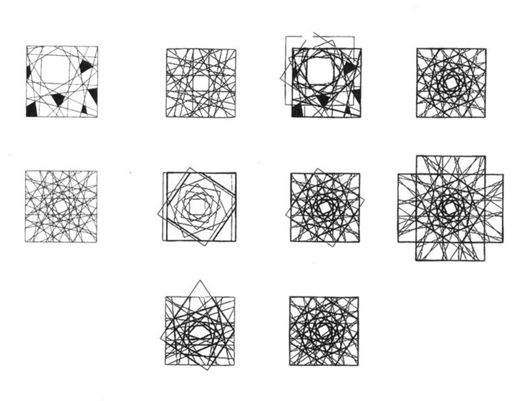

Then We want to fold it in GRASSHOPPER.

Did notice however .cache files in my case located at
C:\Users\Ed\AppData\Roaming\Grasshopper\ScriptBackup
eg 636893337454339077.cache with a time stamp.
I managed to open this text file with NotePad. Its scrambled but editable.
Just thought ID mention it in case its of help to anyone but also I see no reference to these .cache files in these discussions - maybe I missed it.
Not sure if there’s a better way to open these ,cache files rather than NotePad?
David Rutten McNeel
3d
The cached scripts can be loaded from within the script component editors (bottom left).
How did you lose the file? Did it become unreadable? Did it disappear?

Vestartas

http://petrasvestartas.com/C-for-Grasshopper

C:\Users\Ed\AppData\Local\Temp\Definitions.7z\Definitions\

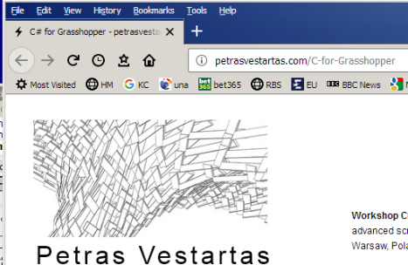
To Preview
Preview & Enable but

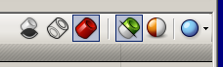

and UnGroup!

look harder on the canvas?

is there another .gh open?

which control of the group has the focus

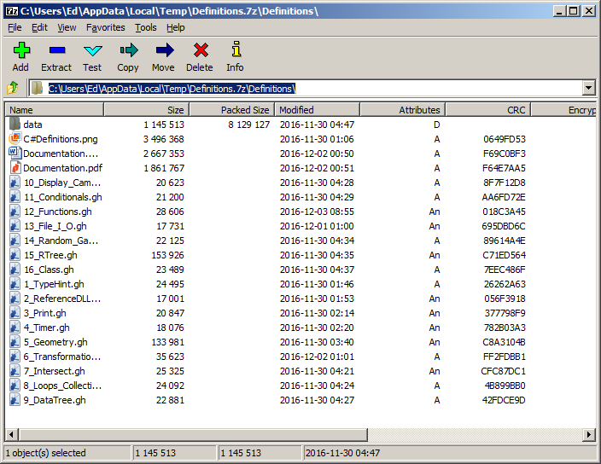

To Prieview – insterad of A= use a Custom? Control (View Vector)
How does he set up eg the Curve Input Parameters? Cant see any curves?

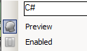

this is Previewed and Enabled!

Make sure its IN VIEW! Shift right-click drag.
Make sure theyre green!
Make sure you’ve got the right script!

Placed in grasshopperC:\Users\Ed\Desktop\grasshooper\vestartis

1-TypeHint Different types Item List Tree

private void RunScript(DataTree<double> x, double y, ref object A)
{
Component.Message = Component.Params.Input[0].Access.ToString();

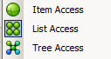

(List<double> x
DataTree<double>

TREE: for(int j = 0; j < x.Branch(i).Count; j++)

Group. Color. Rectangular Outline but still have to enable/Preview each compt! Select All!
2- ReferenceDLL

//Static function, does not require to declare a class each time you want to call a function
A = ClassLibrary1.Class1.currentDate(); ??

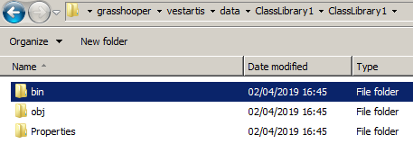
Need to set a reference to ClassLibrary1

See Vestartsas for reference – dll ?

3- Print

Component.ExpireSolution()

if (reset) // The Press button
n = 0;
else if(run){ // The toggle. Should be If?
n++;
Component.ExpireSolution(true);

I think that ExpireSolution means give over to the output ie the Panel

Timer
same thing but timer doesn’t need ExpireSolution

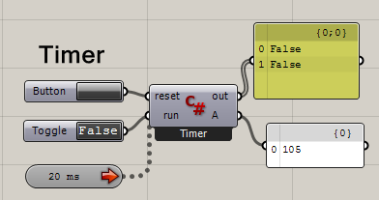

Double-click Boolean Toggle

Click Button to Run. Double-click Toggle.

Drag on Timer

Print(reset.ToString());
Print(run.ToString());

Global variables!
// <Custom additional code>
int n = 0;
// </Custom additional code>

----------------------------------

Makes loads of random meshes

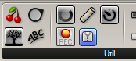
To Draw Text:

C# - > Rectangle component -> Mesh Component.

Branching

4. Timer Same as 3?

5 - Geometry.gh Loads of curves etc. Make good tute!

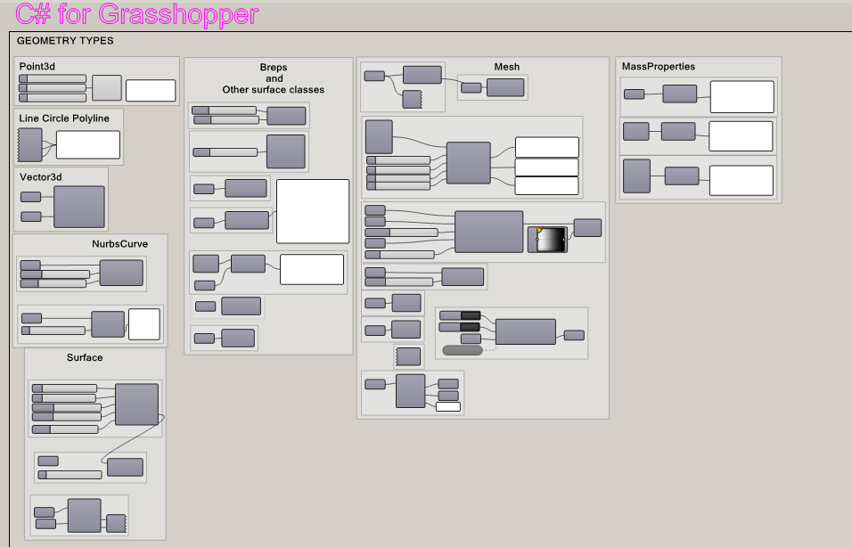

Point3d

Line Circle Polyline

B = new Circle(Plane.WorldXY, 10);

Vector3D

//Move a point by a vector
Point3d movedPoint = Point3d.Origin + v0;
MovedPoint = movedPoint;

NurbsCurve 5

NurbsCurve nc = NurbsCurve.Create(true, degree, CPoints);

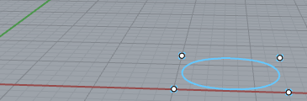

But if we change the weight (same for each Contol Point.)

eg weight = 2.5

nc.Points.SetPoint(index, CPoints[index].X, CPoints[index].Y, CPoints[index].Z, weight);

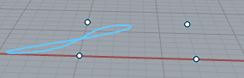

and divide the curve:

//Divide curve
Point3d[] points;
nc.DivideByCount(divisions, true, out points);

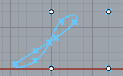

change the degree

//Create nurbs curve
int degree = 1;

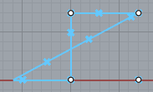

ie straight line segments
Surface(Nurbs) 5

Use this. Return for detail. Divide Surface. Projected curve
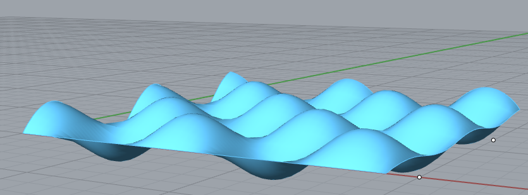

n number of crves
uDegree shape of curve in x dirn vDegree shape of curve in y dirn

//Create surface
NurbsSurface surface = Rhino.Geometry.NurbsSurface.CreateThroughPoints(Pts, n1, n2, uDegree, vDegree, false, false);

//Change control point weight
surface.Points.SetControlPoint(6, 6, new ControlPoint(surface.Points.GetControlPoint(6, 6).Location, weight));

-----------------------------------------------------------------------

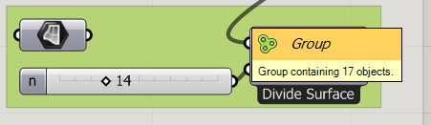

//Take one brep face and convert it to nurbs surface
NurbsSurface ns = brep.Faces[0].ToNurbsSurface();

//Normalize domain
ns.SetDomain(0, new Interval(0, 1));

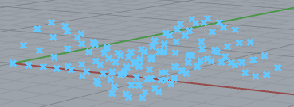

---------------------------------------------------------
//Projected Curve
Curve[] projectedCrv = Curve.ProjectToBrep(Crv, srf.ToBrep(), -Vector3d.ZAxis, 0.01);
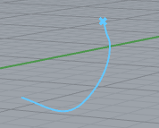

--------------------------------------------------
Breps and Other 5

Brep Corners. counts corners and stuff Loads!

-------------------------------------------------------------
Component.Message = "Cone";
A = new Cone(new Plane(Point3d.Origin, new Vector3d(0, 1, 1)), height, radius);
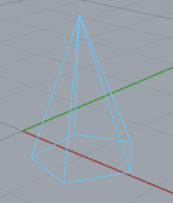

-------------------------------------------------------------
Sphere
Component.Message = "Sphere";
Sphere sphere = new Sphere(Point3d.Origin, radius);
//Get bounding box
BoundingBox bbox = sphere.BoundingBox;
//Find Box center
Point3d center = bbox.Center

-------------------------------------------------------------
Box
Brep brep = Rhino.Geometry.Brep.CreateFromBox(Corners); (Box distorted!)

Print("N of brep.Curves2D = " + brep.Curves2D.Count.ToString());

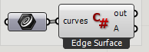

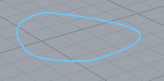

A = Brep.CreateEdgeSurface(curves);

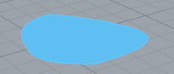

-------------------------------------------------------------

-------------------------------------------------------------

Loft Curve 5

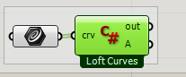

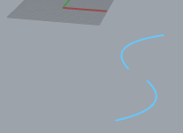

A = Brep.CreateFromLoft(crv, Point3d.Unset, Point3d.Unset, LoftType.Normal, false);

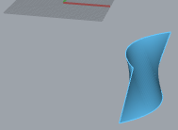

(Well off the screen!)

-------------------------------------------------------------

Point Inside or outside.

BoundingBox bbox = sphere.BoundingBox;

geo.IsPointInside(pt, Rhino.R

Mesh 5 5

Select.

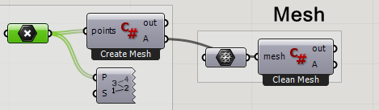

Select to show numbers.

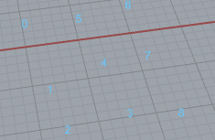
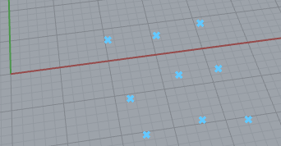

//Initialize mesh
Mesh mesh = new Mesh();

//Add Vertices
mesh.Vertices.AddVertices(points);

//Create faces
mesh.Faces.AddFace(new MeshFace(0, 1, 4, 5)); //anticlockwise
mesh.Faces.AddFace(new MeshFace(1, 2, 3, 4));
mesh.Faces.AddFace(new MeshFace(5, 4, 7, 6));
mesh.Faces.AddFace(new MeshFace(7, 4, 3, 8));

A = mesh;

Creates a planar mesh:

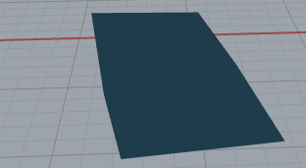

----------------------------------------------------------------------------------------------

----------------------------------------------------------------------------------------------

Clean Mesh 5

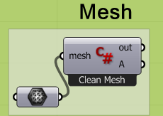

Before:

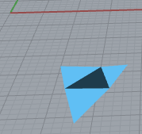

Component.Message = "Clean Mesh";

mesh.Vertices.CombineIdentical(true, true);
mesh.Vertices.CullUnused();
mesh.Weld(3.14159265358979);

mesh.UnifyNormals();
mesh.FaceNormals.ComputeFaceNormals();
mesh.Normals.ComputeNormals();

A = mesh;

After:

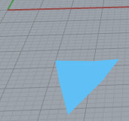

-------------------------------------------------------------------------------------

Deconstruct Mesh 5

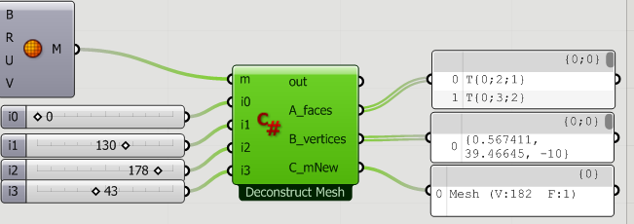

Start with a mesh sphere.

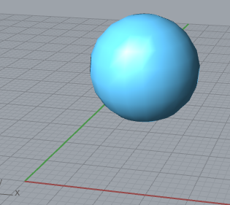

Component.Message = "Deconstruct Mesh";

// 1 Read from existing mesh
// Get faces and vertices from mesh

List<MeshFace> faces = new List<MeshFace>();
List<Point3d> vertices = new List<Point3d>();

foreach(MeshFace i in m.Faces){
faces.Add(i);
}
foreach(Point3d i in m.Vertices){
vertices.Add(i);
}

// 2 Get indexes and coordinates for a 10th mesh face
// First we need to get indexes of each face point
// Second we need to get the Point3d of each Vertex using that index.

int[] indices = new int[4]; // To hold the 4 vetices of on quad mesh.
Point3d[] facePts = new Point3d[4];

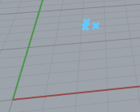
indices[0] = m.Faces[10].A;
indices[0] = m.Faces[10].B; //1 etc?
indices[0] = m.Faces[10].C; // facepoints
indices[0] = m.Faces[10].D;

for (int i = 0; i < 4; i++){
facePts[i] = m.Vertices[indices[i]];// Array of 4 Points
} // facePts not used!

// 3 Now Make a mesh from scratch
Mesh mNew = new Mesh();
mNew.Vertices.AddVertices(vertices);
MeshFace tempFace = new MeshFace(i0, i1, i2, i3);
mNew.Faces.AddFace(tempFace);

//Output
A_faces = faces;
B_vertices = vertices;
C_mNew = mNew;

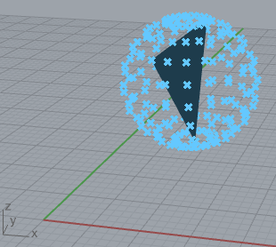

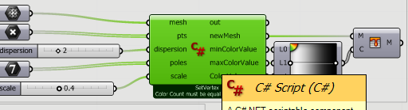

Brep To Box: 5

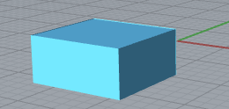

private void RunScript(Brep nurbs, double maxLen, ref object A)
{

Component.Message = "Brep To Mesh";

//From brep to mesh:

Mesh[] mesh; //Array of meshes

//Calling mesh parameters
MeshingParameters mp = new MeshingParameters();
mp.MaximumEdgeLength = maxLen;

//Mesh from brep
mesh = Mesh.CreateFromBrep(nurbs, mp);
//Array to List
List <Mesh> m = mesh.ToList<Mesh>();

//Join mesh:
Mesh joinedMesh = new Mesh();

foreach(Mesh i in m){
joinedMesh.Append(i);
}

A = joinedMesh;

Mesh from Polyline

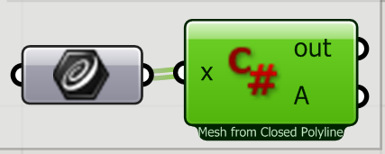

private void RunScript(Polyline x, ref object A)
{
Component.Message = "Mesh from Closed Polyline";
A = Mesh.CreateFromClosedPolyline(x);
}
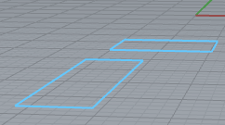
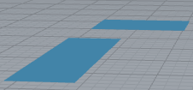

----------------------------------------------------
----------------------------------------------------

Explode Mesh 5

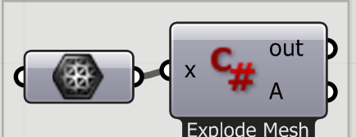

before after
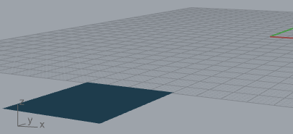
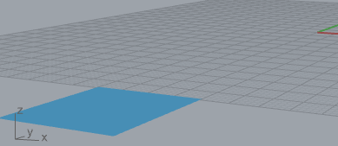

private void RunScript(Mesh x, ref object A)
{
Component.Message = "Explode Mesh";
A = Explode(x);
}
-------------------------------------------------------

Color Vertices

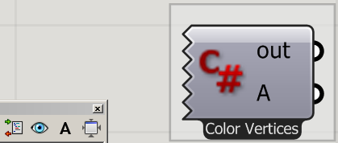

Component.Message = "Color Vertices";

//Declare an empty mesh
Mesh m = new Mesh();

//Create vertices
m.Vertices.Add(10, 10, 0);
m.Vertices.Add(15, 10, 0);
m.Vertices.Add(15, 12, 0);
m.Vertices.Add(10, 12, 0);
m.Vertices.Add(20, 10, 0);
m.Vertices.Add(20, 12, 0);

//Create color list
m.VertexColors.Add(Color.Red);
m.VertexColors.Add(Color.Yellow);
m.VertexColors.Add(Color.Yellow);
m.VertexColors.Add(Color.Red);
m.VertexColors.Add(Color.Black);
m.VertexColors.Add(Color.Black);

//Create faces using vertex indeces
m.Faces.AddFace(0, 1, 2, 3);
m.Faces.AddFace(1, 4, 5, 2);

//Output
A = m;
Naked Vetices:

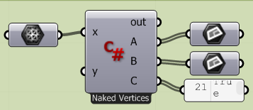

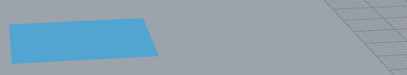

private void RunScript(Mesh x, List<object> y, ref object A, ref object B, ref object C)
{
//Naked points as boolean
bool[] nakedPtsB = x.GetNakedEdgePointStatus();

//Mesh planes
List<Plane> nakedPlane = new List<Plane>();

List<Plane> clothedPlane = new List<Plane>();

//Add mesh planes to nakedPlane / clothedPlane List

for (int i = 0; i < nakedPtsB.Length; i++){

Plane pl = new Plane(x.Vertices[i], x.Normals[i]);

if (nakedPtsB[i] == true){
nakedPlane.Add(pl);
} else{
clothedPlane.Add(pl);
}
}
//Output
A = nakedPlane;
B = clothedPlane;
C = nakedPtsB;
}
}

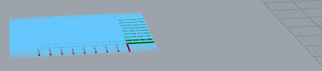

--------------------------------------------

Set Vertex Colours 5

private void RunScript(bool dontStopPressing, bool reset, Mesh meshPlane, ref object A)
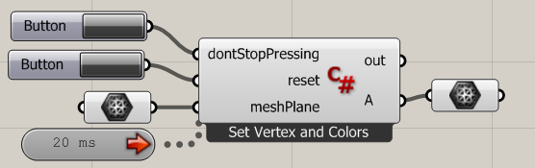
{
//Timer
_counter++;

//Button actions
if(dontStopPressing){
_counterAll.Add(_counter);
}

if(reset){
_counterAll.Clear();
_counter = 0;
//List of distances between mesh vertices and Point3d
CalcDistances(meshPlane, new Point3d(0, 0, 0));
}

//Mesh colours
meshPlane.VertexColors.Clear();
int i = 0;

foreach(var v in meshPlane.Vertices){
bool colorize = false;
//Looping through All counters
foreach(var c in _counterAll){
if (_counter == (c + (int) (distances[i]) )){
colorize = true;
}
}
//Change color and move up
if(colorize){
meshPlane.VertexColors.Add(Color.White);
meshPlane.Vertices.SetVertex(i, meshPlane.Vertices[i].X, meshPlane.Vertices[i].Y, 10);
} else {
meshPlane.VertexColors.Add(Color.Black);
meshPlane.Vertices.SetVertex(i, meshPlane.Vertices[i].X, meshPlane.Vertices[i].Y, 0);
}// end of colorize
i++;
}
//Output
A = meshPlane;
}
//Timer
int _counter = 0;
List<int> _counterAll = new List<int>();

//Speed up calculation
List<double> distances = new List<double>();

public void CalcDistances(Mesh m, Point3d pt){
distances.Clear();
foreach(var v in m.Vertices){
distances.Add(pt.DistanceTo(v));
}
}
Mass 5

--------------------------------------------------------

private void RunScript(Curve geo, ref object A)
{

AreaMassProperties amp = AreaMassProperties.Compute(geo);

Print("Area: " + amp.Area.ToString());

--------------------------------------------------------
private void RunScript(Brep geo, ref object B)
{

Component.Message = "VolumeMassProperties";

VolumeMassProperties vmp = VolumeMassProperties.Compute(geo);

Print("Volume: " + vmp.Volume);

B = vmp.Centroid;

private void RunScript(Mesh geo, ref object B)
{

Component.Message = "VolumeMassProperties";

VolumeMassProperties vmp = VolumeMassProperties.Compute(geo);

Print("Volume: " + vmp.Volume);

B = vmp.Centroid;

-------------------------------------------------------------------

6 - Transformations
Turn Preview on for all and just make sure c# component you want has the focus! Just give it the focus!

Point3d

Component.Message = "Transform point by: \r\n Transform matrix \r\n adding vector \r\n adding other point";
pt.Transform(Transform.Translation(Vector3d.ZAxis)); //Transform matrix
/// moves it up one unit.
pt += Vector3d.ZAxis; //Add a vector
/// moves it up one unit. Another method.
pt += new Point3d(0, 0, 1); //Add a point
/// moves it up one unit. Another method.
A = pt;

Line

//Line is a struct so copy lines is simple like this
Line newLine = line;
newLine.Transform(Transform.Scale(newLine.PointAt(0.5), factor));
Scales it from its midpoint.
-------------------------------
Ellipse

Lofts an ellipse. ie uses a loop to draw more of them.

private void RunScript(double X, double R, double N, ref object A, ref object B)// X determines the spacing.

for(double i = 0; i < 0.1 * N ; i += 0.1){ // N : No of ellipses.
Ellipse c = new Ellipse(Plane.WorldXY, (i + 2) / 1.5, (i + 2));

var nurbs = c.ToNurbsCurve(); // Cant rotate just an ellipse?

nurbs.Rotate(R * i, Vector3d.YAxis, new Point3d(X, 0, 0));
// Apply Rotate directly. X is centre of rotation.

cList.Add(nurbs);

var f = Rhino.Geometry.AreaMassProperties.Compute(nurbs).Centroid;
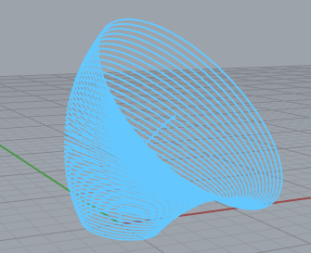
pList.Add(f); // for demo. Shows the "centre line"

Rotate Method
angleRadians
Type: System.Double
Angle of rotation in radians.
rotationAxis
Type: Rhino.Geometry.Vector3d
Direction of the axis of rotation.
rotationCenter
Type: Rhino.Geometry.Point3d
Point on the axis of rotation.

After running the code make sure the component has the focus.

Curve 6

Scale Rotate & Move a Curve

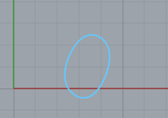
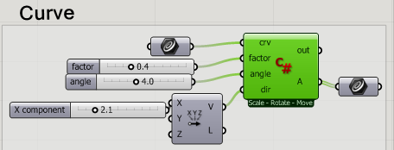

original curve:

//Scale
Curve Scrv = crv A = L1 ; (); // Make another curve

Scrv.Transform(Transform.Scale(Point3d.Origin, factor));
curves.Add(Scrv);
A = curves;

//Rotate
Curve Rcrv = crv.DuplicateCurve();
Rcrv.Rotate(angle, Vector3d.ZAxis, crv.PointAt(0.5));
curves.Add(Rcrv);

//Move
Curve Mcrv = crv.DuplicateCurve();
Mcrv.Translate(dir);
curves.Add(Mcrv);

Transform the CURVE not a NURBS.

Curve contd (lower one) Move rectangle along a profile curve and lt.

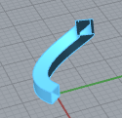
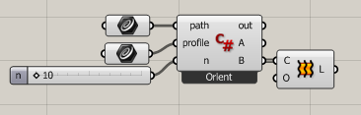

profile is a Polyline rectangle.

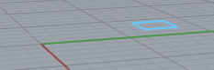

//Get PLANE of the profile curve
Plane basePlane = new Plane(profile.GetBoundingBox(false).Center, Vector3d.ZAxis);

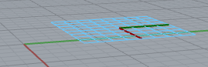

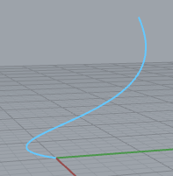

path is the profile curve

I guess this resets the t value:

//Normalized curve
path.Domain = new Interval(0, 1);

This makes planes perpndicualr to the above curve
Plane plane;
path.PerpendicularFrameAt((double) i / n, out plane);
perFrames.Add(plane);

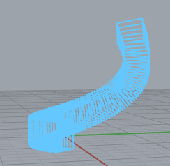
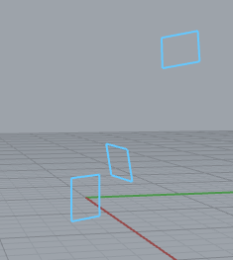
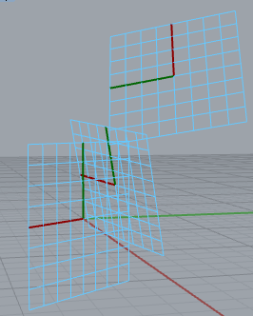

Draw the curves (profile) on these planes.

//Copy a curve and orient it to path
Curve newCurve = profile.DuplicateCurve();
newCurve.Transform(Transform.PlaneToPlane(basePlane, plane));

-----------------------------------------------------
Surface 6 of cyliners and cones!

private void RunScript(Surface srf, List<Brep> breps, int n, ref object A, ref object B)
{
srf.SetDomain(0, new Interval(0, 1));
srf.SetDomain(1, new Interval(0, 1));

List<Plane> planes = new List<Plane>();
List<Plane> orientplanes = new List<Plane>();
List<Brep> objects = new List<Brep>();

//Get orientation planes
foreach(Brep b in breps){
Point3d pointCenter = b.GetBoundingBox(true).Center;
Point3d pointLowest = b.GetBoundingBox(true).Min;
Point3d pointLowCen = new Point3d(pointCenter.X, pointCenter.Y, pointLowest.Z);
orientplanes.Add(new Plane(pointLowCen, Vector3d.ZAxis));
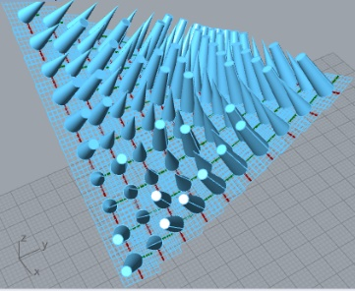
}

Random random = new Random();

//Divide and orient

for(int i = 0; i < n; i++){
for(int j = 0; j < n; j++){

//Get Planes
Plane plane;
srf.FrameAt((double) i / n, (double) j / n, out plane);
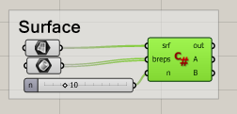
planes.Add(plane);

//Orient breps
switch(random.Next(0, 2)){

case 0:
Brep newBrep = breps[0].DuplicateBrep();
newBrep.Transform(Transform.PlaneToPlane(orientplanes[0], plane));
objects.Add(newBrep);
break;

case 2:
newBrep = breps[2].DuplicateBrep();
newBrep.Transform(Transform.PlaneToPlane(orientplanes[2], plane));
objects.Add(newBrep);
break;

default:
newBrep = breps[1].DuplicateBrep();
newBrep.Transform(Transform.PlaneToPlane(orientplanes[1], plane));
objects.Add(newBrep);
break;
}
}
}
A = planes; B = objects;
}

----------------------------------------------------

Brep 6

Get faces (Move them out to “explode”

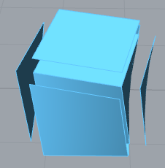
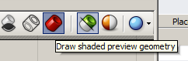

Click to see shaded oject.

Point3d pt = brep.GetBoundingBox(false).Center;

faces[i].Translate(dir);

----------------------------------------------------

Mesh 6

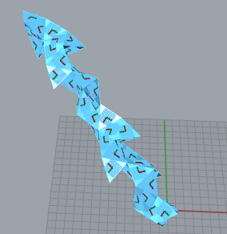

Mesh tile = mesh.DuplicateMesh();

7 - Intersect

private void RunScript(Line line, Plane plane, Surface sphere, Circle circle, ref object A, ref object B, ref object C)

//Line - Sphere
Rhino.Geometry.Intersect.Intersection.LineSphere(line, s, out pts[0], out pts[1]);
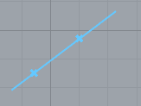

//Plane Sphere
Circle c;
Rhino.Geometry.Intersect.Intersection.PlaneSphere(plane, s, out c);

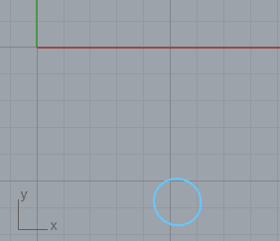

//Curve - Curve
Rhino.Geometry.Intersect.CurveIntersections ie = Rhino.Geometry.Intersect.Intersection.CurveCurve(line.ToNurbsCurve(), circle.ToNurbsCurve(), Rhino.RhinoDoc.ActiveDoc.ModelAbsoluteTolerance, 0.05);
List<Point3d> points = new List<Point3d>();

meshes 7

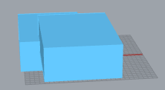

A = Mesh.CreateBooleanUnion(meshes);
B = Mesh.CreateBooleanDifference(new Mesh[]{meshes[0]}, new Mesh[]{meshes[1]});
C = Mesh.CreateBooleanIntersection(new Mesh[]{meshes[0]}, new Mesh[]{meshes[1]});
--------------------------------------------------

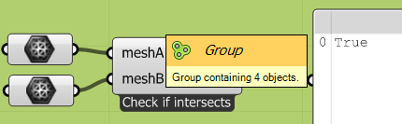

Note use of class:

A = Utilities.IsInsideSimpleMesh(meshA, meshB);

class Utilities
{
public static bool IsInsideSimpleMesh (Mesh meshA, Mesh meshB)

~~~~~~~~~~~

meshA.FaceNormals.ComputeFaceNormals();

AddtionalMath.DotProduct etc

~~~~~~~~~~~
7-
Component.Message = "Geometry Intersections";

//Line Sphere
Point3d[] pts = new Point3d[2];
Sphere s;
sphere.TryGetSphere(out s);
Rhino.Geometry.Intersect.Intersection.LineSphere(line, s, out pts[0], out pts[1]);

//Plane Sphere
Circle c;
Rhino.Geometry.Intersect.Intersection.PlaneSphere(plane, s, out c);

//Curve Curve
Rhino.Geometry.Intersect.CurveIntersections ie = Rhino.Geometry.Intersect.Intersection.CurveCurve(line.ToNurbsCurve(), circle.ToNurbsCurve(), Rhino.RhinoDoc.ActiveDoc.ModelAbsoluteTolerance, 0.05);
List<Point3d> points = new List<Point3d>();

//Collect start points
for(int i = 0; i < ie.Count; i++){
points.Add(ie[i].PointA);
}

A = pts;
B = c;
C = points;
---------------------------------------------------------------------
Component.Message = "Mesh union/intersection/difference";

A = Mesh.CreateBooleanUnion(meshes);
B = Mesh.CreateBooleanDifference(new Mesh[]{meshes[0]}, new Mesh[]{meshes[1]});
C = Mesh.CreateBooleanIntersection(new Mesh[]{meshes[0]}, new Mesh[]{meshes[1]});

Component.Message = "Check if intersects";

A = Utilities.IsInsideSimpleMesh(meshA, meshB);

}

// <Custom additional code>

class Utilities
{
public static bool IsInsideSimpleMesh (Mesh meshA, Mesh meshB)
{
if (meshA == null) throw new ArgumentNullException("meshA");
if (meshB == null) throw new ArgumentNullException("meshB");

meshA.FaceNormals.ComputeFaceNormals();

for (int i = 0; i < meshB.Vertices.Count; i++)
{
bool isInside = true;

for (int j = 0; j < meshA.FaceNormals.Count; j++)
{
Vector3d vec = meshB.Vertices[i] - meshA.Faces.GetFaceCenter(j);

if (AddtionalMath.DotProduct(meshA.FaceNormals[j], vec, true) > -Rhino.RhinoDoc.ActiveDoc.ModelAbsoluteTolerance)
{
isInside = false;
break;
}
}

if (isInside)
return true;
}
return false;

}
}
class AddtionalMath
{
public static float DotProduct(Vector3f a, Vector3f b, bool unitize)
{
if (unitize) {a.Unitize();b.Unitize();}
return (a.X * b.X) + (a.Y * b.Y) + (a.Z * b.Z);
}
public static double DotProduct(Vector3d a, Vector3d b, bool unitize)
{
if (unitize) {a.Unitize();b.Unitize();}
return (a.X * b.X) + (a.Y * b.Y) + (a.Z * b.Z);
}
}
---------------------------------------------------------------------------

8-Loops & Collections
//List of numbers
List<int> numbers = new List<int> ();

for (int i = 0 ; i < 3; i++){
numbers.Add(i);
Basic exercise.
}

A = numbers;

//List of points
List <Point3d> pts = new List<Point3d>();
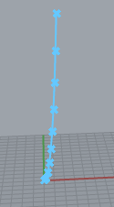
for (int i = 0; i < 10; i++){
Point3d temPt = new Point3d(i, 0, Math.Pow(i, 2));
pts.Add(temPt);
}

B = pts;

//list.AddRange(); Adds two list together but it list must be equal time

PolylineCurve pl = new PolylineCurve(pts);

C = pl;

for
Maybe start here.!
For Each
While
Array of arrays

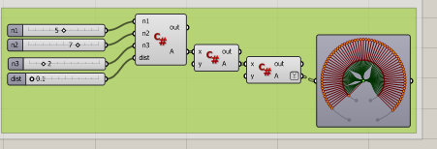
8-

private void RunScript(int n1, int n2, int n3, double dist, ref object A)
{
Component.Message = "3D array of Points ";

Point3d[][][] points = new Point3d[n1][][];

for (int i = 0; i < n1 ; i++){
points[i] = new Point3d[n2 * i][];
for(int j = 0; j < n2 * i; j++){
points[i][j] = new Point3d[j * n3];
for(int k = 0; k < j * n3; k++)
points[i][j][k] = new Point3d((double) i * dist, (double) j * dist, (double) k * dist);
}
}
A = points;
*********************
private void RunScript(object x, object y, ref object A)
{
A = x;
}

9.Data Tree

Component.Message = "Create DataTree";

DataTree<Point3d> points = new DataTree<Point3d>();

for (int i = 0; i < n ; i++)
for(int j = 0; j < n; j++)
for(int k = 0; k < n; k++)
points.Add(new Point3d(i * dist, j * dist, k * dist), new GH_Path(i, j));

A = points;
Component.Message = "Loop through DataTree";

for(int i = 0 ; i < x.BranchCount; i++) //Loop through all branches
for(int j = 0; j < x.Branch(i).Count; j++) //Loop through specific branch items
x.Branch(i)[j] += y;

A = x;
----------------------------------------------------------------------

10 Display Camera

private void RunScript(int n1, int n2, int n3, double dist, ref object A)
{
Component.Message = "PointCloud Display";

PointCloud pointCloud = new PointCloud();

for (int i = 0; i < n1 ; i++)
for(int j = 0; j < n2; j++)
for(int k = 0; k < n3; k++)
pointCloud.Add(new Point3d(i * dist, j * dist, k * dist), Color.FromArgb(i * 2 % 255, j * 2 % 255, k * 2 % 255));

_pointCloud = pointCloud;

}

// <Custom additional code>
PointCloud _pointCloud = new PointCloud();

public override BoundingBox ClippingBox
{
get { return _pointCloud.GetBoundingBox(false);}
}

public override void DrawViewportMeshes(IGH_PreviewArgs args){
args.Display.DrawPointCloud(_pointCloud, 5);
}

private void RunScript(bool run, ref object location, ref object target, ref object lens, ref object direction)
{
Component.Message = "Get Camera";

if(run){
//Get camera
//Get current viewport
vp = doc.Views.ActiveView.ActiveViewport;
//save camera location and camera target
location = vp.CameraLocation;
target = vp.CameraTarget;
lens = vp.Camera35mmLensLength;
direction = vp.CameraUp;
}
}

// <Custom additional code>
Rhino.Display.RhinoViewport vp; //use to get and set rhino camera properties

// </Custom additional code>
}

private void RunScript(Point3d location, Point3d target, double lens, bool run)
{
Component.Message = "Set Camera";
if (run){
//Get current viewport
vp = Rhino.RhinoDoc.ActiveDoc.Views.ActiveView.ActiveViewport;
//Set new camera
vp.SetCameraLocations(target, location);
vp.ChangeToPerspectiveProjection(true, lens);
}
}
// <Custom additional code>
//To get and set camera properties
Rhino.Display.RhinoViewport vp;
// </Custom additional code>
}
---------------------------------------------------------------------

11 Conditionals

If
Switch
Conditional

12 Functions

DoStuff();

int a = AddNumbers(1, 2);

-----------------------------------------
generalization of t formula?
return d2A + (d2B - d2A) * ((v1 - d1A) / (d1B - d1A));

------------------------------------------------

recursive: 12
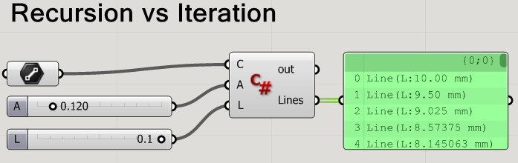

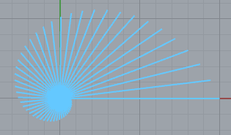
Starting line C:

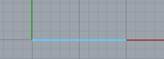

private void RunScript(Line C, double A, double L, ref object Lines)
{
//Declare all lines A is angle in radian L is minLength
allLines = new List<Line>(){C}; // Ready to store all the lines.

//Call the Recursive function
DivideAndRotate(C, A, L);

//Assign return value
Lines = allLines; // output
}

List<Line> allLines = new List<Line>();

void DivideAndRotate(Line line, double angle, double minLength){

if(line.Length > minLength){

//Take portion of the line
Line newLine = line;
Point3d endPt = newLine.PointAt(0.95); // ie reduce in size.

//Change lines end point ie shorten the line.
newLine.To = endPt;

//Rotate as well:
newLine.Transform(Transform.Rotation(angle, Vector3d.ZAxis, line.From)); // Rotates abt start pt - abt the z axis.

//Add to line list
allLines.Add(newLine);

//Recursion happens here:
DivideAndRotate(newLine, angle, minLength);
}
}

next on doesn’t use recursion does the same thing.
//Check the stopping condition
while (allLines.Last().Length > L)
allLines.Add(DivideAndRotate(allLines.Last(), A));

Subdivision
12
private void RunScript(int generations, double height, Polyline tri, ref object A)
{
Component.Message = "Subdivision";

List < Polyline > a = subdivide(tri, height);
List < Polyline > b = new List<Polyline>();

for(int i = 0; i < generations; i++){

b.Clear();

for(int j = 0; j < a.Count; j++)
b.AddRange(subdivide(a[j], height));

a = new List<Polyline>(b);
}

A = a;
}

List<Polyline> subdivide(Polyline triangle, double height){

Line[] segments = triangle.GetSegments();

//Finding normal
Vector3d normal = Vector3d.CrossProduct(segments[0].Direction, segments[1].Direction);
normal.Unitize();
normal *= height;

//Create Middle points
List<Point3d> midPts = new List<Point3d>();

foreach(Line s in segments){
Vector3d m = (Vector3d) (s.PointAt(0.5));
m += normal;
midPts.Add((Point3d) m);
}

//Draw Triangles
Polyline a = new Polyline(new List<Point3d>{segments[0].From, midPts[0], midPts[2],segments[0].From});
Polyline b = new Polyline(new List<Point3d>{midPts[0], segments[1].From, midPts[1],midPts[0]});
Polyline c = new Polyline(new List<Point3d>{midPts[2], midPts[1], segments[2].From,midPts[2]});
Polyline d = new Polyline(new List<Point3d>{midPts[0], midPts[1], midPts[2],midPts[0]});

return new List<Polyline>{a,b,c,d};
}
cant quite work it. is this just the triangle sub div elsewhere?
-----------------------------------------------------

------------------------------------
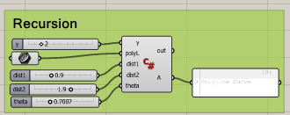

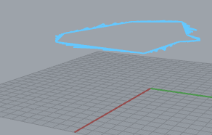

sierpinski division

-------------------------------------

13 FileIO
private void RunScript(string path, ref object A)
{

//Check if files exists
if(!System.IO.File.Exists(path)){
Print("Exit without reading");
return;
}

//Read the file
string[] lines = System.IO.File.ReadAllLines(path);

//Check if the file is not empty
if(lines.Length == 0){
Print("Files has no content");
return;
}

//Declare a list of points
var points = new List<Point3d>();

//Loop through lines
foreach(string line in lines){
//Tokenize line into array of strings separated by ","
string[] parts = line.Split(",".ToCharArray());
//Make sure that each line has exactly 3 values
if(parts.Length != 3)
continue;

//Convert each coordinate from string to double
double x = Convert.ToDouble(parts[0]);
double y = Convert.ToDouble(parts[1]);
double z = Convert.ToDouble(parts[2]);

points.Add(new Point3d(x, y, z));
}

A = points;

}
------------------------------------------------------------------

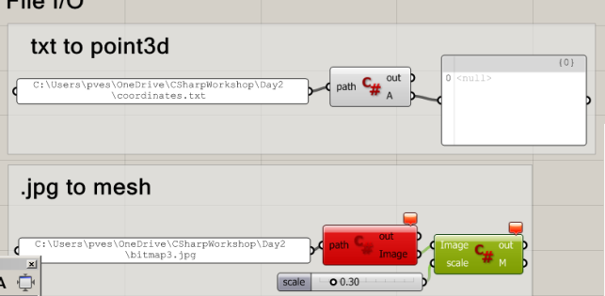

14-

14 GuassianNoise

double dist = SimplexNoise.Noise.Generate(Convert.ToSingle(xOff), Convert.ToSingle(yOff), Convert.ToSingle(zOff))

15 RTree

private void RunScript(List<Line> lineList, double radius, int item, ref object A, ref object B)
{

Component.Message = "RTee";

lineList2 = lineList;
cl.Clear();
ci.Clear();

RTree tree = new RTree();

for(int i = 0; i < lineList.Count; i++)
tree.Insert(lineList[i].PointAt(0.5), i);

tree.Search(new Sphere(lineList[item].PointAt(0.5), radius), method);

A = cl;
B = ci;

}

// <Custom additional code>
List<Line> cl = new List<Line>();
List<int> ci = new List<int>();
List<Line> lineList2 = new List<Line>();

private void method(object sender, RTreeEventArgs e){
cl.Add(lineList2[e.Id]);
ci.Add(e.Id);
}

// </Custom additional code>
}

16 Class.gh

Walker
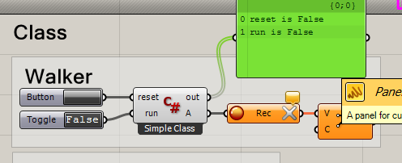
Produces random walk (as per chap .. but uses classes.

Uses class:

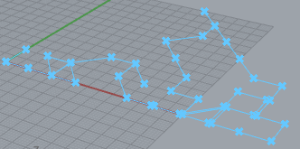

Need to clear the memory each time.
Just toggle this one to start. But..

private void RunScript(bool reset, bool run, ref object A)
{
Print("reset is " + reset.ToString());
Print("run is " + run.ToString());

if(reset || !run) // If reset clicked OR run is toggled false
walker.reset(); // Put it back to zero.
else{
walker.step();
Component.ExpireSolution(true); //Yield?
}
A = walker.pt;
}

Walker walker = new Walker(); // Appears after use!!

public class Walker
{
Random random = new Random();

public Point3d pt = new Point3d(0, 0, 0);

//class constructor
public Walker(){
}
//Class Methods
public void reset(){

pt = new Point3d(0, 0, 0);
}

public void step(){

pt.X += random.Next(-1, 2) * 10;
pt.Y += random.Next(-1, 2) * 10;

//Boundaries
pt.X = Math.Max(0, Math.Min(100 - 1, pt.X));
pt.Y = Math.Max(0, Math.Min(100 - 1, pt.Y));
}
}
-------------------------------------------------
Bouncing Ball 16

Uses class

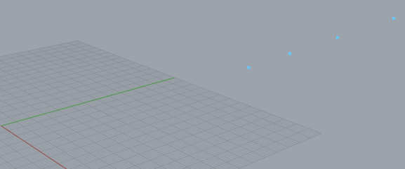
THESE CROSSES MOVE ACROSS THE SCREEN l->r.

b = new Bob[size]; // Indexer! ?

private void RunScript(bool reset, int size, ref object A)
{
// size is the no of crosses (points).

Print("reset is " + reset.ToString()); // For debugging.
Print("size is " + size.ToString());

//Initialize bob
if (reset || b == null){
b = new Bob[size]; // Indexer!! ?
for (int i = 0; i < size; i++){
b[i] = new Bob(i * 20, 100, i * 10);
}
}
//Increment bob
for (int i = 0; i < size; i++){
b[i].step(); // Move each Bob synchronously L->R.
}
//Display bob
pts.Clear();
for (int i = 0; i < size; i++){
pts.Add(b[i].pt());
}

A = pts; // Display size points.
}

// <Custom additional code>

Bob[] b; // An array of Bob objects.

List<Point3d> pts = new List<Point3d>(); // Global List.

class Bob{

public Vector3d loc; // posn and
public Vector3d vel; // speed are incremented.

//Constructor
public Bob(double x, double y, double z){
loc = new Vector3d(x, y, z);
vel = new Vector3d(5, z / 25, 0);
}

//Display
public Point3d pt(){
Point3d point = new Point3d(loc.X, loc.Y, loc.Z);
return point;
}

//Increment
public void step(){
loc += vel;
//Boundary
if( (loc.X > 1280) || ( loc.X < 0) ){
vel.X *= -1;
}
if( (loc.Y > 720 ) || (loc.Y < 0) ){
vel.Y *= -1;
}
if( (loc.Z > 200 ) || (loc.Z < 0) ){
vel.Z *= -1;
}
}
}

---------------------------------------------------------

End Vest examples.

Matrix
You can use Rhino.Geometry.Matrix in Grasshopper scripting components. Here is how.
(The only missing bit is the automatic casting made by the 'TypeHint' of the input, but we can do that in scripting directly, too.)
Matrix m = null;
if (x is Matrix)
{
m = (Matrix)x; //Cast if it is a Matrix
}
else if(x == null)
{
m = new Matrix(3, 3); //What should happen if it is null?
}
else
{
throw new ArgumentException( //some other type: exception
string.Format("Conversion of x failed from {0} to Matrix.",
x.GetType().ToString())
);
}
//Do something with m...
m.Invert(0.001); A = m;
invert-example.gh, 6 KB
1. Matrix mx = new Matrix(5, 6); will declare a new 5x6 Matrix
2. using the "item" property you can set and get specific matrix values - mx[3,2] = 2.0; will set the value of the cell at 3,2.

https://www.grasshopper3d.com/forum/topics/subsurface-in-c

subsurf_test_c.gh

private void RunScript(int X, int Y, ref object S, ref object N, ref object F)
{
List<Point3d> pts = new List<Point3d>();
for (int i = 0; i < 30; i++)
for (int j = 0; j < 30; j++)
pts.Add(new Point3d(i, j, (Math.Cos(i) * Math.Sin(j))));
// 30 no. points u dirn. 30 no. points v dirn. 2 degree in u. 2 degree in v
NurbsSurface surface = NurbsSurface.CreateFromPoints(pts, 30, 30, 2, 2);

// Create edge curves along U and V.
Curve curveU = surface.IsoCurve(0, 0);
Curve curveV = surface.IsoCurve(1, 0);

// Divide edge curves into equal-length segments.
double[] paramsU = curveU.DivideByCount(X, true);
double[] paramsV = curveV.DivideByCount(Y, true);

List<Surface> fragments = new List<Surface>();

for (int i = 0; i < paramsU.Length - 1; i++)
for (int j = 0; j < paramsV.Length - 1; j++)
{
Interval trimU = new Interval(paramsU[i], paramsU[i + 1]);
Interval trimV = new Interval(paramsV[j], paramsV[j + 1]);

Surface fragment = surface.Trim(trimU, trimV);
fragments.Add(fragment);
}

S = surface;
N = fragments.Count;
F = fragments;
}

}

For help eg rhinocommon CreateFromPoints

public static NurbsSurface CreateFromPoints(
IEnumerable<Point3d> points,
int uCount,
int vCount,
int uDegree,
int vDegree

better use this?
https://developer.rhino3d.com/api/RhinoCommon/html/M_Rhino_Geometry_NurbsSurface_Create.htm

Non-rational control points do not
// need to specify a weight.
Cause theyre all 1 I guess.

subsurf_test_d.gh v slow

List<Point3d> pts = new List<Point3d>();
for (int i = 0; i < X; i++) // 900 points!
{
for(int j = 0; j < X; j++)
{
pts.Add(new Point3d(i, j, (Math.Cos(i) * Math.Sin(j))));
Print(pts[i].X.ToString() + " " + pts[i].Y.ToString() + " " + pts[i].Z.ToString());
}
Print(" ");
}

NurbsSurface surface = NurbsSurface.CreateFromPoints(pts, X, X, 2, 2);

S = surface;
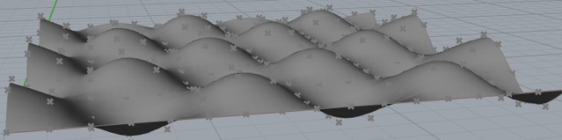
F = pts;

-------------------------------------------------------------------
An isoparametric curve (or isocurve) is a curve of constant u- or v-value on a surface. Rhino uses isocurves and surface edge curves to create a wireframe of the shape of a NURBS surface. By default isocurves are drawn at knot location
Curve curveU = surface.IsoCurve(0, 0);
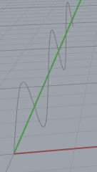

https://discourse.mcneel.com/t/rhino-6-grasshopper-render-preview-materials/63087/6

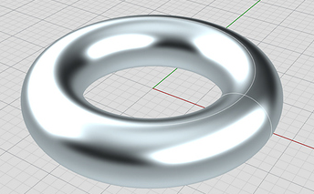

GRASSHOPPER

Rutten videos
https://vimeo.com/78868366

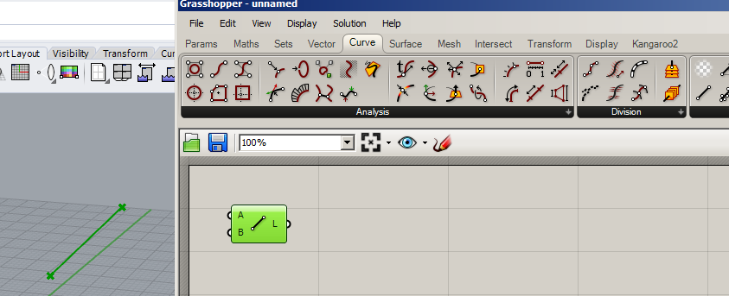
Actually MAKES a line.

Whereas this references a line already drawn in rhino

polysurface = brep
---------------------------------------------------------------------------------------------------------

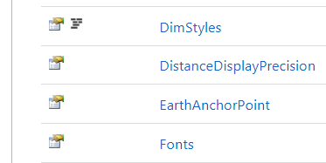
EXAMPLES!

__________________________________________________________________

//double[,] m1 = new double[2, 2]

double[,] m1 = {{1,2},{3,4}};
double[,] m2 = {{1,2},{3,4}};

Matrix mat1 = new Matrix(2, 2);
Matrix mat2 = new Matrix(2, 2);
Matrix mat3 = new Matrix(2, 2);

mat1[0,0] = 1;mat1[0,1] = 2;
mat1[1,0] = 3;mat1[1,1] = 4;

mat2[0, 0] = 1;mat2[0, 1] = 2;
mat2[1, 0] = 3;mat2[1, 1] = 4;

mat3 = mat1* mat2;

Print(m2[0,0].ToString());
https://developer.rhino3d.com/api/grasshopper/html/723c01da-9986-4db2-8f53-6f3a7494df75.htm

Grasshopper SDK
This help-file contains information for those who wish to develop custom components, parameters and data-types for Grasshopper®.
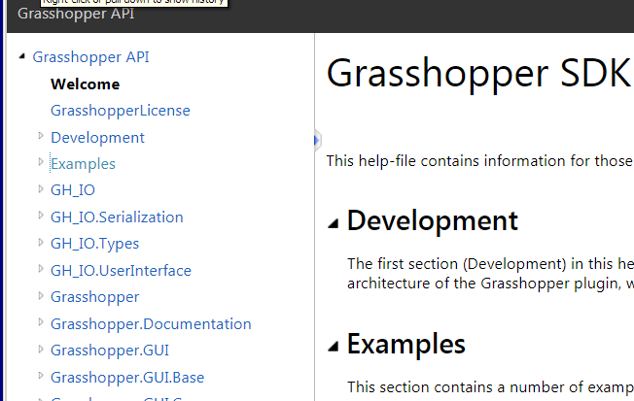

rotation rutten:

- if (!perform)
return;

ObjRef obj = new ObjRef(id);
BoundingBox box = obj.Geometry().GetBoundingBox(true);

Point3d center = box.Center;
Vector3d axis = new Vector3d(1, 1, 1);
Transform transform = Transform.Rotation(Math.PI / 6, axis, center);

RhinoDocument.Objects.Transform(obj, transform, true);
-----------------------------------------------------------------------

Forum: Hello I'm trying to construct an architectural design with intersecting Polylines.

I create a rectangle using Polylines.

I now want to rotate it. I dont think I can rotate a set of polylines in one go.
Is it best to create a nurbs curve in order to rotate it? as per my C# code.

Thanks

Ed

<a class="attachment" href="/uploads/default/original/3X/8/3/83f48a71337ebc889c28215bab394b7c072775d0.gh">expt.gh</a> (3.4 KB)

private void RunScript(object x, object y, ref object A, ref object B)
{
Polyline P = makePolygon(10);
var nurbs = P.ToNurbsCurve();
//bool b = nurbs.MakeClosed(0.001);
nurbs.Rotate(Math.PI/4, Vector3d.ZAxis, new Point3d(0, 0, 0));
A = nurbs;
}

Polyline makePolygon(int sz)
{
Point3d[] pts = new Point3d[4]; // An array of 4 points (vertices)for each polygon.
pts[0] = new Point3d(0, 0, 0); pts[1] = new Point3d(0, sz, 0); // These are the 4 vertices
pts[2] = new Point3d(sz, sz, 0); pts[3] = new Point3d(sz, 0, 0);
Polyline T = new Polyline(pts);
return T;
}
}


Petras_Vestartas For all transformations in any geometry class, such as rotations, scale, planetoplane and others use transform method. Transform method is also static, so you can call typical matrix operations.For instance:
private void RunScript(object x, object y, ref object A, ref object B)
{
Polyline P = makePolygon(10);
P.Transform(Transform.Rotation(Math.PI / 4, Vector3d.ZAxis, new Point3d(0, 0, 0)));
A = P;
}
Edrobinson200 Great. Thanks for making it so simple Very grateful.

Lesson 8th March

Custom Preview?

serpLatest4.gh

1. Make a function called myFunction which accepts an integer and return the square of number. Print the result to the out.

2. Make array of 4 Points and draw a polyline from them.

private void RunScript(object x, object y, ref object A)
{
double sz = 10;
Point3d[] pts = new Point3d[4]; // An array of 4 points (vertices)for each polygon.
pts[0] = new Point3d(0, 0, 0); pts[1] = new Point3d(0, sz, 0); // These are the 4 vertices
pts[2] = new Point3d(sz, sz, 0); pts[3] = new Point3d(sz, 0, 0); // of our original square.
Polyline P = new Polyline(pts);
A = P;
}
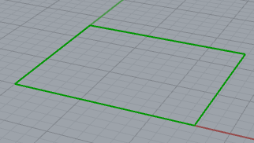
All these quadrilateral polylines are actually rectangles.)

3. Make another size 20 Polyline of 4 sides and print it to another output called B.

double sz = 10;
Point3d[] pts = new Point3d[4]; // An array of 4 points (vertices)for each polygon.
pts[0] = new Point3d(0, 0, 0); pts[1] = new Point3d(0, sz, 0); // These are the 4 vertices
pts[2] = new Point3d(sz, sz, 0); pts[3] = new Point3d(sz, 0, 0); // of our original square.

Polyline P = new Polyline(pts);

A = P;

sz = 20;
pts[0] = new Point3d(0, 0, 0); pts[1] = new Point3d(0, sz, 0); // These are the 4 vertices
pts[2] = new Point3d(sz, sz, 0); pts[3] = new Point3d(sz, 0, 0); // of our original square.

Polyline Q = new Polyline(pts);

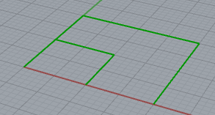
B = Q;

4. Make a single function called makePolygon() to construct each the above two polylines

Pass only the size of the polyline (actually it’s only a rectangle).

= makePolygon(10);

(ie it should return a Polyline) and return it for A output.

Polyline P = makePolygon(10);

A = P;
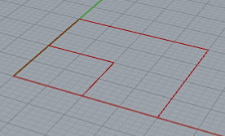

private void RunScript(object x, object y, ref object A, ref object B)
{
Polyline P = makePolygon(10);
A = P;
Polyline Q = makePolygon(20);
B = Q;
}
// <Custom additional code>

Polyline makePolygon(int sz)
{
Print(sz.ToString());
Point3d[] pts = new Point3d[4]; // An array of 4 points (vertices)for each polygon.

pts[0] = new Point3d(0, 0, 0); pts[1] = new Point3d(0, sz, 0); // These are the 4 vertices

pts[2] = new Point3d(sz, sz, 0); pts[3] = new Point3d(sz, 0, 0);

Polyline T = new Polyline(pts);

return T;
}
// </Custom additional code>
}

5. Make a list called Quads to hold the 2 polylines above.

List<Polyline> Quads = new List<Polyline>();

Add each polyline (P & Q) to the list.

output Quads to A (only).

List<Polyline> Quads = new List<Polyline>();

Polyline P = makePolygon(10);

Polyline Q = makePolygon(20);

Quads.Add(P);
Quads.Add(Q);

A = Quads;

OR

Polyline P = makePolygon(10);

Polyline Q = makePolygon(20);

List < Polyline > Quads = new List<Polyline>{P,Q};

A = Quads;

OR EVEN

List < Polyline > Quads = new List<Polyline>{ makePolygon(10),makePolygon(20)};

A = Quads;

6. Make a function which takes 4 points and draws a CLOSED polyline
ie add the original point again.

private void RunScript(object x, object y, ref object A)
{
double sz = 10;
Point3d[] pts = new Point3d[4]; // An array of 4 points (vertices) for each polygon.
pts[0] = new Point3d(0, 0, 0); pts[1] = new Point3d(0, sz, 0); // These are the 4 vertices
pts[2] = new Point3d(sz, sz, 0); pts[3] = new Point3d(sz, 0, 0); // of our original square.
Polyline P = myPolyline(pts);
A = P;
}

Polyline myPolyline(Point3d[] p)
{
int sz = (int)p.Length;
Point3d[] q = new Point3d[sz + 1];
for (int i = 0; i < 4; i++)
{
q[i] = p[i];
}
q[4] = p[0];
Polyline Q = new Polyline(q);
return Q;
}

MakeClosed Rhino function?

7. Make a line between these two points

Point3d p1 = new Point3d(0, 0, 0); Point3d p2 = new Point3d(10, 10, 0);

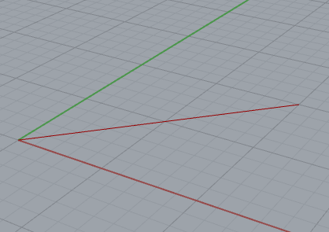

Point3d p1 = new Point3d(0, 0, 0); Point3d p2 = new Point3d(10, 10, 0);

Line q1 = new Line(p1, p2);

A = q1;

8. Extend the line 5 units backwards and 10 units forward.

use .Extend

Point3d p1 = new Point3d(0, 0, 0); Point3d p2 = new Point3d(10, 10, 0);

Line q1 = new Line(p1, p2);

q1.Extend(5, 10);

A = q1;

-----------------------------------

9. Divide our line (original in the ratio of 2:1

double t= 1.0/3.0.

Point3d p = ((1 - t) * p1 + t * p2);

10 Place it in a function called divideSegment which returns a Point3d.

----------------------------------------

11. Find the Length of our original line

Use .Length

-----------------------------------------------------------------
12. Set the length of the line to be 50% longer.

----------------------------------------------------------------
13. Make two lines

Find their intersection point.

bool rc = Intersection.LineLine(ln1, ln2 out t1, out t2, tol, false);
// t1,t2 measured from the line start.

Maybe print the coordinates to out.
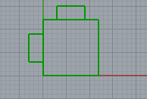
---------------------------------------------------------------

14. Try Modulo function. Maybe in a for loop.

(i + 1) % 4

-------------------------------------
15. Produce this: (Use rotation.)
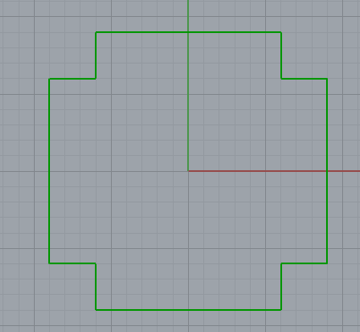

------------------------------------------------------------------

Building1.gh

private void RunScript(object x, object y, ref object A)
{
Polyline B = new Polyline(); // For the building

B = DrawOutline();

A = B;

// TODO find interstction of a line with B (our polyline for the whole building)

}
// <Custom additional code>

Polyline DrawOutline()
{
Polyline TotP = new Polyline(); // For the building

Point3d[] pts = new Point3d[5]; // Left hand shape. 5 MUST be the exact number of points.

pts[0] = new Point3d(-6, -9, 0); pts[1] = new Point3d(-6, -6, 0);
pts[2] = new Point3d(-9, -6, 0); pts[3] = new Point3d(-9, 6, 0);
pts[4] = new Point3d(-6, 6, 0); //pts[5] = new Point3d(-6, 9, 0);

Polyline[] P = new Polyline[4]; // For each side

P[0] = new Polyline(pts); // LHS of the building

TotP = P[0]; // LHS of the building

for (int i = 0; i < 3; i++) // Do the other 3 sides.
{

P[i + 1] = P[i].Duplicate(); // Need to make a copy in order to rotate it.

Transform trans = Transform.Rotation(-Math.PI / 2, Vector3d.ZAxis, new Point3d(0, 0, 0));

P[i + 1].Transform(trans); // Do the top side etc.

TotP.AddRange(P[i + 1]); // Add the top side to the LH side etc
}
return TotP;
}
// </Custom additional code>
}

Curve Intersection
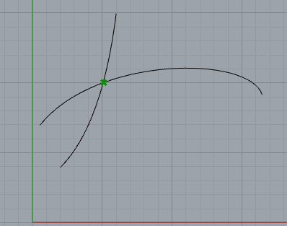

private void RunScript(Curve curveA, Curve curveB, ref object A, ref object B)
{
// using Rhino.Geometry.Intersect;
var tol = 0.001;

// Intersect curveA with curveB:
var isect = Intersection.CurveCurve(curveA, curveB, tol, tol);

Print(isect.Count.ToString()); // 1 ie only isect[0].

A = isect[0].PointA; // (5,10,0)
}

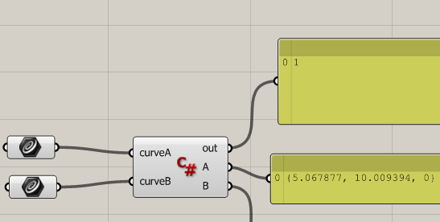

Print(isect.GetType().ToString());
// -> Rhino.Geometry.Intersect.CurveIntersections;
ie a structure containing PointA etc.

Print(isect[0].PointA.GetType().ToString());
-> Point3d.

Print(isect[0].ParameterA.ToString()); // 6,621520..

PointA2 etc is only for when curves overlap instead of intersect once.

How to get help from RhinoCommon.

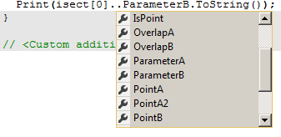

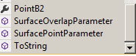

Best to get help from this!

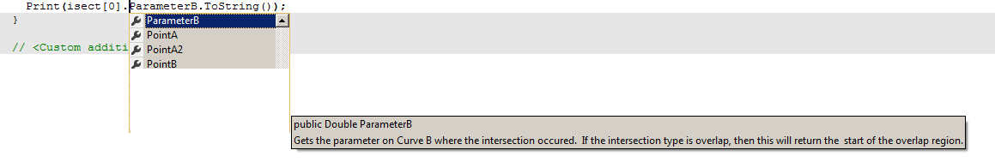

OR: (Help not so good!)

CurveCurve https://developer.rhino3d.com/api/RhinoCommon/html/M_Rhino_Geometry_Intersect_Intersection_CurveCurve.htm

CurveIntersections CurveIntersections
ParameterA
Gets the parameter on Curve A where the intersection occured. If the intersection type is overlap, then this will return the start of the overlap region.

PointA2
https://developer.rhino3d.com/api/RhinoCommon/html/P_Rhino_Geometry_Intersect_IntersectionEvent_PointA2.htm
Gets the end point of the overlap on Curve A. If the intersection type is not overlap, this value is meaningless.

PointA
https://developer.rhino3d.com/api/RhinoCommon/html/P_Rhino_Geometry_Intersect_IntersectionEvent_PointA.htm
Gets the point on Curve A where the intersection occured. If the intersection type is overlap, then this will return the start of the overlap region.

curveA.PointAtEnd is read only

Curve and Line:

private void RunScript(Curve curveA, Curve curveB, ref object A, ref object B)
{
// using Rhino.Geometry.Intersect;
var tol = 0.001;

Line L1 = new Line(new Point3d(0, 15, 0), new Point3d(10, 5, 0));

CurveIntersections isect = Intersection.CurveLine(curveA, L1, tol, tol);
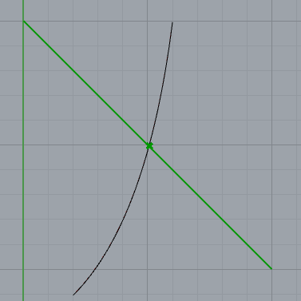
A = L1;

B = isect[0].PointA;

}

PolyCurve and Line:

private void RunScript(Curve curveA, Curve curveB, ref object A, ref object B, ref object C, ref object D)
{
// using Rhino.Geometry.Intersect;
var tol = 0.001;

Line L1 = new Line(new Point3d(0, 15, 0), new Point3d(10, 5, 0));

Point3d[] pts = { new Point3d(0, 10, 0), new Point3d(15, 15, 0), new Point3d(0, 0, 0) };

Polyline P = new Polyline(pts);

PolylineCurve PC = P.ToPolylineCurve();

CurveIntersections isect = Intersection.CurveLine(PC, L1, tol, tol);

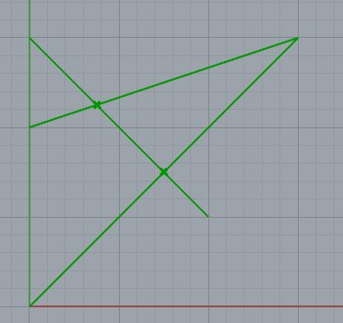
A = PC;

B = L1;

C = isect[0].PointA;

D = isect[1].PointA; Line L1
};

Building2.gh

Intersection of the big Polyline with a Line:

using Rhino.Geometry.Intersect;

private void RunScript(object x, object y, ref object A, ref object B, ref object C)
{
// using Rhino.Geometry.Intersect;
var tol = 0.001;//double len;

Polyline PL = new Polyline(); // For the building
PL = MakeOutline();
PolylineCurve PC = PL.ToPolylineCurve();

Line L1 = new Line(new Point3d(-6, 0, 0), new Point3d(-3, 6, 0));
L1.Extend(12, 12);
//len = L1.Length;

CurveIntersections isect = Intersection.CurveLine(PC, L1, tol, tol);

Point3d p1 = new Point3d(); p1 = isect[0].PointA;
Point3d p2 = new Point3d(); p2 = isect[1].PointA;

//Print(isect.Count.ToString()); // 2

Line L2 = new Line(p1, p2);

A = PC;

B = L1;

C = p1;

D = p2;
}
Polyline MakeOutline()
{
Polyline TotP = new Polyline(); // For the building

Point3d[] pts = new Point3d[5]; // Left hand shape. 5 MUST be the exact number of points.

pts[0] = new Point3d(-6, -9, 0); pts[1] = new Point3d(-6, -6, 0);
pts[2] = new Point3d(-9, -6, 0); pts[3] = new Point3d(-9, 6, 0);
pts[4] = new Point3d(-6, 6, 0); //pts[5] = new Point3d(-6, 9, 0);

Polyline[] P = new Polyline[4]; // For each side

P[0] = new Polyline(pts); // LHS of the building

TotP = P[0]; // LHS of the building

for (int i = 0; i < 3; i++) // Do the other 3 sides.
{
P[i + 1] = P[i].Duplicate();// Need to make a copy in order to rotate it.

Transform trans = Transform.Rotation(-Math.PI / 2, Vector3d.ZAxis, new Point3d(0, 0, 0));

P[i + 1].Transform(trans); // Do the top side etc.

TotP.AddRange(P[i + 1]); // Add the top side to the LH side etc
}
return TotP;
}
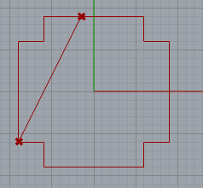
}

TODO All done.

1. Bundle into a function ie draw a line intersection of a polyline and a line.
See building3.gh.

2. Make it scalable.

3. Centre widget: SerpLatest4.gh

4. Extend all sides.

5. Superimpose building outline

6. Truncate lines to building

Quick way to make a slider

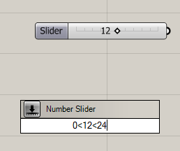

Quick way to make a panel: Double-click on canvas and type “

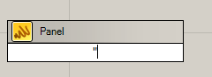
Press Enter:

Panel appears
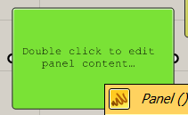

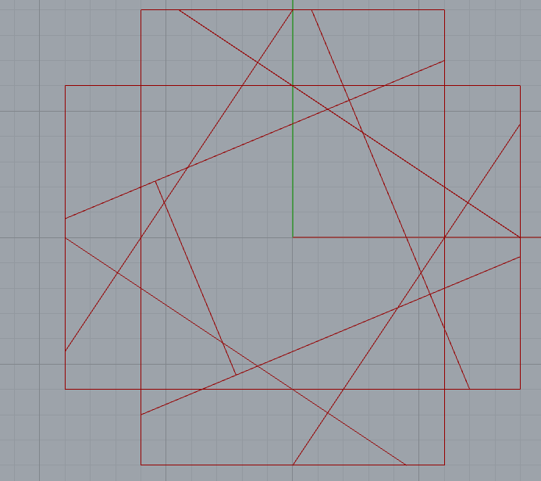 error here because of double drawing an edge!

private void RunScript(Curve curveA, Curve curveB, ref object A, ref object B, ref object C, ref object D)
{
List <Line> lst = new List<Line>();

Point3d[] pts = new Point3d[4];

pts[0] = new Point3d(0, 0, 0); pts[1] = new Point3d(1, 1, 1);
pts[2] = new Point3d(2, 2, 0); pts[3] = new Point3d(3, 3, 1);

Line L1 = new Line(pts[0], pts[1]);
Line L2 = new Line(pts[2], pts[3]);

lst.Add(L1);
lst.Add(L2);

Print(lst[0].ToString());

A = lst; // Works So we CAN send a list to output
}

using Rhino.Geometry.Intersect;

private void RunScript(Curve curveA, Curve curveB, ref object A, ref object B, ref object C, ref object D)
{
List <Line[]> xtLines = new List<Line[]>(); // List of arrays.

Line[] lns = new Line[2]; // An array of 2 lines.

lns[0] = new Line(new Point3d(0, 0, 0), new Point3d(1, 1, 1));
lns[1] = new Line(new Point3d(2, 2, 0), new Point3d(3, 3, 1));

xtLines.Add(lns);

lns[0] = new Line(new Point3d(4, 4, 0), new Point3d(5, 5, 1));
lns[1] = new Line(new Point3d(6, 6, 0), new Point3d(7, 7, 1));

xtLines.Add(lns);

A = xtLines[0]; // Same as xtLines[0]!

B = xtLines[1]; // Same!
}
}

List <Line[]> xtLines = new List<Line[]>();

Line[] lns = new Line[2]; // One array of 2 lines.

// Create 2 lines:
lns[0] = new Line(new Point3d(0, 0, 0), new Point3d(1, 1, 1));
lns[1] = new Line(new Point3d(2, 2, 0), new Point3d(3, 3, 1));

xtLines.Add(lns); // Add the lns array to the list

lns[0] = new Line(new Point3d(4, 4, 0), new Point3d(5, 5, 1));
lns[1] = new Line(new Point3d(6, 6, 0), new Point3d(7, 7, 1));

xtLines.Add(lns); // Add the lns array to the list

A = xtLines[0]; // Out the first array but this lot is the same as xtLines[1].

B = xtLines[1]; // ie last lot OVERWRITES the previous lns array?

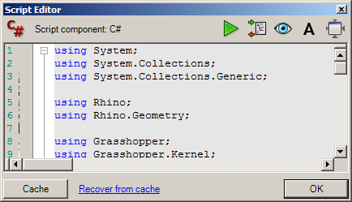
But if we close grasshopper it will ask if you want to save ie save the script file as well.
Recover previous versions!
Must click OK else it wont be saved!
private void RunScript(double x, double y, ref object A, ref object B, ref object C, ref object D)
{
List <lns> xtLines = new List<lns>();

var item1 = new lns
{
L1 = new Line(new Point3d(0, 0, 0), new Point3d(1, 1, 1)),
L2 = new Line(new Point3d(2, 2, 0), new Point3d(3, 3, 1))
};

xtLines.Add(item1);

var item2 = new lns
{
L1 = new Line(new Point3d(4, 4, 0), new Point3d(5, 5, 1)),
L2 = new Line(new Point3d(6, 6, 0), new Point3d(7, 7, 1))
};

xtLines.Add(item2);

A = xtLines[0].L1;
B = xtLines[0].L2;
C = xtLines[1].L1;
D = xtLines[1].L2;
}

public class lns
{
public Line L1{ get; set; }
public Line L2{ get; set; }
}

}-----------------------------------------------------------------

waste of time!

Just use:

List <Line> xtLines = new List<Line>();

Line ln = new Line(new Point3d(0, 0, 0), new Point3d(1, 1, 1));

xtLines.Add(ln); // Add the line to the list

ln = new Line(new Point3d(2, 2, 0), new Point3d(3, 3, 1));

xtLines.Add(ln); // Add the line to the list

A = xtLines;

ie just keep adding to a big List.

serpLatest7.gh
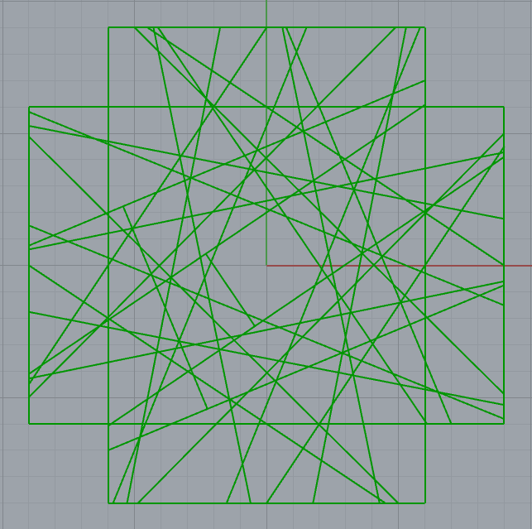

error! (amended)

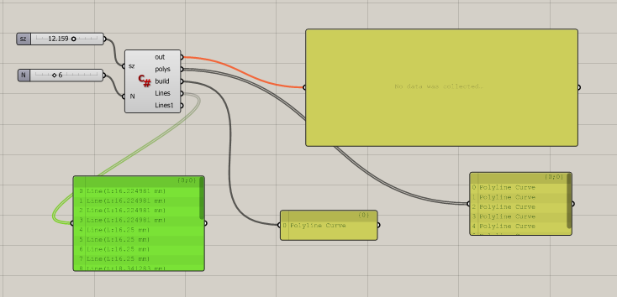

serpLatest7.gh

private void RunScript(double sz, int N, ref object polys, ref object build, ref object Lines, ref object Lines1)
{
// This Program:
// Constructs a square of side 12.
// Draws a building outline. PolyLines PL.
// Draws the 1st Widget (1/2 way , 2/3 way across etc to form a quadrilateral.
// At the same time it extends the lines to the building. Each array of these 4 lines is in the Polyline lns.
// Each of these poly lines is stored in a List called xtLines.

//++++++++++++++++++++ DECLARE STUFF ++++++++++++++++++

sz = 12.0; //N = 3; // Override .sz is the length of the square. N is the number of quads to draw (inc the square).

double w = 3.0; // Height of the wall

Point3d[] pts = new Point3d[4]; // An array of 4 points (vertices)for each new polygon.

Line[] lns = new Line[4]; // One array of 4 extended lines for each polygon (intersecting with the building).

Polyline[] Quads = new Polyline[N]; // N polyline quadrilaterals to be drawn at once.

List <Line> xtLines = new List<Line>(); // A List of Lines - to hold ALL the extended lines.

List<Polyline> Polys = new List <Polyline>(); // Aggregate of all polylines to display at once.

//++++++++++++++++++++ ORIGINAL SQUARE ++++++++++++++++++

pts = SetSquarePoints(pts, sz); // Set the vertices of the SQUARE.

Quads[0] = myPolyline(pts); // Makes the original square. Quads[0] is the polyline for the SQUARE.

// ++++++++++++++++++ DRAW BUILDING ie "outline"++++++++++

Polyline PL = new Polyline(); // For the outside building

PL = MakeOutline(sz, w); // Make the building polyline.

// ++++++++++++++++++ CONSTRUCT MANY POLYGONS++++++++++++

for (int i = 1; i < N; i++) // N-1 polylines // Start with i=1 because Quads[0]is already made.
{

bool b;

b = MakeQuadPointsAndLines(pts, lns, PL); // New points for old! Pass by reference! lns as well. Just does ONE quad and 4 lines.

foreach (Line ln in lns)
{
xtLines.Add(ln); // Add each one of the set of 4 lines to the List.
}

Quads[i] = myPolyline(pts); // Aggregate the quads. Get the next Quadrilateral polyline.(1st one done already(Square).

}
//+++++++++++++++ Actually DRAW the polygons and EXTENDED LINES ++++++++++++

for (int i = 0; i < N; i++)
{
Polys.Add(Quads[i]); // Aggregate all of the N Polylines into the LIST Polys.
}

polys = Polys; // Pass the LIST of polylines to the output parameter rect to display.

build = PL; // Draw the building as well.

Lines = xtLines;

//+++++++++++++++++++++++++++++++++++++++++++++++++++++++
}

// <Custom additional code>

//++++++++++ Set the Square Vertices ++++++++

Point3d[] SetSquarePoints(Point3d[] Pts, double sz)
{
double s = sz / 2;

Pts[0] = new Point3d(-s, -s, 0); Pts[1] = new Point3d(-s, s, 0); // These are the 4 vertices

Pts[2] = new Point3d(s, s, 0); Pts[3] = new Point3d(s, -s, 0); // of our original square.

return Pts;
}

//+++++++++++++This does ONE set of 4 vertices and ONE set of 4 extended lines.+++++++++++++++

// It gets the set of points (by reference)for one new quadrilateral and the set of 4 extended lines(by reference).

bool MakeQuadPointsAndLines(Point3d[] verts, Line[] lns, Polyline PL) // (We need to pass the building polyline PL as well each time.)
{
// We need to make 4 LINES (in oreder to find INTERSECTION to get the 4 endpoints of the new quadrilateral.

double t1,t2; var tol = 0.001; bool rc; // t1 t2 are line paramters. tol, rc for intersection.

Line[] sd = new Line[4]; // 4 SIDES of a new polygon

for (int i = 0 ; i < 4; i++) // Make the 4 lines.
{
// Now make 4 extended lines between adjacent line segment pairs.

sd[i] = makeLineExtended(verts[i], verts[(i + 1) % 4], verts[(i + 1) % 4], verts[(i + 2) % 4]);

}

for (int i = 0; i < 4; i++)
{
// Now get 4 apex intersections and 4 extended lines (up to the building).

rc = Intersection.LineLine(sd[i], sd[(i + 1) % 4], out t1, out t2, tol, false); // // Intersection of the lines. t1,t2 measured from the line start.

// Now get the point at the END ie where it cuts the next side of the quadrilateral.

verts[(i + 1) % 4] = sd[i].PointAt(t1); // verts[1] verts[2] verts[3] verts[0] IN THAT ORDER. sd[0] sd[1] sd[2] sd[3] respectively. (We DONT USE t2.)
// (We need these 4 points for the NEXT quadrilateral!)

// We also need to get the 4 EXTENDED lines ie find where they intersect the BUILDING.

lns[i] = DrawLineToOutline(sd[i], PL);

//Print(verts[(i + 1) % 4].ToString());

}

//return verts;

return true; // Dummy return! Cant make a sub in GH?
}
//++++++++++++++++++++ Make one Side ++++++++++++++++++++++

// Makes an extended line between two points p1 and p2.
// p1 and p2 are the respective points on the lines ptA1-ptA2 and ptB1-ptB2.

Line makeLineExtended(Point3d ptA1, Point3d ptA2, Point3d ptB1, Point3d ptB2)
{
double ta = 0.5; double tb = 1.0 / 3.0; double sdExt = 12.0; // sdExt is the extnsion amount (in both directions)

Point3d p1 = divideSegment(ptA1, ptA2, ta);

Point3d p2 = divideSegment(ptB1, ptB2, tb);

Line q1 = new Line(p1, p2); // ie Will form(after truncation) the first side of our new quadrilateral.

bool b = q1.Extend(sdExt, sdExt); // Extend sdExt units - in both directions.

return q1;
}

//++++++++++++++++++++ Divide Points in Ratio +++++++++++++++++++++++++

// Finds the point between 2 points in the given paramter (ratio) t.

Point3d divideSegment(Point3d p1, Point3d p2, double t)
{
Point3d p = ((1 - t) * p1 + t * p2);

return p;
}

//++++++++++++++++++++ Closed Polyline ++++++++++++++++++++++++++++++++

// Make our own Poyline function! to CLOSE the polyline by repeating the first point at the END!

Polyline myPolyline(Point3d[] p)
{
Point3d[] q = new Point3d[5];

for (int i = 0; i < 4; i++)
{
q[i] = p[i];
}
q[4] = p[0];

Polyline Q = new Polyline(q);

return Q;
}
//+++++++++++++++++++++++++++++++++++++++++++++++++++++++++++++++++++++

Line DrawLineToOutline(Line L1, Polyline PL)
{
// Makes one line segment of the line intersecting the building.

// using Rhino.Geometry.Intersect;
var tol = 0.001;//double len;

PolylineCurve PC = PL.ToPolylineCurve();

CurveIntersections isect = Intersection.CurveLine(PC, L1, tol, tol);

Point3d p1 = new Point3d(); p1 = isect[0].PointA;
Point3d p2 = new Point3d(); p2 = isect[1].PointA;

Line L2 = new Line(p1, p2);

//Print(p1.ToString());
//Print(p2.ToString());

// Print(isect[0].ParameterA.ToString());
// Print(isect[0].ParameterB.ToString());
//
// Print(isect[1].ParameterA.ToString());
// Print(isect[1].ParameterB.ToString());

//Print(L1.PointAt(isect[0].ParameterA).ToString());

return L2;
}
//++++++++++++++++++++++++Make the building outline+++++++++++++++++++++++++++++++++++

Polyline MakeOutline(double sz, double w)
{
// This makes the whole building.

double s = sz / 2;

Polyline TotP = new Polyline(); // For the whole building

Point3d[] pts = new Point3d[4]; // Left hand shape. MUST be the exact number of points : 5.

pts[0] = new Point3d(-s, -s - w, 0); pts[1] = new Point3d(-s, -s, 0);
pts[2] = new Point3d(-s - w, -s, 0); pts[3] = new Point3d(-s - w, s, 0);
// pts[4] = new Point3d(-s, s, 0);

Polyline[] P = new Polyline[4]; // For each side

P[0] = new Polyline(pts); // LHS of the building

TotP.AddRange(P[0]); // LHS of the building

for (int i = 0; i < 3; i++) // Do the other 3 sides.
{
P[i + 1] = P[i].Duplicate(); // Need to make a copy in order to rotate it.

Transform trans = Transform.Rotation(-Math.PI / 2, Vector3d.ZAxis, new Point3d(0, 0, 0));

P[i + 1].Transform(trans); // Do the top side etc.

TotP.AddRange(P[i + 1]); // Add the top side to the LH side etc
}

return TotP;
}

// </Custom additional code>
}

Lesson

1st create the “building” or “outline”

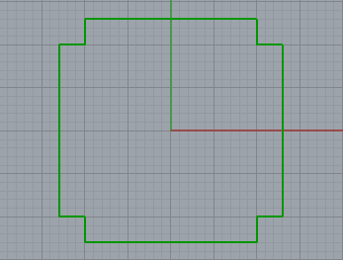

by rotating this
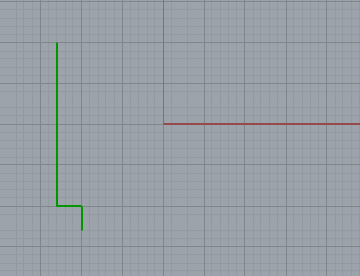

Polyline MakeOutline(double sz, double w)
{
// This makes the whole building.
double s = sz / 2;
Polyline TotP = new Polyline(); // For the whole building
Point3d[] pts = new Point3d[4]; // Left hand shape. MUST be the exact number of points : 4.
pts[0] = new Point3d(-s, -s - w, 0); pts[1] = new Point3d(-s, -s, 0);
pts[2] = new Point3d(-s - w, -s, 0); pts[3] = new Point3d(-s - w, s, 0);
// pts[4] = new Point3d(-s, s, 0);
Polyline[] P = new Polyline[4]; // For each side
P[0] = new Polyline(pts); // LHS of the building
TotP.AddRange(P[0]); // LHS of the building
for (int i = 0; i < 3; i++) // Do the other 3 sides.
{
P[i + 1] = P[i].Duplicate(); // Need to make a copy in order to rotate it.
Transform trans = Transform.Rotation(-Math.PI / 2, Vector3d.ZAxis, new Point3d(0, 0, 0));
P[i + 1].Transform(trans); // Do the top side etc.
TotP.AddRange(P[i + 1]); // Add the top side to the LH side etc
}
return TotP;
}
Next draw the square Quads(0)

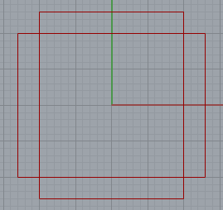

++++++++++ Set the Square Vertices ++++++++
Point3d[] SetSquarePoints(Point3d[] Pts, double sz)
{
double s = sz / 2;
Pts[0] = new Point3d(-s, -s, 0); Pts[1] = new Point3d(-s, s, 0); // These are the 4 vertices
Pts[2] = new Point3d(s, s, 0); Pts[3] = new Point3d(s, -s, 0); // of our original square.
return Pts;
}

4. Find this point.

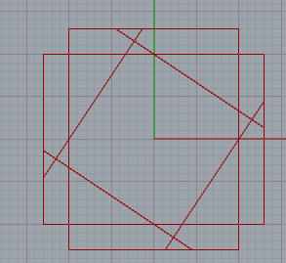
3. Same for this line.

1. Draw this line segment BETWEEN THE SQUARE.

2. Extend it.
5. Extend it again and find where it hits the outline. Draw this line.

Repeat
bool MakeQuadPointsAndLines(Point3d[] verts, Line[] lns, Polyline PL) // (We need to pass the building polyline PL as well each time.)
{
// We need to make 4 LINES (in oreder to find INTERSECTION to get the 4 endpoints of the new quadrilateral.
double t1, t2; var tol = 0.001; bool rc; // t1 t2 are line paramters. tol, rc for intersection.

Line[] sd = new Line[4]; // 4 SIDES of a new polygon

for (int i = 0; i < 4; i++) // Make the 4 lines.
{
2. Extend it.
3. Same for this line.
// Now make 4 extended lines between adjacent line segment pairs.
sd[i] = makeLineExtended(verts[i], verts[(i + 1) % 4], verts[(i + 1) % 4], verts[(i + 2) % 4]);
}
for (int i = 0; i < 4; i++)
{
// Now get 4 apex intersections and 4 extended lines (up to the building).
4. Find this point.
rc = Intersection.LineLine(sd[i], sd[(i + 1) % 4], out t1, out t2, tol, false); // // Intersection of the lines. t1,t2 measured from the line start.
// Now get the point at the END ie where it cuts the next side of the quadrilateral.
verts[(i + 1) % 4] = sd[i].PointAt(t1); // verts[1] verts[2] verts[3] verts[0] IN THAT ORDER. sd[0] sd[1] sd[2] sd[3] respectively. (We DONT USE t2.)
// (We need these 4 points for the NEXT quadrilateral!)
// We also need to get the 4 EXTENDED lines ie find where they intersect the BUILDING.
5. Extend it again and find where it hits the outline. Draw this line.
lns[i] = DrawLineToOutline(sd[i], PL);

//Print(verts[(i + 1) % 4].ToString());
}
//return verts;
return true; // Dummy return! Cant make a sub in GH?
}
-------------------------------------------------------------------------------------------------------------

If delete doesn’t work then Maximize/Minimize grasshopper.

----------------------------------------------------------------------------------------------------------------
3rd video Lesson – After 2nd video.

show p0 + P1 and 2 * p1.

Find the mid point.

Point3d p0 = new Point3d(5, 5, 0);
Point3d p1= new Point3d(17, 11, 0);

Point3d p = new Point3d();

p = (p0 + p1)/2.0;

A = p;

OR p = .5 * p0 + .5 * p1

In general

Divide our line (original in the ratio of 2:1

double t= 1.0/3.0.

Point3d p = ((1 - t) * p1 + t * p2);

Show METHODS of Line:

8. Extend the line 5 units backwards and 10 units forward.

use .Extend

Point3d p1 = new Point3d(0, 0, 0); Point3d p2 = new Point3d(10, 10, 0);

Line q1 = new Line(p1, p2);

q1.Extend(5, 10);

A = q1;

11. Find the Length of our original line

Use .Length

-----------------------------------------------------------------
12. Set the length of the line to be 50% longer.

----------------------------------------------------------------
13. Make two lines

Find their intersection point.

bool rc = Intersection.LineLine(ln1, ln2 out t1, out t2, tol, false);
// t1,t2 measured from the line start.

Maybe print out corrdinates

Explain t. How to effectively reduce the length.

Transformation: Rotation:. Translation.

Duplication of line is neded if we want to retain the original as well!

Curves:

But show how to input curves.

Intersection of curves (click) : Page … of this manual

https://www.techspot.com/ for google desktop
http://james-ramsden.com/subdivide-mesh-face-in-grasshopper-with-c/
http://james-ramsden.com/grasshopper-map-a-path-using-c/
http://james-ramsden.com/convert-a-brep-to-a-mesh-in-rhinograsshopper-c/
http://james-ramsden.com/how-to-explode-a-mesh-in-grasshopper/

Rhino To make a mesh
Create a nurbs sphere first or:

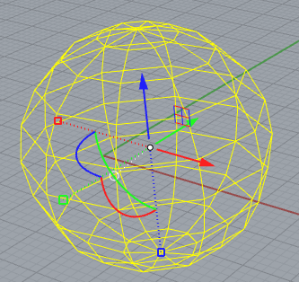
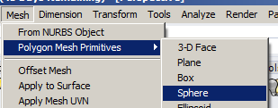

Puts little green crosses on each face

http://james-ramsden.com/the-mesh-data-structure-in-grasshopper/

private void RunScript(Mesh x, ref object A, ref object B)
{

List<Point3d> rtnlist = new List<Point3d>();
Mesh rtnmesh = new Mesh();

//get centre points
for (int face = 0; face < x.Faces.Count; face++)
{
Point3d centrepoint = new Point3d(0, 0, 0);

centrepoint.X += x.Vertices[x.Faces[face].A].X;
centrepoint.Y += x.Vertices[x.Faces[face].A].Y;
centrepoint.Z += x.Vertices[x.Faces[face].A].Z;

centrepoint.X += x.Vertices[x.Faces[face].B].X;
centrepoint.Y += x.Vertices[x.Faces[face].B].Y;
centrepoint.Z += x.Vertices[x.Faces[face].B].Z;

centrepoint.X += x.Vertices[x.Faces[face].C].X;
centrepoint.Y += x.Vertices[x.Faces[face].C].Y;
centrepoint.Z += x.Vertices[x.Faces[face].C].Z;

if (x.Faces[face].IsQuad)
{
centrepoint.X += x.Vertices[x.Faces[face].D].X;
centrepoint.Y += x.Vertices[x.Faces[face].D].Y;
centrepoint.Z += x.Vertices[x.Faces[face].D].Z;

centrepoint.X /= 4;
centrepoint.Y /= 4;
centrepoint.Z /= 4;
}
if (x.Faces[face].IsTriangle)
{
centrepoint.X /= 3;
centrepoint.Y /= 3;
centrepoint.Z /= 3;
}
rtnlist.Add(new Point3d(centrepoint));
}

//Populate new mesh
//add vertices
foreach (Point3d v in x.Vertices)
{
rtnmesh.Vertices.Add(v.X, v.Y, v.Z);
}

foreach (Point3d v in rtnlist)
{
rtnmesh.Vertices.Add(v.X, v.Y, v.Z);
}
//Add faces
int[] node = new int[3]; //For indexes for mesh face

//For each face, we need to add 4 faces
for (int face = 0; face < x.Faces.Count; face++)
{
//face 1
node[0] = x.Faces[face].A;
node[1] = x.Faces[face].B;
node[2] = x.Vertices.Count + face;
MeshFace tempface = new MeshFace(node[0], node[1], node[2]);
rtnmesh.Faces.AddFace(tempface);
//face 2
node[0] = x.Faces[face].B;
node[1] = x.Faces[face].C;
node[2] = x.Vertices.Count + face;
MeshFace tempface2 = new MeshFace(node[0], node[1], node[2]);
rtnmesh.Faces.AddFace(tempface2);
//face 3
node[0] = x.Faces[face].C;
node[1] = x.Faces[face].D;
node[2] = x.Vertices.Count + face;
MeshFace tempface3 = new MeshFace(node[0], node[1], node[2]);
rtnmesh.Faces.AddFace(tempface3);
//face 4
node[0] = x.Faces[face].D;
node[1] = x.Faces[face].A;
node[2] = x.Vertices.Count + face;
MeshFace tempface4 = new MeshFace(node[0], node[1], node[2]);
rtnmesh.Faces.AddFace(tempface4);

}

A = rtnlist;
B = rtnmesh;

}
NURBS

Non-uniform rational basis spline

Rational: weightings are different

Free-form curves in Rhino are NURBS curves

Draw a curve using Rhino.

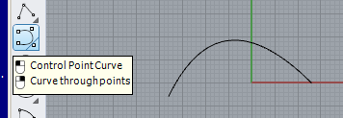

But what if you wanted to give instructions to another program/person to recreate this curve?
Loads of XY cordintes? Lot of memory required.

Solution: Specifty this curve using its end points and a control point.
Click on a Rhino curve to see them.
Control point (at -7,20).
To this point is attributed a “weight” which determines the amount of “magnestism!” pulling the curve towards it.

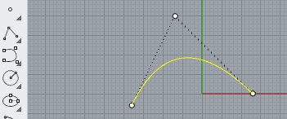

Shipbuilders of old used splines.

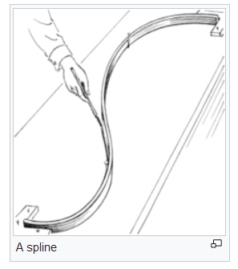
“Control points” were called “ducks”.

Now to spefiy our curve we only need to specify 3 points. The NURBS” formula can then be used to reconstruct the curve we specify.along with the 3 points.

A curve usually has more thatn one control polint- detemined by the “degree” of the curve.

Curves in Rhino are NURBS
A Bezier curve is a special case of a NURBS. It was used by Renot to design cars.
Take a look at the complicity of the furmalas used to reconstruct ths curve and some lovely animations twords the bottom of the page showing how they are constructed.
https://en.wikipedia.org/wiki/B%C3%A9zier_curve

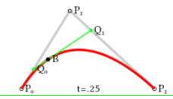

Use the Grasshopper ie Add Control Points control:

Control points:

Weights

Knots (These act with the control points and the weights to produce the final curve.)

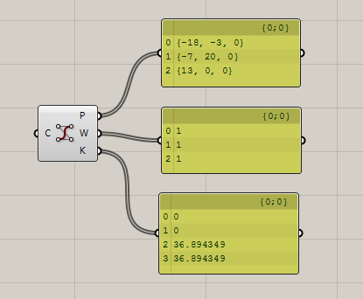
https://www.codeproject.com/Articles/1095142/Generate-and-understand-NURBS-curves
not great

Add NURBS Curve
https://developer.rhino3d.com/samples/rhinocommon/add-nurbs-curve/

using Rhino.Collections;

private void RunScript(object x, object y, ref object A)
{
Point3dList points = new Point3dList(5);

points.Add(-18, -3, 0);
points.Add(-7, 20, 0);
points.Add(13, 0, 0);

Rhino.Geometry.NurbsCurve nc = Rhino.Geometry.NurbsCurve.Create(false, 2, points);

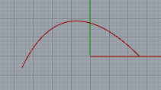
A = nc;
}

To get points:

Point3d pt = new Point3d();
List <Point3d> L = new List <Point3d>();
for (int i = 0; i <= nc.Points.Count-1 ; i++)
{
var T = nc.Points.GetPoint(i, out pt);
L.Add(pt);
}
B = L;
-------------------------

NurbsMove.gh
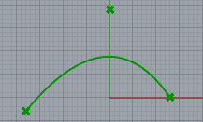
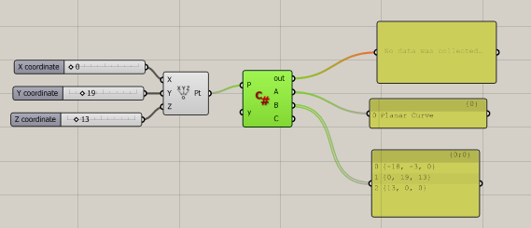

private void RunScript(Point3d P, object y, ref object A, ref object B)
{
Point3dList points = new Point3dList(5);

points.Add(-18, -3, 0);
points.Add(P); //points.Add(-7, 20, 0);
etc

http://james-ramsden.com/offset-a-curve-using-the-c-component-in-grasshopper/

private void RunScript(Curve inputCurve, object y, ref object A)
{
NurbsCurve crv = new NurbsCurve(inputCurve.ToNurbsCurve()); //input curve to use as offset base
Point3d origin = new Point3d(0, 0, 0);
Vector3d vectxy = new Vector3d(0, 0, 1);
Plane xy = new Plane(new Point3d(0, 0, 0), vectxy);

Curve[] crv4 = crv.Offset(xy, 1, 0.01, 0); //Get the offset curve array. An array of CURVES.

int c = crv4.Length; // Only ONE curve!

Print(c.ToString());

NurbsCurve[] crv3 = new NurbsCurve[c]; //Make a new array of NURBSCURVES with the size of crv4.count. (Error use .Length!)

for (int x = 0; x < c; x++)
{
//Loop through the Curve[] array of curves.
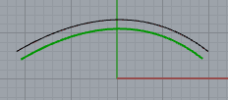
crv3[x] = new NurbsCurve(crv4[x].ToNurbsCurve()); //Convert each Curve into a NurbyCurvey
}
A = crv3;
//A = crv4; / WOrks as well.

}

A=xy;

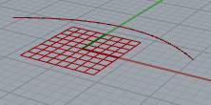

Works for multiple curves:

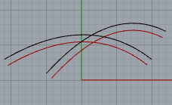

http://james-ramsden.com/data-trees-and-c-in-grasshopper/
3-D Objects

There are two (three?) definitions of 3 dimensional objects in Grasshopper.

1. A continuous single NURBS surface. Its shape is determined by control points.

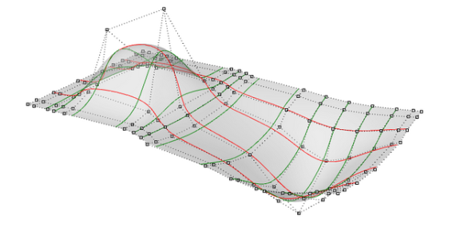

2. The other is the BRFEP, this can be a composition of multiple surfaces. Hence the term Brep, or boundary representation. Also called Polysurface.

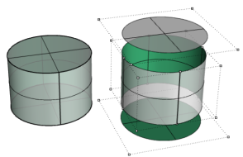

3. MESH? Consists of triangles and quadrilaterals.

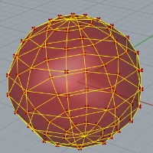

BREP:

NURBS SURFACE

SrfPt command

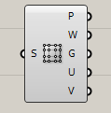
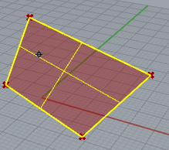

See NurbsSurface in this manual

MESH

From Rhino:

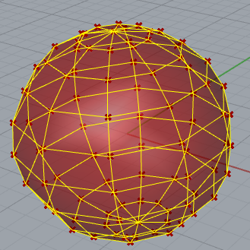
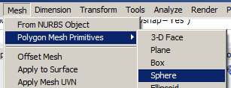

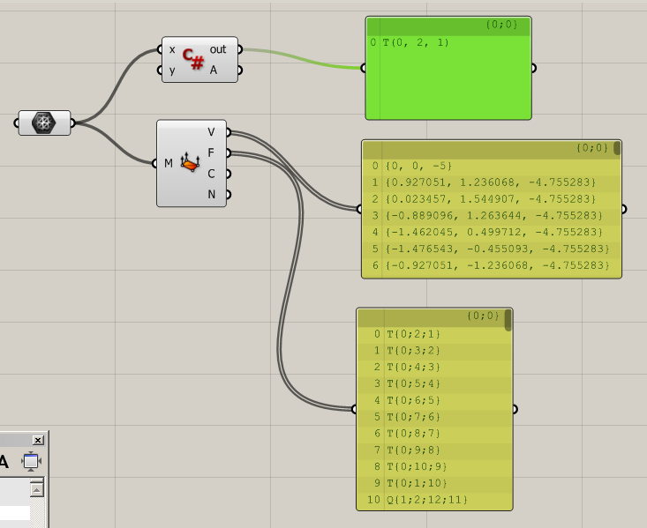

saved as mesh.gh

Print(x.Faces.GetFace(0).ToString());

To create a mesh

http://james-ramsden.com/the-mesh-data-structure-in-grasshopper/

James Ramsden

The mesh data structure in Grasshopper

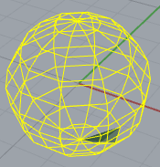
Private void RunScript(Mesh mesh, ref Object A)
{
//1) Let's read from an existing mesh

//get faces from mesh
List<MeshFace> faces = new List<MeshFace>();
foreach(MeshFace face in mesh.Faces)
{
faces.Add(face);
}
Colours green this face of (any) mesh drawn.
//get vertices from mesh
List<Point3d> vertices = new List<Point3d>();
foreach(Point3d vertex in mesh.Vertices)
{
vertices.Add(vertex);
}

//2) Let's get the coordinates for a mesh face

//get the indices for the 10th face
int[] indices = new int[4];
indices[0] = mesh.Faces[10].A;
indices[1] = mesh.Faces[10].B;
indices[2] = mesh.Faces[10].C;
indices[3] = mesh.Faces[10].D;

//We can now get the coordinates for the 10th face from these indices
Point3d[] facepts = new Point3d[4];
for (int i = 0; i <4; i++)
{
facepts[i] = mesh.Vertices[indices[i]];
}

//3) Let's make a new mesh from scratch

Mesh rtnmesh = new Mesh();
//for the new mesh, we first need to define the vertices
//we can add any points we like - let's just copy over the vertices list
rtnmesh.Vertices.AddVertices(vertices);
//now let's make a face and add it to the (currently empty) face list
MeshFace tempface = New MeshFace(0, 1, 12, 11);
rtnmesh.Faces.AddFace(tempface);

A = rtnmesh;

}

Ramsden

private void RunScript(object x, object y, ref object A)
{
Rhino.RhinoApp.RunScript("Save", true);
}
-----------------------------------------------------------------------------------------------------------

private void RunScript(object x, object y, ref object A)
{

GrasshopperDocument = Instances.ActiveCanvas.Document;

Print(GrasshopperDocument.DisplayName.ToString());

}
-------------------------------------------------------------------

Print(RhinoDoc.ActiveDoc.Name.ToString());

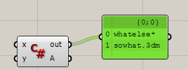

must have named doc.

-------------------------------------------------------------------------------------------------------------

System.Windows.Forms.MessageBox.Show("If you're happy and you know it, clap your hands");

Mesh line intersections in Grasshopper in C#
http://james-ramsden.com/mesh-line-intersections-in-grasshopper-in-c/

How to colour a mesh using the C# component in Grasshopper
http://james-ramsden.com/how-to-colour-a-mesh-using-the-c-sharp-component-in-grasshopper/

We set each node to a colour

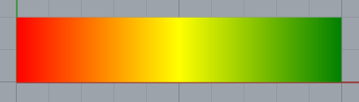

using System.Drawing; // For color

private void RunScript(object x, object y, ref object A)
{
//Declare an empty mesh
var mesh = new Mesh();

//create vertices
mesh.Vertices.Add(0, 0, 0);
mesh.Vertices.Add(5, 0, 0);
mesh.Vertices.Add(5, 2, 0);
mesh.Vertices.Add(0, 2, 0);
mesh.Vertices.Add(10, 0, 0);
mesh.Vertices.Add(10, 2, 0);

//Create colour list. The vertex [i] is coloured by the value at VertexColors[i]
//The VertexColors list MUST be the same length as the vertices list.

mesh.VertexColors.Add(Color.Red);
mesh.VertexColors.Add(Color.Yellow);
mesh.VertexColors.Add(Color.Yellow);
mesh.VertexColors.Add(Color.Red);
mesh.VertexColors.Add(Color.Green);
mesh.VertexColors.Add(Color.Green);

//Create faces using vertex indices
mesh.Faces.AddFace(0, 1, 2, 3);
mesh.Faces.AddFace(1, 4, 5, 2);

//return mesh
A = mesh;
}

TO draw the grid:

Point3d[] P = mesh.Vertices.ToPoint3dArray();
Polyline p = new Polyline(P);

A = p;

A simple timer example for the Grasshopper C# component

-----------------------------------------------------------------------------------------------------

https://issuu.com/knazar/docs/csharpforgh_reference_1sted

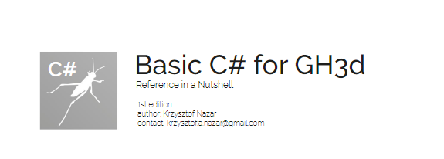

good summary. use this as outline (but cant download it)

--------------------------------------------------------------------------------------------------------------

--------------------------------------------------------------------
to prieview can use a control rather than A=
eg custom display vector or something
-----------------------------------------------------------------

RhinoCommon Duplicate Object whatever.gh

using Rhino.Commands; // For Result
using Rhino.DocObjects; // For ObjRef
using Rhino.Input; // For GetResult

private void RunScript(object x, object y, ref object A)
{
var d = RhinoDoc.ActiveDoc;

Result rc = DuplicateObject(d);
//A = rc.ToString();
}
public static Result DuplicateObject(RhinoDoc doc)
{
ObjRef obj_ref;

var rc = RhinoGet.GetOneObject("Select object to duplicate", false, ObjectType.AnyObject, out obj_ref);

if (rc != Result.Success) return rc;

var rhino_object = obj_ref.Object();

var geometry_base = rhino_object.DuplicateGeometry();

if (geometry_base != null)
if (doc.Objects.Add(geometry_base) != Guid.Empty)
doc.Views.Redraw();

return Result.Success;
}
------------------------------------------------------------
Duplicate Object (Paraphrased form)

using Rhino.Commands; // For
using Rhino.DocObjects; // For
using Rhino.Input; // For

var D = RhinoDoc.ActiveDoc.Objects.Document;

var E = DuplicateObject(D);

A = E;
public static Result DuplicateObject(RhinoDoc doc)

{
ObjRef obj_ref;
var rc = RhinoGet.GetOneObject("Select your object to duplicate", false, ObjectType.AnyObject, out obj_ref);

var rhino_object = obj_ref.Object();

var geometry_base = rhino_object.DuplicateGeometry();

if (geometry_base != null)
if (doc.Objects.Add(geometry_base) != Guid.Empty)
doc.Views.Redraw();

return Result.Success;
}
code for videos

Line L1 = new Line(new Point3d(5, 5, 0), new Point3d(25, 15, 0));
Line L2 = new Line(new Point3d(5, 15, 0), new Point3d(25, 5, 0));

double a,b;

bool S = Rhino.Geometry.Intersect.Intersection.LineLine(L1, L2, out a, out b);

A = a;
B = b;
C = L1;
D = L2;
------------------------------------------------------------------
Line L1 = new Line(new Point3d(5, 5, 0), new Point3d(25, 15, 0));

Line L2 = L1;

Transform tr1 = Transform.Rotation(Math.PI/6,new Point3d(15,10,0));

bool S = L1.Transform(tr1);

A = L1;

B = L2 ;
------------------------------------------------------------

Polyline

You might be forgiven to think that a polyline is a collection of Lines:

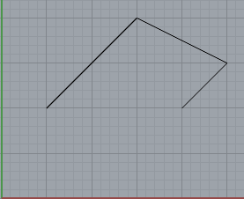

Its not – it’s a Collection of POINTS.

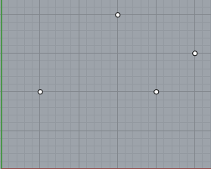

Polyline PL = new Polyline(pts);
AddRange

Adds the elements of the specified collection to the end of the List.
-------------------
microsoft :
https://docs.microsoft.com/en-us/dotnet/api/system.collections.generic.list-1.addrange?view=netframework-4.8

List<T>.AddRange(IEnumerable<T>) Method
Namespace: System.Collections.Generic Adds the elements of the specified collection to the end of the List<T>.

public void AddRange (System.Collections.Generic.IEnumerable<T> collection);
--------------------------------------------------
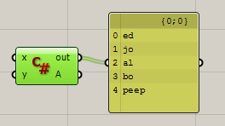

private void RunScript(object x, object y, ref object A)
{
List < string > students = new List<string>{"ed","jo"};

// students.Add("al"); This is how we add one element.

string[] pets = new string []{"bo", "peep"};

students.AddRange(pets); // but this is how we add an Ienumerable list.

PrintAll(students);
}
// <Custom additional code>

void PrintAll(List < string > students)
{
foreach (string d in students)

Print(d.ToString());
}
// </Custom additional code>

--------------------------------

RhinoCommon:

public void AddRange(
IEnumerable<T> collection
)
-------------------------------

addrange.gh

A Polyline is a collection of points:

Polyline Constructor (IEnumerable<Point3d>)

public Polyline(
IEnumerable<Point3d> collection

--------------------------------------------
private void RunScript(object x, object y, ref object A)
{

Point3d[] pts = new Point3d[]{new Point3d(0, 0, 0),new Point3d(10, 10, 0)}; // An (Ienumerable) Array of points.
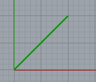
Polyline PL = new Polyline(pts);

Polyline TotPL = new Polyline(); // For the whole building

TotPL.AddRange(PL); // We are adding a COLLECTION of points!
// A Polyline is a collection of points so we must use Addrange rather than Add.
A = TotPL;
}

Of course we could now add ANOTHER polyline to TotPL using AddRange again.

If we try to use .Add to the polyline it only offers us Add a point not a line.

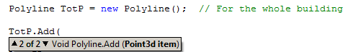

----------------------------------------------------------------------

x.Domain = new Interval(0, 1);

reparameterize

Reference Objects

“Strange behaviour.”
A Polyline is a reference type.

First draw a Polyline – and rotate it by 30 deg.

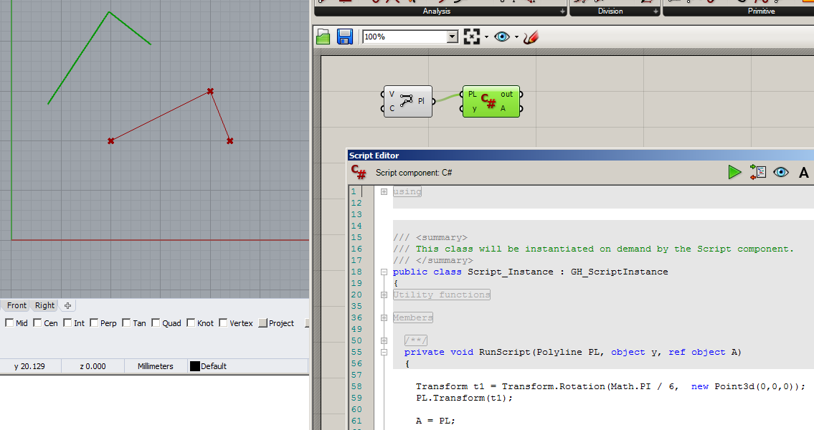

So far so good.
But now make a new Polyline and out it equal to the original Polyline.

private void RunScript(Polyline PL, object y, ref object A)
{
Or:
Polyline PL1 = new Polyline();
PL1= PL;

Polyline PL1 = PL;

Transform t1 = Transform.Rotation(Math.PI / 6, new Point3d(0,0,0));
PL.Transform(t1);
… and output PL1.
A = PL1;
}
PL1 has been rotated as well! ie PL1 and PL are ONE AND THE SAME THING.
So when we say:
PL1 = Polyline whtever happens to one happens to the other.
Technically Polyline PL1 = Polyline has the effect of giving the address of PL to PL1! ie they both REFER to thte same object. This is the way reference objects behave.

If we want out 2nd object to behave differently then we must DUPLICATE it as follows:.

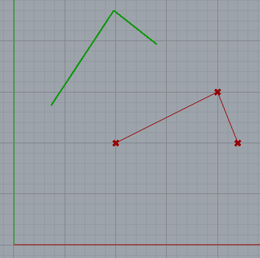

Try this ie Duplicate PL.:

private void RunScript(Polyline PL, object y, ref object A)
{

Polyline PL1 = PL.Duplicate();

Transform t1 = Transform.Rotation(Math.PI / 6, new Point3d(0, 0, 0));

PL.Transform(t1);

A = PL1;

}

Now PL1 is not rotated as well. (You may wish to check that Polyline IS rotated still ie A = PL.)

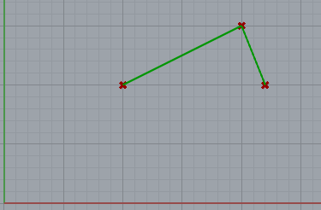

Summary:

PL1 = PL creates another REFERENCE to the same object.
SO now what ever happens to one happens to the other.

private void RunScript(object x, object y, ref object A)
{
e1.seti(0);
e2 = e1;
e2.seti(2);

A = e1.geti(); // -> 2!
}

// <Custom additional code>

Ed e1 = new Ed();
Ed e2 = new Ed();

public class Ed
{
private int i;

public void seti(int _i)
{
i = _i;
}
public int geti()
{
return i;
}
}
----------------------------------------------------
private void RunScript(object x, object y, ref object A)
{
e1.i=0 ;

e2 = e1 ;

e2.i= 2 ;

A = e1.i ; // -> 2!

}

// <Custom additional code>

Ed e1 = new Ed();
Ed e2 = new Ed();

public class Ed // Change to struct // -> 0 !(Try this first!)
{
public int i;
}
-----------------------------------------------

A List of Lines

private void RunScript(object x, object y, ref object A)
{
Line L1 = new Line(0, 0, 0, 10, 10, 0);
Line L2 = new Line(10, 10, 0, 15, 5, 0);

List<Line> xtLines = new List<Line>();

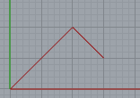
xtLines.Add(L1); // We don’t need to use AddRange cf Polyline.
xtLines.Add(L2);

A = xtLines;
}

Note how we can send a List to the 3D output and it draws the Lines!.

