Internet & Email

Email

There are two main types : 1. Web-based eg Hotmail, Yahoo Outlook and 2. etc.

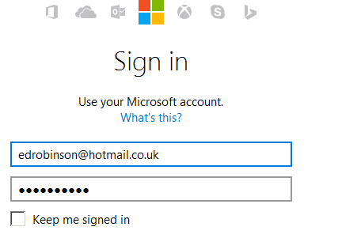
1. Web-based eg Hotmail: Start the Browser eg Mozilla and start you Hotmail or Yahoo etc

- Sign In.

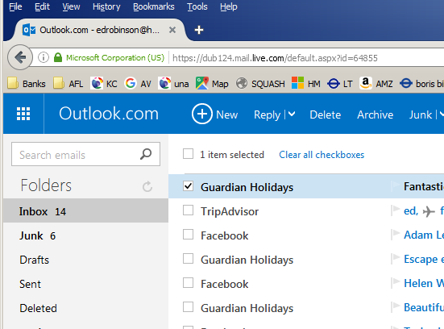

- Note the folders and their purpose.

What is a draft? How would you
make one?

- To send a new email click on New above.
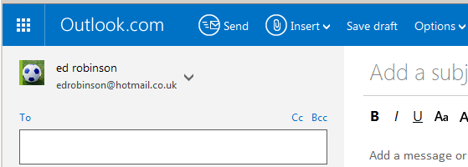

- Type in the address You could send to yourself! or eg edrobinson@hotmail.co.uk)

- What is the purpose of Cc and Bcc. What’s the difference?

- Note that you can also apply formatting. But you must be in Rich Text.
(See Options (In the blue bar for Rich Text.)

- Click Send etc.
Exercises:

1. Make a Word Document. Note where you save it (Probably best on the Desktop.)

2. Send it as an attachment.
- Click Insert etc.

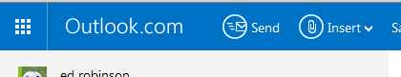

3. Send another email but this time copy and paste the contents of the Word document into an email and send it.

4. Practise a Reply.

5. Practise a Forward. (Sometimes after you have sent an email to a wrong address you may have trouble sending it with the correct address. It may then be more convenient to forward it.)

5. Send an excel spreadsheet as an attachment.

2. Outlook

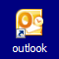
- Double-click
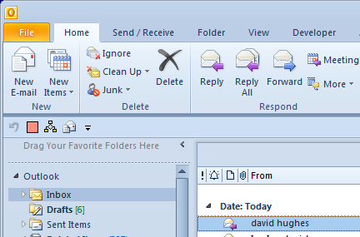

Inbox

Sent Items

- Make a new email.
Exercises:

1. Attach a PowerPoint presentation.

2. Copy and paste some text from a Word document into the email

3. Practice deleting a lot of emails in the Deleted folder.

Remember that to select ALL , use Ctrl-A.
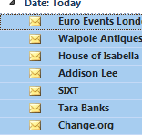

Remember To Select various use click with the Ctrl- Key
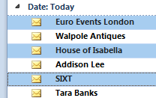

Remember To Select contiguous use click with the Shift- Key
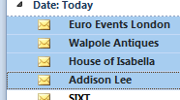

4. Make a new folder to store special emails (Sent or received) and transfer some emails to it.

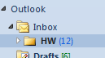
eg a HW (Homework) folder.
Note that the (12) means that there are 12 unread.

Note that Outlook is more that email.

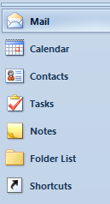
Email
Plan your day. Set alarms.
Organize your addresses.
Check off things to do.

Browsing

Internet Explorer Mozilla Firefox Google Chrome
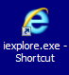
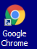
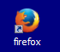

eg Mozilla
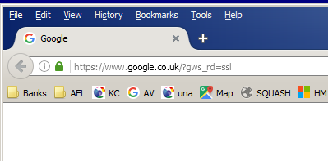

Practice:

- Save as Favourite (Internet Explorer) or as a BookMark (Mozilla)
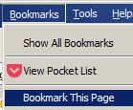
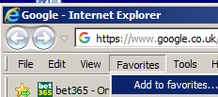

- Set the Home Page. (The Home Page is the one that opens first when you start your browser ie the default page.
Tools, Options etc.

- View all the Menu Items (Right-click on the title)

- View the History.

- View the HTML (Advanced)

- Save the Page. (Note that sometimes when you save the page itwill get saved as a Folder and an HTML page which serve to “Parachute “ open the files in the folder.
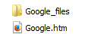

- Making your own web site! Get a Name for yourself First eg http://www.virtualnames.co.uk/ etc

- Save a Word document as web page and open it in your Browser (Advanced)

