mvnpdf mvnpdf
Matlab

http://www.una.co.uk/

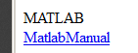

Exercise: Find the inverse of a 2x2 matrix from “first principles” and using inv().

string handling
eg
p = '<Person>'
st = '<Table1><Person>ed<\Person></Table1>';
l=length(p)
pos1=strfind(st,'<Person>')+l
pos2=strfind(st,'<\Person>')
st(pos1:pos2-1)

Matlab and Finance

http://finance.bi.no/~bernt/gcc_prog/

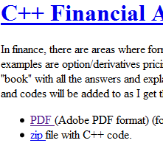

- Open

Page 18:

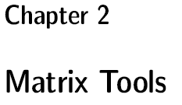

and try all the financial examples!

Code:

- Some of the Matlab code examples can be found here.

ie here:

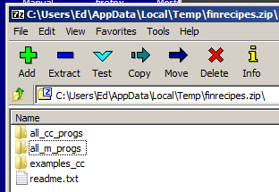

see vbaFinancial Math VBAver1.doc stats.xlsm variances1 see labels sheet

 | X | Y | l/hand |  |  | calculated | Ɣ | (gamma)
month1 | 1.0 | 3.0 | 2.0 | = c3*ga+(1-ga)*d3 |  | 3.25 | 0.500
month2 | 2.0 | 3.5 | 2.8 | = c4*ga+(1-ga)*d4 |  | 1.625
month3 | 3.0 | 7.0 | 5.0 | = c5*ga+(1-ga)*d5 |  | = Ɣ ^2*vX+(1- Ɣ)^2*vY+2* Ɣ *(1- Ɣ)*cXY
covXY | 1.33
mean | 2.0 | 4.5 | 3.25 | =AVERAGE(E3:E5)
var | 0.67 | 3.17 | 1.625 | =VARP(e3:e5) etc
 |  |  | same

The overall mean is 3.25
Exercise: Expand:

Expand:

clc;

syms L M g XX XY YY X real
L = [g 1-g]
M= [XX XY; XY YY]
X=L*M*L'
expand(X)
etc

Using Matlab:

clc;
% page 138 Benninga

X=[1,2,3];
Y=[3,3.5,7];

mX=mean(X);
mY=mean(Y);
M = [mX ; mY]

% L=[0:.1:.4]
ga=0.5;
L = [ga ; 1-ga];

mXY =L'* M % or mXY =M' *L or mXY =L*mX+(1-L)*mY

M =
2.0000
4.5000
L =
0.5000
0.5000
mXY =
3.2500

The overall variance is 1.625

cov(X,Y,1) -> 0.6667 1.3333
1.3333 3.1667

L'*cov(X,Y,1)*L -> 1.6250

For 3 shares

X Y Z
1.0000 3.0000 1.0000
2.0000 3.5000 2.0000
3.0000 7.0000 3.0000

clc;
format compact
X=[1,2,3];
Y=[3,3.5,7];
Z=[1,2,3];

A = [X' Y' Z']

ga1=0.5;ga2=0.25;ga3=(1-ga1-ga2);
L = [ga1 ; ga2; ga3 ];

cov(A,1)

L'*cov(A,1)*L

ans =
0.6667 1.3333 0.6667
1.3333 3.1667 1.3333
0.6667 1.3333 0.6667
ans =
1.0729

This is the overall variance.

good beg ref:
http://www.ise.ncsu.edu/kay/Basic_Concepts_in_Matlab.pdf

Frontier for 2 assets

clc;

X=[1,2,3];
Y=[3,3.5,7];

A = [X' Y']

mX=mean(X);
mY=mean(Y);
M = [mX ; mY];

ga=[0:.1:2]';
L = [ga 1-ga]

mXY =L*M; % or mXY =L*mX+(1-L)*mY

C= cov(A,1);
D = L * C * L';
varXY=diag(D)

plot (varXY,mXY)

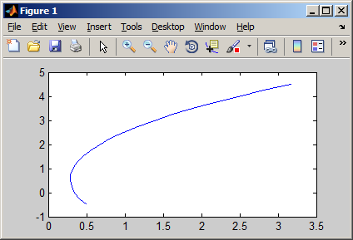

see
Chapter 6
The Mean Variance Frontier
page68 of Odegaarfds pdf!

Matlab Finance Odegaard Examples

from recipes.pdf from http://finance.bi.no/~bernt/gcc_prog/ pdf file

The value of time page 27

(Page numbers are the actual page numbers according to the editor)

Example

An investment project has an investment cost of 100 today, and produces cash flows of 75 each of the next two years. What is the Net Present Value of the project?

clc;
C=[-100 75 75]
t=[0 1 2]
r = 0.1
d=(1/(1+r)).^t
NPV=C*d'

C =
-100 75 75
t =
0 1 2
r =
0.1000
d =
1.0000 0.9091 0.8264
NPV =
30.1653

Find the internal rate of return of this sequence of cash flows.

Matlab program:

IRR = irr(C)

IRR =
0.3187

3.3 Continuously compounded interest page 35

Example

1. Given a 15% interest rate with monthly compounding, calculate the equivalent interest rate with continuous compounding.
2. Given a 12% interest rate with continuous compounding, find the equivalent interest rate with quarterly compounding.
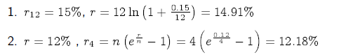

Matlab program:

r = 12 * log( 1+0.15/12)
r4 = 4 * ( exp(0.12/4)-1 )

Output from Matlab program:
r = 0.14907
r4 = 0.12182

Bond Pricing with a flat term structure page 37

Example

A 3 year bond with a face value of $100 makes annual coupon payments of 10%.
The current interest rate (with annual compounding) is 9%.

- Determine the current bond price.

Matlab program:

C =[10,10,110]
t = 1:3
r = 0.09
d=(1./(1+r).^t)
B= d * C'

Output from Matlab program:
C =
10 10 110
t =
1 2 3
r = 0.090000
d =
0.91743 0.84168 0.77218
B = 102.53

4.1.2 Yield to maturity page 39

Example
A 3 year bond with a face value of $100 makes annual coupon payments of 10%. The current interest rate (with annual compounding) is 9%.

- Find the bond’s current price.

- Find the bond’s yield to maturity.

Matlab program:

C = [ 10 10 110 ];
t = 1:3;
r=0.09;
B = C * (1./((1+r).^t))'
y = irr([-B C ])

Output from Matlab program:
B = 102.53
y = 0.090000

4.1.3 Duration

Example page 42

A 3 year bond with a face value of $100 makes annual coupon payments of 10%.
The current interest rate (with annual compounding) is 9%.

- Determine the current bond price.

- Calculate the duration using the current interest rate.

- Calculate the duration using the MaCaulay definition.

Matlab program:

C =[10,10,110];
t = 1:3;
r = 0.09;
B= C * (1./(1+r).^t)'
D= (1/B)*t.* C * (1./(1+r).^t)'
y = irr([-B C ])
DM= (1/B)*t.* C * (1./(1+y).^t)'

Output from Matlab program:
B = 102.53
D = 2.7390
y = 0.090000
DM = 2.7390

Continually Compounding Interest page 48

Example page 50

A 3 year bond with a face value of $100 makes annual coupon payments of 10%. The current interest rate (with continuous compounding) is 9%.

1. Calculate the bond’s price, yield to maturity, duration and convexity.
2. Suppose the interest rate falls to 8%. Estimate the new bond price using duration, and compare with the actual bond price using the correct interest rate.

Calculations:
Matlab program:

C =[10,10,110]
t = 1:3
r = 0.09
d=(1./(1+r).^t)
B= C * d'
D=1/B*C.*t*d'
Dadj=D/(1+r)
r=0.1
actualB = C*(1./(1+r).^t)'

5.3.2 Interpolated term structure class.

Linear interpolation of yields. Note that the algorithm assumes the yields are ordered in increasing order of time to maturity.

Example

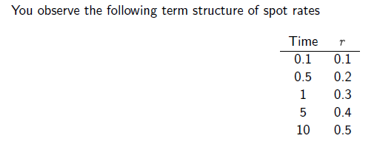

Interpolate spot rates (zero rates) at times 0.1, 0.5, 1, 3, 5 and 10.

Output from C++ program: (Write the same in Matlab)

yields at times:
t=0.1 0.1
t=0.5 0.2
t=1 0.3
t=3 0.35
t=5 0.4
t=10 0.5

Interval bisection and Newton Raphson

Black Scholes

First: chapter 16 Benniga page 297

The Implied Variance (the Variance for a given S,X, T & r is done by 2 methods.

- The s/sheet method of looking at the graph of C vs sigma (pagae301) and then some interpolation or
- Using the VBA function to calculate precisely by interval bisection (page304)

Discussion:
Interval bisection: y = x^2 -1. start with x = 1.5 high and .5 low.

Newton Raphson: y = x^2 -1. start with x = 1.5.

C++ Code:

#include <iostream>
#include <cmath>
using namespace std ;

int main(void)
{
double xl = .50, xr = 1.5 ;
double xm , fl , fm , fr ;

for(int i = 1 ; i <= 8 ; i++)
{
xm =(xl + xr)/2 ;

fl = pow(xl,2.0)-2.0 ;
fm = pow(xm,2.0)-2.0 ;
fr = pow(xr,2.0)-2.0 ;

if (fm * fr < 0)
xl = xm ;
else
xr= xm ;

}

cout << xm << endl ;

cin.get() ;
return 0 ;
}

///////////////////////////////////////////////////////////

#include <iostream>
#include <cmath>
using namespace std ;

int main(void)
{

double x = 1.5 ;

for(int i = 1 ; i <= 8 ; i++)
{

x = x - (pow(x , 2.0) - 2)/(2.0 * x ) ;

}

cout << x << endl ;

cin.get() ;
return 0 ;

}

To Solve X^2 – 2 = 0

#include <iostream>
#include <cmath>
using namespace std ;

int main(void)
{

double x = 1.5 , prevx = 0.00;

while(true)
{

x = x - (pow(x , 2.0) - 2)/(2.0 * x ) ;

cout << x << endl ;

if (abs(prevx - x) < .000001) break ;
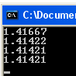
prevx = x ;

}

cin.get() ;
return 0 ;
}
///////////////////////////////////////////////////

#include <iostream>
#include <cmath>
using namespace std ;

int main(void)

double x = 1.5 , prevx = x ;
double diff ;

do
{

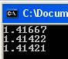
x = x - (pow(x , 2.0) - 2)/(2.0 * x ) ;

diff = prevx - x ;

cout << x << endl ;

prevx = x ;

} while( diff > 0.001 ) ;

cin.get() ;
return 0 ;
}

Chapter 6
The Mean Variance Frontier page 68

Example

An investor can invest in three assets with expected returns and variances as specified in the following table.

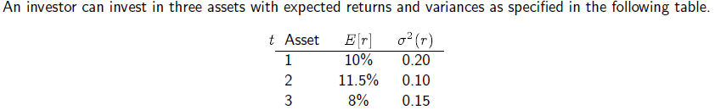

The three assets are independent (uncorrelated).

1. Determine the expected return and standard deviation of an equally weighted portfolio of the three
assets

Matlab program:

e=[0.1 0.11 0.08]
V=[ 0.2 0 0; 0 0.1 0 ; 0 0 0.15]
w=1/3*[1 1 1]
er= e*w'
sigma=sqrt(w*V*w')

Output from Matlab program:

e =
0.1000 0.1100 0.0800
V =
0.2000 0 0
0 0.1000 0
0 0 0.1500
w =
0.3333 0.3333 0.3333
er =
0.0967
sigma =
0.2236

6.3 Calculation of frontier portfolios page 70

Example page 71

An investor can invest in three assets with expected returns and variances as specified in the following table.

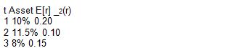

The three assets are independent (uncorrelated).
What are the weights of the minimum variance portfolio with mean 9%?

Matlab program:

e=[0.1 0.11 0.08]'
V=[ 0.2 0 0; 0 0.1 0 ; 0 0 0.15]
r=0.09
n = length(e)
a = ones(1,n)* inv(V)*e
b = e'*inv(V)*e
c = ones(1,n)* inv(V)*ones(n,1)
A = [b a;a c]
d = det(A)
g = 1/d*(b*ones(1,n) - a*e')* inv(V)
h = 1/d*(c*e' - a*ones(1,n))* inv(V)
w = g+h*r

Output from Matlab program:
e =
0.1000
0.1100
0.0800
V =
0.2000 0 0
0 0.1000 0
0 0 0.1500
r = 0.0900
n = 3
a = 2.1333
b = 0.2137
c = 21.6667
A =
0.2137 2.1333
2.1333 21.6667
d = 0.0783
g =
0.0213 -2.6809 3.6596
h =
2.1277 31.9149 -34.0426
w =
0.2128 0.1915 0.5957

This calculation is put into a Matlab function in Matlab Code 6.1.

function w = min variance portfolio(e,V,r)
n = length(e);
a = ones(1,n)*inv(V)*e;
b = e’*inv(V)*e;
c = ones(1,n)*inv(V)*ones(n,1);
A = [b a;a c];
d = det(A);
g = 1/d*(b*ones(1,n) 􀀀 a*e’)*inv(V);
h = h = 1/d*(c*e’ - a*ones(1,n))*inv(V);
w=g+h*r;
end

Matlab Code 6.1: Calculation of minimum variance portfolio for given return

Matlab program:

e=[0.1 0.11 0.08]
V=[ 0.2 0 0; 0 0.1 0 ; 0 0 0.15]
w=1/3*[1 1 1]
er= e*w’
sigma=sqrt(w*V*w’)

6.13 Mean variance analysis using matrix libraries page 78

use newmat

Example
Mean variance calculations.
e = _ 0:05
0:1 _
V = _ 1:0 0:0
0:0 1:0 _
Calculate mean, variance and stdev for portfolio
w = _ 0:5

0:5 _

Futures algorithms. page 82

convert the C++ code to Matlab

Chapter 8
Binomial option pricing

Chapter 9
Basic Option Pricing, the Black Scholes
formula

Matlab Code 9.1: Price of European call option using the Black Scholes formula
91

Example
Stock in company XYZ is currently trading at 50. Consider a call option on XYZ stock with an exercise price
of K = 50 and time to maturity of 6 months. The volatility of XYZ stock has been estimated to be _ = 30%.
The current risk free interest rate (with continuous compounding) for six month borrowing is 10%.
1. Determine the option price.
To calculate the price of this option we use the Black Scholes formula with inputs S = 50, K = 50, r = 0:10,
_ = 0:3 and (T 􀀀 t) = 0:5.

Matlab program:
S = 100;
K = 100;
r = 0.1;
sigma = 0.1;
time = 1;
c = black scholes call(S,K,r,sigma,time)

Output from Matlab program:
c = 10.308

9.3.3 Implied Volatility.

write Matlab code for interval bisection etc

done previously

Chapter 12
Option pricing with binomial approximations
C++ Code 12.2: Price of American call option using a binomial approximation
Actually, for this particular case, the american price will equal the european.

12.2.3 Matlab implementation
To illustrate differences between Matlab and C++, consider the two implementations in Matlab Code 12.1
and Matlab Code 12.2. The calculation of a put is more compact, with less loops, by some judicious use of array indexing.

function c = bin am call( S, K, r, sigma,t,steps)
R = exp(r*(t/steps));
Rinv = 1.0/R;
u = exp(sigma*sqrt(t/steps));
d = 1.0/u;
p up = (R􀀀d)/(u􀀀d);
p down = 1.0􀀀p up;
prices = zeros(steps+1);
prices(1) = S*(d^steps);
uu = u*u;
for i=2:steps
prices(i) = uu*prices(i􀀀1);
end
call values = max(0.0, (prices􀀀K));
for step=steps:􀀀1:1
for i=1:step+1
call values(i) = (p up*call values(i+1)+p down*call values(i))*Rinv;
prices(i) = d*prices(i+1);
call values(i) = max(call values(i),prices(i)􀀀K);
end
end
c= call values(1);
end

function p = bin am put( S, K, r, sigma, t, steps)
R = exp(r*(t/steps));
Rinv = 1.0/R;
u = exp(sigma*sqrt(t/steps));
d = 1.0/u;
p up = (R􀀀d)/(u􀀀d);
p down = 1.0􀀀p up;
prices = zeros(steps+1,1);
prices(1) = S*(d^steps);
uu = u*u;
for i=2:steps+1
prices(i) = uu*prices(i􀀀1);
end
values = max(0.0, (K􀀀prices));
for step=steps:􀀀1:1
values = Rinv * ( p up*values(2:step+1) + p down*values(1:step) );
prices = u*prices(1:step);
values = max(values,K􀀀prices);
end
p=values(1);
end

Matlab Code 12.2: Price of American call using a binomial approximation

Chapter 14
Option pricing by simulation

Normal Distribution approximations. page 232

convert this code:
using namespace std;
double N(const double& z) {
if (z > 6.0) { return 1.0; }; // this guards against overflow
if (z < 􀀀6.0) { return 0.0; };
double b1 = 0.31938153;
double b2 = 􀀀0.356563782;
double b3 = 1.781477937;
double b4 = 􀀀1.821255978;
double b5 = 1.330274429;
double p = 0.2316419;
double c2 = 0.3989423;
double a=fabs(z);
double t = 1.0/(1.0+a*p);
double b = c2*exp((􀀀z)*(z/2.0));
double n = ((((b5*t+b4)*t+b3)*t+b2)*t+b1)*t;
n = 1.0􀀀b*n;
if ( z < 0.0 ) n = 1.0 􀀀 n;
return n;
};

see Utilize Library For Financial Numerical Recipes In Cver1.docx
or following. (Convert to Matlab)

and chapter 14 of recipes.pdf
Chapter 14
Option pricing by simulation

Monte Carlo

Lognormal distribution ch 15 page 276 Benniga for general info.

Security price over time can be modeled by lognormal.

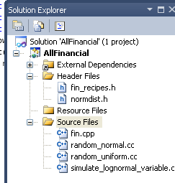
Page 143 Odegaard.

#include "normdist.h"
#include "fin_recipes.h"
#include <iostream>
using namespace std;

int main(void)
{
double K = 100 ;
double r = .1 ; // mean return is 10%
double sigma = .25 ; // mean sd is 25%
double t = 1 ; // over 1 day.

cout << simulate_lognormal_random_variable(K,r,sigma,t);

cin.get() ;
1 simulation.
return 0 ;
}
simulate_lognormal_variable.cc
From all_cc_progs.

#include <cmath>
using namespace std;
#include "normdist.h"

double simulate_lognormal_random_variable(const double& S, // current value of variable
const double& r, // interest rate
const double& sigma, // volatitily
const double& time) { // time to final date
double R = (r - 0.5 * pow(sigma,2) )*time;
double SD = sigma * sqrt(time);
return S * exp(R + SD * random_normal());
};
Calls the normal random number generator . Needs random_normal.cc which needs random_uniform.cc

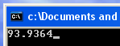
Stock price I day later. .

So take 1000 simulations:

#include "normdist.h"
#include "fin_recipes.h"
#include <iostream>
using namespace std;

int main(void)
{
double K = 100 ;
double r = .1 ;
double sigma = .25 ;
double t = 1 ;

double S ;
double sum = 0 ;
double N = 1000 ;

for (int i = 1; i <= N;i++)
{
S = simulate_lognormal_random_variable(K,r,sigma,t) ;
cout << S << endl ;
sum = sum + S ;
}

cout << "mean = " << sum/double(N) << endl ;

cin.get() ;
return 0 ;
}

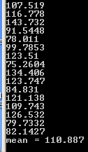

1000 values that the stock could have after 1 day.

The mean stock price is 10% inc on 100.

Option Pricing By Simulation page 142 Chapter 14 Odegaard.

#include "normdist.h"
#include "fin_recipes.h"
After examples_simulation.cc.
#include <iostream>
using namespace std;

int main(void)
{

double S=100.0; double K=100.0; double r=0.1; double sigma=0.25;
double time=1.0; int no_sims=5000;

cout << " call: black scholes price = " << option_price_call_black_scholes(S,K,r,sigma,time) << endl;
cout << " simulated price = "
<< option_price_call_european_simulated(S,K,r,sigma,time,no_sims) << endl;

// cout << " put: black scholes price = " << option_price_put_black_scholes(S,K,r,sigma,time) << endl;
// cout << " simulated price = "
//<< option_price_put_european_simulated(S,K,r,sigma,time, no_sims) << endl;

cin.get() ;
return 0 ;
Add this to project.
(option_price_call_black_scholes already added.)
}

imulated_call_euro.cc

#include <cmath> // standard mathematical functions
#include <algorithm> // define the max() function
using namespace std;
#include "normdist.h" // definition of random number generator

double option_price_call_european_simulated( const double& S,
const double& K,
const double& r,
const double& sigma,
const double& time,
const int& no_sims){
double R = (r - 0.5 * pow(sigma,2))*time;
double SD = sigma * sqrt(time);
double sum_payoffs = 0.0;
for (int n=1; n<=no_sims; n++) {
double S_T = S* exp(R + SD * random_normal());
Simulated stock price minus Exercise price. But if this is negative the payoff is zero.
sum_payoffs += max(0.0, S_T-K);
};
return exp(-r*time) * (sum_payoffs/double(no_sims));
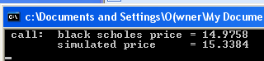
};

A.5 Simulating random normal numbers page 232

convert this C++ to Matlab

#include <cmath> // math functions.
using namespace std;
double N(const double& z) {
if (z > 6.0) { return 1.0; }; // this guards against overflow
if (z < 􀀀6.0) { return 0.0; };
double b1 = 0.31938153;
double b2 = 􀀀0.356563782;
double b3 = 1.781477937;
double b4 = 􀀀1.821255978;
double b5 = 1.330274429;
double p = 0.2316419;
double c2 = 0.3989423;
double a=fabs(z);
double t = 1.0/(1.0+a*p);
double b = c2*exp((􀀀z)*(z/2.0));
double n = ((((b5*t+b4)*t+b3)*t+b2)*t+b1)*t;
n = 1.0􀀀b*n;
if ( z < 0.0 ) n = 1.0 􀀀 n;
return

VBA Collection

Sub UseKey()

Dim collMark As New Collection

collMark.Add 30, "ed"
collMark.Add 10, "jo"
collMark.Add Item:=20, Key:="al" ' For a change

' Debug.Print collMark("ed") 'Print ed's mark

‘Print all items
Dim i As Long
For i = 1 To collMark.Count
Debug.Print collMark(i)
Next i

End Sub

30
10
20

' There are three issues with using keys in collections
'
' You cannot check if the key exists
' You cannot change the key
' You cannot retrieve the key
'
'VBA contains a class similar to the Collection called the Dictionary. With a Dictionary you always use keys to add an item. The Dictionary provides more functionality to work with keys.

VBA Dictionary

Sub SortDictionaryByKey()

'http://www.xl-central.com/sort-a-dictionary-by-key.html
'Set a reference to Microsoft Scripting Runtime by using
'Tools > References in the Visual Basic Editor (Alt+F11)- NO!
Dim Dict As Object: Set Dict = CreateObject("Scripting.Dictionary")
Dim TempDict As Object: Set TempDict = CreateObject("Scripting.Dictionary")

Dim myArr(1) As Variant ' myArr(0) and myArr(1)! Each is a Variant and as such can(and WILL be) an array! ie myArr(0)(0) etc

Dim KeyVal As Variant ', Arr() As Variant, Temp As Variant

Dim i As Long

'Set the comparison mode to perform a textual comparison
'Dict.CompareMode = TextCompare 'Doesnt work' Default is BinaryCompare anyway.

'Add keys and items to the Dictionary
Dict.Add 10, "ed"
Dict.Add 25, "jo"
Dict.Add 20, "bo"

'Dict.Add 10, "al" ' Error Cant have repeated keys!!
'Can a COLLECTION have repeated keys? Maybe I'll just have to define 2 arrays from scratch. I recall doing this ages ago and use a KEY for array access.
'NO - Sort by Item!!

'Allocate storage space for the dynamic array
ReDim arr(0 To Dict.Count - 1)

'Fill the array with the keys from the Dictionary
'For i = 0 To Dict.Count - 1
'arr(i) = Dict.Keys(i) 'Error Dont seem to be able to access individual indexed Keys.
'Next i

arr = Dict.Keys 'Use this instead

sortArray arr 'Sort the array using the bubble sort method - on the Key!

'Add the keys and items to the temporary Dictionary,using the sorted keys from the array
For i = LBound(arr) To UBound(arr)
KeyVal = arr(i)
TempDict.Add Key:=KeyVal, Item:=Dict.Item(KeyVal)
Next i

'The Items can be PRINTED ie ? TempDict.Item("ed")-> 10 but they don't appear in the debug window!?? (The KEYS do! - called Items!)

Set Dict = TempDict
Set TempDict = Nothing

printDict Dict

Debug.Print

'myArr(0) = Dict.Keys
'myArr(1) = Dict.Items

'printArray myArr(0)
'printArray myArr(1)

End Sub

Sub printDict(Dict As Object)
Dim x
For Each x In Dict 'Not sure why x works ie gives x - the KEY (Default property?). So maybe best put them into an array (See below) to print them out I guess - like they do.
Debug.Print x, Dict.Item(x)
Next x
End Sub

Sub printArray(myArr As Variant)
Dim x
For Each x In myArr
Debug.Print x
Next x
End Sub

Sub sortArray(arr() As Variant) 'arr passed by REFERENCE
Dim i As Integer, j As Integer, Temp As Variant
For i = LBound(arr) To UBound(arr) - 1
For j = i + 1 To UBound(arr)
If arr(i) > arr(j) Then
Temp = arr(j)
arr(j) = arr(i)
arr(i) = Temp
End If
Next j
Next i
End Sub

Private Sub cmdSortDict_Click()
'SortDictionaryByItem

SortDictionaryByKey
End Sub

Sub SortDictionaryByItem()
'http://www.xl-central.com/sort-a-dictionary-by-item.html

'Set a reference to Microsoft Scripting Runtime by using
'Tools > References in the Visual Basic Editor (Alt+F11)- NO!

Dim myArr(1) As Variant ' myArr(0) and myArr(1)! Each is a Variant and as such can(and WILL be) an array! ie myArr(0)(0) etc

Dim Dict As Object
Dim TempDict As Object

Set Dict = CreateObject("Scripting.Dictionary")
Set TempDict = CreateObject("Scripting.Dictionary")

'Declare the variables

Dim arr() As Variant
Dim Temp1 As Variant
Dim Temp2 As Variant
Dim Txt As String
Dim i As Long
Dim j As Long

'Set the comparison mode to perform a textual comparison
' Dict.CompareMode = TextCompare

'Add keys and items to the Dictionary
Dict.Add "Mango", "M250"
Dict.Add "Kiwi", "K150"
Dict.Add "Apple", "A325"
Dict.Add "Peach", "P350"
Dict.Add "Lime", "L275"

'Allocate storage space for the dynamic array
ReDim arr(0 To Dict.Count - 1, 0 To 1)

' 'Fill the array with the keys and items from the Dictionary
' For i = 0 To Dict.Count - 1
' Arr(i, 0) = Dict.Keys(i) 'Error Dont seem to be able to access individual indexed Keys.
' Arr(i, 1) = Dict.Items(i)
' Next i

arr = Dict.Keys 'Use this instead

'Sort the array using the bubble sort method
For i = LBound(arr, 1) To UBound(arr, 1) - 1
For j = i + 1 To UBound(arr, 1)
If arr(i, 1) > arr(j, 1) Then
Temp1 = arr(j, 0)
Temp2 = arr(j, 1)
arr(j, 0) = arr(i, 0)
arr(j, 1) = arr(i, 1)
arr(i, 0) = Temp1
arr(i, 1) = Temp2
End If
Next j
Next i

'Clear the Dictionary
Dict.RemoveAll

'Add the sorted keys and items from the array back to the Dictionary
For i = LBound(arr, 1) To UBound(arr, 1)
Dict.Add Key:=arr(i, 0), Item:=arr(i, 1)
Next i

'The Items can be printed ie ? TempDict.Item("Mango")-> M250
'but they dont appear in the debug window! (The keys do!)
'Build a list of keys and items from the Dictionary
' For i = 0 To Dict.Count - 1
' Txt = Txt & Dict.Keys(i) & vbTab & Dict.Items(i) & vbCrLf
' Next i

'Display the list in a message box
MsgBox Txt, vbInformation

End Sub

Sortdictionarybykey

Private Sub cmdSortDict_Click()
'SortDictionaryByItem
SortDictionaryByKey
End Sub
Sub SortDictionaryByItem()
'http://www.xl-central.com/sort-a-dictionary-by-item.html
'Set a reference to Microsoft Scripting Runtime by using
'Tools > References in the Visual Basic Editor (Alt+F11)- NO!
Dim myArr(1) As Variant ' myArr(0) and myArr(1)! Each is a Variant and as such can(and WILL be) an array! ie myArr(0)(0) etc
Dim Dict As Object
Dim TempDict As Object

Set Dict = CreateObject("Scripting.Dictionary")
Set TempDict = CreateObject("Scripting.Dictionary")

'Set the comparison mode to perform a textual comparison
' Dict.CompareMode = TextCompare

'Add keys and items to the Dictionary
Dict.Add "jo", 20
Dict.Add "ed", 10
Dict.Add "al", 15

myArr(0) = Dict.Keys 'Use this instead
myArr(1) = Dict.Items 'Use this instead

sortArray myArr

'Should now restore the dictionary but cant be bothered since we really only need to use TWO arrays anyway without the dictionary

printWholeArray myArr

End Sub

Private Sub sortArray(arr)

Dim i As Long, j As Long
Dim Temp1 As Variant, Temp2 As Variant

'Sort the array using the bubble sort method on the second element ie the 20, 10 & 15.
' ed 20
' jo 10
' al 15

For i = LBound(arr(1), 1) To UBound(arr(1), 1) - 1 '0 to 2

For j = i + 1 To UBound(arr(1), 1) '1 to 2

If arr(1)(i) > arr(1)(j) Then ' If 20 > 10 which it is then swap 20 <-> 10

Temp1 = arr(1)(j) ' Store 20 in Temp1 ie Temp1 <- 20
Temp2 = arr(0)(j)

arr(1)(j) = arr(1)(i) ' ie second element is now 20.
arr(0)(j) = arr(0)(i)

arr(1)(i) = Temp1 ' First element <- 10.
arr(0)(i) = Temp2
' Now consider next pair
End If
Next j
Next i

' al 15
' ed 20
' jo 10

End Sub

Sub printWholeArray(myArr As Variant)

Dim i As Integer
For i = 0 To UBound(myArr(0))
Debug.Print myArr(0)(i), myArr(1)(i)
Next i

End Sub

To Sort Two Associated Arrays

Sub test()

'Problem: To sort two associated arrays

Dim arr1(2) As Variant, arr2(2) As Variant

arr1(0) = "ed": arr2(0) = 30
arr1(1) = "jo": arr2(1) = 10
arr1(2) = "al": arr2(2) = 20

sortArrays arr1, arr2

printArray arr1
printArray arr2

End Sub

Sub sortArrays(arr1() As Variant, arr2() As Variant) 'arrays passed by REFERENCE
Dim i As Integer, j As Integer, Temp1 As Variant, Temp2 As Variant
For i = LBound(arr1) To UBound(arr1) - 1
For j = i + 1 To UBound(arr1)
If arr1(i) > arr1(j) Then
Temp1 = arr1(j): Temp2 = arr2(j)
arr1(j) = arr1(i): arr2(j) = arr2(i)
arr1(i) = Temp1: arr2(i) = Temp2:
End If
Next j
Next i
End Sub

Make this into a single 2D array

To Sort This Array:
' ed 20
' jo 10
' al 15
into this:
' al 15
' ed 20
' jo 10
using a single 2D array to hold the values

http://stackoverflow.com/questions/7649046/one-dimensional-array-from-excel-range for converting 2d to 1D, (Doesn’t work for v large range.)

Sub SortDoubleArray()

Dim myArr(1) As Variant ' myArr(0) and myArr(1)! Each is a Variant and as such can(and WILL be) an array! ie myArr(0)(1) etc. Zero-based!

myArr(0) = Application.Transpose(Range("A1:A3")) 'This makes a 2D (Range) array into a 1D array. Not sure why it works! -> One-based!
myArr(1) = Application.Transpose(Range("B1:B3")) 'Otherwise we would have myArr((0)(1)(1) etc !!

'myArr(0)(1) = "ed" : myArr(1)(1) = 20
'myArr(0)(1) = "jo" : myArr(1)(1) = 10
'myArr(0)(1) = "al" : myArr(1)(1) = 15

sortArray myArr 'The 2D array is sent off to be sorted on the numeric values

printWholeArray myArr

End Sub

Private Sub sortArray(arr)

Dim i As Long, j As Long
Dim Temp1 As Variant, Temp2 As Variant

'Sort the array using the bubble sort method on the second element ie the 20, 10 & 15.
' ed 20
' jo 10
' al 15

For i = LBound(arr(1), 1) To UBound(arr(1), 1) - 1 '0 to 2

For j = i + 1 To UBound(arr(1), 1) '1 to 2

If arr(1)(i) > arr(1)(j) Then ' If 20 > 10 which it is then swap 20 <-> 10
Temp1 = arr(1)(j) ' First Store 20 in Temp1 ie Temp1 <- 20
Temp2 = arr(0)(j) ' (Correspondingly "ed" etc are moved with their associated values (20 for ed). This is the crux of it.)

arr(1)(j) = arr(1)(i) 'ie Second element is now 20.
arr(0)(j) = arr(0)(i)

arr(1)(i) = Temp1 ' First element <- 10.
arr(0)(i) = Temp2
' Now consider next pair
End If
Next j
Next i
' al 15
' ed 20
' jo 10
End Sub

Sub printWholeArray(myArr As Variant)

Dim i As Integer

For i = 1 To UBound(myArr(0))

Debug.Print myArr(0)(i), myArr(1)(i)

Next i

End Sub

To get round the ReDim Preserve limitation

We want to Redim preserve the 1st dimension (not normally possible)

Trick: Create a 1D variant array and assign to each element another 1D variant array!

If a variant array can contain anything it can contain a 1D array!
Option Base 1

Sub test()

Dim arrCols(10) As Variant, arrRow As Variant

arrRow = Array(1, 2, 3, 4, 5, 6, 7, 8, 9, 10)

arrCols(1) = arrRow
arrCols(2) = arrow

'etc
End Sub
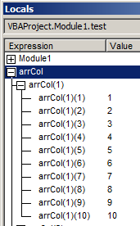

We can therefore ReDim Preserve the “first dimension”
(We have to Dim(), Redim() arrCols first).
We can put one row equal to another:
arrCols(2) = arrCols(1)

Option Base 1

Sub test()

Dim arrCols() As Variant, arrRow As Variant

For i = 1 To UBound(arrCols, 1)

arrCols (i) = arrRow

Next i
ReDim arrCols(10)

arrRow = Array(1, 2, 3, 4, 5, 6, 7, 8, 9, 10)

arrCols(1) = arrRow
arrCols(2) = arrRow
'etc

ReDim Preserve arrCols(9) 'Make it smaller

End Sub

Sub test()

Dim arr1 As Variant, arr2 As Variant, arr() As Variant, rz As Integer
rz = 10

arr1 = Application.Transpose(Range("rngCompanies")) 'This makes a 2D (Range) array into a 1D array. Not sure why it works! One-based!
arr2 = Application.Transpose(Range("rngCompanies").Offset(0, 4))

arr = Array(arr1, arr2)

ReDim Preserve arr1(rz)
ReDim Preserve arr2(rz)

arr = Array(arr1, arr2) 'Reconstitute the array

End Sub

Option Base 1 see SPE350CES_LVver1.xlsm Data sheet. Matlab button.
Option Explicit

Private Sub cmdTest_Click()

ArrayOps

End Sub

Sub stance()
Dim x As Long
For x = 1 To 10
Debug.Print x
Next

Debug.Print Now
Application.SendKeys " ^a {DEL}"

End Sub

Sub ArrayOps()

Dim col1 As Variant, col2 As Variant 'The individual columns
Dim arrWhole() As Variant ' The amalgamation of the two columns: Companies & Volatilities
Dim arrTop() As Variant 'Will contain the top 50 for example
Dim arrSame() As Variant 'The commonality array.
Dim arrSorted() As Variant 'The ones to look for in a bigger array.
Dim arrJoin() As Variant 'The ones to look for in a bigger array.

'stance

getRanges col1, col2 'Gets the two columns from the s/sheet.

arrWhole = Array(col1, col2) ' Make a 2x64 array.
Debug.Print " Whole Array"
printArray arrWhole

arrSorted = sortTheArray(arrWhole) 'Sorts on the second column ie arr2 (Which will be the volatilities (or reciprocals thereof).
Debug.Print 'Separating space
Debug.Print " Sorted"
printArray arrSorted

arrTop = ChooseTopReDim(arrSorted, 5) 'arrTop will find the top so many volatilities for example.
Debug.Print 'Separating space
Debug.Print " Top 5 Using ReDim"
printArray arrTop

arrTop = ChooseTopNew(arrSorted, 5) 'arrTop will find the top so many volatilities for example.
Debug.Print 'Separating space
Debug.Print " Top 5 Using New Array"
printArray arrTop

arrSame = FindSame(arrSorted, arrTop) 'For example Find all of the elements in arrIn which are in sortedArray. ie whose Company names (The FIRST array)are the same.
Debug.Print 'Separating space
Debug.Print " Sames"
printArray arrSame

arrJoin = JoinArrays(arrWhole, arrTop) ' As an example (not very one good yet )
Debug.Print 'Separating space
Debug.Print " Joined"
printArray arrJoin

Debug.Print 'Separating space
End Sub

Function JoinArrays(arr1, arr2) As Variant

'Not done yet- need to exclude repeats - if there are any?? maybe not!
'OK do it assuming two DISJOINT arrays

JoinArrays = arr1 ' just temporary return
End Function

Sub getRanges(ar1 As Variant, ar2 As Variant) 'Passed by ref so will get changed (initialized)

ar1 = Application.Transpose(Range("rngCompanies")) 'This makes a 2D (Range) array into a 1D array. Not sure why it works! Its One-based!
ar2 = Application.Transpose(Range("rngCompanies").Offset(0, 4))

ReDim Preserve ar1(10) 'For Debugging make them a bit smaller.
ReDim Preserve ar2(10) 'Remove these two lines later.

End Sub

Function FindSame(arrL() As Variant, arrS() As Variant) As Variant

Dim i As Integer, j As Integer, c As Integer
Dim arrC1() As Variant, arrC2() As Variant 'These will hold the respective columns of the commonality array.
c = 0 'Set the commonality array (size of the)index to zero.
For i = 1 To UBound(arrL(1), 1) 'Do the larger loop

For j = 1 To UBound(arrS(1), 1) 'Do the smaller loop

If (arrL(1)(i) = arrS(1)(j)) Then 'The j's are the "insiders". The i's are the "outsiders".
'We have here compared the Companies in the first column of the respective arrays.
'We could equally compare the second column:If (arrL(1)(i) = arrS(1)(j))

' Debug.Print arrL(1)(i), arrL(2)(i) 'Print for the Company names which are the same. 'Could equally print arrS(1)(j), arrS(2)(j)
'Put the common elements into another array.

c = c + 1 ' Increment the commonality array size by one in order to store the next pair of common elements

ReDim Preserve arrC1(c) 'Redim the common companies array
ReDim Preserve arrC2(c) 'Redim the common volatilities array

arrC1(c) = arrL(1)(i) 'Put the companies in the new commonality array
arrC2(c) = arrL(2)(i) 'Put the volatilities in the new commonality array

End If

Next j

Next i

FindSame = Array(arrC1, arrC2) 'Need to return the array of common elements

End Function

Private Function sortTheArray(ByVal arr As Variant) As Variant

Dim i As Long, j As Long
Dim Temp1 As Variant, Temp2 As Variant

'Sort the array using the bubble sort method on the second element ie the 34.8 etc.
'406566 34.8
'B01FLQ 40.24
'711072 56
'401597 56
'405671 77

For i = LBound(arr(2), 1) To UBound(arr(2), 1) '1 to 10

For j = i + 1 To UBound(arr(1), 1) '2 to 10 etc

If arr(2)(i) > arr(2)(j) Then ' If 20 > 10 which it is then swap 20 <-> 10
Temp1 = arr(2)(j) ' First Store 20 in Temp1 ie Temp1 <- 20
Temp2 = arr(1)(j) ' (Correspondingly "ed" etc are moved with their associated values (20 for ed). This is the crux of it.)

arr(2)(j) = arr(2)(i) 'ie Second element is now 20.
arr(1)(j) = arr(1)(i)

arr(2)(i) = Temp1 ' First element <- 10.
arr(1)(i) = Temp2
' Now consider next pair
End If
Next j
Next i

sortTheArray = arr

End Function

Function ChooseTopReDim(ByVal arr As Variant, rz As Integer) As Variant

'arr is a 2x64 array
'We want to reduce it in size to a 2x50 (Thus selecting the top 50)
'This works by separating arr into arr1 and arr2 and then reducing EACH of the latter two arrays arr1 & arr2 in size to 50.
'We then reconstitute arr.

Dim arr1 As Variant, arr2 As Variant
arr1 = arr(1) 'Separate the first row from arr.
arr2 = arr(2) 'Separate the secnd row from arr.

ReDim Preserve arr1(rz) ' Reduce the size of the first row to rz.
ReDim Preserve arr2(rz) ' Reduce the size of the secnd row to rz.

ChooseTopReDim = Array(arr1, arr2) 'Reconstitute the array

End Function

Function ChooseTopNew(ByVal arr As Variant, rz As Integer) As Variant

'Not done yet
'We wish this time to make a new array arrSize of size rz and use a loop rz times to transfer arr into it.

ChooseTopNew = arr 'Temporary only ChooseTopNew = arrSize

End Function

Sub printArray(MyArr() As Variant)

Dim i As Integer

For i = 1 To UBound(MyArr(1))

Debug.Print MyArr(1)(i), MyArr(2)(i)

Next i

End Sub

Matlab & Excel

From Excel File Options, Go, AddIns Browse

C:\Program Files\MATLAB\R2013a\toolbox\exlink

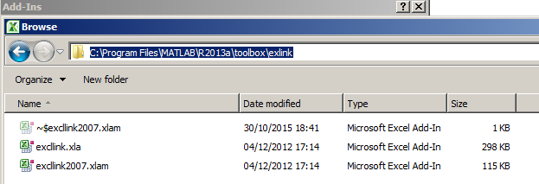

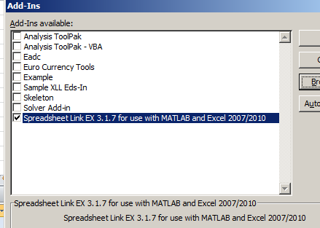

ok

From Matlab on the Ribbon choose preferences

C:\Program Files\MATLAB\R2013a
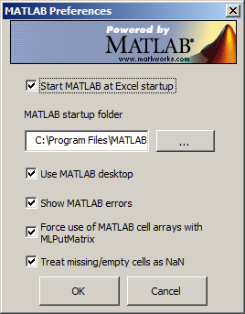

- Looks like Matlab should not be running? Close it if it is and start it from Excel.

- Best make them all cells lest text in excel become cells as it should but number doesn’t ie if we had to concatenate a row of text and a row of numbers. Make sure that they are consistent. We won’t get error message if not !

(Maybe make then not cells and import them separately.)

Maybe need to do the above and start Excel which starts Matlab

Highlight the data in Excel
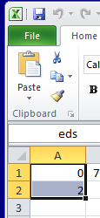

From The Ribbon:

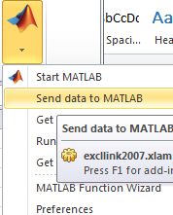

- Send data to Matlab.

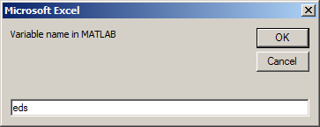

- Give it a name.

From Matlab: Data will appear as a WorkSpace variable

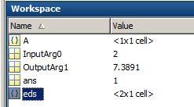

Work with MATLAB Functions in Microsoft Excel

http://uk.mathworks.com/help/exlink/work-with-matlab-functions-in-microsoft-excel.html

htp://uk.mathworks.com/help/exlink/index.html
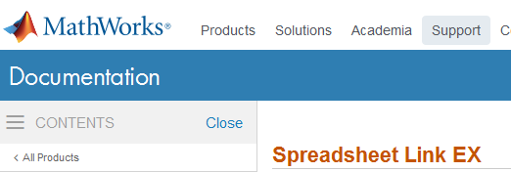

There are two ways that we can send and get data from Matlab.
(As a consequence, using either method, from Excel we could send data to Matlab, manipulate the data in Matlab - with all of Matlab’s functionality! and then return it to the spreadsheet.

Method1: Worksheet Functions:

From the spreadsheet simply type in a worksheet function.

Putting data into Matlab:

MLPutMatrix

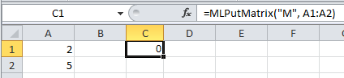
(After a Spreadsheet Link EX function successfully executes as a worksheet formula, the cell contains the value 0 to indicate success.)

Matlab:

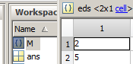

Getting data from Matlab:

MLGetMatrix

We will return our matrix M from Matlab:
Only the first cell (B1 in this case) of the return-to range is required.
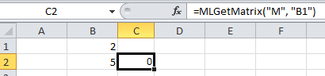

The matrix is returned from Matlab.
Method2: Using Excel VBA

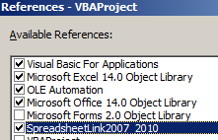

1st Make sure that we have this reference.

test.xlsm Matlab sheet. Matlab Button

PutMatrix Excel -> Matlab

Private Sub cmdMatlab_Click()

MLPutMatrix "M", Range("A1:A2")

End Sub

GetMatrix Matlab ->Excel

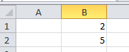
Private Sub cmdMatlab_Click()

MLGetMatrix "M", "B1:B2"

MatlabRequest

End Sub

MLGetVar variable: Matlab ->Excel
Matlab Excel VBA
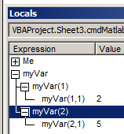
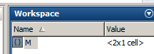
MLPutMatrix "M", Range("A1:A2")

Dim myVar As Variant

MLGetVar "M", myVar

I don’t see how myVar can be anything but a Variant.

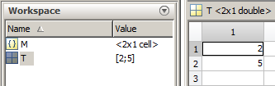
MLPutVar variable: Excel -> Matlab

Dim myVar As Variant

myVar = Array(2, 5)

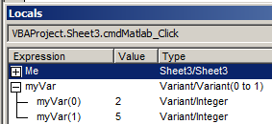
MLPutVar "T", myVar

Not sure why T is a 2 x 1.
(Array must produce a column vector not a row vector.)
http://uk.mathworks.com/help/exlink/functionlist.html

Spreadsheet Link EX Functions
Top of Form
Bottom of Form

Startup and Shutdown
matlabinit | Initialize Spreadsheet Link EX and start MATLAB
MLAutoStart | Automatically start MATLAB
MLClose | Stop MATLAB
MLOpen | Start MATLAB

Customization
MLMissingDataAsNaN | Set empty cells to NaN or 0
MLShowMatlabErrors | Return standard Spreadsheet Link EX errors or full MATLAB errors using MLEvalString
MLStartDir | Specify MATLAB current working folder after startup
MLUseCellArray | Toggle MLPutMatrix to use MATLAB cell arrays
MLUseFullDesktop | Specify whether to use full MATLAB desktop or Command Window

Data Export to MATLAB
MLAppendMatrix | Create or append MATLAB matrix with data from Microsoft Excel worksheet
MLDeleteMatrix | Delete MATLAB matrix
MLPutMatrix | Create or overwrite MATLAB matrix with data from Microsoft Excel worksheet
MLPutRanges | Send data in Microsoft Excel named ranges to MATLAB
MLPutVar | Create or overwrite MATLAB matrix with data from Microsoft Excel VBA variable

Data Import from MATLAB
MLGetFigure | Import current MATLAB figure into Microsoft Excel spreadsheet
MLGetMatrix | Write contents of MATLAB matrix to Microsoft Excel worksheet
MLGetVar | Write contents of MATLAB matrix in Microsoft Excel VBA variable

MATLAB Commands in Microsoft Excel
matlabfcn | Evaluate MATLAB command given Microsoft Excel data
matlabsub | Evaluate MATLAB command given Microsoft Excel data and designate output location
MLEvalString | Evaluate command in MATLAB
MLShowMatlabErrors | Return standard Spreadsheet Link EX errors or full MATLAB errors using MLEvalString

To join two columns into one matrix (the Matlab Cols matrix)

SPE350CES_LVver1.xlsm Data sheet. Matlab button.

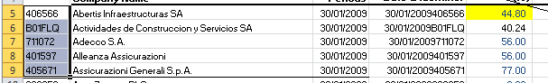

Private Sub cmdMatlab_Click() on SPE350CES_LVver1.xlsm
Dim rng1 As Range, rng2 As Range
Set rng1 = Range("rngTest")
Set rng2 = Range("rngTest").Offset(, 4)
'Set rng = Union(rng1, rng2)
maybe best to join them….??
MLPutMatrix "Col1", rng1
MLPutMatrix "Col2", rng2
MLEvalString ("Cols=[Col1 Col2]")
End Sub

Do we need to initialize variables exactly and dimension exactly before running the VBA? (Do we need to run a “fresh” Matlab from Excel ?)
eg do we need to make the Matlab variable cols first?

Cols =
'406566' [44.8000]
'B01FLQ' [40.2400]
'711072' [ 56]
'401597' [ 56]

'405671' [ 77] Now we can use the Matlab functions eg sortrows:
%Sort
B = sortrows(Cols,2)

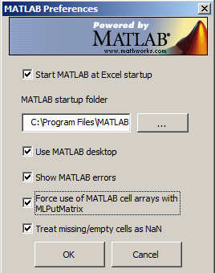
B =
'B01FLQ' [40.2400]
'406566' [44.8000]
'711072' [ 56]
'401597' [ 56]
'405671' [ 77]
- At the moment both the numeric and the string columns in Excel will be exported as Strings (ie a cell array).
%Take top 3
Top= B(1:3,:)

Top =
'B01FLQ' [40.2400]
'406566' [44.8000]
'711072' [ 56]
>>

TODO
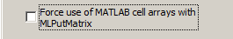
% Join 2 matrices
- Change it so that the numbers will be exported as numbers (doubles) for experimental purposes..
[ B Top ]

% Intersection
C = intersect(A,B)

% Subtract 2 matrices

A&B; // logical AND
From Matlab:
clc;
Col1={1;2;3;4;5}
Col2={1;2;3;4;5}
Cols={1,3;4,5;1,2;3,4;5,4}
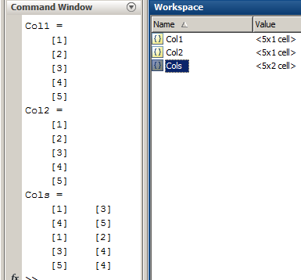

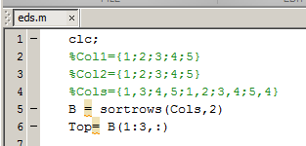
To Run a Matlab script from Excel

MLEvalString ("eds") where eds: ->

Seems the .m file must be in
C:\Program Files\MATLAB\R2013a and Matlab must be “started” from Excel.

Note that we will see nothing in the Matlab Command Window.
We can only tell if it has run OK by looking at the WorkSpace variables created.
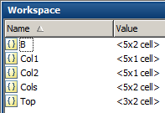

Now we need to paste this result back to Excel.

MLGetMatrix "Top", "O5:O8"
MatlabRequest
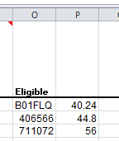
Bingo!

No need to fully specify the destination range; just the starting cell is OK ie :

MLGetMatrix "Top", "O5"We could also put Top into VBA variable - see PutVar previously)

But can we work FROM Matlab ? yes:

xlsread

Read Microsoft Excel spreadsheet file

Syntax
- num = xlsread(filename)
http://uk.mathworks.com/help/matlab/ref/xlsread.html

[num,txt,raw] = xlsread('E:\Users\Ed\Desktop\Daniel\SPE350CES_LVver1.xlsm','Data','A5:E9')

This command produces THREE arrays: num,txt,raw
num just reads numbers so will miss the first few columns!:
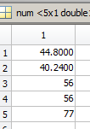

Likewise txt will miss the numbers!

So we need raw: which will read anything.
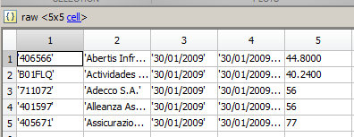

[x,y,z]is just as good as [num,txt,raw] but it appears none can be omitted!

So to write it back:

clc;
clear;
[x,y,raw] = xlsread('E:\Users\Ed\Desktop\Daniel\SPE350CES_LVver1.xlsm','Data','A5:E9')
Cols=raw(:,[1,5])
B = sortrows(Cols,2)
Top= B(1:3,:)

xlswrite('E:\Users\Ed\Desktop\Daniel\SPE350CES_LVver1.xlsm',Top,'Data','O5:P7')

Its OK if the spreadsheet is open.

When writing we can also call a Matlab UDF.
Not sure why we need to do that.
see xlsread.

We wish to Find the intersection of Top & Cols.
(Should be just Top.)

Structures

A = struct('name',{'ed','jo','al'},'bal',{10,20,10} );

A(1)

ans =
name: 'ed'
bal: 10

3 structures are created within the structure A.

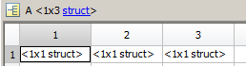
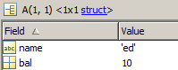
Name is char.
bal is Double

A(1).name

ans =
ed

any

If NON- zero

C = [0 0 1;
0 1 1;
0 1 1]

A = any(C)

result:

A =
0 1 1 ie column 1 is zero-free, column 2 is not, column 3 is not.

To find the intersection of Cell arrays (forum answer)

clc;
C = {'one', 1;'two', 2; 'three' , 3}
A = {'one', 1;'three' , 3}

% C =
% 'one' [1]
% 'two' [2]
% 'three' [3]
% A =
% 'one' [1]
% 'three' [3]

n1 = 1:size(A,1) %n1 = 1 2
n2 = 1:size(C,1) %n2 = 1 2 3
[ROW,COL] = ndgrid(n1,n2) ;
W=[ROW,COL]
% W =
% 1 1 1 1 2 3
% 2 2 2 1 2 3

match_matrix = arrayfun(@(J,K) isequal(A(J,:),C(K,:)),ROW,COL)

% match_matrix =
% 1 0 0
% 0 0 1

X = C( any(match_matrix & cumsum(match_matrix,2)==1), :) % "any" determines if any elements are non-zero

result:
X =
'one' [1]
'three' [3]

note that setting preference in Matlab:

Seems the .m file must be in
C:\Program Files\MATLAB\R2013a and Matlab must be “started” from Excel.

In Excel VBA

Private Sub cmdTestMatlab_Click()

MLPutMatrix "dan1", Range("A1:C2")

MLEvalString ("daniel")

End Sub

In Matlab:

daniel.m

clc
% dan1 =[3 6 4;
% 7 12 -9]
C = cov(dan1')

C(2,1) (Doesn’t display this) even this doesn’t: display(C(2,1))

result:
