Physics B Lessons

Spec:

http://fdslive.oup.com/www.oup.com/oxed/secondary/science/advancingphysics/about_the_course/a2_course.html

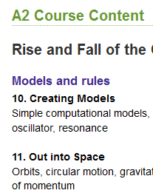

http://www.ocr.org.uk/Images/74952-specification.pdf
ocr detailed but look for Assessable Learning outcomes.
eg page 33:
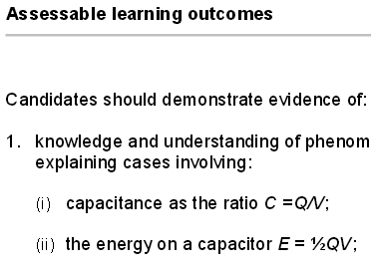

Revision Book

Page references are to pages in Revision Book:

ELECTROMAGNETISM:

Page 56 Charged Ps in Mag Field - first !
Page 66 Particle Accelerators

Page 46 Mag Fields and Motors
Page 48 Electromagnetic Induction
Page 50 Transformers and Alternators
Page 50 Transformers and Alternators

permeance permeability page 143 green book
https://en.wikibooks.org/wiki/A-level_Physics_%28Advancing_Physics%29/Flux

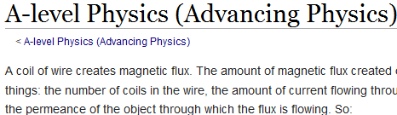

permeability is a property of the material only.
(my note on page 143 of green book)

current between wires beautiful you tube
https://www.youtube.com/watch?v=kapi6ZDvoRs

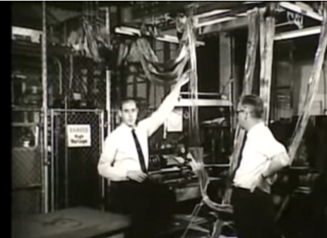

less dramatic
https://www.youtube.com/watch?v=43AeuDvWc0k

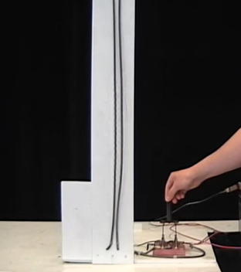

rh rule
https://www.youtube.com/watch?v=9p3t9NOfCtA&spfreload=10

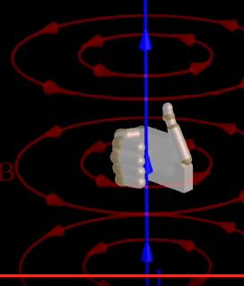

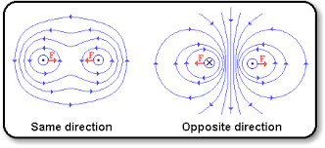

battery mag field
https://micro.magnet.fsu.edu/electromag/java/compass/index.html
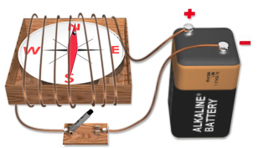

faraday coil
https://micro.magnet.fsu.edu/electromag/java/faraday2/index.html
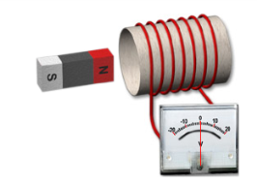

https://micro.magnet.fsu.edu/electromag/electricity/inductance.html
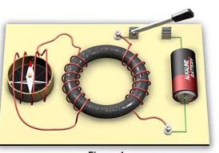

transformer
https://micro.magnet.fsu.edu/electromag/java/transformer/

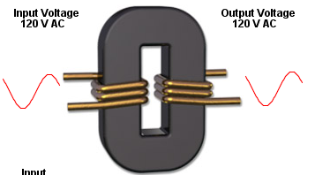

Page 56 Particles in Mag Fields

https://sites.google.com/site/physicsflash/home/cyclotron

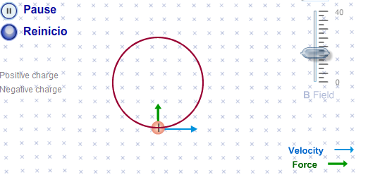

http://phys23p.sl.psu.edu/phys_anim/EM/charge_in_bfield_helical.avi

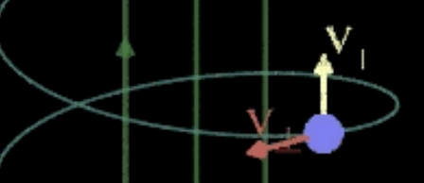

Page 66 Accelerators
https://sites.google.com/site/physicsflash/home/cyclotron

http://phys23p.sl.psu.edu/phys_anim/EM/charge_in_bfield_helical.avi

ac generator
https://micro.magnet.fsu.edu/electromag/java/generator/ac.html
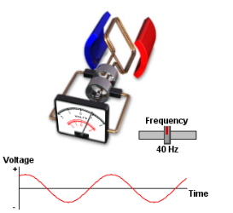

dc generator
https://micro.magnet.fsu.edu/electromag/java/generator/dc.html
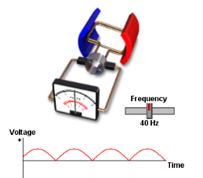

how loud speaker works
https://micro.magnet.fsu.edu/electromag/java/speaker/index.html

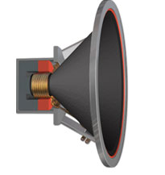

forces loop wire segments
http://phys23p.sl.psu.edu/phys_anim/EM/mag_torque_loop.avi
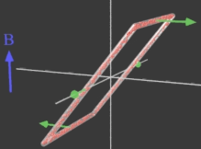

motor
http://phys23p.sl.psu.edu/phys_anim/EM/DC_motor.avi

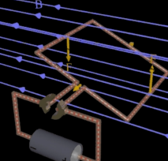

r h rule
http://www.mrwaynesclass.com/teacher/eANDm/closedRtHand/Closed_RightHand_rule2.swf
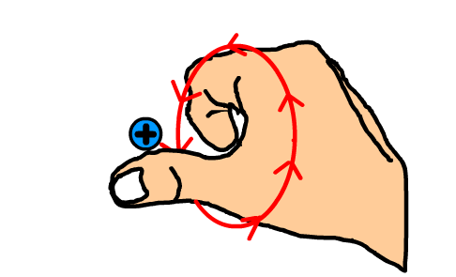

motion conductor in B
http://www.mrwaynesclass.com/teacher/eANDm/openrthand/home.html
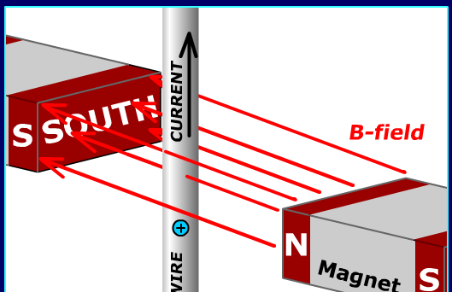

motor
http://www.physics-chemistry-interactive-flash-animation.com/electricity_electromagnetism_interactive/laplace_lorentz_force_electric_motor_principle_brushes_split_ring.htm

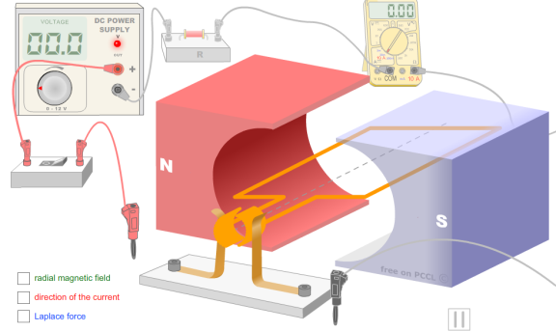

dc motor excellent
https://www.youtube.com/watch?v=LAtPHANEfQo
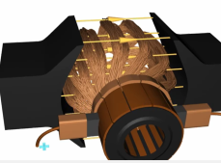

Lorentz force
http://www.physics-chemistry-interactive-flash-animation.com/mechanics_forces_gravitation_energy_interactive/lorentz_force_rail_gun_three_fingers_right_hand_rule.htm

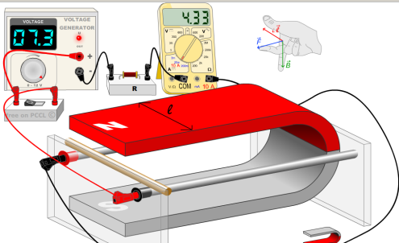

eddy damping – towards end

https://www.youtube.com/watch?v=otu-KV3iH_I&ebc=ANyPxKoNWA5RldHAsiUZ2I8S0hTJ-Q1ygtA1I4nlbF6JtTHjbx5Of7g_vDSac-qBCsAM8qc5UFPNzCRSPQdGAq3fVQMleezCVA

bow tie but @ 1 min see aluminium
https://www.youtube.com/watch?v=gK9LD1G6fX8

levitating ring
https://www.youtube.com/watch?v=-HLFT7XCMjc
transformer visualization
https://www.youtube.com/watch?v=VucsoEhB0NA&nohtml5=False
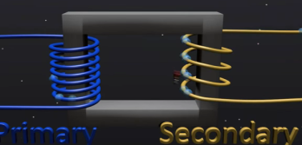

transformer construction

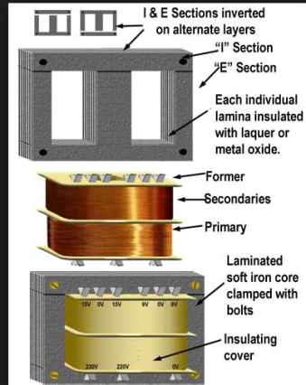

eddy current
https://www.youtube.com/watch?v=Yu1uRvErM80&nohtml5=False
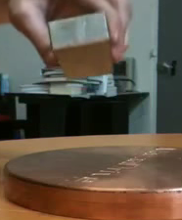

Page 32 Doppler
Page 34 Hubble
Page 36 Gases Temp
Page 44 Boltzmann Factor
Page 54 Millikan
Page 56 Particles in Mag Fields
Page 58 Alpha Scattering
Page 60 Particles Antiparticles Quarks
Page 66 Accelerators
Page 68 Bohr
Page 70 Alpha Beta Gamma
Page 72 Nuclear Decay
Page 74 Binding Energy
Page 76 Fission Fusion
Page 78 Log Graphs

Papers: Links to All Past Papers G494 and G495 and Mark Schemes

http://physics.taskermilward.org.uk/KS5/past_papers/index.htm

http://www.ocr.org.uk/qualifications/as-a-level-gce-physics-b-advancing-physics-h159-h559/

http://physics.taskermilward.org.uk/KS5/past_papers/index.htm

Links:

Bryanston http://web.bryanston.co.uk/physics/APRG2004/RevGuide/RGch06.pdf

Wiki: https://en.wikibooks.org/wiki/A-level_Physics_%28Advancing_Physics%29

Dr Physicshttps://www.youtube.com/watch?v=2vsAY-tp9js&list=PL5D99A319E129A5B7

contraction relativistic
http://www.mrwaynesclass.com/teacher/relativity/home.html
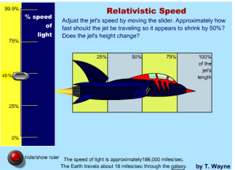

Page 32 Doppler

Doppler
http://www.animations.physics.unsw.edu.au/waves-sound/Doppler/index.html
doppler_ms_animation.swf
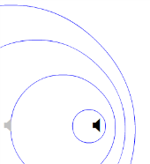

doppler_sonicboom.swf
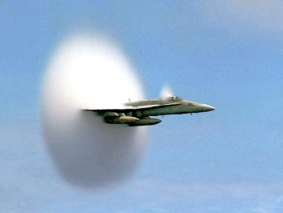
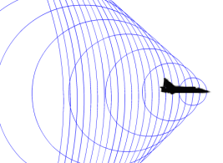

https://www.youtube.com/watch?v=fW2Y8DLwvxs&ebc=ANyPxKp3VU7odwBLfxxA3IEa2nGGU6LlvMSbudQrexI6jEObCW6IphjqVY4FgRGm440ehtGLNK-gatzhgyBeD9oMd26tkVcZBg

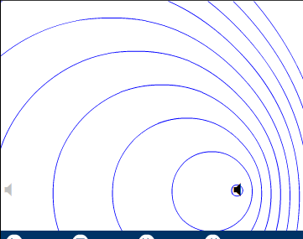

Page 34 Hubble

Page 36 Gases Temp

heat transfer
http://www.wwnorton.com/college/physics/om/_tutorials/chap20/heat_and_temperature/index.htm

gas expansions
http://www.mrwaynesclass.com/teacher/Thermo/cycle/home.html

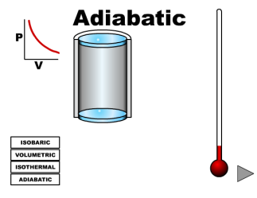

heat / molecules
http://www.mrwaynesclass.com/teacher/Thermo/hotmolecules/home.html

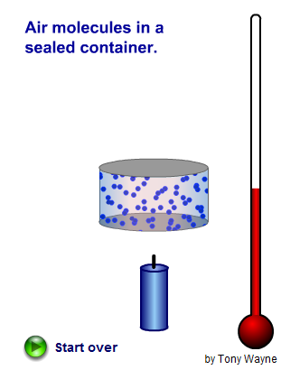

Page 44 Boltzmann Factor

BF is simply the probability that a molecule will have at least this energy
(To talk of ratio on page 44 is a bit confusing - this ratio factor is just a property of the exponential function.)
Animation of molecules
Do the problems from this wiki reference (use the worked solutions)

sketch/plot graph of exp(-1/x)
inflexion at ? as x -> inf the function -> 1

boltzman constant you tube khan
https://www.youtube.com/watch?v=SHNsG4sBEr0&ebc=ANyPxKr6SShlfM_RWpDrnaAoHptpzM3_stLpauwpXj8bsUfdjXQJxsBbkFJFajCWhxOe1n1XD3IwuI2fjMQoYLOKVD8BXgD6ag

feynman
http://www.feynmanlectures.caltech.edu/I_40.html

chemistry
http://www.chem1.com/acad/webtext/dynamics/dynamics-3.html

distn vels
http://astro.unl.edu/naap/atmosphere/distribution.html

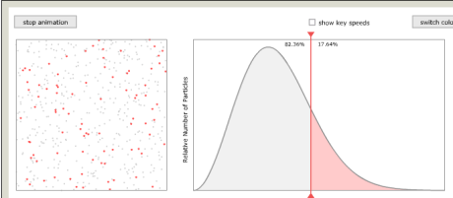

atmosphere needs java and IE
http://mutuslab.cs.uwindsor.ca/schurko/animations/idealatmosphere/idealatmosphere.html

diagram shows atmospheric temp goes down to -60
http://hmxearthscience.com/Warehouse/meteorology/atmosphere/animations/Structure%20of%20the%20Atmosphere.swf

nice description of atmosphere
http://chemwiki.ucdavis.edu/Textbook_Maps/General_Chemistry_Textbook_Maps/Map%3A_Chem1_%28Lower%29/06._Properties_of_Gases/6.4%3A_Kinetic_Molecular_Theory_%28Overview%29Distribution of gas molecules in a gravitational field

Page 54 Millikan

stokes law: 6 * pi * neta * v but proof not required

page 55: says field was applied til drop was stationary.
This allows us to calculate the radius (or mass - same thing since we know the density of the oil.)
Note that Bouyancy is ignored!

millikan you tube v good
https://www.youtube.com/watch?v=ijHKu6iXiRk
but buoyancy

simpler
http://highered.mheducation.com/olcweb/cgi/pluginpop.cgi?it=swf::100%::100%::/sites/dl/free/0072512644/117354/02_Millikan_Oil_Drop.swf::Milikan%20Oil%20Drop

shows more than one velocity
http://www.dnatube.com/video/2801/Millikan-Oil-Drop-Experiment

wiki including scandal
https://en.wikipedia.org/wiki/Oil_drop_experiment#

archive film
https://archive.org/details/TheMillikanExperiment
about 7 min to see varied velocities

Page 56 Particles in Mag Fields

see Page 66 Accelerators

https://sites.google.com/site/physicsflash/home/cyclotron

http://phys23p.sl.psu.edu/phys_anim/EM/charge_in_bfield_helical.avi

Page 58 Alpha Scattering

Rutherford
https://www.google.co.uk/search?q=alpha+scattering+animation&num=100&tbm=isch&tbo=u&source=univ&sa=X&ved=0ahUKEwiXueqAuJvLAhVGOhQKHVs0BJcQsAQILg&biw=1263&bih=880#imgrc=kg9Ab4sytqbu9M%3A

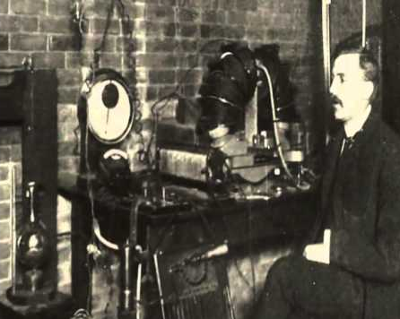

alpha animation “film”
http://www.learnerstv.com/animation/animation.php?ani=121&cat=chemistry

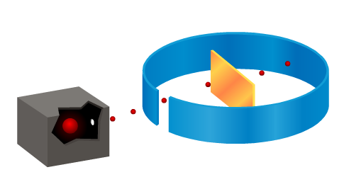

film
http://www.dnatube.com/video/28697/Gold-Foil-Experiment-By-Rutherford

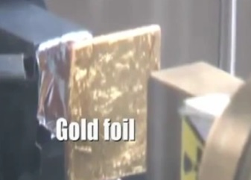

Page 60 Particles Antiparticles Quarks

nuclear physics revision
https://wwwf.imperial.ac.uk/~kb514/physics/nuclear.pdf

gluons etc too long skip ads!
https://www.youtube.com/watch?v=6uGZdo-fsjI

https://www.youtube.com/watch?v=pdVybAwVqUs

quarks and leptons for beginners
https://www.youtube.com/watch?v=pdVybAwVqUs

Dr Physics Elementary particles v good! use this!
https://www.youtube.com/watch?v=2zZ1kv6vlq0&ebc=ANyPxKrOUZg8y5io2pjwMnY1oficr9kEgqgf9pCIo7W8pYjxIMmyFUvHbJyt8ms45nEkDMvL3jtSjoAN9cO4IS8WNM2-gfkkWg

Page 66 Accelerators

see p56 Charged P’s in Mag field

https://sites.google.com/site/physicsflash/home/cyclotron

http://phys23p.sl.psu.edu/phys_anim/EM/charge_in_bfield_helical.avi

velocity selector
http://www.compadre.org/Physlets/electromagnetism/prob27_9.cfm
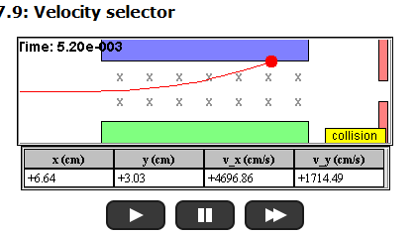

Page 68 Bohr

hydrogen energy levels great animation 1st bit only
http://science.sbcc.edu/physics/flash/siliconsolarcell/bohratom.swf
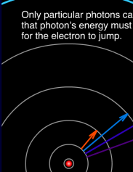

for spectrum
http://www.avogadro.co.uk/light/bohr/spectra.htm

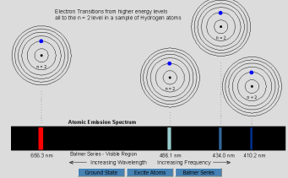

confirms the electron falling back
http://www3.nd.edu/~ysun/Yang/PhysicsAnimation/collection/bohrP.swf

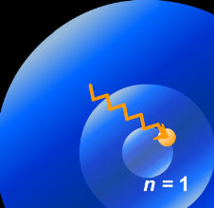

Page 70 Alpha Beta Gamma

cloud chamber various
http://practicalphysics.org/display-cloud-chamber-photographs.html
eg
http://practicalphysics.org/alpha-particle-tracks-showing-their-short-range.html
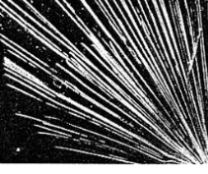

animated
https://en.wikipedia.org/wiki/File:Cloud_chamber_ani_bionerd.gif
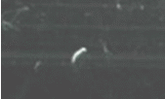
Page 72 Nuclear Decay

nuclear decay
http://www.learnerstv.com/animation/animation.php?ani=43&cat=physics

Page 74 Binding Energy

Page 76 Fission Fusion

fission
http://www3.nd.edu/~ysun/Yang/PhysicsAnimation/collection/nuclearP.swf

nuclear bomb enrichment interesting but irrelevant
https://www.youtube.com/watch?v=fIbACkLU-38

fusion https://www.youtube.com/watch?v=Cb8NX3HiS4U

fission https://www.youtube.com/watch?v=mBdVK4cqiFs
good but no calculations

fission interactive neutron
http://www.visionlearning.com/en/library/Animations

fission v good animation but no calcs
https://www.youtube.com/watch?v=Ezbyg2iNdQs&feature=iv&src_vid=kHXMiYsFSrU&annotation_id=annotation_696116

Page 78 Log Graphs

Notes y = ax+ b etc

Graph Paper

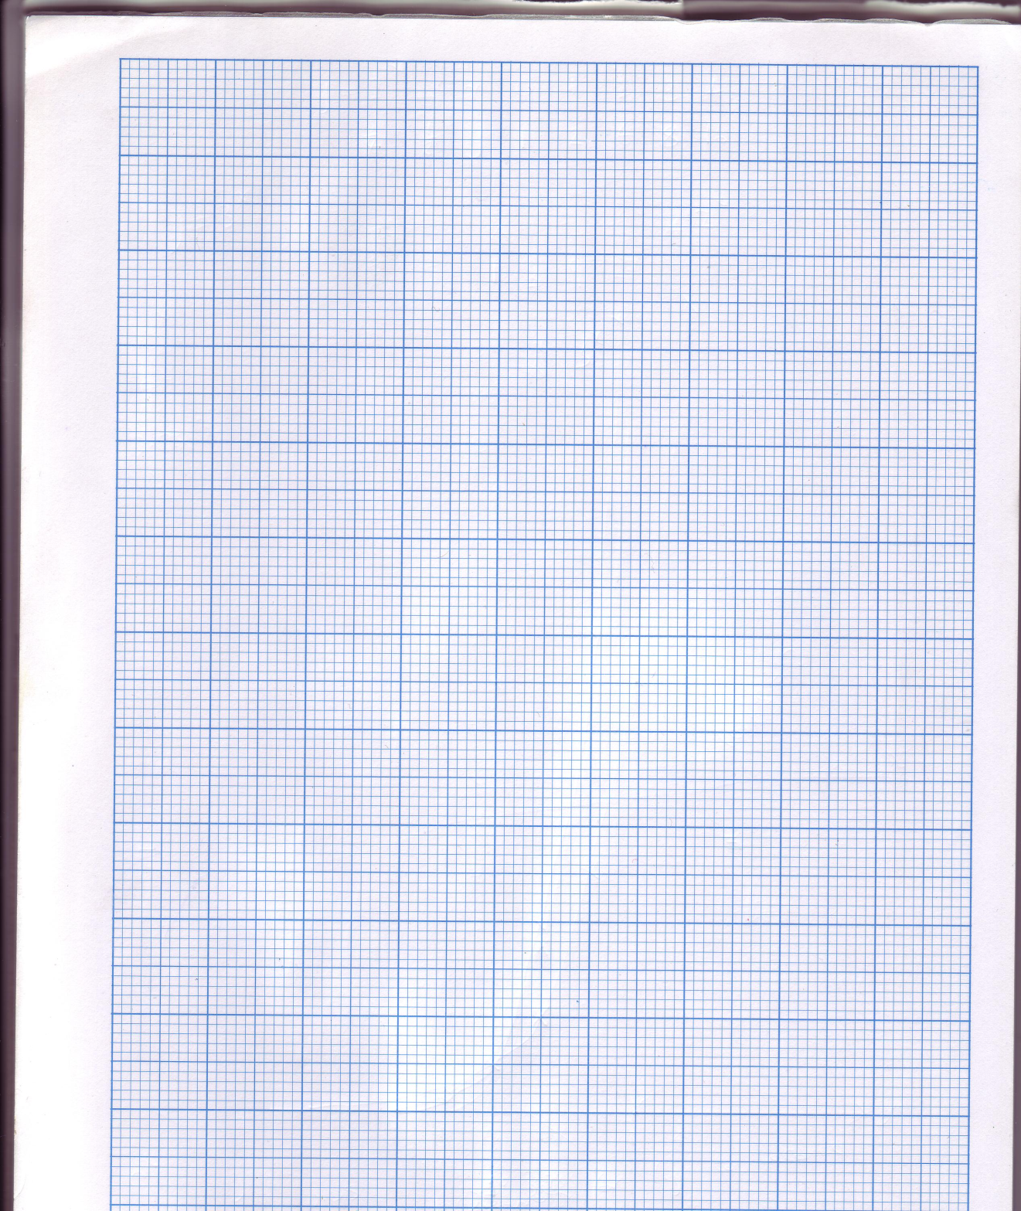

My Graph Paper
 |  |  |  |  |  |  | 14
 |  |  |  |  |  |  | 13
 |  |  |  |  |  |  | 12
 |  |  |  |  |  |  | 11
 |  |  |  |  |  |  | 10
 |  |  |  |  |  |  | 9
 |  |  |  |  |  |  | 8
 |  |  |  |  |  |  | 7
 |  |  |  |  |  |  | 6
 |  |  |  |  |  |  | 5
 |  |  |  |  |  |  | 4
 |  |  |  |  |  |  | 3
 |  |  |  |  |  |  | 2
 |  |  |  |  |  |  | 1
 | -6 | -5 | -4 | -3 | -2 | -1 | 0 | 1 | 2 | 3 | 4 | 5 | 6 | 7
 |  |  |  |  |  |  | -1
 |  |  |  |  |  |  | -2
 |  |  |  |  |  |  | -3
 |  |  |  |  |  |  | -4
 |  |  |  |  |  |  | -5
 |  |  |  |  |  |  | -6
 |  |  |  |  |  |  | -7
 |  |  |  |  |  |  | -8

 | 8
 | 7
 | 6
 | 5
 | 4
 | 3
 | 2
 | 1
 |  |  | 1 |  | 2 |  | 3 |  | 4 |  | 5 |  | 6

