GCSE Physics eds web site address www.una.co.uk

Notes

Moments Page 226

Centre of Mass Page 228
Balancing Page 230

Stability Page 232

https://www.youtube.com/watch?v=qRsJXXb9WNE
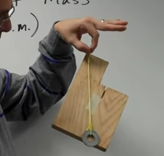

he does stability as well

motion of centre of mass
http://www.mrwaynesclass.com/teacher/cm/home.html
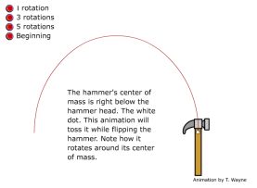

sumner miller: v interesting
https://www.youtube.com/watch?v=YN2oALaRfL4
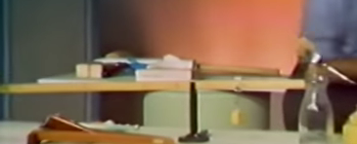

Hydraulics Page 234

http://www.absorblearning.com/media/attachment.action?quick=104&att=2589

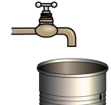

http://www.dynamicscience.com.au/tester/solutions1/hydraulicus/hydraulicsforceandwork2.htm
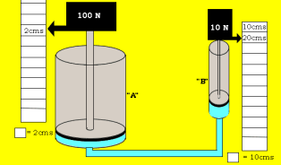

http://www.dynamicscience.com.au/tester/solutions1/hydraulicus/statesofmatterhydraulics.htm
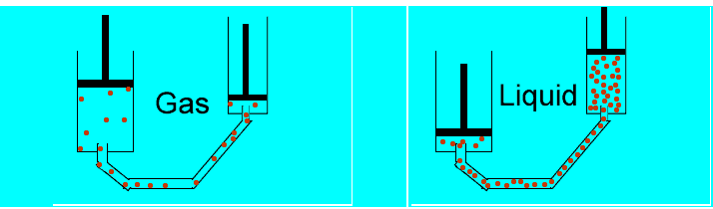

syphon
https://www.youtube.com/watch?v=CZmP0vsRBZ8

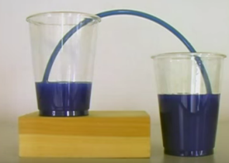

double decker leaning
https://www.youtube.com/watch?v=v2_T4WVnnFU
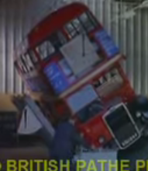

Circ Motion Page 236

https://www.youtube.com/watch?v=fNM9GFV9adg

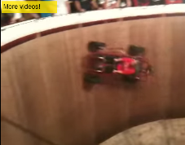

https://www.youtube.com/watch?v=g3GC3F7zrok&nohtml5=False

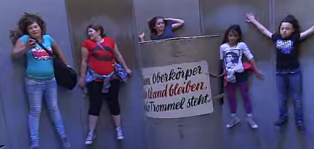

http://glencoe.com/sec/science/physics/ppp_09/animation/Chapter%206/Circular%20Motion%20and%20Centripetal%20Acceleration.swf

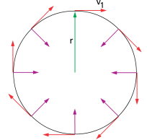

circ motion forces
http://www.mrwaynesclass.com/teacher/circular/CarAndCurve.htm
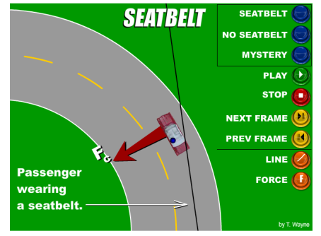

circ motion vectors (not required)
http://www.mrwaynesclass.com/teacher/circular/components/home.html

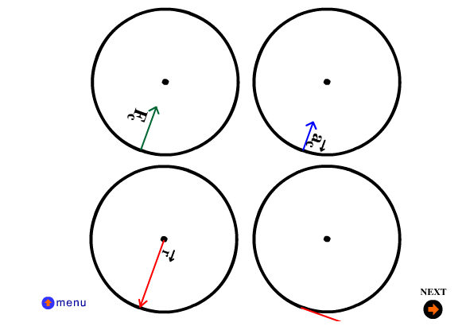

tangential velocity
http://www.mrwaynesclass.com/teacher/circular/TargetPractice/home.html
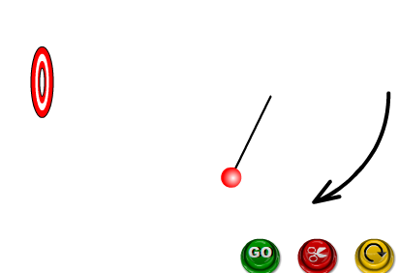

Pendulum Page 238

http://www.physics-chemistry-interactive-flash-animation.com/mechanics_forces_gravitation_energy_interactive/oscillations_simple_gravity_pendulum_period.htm
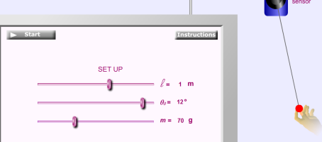

http://blog.onlineclock.net/pendulum-clock/
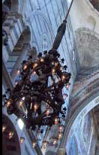

https://www.youtube.com/watch?v=D9UT6YwzmBU

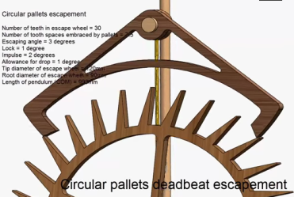

sound tick:
https://www.youtube.com/watch?v=8XoY6gxDwLE&ebc=ANyPxKo25sSQ_1Lfaj7o-PyO4Vbrjd_-BnFMq4wncIilOuOlnh1DoPFTjjtvr8Z2j3rTh_ssQzluiKHqHegR0pNggRyqaccDuQ&nohtml5=False

harrison
http://www.math.nus.edu.sg/aslaksen/gem-projects/hm/0203-1-10-instruments/chronometer.htm

Spec
http://www.aqa.org.uk/subjects/science/gcse/further-additional-science-4410
http://filestore.aqa.org.uk/subjects/AQA-FURSCI-W-SP.PDF
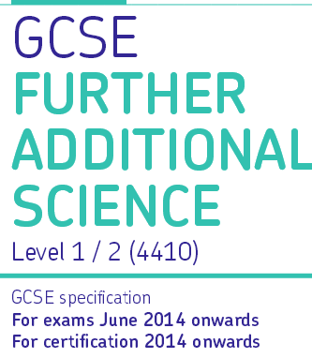

papers:
additional science
http://www.aqa.org.uk/subjects/science/gcse/additional-science-4408/past-papers-and-mark-schemes

further additional science
http://www.aqa.org.uk/subjects/science/gcse/further-additional-science-4410/past-papers-and-mark-schemes

digital book
http://www.kerboodle.com/app/courses/4204/modules/Digital%20Book
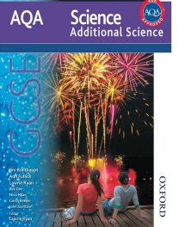

text answers
http://www.kerboodle.com/app/courses/4204/modules/Resources

bitesize
http://www.bbc.co.uk/education/subjects/zpm6fg8

gcse workbook
http://www.amazon.co.uk/dp/1847626785/ref=pd_lpo_sbs_dp_ss_1?pf_rd_p=569136327&pf_rd_s=lpo-top-stripe&pf_rd_t=201&pf_rd_i=1847626297&pf_rd_m=A3P5ROKL5A1OLE&pf_rd_r=03GM72QXD5HW2D3JCK4J

Past Papers

May 2014
QP: http://filestore.aqa.org.uk/subjects/AQA-FAS3HP-QP-JUN14.PDF
MS: http://filestore.aqa.org.uk/subjects/AQA-FAS3HP-W-MS-JUN14.PDF

switching power supply
http://www.hardwaresecrets.com/anatomy-of-switching-power-supplies/6/

