Python

Lesson

dictionary

lambda

Getting Started. There are many ways to download/setup and use Python.
We will use Visual Studio.

Visual Studio
Find the Visual Studio Installer on your computer.
For example, on a computer running Windows 10, select Start, and then scroll to the letter V, where it's listed as Visual Studio Installer.
Run the Installer, then select the Modify option. In the Workloads tab, select the Python development workload (Figure 2).
https://docs.microsoft.com/en-us/visualstudio/python/installing-python-support-in-visual-studio?view=vs-2017

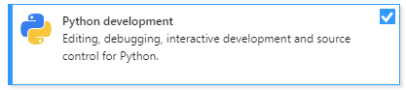
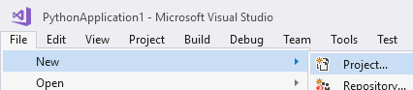

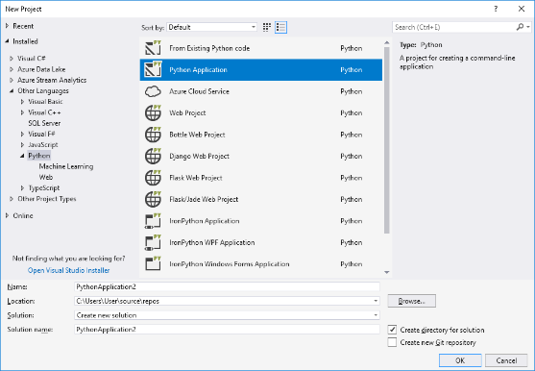

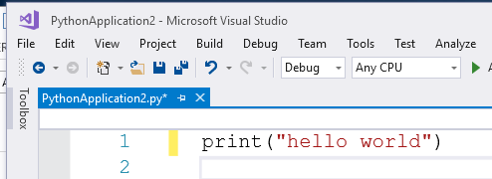

Click Debug Start Without Debugging – or press Ctrl-F5

print("hello world")
Use parenthesis lest you get an error. Earlier version of Python did not use them.

Hey presto:
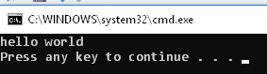

Your first Python program.

Read:

https://www.codemag.com/article/1807081/Learn-Python-with-Visual-Studio

Make notes on

- Tools/Python/Python Interactive Window
- Solution Explorer
- pip install matplotlib from PyPI
- Interactive Debugger

We will use two tutorials

Tutorial 1: https://www.programiz.com/python-programming#tutorial

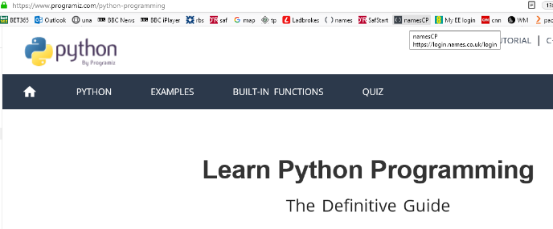

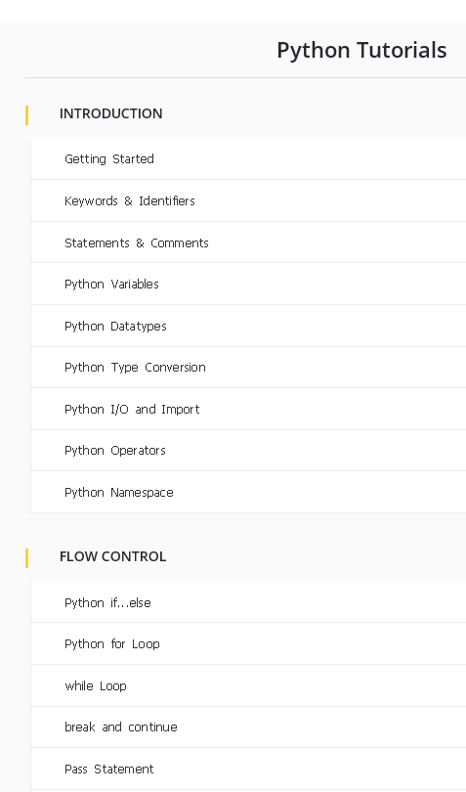

A single recommended text book is yet to be found. Try one that suits you.

Functions

DataTypes

File Handling

Object & Class

Etc.

Tutorial 2 :https://www.tutorialspoint.com/python/index.htm.

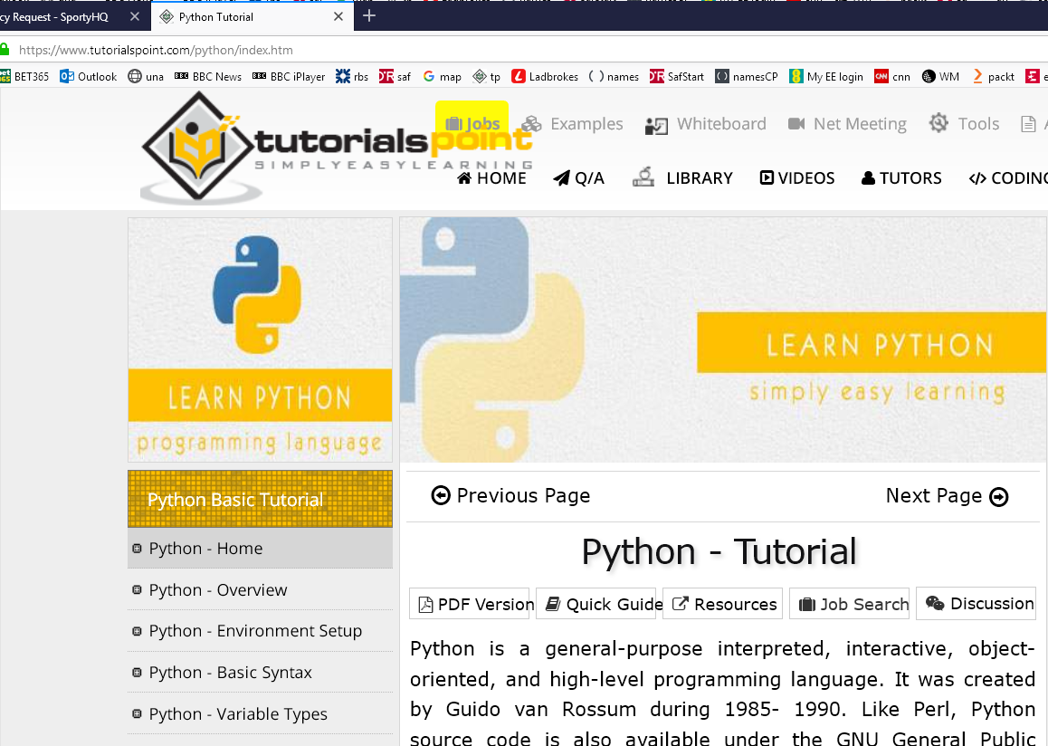
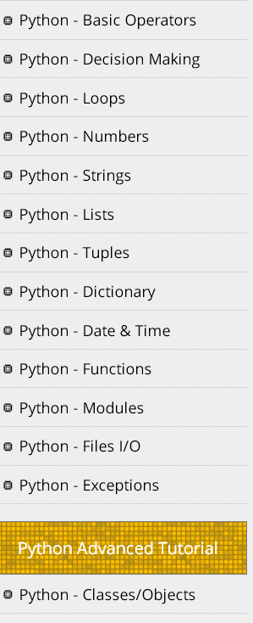

Tutorial 2 https://www.tutorialspoint.com/python/index.htm

Note: Interpreted

Object Oriented

See: Lines and Indentation
Python provides no braces to indicate blocks of code for class and function definitions or flow control. Blocks of code are denoted by line indentation, which is rigidly enforced
Try this code in the window we have just produced and run it.
We haven’t done If statement etc but you might get the idea.
var = 100
if ( var == 100 ) :
print ("Value of expression is 100")
print ("Good bye!")
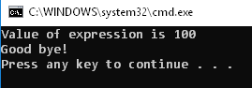
BOTH of these statement “belong” to the If because of the indentation above.

Change var to 200
Run it. Now NEITHER statement is executed.
BUT when we indent like so:
var = 200
if ( var == 100 ) :
print ("Value of expression is 100")
print ("Good bye!")
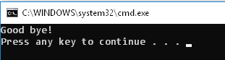
Good bye!" appears
(always – for 100 or 200)

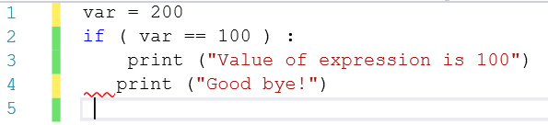

Always use the TAB key to indent. If you use (the wrong number of) spaces you will get an error.

Note: Comments

Python - Variable Types

counter = 100
str = 'ed' # or "ed"

lst = ['a', 1 , 2.2]

tpl = ('a', 1 , 2.2) More about lists etc further down.

dct = {'a':1, 'b':2}

x = int("23")
Investigate using print() on each of these.

Python - Basic Operators

x = 1 + 2

Decision Making

var = 100
if ( var == 100 ) : print "Value of expression is 100"
print "Good bye!"

Numbers
abs(x)
The absolute value of x: the (positive) distance between x and zero.
pow(x, y)
The value of x**y.
sqrt(x)
The square root of x for x > 0

import random

# First random number
print random.random()

Strings are text

var1 = 'Hello World!'

print (var2[1:5]) # remember the ()’s.

print (“ed/n”) # take care in copying this code (the “” ‘s will cause trouble)

print "My name is %s and weight is %d kg!" % ('Zara', 21) ## place holders and formatters eg %s means a string

upper() (Try it)
Converts lowercase letters in string to uppercase.

Lists

lst = ['physics', 'chemistry', 1997, 2000];
print list[0]

Tuples
tup1 = ('physics', 'chemistry', 1997, 2000);
print tup1[0]
->physics
Tuples are immutable

Dictionary
dict = {'Name': 'Zara', 'Age': 7, 'Class': 'First'}
print dict['Age']
->7

dict.keys() Returns list of dictionary dict's keys
->dict_keys(['Name', 'Age', 'Class'])

dict.values() Returns list of dictionary dict's values
->dict_values(['Zara', 7, 'First'])

str(dict) Produces a printable string representation of a dictionary
- {'Name': 'Zara', 'Age': 7, 'Class': 'First'}

Date & Time
import time;

lt = time.localtime(time.time())

# time.time()is total ticks since..time began. -> 1647617866.6119747

print (lt[0]) # -> 2019 ie 1st value in the tuple. eg

print (lt.tm_year)

-> 2022

asctime

import calendar
print(calendar.isleap(1900))
-> false (they got it right – not a leap year.)

Functions
def myfn(x=1):
return 2*x

y=myfn(3) # could also have y=myfn(x=3) for clarity
print(y)
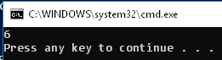

Try y=myfn() - The default of x=1 is used.

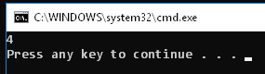

Can return more than one value!!:

def myfn():
return 2,3

x,y=myfn()
print(x,y)
-> 2 3

pass by ref?

def foo(x):
x = 'another value'
print (x) # will obviously print this local value first. ie 'another value'

y = 'some value'
foo(y)
print (y)
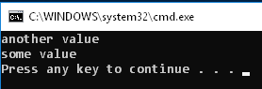

y is not changed. x creates another reference

Same:
def foo(x):
x = 1
print (x)

y = 2
foo(y) #integers are objects as well.
print (y)

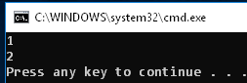

But lists, arrays, dictionaries etc will get changed permanently

def changelist(mylist):
mylist[0]=0
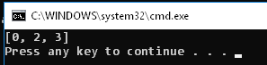
mylist = [1,2,3];
changelist(mylist);
print (mylist)

Come to think of it – so will a string if we change an element:
Whoops – strings are immutable.

return is optional if nothing returned

this tutorial’s treatment of Pass by reference vs value is misleading but this is very true:
All parameters (arguments) in the Python language are passed by reference. But the “change also reflects back in the calling function” is v misleading

multiple arguments:

def myfn(*x):
print (x)
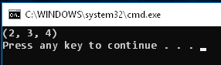
myfn(2,3) # -> (2,3)

eg try myfn(2,3,4)

Lambda functions – are one-liner functions

Consider first this function (not a lambda function)

def myfn(x):
return 2*x

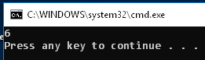
y = myfn(3)

print(y)

Here is the lambda equivalent:
mult2 = lambda x: 2*x

print(mult2(3))

Note that the function does not even have a name

We could also have: print((lambda x: 2*x)(3))
Scope is where the variable is known/recognized.

def myfn():
x is known only inside this function. It has local scope.
x=1
return

myfun()
print(x)

will cause an error since x is not recognized outside the function.

but:
x is global
x=1

def myfn():
return

myfun()
print(x)

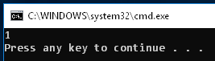

x is known thru the whole program – it has global scope.

Rule: Make your variables as local as possible

Modules
set pythonpath = C:\PY\PythonApplication1\PythonApplication1
pythonpath = "£C:\PY\PythonApplication1\PythonApplication1" ?

import eds
print ("Value of total : ", eds.sum( 1, 2 ))
print ("Value of total : ", eds.sum1( 20, 20 ))

eds.py
sum = lambda arg1, arg2: arg1 + arg2;
def sum1(x,y):
return x+y PyCharm

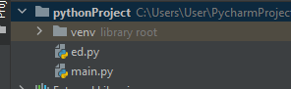
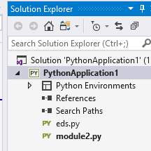

Value of total : 3
Value of total : 40

Packages

File IO

Exceptions
try:
x=4/0
except:
print ("error")

Classes/Objects
A Class is a template for an object

class Eds:
x
x & y are data members – also known as attributes.
y

class Eds:
x=0
y=0

An object is created using this template like so: (Try it)

e1 = Eds() # We create an object e1. (e2 = Eds() for another object e2.)
We set the data
e1.x = 1
e1.y = 2
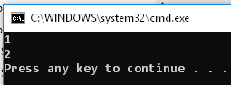
We get the data
print(e1.x)
print(e1.y)

The data is “encapsulated” in the class Eds.

In C#, C++ etc this encapsulation is more rigorous. Indeed, a class can be in compiled (changed to 1’s and 0’s and placed in a library which can then be reused. Since Python is an interpreted language (instructions are carried out line at a time when the program is run ) ie not compiled to 1,s and 0,s Classes/Objects is not as useful in Python.

Classes/Objects in Python are more a way of organizing code into units. See the vector example in the tute for a practical application – a way of storing ordered pairs.

Methods are functions inside a class.

class Eds:
x=0
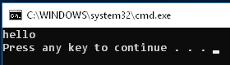
y=0
We must always include self
def myMethod(self):
print("hello")
Our method is called using the dot operator.
e1 = Eds()
e1.myMethod()
A Constructor is a special method inside a class which is automatically called whenever an object is created.
self is always included. It is a reference to the object itself (e1 in this case).

class Eds:
Two* leading underscores means that the function __init__ is private (local) to the class. The two trailing underscores means that TODO …
def __init__(self,x=1,y=2):
self.x=x
self.y=y

e1 = Eds()

#e1.x = 1 # no need
#e1.y = 2

print(e1.x)
print(e1.y)
*One leading underscore means that
Inheritance: One class is derived from another class.

It has all the attributes of the first (base) class and some of its own.

class Eds:
pass # (you may need this (useless) formatting “placeholder”)

class Der(Eds):
The derived class Der has its own attributes as well as those of Eds. (Eds has none at the moment.)
a=1
b=2

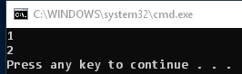
d1 = Der()

print(d1.a)
print(d1.b)

Exercise: At the moment, Eds has no attributes.

Give it some as below – and show that the derived class d1 can access these attributes as well.

Solution

class Eds:
x=0
y=0

class Der(Eds):
a=1
b=2

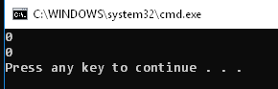
d1 = Der()

print(d1.x)
print(d1.y)

Overriding Methods
See tutorial:

class Parent: # define parent class
def myMethod(self):
print 'Calling parent method'
This derived class method gates called in preference to the base class’s method.
class Child(Parent): # define child class
def myMethod(self):
print 'Calling child method'

c = Child() # instance of child
c.myMethod() # child calls overridden method

-> 'Calling child method'
Overloading Operators changes the meaning of signs eg the plus sign (+)

In this case it assumes that the (default) x’s are to be added.
Constructor
class Eds:
There are loads of these special overload functions besides __add__ ( eg __sub__ __mult__,
(We could use any other variable for oth.)
oth is the rhs argument.
def __init__(self,x):
self.x=x

def __add__(self,oth):
return Eds(self.x + oth.x)

e1=Eds(1)
We are asking to add two objects!
Imagine though that we had more data elements eg y as well as x in Eds.
How would it know that it wanted to add the x’s. How about the y’s?
e2=Eds(2)

e = e1 + e2

print(e.x)
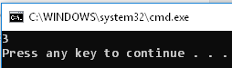

At the moment the + sign adds together the data elements (integers) even tho we are asking it to add two objects! e1 + e2.

We could change it to something silly eg
return Eds(self.x * oth.x) then the data elements would be multiplied.

Now go back and repeat in tutorial 1!
TODO

• Python - Reg Expressions

• Python - Database Access

• Python - Multithreading
• Python - XML Processing
• Python - GUI Programming
• Python - Further Extensions

https://www.programiz.com/python-programming/function

A tuple in Python is similar to a list. The difference between the two is that we cannot change the elements of a tuple once it is assigned whereas we can change the elements of a list.

https://learnpython.com/blog/python-array-vs-list/

array data structure belongs to the "must-import" category. To use an array in Python, you'll need to import this data structure from the NumPy package

import array as arr
array module requires all array elements to be of the same type.

nmpy can have different data types.
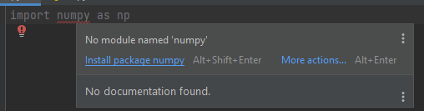

List items are enclosed in square brackets, like this [item1, item2, item3].
We can use the index operator [] to access an item in a list
Start at 0.

The index of -1 refers to the last item, -2 to the second last item and so on.

print(my_list[:])
print(my_list[0:])

#When we slice lists, the start index is inclusive, but the end index is exclusive.
For example, my_list[2: 5] returns a list with elements at index 2, 3 and 4, but not 5.

List Elements can be of different data types: you can combine strings, integers, and objects in the same list.

Lists are mutable, meaning their elements can be changed unlike string or tuple.

odd.extend([9, 11, 13])

odd = [1, 3, 5]
print(odd + [9, 7, 5])
print(["re"] * 3)

del my_list[1:5]

see pop etc:
https://www.programiz.com/python-programming/list

https://www.programiz.com/python-programming/tuple
A tuple is created by placing all the items (elements) inside parentheses (), separated by commas

Tuples are more memory efficient than the lists.

Lists and dictionaries are the most widely used built-in data types in Python.
Dictionary

Creating a dictionary is as simple as placing items inside curly braces {} using colons, separated by commas.

While the values can be of any data type and can repeat, keys must be of immutable type (string, number or tuple with immutable elements) and must be unique.

(We can also create a dictionary using the built-in dict() function.)

While indexing is used with other data types to access values, a dictionary uses keys.

print(my_dict['age')]) ie square brackets to access
print(my_dict.get('age')) ie get prevents error if not there.

See pop()

https://cs.stanford.edu/people/nick/py/python-map-lambda.html

list command (is like split?)
https://www.programiz.com/python-programming/methods/built-in/list
text = 'Python'
# convert string to list
text_list = list(text)
print(text_list)
# Output: ['P', 'y', 't', 'h', 'o', 'n']

The map() function runs a lambda function over the list [1, 2, 3, 4, 5], building a list-like collection of the results, like this:
list(map(lambda n: n * 2, [1, 2, 3, 4, 5]))
So I guess map is like “predicate” in c# lambda functions.

Map works with a def too
def double(n):
return n * 2
nums = [1, 2, 3, 4, 5, 6]
a=list (map(double, nums)) # use name of function "double"
print(a[0])
->2
-------------------------------------
https://www.w3schools.com/python/python_dictionaries_loop.asp

for x in thisdict,keys():
print(thisdict[x]) # keys is default.

If we want values:
for x in thisdict.values():
print(x)

Loop through both keys and values, by using the items() method:
for x, y in thisdict.items():
print(x, y)

Lambda
https://www.codegrepper.com/code-examples/python/apply+lambda+with+if

1 parameter
m = lambda x : x * 2
print(m(20))
->40
2 parameters
#multiplication using python
m = lambda x, y : x * y
print(m(20,7))
->140

def myfunc(n):
return lambda a : a * n
mydoubler = myfunc(2)
print(mydoubler(11)) #22
->22 ie n=2, a=11!

# creating a list in Python
mylist= [3,5,1,5,7,8,2,6]

#filter all the odd numbers using list Comprehension
result = [x for x in mylist if x%2!=0]
print('The odd numbers are ',list(result))

write dictionary to file
d = {'someKey' : 'someValue'}
pth = 'C:/t/ed.py'
with open(pth, 'w') as fl:
print(d, file=fl)
- {'someKey': 'someValue'}

Find a key given a value:
codes = {'A': '11000', 'B': '10011', 'C': '01110'}
# find the key for 10011
def findKey(v):
x: str
for x, y in codes.items():
if y == '10011':
return x
k = findKey('10011')
print(k)

codes = {'A': '11000', 'B': '10011', 'C': '01110'}
# find the key for 10011
code=[x for (x, y) in codes.items() if y == '10011']
print(code)
->[‘B’]

d = {'A': '11000', 'B': '10011', 'C': '01110'}
# find the key for 10011
# {key: value for key, value in d}
# values = map(lambda key: d[key], d.keys())
v = filter(lambda x: x[1] == '10011', d.items())
print(list(v))
-> [('B', '10011')]

----------------------------------

https://www.learnbyexample.org/python-lambda-function/

map has the function first and then the list

# Double each item of the list
def doubler(x):
return x*2
L = [1, 2, 3, 4, 5, 6]
mod_list = map(doubler, L)

same with filter

n body

https://medium.com/swlh/create-your-own-n-body-simulation-with-python-f417234885e9

on C:\pyth on QW
code from github

http://www.notespoint.com/physics-engine/

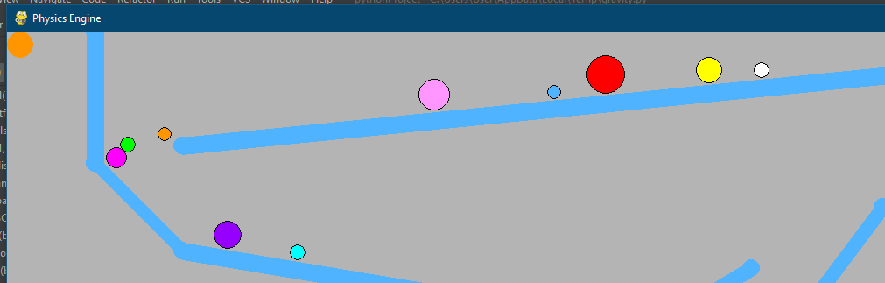

This creates a circle

pygame.draw.circle(win, (255, 0, 0), (100, 100), 30, 2)

Creates a list balls[] of dictionaries

import pygame
balls = []
platform = []
pygame.init()
size = (400, 400)
win = pygame.display.set_mode(size)
done = True
while done:
win.fill((180, 180, 180))
# pygame.draw.circle(win, (255, 0, 0), (100, 100), 30, 2)
balls = [] # empty list
balls.append({"x": 100, "y": 100, "size": 10, "r": 255, "g": 0, "b": 0}) #append a dictionary.
X = balls[0]['x'] # first list item's key is x=100.
pygame.draw.circle(win, (255, 0, 0), (balls[0]['x'], 100), 30, 2)
pygame.draw.line(win, (0, 0, 255), (150, 150), (250, 150), 2)
for event in pygame.event.get():
if event.type == pygame.QUIT:
done = False
pygame.display.flip()

https://levelup.gitconnected.com/the-two-body-problem-in-python-6bbe4a0b2f88

https://github.com/Tanmay-R-Choudhary/Gravity-Simulation
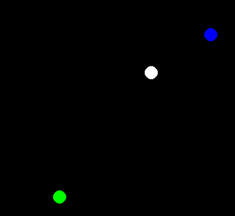

On QW PyCharm:
main.py
body.py
simulation.py
physics_engine.py see comments.

Calculate force between them using mass etc and then using Euler calculates the new position.
import numpy as np
F=10
m=2
v1 = np.array([[3, 4, 12]])
v2 = np.array([[0.0, 0.0, 0.0]])
v2=v1+F/m*np.array([[1, 1, 1]])*.01
print(v2)

to setup the screen: setup.py

import pygame
space_plane_size = (1000, 800) # width, height of canvas
run = True
# setting up pygame
pygame.init()
pygame.display.set_caption("Orbit simulator")
space = pygame.display.set_mode(space_plane_size) # Display rectangle
while run: # continuous game while loop.
space.fill((0, 0, 0))
for event in pygame.event.get():
if event.type == pygame.QUIT:
run = False # ie run until

import pygame
import numpy as np
space_plane_size = (1000, 800) # width, height of canvas
run = True
# setting up pygame
pygame.init()
pygame.display.set_caption("Orbit simulator")
space = pygame.display.set_mode(space_plane_size) # Display rectangle
while run: # continuous game while loop.
space.fill((0, 0, 0))
for event in pygame.event.get():
if event.type == pygame.QUIT:
run = False # ie run until
position_array = np.array([[500, 300, 0]])
mass = 10
color = (255, 255, 255)
radius =10
# pygame.draw.circle(space, color, position_array, np.array([0, 0, 0]), radius)
pygame.draw.circle(space, color, np.array([0, 0, 0]), np.array([0, 1, 0]), radius, radius)

circle doesn’t quite work

next: move the circle

then calclaute new position using euler.

Then do 3 circles

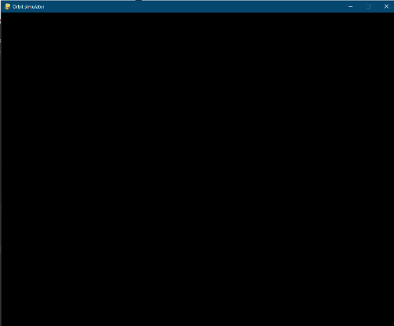
body.py

mport pygame
import numpy as np
# CONSTANTS
TIME_DELAY = 0.0005
class Body:
def __init__(self, position_array, mass, color, radius=10):
self.velocity = np.array([[0, 0, 0]])
self.force = np.array([[0, 0, 0]])
self.mass = mass
self.position = position_array
self.radius = radius
self.thickness = self.radius * 2
self.color = color
def draw(self, surface):
pygame.draw.circle(surface, self.color, (self.position[0][0], self.position[0][1]), self.radius, self.thickness)
def add_velocity(self, velocity_array):
self.velocity = self.velocity + velocity_array
def add_force(self, force_array):
self.force = self.force + force_array
def move(self):
self.velocity = self.velocity + (self.force / self.mass) * TIME_DELAY
self.position = self.position + self.velocity * TIME_DELAY

