KENSINGTON COLLEGE

Training Manual
Excel VBA

Manuals are all on www.una.co.uk
EXCEL VBA
Chapt 1
Chapt 2
Chapt 3
Chapt 4
Chapt 5
Chapt 6
Chapt 7
Chapt 8
Chapt 9
Chapt 10
Chapt 11
Chapt 12
Chapt 13
Chapt 14
Why VBA?
https://www.youtube.com/watch?v=X_F-50--8Xk&feature=youtu.be
(Note to revise Vlookup:
YouTube: ExcelAdvLesson2c https://youtu.be/Ptxg-urzBUc
Vlookup 0:13 secs)

For mac: Command button
https://support.office.com/en-us/article/Add-a-button-and-assign-a-macro-to-it-0D07DB65-6E97-41A0-8396-4DB6AEF7B3BB
record macro
https://support.office.com/en-us/article/Use-the-Developer-tab-to-create-or-delete-a-macro-in-Excel-2016-for-Mac-5bd3dfb9-39d7-496a-a812-1b5e8e81d96a

Email HW to ed@una.co.uk
When sending HW solutions (text in an email pls if possible) pls include the question at the top.

Remote Access Demo:

https://www.youtube.com/watch?v=MFc2JBpvSZs

Youtube:VBA1 https://youtu.be/aN1AL6wRTPk

Excel VBA

To write any code we need the Developer Toolbar

We must first make sure that the Developer Toolbar is on the Ribbon as follows.

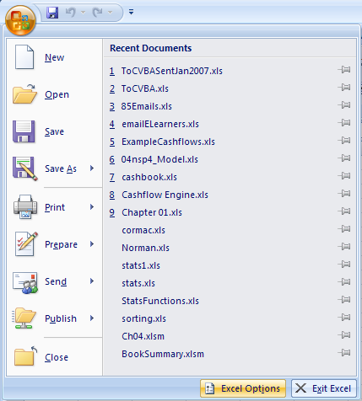
- For 2010,13,16 Click here...
- .. then Options.
- For 2007 Click here…
- ..then Excel Options.

And then.. (for 2007) And then.. (for 2010,2013,16)
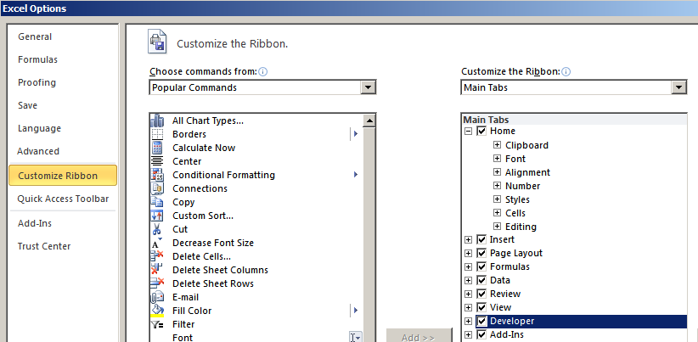
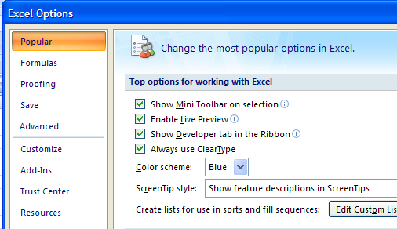
- Check the Developer checkbox and click OK.
- Customize Ribbon
- Popular.
- Check Show Developer tab in Ribbon and click OK .

Writing your first program

To place a command button on the worksheet.

- Choose the Developer tab.
- Click on the Insert button. (Don't confuse this with Insert on the menu.)

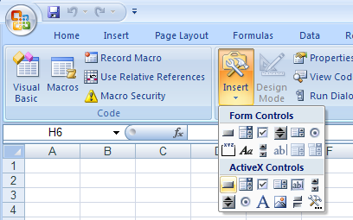
- Click on the Command Button button.

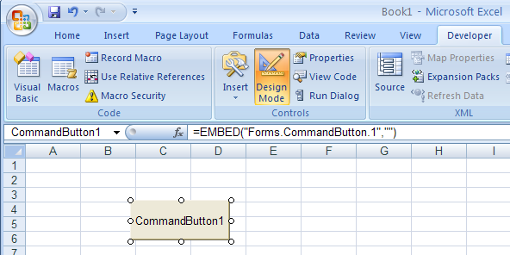
- (Make sure that you choose from the SECOND LOT of controls.
The upper set belongs to Excel 95!). It is a common mistake to choose from the first lot instead.
- Draw a button on the sheet and double-click on it to write some code.

The Visual Basic Editor (VBE) appears. Click inside
this “code skeleton” to place the cursor here.
You can reposition the command button by clicking on it and dragging. You can resize it by clicking on the sizing handles and dragging.

Other windows may appear in
the VBE application
window as well (for example, the Project Explorer window).

This code module is specific to this particular worksheet. Each
The VBE will capitalize keywords for you. We can take advantage of this
by always typing keywords in lower case. As you press the Enter key, the VBE will capitalize them for you – thereby checking your spelling! For example, type “range” instead of “Range”. (Words which are not keywords, e.g. “Simple” in this case, of course are not automatically capitalized.)
worksheet has its own code module in which code can be placed.
In this module, you will notice that some code already appears.

Option Explicit (if it does appear) will be explained in
Chapter 2. It could be considered to invoke spell-checking.

Private means that this code can only be referred to in the
code module for this particular sheet. (It also does not presently
concern us and could even be omitted if desired at this stage.)
CommandButton1 refers to the command button (object) that
we placed on the sheet. Click is what we are about to do to the
command button to run the program.

Sub and End Sub is a way of indicating a self-contained unit of
code. (More about subs in Chapter 10.)

6 Type in the code shown.

Private Sub CommandButton1_Click()
Range("A1").Value = "Simple"
End Sub

A drop-down box may appear as you type. This is IntelliSense
Alternatively, hold down the Alt key and continue to press Tab until you see the Excel icon – and then release the Alt key as well.
Alternatively, press Alt-F11 to toggle between the VBE (Visual Basic Editor) and Excel itself).
Extra spaces don’t matter (so long as there is at least one between words) when typing your code. The VBE will decide the spacing for you anyway!

Closing the VBE window by clicking its Close button will not close Excel as well.
and is discussed on page 24.) The code above will simply place
the word “Simple” into the top left cell of the spreadsheet when
we run the program. As we will see, Value is a property of the
Range object and indeed is the default property. Being a default
property, it can be omitted, i.e. we could simply have:

Range("A1") = "Simple"

Private Sub CommandButton1_Click()
Range("A1").Value = "Simple"
End Sub

Go back to the Excel spreadsheet by choosing Excel at the bottom of the screen.

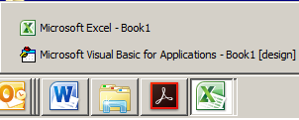

Range("A2").Clear
'Methods - do something

Running your program

Now that you have written the code, it’s time to test it.

1 To deselect Design Mode , click the Design Mode button from either ….
…Excel or the VBE

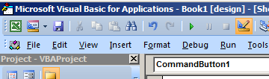
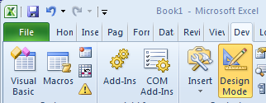

2 The command button has also become “deselected” as shown below.
Click on it to run the program.
If the code won’t run after you have closed and reopened the workbook, it maybe that your security setting needs to be changed to Low, (From the Excel on the Developer tab choose, Macro, Security, Enable all macros.....) but it will not take effect until you close and reopen the workbook.
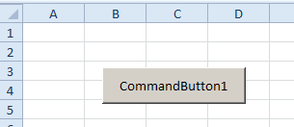

3 The text appears in cell A1.

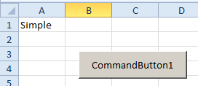

Editing the code

1 Return to the VBE by clicking on the View Code button on the
Control Toolbox. (You will only need to have the Design Mode
button depressed if the command button has the focus.)
A piece of text eg “Simple” is known as a string in Visual Basic. If you wish to place a number rather than a string, you don’t need the inverted commas.

2 Edit the code as shown below.

Private Sub CommandButton1_Click()
Range("A2").Value = 2
End Sub

3 Return to the Excel window. Make sure that the Design Mode
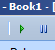
button is not depressed. Click on the command button to run
the program. Alternatively, you could click on the Run button
in the VBE (making sure that your cursor is in the code first).

If your text turns red in the VBE after you have typed a line, it indicates that you have made a syntax error. In addition you will receive a message if Auto Syntax Check is turned on (Tools, Options... from the VBE menu). You may prefer to have this option turned off to avoid interruption during certain operations, e.g. cutting and pasting.
4 Return to the Excel window. The number 2 will appear in cell
A2.

If your program doesn’t run

For example, if you made a spelling mistake, you may get a
message like this.

It is worth making a deliberate error like this, even at this stage to see the problems such an error can create.

1 Click OK – but that is not the end of the story!

2 You must now click on the Stop button.

If you were not to click the Stop button after making such an error, you will find that you are still able to click your command button if you return to the Excel window. It might appear that your program has run, but indeed you will find that it is still stalled in the VBE. This can be a common source of grievance. (Alternatively, if you close the VBE window by clicking the close button, you can click OK when warned that “This command will stop the debugger”.)

Arranging Windows

Once code has been written, arrange both windows so that they are visible as shown below.
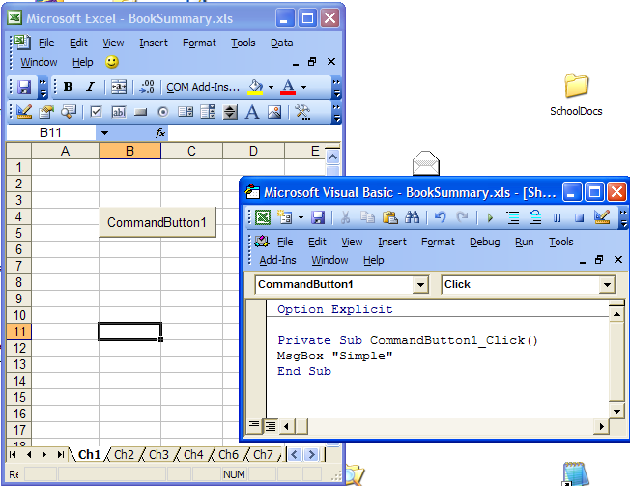
- Make sure that Design Mode is off.

Best to arrange windows so they don’t overlap!

- (If you lose your code window, it is probably easiest to right-click the sheet tab at the bottom of the Excel Window and ..

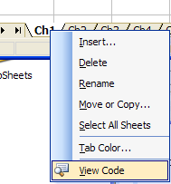
… choose View Code.

Make sure that you SAVE your workbook as a macro enabled file ie and .xlsm file not .xlsx - otherwise you will lose all your valuable code!

