Chapter Two

Basic programming techniques

Variables

VBA Lesson2a https://youtu.be/XAuWIk-x3FU (basic allocation) and
VBA Lesson2b https://youtu.be/cSL7RYF7O9E (swapping variables)

A variable is a name that we use to store a value. There are a few
TIP: After you enter a
line containing an
illegal variable
name in the VBE,
the line will turn
red.

restrictions on the names that we may choose – for example they
cannot start with a number and they cannot contain periods (fullstops),
for example x, y1, var1, sumX are legitimate variable names
whereas 1x and x.1 are not. Be careful not to use keywords as
variable names, e.g. Sub is an illegal name for a variable. Variables
are used to store values which you may wish to use later in your
program. Variables are categorized depending on the type of data
they will contain. A common type is Integer. A variable of
Integer type, strictly speaking, can only hold whole number
values, e.g.
(Giving a variable a value is known as initializing it.)

x = 2

String variable types contain text, e.g.

Surname = "Jones"

We indicate the type of the variable by using the Dim statement, e.g.

Dim x As Integer
Dim Surname As String

This is known as declaring variables. Different variable types occupy
different amounts of space in memory. The Dim statement
signals how much memory is going to be required for this particular variable.

We will edit the previous code to include a variable. It will simply
place 2 in the top left cell.
(Option Explicit, which will be explained later, may or may not be included in your code at this stage.)

Option Explicit

Private Sub CommandButton1_Click()
Dim x As Integer
x = 2
Range("A1").Value = x
Programming works from
RIGHT TO LEFT of an equal sign.
x = 2
To give you the idea try:
Let x = 2.
It will do exactly the same.

End Sub

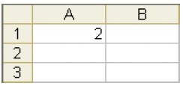

Swapping Values

Why use variables? Consider this example. We have two integers in
two spreadsheet cells as shown below. We wish to write a program
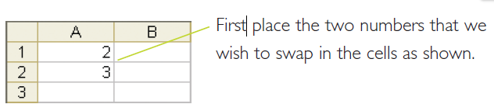
to swap them.

If you were to try the following code it wouldn’t work.

Range("A1").Value = Range("A2").Value
Range("A2").Value = Range("A1").Value

The problem is that the value in A1 gets overwritten and therefore
lost. The result would be that both cells would finally contain 3.

We need to be able to save the value in A1 in a variable as follows:

Private Sub CommandButton1_Click()
Dim x As Integer
x = Range("A1").Value
Range("A1").Value = Range("A2").Value
Range("A2").Value = x
End Sub

When we run this program by returning to the Excel window and
clicking on the command button on the sheet, the values in the
cells will be successfully swapped:

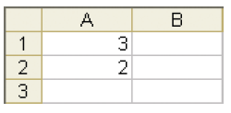

(Note that if you were to click the command button again, the
numbers would again be swapped.)

The message box

The message box is a means of displaying data.

The following code will cause a message box to appear when we
click the command button on the sheet.

Private Sub CommandButton1_Click()
MsgBox "Simple"
End Sub

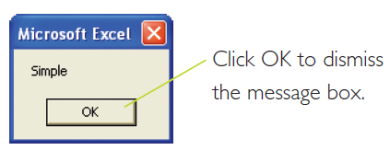

We can display a combination of text and the value of a variable:

Private Sub CommandButton1_Click()
Dim x As Integer
x = 2
MsgBox "The value of x is " + CStr(x) ’ use + instead of &.

End Sub
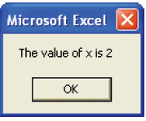
Whereas the CStr()
function can actually be
omitted (whereby the VBE forces an implicit type conversion from Integer to String), it is not considered good programming practice.

The MsgBox’s message (prompt) must be a string (text), hence the CStr() function is required to convert an integer to a string, which is then concatenated with the first string using the & operator.

(More about strings in Chapter 3.)

Comments

Comments are text that you can place in the code purely for
annotation. Comments play no part in the running of the
program. Comments can be useful when later reading through
your code to remind you what you did! To make a comment,
place an apostrophe at the start of the text. After the line is
entered, it should turn green to indicate that it is a comment.

Dim x As Integer 'Declare x
'This whole line is a comment

If you have many lines that you wish to comment, you can use the
Comment Block button which can be placed on your VBE toolbar
as follows. From the VBE menu, choose View, Toolbars and then
click Customize.... The Customize dialog box should appear as
below.

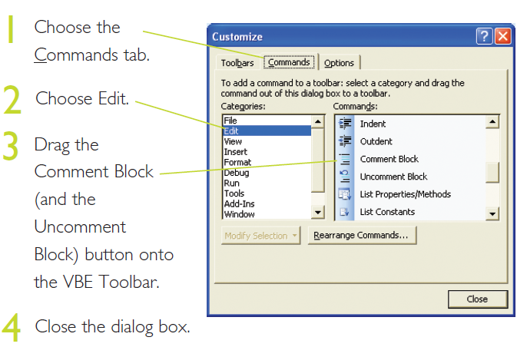
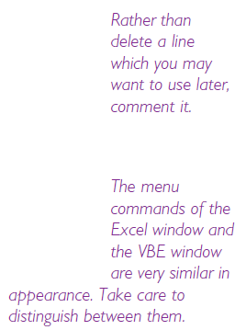

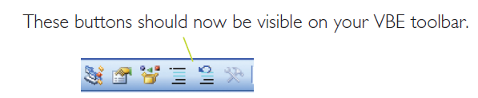

Now, in order to comment out a block of text, simply highlight the
block and click the Comment Block button. Likewise, in order to
uncomment a block, highlight the commented block and click the
Uncomment Block button.

Option Explicit

You may have noticed in our previous code examples, that
sometimes Option Explicit appears and sometimes it doesn’t.
That’s because it is optional! Option Explicit at the top of our
code module forces us to declare all of our variables, i.e. use Dim
statements. At the least, Option Explicit invokes spell-checking.
The example below uses the variable sales, but does not use
Option Explicit. (Simply delete/comment it if it is there.)

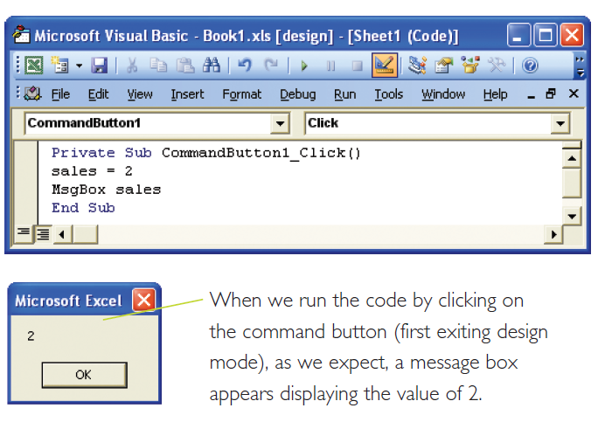

In the example below however, the second sales variable has
been inadvertently misspelled as sals. When this program is run,
the mistake goes undetected! A message box appears, but with a
blank value, (see next page) because the misspelled variable sals is
regarded as another legitimate variable without a value!
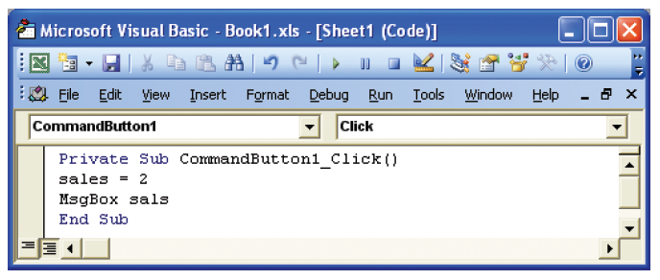

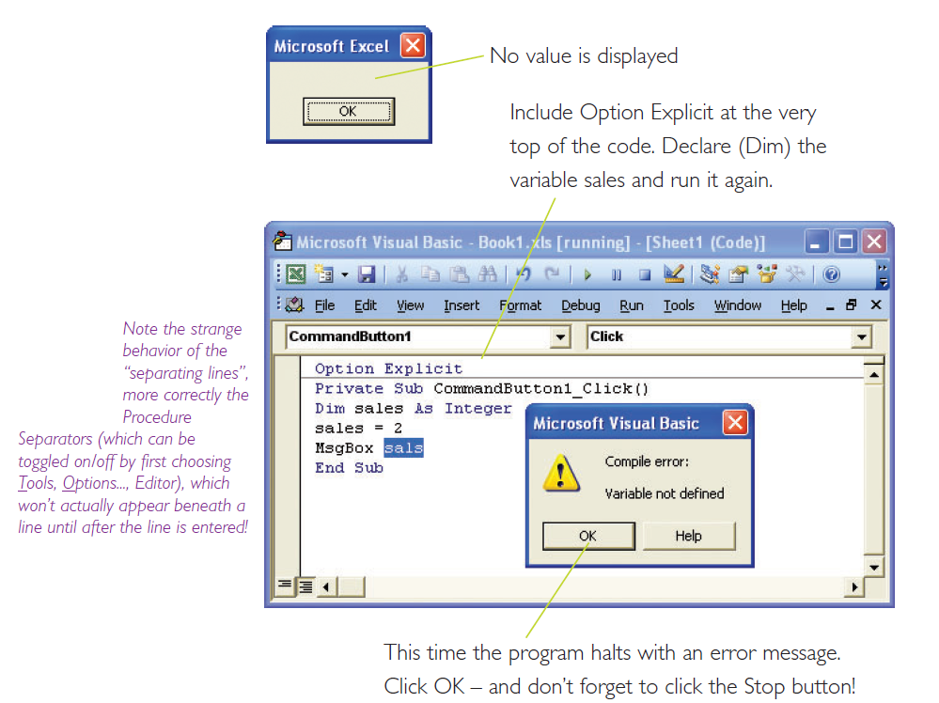

If you now correct the typo (i.e. change sals to sales), the
program should now run as expected, i.e. the message box will now
correctly display 2.

If using Option Explicit may seem a bit unnecessary, even at
Always include
Option Explicit at
the top of your
code - even
though it is
optional!

this early stage, it is a good idea to get used to it now – it will
eventually save you time, especially as programs become larger.

Option Explicit can be made to appear automatically at the top
of your code by checking Require Variable Declaration, after
choosing Tools, Options..., Editor from the VBE menu. It will not
take effect however, until you open a new workbook. Meanwhile,
you can simply type Option Explicit in the General
Declarations section if it does not already appear.
Note the strange behaviour of the “separating lines”, more correctly the Procedure Separators (which can be toggled on/off by first choosing Tools, Options..., Editor), which won’t actually appear beneath a line until after the line is entered!

Other variable types

The Long (meaning long integer) variable type is used for large
integers up to 2,147,483,647. (Integer can only take values up to
32,767.)
Single can cater for decimal values as well as integers.
Double (64 bit) is a more accurate version of the 32 bit Single
type.
Boolean can take only the values True or False.
Variant can take any type!
Date is used for storing dates. (More about Date later.)
Generally speaking, if you are not sure of the size of variable
required, opt for the larger capacity, e.g. use Long rather than
Integer.
The following code segment demonstrates common types.
What’s the point? If we are more specific about the type then errors will be easier to find later. Denis.
Option Explicit
Private Sub CommandButton1_Click()
Dim lg As Long
Dim sg As Single
Dim db As Double
It is very tempting to declare all
variables as Variant. This has
disadvantages not only from performance point of view, (i.e. your code will run slower) but you should find that errors are easier to isolate if you are more specific as to the variable type.

Dim tf As Boolean
Dim vr As Variant
Dim dt As Date
lg = 205
sg = 2.125
db = 2.125
tf = True
vr = 2.6
dt = #1/1/2005#
Range("A1").Value = lg
The l (“ell”) in the default VBA font can be easily mistaken for the VBA 1 (one).

Range("A2").Value = sg
Range("A3").Value = db
Range("A4").Value = tf
Range("A5").Value = vr
Range("A6").Value = dt
End Sub

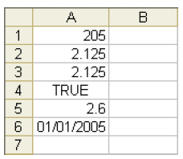

It is possible to Dim many variables on the same line, e.g.

Dim lg As Long, sg As Single, db As Double

If we wish to specify a variable as a Variant type, we can omit the
type qualifier altogether, e.g. instead of Dim vr As Variant, we
could simply have Dim vr, since Variant is the default data type.

Take care however when declaring the variables on one line, e.g.

Dim x, y, z As Integer

will declare x and y as Variant, but only z as an Integer.

An alternative method of declaring variables is to use a type declaration
character. This is a character which is appended to the variable name, e.g.

Dim i As Integer can be replaced by Dim i%
and Dim lg As Long can be replaced by Dim lg&.
The use of
type-declaration characters however is deprecated, i.e. is to be
phased out and eventually not supported, and is only mentioned
here in case it is encountered.

It is good programming practise to ensure that all variable
declarations are placed at the very start of the code.

Unfortunately, with Excel VBA, it is not yet possible to declare and
initialize a variable in one statement, e.g.
Dim s As Single = 22.1 is not yet possible.

IntelliSense

You have probably by now, noticed a drop-down box which
sometimes appears as you type. This is IntelliSense.

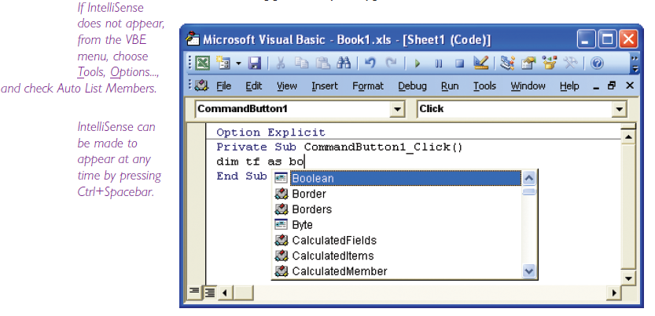
If IntelliSense
does not appear,
from the VBE
menu, choose
Tools, Options...,
and check Auto List Members.

IntelliSense can
be made to
appear at any
time by pressing
Ctrl+Spacebar.

IntelliSense is a feature of the VBE which allows you to easily
complete your line of code.
To accept the
IntelliSense
suggestion
without starting a
new line, press
the Tab key.

Note that as a space is typed, as in the above example after the
"as", IntelliSense appears. As further letters are typed, the
IntelliSense suggestions become more specific. To accept the
suggestion, either implicitly accept the suggestion by continuing to
type the remainder of the line, or double-click on the suggestion.
(If the Enter key is pressed to accept the highlighted suggestion, a
new line will be also started.)

You will also notice that IntelliSense will sometimes even make a
suggestion for the value of a variable. For example, in our case, as
shown below, when "tf =" is typed, True or False is suggested
(but only if you are declaring your variables using Dim etc.).
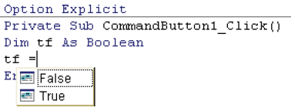

Help

Excel VBA has a very comprehensive built-in reference. The most
Excel VBA Help is
not installed by
default in a
standard
installation of
Microsoft Office. You may need
to run the Office setup program
again and choose the option to
install it.

reliable way to get Help is the easiest! Simply highlight the word
(you could double-click on the word) for which you want Help,
and then press the F1 key. For example, highlight the keyword
Boolean as shown below and then press the F1 key.

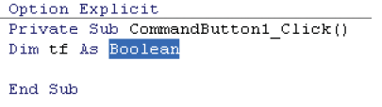
To get Help, you
can sometimes
simply place the
cursor in a word
and press F1.

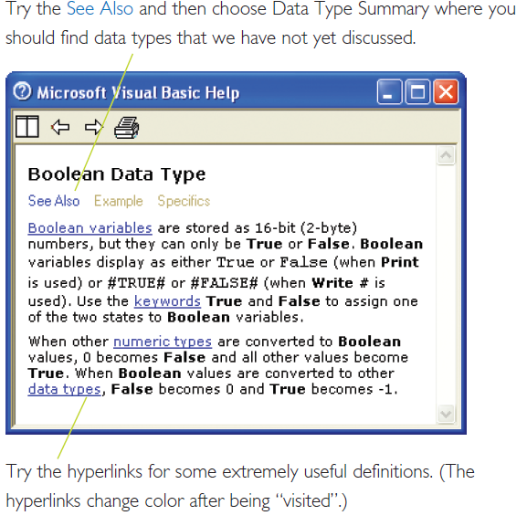
The Help dialog box appears as shown below.

Help can also be
accessed by
choosing Help
from the VBE
menu and clicking
Microsoft Visual Basic Help.

Arithmetic operations

You are most probably already familiar with Excel formulas.
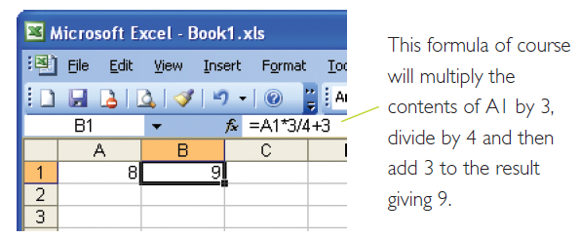

The same operator symbols are used in VBA. We could carry out
the above operation in VBA as follows.
Use the Single or
Double data type
when the result
could be a
decimal number.

Private Sub CommandButton1_Click()
Dim x As Single
x = Range("a1").Value
Range("B1").Value = x * 3 / 4 + 3
End Sub

Try the exponentiation operator; replace the corresponding line
above with

Range("B1").Value = x ^ 2

in which case the value of x is raised to the power of 2, i.e. in this
case, 8 is squared to give 64 and placed in B1.

As in Excel itself, parentheses ensure priority as shown below.

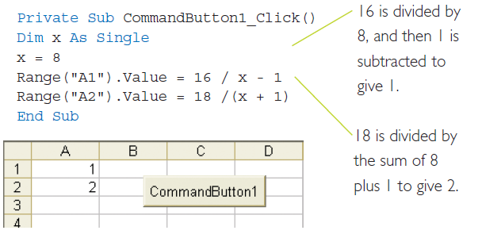

Input Box

Run this

Private Sub CommandButton1_Click()
Prompt text.

Dim x As String
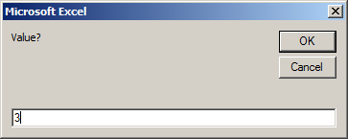
x = InputBox("Value?")

MsgBox x
x is here what is returned in this part of the input box. By default it is a string (ie text).

End Sub

Enter a value and click OK.

The entered value is placed into the variable x and then…

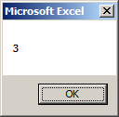
…appears in a message box:

Exercise 1 Instead of outputting in a message box place the value in cell A1 on the s/sheet.

Exercise 2 Write code which will input a value in centigrade and output into a message box the value in Fahrenheit. The formula is F = 9/5 * C + 32. Use Double.

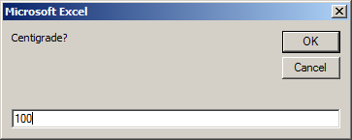

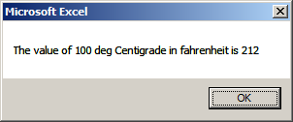

CDbl() : converts to Double
CInt() : converts to Integer
CStr() : converts to String
Course Work Exercise:

We wish to be able to …
- …. type a value into A1…

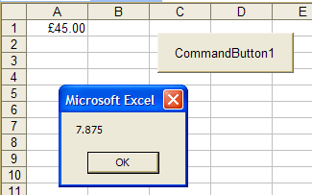
…. Whereupon, a message box will appear showing the corresponding amount of VAT (17.5%)
- …. and then click the command button.

Improvement:

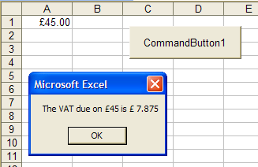
Show the original amount and text as well – as shown here.
Use a variable to hold the value from cell A1.

Website for homework solutions and course code:
http://www.una.co.uk/

To see Chapter by chapter demonstrations see
http://www.una.co.uk/BookSummary.xls

Coursework to be sent to ed@una.co.uk

