Branching and looping

Chapter 3
Now that we can write a simple program, we can proceed to learn the basic programming techniques which will enable us to write useful, practical programs.

The For...Next loop 2
Using Cells 3
The debugger 4
Breakpoints 5
The Immediate Window 6
If...Then 7
Logical operators 11
Do...Loops 12
Select Case 38
A practical example
Program development Loops inside loops 44
A number search 45
A program to delete blank cells 48 String handling 50
Regex

For Loop: https://youtu.be/BhHm5vuaMvU
If Then: https://youtu.be/inmYPtrmZlw
Lesson3a https://youtu.be/WiGGWZv5Qqw
Else if Do Select case Loop inside Loop Reconcile
ExcelVBAStringsLess3 https://youtu.be/whLci0rI9uk
Strings, basics and finding extensions.
VBAStringLess2 https://youtu.be/f8R_JlEs1Uw
Examples. Ed Robinson Fish ABCD..Z

The For...Next loop
The For...Next loop is one of the most useful program constructs. We usually first declare an Integer counter variable which will get automatically incremented as control is transferred cyclically from the last line of the loop to the first. The For...Next keyword pair serve to enclose the code.
This code will simply cause a message box to appear three times after the command button is clicked to run the program.

Use the Tab key
Private Sub CommandButton1_Click() Dim i As Integer

to indent a line of
code in order to improve legibility.
For i = 1 To 3 MsgBox "Simple" Next i
End Sub
After reaching Next, control is transferred back to For.

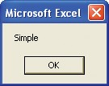
The message box will appear (and need to be dismissed) three times.

The For keyword signals the start of the loop. The value of i is initially 1. Program control continues down, line by line – the message box is displayed – until the Next keyword is reached. Program control then automatically returns to the For above.
The value of i is then incremented to 2. This process continues until i becomes 3 – control is no longer transferred back to the For but continues down to the statement after the Next – the End Sub whereupon the program terminates.
Change the code to that shown below so that the message box will now display 1, 2 and 3 respectively.
Private Sub CommandButton1_Click() Dim i As Integer
Step 2 to jump 2.

Step -1 to go backwards.

For i = 1 To 3 MsgBox CStr(i) Next i
End Sub

Using Cells

Rows first and then columns. (It may help to remember Rose Collins!)

Value could be omitted since it is the default property.

Whereas Integer type is acceptable for experimental purposes, Long is preferable for
more serious applications. Indeed, the number of spreadsheet rows (65,536), is more than twice the capacity of Integer (32,767)!

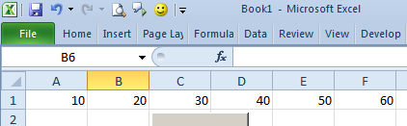

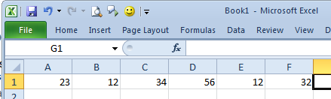

Cells is an alternative to Range. It is used to refer to a particular spreadsheet cell using indices. Cells(1,2) for example would refer to the cell of row 1 and column 2 using the indices 1 and the
2. The equivalent, using the Range notation would be
Range("B1"), so to place a 3 in cell B1 we would use:
Private Sub CommandButton1_Click() Cells(1, 2).Value = 3
End Sub
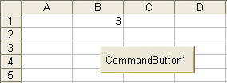

The advantage of using the Cells notation is that it can be used with variable indices, which is particularly useful for looping as we shall now see. This program simply places the number 10 in the first five cells of the first column.
Private Sub CommandButton1_Click() Dim i As Integer
For i = 1 To 5 Cells(i, 1).Value = 10 Next i
End Sub
Exercise: Make a program to place 10 20 30 across the top row
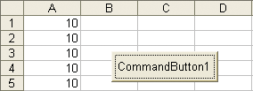

The Cells notation can also be used to get values from a cell. To read the value in cell B1 into a variable x we would use:
x = Cells(1,2).Value
Exercise: Make a program which loops thru these numbers and MsgBox them out.

The debugger
The debugger tool assists with finding errors. It can be used to step through the code one line at a time. This is useful for instructional purposes – the program can be run in slow motion!
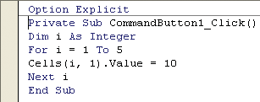
1 View the previous program in the VBE and place the cursor at the start.

Step Into.
Instead of pressing the F8 key, from the VBE menu you can choose Debug,

2

Press the F8 key to single step through the code.

If the Excel window is arranged alongside the VBE window, the
values can be seen being placed simultaneously on the sheet – one by one – as you single step
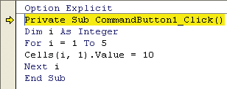
through the code!
The yellow bar shows the current line.

3 Continue to press F8 to single step. (Note that it doesn’t seem to “land” on the For statement as it cycles around the loop.)

To enable this “little yellow box” (more correctly the Data Tips window), make
sure that Auto Data Tips is checked. (Choose Tools, Options..., Editor from the VBE menu.)

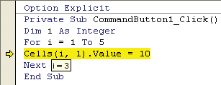
If you very carefully place your cursor on a variable as you debug, the value of the variable will appear in a small yellow box.
4 If you wish to stop single stepping, click the Stop button (or click the (triangular) Continue button to continue running).

Breakpoints
The program can be made to halt temporarily at a particular line by using a breakpoint.
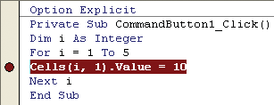
- Click on the left margin of the VBE at the point where you would like to set a breakpoint. A brown/maroon dot appears.
- Run the program by clicking the command button on the spreadsheet, or by clicking the Run button from the VBE, making
sure that the cursor is within the code. The program will halt at the breakpoint.
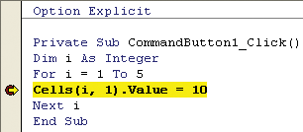

The F5 key can also be used from the VBE to run the program. (Make sure that
the cursor is at the start of the code.)
- By holding the cursor steady on a variable, we can inspect the value of the variable as we saw previously. Single step by pressing
the F8 key or continue to click the Continue (Run) button to run (loop) to the breakpoint. If you wish to stop the program, click the Reset (Stop) button.
- To remove the breakpoint, simply click on it. (To clear all breakpoints, from the VBE menu choose Debug, Clear All
Breakpoints.)

The Immediate window
The Immediate window is used to display output and accept input whilst debugging. It can be used to display values of variables as the program single steps. To display the Immediate window, from the VBE menu choose View, Immediate Window.
Debug.Print is used in the code to send output from your program to the Immediate window. Include Debug.Print i in the code of the previous example as shown below, and single step (continue pressing F8). In this case, the value of the counter will be printed to the Immediate window for each loop.
Private Sub CommandButton1_Click() Dim i As Integer
For i = 1 To 5 Cells(i, 1).Value = 10 Debug.Print i
Next i
End Sub Debug.Print i will cause the value of i
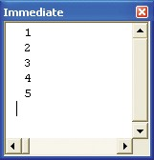
to be output to the Immediate window as the program loops.

If you wish to repeat a command whilst in the Immediate window, simply
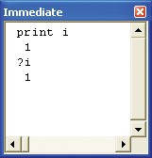
place your cursor at the end of the command and press the Enter key.

Print i can be abbreviated to ?i.

Whilst debugging, you can type directly into the Immediate window while the program is temporarily halted (break mode). Typing print i will cause the value of i to appear.

If...Then

Another extremely important statement pair is the If...Then pair. An action is either performed or not performed, depending on whether a condition is satisfied.
Private Sub CommandButton1_Click()
Dim i As Integer i = 2
If i = 2 Then Cells(1, 1).Value = "yes"
End Sub

Since the condition is fulfilled, “yes” is placed in cell A1.

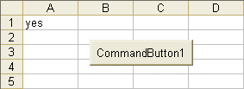

Change i = 2 to i = 3. The condition i = 2 now of course is false. When the program runs, nothing happens. (Make sure that you delete the “yes” in the spreadsheet before you run the program else you won’t see that nothing has happened!)
We have just seen how the If...Then construction was placed on one line. It can be “split” by placing the conditional code in an If....End If block as shown below.
When run, this code will perform exactly as the previous code.
Option Explicit
Private Sub CommandButton1_Click()
Dim i As Integer
i = 2

No matter what construction is used, the If and Then are always on the same line.
If i = 2 Then
Cells(1, 1).Value = "yes" End If
End Sub
The If and End If serve to enclose the conditional code.

The advantage of this construction is that more than one statement can be executed if the condition is satisfied, as we will now see.

...cont’d

Private Sub CommandButton1_Click()
Dim i As Integer i = 2
If i = 2 Then
Cells(1, 1).Value = "yes" Cells(1, 2).Value = "of course" End If
End Sub

The If and End If now enclose more than one statement.

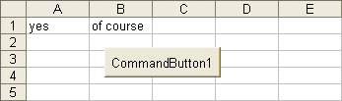
The result of running the previous code is that text appears in two cells.

Else
(Before proceeding, clear the cells A1 and B1.)
Else is used with If...Then to cater for the alternative.
Private Sub CommandButton1_Click()
Dim i As Integer i = 1
If i = 2 Then
Cells(1, 1).Value = "yes"
Cells(1, 2).Value = "of course"

Else
Cells(2, 1).Value = "sorry" End If
End Sub
Since the condition is
not satisfied, only the Else section of the code is performed.

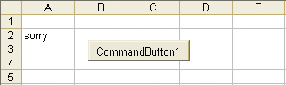

Swapping

Exercise:

Preliminaries:

1. We have already written code to swap two values (as below).

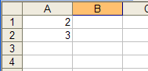

Private Sub CommandButton1_Click()
Dim x As Integer
x = Range("A1").Value
Range("A1").Value = Range("A2").Value
Range("A2").Value = x
End Sub

2. Re-write it using Cells notation.

3. Write code to test whether a 1st one (in this case the 3) is bigger than the 2nd value (2).

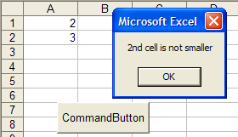
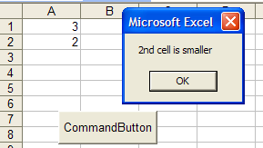

4. Write some code to swap two such values but only if 1st one (in this case the 3) is bigger than the 2nd. (ie the top value should be the smaller as shown below.) ie sorted!

(Hint: Combine programs 2. & 3. above, ie enclose the swap code of program 2 in the If statement of program 3 above.)

YouTube Lesson3a https://youtu.be/WiGGWZv5Qqw
Else if Do Select case Loop inside Loop Reconcile

ElseIf

ElseIf is similar to another If, but if an ElseIf (or If) is executed, the following ElseIfs don’t get a look in! eg:

Private Sub CommandButton1_Click()
Dim x As Integer
Once this is found to be true, the other Elseifs are not considered (even though they are true!!!)
x = 3
If x > 1 Then
MsgBox "Greater than 1"
ElseIf x > 2 Then
MsgBox " Greater than 2"
ElseIf x > 3 Then
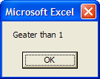
MsgBox " Greater than 3"
End If
End Sub

only!

Logical operators
The most common logical operators are And, Or and Not.
When each of the three simple programs below is run, the result will be the same – “yes” will be placed in the top left cell of the spreadsheet in each case.

And
Private Sub CommandButton1_Click()

To put two statements on one line, place a colon (:) in between(see below.)
Dim i As Integer, j As Integer i = 1
j = 2
If i = 1 And j = 2 Then Cells(1,1) = "yes"
End Sub

Both conditions
must be true.

Or

Private Sub CommandButton1_Click()
Dim i As Integer, j As Integer i = 1
j = 3
If i = 1 Or j = 2 Then Cells(1,1) = "yes"
End Sub

Not
Either condition is sufficient.

Private Sub CommandButton1_Click()
Dim i As Integer i = 1
If Not i = 2 Then Cells(1,1) = "yes"
End Sub
Any value for i other than 2 will result in the condition being satisfied.
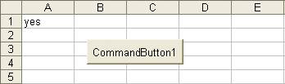

Do...Loops

Do and Loop also occur in pairs and serve to enclose code which “repeats”. The program below will perform exactly as the For...Next example we met previously. It will place five 10’s in the first column of the sheet. Whereas the For...Next loop will increment the counter for us automatically, when using the Do...Loop we must increment it explicitly.
Private Sub CommandButton1_Click() Dim i As Integer

value of i by 1.

It is most important to understand that i = i + 1 means increment the
i = 0 Do
i = i + 1 Cells(i, 1) = 10 Loop Until i = 5 End Sub
The statement i = i + 1 means “take the present value of i and add 1 to it”.

For values of i less than 5, control is transferred back to the For. When i finally becomes 5, the loop terminates.

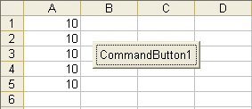
When we click on the Command Button on the sheet, five 10’s are placed in the first column.

The following is a variation of the above. Five 10’s will be placed in the first column as shown above.
Private Sub CommandButton1_Click() Dim i As Integer

i = 0
Do Until i = 5 i = i + 1 Cells(i, 1) = 10 Loop
End Sub
The only difference is that the condition is tested at the start of the loop. After i becomes 5 inside the loop, Loop sends control back to the Do Until whereupon the loop terminates.

...cont’d

Instead of Do...Until, we may use Do...While. Again the effect of this code will be identical.
Private Sub CommandButton1_Click() Dim i As Integer

i = 0
Do While i < 5 i = i + 1 Cells(i, 1) = 10 Loop
End Sub
i < 5 allows the loop to be entered
while i is less than 5, but when i becomes 5 inside the loop and control is transferred back to the Do While, the loop terminates.

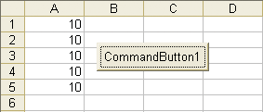

As you can see, the differences between loops using Do...Loop is quite subtle – familiarity with one would suffice at this stage.
The condition after the Do (or the Loop) (e.g. i < 5) evaluates to either True or False. If we were to run something like this...

Do While False

Loop
Since the condition is False, the program doesn’t loop at all.

...nothing would happen, it wouldn’t loop at all, whereas the following code would loop forever. (Don’t try this!)

To halt a continuous loop, press Ctrl+Break on the keyboard.
Do While True

Loop
Since the condition is True, the program would loop continuously.

In general, a For...Next loop is used when the number of loops required is quite definite, whereas the other loops, e.g. Do...While are used when a variable, which is not necessarily the loop counter, meets a condition inside the loop.

Do…Loop cont’d

Do can be used without a loop counter ie we can loop around until a certain condition (in this case finding a blank cell) is satisfied.

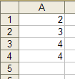
This code illustrates the difference between a For and a Do.
The For is for a fixed number of times.
The Do only finds out at run-time how many times it has to loop.

Cells(1, 1).Select
Do Until IsEmpty(ActiveCell.Value)
MsgBox ActiveCell
ActiveCell.Offset(1).Select
Loop
ActiveCell.Offset(1)means the cell beneath the active cell.
(OffSet will be considered on p.117 of the book.)

Result:

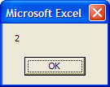 …….. 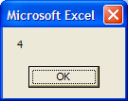

(Strictly speaking, IsEmpty should really only be used in code to test whether a Variant variable has not been initialized with a value - but it seems to work in this situation where we are testing to see whether a cell contains any value (text or number).)

Exercise1:

We have several numbers in column A:

Write code (use a loop) that increases them by 20% in situ. ie the result should be:
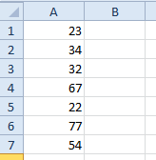

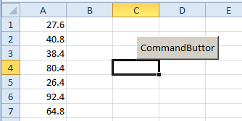

Exercise2:

Write code that prints these new values and place them on cell to the right. (Leave column 1 as it was.)

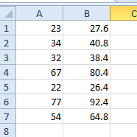

Select Case See video 8:33
Select Case is like a multiple If statement. The option chosen will depend on the value of a variable.
Private Sub CommandButton1_Click() Dim x As Integer

x = 7
Select Case x Case 5 MsgBox "Five" Case 7 MsgBox "Seven" End Select
End Sub
The value of the variable x will determine which Case is selected.
Since the value of x is 7, this section of the code (only) will be executed.
End Select always accompanies Select Case.

As a result of running the program, the message box will appear as below.
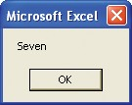

The most convenient way to get Help is to select the words (e.g. Select Case)
in the VBE and press F1.

When using this particular Help Example, make sure that the Immediate
window is open. (From the VBE choose View, Immediate Window
- or Ctrl+G) to see the result of the Debug.Print statement.)
From the VBE, take a look at the Help for Select Case.
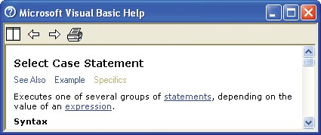
The Help Example is particularly useful. Copy and paste it into the CommandButton procedure. Note in the example how the option chosen can depend on a range of values rather than a single value. Note also the use of the comparison operators Is < and Is >.

Select Case

… the same as ElseIf eg :

Private Sub CommandButton1_Click()
Dim x As Integer
x = 0
- Once this is found to be true, the other Case statements are not considered (even though they are also true!)
Select Case x
Case Is < 1
MsgBox "Less than 1"
Case Is < 2
MsgBox "Less than 2"
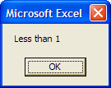
Case Is < 3
MsgBox "Less than 3"
End Select
End Sub

Only gives:

ie after one correct Case is encountered, all the following Case statements are not even considered!

A practical example
A salesman receives a commission which increases with his sales. For sales of less than 1000 dollars he receives 5 %.
Between 1000 and 2000 dollars (inclusive) he receives 10 %.
For greater than 2000 dollars he receives 15 %.

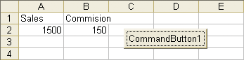
We want to enter the sales value into cell A2, and then click the command button for his commission to appear in B2.

Private Sub CommandButton1_Click() Dim sales As Single, comm As Single sales = Cells(2, 1).Value

Select Case sales Case Is < 1000
comm = 0.05
Case 1000 To 2000
comm = 0.1 Case Is > 2000
comm = 0.15 End Select
The sales value is obtained from the cell A2.
The commission percentage is determined by the value of sales.

Cells(2, 2).Value = sales * comm End Sub

The total amount of commission that he receives will be calculated and appear in cell B2.

Program development
We wish to write a program which will indicate by means of a message box, the number of occurrences of a particular number, in this case, the number of occurrences of 12, as shown below. First place eight numbers (including some 12’s) in the first column of a sheet as shown.
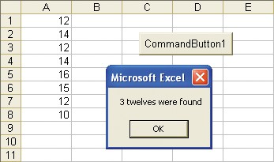
Rather than write the complete program to do this in one attempt, we will write and test small sections, and finally piece them together – step by step.
1 Write some code to output all of the eight values in column A one at a time.

Private Sub CommandButton1_Click() Dim i As Integer
For i = 1 To 8
MsgBox Cells(i,1).Value Next i

End Sub
The row value of Cells(i , i) is
increased by i each time it loops.

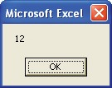
Eight message boxes should appear with the respective values.

...cont’d

2 Have the message box appear only if the value in the cell is 12. Use an If. (In our example, the
message box displaying 12 should appear 3 times.)

Private Sub CommandButton1_Click() Dim i As Integer
For i = 1 To 8
If Cells(i,1).Value = 12 Then Msgbox Cells(i,1).Value
End If Next i
End Sub
3 Use a counter (c in this case), and increment it each time that a 12 is encountered. Finally, include a MsgBox statement after the
loop has ended to report the value of this counter.

To indent a block of code to make it more legible, highlight the block that you wish to
indent and press the Tab key. (To “un-indent” (more correctly to outdent it), highlight it and press Shift+Tab.)
Private Sub CommandButton1_Click()
Dim i As Integer, c As Integer c = 0
For i = 1 To 8
If Cells(i,1).Value = 12 Then c = c + 1
End If Next i
MsgBox CStr(c) & " twelve/s found"
End Sub

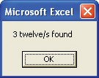
4 When the program is run, we should get a message box indicating
the number of 12’s found.

...cont’d

Using a flag
What if we wished to know not how many 12’s there are, but whether there is a 12 in a list of numbers? We need to indicate or flag that a 12 was found. It is usual to declare a flag as a Boolean type and initially set it to False. (The default value of a Boolean type is False, but it is always good practise to initialize variables explicitly.) If a 12 is found, we could use an If statement to set the flag variable to True and after exiting the loop, use a message box to display the state of the flag as shown.
Private Sub CommandButton1_Click()
Dim i As Integer, fl As Boolean fl = False
For i = 1 To 8
If Cells(i, 1).Value = 12 Then fl = True Next i

If fl = True Then MsgBox "Found a 12" Else
MsgBox "12 not found" End If
If a 12 is found, then the flag is set to True.

End Sub
(You could try removing all of the 12’s from the
values in column A to test the Else condition.)

For the sake of code efficiency, the For...Next loop in the above program could be modified to include an Exit For as shown below, so that when one 12 is found, the For...Next could be terminated and the flag would not repeatedly be set to True each time that another 12 was found. If the debugger were used to single step, you would see an exit from the For...Next as soon as the first 12 was found.
For i = 1 To 8
If Cells(i, 1).Value = 12 Then fl = True

Exit For End If
Next i
Note that we need to use an If...End If because there is more than one statement to be executed if a 12 is encountered.

...cont’d

Adding flexibility
So far, we have written a program that searches for the number of 12’s. The 12 is built into the program. What if we wished to search for 14 or a 15? How should we let our program know what number to look for? We will enter it into a cell (C1 in our case) on the sheet itself, and then click the command button to find whether this number is in our set of numbers.
Private Sub CommandButton1_Click()
Dim i As Integer, fl As Boolean, x As Variant x = Cells(1, 3).Value

fl = False

For i = 1 To 8
If Cells(i, 1).Value = x Then fl = True
If the number is found then the flag is set to True and the loop is exited.
Exit For
End If

The number that we
wish to search for is input from cell C1.

Sometimes an
error message will appear warning that you have a “Next without

For”, where in reality it’s an End If that’s missing.

Save this code for
If fl = True Then
MsgBox "Found a " & x Else
MsgBox x & " not found" End If
End Sub

The message box will also remind us of the number that we are looking for.

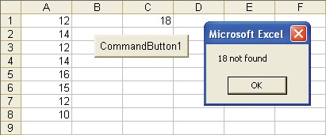
a following exercise. (A convenient way to do this is to
comment it and perhaps drag it out of the CommandButton procedure.)
The number that we are to look for is placed in cell C1. (Fully test the code by using a number which is not in column A.)

Loops inside loops
We wish to write a program which will iterate through this table of values and display them one at a time using a message box. First, use the code below to iterate across the top row only.
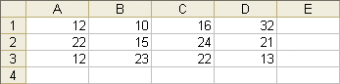

Private Sub CommandButton1_Click()

Reduce and rearrange both the Excel window and the VBE window to be
able to see your code in action.
Dim j As Integer For j = 1 To 4 Cells(1, j).Select
MsgBox Cells(1, j).Value Next j
End Sub
(The Select statement is only included so that the cell will appear selected each time the message box appears.)

So far, we have iterated through the first row only. In order to move down one row at a time in order to iterate through the next two rows, we need another loop. The counter of this outer loop (i), will need to increment from 1 to 3, thereby incrementing the row number.
Private Sub CommandButton1_Click() Dim i As Integer,j As Integer

For i = 1 To 3
For j = 1 To 4 Cells(i, j).Select
MsgBox Cells(i, j).Value Next j
For each of the 3 values of i (the row number), the inner loop cycles 4 times.

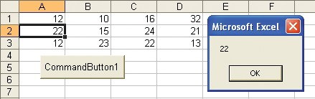
Next i
End Sub
Watch the selection move across and then down.

A number search
In a previous example, we searched through a list of numbers in column A to find a number which was read in from a particular spreadsheet cell. What if we wanted to find a series of such numbers?
In this example, we want to search for each of the three numbers in column C, one at a time, to see if they exist in the list of eight numbers in column A. We need a loop inside a loop.
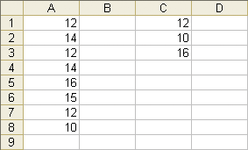
We want to determine whether these numbers are in column A.
(Of course they all are presently.)

When your statement won’t fit onto one line, use the special line continuation
character. Type a space

Private Sub CommandButton1_Click() Dim i As Integer, fl As Boolean, _ x As Variant, j As Integer

followed by an underscore and then press the Enter key. Don’t forget the space!
For j = 1 To 3 fl = False
x = Cells(j, 3).Value For i = 1 To 8
The outer loop iterates through the 3 values in column C.

If Cells(i, 1).Value = x Then fl = True

Always test code under all conditions. In this example include a number in
column C (e.g. 18) which is not in column A.
Exit For End If
Next i
If fl = True Then MsgBox "Found a " & x Else
MsgBox x & " not found"
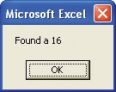
End If
If the value is found in column A, set the flag = True and exit the inner loop.

Next j End Sub
Three such message
boxes will appear in our example.

Reconciliation Exercise

Suppose we have cash book entries for cheques received and a bank statement for cheques hopefully banked.

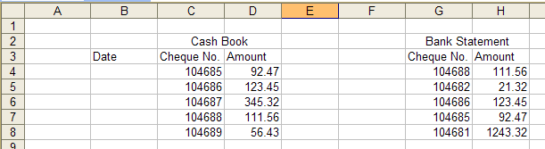

We wish to delete the entries which exactly correspond, so that, in this case we will have:

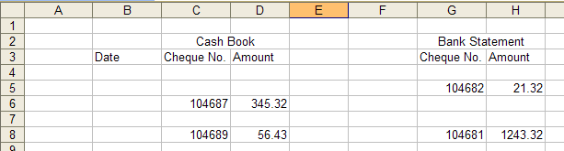

As a further exercise, we may wish to place the deleted items in a separate table ie.

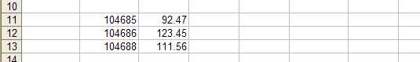

It may be better/easier to just COLOUR the entries which are the same rather than delete them.(see below.)

I may also be easier to just do the Cheque No s for the moment
ie Just use this simplified table first:
(For copying.)
bank |  |  | cash
104685 |  |  | 104688
104686 |  |  | 104682
104687 |  |  | 104686
104688 |  |  | 104685
104689 |  |  | 104681
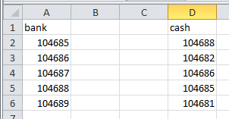

You could choose to perhaps embolden the common elements using Font.Bold = True or perhaps make then red with Font.ColorIndex = 3.

The result might be:

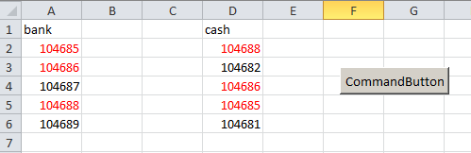

Exercise

1. Find the maximum value in these 4 numbers using a loop. Ans: 28.

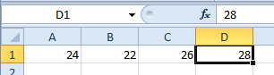
As a preliminary, starting at B1 loop, thru them one at a time and MsgBox out each one.

Hint : Set the FIRST cell as maxSoFar and compare the others with this and swap if necessary.

2. Optional: Sort them in ascending order using a nested loop. (Difficult).

Hint: The inside loop “limits” of the For loop don’t have to be constants.
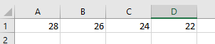
ie

becomes:
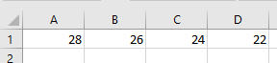
BTW: Use the Watch Window to watch the cell contents.

There are perhaps more straightforward way of doing them but not from 1st principles ie not using loops.
Max:
Dim m As Integer
m = WorksheetFunction.Max(Range("A1:D1"))

Sort:
Range("A1:D1").Sort Key1:=Range("A1"), Header:=xlNo, Orientation:=xlLeftToRight

A program to delete blank cells See below for prelim.
We are able to delete blank cells from Excel, but the method has a

A multiple selection can also be made holding down the Ctrl key whilst selecting.

Whilst testing and developing, it’s a good idea to have a reserve set of values on the
same sheet which can be quickly copied across if the originals are erroneously altered by your code.
shortcoming; if we were to first select the blank cells by selecting the whole range and choosing Edit, Go To..., Special..., Blanks and then from the Excel menu, delete them using Edit, Delete..., Shift cells up, all cells beneath the selection would be moved up as well! How can we avoid also moving these cells up? VBA to the rescue! Once again, rather than write the program to do this in one attempt, we will develop our program in a step by step manner, testing the techniques required as we go.
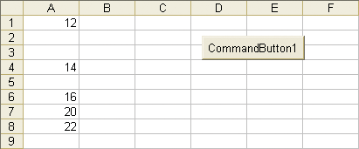

For the moment, let’s make the requirement a bit simpler. Say that we are now required only to move all of the cells to the right which are non-blank, as shown below.
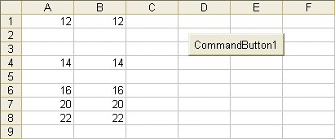
The following code should perform that task.
Prelim to the above: 1. Loop thru the cells in column A and move them two to the right only if they are not 100. Result should be:

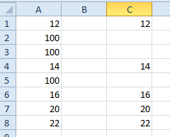

Change the 100s to blank. Now move them if they are not blank.
Single-step.

...cont’d

Private Sub CommandButton1_Click()

Dim i As Integer For i = 1 To 8
“” indicates a blank (empty cell).

If Cells(i, 1) <> "" Then
Cells(i, 2).Value = Cells(i, 1).Value End If

Next i End Sub
<> means “not equal to”.

The contents of the cell in column 1 is copied to the corresponding cell (on the same row) in column 2.

Say that we now require the cells in the second column to be “bunched up”- with no spaces, as shown below.
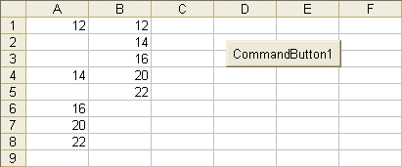
To achieve this, we need a counter which will keep track of the number of occupied cells in the second column. We will use c as this counter and increment c each time that a cell is copied across – each time that a non-blank is found.
Private Sub CommandButton1_Click()
Dim i As Integer, c As Integer c = 0
For i = 1 To 8
If Cells(i, 1) <> "" Then c = c + 1
Cells(c, 2).Value = Cells(i, 1).Value
End If

Next i End Sub
The variable c keeps track of the next available row in column B.

String handling
ExcelVBAStringsLess3 https://youtu.be/whLci0rI9uk
Strings, basics and finding document extensions.

We previously mentioned that a piece of text is known as a string in VBA (and many other languages as well). We can use special functions to join (concatenate) them, split them, search for one string inside another, etc.
We have seen how to declare and initialize String types:
Dim st1 As String, st2 As String st1 = "house" : st2 = "boat"

Concatenation
To join two strings, use the & operator.
Cells(1, 1) = st1 & st2

“house” and “boat” are concatenated to give “houseboat”.
Place these lines of code into a command button procedure. Run the following lines of code as well.

Left
Left extracts the leftmost characters from a string, e.g.
Cells(2, 1) = Left(st1, 2)

The 2 leftmost characters of

Right
“house”, i.e. “ho” are extracted.

Right extracts the rightmost characters from a string, e.g.
Cells(3, 1) = Right(st1, 2)

The 2 rightmost characters of

Instr
“house”, i.e. “se” are extracted.

Instr finds the position of a substring in a string, e.g.
Cells(4, 1) = InStr(st1, "us")
The position of the string “us” inside the string “house” is found – at position 3.

...cont’d
Note: InStr has an extra parameter (see page 54 and exercise 4b later.)
Private Sub CommandButton3_Click()
Dim st As String, pos As Integer
st = "123.xyz.345"
'Find position of 1st full-stop.
pos = InStr(st, ".") ' 4
'Find position of 2nd full-stop.
pos = InStr(7, st, ".") ' 8
End Sub

Mid
Mid extracts a substring, e.g.
Cells(5, 1) = Mid(st1, 3, 2)

The substring of the string “house”, starting at position 3 and of length 2, i.e. “us” is extracted.
Len
Exercise:
Extract your middle name from your fullname
eg If your name is Winston Spencer Churchill then extract Spencer.
Len simply finds the length of the string, i.e. the number of characters, e.g.
Cells(6, 1).Value = Len(st1)
The length of the string “house” is determined, i.e. 5 characters.

The results of all of these previous lines of code is shown below.

See Help for more information about other interesting string- related functions
e.g. Trim, CStr, Val, etc.
“house” & “boat” Left(“house”,2)
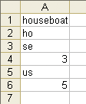
Right(“house”,2)
Instr(“house”,”us”)
Mid(“house”,3, 2) Len(“house”)
When using the Mid function,
if we don’t specify the last number, the substring extracted will be the rest of the string to the right, from the position specified, e.g. if instead of Mid("house", 3, 2) which produced “us”, we used Mid("house", 3) then “use” would result. When extracting characters to the right from a string, the Mid function is surprisingly more useful than Right, since it is usually more convenient to specify the starting position for string extraction, rather than the number of characters to the right to be extracted.

...cont’d
To rearrange a string
We are given a person’s full name, e.g. Jack Robinson. We wish to convert this to the format Robinson,Jack i.e. the surname followed by a comma (no spaces), followed by the Christian name. We require this technique to work for any Christian name-surname pair(Try yours!).
First we must extract the Christian name.
Before that though, we need to find the position of the space. We can then extract all of the characters to the left of this position (the Christian name). We then need to extract all of the characters to the right of this position (the surname). Finally, we can concatenate the surname with the Christian name (in that order), not forgetting to put a comma in between.
Place the full name to be processed in cell A1 and run this code.
Private Sub CommandButton1_Click()
Dim fullName As String, pos As Integer, _
cn As String, sn As String, newName As String fullName = Cells(1,1).Value'Full name in cell A1 pos = InStr(fullName, " ") 'Position of space cn = Left(fullName, pos - 1) 'Christian name
sn = Mid(fullName, pos + 1) 'surname newName = sn & "," & cn
Cells(1, 2) = newName 'B1 holds new name End Sub
Test it by trying a different full name in cell A1.
This technique could be employed for example to loop through a set of full names in the column of a spreadsheet and place the names with the modified format in the next column to the right as shown below.
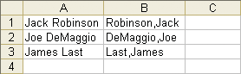

Start with this:
Dim fullName As String, pos As Integer
Dim cn As String, sn As String

fullName = "ed robinson"

pos =

Exercises

1. Find the 3-lettered extension (eg .doc) in a given file name eg letter1.doc or Book1.xls. (Use Right.) Start with this:

Dim st as String
st = "letter1.doc"
MsgBox …

2. Find the position of the dot (full-stop) in st = "letter1.doc" (ans = 8)

3. Extract the text to the right of the dot in st = "letter1.doc". (ie doc) but
make it general ie show that it also works for eg st = "letter1.docx"
(The solution is already done on YouTube video.)

4. a. Find the position of the first "and" in st = "Ed and Joe and Flo and Mary".
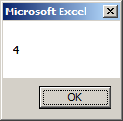

b. Take a look at the Help on InStr

What is the purpose of the 1st parameter ie [start,]. Why is it in (square) brackets?
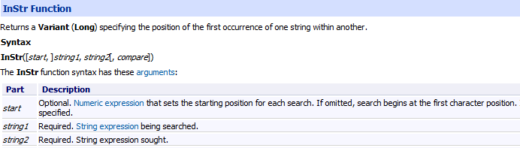
Use it to find the position of the second "and" in
st = "Ed and Joe and Flo and Mary".

(Hint: Set the start to about position 5 (greater than 3).)

What happens if you use pos = InStr(4, st, "and")?

Why?

5. Find all the positions of "and" in the string "Ed and joe and Flo and Mary".
Start with this:

Dim st as String, i as Integer, pos as Integer

st = "Ed and Joe and Flo and Mary"

For i = 1 to 3

pos =

Next i

Take care to not search for the same “and”: Hint: use pos + 1.

6. What does InStr return if nothing is found? Try this.

Dim st as String, pos as Integer

st = "Ed and Joe and Flo and Mary".

and use InStr to try to find “fred”. (Not fouind)

7. Use a Do Loop to loop thru st = "Ed and joe and flo and mary" to find the position of "and". How will you stop it?

As above use pos +1 as a [Start] rather than just pos. Else you will keep finding the same “and”.
ie pos = InStr(pos + 1, st, "and")

Hint: While testing your code use single – stepping (F8) to avoid going into an infinite loop”

8. For st = "abc.123.xxx.345" extract the text before the first dot (ie abc) but note that the string could be st = "abcd.123.xxx.345" so it must be general.

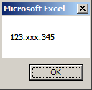
9. Remove the text before the 1st dot so that the string becomes "123.xxx.345". Once again it must be general work for
eg s t = "abcd.123.xxx.345"
so now st = "123.xxx.345"

10. How might we find just all the characters between the dots ie
abcd
We may save ourselves a bit of trouble and use Split (but this will involve arrays – see chapt 11)
123
xxx
345

XML: See XML demo Access - > Excel

If you wish you may just answer Qu 6. ie extract the data from
stXML = "<Table1><Person>ed</Person><Person>joe</Person></Table1>"

1. Find the position of "<Person>" in this string. (ans: 9)
st = "<Table1><Person>ed</Person></Table1>"

2. Given the answer above (9) find the position of the second "<Person>" in this string. (ans: 29)
stXML = "<Table1><Person>ed</Person><Person>joe</Person></Table1>"

Hint: Recall that Instr has a parameter at the start:

pos1 = InStr(1, stXML, "<Person>")

3. Use a For loop (from 1 To 2) to find the positions of both <Person> tags in this string. (Ans: 9,29)

stXML = "<Table1><Person>ed</Person><Person>joe</Person></Table1>"

Hint: Use pos+1

4. Use a Do loop to find the positions of both <Person> tags in the string above.
(Ans: 9,29)
Hint: Take a look again at the Help for Instr. What value is returned by if nothing is found?

Now we will extract the data:

5. We have already found the position of "<Person>" in this string (Qu. 1) .

stXML = "<Table1><Person>ed</Person</Table1>"

Put pos1 (Dim pos1 as Integer) equal to this position value (9).

Also find the position of "</Person>". (19). Call it pos2.

Use pos1and pos2to extract the data - ed in this case – it must work for any data between the tags eg fred. Hint you may need to use the length of <Person> ie Len(<Person>).

stXML = "<Table1><Person>ed</Person><Person>joe</Person></Table1>"

6. Extract the text "ed" and "jo" (first search for the tags <Person> and </Person>).

Dim stXML As String, pos1 As Integer, pos2 As Integer
Dim L As Integer, txt As String

stXML = "<Person>ed</Person><Person>joe</Person>"

Search first for <Person> and </Person>". You may use Len("<Person>".

Use a loop (You might start with a For and later use a Do) to find all instances of data eg between the <Person>tags for this string:
To make it more general we could use:
strtTag = "Person"
endTag = "</" & strtTag & ">"
strtTag = "<" & strtTag & ">"

Exercise: A .csv (comma separated values) file looks like this.
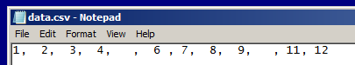

It is simply a text file where the data is separated
Actually probably better to use Split ie :
Dim st As Variant
st = "1997,Ford, E350"
st = Split(st, ",")
MsgBox st(0)
MsgBox st(1)
MsgBox st(2)
It uses Variant arrays which will be covered in CH 11.

(delimited) by commas.

Exercise : Extract the data in this CSV file:
1997,Ford, E350
(Use Trim to remove any spaces

json
https://medium.com/swlh/excel-vba-parse-json-easily-c2213f4d8e7a

{
"firstName": "John",

"postalCode": "10021-3100"
}

Exercise: Find the data!

List of String functions: Built-In VBA Functions
http://www.excelfunctions.net/vba-functions.html

VBA Text Functions
Format | Applies a format to an expression and returns the result as a string.
InStr | Returns the position of a substring within a string.
InStrRev | Returns the position of a substring within a string, searching from right to left.
Left | Returns a substring from the start of a supplied string.
Len | Returns the length of a supplied string.
LCase | Converts a supplied string to lower case text.
LTrim | Removes leading spaces from a supplied string.
Mid | Returns a substring from the middle of a supplied string.
Replace | Replaces a substring within a supplied text string.
Right | Returns a substring from the end of a supplied string.
RTrim | Removes trailing spaces from a supplied string.
Space | Creates a string consisting of a specified number of spaces.
StrComp | Compares two strings and returns an integer representing the result of the comparison.
StrConv | Converts a string into a specified format.
String | Creates a string consisting of a number of repeated characters.
StrReverse | Reverses a supplied string.
Trim | Removes leading and trailing spaces from a supplied string.
UCase | Converts a supplied string to upper case text.

The Ultimate Guide to VBA String Functions for more explanation
https://excelmacromastery.com/vba-string-functions/
eg see his use of Split.

or get individual help on M/soft – select and press F1. eg.
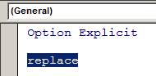

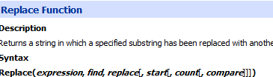

Miscellaneous string functions:

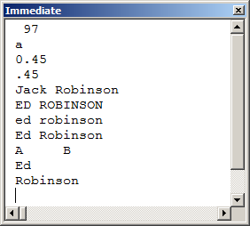
Private Sub CommandButton1_Click()

Debug.Print Asc("a") '97 'ASCII or ANSI

Debug.Print Chr(97) ' a

Debug.Print Format(0.45, "0.00") '0.45
Debug.Print Format(0.45, "#.00") '.45

Debug.Print Replace("Ed Robinson", "Ed", "Jack") 'Jack robinson
Debug.Print UCase("Ed Robinson") 'ED ROBINSON
Debug.Print LCase("Ed Robinson") 'ed robinson

Debug.Print StrConv("ed robinson", vbProperCase) 'Ed Robinson

Debug.Print "A" & Space(5) & "B" 'A B

Dim arr As Variant '(Havent done variant arrays yet.)
arr = Split("Ed Robinson") 'Take a look in the Locals Window.
Debug.Print arr(0) 'Ed
Debug.Print arr(1) 'Robinson

End Sub
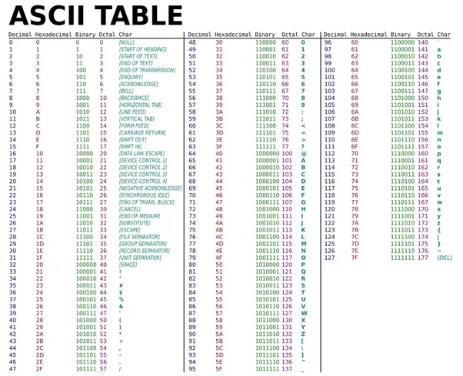

Exercise:

1. Here is a partial list of fish Genus approved in Britain for import whose name starts with B.
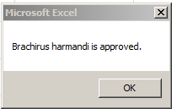
Bororas
Botia
Boulengerella
Boulengerochromis
Show that the species Botia Speciatus is an approved fish. Hints:
First extract the Genus name Botia from Botia Speciatus. (Search first for the space.)
(We wish to make this general ie work for any fish.)
- Loop thru the above list to show that you can find this Genus.

1.a (Difficult and optional- maybe later)
The above is an extract from a fish regulatory authority but it is indeed is a little more complex as below. “Anyone who is unsure whether a listed species is licensed or not should contact the Fish Health Inspectorate at Cefas”! Here is an extract for the “B” fish page:
 |  |  | Maybe as a prelim exercise ignore the (except) types for the moment.
  Barbucca
  Barbus (except) | albanicus
   | balcanicus
   | caninus
   | carotte
Bororas
Botia
Boulengerella
Boulengerochromis
Brachirus | harmandi
 | panoides
 | siamensis
Brachychalcinus

ie Barbucca anyspeciotus IS approved (there is NO species specification)
Barbus albanicus IS NOT.
Barbus marenthius IS. (ie It’s not found under Barbus.)
Brachirus harmandi IS
Brachirus robinsonus IS NOT (ie It’s not found under Brachirus.)

Write code to do that!
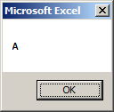
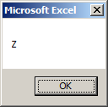
2. Take the string st= "ABCDEFGHIJKLMNOPQRSTUVWXYZ" and MsgBox out one character at a time.

ie . . . . . . . . .

3. Take the string st= "Ed Robinson" and replace Ed with Jack so that the string becomes Jack Robinson. Use Replace. See Help on Replace:

Replace | Replaces a substring within a supplied text string.
3.a: For this piece of text: “His Christian name is Ed.”
replace “Christian” with “first”. So: it then should read:
“His first name is Ed.”

4. Use a loop to extract the data from this “CSV” string "IBM, USG, ICL".
Ie IBM
USG
As a preliminary you could just find the position of the first comma (ie 4).
ICL
Start with For i = 1 To 3

You might use pos = Instr(st,pos…… ) inside your loop.

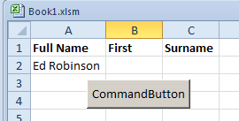
5. XML HTML
https://youtu.be/bgvHkX81_I8

When we click the button we wish the
first name and surname to be placed here.

Find In AddresesExpt.xlsm find sheet.
The rest of this chapter is perhaps for students who have advanced and/or could be left to a later date ie after completion of the course.

Find is used to search a range. It will find the first occurrence
only. It returns a Range object. This code finds 2 in A1:A5.

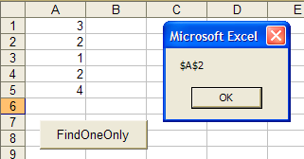
Private Sub cmdFind_Click()
Dim c As Range, rng As Range

Set rng = ActiveSheet.Range("a1:a5")

Set c = rng.Find(2)
MsgBox c.Address
End Sub

The VBA .Find will run faster than your code using looping!
Note that the Find and Replace dialog box reflects and retains the settings of the previous search.

- (Choose Edit Find… from the Excel menu.)

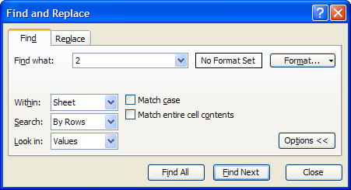

..and in the code: Find will retain the previous search.

- The 2 is retained from the previous search.

We can modify the Find statement above to start searching after cell A2:

Set c = rng.Find(2, after:=Range("A2"))

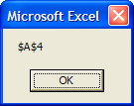
FindNext and FindPrevious

- Modify the code:

Private Sub CommandButton1_Click()
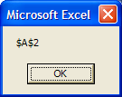
Dim c As Range, rng As Range

Set rng = ActiveSheet.Range("a1:a5")

Set c = rng.Find(2, after:=Range("A2"))

Set c = rng.FindPrevious(c)

MsgBox c.Address
c is the cell object of the first Find . ie range object Range("A2")

End Sub

Finding the others is a little unorthodox:

FindNext can be enclosed in a loop to find all of the values in a certain range.
The problem is that after finding A2 and A4 it starts again! at the top and continues in an infinite loop. You may not wish to run this but if you may need Ctrl-Break (or Pause) may stop it.
Private Sub CommandButton1_Click()

Dim c As Range, rng As Range

Set rng = ActiveSheet.Range("a1:a5")

Set c = rng.Find(2)

Do Until c Is Nothing
MsgBox c.Address

Set c = rng.FindNext(c)

Loop

End Sub

How to halt the cycle?

We must test the Address of the FindNext cell against the Address of the (first) Found cell.

Private Sub CommandButton1_Click()

Dim r As Range, f As Range, firstAddress As String, st As String

st = "2"
Set r = Range("A1:A5")
Set f = r.Find(st)
If f Is Nothing Then GoTo finish
firstAddress = f.Address
If Not f Is Nothing Then ' ie found one
f.Select
MsgBox f.Value & " at " & f.Address
End If

Do
Set f = r.FindNext(f)
If (f Is Nothing) Or (f.Address = firstAddress) Then
Exit Do ' ie nothing found
Else ' If found something...
f.Select
MsgBox f.Value & " at " & f.Address
End If
Loop Until (f Is Nothing)
Exit Sub

finish:

MsgBox st & " not found"

End Sub

Unfortunately it will find a 20! as well.
Exercise: Remedy this. Hint: Use the Help for Find.

REGEX (Regular Expressions) is used when we want to find patterns of text or numbers.
For example, replace all of the numbers in a piece of text eg 34ABcd454WXyz by a single character. See below.
As an alternative to setting a Reference we may use:
Dim regex As Object
Set regex = CreateObject("VBScript.RegExp")
We need to first set a Reference as shown here:

From the VBE:
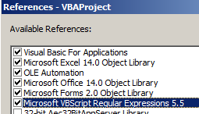
Tools. References.

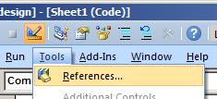
Microsoft VBScript Regular Expressions 5.5
(or similar version.)

This code finds the only the first number (ie 3) in 34ABcd454WXyz and replaces it with an asterix (ie *)
Private Sub CommandButton1_Click()

Dim regEx As New RegExp
Copy the code from here:

'Dim regEx As Object
'Set regex = CreateObject("VBScript.RegExp")

Dim regEx As New RegExp

Dim strOrg As String, strNew As String, strPattern As String

strOrg = "34ABcd454WXyz" ' The original string

strPattern = "cd"

regEx.Pattern = strPattern

strNew = regEx.Replace(strOrg, "*")

Debug.Print strOrg
Debug.Print strNew
Dim strOrg As String, strNew As String, strPattern As String

strOrg = "34ABcd454WXyz" ' The original string
ie This says find any single number 0, 1, 2, 3,…9.
(Square brackets are used to enclose our search pattern.)
strPattern = "[0-9]"

If we don’t use square brackets ie strPattern = "cd" then that will literally find cd. ie Use square brackets ie []’s only when we want to find the pattern. Maybe try that first!

Now try this:
Load up our regEx object with the required pattern.
regEx.Pattern = strPattern

strNew = regEx.Replace(strOrg, "*")

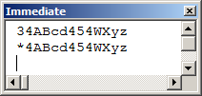
Debug.Print strOrg
Debug.Print strNew

End Sub

Only the first number found has been replaced.

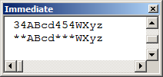
Now include this line: regEx.Global = True

Now all numbers will been replaced.

Try:
strPattern = "[A-Z]" This, says all capital letters will be found and replaced.
strPattern = "[a-z]" This, says all small letters will be found and replaced.
strPattern = "[a-zA-Z]" This, says all both capital and small will be found and replaced.

No punctuation in between. This requires a bit of getting used to!
It could equally be written as "[A-Za-z]". Try it.

See https://blog.udemy.com/vba-regex/ For list of other codes.
Eg a full stop (period) matches any single character.
(But also, this is a very good follow up tutorial.)

REGEX: To split up a CSV file eg "abc, frgh, sdr"

Option Explicit

Private Sub CommandButton1_Click()

Dim matches, m
Dim regEx As New RegExp
Dim strOrg As String, strNew As String, strPatt As String

strOrg = "abc,frgh,sdr"
The + means search for one or more characters - not just the first. eg abc not just a etc. (Try without it.)

strPatt = "[A-Za-z]+"

regEx.Global = True
regEx.Pattern = strPatt
matches contains the collection of results – in one go…

Set matches = regEx.Execute(strOrg)

… so we can iterate thru matches one at a time.

For Each m In matches

MsgBox m.Value
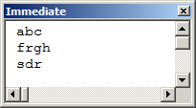
Next m
(matches is a variant array which we have not covered yet – but you should get the idea.)
End Sub

Now watch follow up YouTube:
https://www.youtube.com/watch?v=sa-TUpSx1JA
(He uses a different method – not VBA – so just watch the theory.)

