Objects and the
Excel Object Model

Chapter Four

We often hear how computer programming has become “object-oriented” - and indeed it has. Whereas Excel VBA is not a truly object-oriented language, we learn in this chapter what an object is in its simplest form, and how objects are categorized in the Microsoft Excel Object Model.

Covers

Properties and methods |  |  |  |  |  | 54
Object hierarchy |  |  |  | 56
Other properties and methods |  |  |  |  |  |  |  | 58
Object variables |  |  | 63
To sum numbers according to color |  |  |  |  |  |  |  |  |  |  |  | 65

YouTube: https://youtu.be/Fv9t7FACkqg
Count -> ColorIndex

YouTube https://youtu.be/73D7NJ-u-fE
Object-> looping down

YouTube: ExcelVBAAddColours https://youtu.be/jHRhjCT1o3A
Sum color

4. Objects and the Excel Object Model 53

Properties and methods

An object has properties and methods. We have already met an example of an object – the Range object. Properties are something which an object has, whereas methods do something to the object. As we will now see, properties and methods are associated with an object by means of the dot operator (period/full-stop).

Properties

An object can have more than one property. Properties have values. They are usually preceded by the dot operator and then the object, thereby associating them with that particular object, as we have seen with Range("A1").Value for example. (Recall that Value is the default property and could therefore be omitted.)

The Count property, when applied to Range objects indicates the number of cells in the corresponding range. For example:

Private Sub CommandButton1_Click()

MsgBox Range("A1:A3").Count

End Sub

The number of cells in the range A1:A3 is 3.
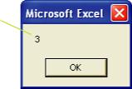

Methods

Methods usually perform some operation on the object with which they are associated. We have already briefly mentioned the Select method, which we used to select a single cell. Indeed we can use the Select method to select more than one cell.

If this code is run, a range of cells A1:C2 will be selected as shown on the next page.

Private Sub CommandButton1_Click()

Range("A1:C2").Select

End Sub

54 Learn to Program in Excel VBA in easy steps

...cont’d
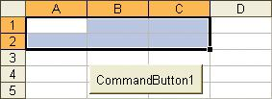

The ClearContents method will clear the contents of a cell. (It is the VBA equivalent of the Excel Edit, Clear, Contents command.) For example, the following code will clear the contents of cell A1.

Private Sub CommandButton1_Click()

Range("A1").ClearContents

End Sub

The ClearContents method of clearing a cell as above, is an alternative to the more primitive Range("A1").Value = "" that we saw previously.

Recall that the IntelliSense drop-down will appear (in this case after the period is typed) to show us a list of suggestions. The suggestions are either methods, (the “flying green bricks”) or properties the (“pointing fingers”).
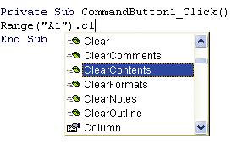

4. Objects and the Excel Object Model 55

Object hierarchy

Objects can belong to other objects. The dot operator is used to associate objects.

For example, the Font object belongs to the Range object. Being an object, Font has properties, e.g. the Bold property. (The Font object is a little exceptional however, as it has no methods.)

For example, to make the contents of cell A1 bold, we could use:

Range("A1").Font.Bold = True

When seeking VBA Help it is probably even worth temporarily typing the word

into the VBE, highlighting it, and then pressing the F1 key, rather than using the Help dialog box.

Object or property?

If we consult the VBA Help for Font, you will find a brief description of Font as a property, and Font as an object where you will find a comprehensive list of the Font object’s properties. Font, as it appears in code is a property. It is a property which “produces” a Font object. We say that the Font property returns a Font object.

The distinction between the Font property and the Font object is somewhat academic. For all intents and purposes, it is the properties and methods of the corresponding objects that we wish to access, so to that end we ought to navigate in the VBA Help to the respective objects – in this case the Font object and ascertain its properties (and usually methods) – for example, the Bold property.

Ambiguity confuses! Range is an object, which as we will see, is returned by many

properties, e.g. Cells, ActiveCell, Selection, Columns, Rows and...Range!

It is no less confusing to hear that Range as it appears in code as above, is also a property. It is a property which returns a Range object.

Instead of the Range, of course we could use Cells.

Cells(1,1).Font.Bold = True

You may even see Range described as a collection (see later), which

indeed it is!, but this classification ought not distract us from seeking the properties and methods of the Range object.

Cells, as it appears in code, as above, is also a property! (If you search Help for Cells, you will see that it is indeed described as a property (there is no Cells object!). Cells is a property which returns a Range object (there are many other properties which return a Range object). In practical terms, this simply means that in order to ascertain the properties and methods of Cells, we need to locate the properties and methods of the Range object.

56 Learn to Program in Excel VBA in easy steps

Other properties and methods

Formula

The Formula property of the Range object is used to insert a formula into a cell.

First place a value into cell A1 and then run this code.

Private Sub CommandButton1_Click()

Range("B1").Formula = "= A1 * 2"

End Sub
(Take care not to include a space before the second equal sign.)
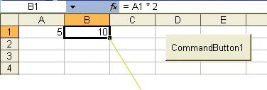

The formula will be placed into cell

B1 and the result calculated.

Operations using properties are of two types, property read and property write. By assigning some data (a formula in the case above, but usually a value) to the property, we perform a property write. On the other hand, as the following piece of code shows, we can also read the Formula property of the particular Range object (if the formula in still in place).

Private Sub CommandButton1_Click()

Dim x As Variant

x = Range("B1").Formula
MsgBox x

End Sub
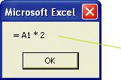
For a property read, the property is usually on the right hand side of an equal sign (whereas for a write it is usually on the left).

The formula in cell B1 will be displayed.

58 Learn to Program in Excel VBA in easy steps

...cont’d

To make all of the formulas in a spreadsheet visible, in the Excel widow

press Ctrl+`(grave). (Press Ctrl+` again to view the values once more.)

A formula is “copied down” when the single formula is “pasted” into a range of cells as shown below.

Private Sub CommandButton1_Click()

Range("B1:B3").Formula = "= A1 * 2"

End Sub

The formula automatically “adjusts” down the column.
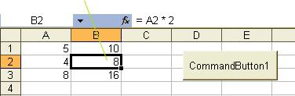

4. Objects and the Excel Object Model 59

...cont’d

Address

The Address property will return the address of a particular range.
It is a String type.

Selection

The Selection property will return a Range object representing the selected cell or cells. It returns a Range type.

First select some cells on the sheet.
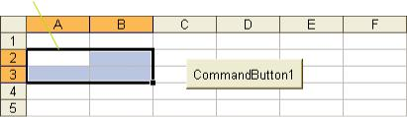

When the code below is then run, a message box will appear with the address of the selection.

Private Sub CommandButton1_Click()

MsgBox Selection.Address

End Sub

The Address of the range selected is returned. At present, it is specified as an absolute reference (the default). (See the VBA Help if you require a relative reference.)
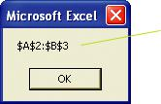
To simply emphasize that the Address property is indeed a String type, for the exercise, we can arbitrarily introduce a variable of String type as shown below to achieve exactly the same result as the code above.

Private Sub CommandButton1_Click()

Dim st As String

st = Selection.Address

MsgBox st

End Sub

60 Learn to Program in Excel VBA in easy steps

...cont’d

For Excel ‘97 users: Whenever an attempt is made to change certain properties

by means of a command button, ColorIndex being one of them, it is necessary to set the TakeFocusOnClick property of the command button to False. See Chapter 9 on setting command button properties. (This “issue” was resolved for Excel 2000 onwards.)

ColorIndex

To change the font color of a spreadsheet cell, we can use the ColorIndex property of the Font object:

Private Sub CommandButton1_Click()

Range("A1:A3").Font.ColorIndex= 3

End Sub

Upon running the code above, the font color of the

3 cells of the range A1:A3 will be changed to red.
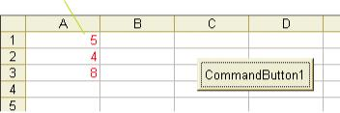

The value of ColorIndex is the offset of a particular color in the Excel color palette of 56 colors. The respective colors in this palette can be reassigned from the much larger range of colors available overall by using the Colors property (see VBA Help and overleaf for more information), but at any given time, only 56 colors are available. As demonstrated above, at present the color which is at offset 3 is red.

A convenient way of determining the ColorIndex of a particular font is to first apply the font color to a spreadsheet cell, select it and then determine its ColorIndex using a message box to display the value, e.g.

MsgBox Selection.Font.ColorIndex

You may be surprised to learn that the ColorIndex for the default font of a cell of an Excel spreadsheet cell is not that of black, i.e. it is not 1; it has the awkward value of -4105. Fortunately, Excel VBA assigns this value to xlColorIndexAutomatic, an Excel VBA built-in constant, so to change the font color of cell A1 back to “black” we could use:

Range("A1").Font.ColorIndex = xlColorIndexAutomatic

4. Objects and the Excel Object Model 61

Object variables

YouTube VBA Lesson 6b https://youtu.be/73D7NJ-u-fE
Object-> looping down

We have seen how to declare and assign variables, e.g.

Dim i As Integer

i = 2

Similarly, we can declare variables of the generic Object type.
When assigning an object variable, use the Set keyword.

It is a common mistake to forget to use Set.

Dim r As Object

Set r = Range("B2:C4")

Whereas this code will perform perfectly well, it is more efficient if we are more specific as to the exact type of the object variable, i.e.

Dim r As Range

Set r = Range("B2:C4")

A Range variable is useful when used in combination with the Cells property. The cell reference can be specified relative to a Range as shown here.

Private Sub CommandButton1_Click()

Dim r As Range

Set r = Range("B2:C4")

r.Cells(1,2).Select
End Sub

The selection will now be made relative to the range r.
(For illustration, place a border round the range B2:C4.)
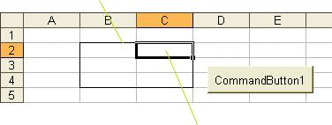

When the code is run, this cell is selected. Cells(1,2) now refers to the cell of the 1st row and 2nd column of the range B2:C4.

...cont’d

When Cells is used with a single index (and without an object qualifier), it will refer to the cells on a worksheet, counting from left to right, e.g.

Cells(3).Select

would select the third cell of the top row. Cells wraps around, so that in the spreadsheet of 256 columns,
(256 Columns in Excel 2013- Lots more columns in Excel 2013 etc.)

Cells(257).Select

would select the first cell of the second row after wrapping around the first row as shown here.
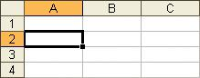

It is particularly convenient to use Cells with a single index to loop through a defined range. For example the following code will loop through and display the first eight cells of the range A1:A8.

Private Sub CommandButton1_Click()
Dim rng As Range
Dim i As Integer
Set rng = Range("A1:A8") | The value of the i^{th}
For i = 1 To 8 | The value of the i^{th}
For i = 1 To 8 | cell in the range A1:A8
Msgbox rng.Cells(i).Value | cell in the range A1:A8
Next i | will be displayed.
End Sub
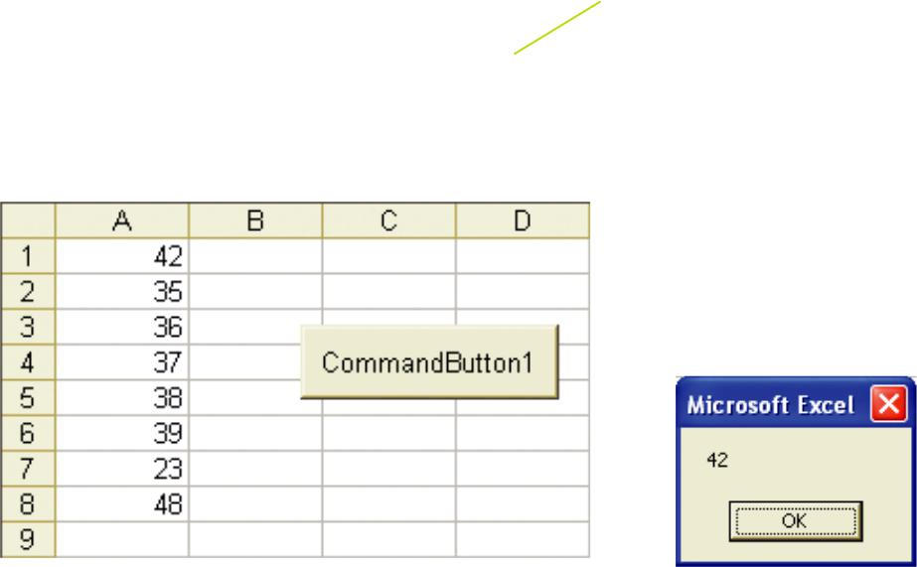

64 Learn to Program in Excel VBA in easy steps

To sum numbers according to color

Sum color

Excel does not have any worksheet functions for dealing with font colors. For example, if we have a list of numbers that we wish to sum or sort according to their color, we will need to write some code. Here we wish to sum red and blue numbers separately, and display the respective totals using a message box.

Place eight numbers in the first

column colored red and blue.
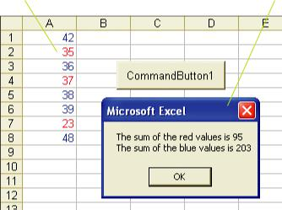
To quickly change the font color of individual cells in Excel, click on a cell containing
that color, double click on the Format Painter button on the tool bar, and then click on the cells to which you wish to apply the color.

We want a message box to appear displaying the respective totals.

Once again, we will develop our code in easy steps.

₁ First modify the code on the previous page (modify the MsgBox line) to display the ColorIndex of the eight consecutive cells by means of the message box as shown below.

.

MsgBox rng.Cells(i).Font.ColorIndex

(Ensure that only the two ColorIndex values 3 and 5 are displayed, else the code overleaf will need to be modified accordingly.)

The use of Select Case will cater for each of the possible values of ColorIndex. We also need to include the mechanism for summing the cell values, which we can do by using the variables sumRed and sumBlue to keep running totals, which are updated on each pass of the loop.

4. Objects and the Excel Object Model 65

Likewise for the blue cell.

If a red cell is found, the value (num) is added to the red total.
...cont’d

The line continuation character must include a space before it.

The complete code to sum numbers according to their color will then be:

Private Sub CommandButton1_Click()

Dim rng As Range, i As Integer, ci As Integer Dim num As Single

Dim sumRed As Single, sumBlue As Single

sumRed = 0: sumBlue = 0 'set the totals to zero Set rng = Range("A1:A8")

For i = 1 To 8 'do all 8 cells
ci = rng.Cells(i).Font.ColorIndex

num = rng.Cells(i).Value

Select Case ci Case 3

sumRed = sumRed + num Case 5

sumBlue = sumBlue + num End Select
Next i

MsgBox "The sum of the red values is" & _ CStr(sumRed) & vbCrLf & _
"The sum of the blue values is" & CStr(sumBlue) End Sub

(vbCrLf (carriage return-linefeed) is another of the VB built-in constants. It forces the string following to be output onto a new line.)

As a result of running this program, a message box ought to appear displaying the respective totals.
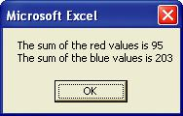

66 Learn to Program in Excel VBA in easy steps

Fo
ColorIndex
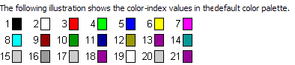

For Help ie to these colour codes search for PatternColorIndex!

Course Work:

Exercise 1:

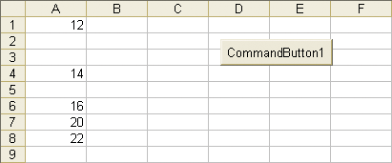
Starting with this: (Page 48 Part 3 of manual):

Write code to place the cells without blanks in column B as shown:

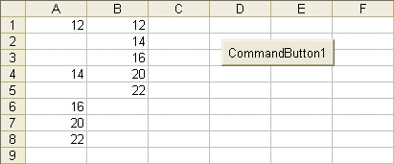

Hint: Cells(c, 2).Value = Cells(i, 1).Value

See page 48-49 CH 3 for solution!

Exercise: 2.

We wish to sort this column of numbers according to colour only (ignore values) into another column.

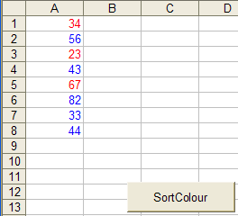
- Click the button.

The numbers are placed into another group according to colour.

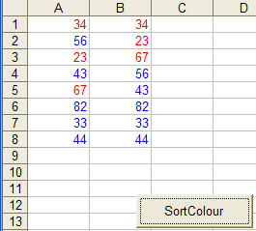

Hint: Use 2 loops (in series).

Tip: To see formulas: Press control ` (ie control grave. The grave is
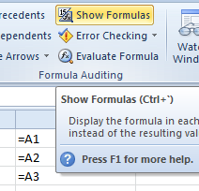
at the top left of the keyboard under the escape key)

(Doesn’t seem to work for Excel 365 so use instead the menu:

