The Macro Recorder
Chapter Five

Not only are you able to write Visual Basic code using the Excel VBA (Visual Basic Editor), but you can get Excel to write it for you using the macro recorder! We learn how to record a macro, and discuss its advantages and shortcomings.

To record and run a macro |  |  |  |  |  |  | 68 |  |  |  |  | 2
To edit a macro
To edit a macro |  |  |  |  |  |  |  |  |  |  |  | 4
Project explorer
Project explorer |  |  |  |  |  |  |  |  |  |  |  | 6
Macros available to other workbooks |  |  |  |  |  | 8
To run a macro from a toolbar button |  |  |  |  |  |  |  |  |  |  |  |  |  | 9

YouTube: VBALesson7a
https://youtu.be/1qPF1aBpuYY
record macro modules R1C1

YouTube: VBALesson7b
https://youtu.be/hKPDs7AQhKo
personal.xlsm

To record and run a macro

We will record and run the simplest of macros, a macro which will place a number into a cell when we press a certain key combination.

To record the macro

Our macro will place the number 2 into cell A1 when we press the

Ctr+z key combination.

- From the Ribbon, choose the Developer tab
and Record Macro....

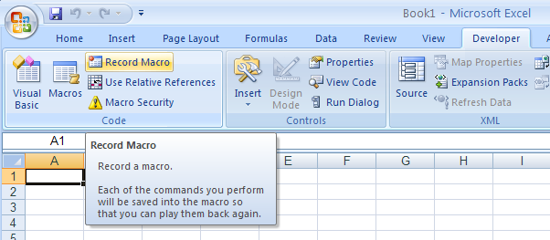

3
Choose This Workbook.
(Be careful not to select
Personal Macro
Workbook at this stage.)

2
Accept the default name for the macro. (In future you
may wish to give it a more
meaningful name.)

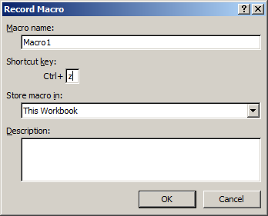
3
Choose the key combination that we would like to use to run the macro (Ctrl+z).

The key combination used to run the macro is case sensitive

5 Click OK.

The “Stop Recording” button appears.

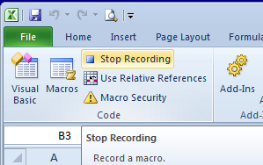
The macro recorder is recording your every move - mistakes included.

₆
Click into cell A1, type 2 and then press Enter.
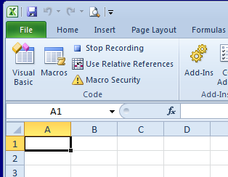
Click the Stop Recording button.

To run the macro

(If the 2 is already in cell A1, delete it.)

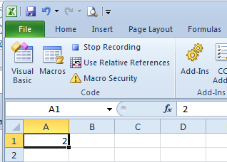

1 From Excel, press Ctrl+z. The 2 should appear in cell A1.

That’s all it takes to run an Excel macro!
To edit a macro

We will now view and modify the VBA code produced by the macro recorder.

- From the Excel menu, choose Tools, Macro, Macros...,
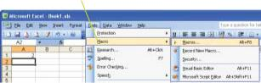

The Macro dialog box appears:

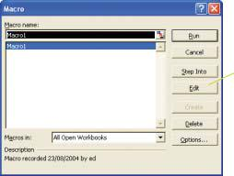

₂ Click
Edit.

A code module now appears (see next page). Note the name in this case - Module1. Unlike the code modules that we have seen in the past, this is a general purpose code module (generally known as a standard code module) for the whole workbook, whereas the modules that we have seen so far were specific to and only available for that particular worksheet.

Learn to Program in Excel VBA in easy steps

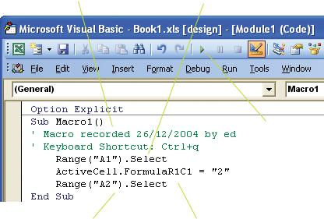
(Comments have been automatically placed in the code.)

The Macro Recorder frequently uses Select and ActiveCell (another property which returns a Range object). We will show how this redundancy can be removed below.

If the cursor moved down one cell when we pressed the Enter key (the default behavior) when we were recording the macro, this Select method statement will also be included.

(Clicking the Run button (blue triangle), with the cursor at the start of

the code, is an
FormulaR1C1
alternative way
is used
of running the
rather than
macro.)
Value by the Macro Recorder.

Removing redundancy

Remove Select and ActiveCell from the macro code and make one line as shown below.

Range("A1").FormulaR1C1 = "2"

If the macro is run again, the result will be exactly the same, i.e. you will see 2 placed into cell A1 (if it is not already there).

5. The Macro Recorder 71

Project explorer

Project Explorer displays all of the code modules in a project. It can be used to view the code that you have written in the respective code modules, as well as that written by the macro recorder.

- To view Project Explorer, click View, Project Explorer from the VBE menu or click the Project Explorer button on the VBE toolbar.
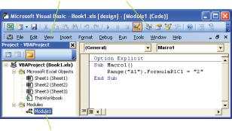
You may need to rearrange your windows in the VBE if you wish the Project

Explorer window to appear docked as shown.

The VBE windows
sometimes refuse
to successfully
dock as shown.
Unfortunately, to
the Windows Registry (first | ₂ Double click on Module1 to see the macro code.
closing Excel) – not a task for the faint-hearted | ₂ Double click on Module1 to see the macro code.
 | (This module may or may not appear in a folder,
 | depending on the state of ToggleFolders.)
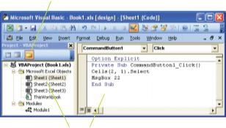

(You can also double click on a sheet module to view any worksheet code which may be present.)
Learn to Program in Excel VBA in easy steps

...cont’d

The macro recorder can be used to produce a code skeleton in which to place

experimental code, in preference to using a command button procedure.

If we were to now record another macro, the code would appear in the same module (in our case Module1). If, on the other hand, we were to start a new session (i.e. close and reopen our Excel workbook), and then record another macro, then a brand new module (Module2 in this case) would appear with the new macro code in it.

The macro recorder is a truly outstanding feature of Excel. It is present in neither Access VBA nor stand-alone Visual Basic, which is further reason why Excel is in many ways a preferable environment for learning Visual Basic.

So why don’t we just use it all of the time?

Because the macro recorder will not produce code for loops for example, (e.g. For...Next) and other conditional code (e.g. If...Then) which is really what programming is all about!

When should we use the macro recorder?

The macro recorder is invaluable when we need assistance with our code. For example, if we did not know the code needed to change the font color of a cell to red, we could simply change the font color of a cell to red whilst recording a macro, and then inspect the code. All will be revealed if we then turn to the code editor and find a line like this:

Selection.Font.ColorIndex = 3
Macros available to other workbooks
YouTube: VBALesson7b
https://youtu.be/hKPDs7AQhKo

We wish to record a macro which will be available not only to the presently open workbook, but to all other workbooks that we might open in future. We will record a simple macro to apply Currency formatting to a cell.

1 Select the cell that you wish to format.

2 From the Ribbon choose the developer tab and choose Record Macro.

3 Give the macro a name
e.g.CurrencyFormat.
4 Choose Personal Macro Workbook.

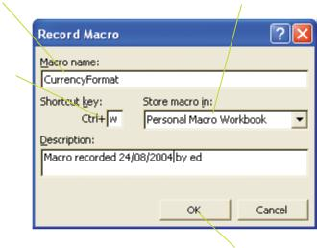

5 Choose the key combination that we would like to use to run our macro (e.g. Ctrl+w).

5 that we would like to use to run our macro (e.g. Ctrl+w).
.

.

6 Click OK

7 Format cell as Currency Format Cells..., Number, Currency, OK) – the cell may or may not have a value in it.

8 Click the Stop Recording button.

You may wish to now run the macro and/or view its code

To run a macro from a toolbar button
see Book page 77.

