Chapter Seven
The Workbook object

By considering the Workbook object as a member of the Workbooks collection, we can employ methods and properties which apply to all open workbooks. By considering the Workbook itself as an object, we can utilize events which can be made to trigger for all the worksheets in a particular workbook.

Covers

The Workbooks collection 96

Workbook properties |  |  |  |  |  |  |  | 97
Workbook/s methods |  |  |  |  |  |  |  |  | 98
Workbook events |  | 99
Workbook in the Excel Object Model |  |  |  |  |  |  |  |  |  |  | 104
An automatic alert |  |  |  |  | 106

YouTube ExcelVBACh7a: https://youtu.be/rDyOBtMVJ5E
->iterate thru w/books

YouTube VBACh7b: https://youtu.be/NslzhwzAqic
Count, index, SheetSelectionChange, SheetDeactivate, BeforePrint, Open, BeforeClose. Join text from 2 w/books.
From 18 min 22 is a bit rambling

7. The Workbook object 95

The Workbooks collection

Just as individual Worksheet objects constitute a Worksheets collection, individual Workbook objects are grouped into a Workbooks collection. The Workbooks collection represents all of the currently open workbooks. The Workbook object is the abstract representation of a physical workbook, much the same as a Worksheet object is a representation of an actual worksheet. The main purpose of organizing Workbook objects into a Workbooks collection object, is to enable us to deal with all (open) workbooks as a whole and to be able to easily refer to them individually using an index just as we saw in the case of the Worksheets collection.
- Create two new workbooks and name (save) them Tax2004.xlsm and Tax2005.xlsm respectively. Write the code as shown below in the Command1_Click event of one of the worksheet modules of either workbook, which will iterate through all of the open workbooks (two in this case) and display their respective names.

Private Sub CommandButton1_Click()

Dim wkb As Workbook

For Each wkb In Workbooks
MsgBox wkb.Name | Name is a property of the
Next wkb | Name is a property of the
End Sub | Workbook object.
- Run the above code by clicking the command button on the sheet. Message boxes will appear with the names of the workbooks, (including the one from which the code was run) in the order that they were opened (or created).

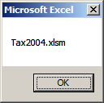
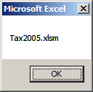

96 Learn to Program in Excel VBA in easy steps

Workbook properties

The code will fail if the named workbook is not open.

The Path of a workbook will be empty if it has not been saved and its (default)

Name will not have an xlsx extension.

Path

Path describes the location of a workbook (usually on the hard disc).

FullName

FullName describes the location and name of a workbook.

The first opened/created workbook has an index of 1.

Private Sub CommandButton1_Click()

MsgBox Workbooks(1).Name

MsgBox Workbooks("Tax2004.xlsm").Path

MsgBox Workbooks("Tax2004.xlsm").FullName

End Sub

The Name of a Workbook can be used as a ”key”. (Don’t forget the file extension.)
When the above code is run, we first get a message box displaying the Workbook Name property...

...followed by a message box displaying the path of the workbook.
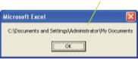
...followed by a message box displaying the path and name (FullName) of the workbook.
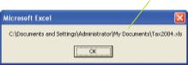

7. The Workbook object 97

Workbook/s methods

The code will fail if Tax2005.xlsx is not in the active directory.

The Workbook object, like all other objects, has methods as well as properties and events.

Close

The Close method can be used to close a particular workbook, e.g. the first opened/created workbook as shown here.
If the file is not in the immediate working directory then we need to fully specify the path eg
"C:\temp\Tax2005.xlsm"
Private Sub CommandButton1_Click()

Workbooks(1).Close

End Sub

Workbooks("Tax2005.xlsm").Close

Workbooks.Close will close all open workbooks. (Try it.) If there have been changes, of course a prompt will appear.

Open

The Open method is used here to open a workbook which is in the active directory (the one that we are currently saving to and opening from). If the file is elsewhere, we would need to specify the file’s path and name. This code would be written in one workbook in order to open another.

Private Sub CommandButton1_Click()
“Back to front” c.f. the Open method!

Workbooks.Open("Tax2005.xlsm")

End Sub

Note that Open is a method of the Workbooks object, not the
Workbook object.

If you view the IntelliSense drop-down for the Workbook object, other useful methods (and properties) such as Activate, PrintOut, Save and SaveAs etc. appear.

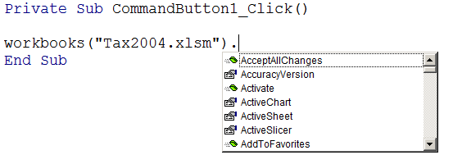

98 Learn to Program in Excel VBA in easy steps

Workbook events

Useful as they are, Worksheet events (of the previous chapter), only trigger for the specific worksheet (which contains the module in which the events are written). On the other hand, Workbook events will trigger for any worksheet in the workbook.

The Workbook_SheetSelectionChange event

The Worksheet event Worksheet_SelectionChange was encountered in the previous chapter. It fired whenever we changed a selection on a particular worksheet. On the other hand, the

Workbook event Workbook_SheetSelectionChange will occur whenever we change the selection on any worksheet.

We will now write a Workbook_SheetSelectionChange event which will produce a message box displaying the name of the worksheet that was clicked upon, along with the address of the cell selected.

Pressing Ctrl+R from the VBE will open Project Explorer.

₁In order to get to the Workbook event procedures, first open Project Explorer.
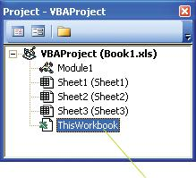

₂ Double-click on ThisWorkbook.

The ThisWorkbook code module is “visible” from every worksheet in the workbook, i.e. its code can be run from any sheet in the workbook.

7. The Workbook object 99

...cont’d

The special ThisWorkbook code module appears as below.
₃ Click the Object | 4 | Click the Procedure
drop-down and | 4 | drop-down and choose

choose Workbook. | SheetSelectionChange.
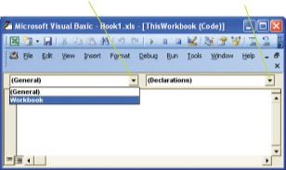

If, when you click on the object drop-down, the default workbook event procedure

appears, i.e. Open, simply ignore it or delete it

- Write the code in the Workbook_SheetSelectionChange procedure as shown below.

Private Sub Workbook_SheetSelectionChange _

(ByVal Sh As Object, ByVal Target As Range)

MsgBox Sh.Name & " " & Target.Address

End Sub

Sh will represent | (We have also | Target is a Range object
the worksheet | placed a space | which represents the cell
that is clicked. | between the two | selected, i.e. the “target”
 | strings.) | of our mouse click.

These variables, Sh and Target are passed to our procedure via the

Windows operating system.

100 Learn to Program in Excel VBA in easy steps

...cont’d

6

Make sure that the Design Mode button on your Control Toolbox is not depressed or
else your event won’t trigger.

Return to Excel and click any cell on any sheet. The message box appears as below, displaying both the name of the sheet that was clicked upon, as well as the address of the cell (with a space in between).
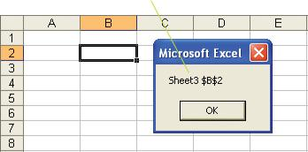

Comment out or delete any other event code so that it won’t trigger as well.

The Workbook_SheetDeactivate event

- Follow the same procedure as before to place code in a Workbook procedure, but this time choose the SheetDeactivate event in the Procedure drop-down and write the code shown.

Private Sub Workbook_SheetDeactivate(ByVal _

Sh As Object)

MsgBox Sh.Name

End Sub

- When we choose another sheet in the workbook (e.g. Sheet2), we get a message box displaying the name of the sheet that was the active sheet.
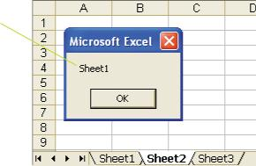

...cont’d

Your printer drivers must be installed for Print Preview to work. You also will need

to have something on the sheet to print.

The Workbook_BeforePrint event (could be omitted)

This Workbook event enables us to specify an operation that will be carried out between choosing the Print (or Print Preview) command and the print operation itself.

For example, we may wish to automatically print a footer at the bottom of each page. This footer, for example, could consist of the file name and its location (the Workbook’s FullName).

- Place the code shown below in the Workbook_BeforePrint procedure.

To determine the necessary code yourself, record a

Private Sub Workbook_BeforePrint(Cancel As Boolean)

ActiveSheet.PageSetup.RightFooter = _

macro to place a footer at the
bottom right of the page.
ThisWorkbook.FullName

End Sub

The ThisWorkbook object represents the workbook which contains the code.

The ActiveSheet object represents the current worksheet. (The sheet about to be printed.)

If you have a carefully designed page footer of your own, it may get overwritten.

- Run the code by clicking the Print Preview button (or the Print button) from Excel.


- The Workbook_BeforePrint triggers, so that you should see the workbook’s location and name in the bottom right-hand corner of each page for this particular worksheet.

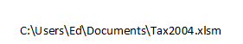
- Click Close to close the Print Preview window.

102 Learn to Program in Excel VBA in easy steps

...cont’d

Note the difference between the Open event and the Open

method. The Open method (of the Workbooks object) causes a workbook to open, whereas the Workbook_Open event fires when the workbook opens.

The Workbook_Open event

This event will occur when a workbook opens.
₁ Write this code as in the Workbook_Open procedure.

Private Sub Workbook_Open()

MsgBox "Don’t forget the April deadline"

End Sub

- Close the workbook (save the changes) and open it again. The following message box should appear after the workbook opens.
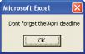

The Workbook_BeforeClose event

Similarly the Workbook_BeforeClose could be used to respond to the closing of the workbook, e.g. this code will cause a message box to appear after File, Close is chosen from the Excel menu.

Private Sub Workbook_BeforeClose(Cancel As Boolean)

MsgBox "Only save the Jan sales figures"

End Sub
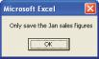

Command bars that we create by code or otherwise, persist, i.e. the next workbook opened will also display them. To avoid this, we could place code in the Workbook_Open procedure to create command bars, and correspondingly place code in the Workbook_BeforeClose to remove them. (Not as easy as it sounds!)

7. The Workbook object 103

Workbook in the Excel Object Model

Where in the Excel Object Model hierarchy is the Workbook object located?
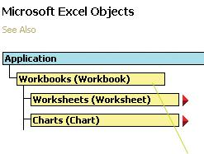

The diagrammatic representation of the Excel Object Model in the VBA Help is version
specific.

The Workbook object is a member of the Workbooks collection which is located directly beneath the Application object. The Application object, which we will discuss later, represents Excel itself.
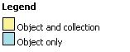
As previously mentioned, the Excel Object Model is useful when we want to know which objects to place on the left (the parent objects) of our dot operators. Fortunately these parent objects are not always compulsory. For example, recall how we made the font of a cell bold.

Range("A1").Font.Bold = True

If we were for example, currently working in Sheet1 of the workbook Tax2005.xls, then we could, if we wished to be more specific, specify (redundantly in this case) the worksheet and workbook explicitly as shown below.

Workbooks("Tax2005.xlsm").WorkSheets("Sheet1"). _
Workbooks("Tax2005.xlsm").WorkSheets("Sheet1").Range("A1").Font.Bold = True

Range("A1").Font.Bold = True

104 Learn to Program in Excel VBA in easy steps

...cont’d

As we can see from the Excel Object Model, the Application object is the parent of the Workbook object so that we could also (redundantly) include it as the parent of the Workbook object if so desired as shown here.

Application.Workbooks("Tax2005.xlsm").WorkSheets("Sheet1").Range("A1").Font.Bold = True

Workbooks("Tax2004.xlsm").WorkSheets("Sheet2").Range("A1").Value = "Income"

If Tax2004.xls containing a sheet named Sheet2 were not open, an error would occur.
Application.Workbooks("Tax2005.xlsm")_

.WorkSheets("Sheet1").Range("A1").Font.Bold = True

In the case we just saw, the specification of the parent object is optional, but specification of the parent objects may sometimes be essential. For example, we may wish to place text on a worksheet different from our active worksheet, or indeed in a workbook different from the current workbook as shown by the code below.

The alternative workbook (Tax2004.xls in this case) would need to be open - recall that the Workbooks collection consists only of open workbooks. (If it were not open, we could use the Workbooks.Open method to open it.)

Workbooks("Tax2004.xlsm").WorkSheets("Sheet2"). _

Range("A1").Value = "Income"

Parent property (omit this)

We could use the TypeName function to determine the Parent of the Worksheet as shown here.

Private Sub CommandButton1_Click()

MsgBox TypeName(Activesheet.Parent)

End Sub
TypeName Parent returns the
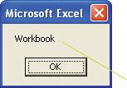
determines parent object of the

the type of (Worksheet) object.

the object.

Workbook is the parent of Worksheet.

Furthermore, we could determine that Application is the parent of the parent of the Worksheet object, by using:

MsgBox TypeName(Activesheet.Parent.Parent)

7. The Workbook object 105

An automatic alert

We have two sales teams, Team1 and Team2. Their respective sales figures are kept on two worksheets named respectively, Team1 and Team2. The total of the sales figures (summed using a SUM formula) appears in the cell B6 on each sheet. If the sum of the sales of either team (i.e. on either sheet) exceeds 20,000, we wish to be alerted as shown below.

We need an event which will trigger when either sheet is recalculated – the Workbook_SheetCalculate event.
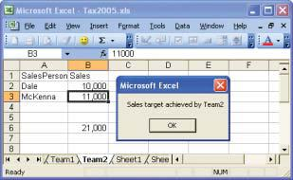

We need to check whether the value of cell B6 on the particular sheet which recalculated exceeded 20,000. This is achieved by testing the value of Sh.Range("B6").Value where Sh will represent the particular worksheet on which the recalculation occurred. When a recalculation does occur (i.e a value upon which a formula depends is changed), this code should cause an alert to appear when the value in cell B6 of either sheet exceeds 20,000.

Private Sub Workbook_SheetCalculate(ByVal Sh As Object)

If Sh.Range("B6").Value > 20000 Then

MsgBox "Sales target achieved by " & Sh.Name
End If

End Sub Sh represents the sheet (and the name of

the team) which caused the recalculation

Gotchas: Using Workbook and Worksheet variables:
NB: If we have:
Dim wkb As Workbook, wks As Worksheet
Dim rng As Range

Set wkb = Workbooks("Book1.xlsm")
Set wks = Worksheets("Sheet1")

then this works:
Set rng = wkb.Worksheets("Sheet1").Range("A1")

but unfortunately this doesn’t:
Set rng = wkb.wks.Range("A1")which is a bit of a pity!

This works:
Dim wkb As Workbook, wks As Worksheet, rng As Range
Set wkb = Workbooks("Book1.xlsx")
Set wks = wkb.Worksheets("Sheet1")
Set rng = wks.Range("A1")
MsgBox rng.Address

Gotcha: Using Select
If we wish to Select a range using .Select on another worksheet then we must Activate the worksheet first eg Worksheets("Sheet2 ).Activate

(This is not the same as “setting” the range eg
Set rng = Worksheets("Sheet2 ).Range("a1")
where we don’t have to Activate the sheet first.)

But in any case using Activate and Select considerably slow down your workbook code.
Avoid them.

Opening a web page from Excel

Preliminary. Open this web page:
If you wish type this URL into your browser:
(or click below!)
http://www.fishbase.se/summary/64588

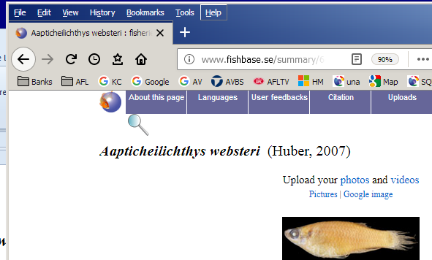

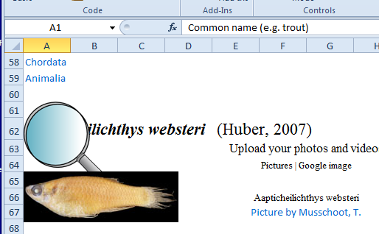
To open the web page into an Excel workbook:

Dim stURL As String
stURL = "http://www.fishbase.se/summary/64588"
Workbooks.Open Filename:=stURL

Exercises Chapter 7:

1. Complete exercise at end of last chapter ie

Optional (Best done when we talk about Intersect and Workbooks.)
2. Open the corresponding w/book. (Do this bit after the next chapter.)

2. Open a few workbooks. In one of them, write some code to determine whether a particular workbook eg Book1.xlsx is open or not. (Iterate thru the WorkBooks collection and check out the Names.) If it is not open then open it.

3. Write code which will message box out the contents of a cell that you double-click upon but only if it is from Sheet1 or Sheet3. (Assuming you have a Sheet1 and Sheet3.)
(You will need to use Cancel = True.)

4. We have 3 workbooks open. Tax2004.xlsx (or.xlsm), Tax2005.xlsx (or.xlsm) and your current workbook which may be called Book1.xlsm. (Don’t forget that a workbook does not have a name until you save it.)

Tax2004.xlsx Tax2005.xlsx
Call the workbooks whatever you like.
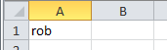
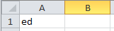

Sheet1 Sheet1

a) Iterate through the 2 workbooks Tax2004 and Tax2005 and collect the data on Sheet1 cell A1 of each sheet and concatenate the data into one string.

b) Alternatively instead of placing them into a string, place them on the current workbook like so.
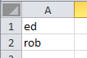
Code to check if a workbook is open – if not open it.
It relies on trapping an error (see later).

Private Sub CommandButton1_Click()

Dim WB As Workbook, stFile As String, stPath As String
Dim stWB As String

stPath = "C:\temp\": stWB = "test.xls"
stFile = stPath & stWB

On Error Resume Next 'If an error then goto the next line.

Set WB = Workbooks(stWB) 'Causes an error! if not open.

If (WB Is Nothing) Then 'ie it's not open.
MsgBox stWB & " is not open. Will Open it."
Set WB = Workbooks.Open(stFile)
Else
MsgBox "File is open"
End If

If (WB Is Nothing) Then ' Its still not there!
MsgBox "Check workbooks/folders"
Exit Sub
End If

On Error GoTo 0 'Turn of error handling.
End Sub

Dir (This could be done later.)

Returns a String representing the name of a file, directory, or folder that matches a specified pattern or file attribute, or the volume label of a drive.

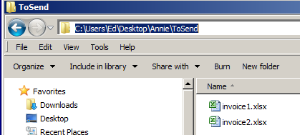

We wish to iterate though a folder to list the files.

Dir will list the first found file only.

Private Sub CommandButton1_Click()
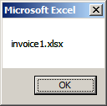
Dim stFile As String

stFile = Dir("C:\temp\test.xls")

MsgBox stFile
Don’t forget the backslash.

End Sub

To specify Excel files only:

stFile = Dir("C:\Users\Ed\Desktop\Annie\ToSend\" + "*.xls*")

Dir is a little odd. To find the remaining files we must NOW loop through them ie
From Help: Dir returns the first file name that matches pathname. To get any additional file names that match pathname, call Dir again with no arguments. When no more file names match, Dir returns a zero-length string ("").

Finally: Code to MsgBox all of the Excel files (.xls , .xlsx & xlsm) in a folder:

Private Sub CommandButton1_Click()

Dim stFile As String

stFile = Dir("C:\temp\" + "*.xls*")

Do Until stFile = ""

MsgBox stFile

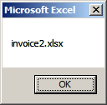
stFile = Dir() ‘ No arguments.

Loop

End Sub

Private Sub cmdOpen_Click()

Dim wbkOpen As Boolean, wkb As Workbook

wbkOpen = False

For Each wkb In Workbooks

If wkb.Name = "testOpen.xlsx" Then

wbkOpen = True

Exit For

End If

If wbkOpen = False Then

Workbooks.Open ("testOpen.xlsx")

End If

Next wkb

End Sub

