The Range object Chapter 8

We have already briefly met the Range object. Since the Range object can be used to represent a region on the spreadsheet, it is probably the most important VBA object of all, so in this chapter we will have more to say about how you can use its properties and methods to gain direct control of Excel’s functionality.

Covers

Columns |  |  |  |  |  | 108
Rows |  |  | 109
Practical examples |  |  |  |  |  |  |  | 110
Value |  |  |  | 112
Copy and Paste methods 113

CurrentRegion |  |  |  |  |  |  |  |  |  | 114
UsedRange |  |  |  |  |  |  |  | 116
Offset |  |  |  |  | 117
Resize |  |  |  |  |  | 119
A dynamic selection |  |  |  |  |  |  |  |  |  |  |  |  |  | 120
Intersect 1 122
Union |  |  | 123
To test a selection |  |  |  |  |  |  |  |  |  |  |  |  |  | 124
The Areas collection |  |  |  |  |  |  |  |  |  |  |  |  |  |  |  | 125

YouTube: VBACh8a.avi
https://youtu.be/827654wUBJU 20:03
columns rows with max greater than iterate range.value copy current region ->page 115

YouTube: VBACh8b.avi
https://www.youtube.com/watch?v=_qI8_MA5Wls&feature=youtu.be see page 115
used range offset lookup udf! Intersect union selection_change-intersect

YouTube: VBACh8No3.avi 20:06
https://youtu.be/CCkloh3c0dY
resize. dynamic selection. areas Intersect & “test a selection” done twice. Areas. allocate for mmerge for cw

8. The Range object 107

Columns

We previously saw how the Columns property, when applied to the Worksheet object, was used to select a whole spreadsheet column. When applied to a Range object however, the Columns property will return a column of that particular range, e.g.

Private Sub CommandButton1_Click()

Range("B2:D4").Columns(2).Select

End Sub

will select the second column of the specified range as shown here.

The second column of the range (B2:D4 has been formatted with a border here for illustration) is selected.
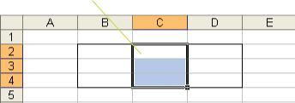

The following code will format the cells (make them blue and bold) of the first column of a table.
(ColorIndex for blue)

Private Sub CommandButton1_Click()

Range("B2:D4").Columns(1).Font.ColorIndex = 5

Range("B2:D4").Columns(1).Font.Bold = True

End Sub
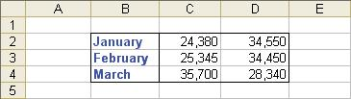

108 Learn to Program in Excel VBA in easy steps

Rows

Similarly, the Rows property can be used to return the row of a specified range, e.g.

Private Sub CommandButton1_Click()

Range("B2:D4").Rows(2).Select

End Sub
The second row of the

range B1:B3 is selected.
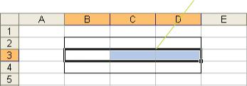

We could, for example, place formulas into the bottom row of a table as shown below to add the values directly above and embolden the result.

Private Sub CommandButton1_Click()
Using
With
End With
can actually be more efficient.

Range("B2:D4").Rows(3).Formula = "=Sum(B2:B3)"

Range("B2:D4").Rows(3).Font.Bold = True

End Sub

Note the use of With ... End With which simply saves the retyping of Range("B2:D4").Rows(3).(With ... End With is of course more useful with larger programs.)
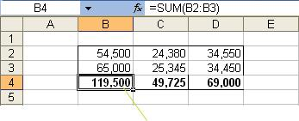

The formula to sum each column has been

copied across to each cell in row 3 of the table.

8. The Range object 109

Practical examples

Example 1

We wish to find the maximum value in a list of numbers.

First place some numbers in the range

B1:B6 whose maximum we wish to find.
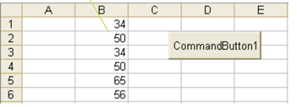

One way of finding the maximum is as follows. First set a temporary maximum variable (mx) to the value of the first cell, and then iterate through the remainder. If a number larger than mx is encountered, ascribe that value to mx, thus replacing mx with the “maximum so far”. Move down the list, repeating the process.

Private Sub CommandButton1_Click()

mx is set to the value in the very first cell.
Dim rng As Range, i As Integer, mx As Variant

Set rng = Range("B1:B6")

mx = rng.Cells(1).Value
For i = 2 To rng.Count
If a bigger number is encountered, then mx is replaced with this new value.
If rng.Cells(i).Value > mx Then
mx = rng.Cells(i).Value
End If

Next i

MsgBox "Max value is " & mx
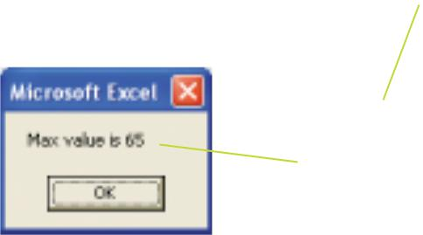
End Sub

After the loop has

been completed,

the value of mx is

displayed.

110 Learn to Program in Excel VBA in easy steps

...cont’d

Minimizing the number of fixed constants in program code improves program

maintainability and “forward compatibility”.

This use of a Range variable (rng in this case), allows us to easily specify another range if desired, i.e. we can easily change the line

Set rng = Range("B1:B6")

to specify a new range, e.g.

Set rng = Range("A1:A6")

which contains a set of numbers whose maximum we now wish to find. Conveniently, rng.Count in the program code would automatically adjust to represent the number of cells in this new range.

Similarly, if we wished to select a range manually before running the code we could use:

Set rng = Selection

The ColorIndex for blue will be 5 only for the default palette, i.e. if the palette

has not been changed using the Colors property.

Example 2

In this second example, (using the same column of numbers as in the previous example) we wish to change the font color of cells to blue if they have a value of 50 or more.

Private Sub CommandButton1_Click()

Dim rng As Range, cl As Range
Set rng = Range("B1:B6") | (An individual
 | cell (cl) is also a
For Each cl In rng | cell (cl) is also a
If cl.Value >= 50 Then | Range object.)
cl.Font.ColorIndex = 5
End If | If the value in the cell is
Next cl | greater than or equal to
End Sub | greater than or equal to
End Sub | 50 then make it blue.
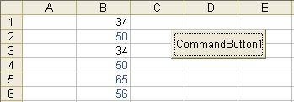


8. The Range object 111

Value

We have previously used the Value property for single values. A little surprisingly, the Value property can also conveniently be used to accommodate multiple values. Copying a set of values to a new location using the Range object with the Value property is simplicity itself.
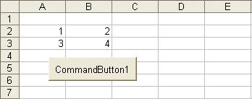

To transfer the values shown above to the range D4:E5, we would use:

Private Sub CommandButton1_Click()

Range("D4:E5").Value = Range("A2:B3").Value

End Sub
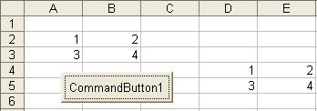

Whereas Value is a default property of the Range object, it cannot be omitted in this case - at least not on the right hand side (lest we attempt to put one Range object equal to the other).

We can also (redundandtly) include the Cells property which simply returns all of the cells (themselves Range objects) of the Range object, as shown below to produce exactly the same result.

Range("D4:E5").Cells.Value = Range("A2:B3").Cells.Value

Exercise 1 Transfer values from one sheet to another

112 Learn to Program in Excel VBA in easy steps

Copy and Paste methods

It is of interest to record a macro to perform the same copy operation, but using the Excel Copy and Paste commands.

The result of recording a macro to copy the values can be seen below. Note the VBA Copy and Paste methods which result. We could incorporate these methods in our own code (along with Cut if necessary) to transfer values, but the technique utilizing Range.Value which we saw previously is much more efficient and straightforward.

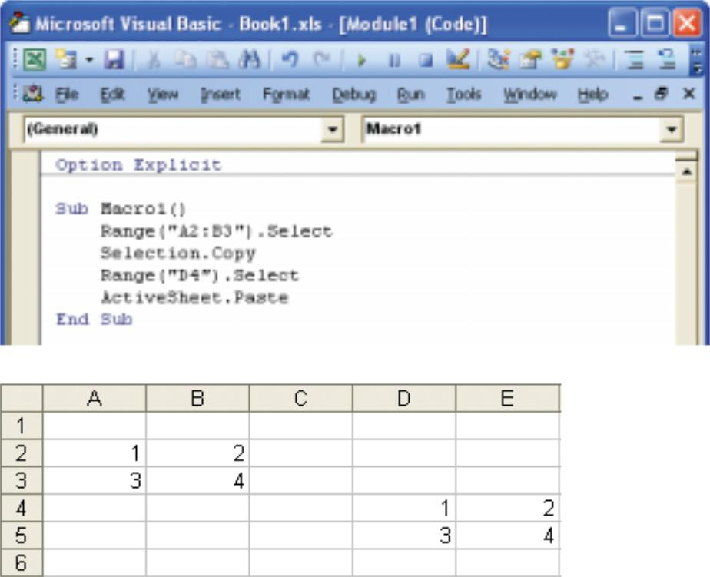

8. The Range object 113

CurrentRegion

According to the VBA Help, “The current region is a range bounded by any combination of blank rows and blank columns”, i.e. the rectangular region around a group of cells.

When using Excel, we can select the current region by placing our cell cursor anywhere in the region, (e.g. cell A1) and pressing the Ctrl+Shift+* key combination.
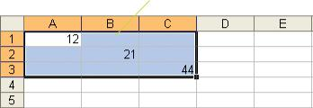

The same effect as above could be achieved from VBA using:

Range("B1").CurrentRegion.Select

CurrentRegion is useful when we don’t know in advance, the exact boundaries of the range that our code will be asked to deal with.

For example, say that we want to write a program that will change the font color of a range of cells which contain numbers (as distinct from text), blue as shown below.
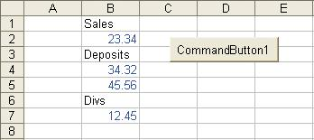

The following code, which utilizes CurrentRegion, should do just that. The IsNumeric function tests whether a cell’s contents is numeric, e.g. IsNumeric(23.34) would return True since 23.34 is numeric, whereas IsNumeric("Divs") would return False.

114 Learn to Program in Excel VBA in easy steps

...cont’d

[B1] (the square brackets mean “evaluate”) can be used as an alternative to
Range("B1").

Private Sub CommandButton1_Click()

Dim rng As Range, cl As Range

Set rng = Range("B1").CurrentRegion

For Each cl In rng.Cells
If IsNumeric(cl.Value) Then |  | (Any cell in the range
cl.Font.ColorIndex = 5 |  | B1:B7 could be
End If |  | chosen as the “seed”
Next cl | The cell will be colored | chosen as the “seed”
Next cl | The cell will be colored | for CurrentRegion.)
End Sub | blue if it is numeric. | for CurrentRegion.)


If using a version of Excel from 2000 on, make sure that Extend list (data range)

formats and formulas is turned off (Tools, Options..., Edit) to avoid spurious formatting effects in this case.

Note that instead of rng.Cells, we might equally just have rng. The advantage of using CurrentRegion is that the user could make additions to the data, contiguous with the current data and no alteration to the code would be necessary before running it. All numeric values will be turned blue as shown below.
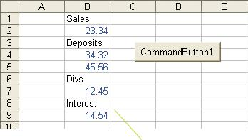

Data can be added before clicking the button

whereupon these numbers should turn blue as well.

If, rather than color the numeric values blue, we wished to color the non-numeric values blue, we could use:

If Not IsNumeric(cl.Value) Then ...

If we wished to manually select a cell in our column of numbers before running the code, rather than specifying a “seed” cell in code, we could replace the corresponding line above with:

Set rng = Selection.CurrentRegion

8. The Range object 115

UsedRange

UsedRange is not always reliable.

UsedRange is a property which returns the range of used cells on a sheet. More specifically, it returns a range bounded by the rectangle whose corners are the most extreme cells. In the example below, these corners are the top-left and bottom-right cells.

Private Sub CommandButton1_Click()

ActiveSheet.UsedRange.Select

End Sub

The top-left cell forms the top-left corner of the UsedRange rectangle.
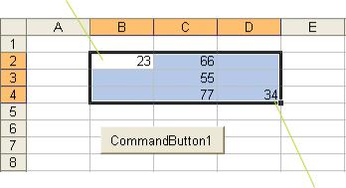

The bottom-right cell forms the bottom-right corner of the UsedRange rectangle.

UsedRange is a property of the Worksheet object and not of the Range object, but it returns a Range object. UsedRange has shortcomings and should be used with care. For example, if a cell is formatted as bold, and then made unbold (as distinct from clearing the formatting using Edit, Clear, Formats), (and any content removed) it is unfortunately still considered as a used cell, and UsedRange would include it in its rectangular boundary.

The End property of the Range object can be used to ascertain the boundaries of a range, e.g.

Range("C2").End(xlDown).Select

would select cell C4 in the example data above, i.e. the cell at the bottom of the region containing C2 (the equivalent of manually selecting cell C2 and pressing the End key along with the down arrow key). See Help on the End property for more details.

Exercise Use End(xlDown)to select a column eg

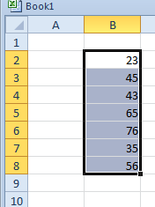
We know it starts at B2 but the column could be any length. Hint: Use the form Range(rng1, rng2) where rng1 is the starting range and rng2 is the end range. (We can be sure that there are no blanks in the range.)
Start with Set rngStart = Range("b2")

116 Learn to Program in Excel VBA in easy steps

Offset

The Offset property will return a Range which has the same size, but which is offset by a number of rows and columns, e.g. Offset(4,1) will return a new Range object with the same dimensions, but offset four rows down and one column across.

Private Sub CommandButton1_Click()

Range("B2:D4").Offset(4,1).Select

End Sub

The range offset by 4 rows and 1 column from the original range is selected.
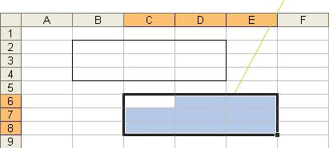

This new range at present has no “permanence”. Accordingly, we could set a variable equal to the new Range object as follows.

Dim rng As Range

Set rng = Range("B2:D4").Offset(4,1)

Specifying only one index will cause the range to be offset by that number of rows, e.g.

Set rng = Range("B2:D4").Offset(4)

will return a Range moved down four rows.

To offset by a number of columns only, we can either use zero as the first parameter, or omit it altogether, e.g. these two lines of code are equivalent and either will return a range offset by one column.
These do the same thing.
Set rng = Range("B2:D4").Offset(0,1)
Set rng = Range("B2:D4").Offset(,1)

8. The Range object 117

to the left of the cell

The value which is one cell
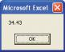
containing “dfg” is displayed.
When the code above is run, a message box
displaying the amount corresponding to
“dfg” should appear.
Amount | Code
23.32 | asd
31.32 | des
34.43 | dfg
21.32 | erg

Private Sub CommandButton1_Click()
Dim rng As Range, code As Variant
Dim i As Integer
code = "dfg"
Set rng = Range("C3:C6") For i = 1 To rng.Count
If rng.Cells(i).Value = code Then
MsgBox rng.Cells(i).Offset(0,-1).Value
End If
Next i End Sub

Using Offset, we could for example, emulate/extend the behavior of the Excel VLOOKUP worksheet function. With reference to the table of numbers below, we could display the Amount corresponding to “dfg” using the code shown.
...cont’d
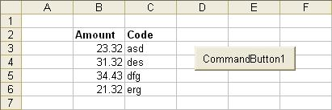

Exercise: 1. Make a UDF (User Defined Function – see end of Chap 10) to emulate the behaviour of the Excel VLookup function but working “backwards as above!

2. Does it work for “forwards” as well?

3. Emulate the behaviour of VLookup to find a non- exact match ie pass a parameter True or False

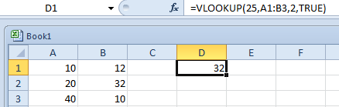 (Use the code above.)

eg: start with

Function myVLookup(code As Variant, rng As Range)
Dim i As Integer
For i = 1 To ….
Next i
End Function
(I may also be a good idea to also take a look at Subs/Functions first Ch 10 – the first few pages.)

118 Learn to Program in Excel VBA in easy steps

Resize

The Resize property will physically change the size of a range to a specified number of rows and columns. The top left cell of the new range remains fixed in place; it is the “anchor point” about which the range is contracted or expanded.

Private Sub CommandButton1_Click()

Range("B2:D4").Resize(2,2).Select

End Sub

The original range (here formatted with a border), is contracted to 2 rows and 2 columns in total size. The top left cell remains as the “anchor point”.
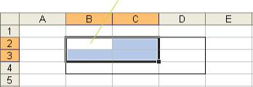

Specifying only one index will cause the range to be resized to that specified number of rows, e.g. Resize(1) will return a range of one row only. We could set a variable to such a new Range object (and select it) as shown:

Private Sub CommandButton1_Click()

Dim rng As Range

Set rng = Range("B2:D4").Resize(1)

rng.Select

End Sub
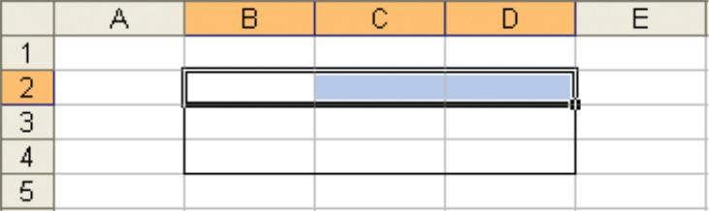

To resize to one column for example, we could simply omit any row specification and use Resize(, 1).

8. The Range object 119

A dynamic selection

We wish to be able to click among any rectangular group of cells

and then click a command button on the sheet...
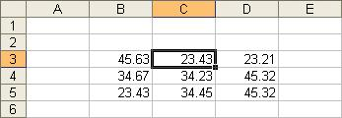
For this exercise make a table which is a different size and different location to that shown to show that this is a general method.

...whereupon the row beneath the cells will be selected.
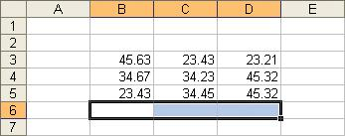

Once again we will write and test our code in easy steps.

- Place a command button on the sheet and write some code in its procedure which will simply select the CurrentRegion around the cell that the user clicks upon.

Private Sub CommandButton1_Click()

Dim rng As Range

Set rng = Selection.CurrentRegion

rng.Select
End Sub

After selecting a cell
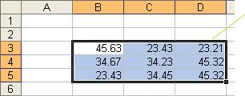
containing data and
running the code,
the current region is
selected.

120 Learn to Program in Excel VBA in easy steps

...cont’d

- Include code in the command button procedure to increase the number of rows in the range by one (and select it).

Select a cell in the table before clicking the command button to run the
program.

Private Sub CommandButton1_Click() Dim rng As Range
Set rng = Selection.CurrentRegion

Set rng = rng.Resize(rng.Rows.Count + 1)

rng.Select | (rng is | rngRows.Count will be 3
End Sub | (rng is | rngRows.Count will be 3
 | redefined.) | when execution reaches this
 |  | line (and 4 immediately after).
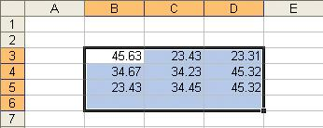

₃ Change the line of code to select the last row of this new range.

Private Sub CommandButton1_Click() Dim rng As Range
Set rng = Selection.CurrentRegion

Set rng = rng.Resize(rng.Rows.Count + 1)
rng.Rows(rng.Rows.Count).Select
End Sub
rngRows.Count will be 4 after resizing.


When a cell in the table is selected and the command button clicked, the last
row will be
selected.
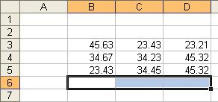
This code should work for any sized table, anywhere on the sheet.

8. The Range object 121

Intersect method

The intersection of two ranges is the region where they meet.
(Borders have been placed around the ranges whose intersection we wish to find.)

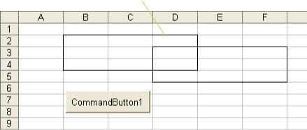

This code will color the intersection of the two ranges.

Private Sub CommandButton1_Click()

Intersect(Range("B2:D4"),Range("D3:F5")).Interior.ColorIndex = 33

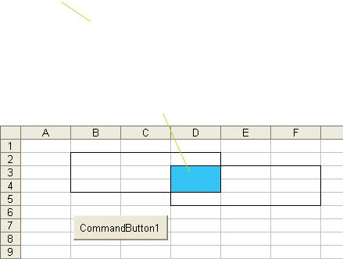
End Sub
(Interior is used when we wish to apply a solid color to the cells’ interior.) (ColorIndex 33 is Sky Blue in the default palette.)

When the program is run, the range intersection is colored blue.

122 Learn to Program in Excel VBA in easy steps

Union method

The union of two ranges is the “amalgamation” of the two ranges.

Modify the previous code to that shown below. (Replace Intersect with Union.)

Private Sub CommandButton1_Click()

Union(Range("B2:D4"),Range("D3:F5")).Interior.ColorIndex = 33
End Sub
When the command button is

clicked, the union is colored blue.
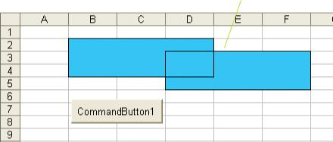

Intersect and Union are methods which return Range objects, so we could assign Range variables as shown.

Dim rng1 As Range, rng2 As Range

Set rng1 = Intersect(Range("B2:D4"),Range("D3:F5"))

Set rng2 = Union(Range("B2:D4"),Range("D3:F5"))

8. The Range object 123

To test a selection

The objective here is to ensure that a user will click in a certain range. If the user does not, a message box will appear, requesting that the correct range be selected.

Private Sub Worksheet_SelectionChange(ByVal Target As Range)

Dim rng As Range

Set rng = Range("B2:D4")

If Intersect(rng, Target) Is Nothing Then

MsgBox "Please select a cell in the range " & rng.Address
Else
MsgBox "OK"
End If  End Sub |  | If there is no intersection,
 |  | the range will be Nothing.
 | If the user clicks on a cell which is not in
 | the required range, a reminder appears.
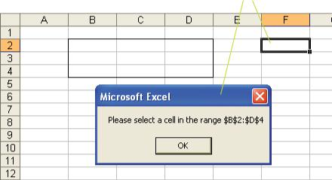

To ensure that the user selects only a single cell, we could include this code just before the Else statement.

ElseIf Target.Cells.Count <> 1 Then

MsgBox "Please select a single cell"

ElseIf provides another alternative to the Else, i.e. if the user does either thing wrong, the If or the ElseIf will be chosen, whereas if the user makes a correct selection, Else will be chosen.

124 Learn to Program in Excel VBA in easy steps

8. The Range object 125

rng.Areas.Count is 2

The Areas collection

Note carefully the placement of the quotation marks.

According to the VBA Help, “Areas is a collection of the areas, or contiguous blocks of cells, within a selection. There is no single Area object; individual members of the Areas collection are Range objects”.
On an Excel spreadsheet, when we make one selection and then hold down the Ctrl key to make another, we are creating two areas.
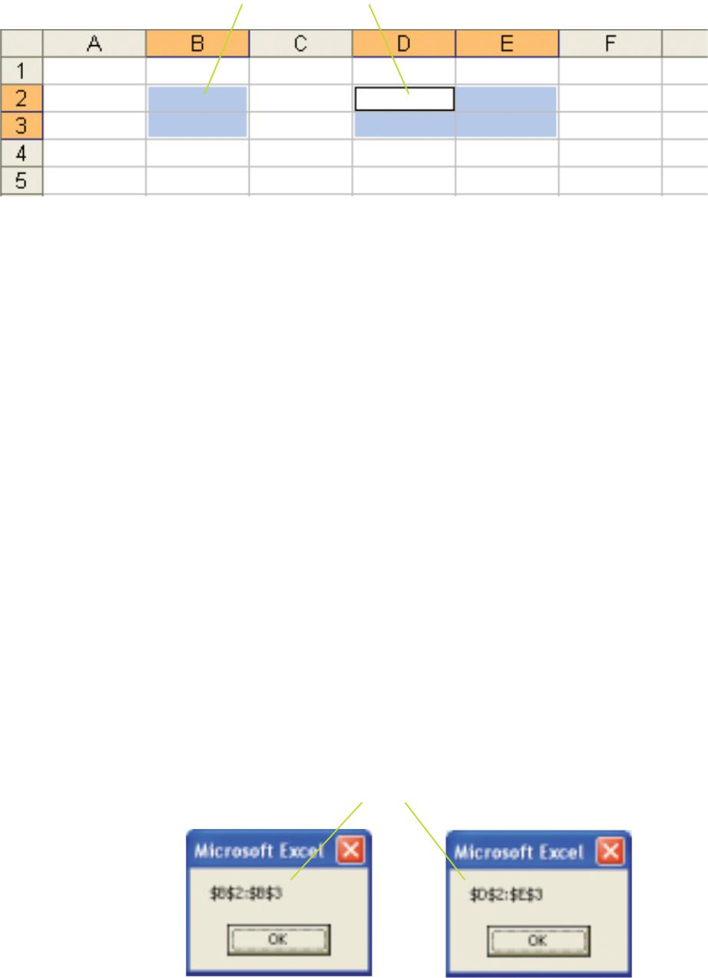

The equivalent of this in code would be:

Range("B2:B3,D2:E3").Select

The two members of this Areas collection have index values of 1 and 2 respectively, i.e. Areas(1) and Areas(2). Correspondingly, the Count property of the Areas collection returns the number of these discrete Range objects in the collection – in this case 2.

For example, the following code will cause the respective addresses of the two areas to be displayed.

Private Sub CommandButton1_Click()

Dim rng As Range, i As Integer

Set rng = Range("B2:B3,D2:E3")

For i = 1 To rng.Areas.Count

MsgBox rng.Areas(i).Address

Next i

When the code is run, the address of each area is displayed.
End Sub

As a practical example, we wish to ensure that a user makes a selection of exactly two single cells (using the Ctrl key).
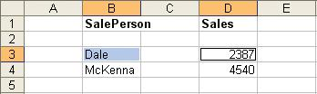

The Selection object represents the If a selection of more or less
user’s choice of one or more areas. than two cells is made

Private Sub CommandButton1_Click()
If Selection.Areas.Count <> 2 Then

MsgBox "You must make exactly 2 selections"
ElseIf Selection.Areas(1).Cells.Count <> 1 Or _ Selection.Areas(2).Cells.Count <> 1 Then MsgBox "You must select single cells"

Else
If either range has

more than 1 cell.
MsgBox "OK"

End If

End Sub

For example, if more than one cell is selected in one of the areas

(and the command button then clicked)...
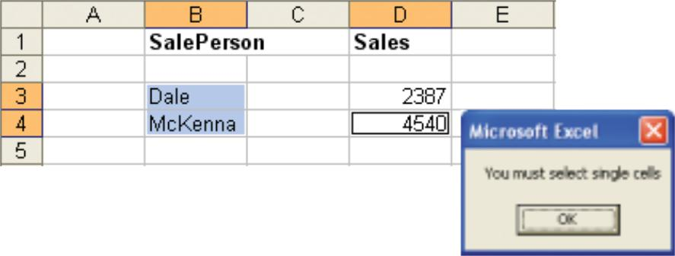

Since Selection is a property of the Application object (discussed later), it will persist from

click to click, and so if no selection is made, it will be the same as the last selection! It could be left as an exercise to develop a more practical version in the Worksheet_SelectionChange event procedure. Hint: the first line could read If Selection.Areas.Count = 2.

... a warning appears:

To further ensure that the selections were from the correct column and the same row, we could check the Column and Row properties respectively, e.g. Selection.Areas(1).Column and Selection.Areas(1).Row.

126 Learn to Program in Excel VBA in easy steps

To Build a Worksheet Formula Using a String Optional

- Write this code to sum A1:A2:
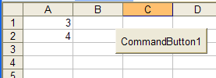

Private Sub CommandButton1_Click()
Range("A3").Formula = "=SUM(A1:A2)"
End Sub

This should of course result in this formula being placed into cell A3.

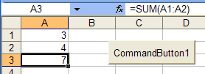

Break the string up as shown below: (It should do exactly the same as above.) We could also omit the Formula property as shown below.

Private Sub CommandButton1_Click()
Dim st As String
st = "A1:A2"
Range("A3") = "=SUM(" & st & ")"
End Sub

- Change the code as shown.

Private Sub CommandButton1_Click()
Dim st As String
st = Selection.Address
Range("A3") = "=SUM(" & st & ")"
End Sub

- Make sure that you make the selection first as shown before clicking the command button.

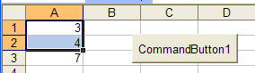

The formula will be placed in cell A3 as before.
Note that the Address property has provided the address as an absolute reference. (It makes no difference, the SUM still works.)

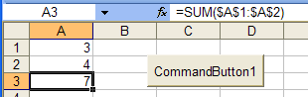

Recall that if we wished to make the Address property return a relative address, we could use:
(When using the Address property, it may be expedient to copy the definition from the Address Property in the VBA Help:
expression.Address(RowAbsolute, ColumnAbsolute, ReferenceStyle, External, RelativeTo)
to your code and modify it.)

… in which case, a relative address will now be placed in A3 when the button is clicked.

Recall how we can copy a formula across a range of cells: (see Formula page 59.)
- Try this.

Private Sub CommandButton1_Click()
Dim rng As Range
Set rng = Range("A3:C3")
rng.Formula = "=SUM(A1:A2)"
End Sub

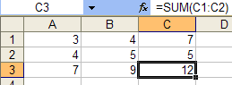
The formula is copied across to each of the 3 cells in the range.

Exercise:
  - “Colour the Surname”
We wish to be able to click on the Surname….
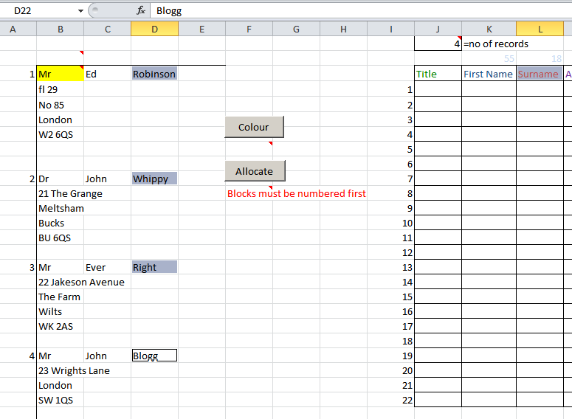

…. and hold down the ctrl-key and then click on the actual surnames so that we have the selection of 5 cells as shown above.

We then need to write some code which upon clicking the Colour button above will colour the 4 actual addresses the same colour as the “Surname” cell (L3).

2. Write code and place it in a new ClearColour button which will remove the colouring of any range that we will select (It should work for a multiple selection as well).

To Perform a Mail-Merge. See Word Manual on www.una.co.uk
WORD
wrdExtraLesson pages 8-13.
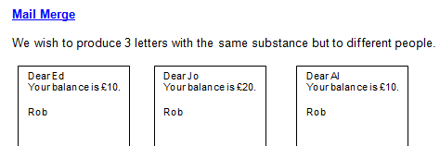

But try using Excel as your data source.

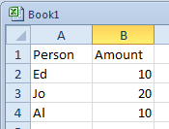

We have seen this previous
Exercise Use End(xlDown)to select a column eg
We know it starts at B2 but the column could be any length. Hint: Use the form Range(rng1,rng2) where rng1 is the starting range and rng2 is the end range. (We can be sure that there are no blanks in the range.)

Solution:

Private Sub CommandButton1_Click()
Dim rng As Range
Set rng = Range(Range("B2"), Range("B2").End(xlDown))
rng.Select
End Sub

Exercise: As above but how would you deal with spaces in the data?
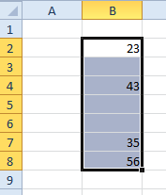

Hint: One method would be to first go to the very last cell of our spreadsheet and then use xlUp as follows.

Solution:

Dim rngStart As Range, rngLast As Range, rngEnd As Range
Dim myRange As Range
Set rngStart = Range("B1")
Set rngLast = Rows(Rows.Count).Columns(rngStart.Column).Cells
' rngLast is the last row of the whole s/sheet!
Set rngEnd = rngLast.End(xlUp) ' (All the way up to the 56.)
Set myRange = Range(rngStart, rngEnd) 'The whole range
myRange.Select 'Select it for demo purposes.

Exercise ? Select these given A1 is starting point.
Labeo barbatulus
Rohita barbatula
Labeo chrysophekadion
Morulius chrysophekadion

Labeo barbatus
Labeo falcifer
Labeo falcipinnis
Labeo cyclopinnis

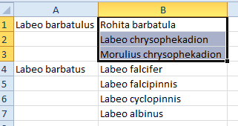

Exercise:
30
20
10
0
Recall how VLookup works when we select the True (or defaualt) option.
=VLookup(15,...,..., True)
Whereupon it will look for the "closest match" for 15 in this table and defaults to the one below.
Exercise: Write code in a command button which will emulate that behaviour- GIven for eample the 15 it will MsgBox that "lower shelf" value (in this case 10)
Assume that the numbers are sorted in descending order as show.
Sub CommandButton1.Click()
Dim rng as Range
Set rng = Range("c19:c22")
etc.
Hint: rng.Cells(1),Value, rng.Cells(2),Value, etc ?

Private Sub Worksheet_BeforeDoubleClick(ByVal Target As Range, Cancel As Boolean)
If Not Intersect(Range("rngDoubleClick"), Target) Is Nothing Then
Cancel = True
Range("rngDoubleClick").Interior.ColorIndex = xlAutomatic ' clear all
Target.Interior.ColorIndex = 24 ' This cell given Mauve interior
Cancel = False
End If
End Sub

