ActiveX controls

This chapter describes controls such as text boxes, combo boxes
and option buttons which can be placed on the worksheet to improve functionality.
Chapter Nine
Covers

Command Button 128

Changing a property at design-time 129

Text Box 133

Spin Button 135

Check Box 137

Option Buttons 138

Combo Box 139

Using Option Buttons 141

Exercises

YouTube VBACh9a https://youtu.be/impiMRnCmV4
command button text box spin buttons option groupname

VBACh9b https://youtu.be/OpdZWtQbUiE
combo box import sheet
Command Button

Controls found on the Control Toolbox (shown below) are ActiveX controls. We have already met one ActiveX control - the CommandButton object.

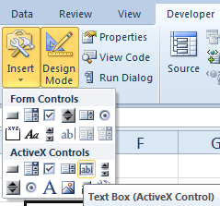
If you hold your mouse cursor steady over the buttons on the Control Toolbox, the types of ActiveX controls will be revealed. (You may wish to draw a few of these on your sheet.)

We have met the Click event of the CommandButton control. These controls are objects, and accordingly, besides events, have properties and methods. For example, we can change the Caption property of a CommandButton object using this code:

Private Sub CommandButton1_Click()
CommandButton1.Caption = "Enabled"
End Sub

When we click on the command button...

...the caption changes.

128 Learn to Program in Excel VBA in easy steps
Changing a property at design-time

So far we have seen how to change a property while the program was running – at run-time. It is also possible to change properties before we run the program – at design-time – as shown below. It is particularly desirable to change the captions of command buttons if we have more than one, in order to distinguish their function, e.g.
A quick way of getting the Properties window of the CommandButton from the Excel window is to right-click on the command button (in design mode) and choose Properties.

1 Place two command buttons on a sheet and access the Properties Window from the VBE by clicking on the Properties Window button (or choosing View, Properties Window from the VBE menu).

Make sure that you are in design mode in order to be able to view the CommandButtons in the Properties Window drop-down.

2Choose CommandButton1
from the drop-down.

(Your Properties
Window may or
may not be docked
as shown.)
2 Choose CommandButton1
from the drop-down.

3 Change the Caption property
to Apply Formatting as shown.

4 Repeat (from Step 2) for the second CommandButton’s Caption property. Change it to Remove Formatting.

9. ActiveX controls 129

The Caption property is simply the text which appears on the
button. The Name property on the other hand, is how the
CommandButton object is programmatically identified. In the
previous example shown here again, the Name property of the
CommandButton object was CommandButton1.

Private Sub CommandButton1_Click()
CommandButton1.Caption = "Enabled"
End Sub

CommandButton1 is the Name of the ComandButton control.

Make sure that you are in design mode in order to be able to view the CommandButtons in the Properties Window drop-down.

We will now change the Name property of our two command
buttons at design-time. The Properties Window should still be
visible.
1 From the Properties Window, change the Name properties of the corresponding Command Buttons to cmdApplyFormat and cmdRemoveFormat respectively.

130 Learn to Program in Excel VBA in easy steps

...cont’d

2 From the Excel window, double-click on the first command button (ensuring that you are still in design mode). Repeat for the second command button. The respective code procedures will appear in the VBE as shown
(It is also possible to create the respective Click procedures by simply selecting them in the object drop-down.)

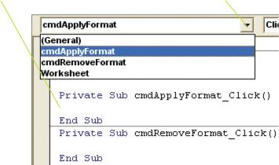
If CommandButton1 or CommandButton2 procedures have been inadvertently created, either ignore or delete them.

Giving the respective CommandButton objects appropriate Names of course enables us to more easily identify the respective procedures. (This becomes more useful as programs become larger.) We can now place appropriate code in the two procedures as shown.

Private Sub cmdApplyFormat_Click()

Selection.Font.ColorIndex = 3
End Sub

1 Insert code into the first procedure which will set the font color of selected cells red.

Private Sub cmdRemoveFormat_Click() Selection.ClearFormats
End Sub
2 Insert code into the second procedure which will clear the formatting of the selected cells.

9. ActiveX controls 131

...cont’d

Exit design mode. To demonstrate the program’s versatility, we will apply formatting to a multiple selection rather than just a single selection. First place some numbers on the sheet which we wish to selectively format as shown below.

3 Make a multiple selection (using the Ctrl key) and then click the Apply Formatting

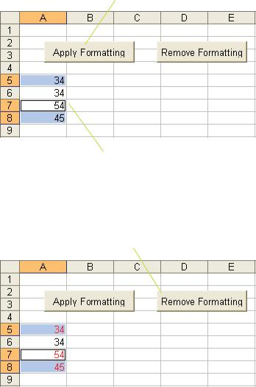

In this example, the 1st, 3rd and 4th cells are will be formatted (made red).)

4 To clear the formatting, make the same selection and then click the Remove Formatting button

All of the cells’ font color should now return to the default

132 Learn to Program in Excel VBA in easy steps

Text Box

We will now place a text box control onto a sheet, and use it to display some text when a command button is clicked. First place a command button on the sheet and then,

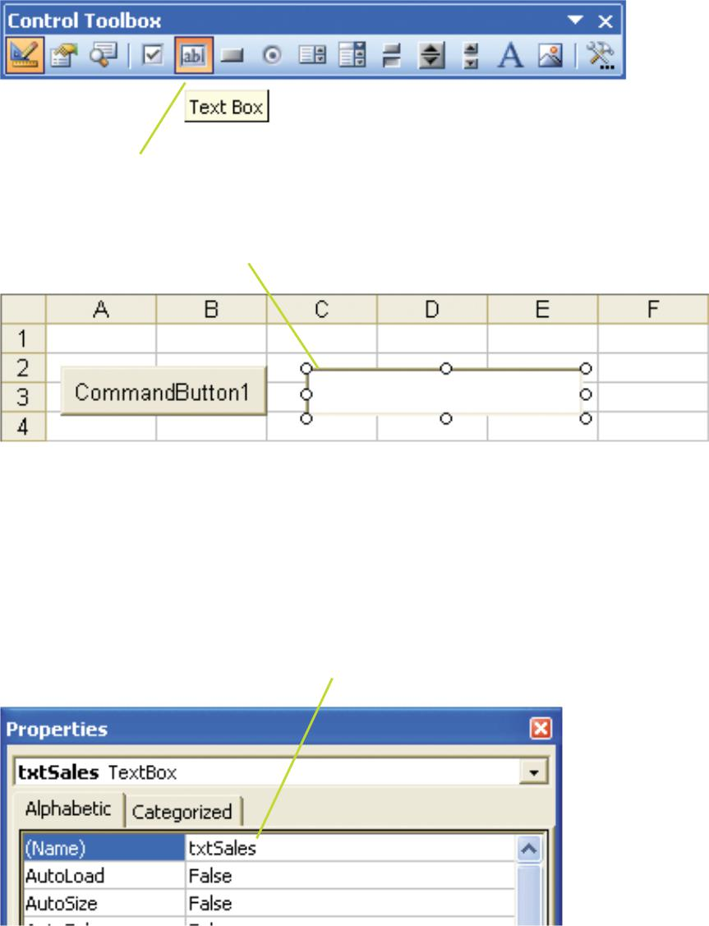
1 Click the Text Box control on
the Control Toolbox

2 Draw a text box on the sheet.

3 Right-click on the text box on the sheet and choose Properties. In the Properties box, change the Name property to txtSales. (As an expedience, you may wish to now copy (Ctr+C) this Name and later paste it into your code (see over) to reduce the prospect of a typo.)

4 Write this code in the CommandButton procedure

Private Sub CommandButton1_Click()
txtSales.Text = "Sales Results are good" End Sub
In order to see the properties of a particular control, make sure that the
control is selected.

Omitting default properties is not recommended.

For one thing your code is less

readable, but could also lead to ambiguity
txtSales is now the Name by which the text box can be referred to in the program – at least in this particular code module. Text is a property of the text box control. You can see it listed in the Properties box for this text box. (It is the default property of the TextBox object and could therefore be omitted.)

5 After exiting design mode, click the command button. The text should appear in the text box

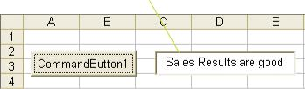

We have thus seen how to give a control (the TextBox control) a name by which we can later refer to it. (It would have been perfectly OK to leave the name as the default (TextBox1 in our case), and use that name to subsequently refer to our TextBox control.)

If, instead of transferring data to our text box, we wished to transfer input data from our text box into a spreadsheet cell, we could for example use:

Cells(1,1).Value = txtSales.Text

(To test this code we need to exit design mode and make sure that there is some text in the text box first before we click.)

Text boxes are more useful when they are placed on a user form, which we will discuss later.

134 Learn to Program in Excel VBA in easy steps

Spin Button

We will place a spin button control on the sheet which will be used to increment and decrement an invoice number in a spreadsheet cell (B2) by utilizing the SpinUp and SpinDown events of the spin button.

1 Use the Control Toolbox to draw a spin button control on the sheet

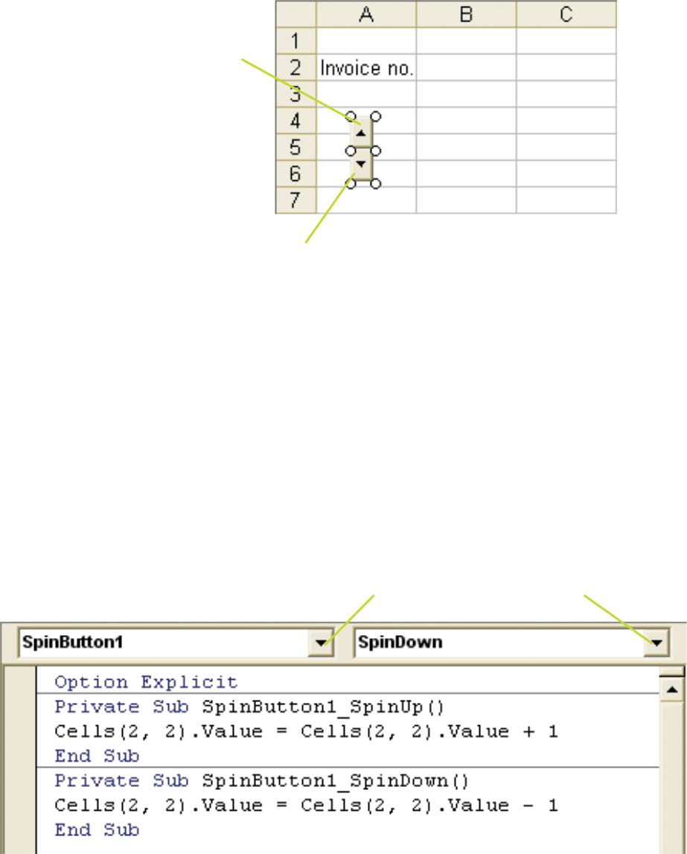

2 Double-Click on the spin button control. The (default) SpinButton1_Change() event procedure will be created. This is the event which responds to the “up” or the “down” arrows being clicked. We want to be more specific. Delete (or ignore) it.

3 Make sure that SpinButton1 is chosen in the Object drop-down. Choose the SpinUp and SpinDown events from the Procedure drop-down (you may need to delete the SpinButton1_Change() event again) and write the code in the respective procedures as shown

9. ActiveX controls 135

4 Use the Control Toolbox to draw a spin button control on the sheet
Before trying this, make sure that you delete/ comment the SpinButton1_SpinUp and SpinButton1_SpinDown event code.

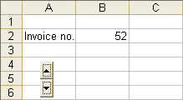

For these experimental purposes, the initialization code could simply be placed in a command button procedure.) More practically, initialization code could be placed in the Worksheet_Activate or Workbook_Open procedure etc. (If the Workbook event is chosen, make sure that SpinButton is qualified by the Worksheet, e.g. Worksheets(1).SpinButton1etc.)

We could achieve the same effect by utilizing the spin button’s
built-in Value property, which is automatically incremented and
decremented upon clicking the spin button’s “up” and “down”
arrows respectively. The Min and Max properties – the minimum
and maximum values that Value can take - can be set at designtime
or at run-time using code such as

Cells(2, 2).Value = Cells(2, 2).Value +1
and similarly, the incremental value can be altered from the default
of 1 by changing the SmallChange property (at design-time or
run-time e.g. SpinButton1.SmallChange = 5).

The Value could then be displayed in the cell using:

Private Sub SpinButton1_Change()
Cells(2,2).Value = SpinButton1.Value
End Sub

In this case, the value displayed in the cell could only change from
100 to 200, in increments determined by the value of
SmallChange.

136 Learn to Program in Excel VBA in easy steps

Check Box

1 Place two check boxes on a sheet. Double-click on one, and
from the VBE choose the Change event procedure from the
Procedure drop-down. (You may wish to delete the default Click
event procedures as they appear.) Choose the other check box
object from Object drop-down, choose its Change event and
write the respective code in each as shown below .

Private Sub CheckBox1_Change()
Range("D3").Value = CheckBox1.Value
End Sub
Private Sub CheckBox2_Change()
Range("D6").Value = CheckBox2.Value
End Sub

2 From Excel, exit design mode and click the respective
check boxes. The corresponding Value properties will
appear in column D – True corresponding to checked,
and False corresponding to unchecked. Note that the
check boxes (compared to option buttons which we willmeet soon) act independently, i.e. checking/unchecking
one has no effect on the state of the other.

9. ActiveX controls 137

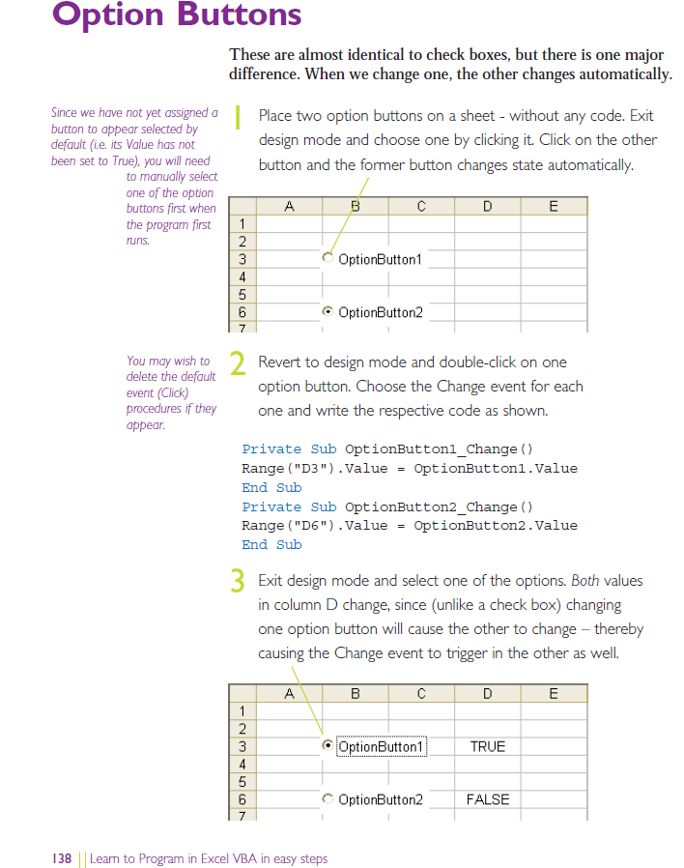

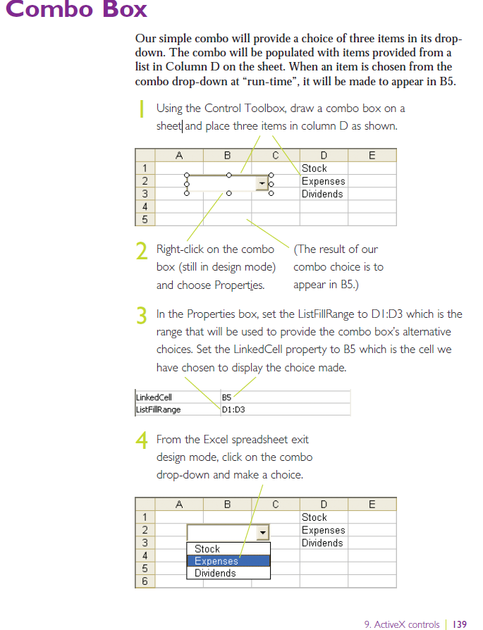

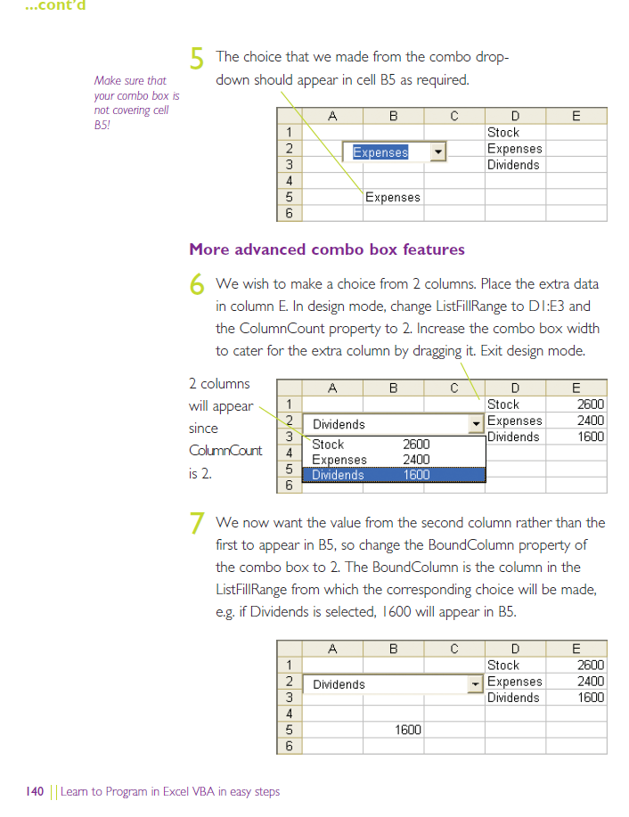

Using Option Buttons

We will use two option buttons to enable us to choose the name of the worksheet which is to be copied into another workbook. Make two workbooks, Company.xlsm with two sheets named 2004 and 2005, and Analysis.xlsm with a sheet named Import.

By choosing an option and clicking the button, the required sheet ought to be copied from Company.xlsm into the current workbook,

1 Place a command button on the Import sheet. Change its Caption to ImportSheet and it’s Name to cmdImportSheet.

2 Place two option buttons on this same sheet. Change their Captions to 2004 and 2005 respectively. (Leave the Names as the default, OptionButton1 and OptionButton2.)
3 Double-click on the Command Button and write this code.

The
sheet,
shName
is to be
copied in.
Use variables like Worksheet.Count (rather than 1 in this case) if we wish to ensure that the sheet is placed last – in case there happens to be more that 1 worksheet in the current workbook.
Private Sub cmdImportSheet_Click()

Dim shName As String
If OptionButton1.Value = True Then
shName = OptionButton1.Caption
ElseIf OptionButton2.Value = True Then
shName = OptionButton2.Caption

End If

Workbooks("Company.xlsm").Worksheets(shName).Copy _
After:= ThisWorkbook.Worksheets(Worksheets.Count)
End Sub
A colon and equal
sign identifies
After as a named
parameter
(discussed later).
Company.xls is the workbook from whence the sheet will be copied.
Copy is a method of the Worksheet object.

4 Make sure that both workbooks are open. After selecting a year and clicking the ImportSheet button...

If you don’t select an option on first running the program, an error will occur. To avoid this, one option button could be made the default choice by setting its Value property to True at design-time.

...you should find that the selected sheet has been copied from Company.xls to this workbook.

Exercise

1. Place 5 option buttons on your sheet as follows:

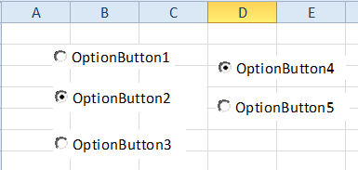

Give these two buttons the GroupName “Costs”
Give these three buttons the GroupName “Sales”.

Write code to determine which option button is true and which group it is from – when one of them is clicked.

Controls are of more use when used on a Userform. For Userform see p.164 Ch 11.

Userform

Exercise:

Make a userform with a command button and a text box named txtText.

Run it from a command button on a worksheet (UserForm1.Show False) .
False means the form is Modal ie we can do other things while its displayed.
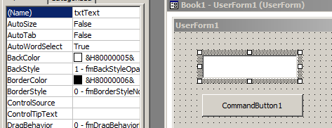
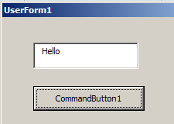

When we click the button “Hello” should appear in the text box.

Exercise: 2. Utilize all the other controls shown previously: ComboBox , Option buttons & Check boxes on one User Form.

See Demo of Email.xlsm in class. This automatically lists all of the excel files in a certain folder.
These files be selected and emailed as attachments by pressing the SendEmail/s button.
(The email address is extracted from cell A1 on the respective invoice worksheet.)

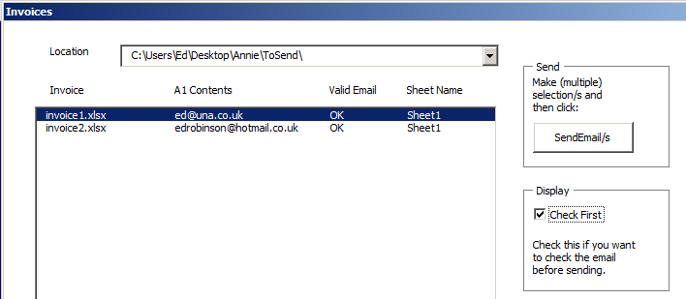
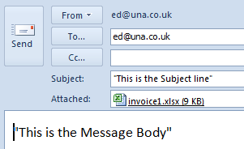

This email then appears:

This email appears.

Interesting Bits of code:
--------------------------------------------------------------------------------------------------------------------------------
For i = 0 To usfEmail.lstFiles.ListCount – 1
‘Picks up emails from selection/s in list box.
If usfEmail.lstFiles.Selected(i) Then
stEmail = usfEmail.lstFiles.List(i, 1) ' eg ed@una.co.uk
--------------------------------------------------------------------------------------------------------------------------------
If (stEmail Like "*?@*?.*?.*?") Then ver = "OK" Else ver = "NOT"
'Check if email address
usfEmail.lstFiles.List(i, 2) = ver 'add verify to listbox 3rd column
---------------------------------------------------------------------------------------------------------------------------------
Set OutApp = CreateObject("Outlook.Application").’ ”Creates” Outlook email.
Set OutMail = OutApp.CreateItem(0)
With OutMail
.To = stEmail
-----------------------------------------------------------------------
wbName = Dir(wbPath + "*.xls*", vbNormal) 'Gets first file in the folder.
-----------------------------------------------------------------------

Note also the use of subs and functions – next Chapter!

