Procedures

Chap 10

YouTube VBACh10a.avi https://youtu.be/0I4Llsu0X3s
(bit obscure) email code use fish instead sub/function pythag exercise byref byval swap byref

YouTube :VBACh10b.avi https://youtu.be/BAbOV5H-vjs
scope lifetime msgbox udf

Procedures allow us to compartmentalize and organize our code. We discuss the two main types, subs and functions along with their practical use.

Covers

Subs |  | 144
Functions |  |  |  |  | 146
Placing Subs in a module  Passing ByRef and ByVal |  |  |  |  |  |  |  |  |  |  |  |  | 147
Using a sub |  |  |  |  |  |  | 148
Using a function |  |  |  |  |  |  |  |  |  |  | 149
Variable scope |  |  |  |  |  |  |  |  |  | 150

To Color the Minimum value 152

Variable lifetime 153

The MsgBox function |  |  |  |  | 154
Named parameters |  |  | 155
User defined functions |  |  |  |  |  |  | 156

Exercises

Subs

Procedures are self-contained blocks of code. Procedures become more useful as program size increases. They are of two main types
– subs and functions. As we will see, the difference between a sub and a function is that a function can return a value whereas a sub cannot.

Writing a sub
Write this code.

Option Explicit
Private Sub CommandButton1_Click()
Square

End Sub

Sub Square() Dim x As Double x = 3
x = x ^ 2 MsgBox x End Sub
Square is the name of our sub.

(As we type “sub Square” and then press Enter, as well as being capitalized, parentheses and End Sub (formatted blue) appear automatically.)

The Square statement in the CommandButton procedure has the effect of “calling” the sub. The called procedure simply squares 3 to give 9, which is then displayed by the message box.
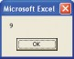

Generally speaking, in the course of program development, it is useful to be able to “wrap” code which has been tried and tested into subs (or functions) with identifiable names, and place them outside the main calling program. That way, our main code area should consist of a series of procedure calls (with recognizable names) with the corresponding encapsulated procedures placed after the main program area.

...cont’d

Passing a value to a sub
At present our sub can only square 3. We could modify it so that it could square any number by passing the number to be squared to the sub as follows.

Option Explicit
Private Sub CommandButton1_Click()
Square 3

End Sub
3 is passed to x.

Use Debug to single step (F8) to
Sub Square(x As Double) x = x ^ 2

watch the transfer of program control.
MsgBox x End Sub
x As Double is the equivalent
of Dim x as Double.

The variable which accepts the passed value (x in this case), is known as a parameter. Strictly speaking, the 3 which is passed is known as an argument, but both are often referred to as parameters.

Change the line
Square 3
to
Square 4
to show that another value can be passed. The result, of course, in the latter case, should be that 16 is displayed.

Placing Subs in a Module
From the VBE
This is a way of organizing your code.
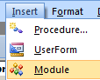

Click Insert and then Module.

Option Explicit
Sub Square()
Write this code in the module.

Dim x As Double
x = 3
x = x ^ 2
MsgBox x
End Sub

It is a good idea to name the module:
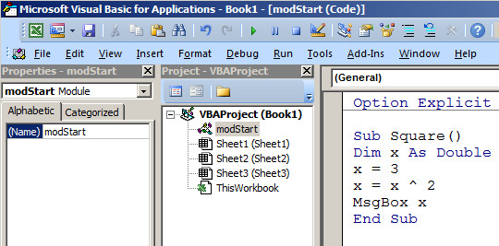
Click on the module Choose properties.
Name the module.

Now back in your command button code type: modStart.Square
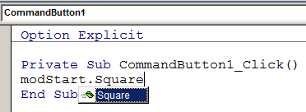
After clicking the command button:
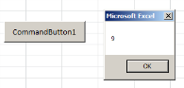
(Note the Itellisense as we type.)

Functions

Functions differ from subs in that they can return a value.

Writing a function
Modify the code as shown. ( Note that after Function is typed,
End Function appears automatically!)
Option Explicit
Private Sub CommandButton1_Click()
Dim y As Double y = Square(3)

MsgBox y End Sub
This time, the value is
returned to y and displayed.

Function Square(x As Double) As Double x = x ^ 2
Square = x End Function

The name of the function (Square) is always “repeated” (usually at the end of the function) and usually put equal to what is to be returned (in this case x).
The return type (also Double) it is also specified when using a function. (If it is omitted, a Variant return type is assumed.)

A function name invariably appears on the “right-hand
-side” of an expression, e.g. y
= Square(3) or MsgBox Square(3).
Note that we could replace the command button code with:

Private Sub CommandButton1_Click() MsgBox Square(3)
End Sub
We can even include our function name in an expression such as

MsgBox 2 * Square(3)
in which case we could regard the function name as a variable with value 9, so that 18 would be displayed. Try it.

Exercise:

- Write a function to find and return the mean of two numbers. Call it mean.
The parameters should be Double. Call the function like this

Private Sub CommandButton1_Click()
MsgBox mean(2, 4)
End Sub

2. Preliminary Pythagoras Theorem:
First place a command button on a sheet in our new workbook and write a program to calculate the hypotenuse:

z = Sqr(x ^ 2 + y ^ 2), where x = 3 and y = 4.
MsgBox z

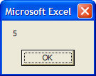
z

3

4

Place the above code in a function called Hypotenuse which is to be called passing two arguments (eg 3 and 4) so that upon return, a message box will produce the hypotenuse (of 5 in this case).

3. Put the code in the box below into a sub which can be used for any w/book. Call it may be using:

Private Sub CommandButton1_Click()
Dim stPath As String, stWB As String
stPath = "C:\temp\": stWB = "test.xlsm"
OpenWB stPath, stWB
End Sub

Code to check if a workbook is open – if not open it.
eg First place test.xlsm in C\temp\

Dim WB As Workbook, stFile As String, stPath As String, stWB As String

stPath = "C:\temp: stWB = "test.xlsm"
stFile = stPath & "\" & stWB

On Error Resume Next ‘If an error then go to the next line.

Set WB = Workbooks(stWB) 'Causes an error! if not open.

If (WB Is Nothing) Then 'ie it’s not open!
MsgBox stWB & " is not open. Will Open it."
Set WB = Workbooks.Open(stFile)
End If

If (WB Is Nothing) Then ' Its still not there!
MsgBox "Check workbooks/folders"
Exit Sub
End If

On Error GoTo 0 ’Turn of error handling.

End Sub

Passing ByRef and ByVal
Modify the code as shown to pass a variable rather than a constant.

Option Explicit
Private Sub CommandButton1_Click()
Dim v As Double v = 3

MsgBox 2 * Square(v) End Sub
The variable v is being
passed to the function.

Although discussed in relation to functions, ByVal and ByRef have
exactly the same effect when used with subs.

Passing a variable to a function or a sub ByRef (by reference), can permanently change the
variable passed, whereas passing ByVal (by value) cannot.

ByRef is the default. Your variables may unintentionally get changed
permanently if they are passed by ByRef.

Technically speaking, ByRef causes the actual memory address of a variable to
be passed to the procedure, whereas ByVal causes a copy of the variable to be passed.

Function Square(x As Double) As Double x = x ^ 2
Square = x End Function
After MsgBox 2 * Square(v), which causes 18 to be displayed, include the line MsgBox v in order to display the value of v.
When the program is run and 18 has been displayed as expected, quite surprisingly, the value of v is displayed as 9, not 3, i.e. the value of v has been permanently changed (squared) by the function to 9. Reverse remote control!
Include ByRef in the corresponding line above so that it becomes:
Function Square(ByRef x As Double) As Double
It won’t make any difference, ByRef is the default. Now change the ByRef to ByVal so that it becomes:
Function Square(ByVal x As Double) As Double
ByVal ensures that the value is passed by value and not modified inside the procedure.

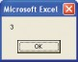
This time, when the code is run (and after the 18 has been displayed), the value of v is displayed as 3 and shown to be unchanged after the function call.

Exercise: Pass TWO values ByRef to a function (or sub) which changes them and show that each of them changes permanently.

Using a sub
As an example, we wish to color any 2’s which appear in a set of numbers red. We will pass the 2, along with the range to be searched to a sub which we will call ColorCells.
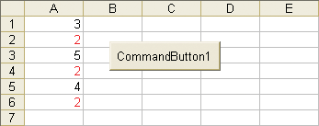
We will search the range A1:A6 and color any 2’s found red.

Commas are used to separate arguments.
Private Sub CommandButton1_Click() ColorCells 2, Range("A1:A6")
End Sub
Two arguments are passed. The range to be searched is passed to rng.

Sub ColorCells(x As Variant, rng As Range) Dim cl As Range
For Each cl In rng
If cl.Value = x Then cl.Font.ColorIndex = 3 Next cl
Private Sub CommandButton1_Click()
ColorCells 2, Range("A1:A6")
End Sub

Sub ColorCells(x As Variant, rng As Range)
Dim cl As Range
For Each cl In rng
If cl.Value = x Then cl.Font.ColorIndex = 3
Next cl
End Sub
End Sub
(Note that the 2 has been passed as a Variant. This would allow us to search for text as well as a number if we wished.)
The advantage of using a procedure here is that we can easily change the number that we are searching for, as well as the range that we are searching. Whereas we have searched a column of
numbers, it is possible to search any range, and also carry out more than one search, so that we would use the same procedure and
modify our calling code to something like this.

Private Sub CommandButton1_Click() ColorCells 2, Range("A1:A6")
ColorCells 4, Range("C1:D4") End Sub

Using a function
As an example, we wish to find the number of 2’s in a certain range. We will pass the 2, along with the range to be searched, to a function which we will call FindNum. As shown below, we use a function rather than a sub, since we wish to return the number of 2’s found to the calling procedure.
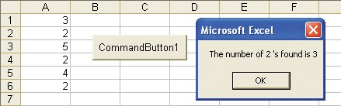

Private Sub CommandButton1_Click() Dim num As Integer, fnd As Variant fnd = 2
Private Sub CommandButton1_Click()

Dim num As Integer, fnd As Variant
fnd = 2
num = FindNum(fnd, Range("A1:A6"))
MsgBox "The number of " & fnd & " 's found is " & CStr(num)

End Sub

Function FindNum(x As Variant, rng As Range) As Integer

Dim c As Integer, cl As Range

c = 0
For Each cl In rng
If cl.Value = x Then c = c + 1
Next cl

FindNum = c
End Function
num = FindNum(fnd, Range("A1:A6"))
MsgBox "The number of " & fnd & _ " 's found is" & CStr(num)
End Sub

num is the number of occurrences of fnd.

Function FindNum(x As Variant, rng As Range) _ As Integer

Dim c As Integer, cl As Range c = 0
For Each cl In rng
If cl.Value = x Then c = c + 1 Next cl
Increment the
counter if a 2 found.

FindNum = c End Function
FindNum is the number of occurrences
of x which is passed back to num.

Use subs and functions wherever possible to organize your code - just like
the professionals.
Summary: When using functions:
- Use the same function name to return the value, e.g.
FindNum = ...
- Use parentheses when passing the arguments, e.g.
FindNum(fnd, Range("A1:A6")) (not with a sub).
- Specify the return type (e.g. As Integer as above).

A shortcoming of functions is that they can only return one value
We can use Passing By Reference to effectively return more than one value as the following exercise illustrates..

Exercise: 1. Write a sub to swap two numbers. Call it swap.

We wish them to be permanently swapped so pass them ByRef.

Private Sub CommandButton1_Click()

Dim a As Double, b As Double

a = 2: b = 4
We wish to call the sub like this:

MsgBox a & ", " & b
swap a, b
MsgBox a & ", " & b

End Sub

The Result should be:

before swap:
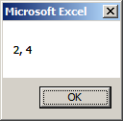

after swap:

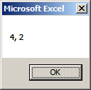

Variable scope
The scope of a variable determines where in the program it is valid. A variable is only “known” at the “level” at which it is declared.
This code below will fail with the message shown. Try it.

Option Explicit
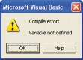
Private Sub CommandButton1_Click()

sub1 sub2 End Sub

Sub sub1()
Dim i As Integer i = 1
End Sub
(Code is “compiled” (converted) before being run.)

Sub sub2() i = 2
End Sub
The problem is that i is not known in the second procedure, since it was declared in the first procedure only.

Include a Dim statement in the second procedure as well, as shown below. It is important to realize that the second i variable is thereby completely independent of the i in the first procedure.
Option Explicit
Private Sub CommandButton1_Click() sub1
sub2 End Sub

Sub sub1()
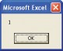
Dim i As Integer i = 1
Msgbox i End Sub

Each i in this case has procedure- level scope.
Sub sub2()
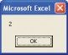
Dim i As Integer i = 2
Msgbox i End Sub

...cont’d

What if we did want the i in the first procedure to also be known, and retain its value, in the second procedure? We need to declare it in the General Declarations section (the top of the module).
Remove the Dim statements from each sub and modify the code as shown below.

Option Explicit Dim i As Integer
Place the Dim statement in the General Declarations. i will be then be known throughout the whole module.

Private Sub CommandButton1_Click() sub1
sub2 End Sub
Sub sub1()

i = 1 MsgBox i End Sub
Sub sub2() MsgBox i End Sub
The value of i was defined as 1 in the first procedure, so this value will also be known in the second procedure.

A global variable is one which is declared in a standard code module using
Public instead of Dim, e.g. Public i as Integer. Such a variable would then be available to every module (and accordingly every procedure) in the program. Try it. You will need to define the variable (e.g. i = 3) in a procedure.
When the program is run, a message box will appear twice displaying 1 each time.
It is very strongly recommended that variables are declared as locally as possible, resisting the strong temptation to use the easy option of module-level variables as above, where the variable is declared outside the procedures that use it (in the General Declarations). One alternative to using module-level or global variables is to pass variables as arguments from one sub to another.

The objective of a programmer is not only to write a program that works, but to make contingency for when it doesn’t. Declaring variables as locally as possible is but one of these contingencies.
(Using Option Explicit is another.) Knowing precisely where variables are declared and defined thereby helps us to localize the source of any potential errors that may occur.

To color the minimum value
This program will color the smallest value in a selected set of
numbers blue. Since the range variable is declared at module level (in the General Declarations), it will be available to all command button procedures in that module, and the selection need not be repeated before clicking the second button to clear the formatting.

Change the Names and Captions of command buttons using the
Properties window.
Option Explicit Dim rng As Range

Private Sub cmdFindMin_Click() Dim i As Integer, mn As Single Dim c As Integer
Private Sub CommandButton1_Click()

Dim i As Integer, mn As Single
Dim c As Integer
Set rng = Selection
mn = rng.Cells(1).Value
c = 1
For i = 2 To rng.Count
If rng.Cells(i).Value < mn Then
mn = rng.Cells(i).Value
c = i
End If
Next i

rng.Cells(c).Font.ColorIndex = 5

End Sub
Set rng = Selection
mn = rng.Cells(1).Value c = 1
For i = 2 To rng.Count
After declaration in the General Declarations, the Range variable is defined in the first procedure.
After the index (c)
If rng.Cells(i).Value < mn Then mn = rng.Cells(i).Value
c = i
End If
Next i rng.Cells(c).Font.ColorIndex = 5 End Sub

Private Sub cmdClearFormats_Click() rng.Cells.ClearFormats
End Sub
of the cell containing the smallest value has been determined, it is used to color that particular cell blue.

rng will also be known in this procedure

Don’t click the Clear Formats button without first clicking Find Min button.
First select the range, and then click the Find Min button. The minimum value (22 in this case) should be colored blue.

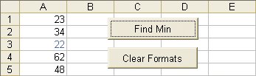
Since rng has module-level scope, there is no need to re-select the range before then clicking Clear Formats.
150 to print

Variable lifetime
Lifetime determines where in the program the value of a variable is remembered. If we declare a variable in a procedure using Static instead of Dim, the variable value will be remembered next time the procedure is called. First we’ll not use Static.
Private Sub CommandButton1_Click() Dim i As Integer

MsgBox i i = i + 1 End Sub
Each time that the command button is
clicked, the same value of i (0) appears. The effect of Dim is to set the value back to 0 each time that the button is clicked.

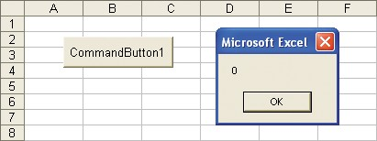

Now change Dim to Static.
Private Sub CommandButton1_Click()
Static i As Integer i = i + 1

MsgBox i End Sub
Static ensures that the value is remembered from the last time that the procedure was called.

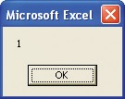
If we now continue to click the command button, the value displayed will be incremented by one each time.

(If the workbook is closed (saved), and reopened, the value of i is forgotten, i.e. it resets to 0.)

The MsgBox function
We have met the MsgBox statement, e.g. MsgBox "Click". We could regard this as calling the built-in MsgBox sub and passing it the parameter "Click". MsgBox can also be used as a function, whereby a value is returned, e.g.

When calling functions, use

x = MsgBox ("Click",4,"Test")

parentheses to enclose the arguments.
The Prompt
is “Click”.
The Title (“Test”) will appear at the top of the message box (see below).

Use the VB built- in constants where possible,
e.g. vbYesNo instead of 4.
The Buttons value of 4 determines that two buttons, Yes and No will appear on the message box (see the VBE Help for more details).
Type in the code as shown below.

To get automatic syntax assistance, Auto Quick Info must be checked. (From the VBE
editor, choose Tools, Options...)

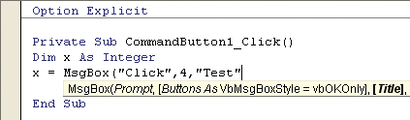
As we type into the VBE, Auto Quick Info provides a guide to the correct syntax (as well as listing the vb constants available).

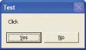
Title is Test and Prompt is Click.
Buttons is Yes/No.

The value of x returned is determined by the button pressed. If Yes is clicked, the value returned is 6 (vbYes). If No is clicked, the value returned is 7 (vbNo). To confirm this, you may wish to use another MsgBox statement to display the value of x.
x = MsgBox ("Click",4,"Test") MsgBox x

Named parameters

Rather than omit the Buttons argument to accept the default, we could
use a Buttons value of 0 (vbOKOnly).
What if we did not want to specify Yes/ No buttons but instead accept the default of an OK button? We could omit the Buttons argument altogether as follows.
x = MsgBox("Click", , "Test")

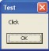
An extra comma indicates a missing argument.

(The default OK button only)

Always include the colon with the equal sign when using named parameters.
Keeping the arguments in strict order, and providing the required extra commas, can be a little tedious – especially as the number of parameters becomes larger. Named parameters obviates this. The equivalent of the above, using named parameters is:
x = MsgBox(Prompt:="Click", Title:="Test")
Note that if named parameters are used, the order of the
arguments no longer matters, e.g. the following statement would be equivalent to the above.
x = MsgBox(Title:="Test", Prompt:="Click")
In a practical situation, we could test for the returned value. For example, if we wish to confirm that we want to delete the contents of the cells in a selection, we could use:
Private Sub CommandButton1_Click()
Dim x As Integer
x = MsgBox(Prompt:="Delete the cell contents?", _ Buttons:=vbYesNo)
If x = vbYes Then Selection.ClearContents End If
'otherwise do nothing End Sub

User defined functions
If we write a function in a standard code module, it can be called from Excel just as we would call a normal worksheet function.
1 From the VBE menu, select Insert, Module. 2 Write this function code in the module to perform a simple currency conversion.

It is possible to write code to automatically
Function doll(st As Single) As Single Dim rate As Single
rate = 1.5

download the relevant up-to-
date exchange rate from the Internet.
doll = st * rate
End Function
3 Type an = sign, followed by the name of our function, along
with the source cell reference.

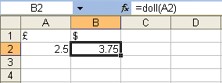
4 If a sterling amount is now entered into A2, the equivalent dollar amount will immediately appear in B2.

Only user defined functions can be written – not user defined subs.

UDF’s can be used (subject to their limitations) rather than CommandButton
procedures to test your code.
Writing the user defined function (UDF) in a standard code module (as well as being essential) immediately qualifies the function as being available for any sheet in the workbook.

Limitations
User defined functions are very useful for providing your user with encapsulated code which the user can access by simply typing the function name into the formula bar as we have seen, but they have restrictions. Foremost of these is that UDF’s cannot be used to change the structure of the spreadsheet in any way. This means that not only can we not change the formatting of any cells, a UDF cannot be used to place a value in a cell. (Worse still, we may not get any indication of the error if we try!)

Exercise: Here is code to find the data between the <Person> tags. Try it.

Private Sub CommandButton1_Click()
Dim stXML As String, pos1 As Integer, pos2 As Integer
Dim stSearch As String, stTag1 As String, stTag2 As String
Dim stData As String
stXML = "<Person>ed</Person><Balance>10</Balance>"
pos1 = 0: pos2 = 0
stSearch = "Person"
stTag1 = "<" & stSearch & ">"
stTag2 = "</" & stSearch & ">"
pos1 = InStr(stXML, stTag1) + Len(stTag1)
pos2 = InStr(stXML, stTag2)
stData = Mid(stXML, pos1, pos2 - pos1)
MsgBox stData
End Sub

What if we now wanted to also find the data between the <Balance> tags? Rewrite the whole thing for <Balance> ? No.
Exercise : Put the code into a function named findString and PASS the string to be searched for (<Person> and the string to search (stXML).
Show that it works when we pass<Balance> to the function instead of <Person>.

Exercise: myVLookup Revisited. Make a UDF such that:
We wish to search in column 2 for our value (of 20 here) and find the corresponding value in column 1. The found value of course is then 4.
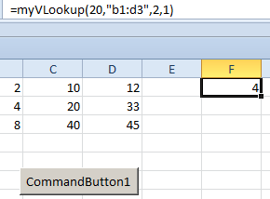

Note the difference from previously: We are passing the whole range (“b1:d3) which is closer to the Excel VLookup functionality.

(You may or may not wish to get it working first using a command button.)

Hint: Some of the UDF code:
Set rngTable = Range(stTable)
Set rngToLook = rngTable.Columns(colLook)
For i = 1 To rngTable.Rows.Count
If rngTable.Columns(colLook).Cells(i).Value = srch Then 'found it then
fnd = rngTable.Columns(colFind).Cells(i).Value'fnd is the found value.
Exit For
End If
Next i
Bonus bonus: Make True the optional default eg =myVLookup(22,”b1:d3”, 2, 1) -> 4
Optional Bonus question: Make it work for “approximate match as well. eg =myVLookup(22,”b1:d3”, 2, 1, True) -> 4

Exercise:
Write a UDF (User Defined Function) called CentToFah which accepts a centigrade value eg 100 and returns a Fahrenheit value (212) in this case.
The formula is F= 9/5 C + 32
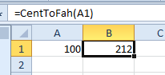

Exercise:
We have a matrix:

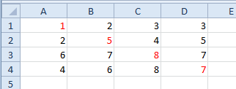

Add the numbers on the leading diagonal (red numbers) ie
1+5+8+7 ie 21
Start off by assigning a Variant array.

Make UserForm containing Text Box, ComboBox Option Check boxes etc

Module to place Subs and Functions
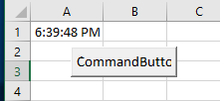
Private Sub CommandButton1_Click()
tellTime
End Sub

Sub tellTime()
A Module is a code sheet that is available throughout the whole workbook ie from every worksheet.
Cells(1, 1).Value = Time
End Sub

Now place the sub in a module like so:
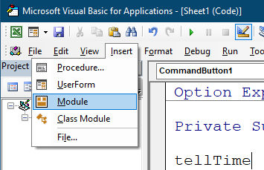
Insert Module

Cut the Sub code from the Sheet1 code sheet…

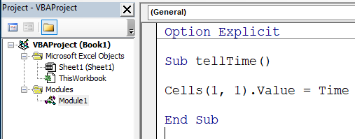
…and paste it into Module1:

The code should run as before - but take care. Sheet1 must be the active sheet.

If it is not- and you wish the time to be placed in Sheet1 then specify Sheet1 as follows:

Sub tellTime()
Worksheets("Sheet1").Cells(1, 1).Value = Time
End Sub

Additionally
We could (redundantly) specify the Module:

Private Sub CommandButton1_Click()
Module1.tellTime
End Sub

To change the name of the Module:

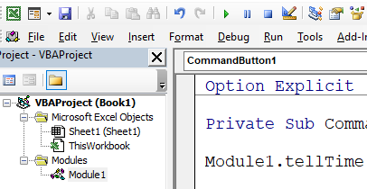
Click in Module1 and click Properties on the menu. (Strangely it won’t do to Right-click.)

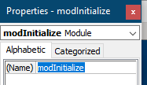

Now we can (redundantly) refer to it as thus:

Private Sub CommandButton1_Click()
modInitialize.tellTime
End Sub

So this probably more serves as a reminder as to where your code is!

Public variable: Is one which is known to every worksheet.

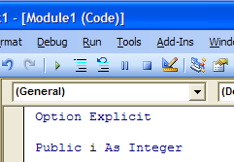
Declare the variable.

Public means that the variable will be known in each code sheet throughout the program i.e. the variable i will have program-level scope.)
(Using Dim would mean that this variable would only be known in this module i.e it would only have module-level scope.)

