The Application object CH 13

The Application object represents Excel itself. As well as having many useful general purpose properties and methods, the Application object gives access to the many well-known Excel worksheet functions.

Covers
Application properties | 180
WorkSheetFunction Methods 184  Volatile 186 | 182

VBACh13a.avi https://youtu.be/3bC3b7LyfEA
SheetsInWorkbook Application object Status Bar Screen Updating DisplayAlerts
WorkSheetFunction PMT EnableEvents Undo

Application properties
The Application object is the parent of all objects in the Excel Object Model.
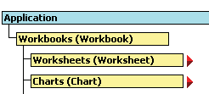

Record a macro whilst setting an option in Excel (Tools, Options...) to determine the
appropriate coding.

Not all option settings are immediate Application object properties.
DisplayGridlines for example, is a property of the Window object, which itself is a child object of the Application object.

The default number of worksheets in future will now
always be 5 unless it is set otherwise using Tools, Options..., General, etc.

To return the default status bar text, it is necessary to use Application.StatusBar
= False. (To set it blank, use Application.StatusBar = “”.)

Option settings
Since it represents the entire Excel application, the Application object can give access to many of the application-wide settings of the Excel Tools, Options... dialog box. For example, we can set the number of worksheets in a (new) workbook using the SheetsInNewWorkbook property as follows.
Private Sub CommandButton1_Click() Application.SheetsInNewWorkbook = 5 End Sub
If this code is run and a new workbook opened, it will contain five worksheets as shown below.

StatusBar
This property is used to set the text which appears on the status bar at the bottom left of the screen.
Private Sub CommandButton1_Click() Application.StatusBar = "Calculating..." End Sub
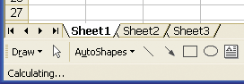
When the code is run, the text will appear in the status bar of the Excel window.

...cont’d

ScreenUpdating
To avoid screen flicker and make your code run faster, the screen can be frozen when your code is running using:
Application.ScreenUpdating = False
Whereas ScreenUpdating will revert to True automatically when the code terminates, it is good practise to do this explicitly with:
Application.ScreenUpdating = True

DisplayAlerts
Under normal circumstances, when we close a workbook, we will be asked for confirmation if changes have been made.
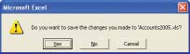

Some Application properties are “globals”, and don’t require to be preceded with
Application, e.g. rather than Application.Selection, we can just use Selection on its own.
If DisplayAlerts is set to False, this dialog box is suppressed, and any changes are lost, as running this code will demonstrate.
Private Sub CommandButton1_Click() Application.DisplayAlerts = False ActiveWorkbook.Close Application.DisplayAlerts = True End Sub

(Returning DisplayAlerts to True is not essential since it will be done automatically upon exit from the procedure.)
Try running the above code after making a change to a sheet. Reopen the workbook and note that the changes have not been saved.
Setting DisplayAlerts to False is particularly useful if we wish to avoid the possibility of a user canceling an operation whilst code is running, thereby possibly avoiding subsequent code conflict.

WorkSheetFunction

WorkSheetFunction is a property which returns a WorkSheetFunction object. The
WorkSheetFunction object can be found in the Excel Object Model diagram as a child of Application object.

Don’t erroneously use String arguments with worksheet functions where a
Range type is expected.

The WorkSheetFunction object gives us access to the extremely useful
mathematical, (e.g. MINVERSE), statistical, (e.g. STDEV), and financial, (e.g. NPV) Excel worksheet functions.
We can access most of Excel’s worksheet functions using VBA’ s
WorkSheetFunction.

Sum
For example, we can obtain the result of Excel’s SUM function shown here by, using the code shown beneath. ( Note that the formula itself is not inserted.)
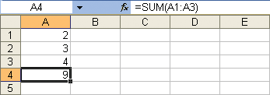

Private Sub CommandButton1_Click() Cells(4, 1).Value = _ WorksheetFunction.Sum(Range("A1:A3")) End Sub
Take note that the argument of Sum is a Range object - not a String.
To determine which of the Excel worksheet functions are available, type WorksheetFunction. into your VBE editor and scroll through the IntelliSense suggestions which appear.
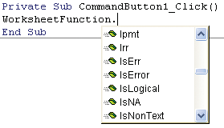
Many Excel functions are duplicated in VBA and serve the same purpose, e.g. Excel’s ABS and VBA’s Abs. Some are not represented at all, e.g. the Excel CO N CATENATE is not available from VBA using the WorkSheetFunction object since VBA has a perfectly good & operator to concatenate strings.

...cont’d

VBA Help.

To get Help on worksheet functions such as PMT, consult Excel Help, not
PMT
From VBA we can access the PMT Excel worksheet function which will allow us to calculate mortgage payments. For example, we could calculate the monthly payments on $100,000 over 20 years at 5% interest using:
Private Sub CommandButton1_Click() Dim rate As Double, nper As Integer Dim paymnt As Double
rate = 0.05 / 12: nper = 20 * 12
paymnt = WorksheetFunction.Pmt(rate, nper, 100000) MsgBox paymnt
End Sub
Note that rate is the rate per period, i.e. the monthly interest rate which is the annual interest rate divided by 12, and nper is the total number of monthly payments over 20 years, i.e. 20 x 12.

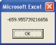
(A negative value indicates that payment must be made.)

If it is desirable to present this result as a positive value correct to two decimal places, for MsgBox paymnt we could substitute:
MsgBox Format(Abs(paymnt), ".##")

(Abs will return positive values only.)
(“.##” will format correct to 2 decimal places, but compared with “.00” will not insert 0 placeholders.)

The payment would then be displayed as shown.
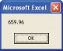

Methods

OnTime
OnTime allows us to run some code at a time of our choosing.

Chose Insert, Module from the VBE menu to insert a standard code module.
1 Create a procedure in a standard code module that we wish to run some time in the future.

Sub mBox()
MsgBox "Sub called" End Sub

2 Write the code shown below which will automatically call the mBox sub three seconds after the command button is clicked.

Private Sub CommandButton1_Click() Application.OnTime Now() + _
TimeSerial(0, 0, 3), "mBox" End Sub

TimeSerial returns a time of 0 hours, 0 minutes and 3 seconds.
The name of the procedure to be run.

Procedures that are called by OnTime and OnKey must be written in a
standard code module.

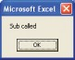
OnKey
Three seconds after the command button is clicked, this message box appears.

Since the command button will have the focus after running this code,
it is necessary to click back on the worksheet before pressing the Tab key (or alternatively, set the CommandButton’s TakeFocusOnClick property to False).
OnKey allows us to run a procedure by simply pressing a key. For example, after this code is run, we could subsequently run the mBox procedure (assuming that it is in the standard code module) by simply pressing the Tab key.

Private Sub CommandButton1_Click() Application.OnKey "{TAB}", "mBox" End Sub
To return the Tab key to its default functionality, use:
Application.OnKey "{TAB}"

...cont’d

Take care that there is no important data in the cell to the right!.

When using a

Undo
Undo will undo the last action taken by the user. Here’s a novel program which saves values that you overtype. It places the
overtyped value in a cell to the right. In this case, Undo causes the typed-over value to temporarily reappear in the same cell.

Private Sub Worksheet_Change(ByVal Target As Range) Dim x As Variant
Application.EnableEvents = False

Worksheet_Change event which itself
changes the
x = Target.Value Application.Undo
The new value entered is saved in x.

contents of a cell, Application.EnableEvents should
Target.Offset(, 1).Value = Target.Value Target.Value = x

be set to False in the procedure,
lest a chain reaction occurs.
Application.EnableEvents = True End Sub
Target.Value = x causes the saved (typed-in) value to be returned to the cell.

After a new number is entered into a cell, the
After the Undo,
Target.Value will hold the old value which is then placed in the cell one column to the right.

The selection will not be seen to move down (or whatever was the default action)
upon pressing Enter, since that operation was also undone. (Target.Offset(1).Select could be used to move it down.)

Whereas it is possible to call Excel functions from the Excel menu using
SendKeys, it is considered something of a last resort.
overtyped value will appear in the cell to the right.

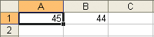

SendKeys
The SendKeys statement can be used in code to send keystrokes to Excel. The effect is exactly the same as physically pressing the corresponding key/s on the keyboard. eg This code will place A in a cell.
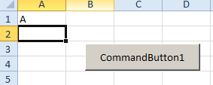
Range("a1").Select
SendKeys "A"
SendKeys Chr(13)
Chr(13) is Enter.

The % character represents the Alt key, the + the shift and ^ the ctrl key. (See Help on Sendkeys.)

Volatile
The Now Excel worksheet function is an example of a volatile function.
To demonstrate this, enter = Now() into a cell and format the cell to show seconds. Perform a calculation elsewhere on the sheet using an arbitrary formula. Now will be seen to update.

A volatile function (see page 189 for volatile functions demo.) is one which is automatically called when a sheet is recalculated. UDF’s (user defined functions) are not volatile by default. Consider this UDF which simply displays the name of the active sheet in a cell. (Type this code into a standard code module and then type the UDF in a cell as shown below.)
Function GetWorksheetName() As Variant GetWorksheetName = ActiveSheet.Name End Function
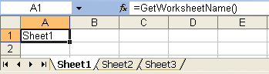

Unfortunately, if the worksheet name is now changed (whereby a recalculation is deemed to have occurred), the UDF will not automatically trigger, and the new name will not be displayed
immediately. (Try it.) To remedy this, include Application.Volatile as the first line in the UDF. Now, if the worksheet name is changed, it will be displayed simultaneously.

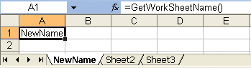
The new name is displayed at once when the sheet name is changed.

Where to go from here
The purpose of this book, has been to introduce Excel VBA in a simple step by step manner, thereby enabling the reader to now be able to easily refer to the many, excellent VBA references which are currently available. The Internet is also invaluable in terms of the instruction and sample code available which the reader could now utilize in order to pursue his or her specialist areas of interest in this intriguing, fascinating and versatile language.

Chapter13

- Record a macro to change SheetsInNewWorkbook.

- Run the code below and take a look at Tools, Options, General.

Application.SheetsInNewWorkbook = 5

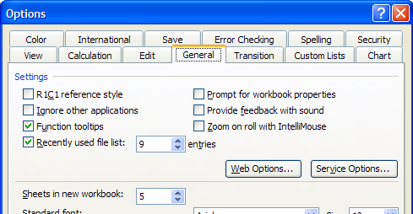

DisplayAlerts

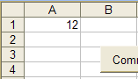
- Make a small change to the spreadsheet and don’t save it.

- Run this code

Application.DisplayAlerts = False
ActiveWorkbook.Close
Application.DisplayAlerts = True
- Open the spreadsheet.

The change has not been saved.
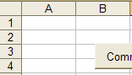

Exercise: Write some code to toggle the spreadsheet gridlines.
(See the 2nd note on the left hand side of page 180.)
You may wish to record a macro to assist with the code. (Tools, Options…, View, Gridlines.)
(Make sure that you don’t record your macro in the personal workbook.)
(Note that the spreadsheet gridlines are independent of the Print Preview gridlines (File, Page
Setup… ,Sheet, Gridlines.))
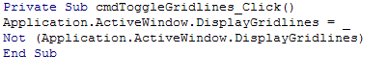

Format vs NumberFormat

Format

- Replace the MsgBox statement on page 183:

with:

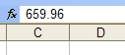
The number itself is changed.

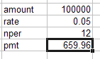

NumberFormat

- Replace the line above with:

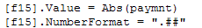

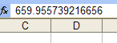
The number itself has not been changed. It has only been formatted in the cell i.e. presented correct to 2 decimal places.

Recall that NumberFormat is equivalent to choosing Format, Cells, Number, Custom from Excel.
Format returns a string and is for use in code.
The notation for NumberFormat for is not the same as for Format.
Volatile Functions page 186
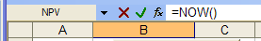
- Type = NOW() into a cell and then format it so that the seconds is visible (Format, Cells…, Time) and then choose a Type which has seconds displayed.
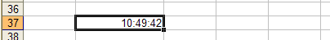
- Place a formula into a cell and a value upon which it relies.
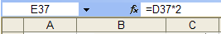
- A formula has been placed here.

The time is updated - showing that Now() is a Volatile function.

To show that Rand is also a volatile function.

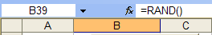
- Type =RAND() into a cell. A random number appears.

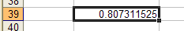

- Recalculate the sheet by changing the value upon which a formula depends – as above. A new random number should appear.

