Additional CH 14

Automation VBACh14a.avi: https://youtu.be/ZTJ8WdpdgII
word macro automate word API get username

Windows APIs
(Included above)

File Handling VBAFilehandling.avi https://youtu.be/CHOfELInQ78
Create Serial Read kill CreateObject

AddIns CH14AddIns.avi: https://youtu.be/9O1VY7IiEEg
Reference Application.Run function MultTwo Sub mySub

Interlude : Word VBA
- Open Microsoft Word and make a macro to insert the word mat at the position of the cursor as shown below.
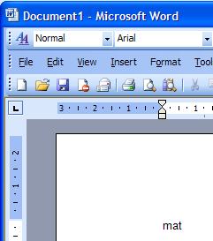
Make sure that you have a Developer tab on the Word Ribbon. Then choose Record Macro etc.

- 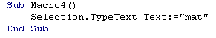Edit the macro to view it's code

Make sure that you have a Developer tab on the Word Ribbon. Then choose Record Macro etc.

We can use VBA with

Access
Powerpoint
Outlook

but none of these has Macro Recorder!

YouTube:
VBACh14a.avi: https://youtu.be/ZTJ8WdpdgII
Automation

Interacting with other Office Applications Using Excel to Place Some Text into a Word Document:

Since we know that Word supports Automation we know that we can get access to Word’s objects from Excel. We say that Word exposes its objects to Excel (to other applications such as Access as well.)

Note that we do not even need to run Word to use its objects. This could be done completely from Excel without opening Word but for the exercise we would like to watch the Word document to see that it works.

Before we start using Word's objects, we need to tell Excel that we intend to use them by setting a reference to the Microsoft Word Object library.

- In Excel, place a Command Button on a sheet an in the VBE …
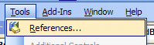
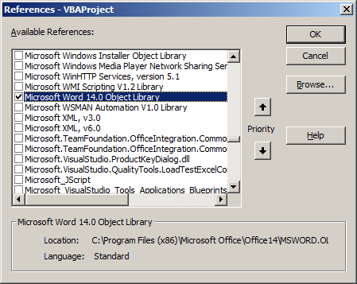
- …click Tools, References….
- Select Microsoft Word 14.0 (or later) Object Library and then click OK.

- Place the following code in a the Command Button procedure and run it

Every application which supports Automation provides an Application object. This is usually our starting point.

Private Sub cmdStartWord_Click()
- Since this is not an Excel Application we must qualify it as a Word application.

Dim appWord As Word.Application
Set appWord = New Word.Application
appWord.Visible = True
appWord.Documents.Add
appWord.Selection.TypeText "mat"
Set appWord = Nothing

End Sub
Note that this bit of the code is identical to the Word code that we produced using the macro recorder.

Note also that when we are typing we get the IntelliSense assisting us – even for Word Keywords! (this is also an indication that the reference to the Word objects library has been successfully set – one of the benefits of “Early Binding”.).

When we click our Command Button on our Excel sheet to run the code, you should find that Word opens with a new document and the text “mat” is placed at the start of the document.

Late Binding is slower, we don’t get the IntelliSense feature when editing and is really only included for backward compatibility.

We do not set a reference (Tools, References etc) when we chose to use Late Binding.

We would then use

Set appWord = GetObject(,"Word.Appication") and CreateObject etc instead of

Dim appWord As Word.Appliction
Set appWord = New Word.Application.) etc.

API (Application Programming Interface)

Many Windows functions can be accessed from Excel VBA. (There are over a 1000 of them!)

We can get and change system information eg
- the User Name
- the Computer Name
- the keyboard repeat rate
- the amount of RAM available etc

We may wish to:
- change the caption of a form
- make it flash
- bring one form(window) to the top
- find which form has got the focus
- change the colour of a command button
- Access a more accurate timer.

How do we find out about API's? – the best source is the net.
Whole books on API's exist. (Fortunately the code we use is identical whether we are using Excel VBA or Visual Basic itself.

Fortunately we don’t have to type in the declarations by hand- we can copy then from a file called
win32API.txt.
- Do a Find File to try to locate this file. (It is also included with various book CDs) – or try from the school site using this URL in Internet Explorer : http://www.una.co.uk and clicking Win32API.txt.

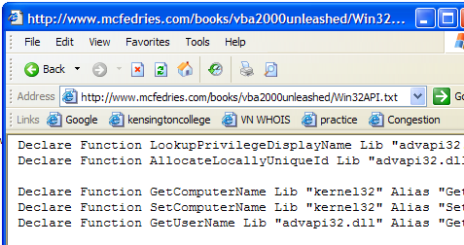

We can of course cut and paste it from this text file.

To Retrieve the User Name from Excel.

- Type the following in a new Module.

Declare Function GetUserName Lib "advapi32.dll" Alias "GetUserNameA" (ByVal lpBuffer As String, nSize As Long) As Long

(Private Declare Function GetUser… etc will allow the declaration to be placed in the sheet code-behind.)
PtrSafe may be necessary.
nSize will be the size of this string buffer.
LpBuffer is where the user name string will eventually be stored. This is a rather unusual way to return the string - implicitly in a "buffer".

- Place a command button on a form and write the following code.

Private Sub CommandButton1_Click()
This creates a dummy fixed length string of size 255 (255 zeros). (API's can't cope with variable length strings.)
Note that the string is actually returned here ie by Reference
di will be 0 for failure or non-zero upon success.
Dim strUserName As String
Dim di As Long
strUserName = String(255, 0)
di = GetUserName(strUserName, 255)
MsgBox strUserName

End Sub

- Run the code.

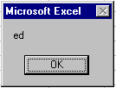You should get a message box with your user name (assuming that you have got one).

File Handling Saving Data To Disc

We will create a File and write to it.

- Place a command button on the spreadsheet. (Give it a name cmdCreateSerial and caption CreateSerial.)

- In order to change the Name and Caption, select the button and choose Properties.

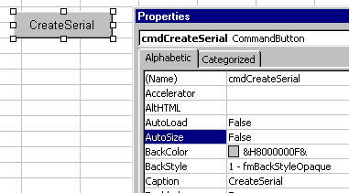
You could be forgiven for skimming thru this and concentrating on the FileSystemObject (later).
- Change the Name.
- Change the Caption.

- Type the following code.

c:\Saver: is the location of the file ie where it is to be saved. If you don’t specify a directory, ie only the file name is specified, then the file will be saved into the directory in which you are currently working on your project.

Output
means output from the memory to disc.

Input means the opposite.

Private Sub cmdCreateSerial_Click()


Open "c:\test\Saver.txt" For Output As 1
Write #1, "ed", "jo", "al"
Close #1

End Sub

Windows may not allow saving directly to the C: drive. So better to create a directory called say test and save it to that ie C:\test.
.

This file number (1) can be any number (provided this number isn’t being currently used as the number of another file). It must be consistent throughout the code.

If you make a typing error, the code of course may stall when run it. BUT the file may have been opened and not closed. If we fix the code and try to run it again, we will probably get an error saying that the file is open. To avoid this, make another button with the following code which will close all files:

Private Sub CommandButton1_Click()
Close #0
End Sub

FreeFile
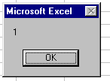
FreeFile returns the next available File Number.
MsgBox FreeFile

To View Our File
Visual Studio (Youre unlikely to have this) can be used to view a binary file.

File, Open, File, Open With

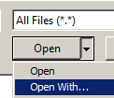

then choose the Binary Editor.

2C (decimal 32+12 = 44) is the (hex) ascii for comma. (This is a comma delimited file.)
22 is the (hex) ascii for an inverted comma.

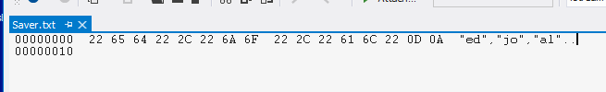
OD OA is hex Ascii for carriage return, line feed, ie the end of your file.

See over for an explanation of hex.

We make also view our file using Notepad or WordPad but this would show the actual characters and not their (hex) ascii equivalent.

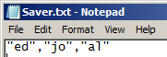

Hexadecimal

Here is some hexadecimal

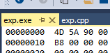
(Two hex digits eg 4D is known as a byte.)

Firstly the numbers 1 – 15

are represented as:

Decimal Hexadecimal
1 1
2 2
. .
. .
9 9
10 A
(Small caps ie
a b c d e f usually work as well.)
11 B
12 C
13 D
14 E
15 F

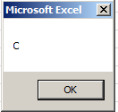
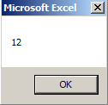
eg Try this in a command button

MsgBox Hex(12) ->

and the other way round

MsgBox &HC ->

(&hC will work as well.)

Remember A is 10.
Secondly – What about two hex digits (ie a byte) eg 3A

The rule is: Multiply the one on the left by 16 and add.

ie 3 x 16 + 10. ie 48 + 10 = 58 is the answer.

Try it:

MsgBox &3A -> 58

Try some others eg 4B BC 7F

A famous one is FF.
The other way round:
In VBA you will not encounter hex as much as you might in C++ or C# languages.

eg Convert 58 to hex. (ans is 3A)

The algorithm* is left as an exercise.

* An algorithm is a method. A “set of instructions” if you like.

How about a 3 digit hex number eg 12A ?

Rule: Multiply the very left number (ie the 1) by 256* and then do the same as before for the other two digits. Confirm your answer using MsgBox &12A

* Why 256 ? Can you guess?
Hint: Think how we deal with a 3 digit decimal number eg 123 as we move left.

How about a 4 digit hex number eg 2AB3 ?

----------------------------------------------------------------------------------------------

Omit this if you haven’t done binary yet.

Why use hex? Hexadecimal is a shorthand way of writing binary

For example, decimal 42 is the equivalent of the hex 2A.

- Write the 2 and the A separately in binary:

2 A

8 4 2 1 8 4 2 1

… … 1… …0 1… 0… 1… 0…

- Now write 42 as binary:

128 64 32 16 8 4 2 1

… … 1… …0 …1 …0 1… …0

They are the same! This is always true – since all of the numbers of the higher hex digit are 16 times those of the lower.

We now wish to

To Read Back The File

- Place a second command button on the spreadsheet with the Name and Caption as below. Type the following code.

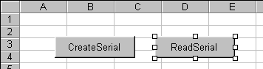

Private Sub cmdReadSerial_Click()

Dim a As String, b As String, c As String
Open "c:\test\Saver.txt" For Input As 1
Input #1, a, b, c
Close #1
Cells(1) = a: Cells(2) = b: Cells(3) = c

End Sub

- Click on the command button. The records are printed onto the sheet as shown below.

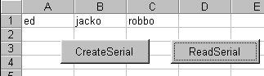

Note that the commas and the inverted commas (these are called field delimiters) are not retrieved as well.

If we were to Write again using the Output mode once again, the new data will over-write the first lot of data as we shall now see.

- Modify the code for the first button using different data strings as shown below:

Private Sub cmdCreateSerial_Click()
Open "c:\test\Saver.txt" For Output As 1
Write #1, "jo", "pam", "dale"
Close #1
End Sub

- Run the program , click on the first button and inspect the file.

Your data has been over-written!

i.e. whenever a file is opened for Output it creates a new file!
(ie Will overwrite a file if one exists.)

Append

- Modify the code for the first button as shown below:

Private Sub cmdAppendSerial_Click()
- Change Output to Append as shown.
Open "c:\test\Saver.txt" For Append As 1
Write #1, "bo", "dee", "bip"
Close #1
End Sub
- Change the data.

- Click on the first button and inspect the file.

You should find that the extra strings have been tacked on to the end.

EOF returns True if the file pointer is at the end of the file.

The use of EOF() however is a little subtle. EOF() will only return True if an error occurs when we attempt to read beyond the end of the file.
EOF() is useful when we wish to read a file but we don’t know how many records it contains.

- Try this.

Private Sub cmdReadToEOF_Click()

Open "c:\test\Saver.txt" For Input As 1
Dim a As String
Do Until EOF(1)
- EOF(1) indicates end of file 1.
Records will be read until the end of the file is encountered and an error occurs. EOF() will then become False and reading will cease.
Input #1, a
MsgBox a
Loop
Close #1

End Sub

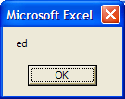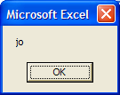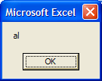

You may wish to place a message box - Msg EOF(1)- before the end of loop. You should get:

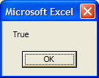
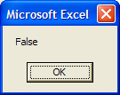 and then:

Kill

Kill is used to delete a file. eg Kill "c:\test\saver.txt"

- Exercise: Make a file to write this XML data:

"<Person>", "ed", "</Person>" and then read it back (use EOF) into the spreadsheet.
FileSystemObject
FileSystemObject is more popular than other (previous) techniques.

Creating a Text File

Private Sub CommandButton1_Click()

Dim fs As Object, a As Object

Set fs = CreateObject("Scripting.FileSystemObject")
Make sure that you have a folder C:\X

Set a = fs.OpenTextFile("c:\X\test.txt", 2)

a.WriteLine ("This is a test.")
Set fs.CreateTextFile("c:\X\test.txt”)
would do the same thing.
a.Close

End Sub

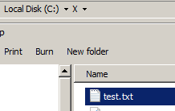

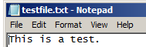
View the file in NotePad. (Double-click on the file or right-click and Open etc

The iomode argument can have any of the following settings
Constant | Value | Description
ForReading | 1 | Open a file for reading only. You can't write to this file.
ForWriting | 2 | Open a file for writing only. Use this mode to replace an existing file with new data. You can't read from this file.
ForAppending | 8 | Open a file and write to the end of the file. You can't read from this file.

If you change the text eg
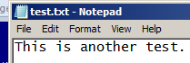
a.WriteLine ("This is another test.")and run it again the file (and the text) will be replaced. ie: You have been warned!

As above but change this to 1 as shown.
Reading a Text File

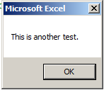
Set a = fs.OpenTextFile("c:\X\test.txt", 1)
MsgBox a.ReadLine ->

Appending to a Text File

Using the code at the top of this page. Replace the 2 with 8.

Set a = fs.OpenTextFile("c:\X\test.txt", 8)

You should find that the text in the file is added to rather than replaced.

For these and other properties and methods see:

https://docs.microsoft.com/en-us/office/vba/language/reference/user-interface-help/filesystemobject-object

eg:here is a sample:

FolderExists | Checks if a specified folder exists.
GetAbsolutePathName | Returns the complete path from the root of the drive for the specified path.
GetBaseName | Returns the base name of a specified file or folder.
GetDriveName | Returns the drive name of a specified path.
GetExtensionName | Returns the file extension name for the last component in a specified path.
GetFileName | Returns the file name or folder name for the last component in a specified path.
GetParentFolderName | Returns the name of the parent folder of the last component in a specified path.

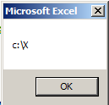
Path

MsgBox fs.GetParentFolderName("c:\X\test.txt") ->

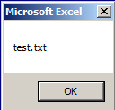
FileName

MsgBox fs.GetFileName("c:\X\test.txt") ->

Move

fs.MoveFile "c:\X\test.txt", "c:\Z\")
Make sure that you have a folder C:\Z as well as C:\X.

Copy

fs.CopyFile "c:\X\test.txt", "c:\Z\"

Rename is a move!

fs.FileMove "c:\X\test.txt" "c:\X\NewName.txt"

You may have noticed as you were typing that there is no Itellisense.

Similarly when debugging, we couldn’t hover over a variable.

This is because we Dimmed as Objects and not specifically (see below) ie we had:

Dim fs As Object, a As Object

Set fs = CreateObject("Scripting.FileSystemObject")

Set a = fs.OpenTextFile("c:\X\test.txt", 2)

a.WriteLine ("This is another test.")

a.Close

To remedy this we must 1. Add a Reference as follows:

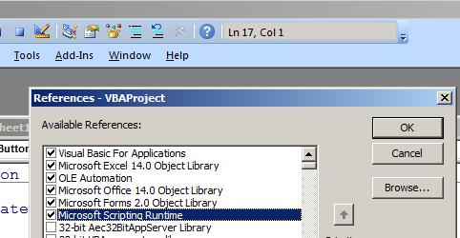
Tools, References.
Choose
Microsoft Scripting Runtime
and click OK.

2. Replace the first two lines above with:

Dim fs As FileSystemObject, a As TextStream

Set fs = New FileSystemObject

Try it. You should now find that you have Itellisense etc.
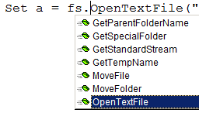

For what it’s worth this is known as Early Binding cf Late Binding which is what we had before.

The choice is yours.

(Early Binding may cause problems with version numbers)

The last Word?

An object is something which has properties and methods.

So for :

Set a = fs.OpenTextFile("c:\X\test.txt", 2)

fs is an object which has the OpenTextFile property

Can you therefore see the difference between these two? :

GetFile | Returns a File object for a specified path.
GetFileName | Returns the file name or folder name for the last component in a specified path.

Error Handling.

On Error Resume Next
Dim fs As Object, a As Object
Set fs = CreateObject("Scripting.FileSystemObject")
Set a = fs.OpenTextFile("c:\X\eds2.txt", 1)
If Err = 53 Then GoTo out
To determine this error number, run it without the error code so see what the error message says.
MsgBox a.ReadLine
a.Close
Exit Sub
out:
MsgBox Err.Description
a.Close
Add-Ins
You can use an AddIn as a repository for your code. Code that will work for any workbook.
Perhaps as an alternative for the personal.xlsb!

An AddIn is a separate workbook that contains functions that we can use in our own workbook.

We will:

1. Make an AddIn
2. Install it.
3. Use the AddIn functions in our own workbook

1. Make an Addin

In a new workbook place this UDF code in a Module (Insert, Module)

Function MultTwo(x As Double) As Double

MultTwo = 2 * x

End Function (You may wish to test the UDF first!)

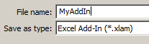
Save the workbook as MyAddin.xlam

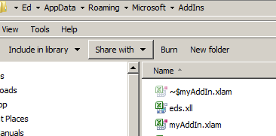

(Notice that when you save it as a .xlam it will be automatically saved into the AddIns folder:
(C:\Users\Ed\AppData\Roaming\Microsoft\AddIns)
(Best make a shortcut to this folder.)

- Close the Add In. It is just as well to close Excel itself
2. Install the AddIn

- Open a new workbook.

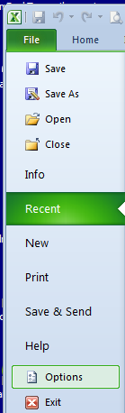

Choose File, Options.

- Choose Add-Ins down the left hand side.

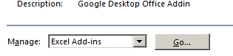

Click Go.

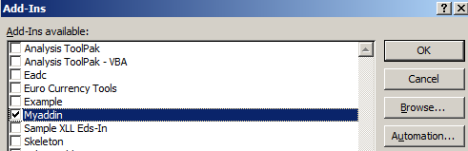

Choose your Add In and click OK.

Browse and select MyAddIn.xlam.

Note that this addin is installed for all future workbooks – unless you uninstall it.
MyAddIn.xlam has been added.

Click OK

3. Use the AddIn functions. (The AddIn workbook does not need to be open.)

- From any workbook test the addin’s function like so:

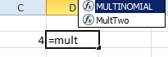
Note that as we type our function appears. Press Enter and..

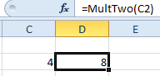

…our number is multiplied by 2.

- Close the workbook.
Using VBA to call our AddIn functions

Generally speaking we can call functions in other workbooks by either

1. Using Application.Run or
In each case the AddIns workbook need not be open.
.

2. Setting a Reference.

1. Using Application.Run

- Place this code in the command button of our new workbook or testAddIn.xlsm.

Private Sub CommandButton1_Click()
The AddIn must be installed.

Dim x As Integer

x = Application.Run("MyAddIn.xlam!MultTwo", 3) 'To call the function

MsgBox x

End Sub

- Click the button:
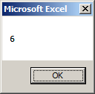

->

We can also run a sub (as distinct from a function) in the addin as follows:.

Add this sub code to the Module in the MyAddIn.xlam.

Public Sub mySub()
Don’t worry if you don’t see much when you open your AddIn. You can still see the code through Project Explorer.

MsgBox "test"

End Sub

and this code in the command button on the test workbook

Application.Run ("MyAddIn.xlam!mysub")

- Now when we click the button in our test workbook the sub should run as well:
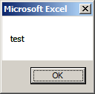
Application.Run can also be used to run code in other workbooks
– in particular the Personal.xlsb as we will see later.

->

- Close Excel and Reopen it. If a blank workbook opens as per usual – close it.

1. Setting a Reference

To use referencing we must rename the project in the AddIn first.

To name the project.

Open the AddIn Myaddin.xlam. (In C:\Users\Ed\AppData\Roaming\Microsoft\AddIns)
When you open your .xlam you will have a pretty blank looking Excel. Don’t worry it’s there but you won’t even be able to use Unhide to see it!
Never mind you can still see it in Project Explorer.

- Go to the code window using Alt-F11.

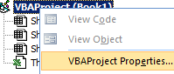
Right-click on the project and choose the Properties.

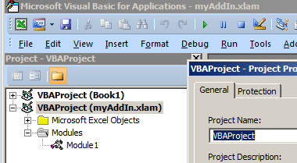

- Change it to say myProject.
All open projects are called VBAProject by default. This is why we have to change ours to distinguish it.

- Save it from the VBE.

Close the addin.

We must now set a reference to our addin project as follow.

- From the VBA in the test workbook choose …

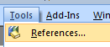
…Tools References.
- You may have to Uninstall and Install the AddIn? and close your testAddIn.xlsm

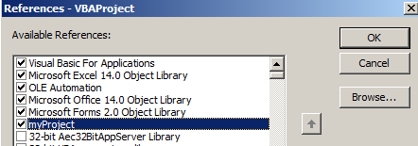

- Browse to our addin MyAddIn.xlam in
C:\Users\Ed\AppData\Roaming\Microsoft\AddIns.

It must be said that a problem with AddIns is the need to install and uninstall the AddIn (see later) when we make a code change to our AddIn.
- Our project is selected as a reference so click OK.

- Place a button on the our workbook and write this code

Private Sub CommandButton1_Click()
MsgBox myProject.MultTwo(2) ' Needs a Reference
End Sub
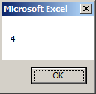
We don’t need the workbook qualifier when we use the reference method.
- Click the button: ->

Now we will call a Sub from code.
- Also place this sub code in the code module of the AddIn.

Public Sub mySub()
MsgBox "test"
End Sub

Recall that a sub doesn’t return anything to the spreadsheet whereas a Function does.

We can run it from the command button of our test workbook using:

myProject.mySub

- Save the Addin. Close Excel? Open Excel? Uninstall the Addin? Install it agai
AddIns
http://www.cpearson.com/excel/createaddin.aspx
add to QA toolbar
http://trumpexcel.com/2016/03/excel-add-in/
Set a Reference to the Add-In
http://www.fontstuff.com/vba/vbatut08.htm
name the .xlam PROJECT first

