Appendix A

HTML
YouTube: https://youtu.be/E2ePHgAElbk HTML * Publish.

Email

Timer

Collections

DAO
YouTube https://youtu.be/541W_FW0eWY

SQL
Basic Access Table Form Query Report https://youtu.be/oeB5gPXcMgs

Automate PowerPoint

ListBox Extra

Shell

HTML

What is it? It’s a simple text file with lots of angle brackets. eg
<head>
HTML is hierarchical.
An opening tag eg <head>is always matched by a closing tag < /head>. Allowing “nesting”.
<b>
hello
</b>
</head>

- Make this above file in notepad and save it as html.html . (I saved mine to C:/temp - easy to find).

What’s HTML used for? To render a document. To render means to lay it out according to instructions – much the same as you might give instructions to the high street printer.
An HTML file is a set of instructions for a browser (renderer) such as Internet Explorer.

- Open Internet Explorer (or FireFox) etc

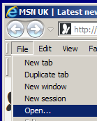

- File, Open.

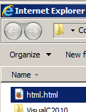

- Navigate to your html file and open it.

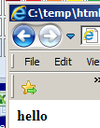
- Hey Presto our html file has been rendered.

To view the html source from Internet Explorer:
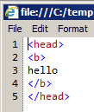
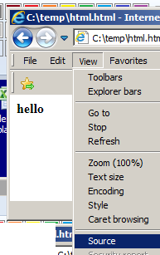
Note the use of the opening and closing b tags which have the effect of making hello bold.
- View, Source.

For more on HTML (great tutorials) see: https://www.w3schools.com/html/default.asp

MS Outlook will also render an email in html format.
To PUBLISH means to convert – usually to html.
See AddressesExpt.xlsm html sheet.

This code will extract some text (data) from an Excel sheet and save it to a file called temp.htm

ie we will convert this: to this:
<tr height=20 style='height:15.0pt'>
<td height=20 class=xl154723 width=64
style='height:15.0pt;width:48pt'>hello</td></tr>

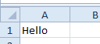

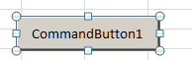
Private Sub CommandButton1_Click()

Range("A1").Activate ' (This extraneous code line is needed to take the focus off an active X control! ie button? )

Dim rngSend As Range

Const htmlFile As String = "c:\temp.htm" ' This is where our html file WILL be stored.

Set rngSend = Worksheets("Sheet1").Range("A1") ' This is where the text is coming FROM.

'The following code will convert and place the text "Hello" from cell A1 into the html file called temp.htm
With ActiveWorkbook.PublishObjects.Add(SourceType:=xlSourceRange, Filename:=htmlFile, Sheet:="Sheet1", Source:=rngSend.Address, HtmlType:=xlHtmlStatic)
.Publish (True)
End With
(You can also have a .html extension instead of .html – no difference.)

End Sub
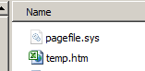

Our html file has been produced. Right-click on it to open it with Internet Explorer. (If Internet Explorer is the default.)

If using FireFox choose Tools, Web Developer, Page Source.

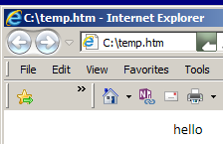
Our html file temp.htm has been rendered (displayed) by Internet Explorer.

If we view the source (For Internet Explorer: View, Source from the menu) we find that we get a bit more html than we bargained for. Here is just a part of it:

<tr height=20 style='height:15.0pt'>
This line is the important bit – it produces the “hello” in the Internet Explorer as shown above.
<td height=20 class=xl154723 width=64
style='height:15.0pt;width:48pt'>hello</td>
</tr>

Sending an email from Excel Addresses.xlsm email sheet.
Part 1 Microsoft reference https://msdn.microsoft.com/en-us/library/ff458119(v=office.12).aspx

https://msdn.microsoft.com/en-us/library/ff519602(v=office.12).aspx#odc_office_UseExcelObjectModeltoSendMailPart2_MailingRangeSelectionBody

1. Plain Text email

- From the VBE set a reference (Tools, References) to the Microsoft Outlook 16.0 (or other versions) Object Library.
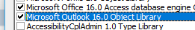
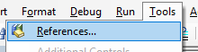

2. Place the code below in a command button and click.

Private Sub cmdOutlook_Click()
Dim rng As Range
Dim OutApp As Outlook.Application
Dim OutMail As Outlook.MailItem

Set OutApp = CreateObject("Outlook.Application")
Set OutMail = OutApp.CreateItem(0)

With OutMail
.To = "ed@una.co.uk"
.CC = ""
.BCC = ""
.Subject = "This is the Subject line"
.Body = "Hello"
'.HTMLBody = "<B>Hello</B>"
.Display'In place of Display, you can use ".Send" to actually send the e-mail.
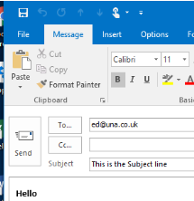
End With

Set OutMail = Nothing
Set OutApp = Nothing

End Sub

This is a piece of html.
<B>…</B> is the HTML instruction for Bold.

2. HTML Formatted email

Uncomment .HTMLBody = "<B>Hello</B>" in above code
and comment out the .Body = "Hello"

To have a more elaborately formatted range - from a spreadsheet use:
.HTMLBody = RangetoHTML(rng) where:
.HTMLBody = "<p>" & Range("H1").Value & " " & Range("H2").Value & "<br>" & _
Range("I1").Value & " " & Range("I2").Value & "</p>"

This function (See next page) will convert the raw data from the spreadsheet to HTML.

Function RangetoHTML(rng As Range)

'Works in Excel 2000, Excel 2002, Excel 2003, Excel 2007, Excel 2010, Outlook 2000, Outlook 2002, Outlook 2003, Outlook 2007, and 2010.
Dim fso As Object
Dim ts As Object
Dim TempFile As String
Dim TempWB As Workbook
TempFile = Environ$("temp")& "/" & Format(Now,"dd-mm-yy h-mm-ss")& ".htm"
'C:\Users\Ed\AppData\Local\Temp/14-03-18 22-33-22.htm
' Copy the range and create a workbook to receive the data.
rng.Copy
Set TempWB = Workbooks.Add(1)
With TempWB.Sheets(1)
.Cells(1).PasteSpecial Paste:=8
.Cells(1).PasteSpecial xlPasteValues, , False, False
.Cells(1).PasteSpecial xlPasteFormats, , False, False
.Cells(1).Select
Unfortunately this must be a 2-stage process – which may sound unnecessary. We must FIRST save our data from the s/sheet into an Excel .htm workbook file and THEN copy the contents of this into our email using the File System Object (FSO).
Application.CutCopyMode = False
On Error Resume Next
.DrawingObjects.Visible = True
.DrawingObjects.Delete
On Error GoTo 0
End With
' Publish the sheet to an .htm file.
With TempWB.PublishObjects.Add( _
SourceType:=xlSourceRange, _
Filename:=TempFile, _
Sheet:=TempWB.Sheets(1).Name, _
Source:=TempWB.Sheets(1).UsedRange.Address, _
HtmlType:=xlHtmlStatic)
Stage 1.
.Publish (True)
End With
' Now read all data from the .htm file into the RangetoHTML subroutine.
Set fso = CreateObject("Scripting.FileSystemObject")
Set ts = fso.GetFile(TempFile).OpenAsTextStream(1, -2)
RangetoHTML = ts.ReadAll
Stage 2.
ts.Close
RangetoHTML = Replace(RangetoHTML, "align=center x:publishsource=", "align=left x:publishsource=")
' Close TempWB.
TempWB.Close savechanges:=False
' Delete the htm file.
Kill TempFile

Set ts = Nothing
Set fso = Nothing
Set TempWB = Nothing
End Function

<html><body> <table><tr><th>Firstname</th><th>Lastname</th>
</tr><tr><td>Jill</td><td>Smith</td>></tr><tr>
<td>Eve</td><td>Jackson</td></tr></table></body></html>
Add an attachment: .Attachments.Add "C:\code\myfile.docx"

Get the attachment/s:

http://www.vbaexpress.com/forum/showthread.php?6653-Solved-Open-attachment-in-Outlook-MailItem-with-VBA

Well it's not possible to open a file without saving somewhere first. (When you "open" an attachment directly from an email, Outlook will save the file to a temp directory first and open it from there.)
It's easy enough for you to do the same.
See AddressExpt.xlsm for complete code to take an attachment.
We need an unread email in InBox. And it needs to be selected:

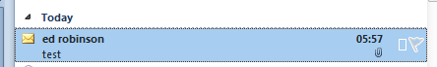

Take the attachment from C:\code\ and save it in
C:\code\ as eg 09-18-2019myfile.docx.

See Sub mytry()

ie We cant just open an attachment- we must SAVE it first.

https://www.slipstick.com/developer/save-attachments-to-the-hard-drive/
“The following code saves the attachments from selected messages”

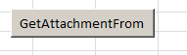
This button is on email sheet in AddressesExpt.xlsm

'

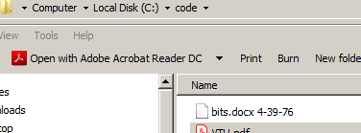
On Error Resume Next

Set objOL = Outlook.Application

strFolderpath = "C:\code\"

strFile = strFolderpath & strFile & " " & Format(Date, "##-##-##")
Format(Now, "yy: …. sss")

It gets attachments from selected emails (unopened as well?) and places them in "C:\code\"

--------------------------------------------------------------------------------------------------------------------

In AddressesExpt.xlsm: Email sheet : Code:

SaveAttachments gets attachments.

myTry checks for unread. Gets description etc. Gets attachments.

-----------------------------------------------------------------------------------------------------------------------

https://stackoverflow.com/questions/11781320/download-attachment-from-outlook-and-open-in-excel
Checks for unread

http://rondebruin.nl/win/s1/outlook/mail.htm

Collections are an alternative to arrays.

The advantage over arrays is that you can easily add/subtract elements.

Comprehensive coverage:
https://excelmacromastery.com/excel-vba-collections/#What_is_a_Collection
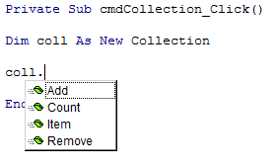

We have already seen Collections; Worksheets & Workbooks. Recall how we can Remove/Delete, Count etc.

We can add pairs:
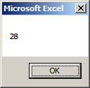
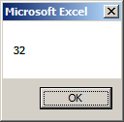
coll.Add 32, "ed"
ed, jo are keys..
coll.Add 28, "jo"

MsgBox coll("ed")
MsgBox coll("jo")

Dictionary uses Script Library reference:
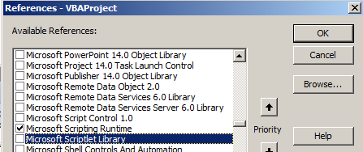

Private Sub CommandButton1_Click()

Dim dict As Dictionary
Set dict = New Dictionary

dict.Add "ed", 10
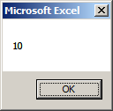
dict.Add "jo", 20
dict.Add "al", 10

MsgBox dict("ed")

dict.Remove ("ed")

End Sub

Timer

Can be used to see how long it takes for your code to execute.

Private Sub cmdTimer_Click()

Dim Start As Currency, Finish As Currency, TotalTime As Currency, i As Currency
Currency variables are stored as 64-bit (8-byte) numbers in an integer format, scaled by 10,000 to give a fixed-point number with 15 digits to the left of the decimal point and 4 digits to the right.
Start = Timer ' Set start time.
For i = 1 To 1000000 'Do Something
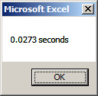
Next i
Finish = Timer ' Set end time.
TotalTime = Finish - Start
MsgBox TotalTime & " seconds"

End Sub

But the problem is that it is accurate to .01 sec only.

Timer using the Windows API

http://www.vbaexpress.com/kb/getarticle.php?kb_id=1068

Private Declare Function getFrequency Lib "kernel32" Alias _
"QueryPerformanceFrequency" (cyFrequency As Currency) As Long

Private Declare Function getTickCount Lib "kernel32" Alias _
"QueryPerformanceCounter" (cyTickCount As Currency) As Long

Private Sub cmdAPITimer_Click()
Test
End Sub

Sub Test()

Dim i As Long, Tim As Double, Result1 As Double, Factor As Long
Tim = MicroTimer

For i = 1 To 100000
' DoEvents 'Yield to button press etc
Next
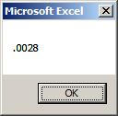
Result1 = MicroTimer - Tim

MsgBox Format(Result1, "###.####")

End Sub

Function MicroTimer() As Double ' returns seconds
Dim cyTicks1 As Currency, cyFrequency As Currency

getFrequency cyFrequency ' get ticks/sec using API

getTickCount cyTicks1 ' get ticks using API

MicroTimer = cyTicks1 / cyFrequency ' calc seconds

End Function

Example : Shows how expensive Activate/Select is:

Option Explicit
' Performance counter API's
#If VBA7 And Win64 Then
'for 64-bit Excel
Declare PtrSafe Function QueryPerformanceCounter Lib "kernel32" (lpPerformanceCount As Currency) As Long

Declare PtrSafe Function QueryPerformanceFrequency Lib "kernel32" (lpFrequency As Currency) As Long
#Else
'for 32-bit Excel
Declare Function QueryPerformanceCounter Lib "kernel32" (lpPerformanceCount As Currency) As Long

Declare Function QueryPerformanceFrequency Lib "kernel32" (lpFrequency As Currency) As Long

#End If

'Purpose: Measure elapsed time in milliseconds
Sub TimeACode()’PUT THIS IN A MODULE
Dim curFrequency As Currency
Dim curStartPerformanceCounter As Currency
Dim curEndPerformanceCounter As Currency
Dim lgResult As Long

'obtain no: of counts per second
lgResult = QueryPerformanceFrequency(curFrequency)
If lgResult > 0 Then
Debug.Print "Frequency: " & curFrequency
End If

'measure start count
lgResult = QueryPerformanceCounter(curStartPerformanceCounter)
If lgResult > 0 Then
Debug.Print "Start Count: " & curStartPerformanceCounter
End If

'*****************************************
'Insert the code here to measure elapsed time
Dim v
' Worksheets("Sheet2").Activate
' Range("a1").Select
' v = ActiveCell.Value ‘USE THE FOLLOWING ALTERNATIVE!
v = Worksheets("Sheet2").Range("a1").Value
Debug.Print v

'*****************************************
'Measure end count
lgResult = QueryPerformanceCounter(curEndPerformanceCounter)
If lgResult > 0 Then
Debug.Print "End Count: " & curEndPerformanceCounter
End If

'measure elapsed time
Debug.Print "Elapsed time (ms): " & (curEndPerformanceCounter - curStartPerformanceCounter) / curFrequency
End Sub

DAO

The DAO (Data Access Object) ref Ch14 Walkenbach

DAO is used in this case to access Access data directly using Excel VBA.

First make an Access database – see next page.

The Access Object model essentially uses Forms and Reports as an interface to access the table’s data but we wish to access the data directly we use the DAO – from Excel VBA.

From Excel VBA need to set a reference to the DAO as follows.

- With the Visual Basic Editor window open…

DAO could also be used to access data in unopen Excel s/sheets!

- Click Tools, References…

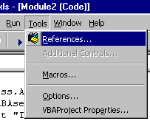

- Make sure that
Microsoft Office 16.0 Access database engine Object Library (or later version) is checked and then click OK.

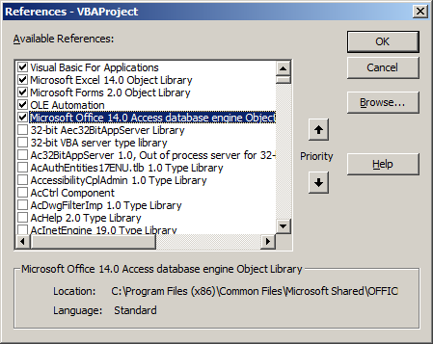

- Open Access and make sure that you have the following database : test.accdb

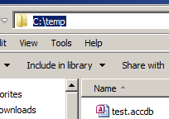
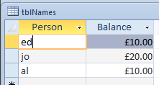

- Note carefully the name of the table (in this case tblNames), the name of the database (in this case test.accdb) and the path of the folder - in this case C:\temp - in which it is stored.

- Try the following in a new button:

Private Sub cmdTestDB_Click()

'"Microsoft Office 12.0 Access database engine Object Library" (or 14.0, for Office 10

Dim DBFullName As String: DBFullName = "C:\temp\test.accdb"

Dim DB As Database: Set DB = OpenDatabase(Name:="C:\temp\test.accdb")

Dim tbl As Recordset: Set tbl = DB.OpenRecordset("tblNames")

tbl.MoveFirst

Cells(1, 1) = tbl!Person: Cells(1, 2) = tbl!Balance

End Sub

Result: ed’s name and balance is placed in the cells.

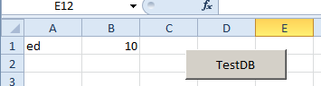

For further reference see:
http://www.globaliconnect.com/excel/index.php?option=com_content&view=article&id=175:connecting-to-microsoft-access-database-from-excel-vba-using-dao-object-model&catid=79&Itemid=475

As well as DAO Microsoft had/has ADO. Decide for yourself the difference (and what the acronyms mean) and when to use which. Meanwhile use DAO when accessing Access

SQL

A Simple SQL query on the Test.accdb
See Sams Teach Yourself SQL in 10 Minutes
http://www.forta.com/books/0672336073/

- Make this table tblNames in Test.accdb.
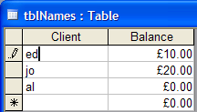

To Produce a Query using the QBD (Query By Design Grid) see Access Notes on una.co.uk..
ACCESS
AccessDay1

We wish to try this SQL statement on the table: SELECT Client, Balance FROM tblNames;

- Make a New query not based upon any table.

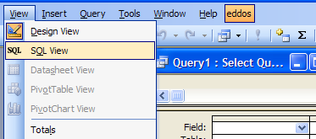
- Choose View, SQL View.
(Make sure that the query is still in Design Mode.)
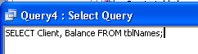

- Paste in the SQL statement.

- Run the query.

In this case all of the records are selected from the table.

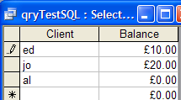
See Teach Yourself SQL in 10 minutes by Ben Forta.
Notes on differences for Access: The % and _ are not allowed in Access.
Use * and ? respectively (page 45). ie % -> * and _ -> ?

The RunSQL command can also be used with DoCmd to run certain SQL commands as we will now see. (Can’t use SELECT - can use SELECT INTO).

See axsVBAUsing Access To Practise SQL.doc on una.co.uk:

ACCESSVBA
axsVBAAccess2010
axsVBAUsing Access To Practise SQL
Automate PowerPoint

Make this table and chart in Excel

 | mon | tue | wed | thu | fri
week1 | 32 | 45 | 23 | 34 | 22
week2 | 45 | 33 | 11 | 22 | 44
week3 | 33 | 45 | 65 | 32 | 12

We wish to write code to copy this chart to a PowerPoint slide.

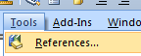
From the VBE Click Tools, References.

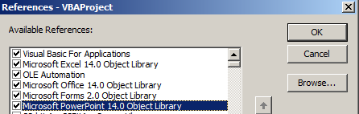
And choose (your version of) the PowerPoint Object Library.

This will enable us to program in Excel VBA as if we were directly programming PowerPoint VBA in from within PowerPoint itself.

Place a command button on the Excel spreadsheet and write this code.

Private Sub CommandButton1_Click()
Make sure PowerPoint is open as well as Excel.
Dim pptApp As PowerPoint.Application
Dim pptPres As PowerPoint.Presentation
Dim pptSlide As PowerPoint.Slide
Getting a reference to the PowerPoint Application Object allows us to write PowerPoint VBA code in Excel VBA….

Dim cht As Chart, cho As ChartObject
Set cho = ActiveSheet.ChartObjects(1)
Set cht = cho.Chart

Set pptApp = GetObject(, "PowerPoint.Application")

Set pptPres = pptApp.Presentations(1)
… eg the 3 lines are PowerPoint VBA code.
Set pptSlide = pptPres.Slides(1)

'Copy chart from Excel
cht.ChartArea.Copy

'Paste chart in PowerPont.
pptSlide.Shapes.Paste

End Sub

Click the command button on Excel.

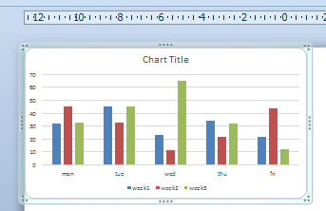
The chart appears in Excel

Embellishments:

Sub CreatePowerPoint()

'First declare the variables
Dim newPowerPoint As PowerPoint.Application
Dim activeSlide As PowerPoint.Slide
Dim cht As Excel.ChartObject
Dim i As Integer

'Look for existing instance
On Error Resume Next
Set newPowerPoint = GetObject(, "PowerPoint.Application")
newPowerPoint.Presentations.Open (FILE PATH)
newPowerPoint.Visible = True
You will need to replace with the path to your PowerPoint presentation.
Dim FILE_PATH As String
FILE_PATH = "C:\temp\eds.pptx"
On Error GoTo 0

'Or Create a new PowerPoint
If newPowerPoint Is Nothing Then
Set newPowerPoint = New PowerPoint.Application
End If
'Make a presentation in PowerPoint
Opens PowerPoint if it is not already open.
If newPowerPoint.Presentations.Count = 0 Then
newPowerPoint.Visible = True
newPowerPoint.Presentations.Open (FILE PATH)
End If

'Loop through each chart in the Excel worksheet and paste them into the PowerPoint
If you have more than one chart.
i = 0
For Each cht In ActiveSheet.ChartObjects
'Add a new slide where we will paste the chart
Set activeSlide = newPowerPoint.ActivePresentation.Slides(i + 1)
newPowerPoint.ActiveWindow.View.GotoSlide (i + 1)
activeSlide.Layout = ppLayoutChart

'Copy the chart and paste it into the PowerPoint as a Metafile Picture
cht.Select
ActiveChart.ChartArea.Copy
activeSlide.Shapes.PasteSpecial(DataType:=ppPasteMetafilePicture).Select

'Adjust the positioning of the Chart on Powerpoint Slide
newPowerPoint.ActiveWindow.Selection.ShapeRange.Left = 50
newPowerPoint.ActiveWindow.Selection.ShapeRange.Top = 125

activeSlide.Shapes(2).Delete
If you wish to size and position your PowerPoint chart.
i = i + 1
Next

AppActivate ("Microsoft PowerPoint")
Set activeSlide = Nothing
Set newPowerPoint = Nothing

End Sub

Further study: Excel VBA/PowerPoint

Excellent Youtube: https://www.youtube.com/watch?v=v_Mv2f9GZ5M

For further advancement it is probably a good idea to first write code directly from PowerPoint Excellent PowerPoint VBA material abounds.
eg see Microsoft Office 2000 VB Programmers Guide Chap 5 “Working with Microsoft PowerPoint Objects” Page 180 is highly recommended.

The previous code was obtained from GitHub.
https://gist.github.com/wmtylerdavis/5879851

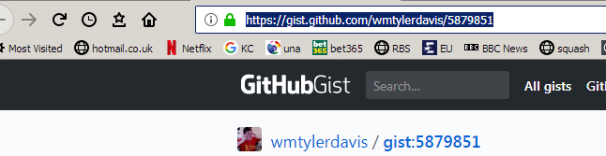

GitHub is a public depository site from which you can download (and upload!) code.

You should create an account on GitHub.

PowerPoint VBA (ie not Excel VBA) see page 188 Microsoft Office 2000 Prog Guide
From PowerPoint:
See PowerPointVBA.pptm Code also in 2000PG folder
From the VBE Insert a Module
Paste in this code

Sub CreatePresentation()
' This procedure illustrates how to create a new PowerPoint
' Presentation object and add slides to the presentation.
' There is a Stop statement where you would insert code to
' add shapes to the slides.
Dim ppApp As PowerPoint.Application
Dim prsPres As PowerPoint.Presentation
Dim sldSlide As PowerPoint.Slide

Set ppApp = New PowerPoint.Application
With ppApp
Set prsPres = .Presentations.Add
With prsPres
Set sldSlide = .Slides.Add(.Slides.Count + 1, ppLayoutText)
With sldSlide
‘Stop
End With
End With
End With
End Sub

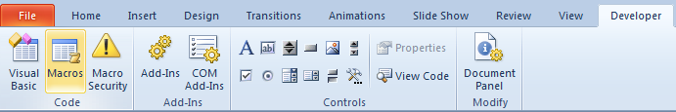
From the Code tag choose Macros.

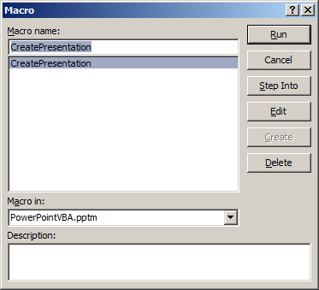
Run

A new presentation with a new slide appears
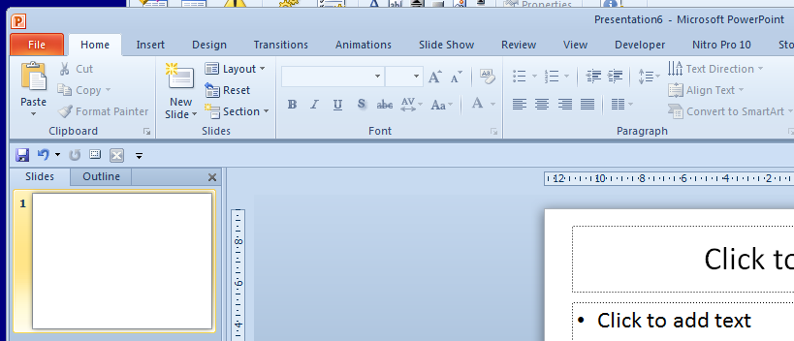

ListBox Extra

See CH11 : UserForm for the basics

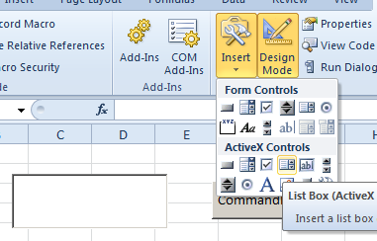

To add items to a Listbox
Need to.AddItem for each item!
Note that the indexing (row number) starts at 0.
ListBox1.AddItem
ListBox1.List(0) = "ed"

ListBox1.AddItem
ListBox1.List(1) = "jo"

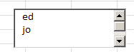

Rule: Rows and columns start at 0.

To add data to columns

ListBox1.ColumnCount = 2
ListBox1.ColumnWidths = "50, 50"

ListBox1.AddItem
The column count (ie the first column) also starts at 0.
ListBox1.List(0, 0) = "ed"
ListBox1.List(0, 1) = 10

ListBox1.AddItem
ListBox1.List(1, 0) = "jo"
ListBox1.List(1, 1) = 20

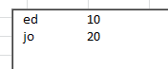

FileDialog

Provides file dialog box functionality similar to the functionality of the standard Open and Save dialog boxes found in Microsoft Office applications.

Dim fd As FileDialog

Set fd = Application.FileDialog(msoFileDialogFilePicker)

fd.Show

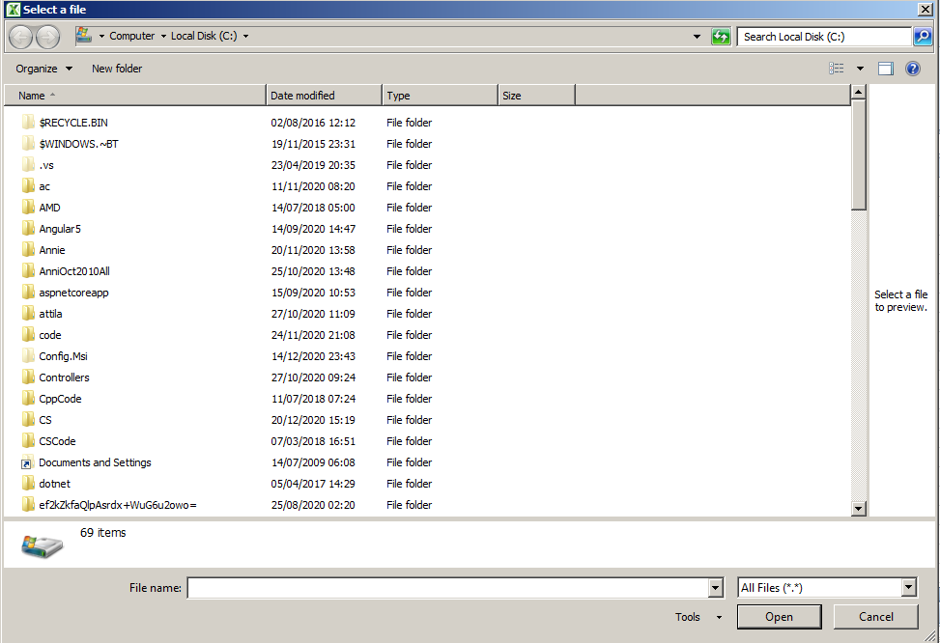

fd.Show actually does a bit more than open it. It also tells if a file was selected and the Open button clicked or the Cancel button was clicked.

Try MsgBox fd.Show instead of fd.Show above.

Run it, select a file and click Open. You should get -1.

Run it again and click Cancel this time. You should get 0.

To get the files selected.

Dim fd As FileDialog, itm

Set fd = Application.FileDialog(msoFileDialogFilePicker)

If fd.Show = -1 Then 'ie Something was selected.
'(Avoids an error if nothing wasn't selected.)

For Each itm In fd.SelectedItems

MsgBox itm
Debug.Print fDialog.SelectedItems(1) should work too - to print out one item (to the Debug window).
Next itm

End If

'fd.AllowMultiSelect = True

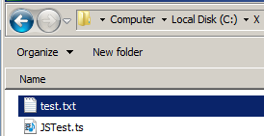
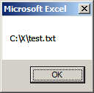
Run the above and select a file and Click Open.

->

To select more than one file try: (ie uncomment above.)

fd.AllowMultiSelect = True

Shell is used for running other apps.
Of course you will need to know where Winword.exe resides.
eg Run Word:

Dim st As String

st = "C:\Program Files (x86)\Microsoft Office\Office14\Winword.exe"
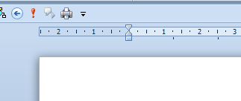
Call Shell(st, 1)

should run and open word.

If you omit the 1 here then Word will open but you wont see it!

WinSCP is used for FTP file transfer.

If you have it installed then try

st = "C:\Users\Ed\AppData\Local\Programs\WinSCP\WinSCP.com"

Call Shell(st)

Again - you will need to know where WinSCP.com resides.

You will now need to look at Task master (Ctrl-Alt-Delete) to see that it is running. Not to worry that you can’t see it. We will just be using the apps functionality.

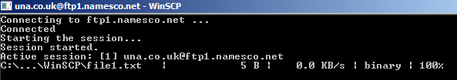

We wish to write code in VBA To Perform a File Transfer in WinSCP:

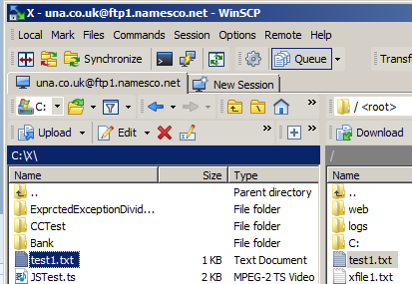

We use the Shell command as before but with a string parameter.

The code itself is simple but the construction of the string is not.

Dim st As String

st = is of the form (see below): /command "open" "put" and "exit"
Open the connection.
Transfer the file.
Call Shell(st, 1)

ie the string st is

The location of your WinSCP program.

C:\Users\Ed\AppData\Local\Programs\WinSCP\WinSCP.com /command "open ftp://una.co.uk:xxxxxxx@ftp1.namesco.net" "put C:\X\test1.txt" "exit"
Your FTP web address.
Your password.
Your FTP host name.
Note the : and @ separators above.
Where the file is coming from.

Here is the code for the construction (concatenation)of st:

(I have split the string up for clarity! It is much complicated by the inverted commas ie the " ’s in the string itself which requires """ etc! See few pages later for explanation.)

Dim st As String, st1 As String, stOpen As String
Dim stPutGet As String, stExit As String, stFtp As String
Dim stUser As String, stPass As String, stHost As String, stLocalPath As String
Dim stApp As String, stFileToTransfer As String

stLocalPath = "C:\Users\Ed\AppData\Local\Programs\WinSCP\"
stUser = "una.co.uk"
You will need to provide your username p/word host name here.
stPass = "xxxxxxxxx”
stHost = "ftp1.namesco.net"
stFtp = "ftp"
stApp = "WinSCP.com"
stFileToTransfer = "C:\X\test1.txt"

st1 = stLocalPath & stApp & " /command "

stOpen = """open " & stFtp & "://" & stUser & ":" & stPass & "@" & stHost & """"

stPutGet = """put " & stFileToTransfer & """"

stExit = """exit"""

st = st1 & stOpen & " " & stPutGet & " " & stExit

'Debug.Print st

Call Shell(st, 1) ' ie VBA calls WinSCP commands !

See AddressesExpt.xlsm WinSCP sheet.

Exercise Make a u/form to input the u/name etc.

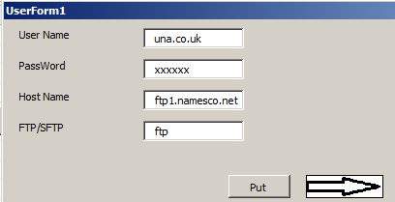

x
The strange behavior of “”” (Triple double-quotes)
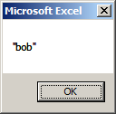
We wish to MsgBox “Bob” (ie including the double quotes):

so we use MsgBox ""bob"" right?

Wrong. We need an extra quote.

MsgBox """bob"""

Don’t ask! But if you do:

The extra quote in this situation is known as an escape character. Escape from reality? No escape from the usual meaning of the “.

In this situation the character " is an escape character which means take the character immediately to the right (ie the next “ literally ie as a “.

MsgBox """bob"""

Try putting an extra space in here or here and you just might get the idea.

Rule: If in doubt, throw in an extra “.

